

The International Committee on Taxonomy of Viruses

Taxonomy Proposal Form, 2024

**Part 1a: Details of taxonomy proposals**

|  |  |  |
| --- | --- | --- |
| **Title:** | Create three new species in the genus *Badnavirus* (*Ortervirales: Caulimoviridae*) | |
| **Code assigned:** | 2024.005P.A.v1.Caulimoviridae_3nsp |

|  |  |  |  |
| --- | --- | --- | --- |
| **Author(s), affiliation and email address(es):** | | | |
| **Name** | **Affiliation** | **Email address** | **Corresponding author(s)** |
| Umber M | INRAe, UR ASTRO, Domaine de Duclos, 97170 Petit Bourg, Guadeloupe, France | [marie.umber@inrae.fr](mailto:marie.umber@inrae.fr) |  |
| Dasgupta I | University of Delhi South Campus, Benito Juarez Road, New Delhi-110021, India | [indranil57@hotmail.com](mailto:indranil57@hotmail.com) |  |
| Geering ADW | QAAFI, The University of Queensland, St Lucia QLD 4072, Australia | [a.geering@uq.edu.au](mailto:a.geering@uq.edu.au) |  |
| Hafrén A | Swedish University of Agriculture, Almas Allé 5, 75007 Uppsala, Sweden | [anders.hafren@slu.se](mailto:anders.hafren@slu.se) |  |
| Hull R | Retired from John Innes Centre | [rogerhull@btinternet.com](mailto:rogerhull@btinternet.com) |  |
| Kreuze J | International Potato Center (CIP), Headquarters, P.O. Box 1558, Lima 15024, Peru | [j.kreuze@cgiar.org](mailto:j.kreuze@cgiar.org) |  |
| Leisner S | University of Toledo, Department of Biological Sciences, Toledo, OH. 43606, USA | [scott.leisner@utoledo.edu](mailto:scott.leisner@utoledo.edu) |  |
| Muller E | CIRAD, UMR AGAP Institut, Avenue Agropolis  34398 Montpellier cedex 5, France | [emmanuelle.muller@cirad.fr](mailto:emmanuelle.muller@cirad.fr) |  |
| Pappu H | Department of Plant Pathology, Washington State University, Pullman, WA, U.S.A | [hrp@wsu.edu](mailto:hrp@wsu.edu) |  |
| Pooggin M | PHIM Plant Health Institute, Univ Montpellier, INRAE, CIRAD, IRD, Institute Agro, 34980 Montpellier, France | [mikhail.pooggin@inrae.fr](mailto:mikhail.pooggin@inrae.fr) |  |
| Richer-Pöggeler K | Julius Kühn-Institut, Messeweg 11-12, D-38104 Braunschweig, Germany | [katja.richert-poeggeler@julius-kuehn.de](mailto:katja.richert-poeggeler@julius-kuehn.de) |  |
| Seal S | Natural Resources Institute, University of Greenwich, Central Avenue, Chatham Maritime, Kent ME4 4TB. UK | [S.E.Seal@greenwich.ac.uk](mailto:S.E.Seal@greenwich.ac.uk) |  |
| Stavolone L | Institute for Sustainable Plant Protection, National Research Council, via Amendola 165/A I-70126 Bari, Italy | [livia.stavolone@ipsp.cnr.it](mailto:livia.stavolone@ipsp.cnr.it) |  |
| Teycheney PY | CIRAD, UMR PVBMT, 7 chemin de l’IRAT, 97410 Saint Pierre, La Réunion, France | [teycheney@cirad.fr](mailto:teycheney@cirad.fr) | X |

**Part 1b: Taxonomy Proposal Submission** <

|  |  |  |  |
| --- | --- | --- | --- |
| **ICTV Subcommittee:** | | | |
| Animal DNA Viruses and Retroviruses |  | Bacterial viruses |  |
| Animal minus-strand and dsRNA viruses |  | Fungal and protist viruses |  |
| Animal positive-strand RNA viruses |  | Plant viruses | **X** |
| Archaeal viruses |  | General |  |

|  |
| --- |
| **List the ICTV Study Group(s) that have seen or have been involved in creating this proposal:** |
| *Caulimoviridae* |

|  |  |  |  |
| --- | --- | --- | --- |
| **Optional – complete only if formally voted on by an ICTV Study Group:** | | | |
| **Study Group** | **Number of members** | | |
| **Votes in support** | **Votes against** | **No vote** |
| *Caulimoviridae* | 12 | 0 | 2 |
|  |  |  |  |

|  |  |
| --- | --- |
| **Submission date:** | 14/06/2024 |

**Part 1c: Feedback from ICTV Executive Committee (EC) meeting**

|  |  |
| --- | --- |
| **Executive Committee Meeting Decision code:** | **X** |
| A – Accept | **X** |
| Ac – Accept subject to revision by relevant subcommittee chair. No further vote required |  |
| U – Accept without revision but with re-evaluation and email vote by the EC |  |
| Uc – Accept subject to revision and re-evaluation and email vote by the EC |  |
| Ud – Deferred to the next EC meeting, with an invitation to revise based on EC comments |  |
| J – Reject |  |
| W – Withdrawn |  |

|  |
| --- |
| **Comments from the Executive Committee:** |
|  |

**Part 1d: Revised Taxonomy Proposal Submission**

|  |
| --- |
| **Response of proposer:** |
|  |

|  |  |
| --- | --- |
| **Revision date:** | DD/MM/YYYY |

**Part 3:** **TAXONOMIC PROPOSAL**

|  |
| --- |
| **Name of accompanying Excel module:** |
| 2024.005P.A.v1.Caulimoviridae_3nsp.xlsx |

|  |  |  |  |
| --- | --- | --- | --- |
| **Taxonomic changes proposed:** | | | |
| Establish new taxon | **X** | Split taxon |  |
| Abolish taxon |  | Merge taxon |  |
| Move taxon |  | Promote taxon |  |
| Rename taxon |  | Demote taxon |  |
| Move and rename |  |

|  |  |
| --- | --- |
| **Is any taxon name used here derived from that of a living person?** | **N** |

|  |
| --- |
| **Abstract of Taxonomy Proposal:** |
| *Taxonomic rank(s) affected*:  Genus *Badnavirus*.  *Description of current taxonomy*:  The family *Caulimoviridae* [1] currently comprises 11 genera whose members share similar genome organization. The molecular species demarcation criteria is <80% identity of nucleotide sequences in the reverse transcriptase (RT) / ribonuclease H (RNase H) region of the polymerase. Genus *Badnavirus* [2] currently includes 71 species and is the largest genus within the family *Caulimoviridae*.  *Proposed* *taxonomic change(s):*  We propose the creation of three new species in the genus *Badnavirus*: *Badnavirus fatsiae*, *Badnavirus tetainflatheobromae* and *Badnavirus zizphi*.  *Justification*:  Complete genomes of the exemplar members of the three proposed new species were sequenced and published recently. Their organizations are similar to those of other members of genus *Badnavirus.* Phylogenetic analyses place them in this genus as distinct representatives of novel species. |

|  |
| --- |
| **Text of Taxonomy proposal** |
| 1. **Creating species *Badnavirus fatsiae* in the genus *Badnavirus***   *Badnavirus fatsiae* can be considered a new species in the genus *Badnavirus* for the following reasons:   1. Its exemplar isolate, Fatsia badnavirus 1 (FaBV1, [3]), has a 7,313-bp circular double-stranded (ds) DNA genome with an organization typical of members of the genus *Badnavirus*, with 3 putative open reading frames (ORF1 to ORF3). ORF3 encodes a large putative polyprotein with the conserved domains of a cysteine-rich zinc finger-like RNA binding protein, a pepsin-like aspartate protease, a reverse transcriptase and an RNase H. 2. The genome of FaBV1 harbors a putative tRNAMet primer binding site. 3. In phylogenetic analyses using the RT/RH1 domain nucleotide sequence, FaBV1 groups within the genus *Badnavirus* (Fig. 1). Its closest relative is Polyscias mosaic virus (PoMV, species *Badnavirus tessellopolysciatis*) (Table 1). 4. FaBV1 displays only 67.9% nucleotide (nt) sequence identity with PoMV in the RT/RH1 domain (Table 1), which is below the species demarcation criterion of 80% nt sequence identity, justifying the classification of *Badnavirus fatsiae* as a separate species. 5. Species name complies with the binomial nomenclature, with the free epithet derived from genus *Fatsia* to which FaBV’s host plant *Fatsia japonica* belongs. 6. **Creating species *Badnavirus tetainflatheobromae* in the genus *Badnavirus***   *Badnavirus tetainflatheobromae* can be considered a new species in the genus *Badnavirus* for the following reasons:   1. Its exemplar isolate, cacao swollen shoot Ghana T virus (CSSGTV, Gha4-15[5]), has a 7,512 bp circular double-stranded (ds) DNA genome with an organization typical of the exemplar isolates of other cacao swollen shoot virus species, with 5 putative open reading frames (ORF1 to ORF5), including two ORFs overlapping with ORF3 [3]. ORF3 encodes a large putative polyprotein with the conserved domains of a zinc-finger, a pepsin-like aspartate protease, a reverse transcriptase and an RNase H. 2. In phylogenetic analyses using the RT/RH1 domain nucleotide sequence, CSSGTV groups within the genus *Badnavirus* (Fig. 1). Its closest relative is cacao swollen shoot Ghana Q virus (CSSGQV, species *Badnavirus epsiloninflatheobromae*) (Table 1). 3. CSSGTV displays only 66.7% nucleotide (nt) sequence identity with CSSGQV in the RT/RH1 domain (Table 1), which is below the species demarcation criterion of 80% nt sequence identity, justifying the classification of *Badnavirus tetainflatheobromae* as a separate species. 4. Species name complies with the binomial nomenclature, with the free epithet derived from genus *Theobroma* to which CSSGTV’s host plant *Theobroma cacao* belongs. 5. **Creating species *Badnavirus ziziphi* in the genus *Badnavirus***   *Badnavirus ziziphi* can be considered a new species in the genus *Badnavirus* for the following reasons:   1. Its exemplar isolate, jujube badnavirus WS (JuBWS, [6]), has a 6,450 bp circular double-stranded (ds) DNA genome. Although on the lower size range among badnaviruses, its genome has an organization typical of members of the genus *Badnavirus* with 3 putative open reading frames (ORF1 to ORF3). ORF3 encodes a large putative polyprotein with the conserved domain of a zinc-finger, a pepsin-like aspartate protease, a reverse transcriptase and an RNase H. 2. The genome of JuBWS harbors a putative tRNAMet primer binding site. 3. In phylogenetic analyses using the RT/RH1 domain nucleotide sequence, JuBWS groups within the genus *Badnavirus* (Fig. 1). Its closest relative is Jujube mosaic-associated virus (JuMaV, species *Badnavirus tesselloziziphi*) (Table 1). 4. JuBWS displays 76.9% nucleotide (nt) sequence identity with JuMaV in the RT/RH1 domain (Table 1), which is below the species demarcation criterion of 80% nt sequence identity, justifying the classification of *Badnavirus ziziphi* as a separate species. 5. Species name complies with the binomial nomenclature, with the free epithet derived from genus *Ziziphus* to which JuBWS’ host plant *Ziziphus jujuba* belongs. |

|  |
| --- |
| **References:** |
| [1] Teycheney PY, Geering ADW, Dasgupta I, Hull R, Kreuze JF, Lockhart B, Muller E, Olszewski N, Pappu H, Pooggin MM, Richert-Pöggeler KR, Schoelz JE, Seal S, Stavolone L, Umber M (2020) ICTV Virus Taxonomy Profile: *Caulimoviridae*. J Gen Virol. 101(10):1025-1026. <https://doi.org/10.1099/jgv.0.001497>  [2] Geering, A.D.W. (2021) Badnaviruses (*Caulimoviridae*). In: Bamford, D.H. and Zuckerman, M. (eds.) Encyclopedia of Virology, 4th Edition, vol. 3, pp. 158–168. Oxford: Academic Press. <http://dx.doi.org/10.1016/B978-0-12-814515-9.00147-8>  [3] Yang Z, Chen Z, Bakht F, Li S, Zi S, Li X, Zhao X, Wen G, Zhao M (2024) Complete genome sequence of a novel badnavirus infecting *Fatsia japonica* in China. *Arch Virol* **169**, 97. <https://doi.org/10.1007/s00705-024-06023-5>  [4] Muller E (2021). Cacao Swollen Shoot Virus (*Caulimoviridae*). In: Bamford, D.H. and Zuckerman, M. (eds.) Encyclopedia of Virology, 4th Edition, vol. 3, 274-284. <https://doi.org/10.1016/B978-0-12-809633-8.21295-8>  [5] Liu B, Zhang G, Song D, Wang Q, Li H, Gu A, Bai J (2022) Complete genome sequence of a novel virus belonging to the genus *Badnavirus* in jujube (*Ziziphus ujube Mill.*) in China. *Arch Virol* **167**, 1885–1888. <https://doi.org/10.1007/s00705-022-05482-y> |

**Figure 1: Phylogenetic tree showing placement of Fatsia badnavirus 1 (FaBV1; exemplar isolate of species *Badnavirus fatsiae)*, cacao swollen shoot Ghana T virus (CSSGTV, exemplar isolate of species *Badnavirus tetainflatheobromae*) and jujube badnavirus WS (JuBWS, exemplar isolate of species *Badnavirus zizphi*).**

Maximum likelihood phylogenetic tree showing the relationships between sequences of viruses from the different genera in the family *Caulimoviridae*. Phylogenetic analyses were performed on the coding part of polymerase gene sequences of exemplar virus isolates of each viral species, corresponding to nucleotide positions 3741–5654 in the genome of cauliflower mosaic virus (V00141). Nucleotide sequence alignment was generated using MAFFT and phylogenetic analyses was done using IQTree v. 1.7 beta with HKY model. Support values above 95% from UltraFast bootstrap method with 10,000 replicates are shown above nodes. Saccharomyces cerevisiae Ty3 virus (genus *Metavirus,*family *Metaviridae*) was used as an outgroup. Colored dots indicate genera. Type members of the proposed new species are shown with open circles and in red boxes.

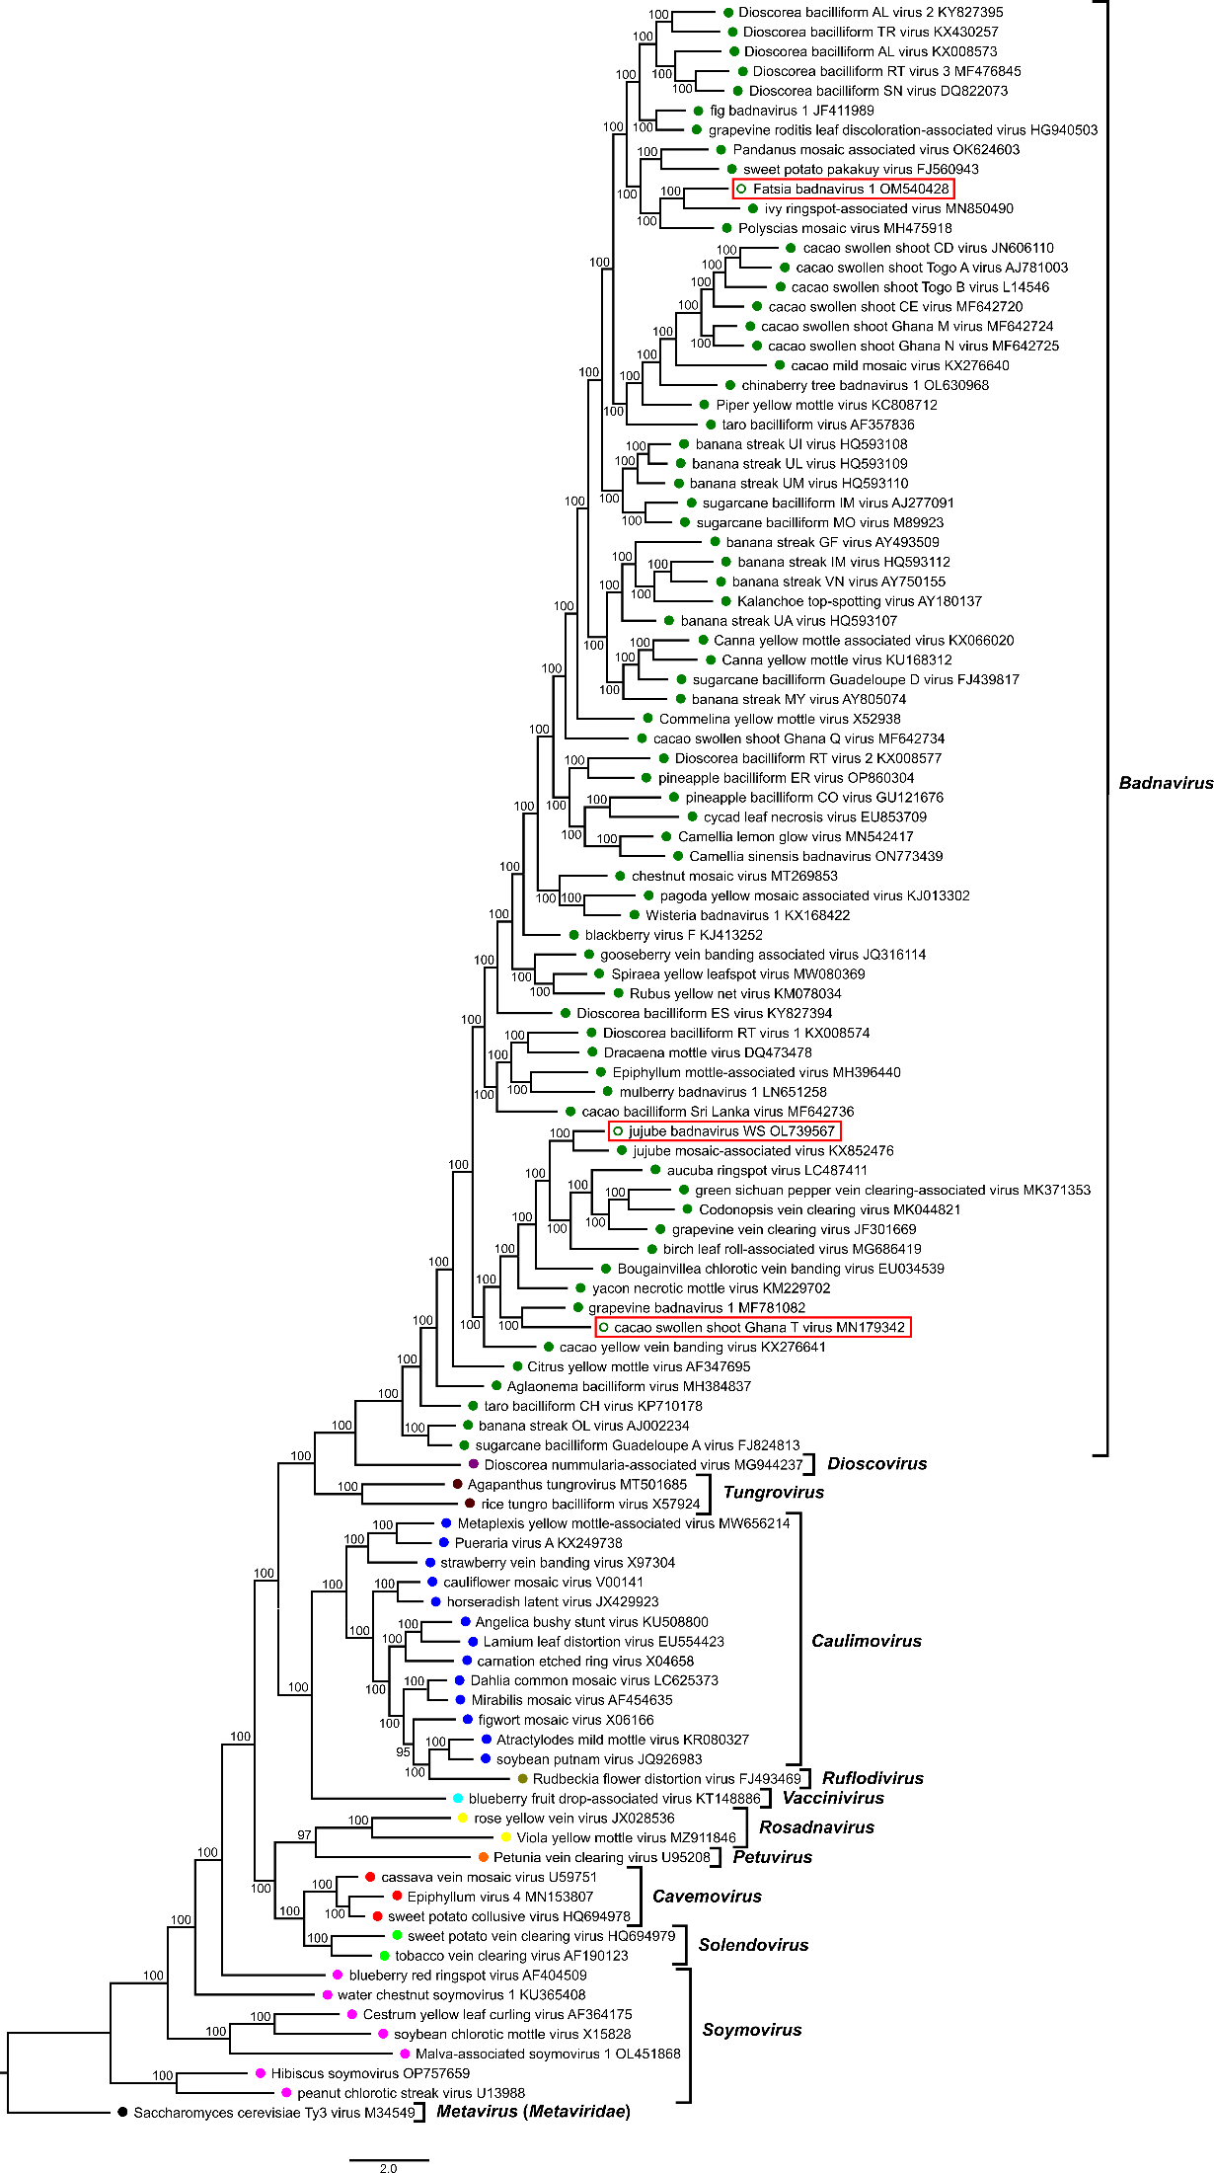

**Table 1: Percent nucleotide identities for the *Caulimoviridae* in *pol* gene nucleotide sequences.**

Figures corresponding to type members of the proposed new species are highlighted in orange.

