

The International Committee on Taxonomy of Viruses

Taxonomy Proposal Form, 2024

**Part 1a: Details of taxonomy proposals**

|  |  |  |
| --- | --- | --- |
| **Title:** | **Creation of a new suborder within the *Pimascovirales* to position and name Pithovirus-related isolates** | |
| **Code assigned:** | 2024.005F.A.v2.Pimascovirales_reorg |

|  |  |  |  |
| --- | --- | --- | --- |
| **Author(s), affiliation and email address(es):** | | | |
| **Name** | **Affiliation** | **Email address** | **Corresponding author(s)** X |
| **Claverie JM** | Information Génomique & Structurale, UMR7256, CNRS & Aix-Marseille Université, Marseille, France | Claverie@igs.cnrs-mrs.fr | X |
| **Legendre M** | Information Génomique & Structurale, UMR7256, CNRS & Aix-Marseille Université, Marseille, France | Matthieu.Legendre@igs.cnrs-mrs.fr |  |
| **Rigou S** | Information Génomique & Structurale, UMR7256, CNRS & Aix-Marseille Université, Marseille, France | Rigou@igs.cnrs-mrs.fr |  |
| **Abergel C** | Information Génomique & Structurale, UMR7256, CNRS & Aix-Marseille Université, Marseille, France | Chantal.Abergel@igs.cnrs-mrs.fr |  |

**Part 1b: Taxonomy Proposal Submission**

|  |  |  |  |
| --- | --- | --- | --- |
| **ICTV Subcommittee:** | | | |
| Animal DNA Viruses and Retroviruses |  | Bacterial viruses |  |
| Animal minus-strand and dsRNA viruses |  | Fungal and protist viruses | **X** |
| Animal positive-strand RNA viruses |  | Plant viruses |  |
| Archaeal viruses |  | General - |  |

|  |
| --- |
| **List the ICTV Study Group(s) that have seen or have been involved in creating this proposal:** |
| Fungal and Protist Viruses |

|  |  |  |  |
| --- | --- | --- | --- |
| **Optional – complete only if formally voted on by an ICTV Study Group:** | | | |
| **Study Group** | **Number of members** | | |
| **Votes in support** | **Votes against** | **No vote** |
| Fungal and Protist Viruses | 7 | 0 | 1 |
| A member of the SG, co-author of the proposal did not vote |  |  |  |

|  |  |
| --- | --- |
| **Submission date:** | 13/03/2024 |

**Part 1c: Feedback from ICTV Executive Committee (EC) meeting**

|  |  |
| --- | --- |
| **Executive Committee Meeting Decision code:** | **X** |
| A – Accept |  |
| Ac – Accept subject to revision by relevant subcommittee chair. No further vote required |  |
| U – Accept without revision but with re-evaluation and email vote by the EC |  |
| Uc – Accept subject to revision and re-evaluation and email vote by the EC |  |
| Ud – Deferred to the next EC meeting, with an invitation to revise based on EC comments |  |
| J - Reject |  |
| W - Withdrawn |  |

|  |
| --- |
| **Comments from the Executive Committee:** |
| Please adjust the Excel file. |

**Part 1d: Revised Taxonomy Proposal Submission**

|  |
| --- |
| **Response of proposer:** |
| Excel file adjusted to reflect proposed changes with the help of Dr. C Hendrickson. Thanks! |

|  |  |
| --- | --- |
| **Revision date:** | 09/10/2024 |

**Part 3:** **TAXONOMIC PROPOSAL**

|  |
| --- |
| **Name of accompanying Excel module:** |
| 2024.005F.A.v2.Pimascovirales_reorg.xlsx |

|  |  |  |  |
| --- | --- | --- | --- |
| **Taxonomic changes proposed:** | | | |
| Establish new taxon | **X** | Split taxon | **X** |
| Abolish taxon | **X** | Merge taxon |  |
| Move taxon |  | Promote taxon |  |
| Rename taxon | **X** | Demote taxon |  |
| Move and rename |  |

|  |  |  |
| --- | --- | --- |
| **Is any taxon name used here derived from that of a living person:** | | **Y/N** |
| **Taxon name** | **Person from whom the name is derived** | **Attached X** |
|  |  |  |

|  |
| --- |
| **Abstract of Taxonomy Proposal:** |
| *Taxonomic rank(s) affected*:  A new suborder, the *Ocovirineae* within the *Pimascovirales,*  3 distinct families: *Pithoviridae*, *Orpheoviridae*, and *Hydriviridae,*  One family, the *Cedratviridae* demoted as the new *orthocedratvirinae* subfamily  Two subfamilies: *Orthopithovirinae* and *Orthocedratvirinae* splitting the *Pithoviridae* family  *Description of current taxonomy*: Previously proposed in proposal **#2023.011F** by Abrahão and colleagues: two different families: *Pithoviridae* & *Cedraviridae* within the *Pimascovirales* order  *Proposed* *taxonomic change(s):* a new suborder, the *Ocovirineae* within the *Pimascovirales*, justified by the need to separate them from the other more distant families *(Marseilleviridae, Ascoviridae, Iridoviridae*) in the same order*.*    The creation of 3 distinct families: *Pithoviridae*, *Orpheoviridae*, and *Hydriviridae* to acknowledge their largedifferences in genome sizes and gene contents (and accommodate new isolates)  The split of the *Pithoviridae* into two subfamilies*: Orthopithovirinae* and *Orthocedratvirinae* to acknowledge their closer proximity compared to members of the other families listed above.  *Justification*: see above |

|  |
| --- |
| **Text of Taxonomy proposal:** |
| **Summary:** The first member of the Pithoviridae family (Pithovirus sibericum) was isolated from Siberian permafrost in our laboratory in 2014 [1]. Since then, many of its more or less distant relatives have been isolated, under genus names such as *Alphapithovirus*, *Alphacedratvirus*, *Alphaorpheovirus*, and one full circular genome assembled from metagenomic data (Hydrivirus). They all share a distinctive elongated ovoid particle, terminated by a characteristic terminal “mouth”-like structure, but significantly differ from each other by the genome sizes and gene contents.  Based on their shared virion morphology, common replication scheme and core gene set, we propose their classification in three distinct families (*Pithoviridae, Orpheoviridae, and Hydriviridae*) within a new suborder, the *Ocovirineae*, justified by the need to separate them from the other more distant families (*Marseilleviridae*, *Ascoviridae*, *Iridoviridae*) already composing the order *Pimascovirale*s.  Our proposal comes as a complement of proposal **#2023.011F**, extending their proposed 3-clade partition to 4 (to include *Hydrivirus*) , and keeping the genera *Alphacedratvirus* *and Alphapithovirus* in the same Pithoviridae family (albeit split into two subfamilies), due to their much closer similarity than with Alphaorpheovirus and Hydrivirus.  **Text:** In the current ICTV classification, large dsDNA previously referred to as “nucleocytoplasmic” viruses are now part of the *Nucleocytoviricota* phylum (see [2] for review and ICTV proposal # 2019.003G.A.v1.Varidnaviria). This phylum is itself composed of two different classes: the *Megaviricetes* and the *Pokkesviricetes*. The *Megaviricetes* class is presently divided into three different orders: the *Algavirales*, the *Imitervirales*, and the *Pimascovirales*. The name “*Pimascovirales*” was coined according to the 4 virus families it includes: *Pithoviridae*, *Iridoviridae*, *Marseilleviridae* and *Ascoviridae* (ICTV proposal 2019.003G.A.v1.Varidnaviria). The aim of our proposal is to update the proposal **#2023.011F** (first to propose a formal classification of Pithovirus-like viruses)to better allocate pithoviruses and their relatives within the *Pimascovirales* order following the characterization of new isolates.  Following the isolation of the pithovirus prototype from an ancient permafrost layer using Acanthamoeba sp. as cellular host [1], several close relatives have been subsequently isolated, documenting the diversity of the genus *Pithovirus* [3-4]. Meanwhile more distant relatives from the original pithovirus were also isolated and characterized under the different genus name “*Cedratviru*s” [5-8]. Finally, two even more divergent pithovirus/cedratvirus relatives have been described: orpheovirus [11], and hydrivirus [12]. Orpheovirus was isolated using Vermamoeba vermiformis as a host, and hydrivirus corresponds to a full (circular) genome metagenomic assembly.  **Proposed suborder Ocovirineae**  According to the current ICTV taxonomy, the order *Pimascovirales* lists the following officially classified families: *Ascoviridae*, *Iridoviridae*, *Marseilleviridae*, *Pithoviridae*, *Cedratviridae* and *Orpheoviridae*.  The profound differences that distinguish pitho-like viruses from members of the families *Ascoviridae*, *Iridoviridae*, *Marseilleviridae* justified the recent recognition of the Pithoviridae, Cedratviridae and Orpheoviridae family, as already proposed in the literature. Pithovirus-like members have much larger genomes (610 kb-1.4 Mb) and virions sizes (up to 1.5 µm in length), a very distinct virion 3-D structure, and a different core gene set compared to members of the *Ascoviridae*, *Iridoviridae*, and *Marseilleviridae*.  On the other hand, grouping all pithoviruses and relatives (pithovirus, cedratvirus, orpheovirus) under the banner of a single *Pithoviridae* family also seems unrealistic, given the diversity of its members (see below), as previously noted in proposal **#2023.011F** by Abrahão and colleagues.  The solution we propose is thus to divide the former *Pithoviridae* family in 3 subclades, the bona fide “Pithoviridae” (split into the *Orthopithovirinae* and the *Orthocedratvirinae* subfamilies), *the Orpheoviridae*, and the *Hydriviridae*.  Within the *Pimascovirales*, we thus propose to group these 3 families into a new suborder given their unambiguous phylogenetic relationship (see Fig.3 in [12]). We propose to name this suborder *Ocovirineae* to acknowledge the morphological features common to their particles, in latin: "Ovoideum Cum Ore (ovoid with a mouth).  **Proposed family Pithoviridae, split into two subfamilies**  The phylogenetic tree (Fig 1) clearly separates cedratviruses from pithoviruses in two different clades (with 100% bootstrap support) that we choose to rank at the subfamily level.  Cedratviruses tend to exhibit a cork/mouth at both apexes of their particles, while pithoviruses only have a single one, although this is not an absolute feature (see Fig. 1C of [13]). In addition, cedratviruses exhibits some translation factors not present in the pithoviruses family. However, no other structural or morphological characteristic distinguishes those two types of viruses, which lead us to propose to split the *Pithoviridae* into two subfamilies – *Orthopithovirinae* and *Orthocedratvirinae* - rather than maintaining the *Cedratviridae* as a separate family. In this context, we propose abolish the recently created family *Cedratviridae*.  **Proposed family *Orpheoviridae***  We retain the *Orpheoviridae* family as previously introduced in proposal **#2023.011F** by Abrahão and colleagues.  **Proposed family *Hydriviridae***  The long branches separating hydrivirus from orpheovirus (Fig. 1) as well as large differences in their gene contents (Fig. 1 in [10]) support the creation of a different family from the *Orpheoviridae*.  Although hydrivirus is not yet isolated we know its complete circular genome sequence [12]. It is thus useful to include it in the taxonomy as a family in anticipation of future related isolates and for providing a more realistic view of the diversity within the *Ocovirineae* suborder. Presently, the *Hydriviridae* family includes a single genus *Alphahydrivirus,* represented by a single species*Alphahydrivirus permafrostis.*  **Proposed genera: *Alphapithovirus*, *Alphacedratvirus*, *Alphaorpheovirus*, *Alphahydrivirus***  We propose that representatives of the same genus within the above families should exhibit similar global genome organizations and sizes (see Fig. S4 of [10]), and a pairwise ANI >80% over 50% of the aligned genome (Fig. 2).  **Delineation of the species**  In agreement with the similarity criteria already used in proposal **#2023.011F**, we propose that isolates exhibiting a pairwise ANI >95% for 75% of their genes should be allocated the same species.  According to this criterium the various genera are divided as follows;  *Alphapithovirus* is represented by 2 species:  - Alphapithovirus massiliense, (with a single isolate Pithovirus strain LC8)  - Alphapithovirus siberiense, (with two isolates):  Pithovirus sibericum P1084-T  Pithovirus mammoth strain Yana14  *Alphacedratviru*s is represented by 4 species:  - Alphacedratvirus aljazairmassiliense (with a single isolate Cedratvirus A11)  (Here we propose to change the species name from Alphacedratvirus aljazairense to Alphacedratvirus aljazairmassiliense. Reason: to address both the place where the sample was collected and the place where the virus was isolated).  - Alphacedratvirus brasiliense, with two isolates  Brazilian cedratvirus IHUMI  Cedratvirus pambiansis isolate Cdv8 (due to duplications, the pairwise ANI coverage is not symmetrical with 99% and 66%, thus >75% on average)  - Alphacedratvirus francolausannense, with 4 isolates  Cedratvirus lausannensis strain CRIB-75  Cedratvirus zaza IHUMI-S29  Cedravirus borely AA  Cedratvirus plusbellavi AB  (Here we propose to change the species name from Alphacedratvirus franciense to Alphacedratvirus francolausannense. Reason: to address both the place where the sample was collected and the place where the virus was isolated).  - Alphacedratvirus rossiense, with 3 isolates  Cedratvirus kamchatka P4  Cedratvirus duvanniense DY1  Cedravirus lenaense DY0  - Alphaorpheovirus is represented by a single specie  Alphaorpheovirus massiliense, (with a single isolate Orpheovirus IHUMI-LCC2)  - Alphahydrivirus is represented by the complete genome sequence OW988864 of a single species  Alphahydrivirus permafrostis |

|  |
| --- |
| **References:** |
| **1.** Legendre M, Bartoli J, Shmakova L, Jeudy S, Labadie K, Adrait A, Lescot M, Poirot O, Bertaux L, Bruley C, Couté Y, Rivkina E, Abergel C, Claverie JM. Thirty-thousand-year-old distant relative of giant icosahedral DNA viruses with a pandoravirus morphology. Proc Natl Acad Sci U S A. 2014;111(11):4274-9. doi: 10.1073/pnas.1320670111.  **2.** Xian Y, Xiao C. Current capsid assembly models of icosahedral nucleocytoviricota viruses. Adv Virus Res. 2020;108:275-313. doi: 10.1016/bs.aivir.2020.09.006  **3.** Alempic JM, Lartigue A, Goncharov AE, Grosse G, Strauss J, Tikhonov AN, Fedorov AN, Poirot O, Legendre M, Santini S, Abergel C, Claverie JM. An Update on Eukaryotic Viruses Revived from Ancient Permafrost. Viruses. 2023;15(2):564. doi: 10.3390/v15020564.  **4.** Levasseur A, Andreani J, Delerce J, Bou Khalil J, Robert C, La Scola B, Raoult D. Comparison of a Modern and Fossil Pithovirus Reveals Its Genetic Conservation and Evolution. Genome Biol Evol. 2016;8(8):2333-9. doi: 10.1093/gbe/evw153.  **5.** Andreani J, Aherfi S, Bou Khalil JY, Di Pinto F, Bitam I, Raoult D, Colson P, La Scola B. Cedratvirus, a Double-Cork Structured Giant Virus, is a Distant Relative of Pithoviruses. Viruses. 2016;8(11):300. doi: 10.3390/v8110300.  **6.** Rodrigues RAL, Andreani J, Andrade ACDSP, et al. Morphologic and Genomic Analyses of New Isolates Reveal a Second Lineage of Cedratviruses. J Virol. 2018;92(13):e00372-18. doi:10.1128/JVI.00372-18.  **7.** Bertelli C, Mueller L, Thomas V, Pillonel T, Jacquier N, Greub G. Cedratvirus lausannensis - digging into Pithoviridae diversity. Environ Microbiol. 2017;19(10):4022-4034. doi: 10.1111/1462-2920.13813.  **8.** Jeudy S, Rigou S, Alempic JM, Claverie JM, Abergel C, Legendre M. The DNA methylation landscape of giant viruses. Nat Commun. 2020;11(1):2657. doi: 10.1038/s41467-020-16414-2.  **9.** Machado TB, Picorelli ACR, de Azevedo BL, et al. Gene duplication as a major force driving the genome expansion in some giant viruses. J Virol. 2023;97(12):e0130923. doi:10.1128/jvi.01309-23.  **10**. Rigou S, Schmitt A, Alempic JM, et al. Pithoviruses Are Invaded by Repeats That Contribute to Their Evolution and Divergence from Cedratviruses. Mol Biol Evol. 2023;40(11):msad244. doi:10.1093/molbev/msad244.  **11**. Andreani J, Khalil JYB, Baptiste E, et al. Orpheovirus IHUMI-LCC2: A New Virus among the Giant Viruses. Front Microbiol. 2018;8:2643. doi:10.3389/fmicb.2017.02643.  **12**. Rigou S, Santini S, Abergel C, Claverie JM, Legendre M. Past and present giant viruses diversity explored through permafrost metagenomics. Nat Commun. 2022;13(1):5853. doi:10.1038/s41467-022-33633-x.  **13**. Okamoto K, Miyazaki N, Song C, et al. Structural variability and complexity of the giant Pithovirus sibericum particle revealed by high-voltage electron cryo-tomography and energy-filtered electron cryo-microscopy. Sci Rep. 2017;7(1):13291. doi:10.1038/s41598-017-13390-4  **14**. Nguyen LT, Schmidt HA, von Haeseler A, Minh BQ. IQ-TREE: a fast and effective stochastic algorithm for estimating maximum-likelihood phylogenies. Mol Biol Evol. 2015;32(1):268-274. doi:10.1093/molbev/msu300  **15.** Notredame C, Higgins DG, Heringa J. T-Coffee: A novel method for fast and accurate multiple sequence alignment. J Mol Biol. 2000;302(1):205-217. doi:10.1006/jmbi.2000.4042  **16.** Steenwyk JL, Buida TJ 3rd, Li Y, Shen XX, Rokas A. ClipKIT: A multiple sequence alignment trimming software for accurate phylogenomic inference. PLoS Biol. 2020;18(12):e3001007. doi:10.1371/journal.pbio.3001007  **17**. Jain C, Rodriguez-R LM, Phillippy AM, Konstantinidis KT, Aluru S. High throughput ANI analysis of 90K prokaryotic genomes reveals clear species boundaries. Nat Commun. 2018;9(1):5114. doi:10.1038/s41467-018-07641-9 |

|  |
| --- |
| **Tables, Figures:** |

<Start here>

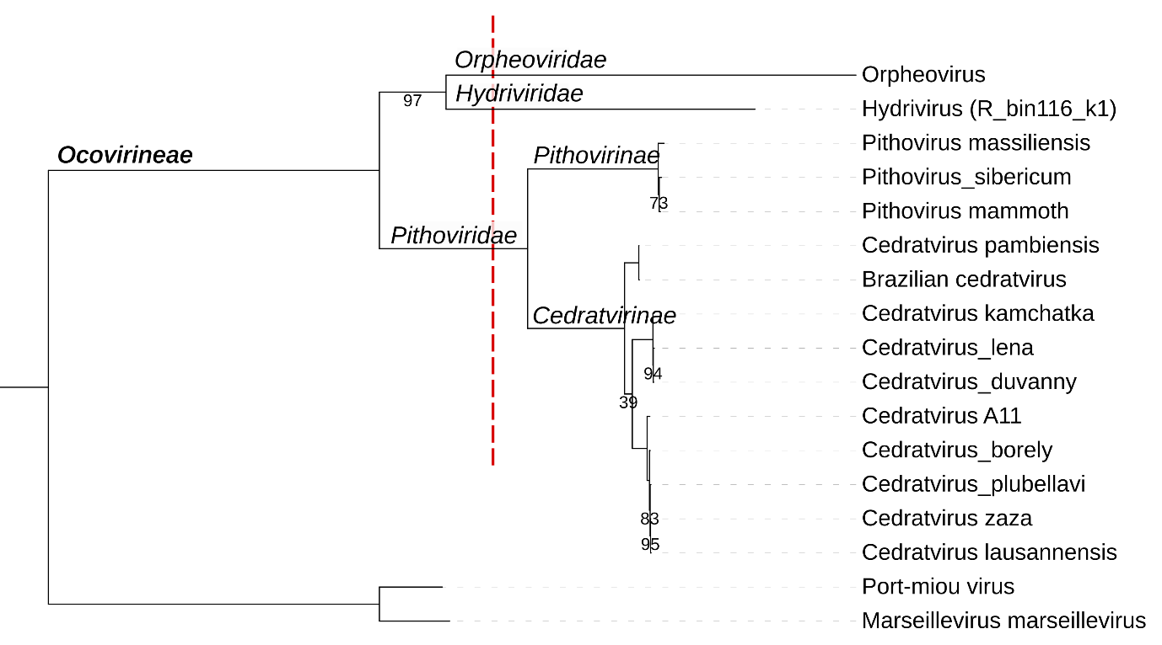

**Figure 1. Phylogenetic topology supporting the creation of 3 separate families within a proposed Ocovirineae suborder within the Pimascovirales order**

Maximum-likelihood phylogenetic tree computed using IQ-TREE [14] from the concatenated alignment of 5 marker genes (Major capsid protein, DNA polymerase, RNA polymerase RPB1 and RPB2, and late transcription factor VLTF3). Multiple alignments were computed using T-coffee [15] and trimmed with ClipKit [16]. The best fit model was LG+F+I+G4. Branch support values result from 5000 ultrafast bootstraps and are indicated only on the branches that are not 100% supported. *Marseilleviridae* were chosen as outgroup. The red dashed line indicates family level delineation.

To avoid confusion between adjacent ranks the subfamilies within the *Pithoviridae* are formally named *Orthopithovirinae* and *Orthocedratvirinae*.

**Genbank accession numbers**

Orpheovirus: NC_036594.1; Hydrivirus: OW988864; P. massiliensis: LT598836; P. sibericum: NC_023423.1;

P. mammoth: OQ413582; C. pambiensis: OR343515; Brazilian Cedratvirus: LT994651.1, C. kamchatka: MN873693.1; C. lena: OQ413577; C. duvanny: OQ413581; C. A11: NC_032108.1; C. borely: OQ413575;

C. plubellavi: OQ413576 ; C. zaza : LT994652.1 ; C. lausannensis : LT907979.1; Port-miou virus : KT428292.1 ; M. marseillevirus : NC_013756 .

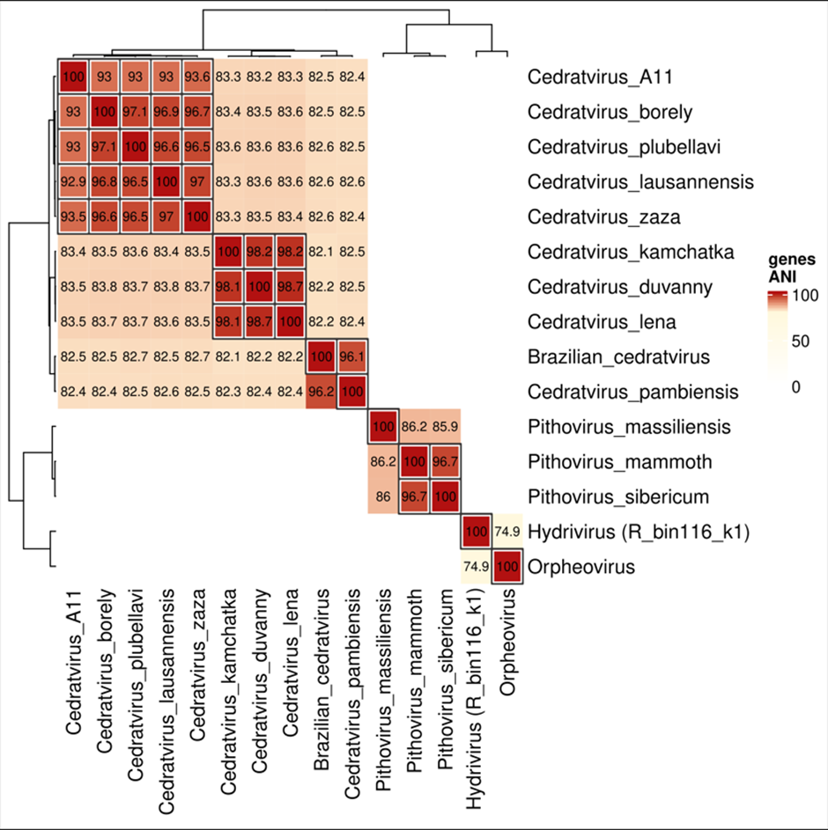

**Figure 2. ANI demarcation criteria supporting the definition of the various viral species and genera**

The nucleotide sequences of ORFs (>50 amino acids) were aligned using fastANI [17] with the "--fragLen 200"

option. The heatmap shows pairwise ANI values. Boxed values indicate >75% of orthologous gene fragments.

All other ANI values are supported by >50% of orthologous fragments, except for cedratvirus pambiensis

(with cedratvirus kamchaka, duvanny and lena) and hydrivirus with orpheovirus.