

The International Committee on Taxonomy of Viruses

Taxonomy Proposal Form, 2024

**Part 1a: Details of taxonomy proposals**

|  |  |  |
| --- | --- | --- |
| **Title:** | Create a new family, “*Soropartitiviridae*”, within the order *Durnavirales* for classification of partiti-like virus infecting thermoacidophilic bacteria | |
| **Code assigned:** | 2024.011B.N.v1.Durnavirales_nf.xlsx |

|  |  |  |  |  |
| --- | --- | --- | --- | --- |
| **Author(s), affiliation and email address(es):** | | | | |
| **Name** | **Affiliation** | **Email address** | **Corresponding author(s)** X |
| Syun-ichi Urayama | Department of Life and Environmental Sciences, Laboratory of Fungal Interaction and Molecular Biology (donated by IFO), University of Tsukuba, Tsukuba, Japan | [urayama.shunichi.gn@u.tsukuba.ac.jp](mailto:urayama.shunichi.gn@u.tsukuba.ac.jp) | X |
| Akihito Fukudome | Howard Hughes Medical Institute,  Department of Biology and Department of Molecular and Cellular Biochemistry, Indiana University, Bloomington, IN, USA | [afukudom@iu.edu](mailto:afukudom@iu.edu) |  |
| Eugene V. Koonin | National Center for Biotechnology Information, National Library of Medicine, National Institutes of Health, Bethesda, MD, USA. | [koonin@ncbi.nlm.nih.gov](mailto:koonin@ncbi.nlm.nih.gov) |  |
| Takuro Nunoura | Research Center for Bioscience and Nanoscience (CeBN), JAMSTEC, Yokosuka, Japan | [takuron@jamstec.go.jp](mailto:takuron@jamstec.go.jp) |  |
| Mart Krupovic | Institut Pasteur, Université Paris Cité, Archaeal Virology Unit, Paris, France | [mart.krupovic@pasteur.fr](mailto:mart.krupovic@pasteur.fr) | X |

**Part 1b: Taxonomy Proposal Submission**

|  |  |  |  |
| --- | --- | --- | --- |
| **ICTV Subcommittee:** | | | |
| Animal DNA Viruses and Retroviruses |  | Bacterial viruses | **X** |
| Animal minus-strand and dsRNA viruses |  | Fungal and protist viruses |  |
| Animal positive-strand RNA viruses |  | Plant viruses |  |
| Archaeal viruses |  | General - |  |

|  |
| --- |
| **List the ICTV Study Group(s) that have seen or have been involved in creating this proposal:** |
| None (there is currently no Study Group for the order *Durnavirales*). |
| **Optional – complete only if formally voted on by an ICTV Study Group:** | | | |
| **Study Group** | **Number of members** | | |
| **Votes in support** | **Votes against** | **No vote** |
|  |  |  |  |
|  |  |  |  |

|  |  |
| --- | --- |
| **Submission date:** | 21/06/2024 |

**Part 1c: Feedback from ICTV Executive Committee (EC) meeting**

|  |  |
| --- | --- |
| **Executive Committee Meeting Decision code:** | **X** |
| A – Accept |  |
| Ac – Accept subject to revision by relevant subcommittee chair. No further vote required |  |
| U – Accept without revision but with re-evaluation and email vote by the EC |  |
| Uc – Accept subject to revision and re-evaluation and email vote by the EC |  |
| Ud – Deferred to the next EC meeting, with an invitation to revise based on EC comments |  |
| J - Reject |  |
| W - Withdrawn |  |

|  |
| --- |
| **Comments from the Executive Committee:** |
|  |

**Part 1d: Revised Taxonomy Proposal Submission**

|  |
| --- |
| **Response of proposer:** |
|  |
| **Revision date:** | DD/MM/YYYY |

**Part 3:** **TAXONOMIC PROPOSAL**

|  |
| --- |
| **Name of accompanying Excel module:** |
| 2024.011B.N.v1.Durnavirales_nf.xlsx |

|  |  |  |  |
| --- | --- | --- | --- |
| **Taxonomic changes proposed:** | | | |
| Establish new taxon | **X** | Split taxon |  |
| Abolish taxon |  | Merge taxon |  |
| Move taxon |  | Promote taxon |  |
| Rename taxon |  | Demote taxon |  |
| Move and rename |  |

|  |  |  |
| --- | --- | --- |
| **Is any taxon name used here derived from that of a living person:** | | **N** |
| **Taxon name** | **Person from whom the name is derived** | **Attached X** |
|  |  |  |
|  |  |  |
|  |  |  |

|  |
| --- |
| **Abstract of Taxonomy Proposal:** |
| *Taxonomic rank(s) affected*:  *Riboviria*, *Orthornavirae*, *Pisuviricota*, *Duplopiviricetes*, *Durnavirales*  *Description of current taxonomy*:  Order *Durnavirales* includes six families of viruses with double-stranded RNA genomes. Most of the durnavirals infect fungal hosts, with the exception of partitivirids, which beside fungi, infect plants and protozoa, and picobirnavirids, which appear to infect bacteria.  *Proposed* *taxonomic change(s):*  Create a new family, “*Soropartitiviridae*”, with a genus, “*Caliparnavirus*”, withinthe order *Durnavirales* to classify partiti-like viruses discovered in the hot spring samples and infecting thermoacidophilic bacteria.  *Justification*:  Phylogenetic analysis based on the RNA-dependent RNA polymerase (RdRP) placed the new group of bacterial partiti-like viruses outside of the established *Partitiviridae* genera. Furthermore, unlike all other classified partititivirids, one of the two segments of “soropartitivirids” is bicistronic. |

|  |
| --- |
| **Text of Taxonomy proposal:** |
| *Taxonomic rank(s) affected*:  *Riboviria*, *Orthornavirae*, *Pisuviricota*, *Duplopiviricetes*, *Durnavirales*  *Description of current taxonomy*:  Order *Durnavirales* includes six families of viruses with double-stranded RNA genomes. Most of the durnavirals infect fungal hosts, with the exception of partitivirids, which beside fungi infect plants and protozoa (Vainio et al., 2018), and picobirnavirids, which appear to infect bacteria.  *Proposed* *taxonomic change(s)*:  Create a new family, “*Soropartitiviridae*”, with a genus, “*Caliparnavirus*”, withinthe order *Durnavirales* to classify partiti-like viruses discovered in the hot spring samples and infecting thermoacidophilic bacteria.  *Demarcation criteria:*  The proposed genus will include a single species. Thus, species demarcation criteria will have to be established once additional members are discovered. Membership in the family will be determined based on the RdRP phylogeny.  *Justification*:  **Discovery and properties of HsPV1-like viruses**  Fragmented and primer-Ligated DsRNA Sequencing (FLDS) of hot spring water samples from the stations H4 (68.8 °C, pH 3.2), H5 (69.7 °C, pH 3.1) and Y66 (68.7 °C, pH 2.7) in the Kirishima National Park, Japan revealed a bipartite virus genome (Fig. 1a) (Urayama et al., 2024). The genomic segments, RNA1 and RNA2, shared conserved 5′ terminal sequences and encoded one and two proteins, respectively (Fig. 1b). ORF1 of RNA1 was unambiguously identified as an RdRP, yielding significant BLASTP hits to RdRPs of members of the *Partitiviridae* family, with the best hit being to the unclassified Driatsky virus (QIS87951; E-value = 1 × 10−95). We denoted this virus as hot spring partiti-like virus (HsPV). The similarity between the termini of the segments precluded assignment of all sets of segments to particular virus strains. However, on the basis of co-occurrence in the same sample and similar abundances, segment pairs RNA1_a and RNA2_b from sample H5 could be assigned to the same virus strain, HsPV1. Phylogenetic analysis of the RdRP sequence from diverse classified and unclassified partiti-like viruses showed that HsPVs and Driatsky virus were nested within genPartiti.0029 (Fig. 1c), a highly diverse, unclassified group defined in a recent metatranscriptome study (Neri et al., 2022). The genPartiti.0029, including HsPV and Driatsky virus and several other subclades, formed a deep clade separate from all other partitivirids. Thus, genPartiti.0029 can be considered a separate sister family to the bona fide *Partitiviridae*. AF2 modelling yielded an HsPV RdRP model closely similar to that of the RdRP of partitivirids, e.g., pepper cryptic virus 1 (PCV1; Fig. 1d), which was confirmed by DALI Z-score-based clustering, where the two viruses formed a clade next to picobirnavirids (Urayama et al., 2024).  ORF1 and ORF2 of RNA2 did not show significant sequence similarity to proteins in sequence or profile databases, except that ORF2 was predicted to encode a membrane protein with two transmembrane domains. Structural modelling of RNA2 ORF1 yielded a high-quality model (pLDDT = 78.8), with only the terminal regions being of lower quality. Structure similarity searches against the PDB database using DALI produced significant hits to capsid proteins of partitiviruses and picobirnaviruses, with the best match (Z-score = 8.2) to the CP of partitivirid PCV1 (Fig. 1e; PDB ID: 7ncr; genus *Deltapartitivirus*). Thus, the RdRP phylogeny and structural similarity of the CPs indicate that HsPV1 is distantly related to members of the family *Partitiviridae*. However, unlike all classified partititivirids, the RNA2 segment of HsPV1-like viruses is bicistronic.  **HsPV1-like viruses probably infect prokaryotic hosts**  All samples in which HsPVs were detected nearly exclusively contained rRNA sequences from prokaryotes, with eukaryotic presence being below 1% (Urayama et al., 2024). This is consistent with eukaryotes being unable to thrive in polyextremophilic conditions combining high temperatures and acidic pH. The microbial communities in the HsPV1-containing sample were dominated by bacteria. In particular, bacteria of the genus *Hydrogenobaculum* (family Aquificaceae) were predominant (>95%) in samples H4 and H5 and highly abundant in Y66 (>85%), suggesting that HsPV detected in all three samples infects *Hydrogenobaculum* sp. Consistently, every gene in HsPVs is preceded by Shine-Dalgarno (SD) motifs, which are essential for translation initiation in many prokaryotes, and their conservation is a diagnostic feature of prokaryotic genes that has been used to assign bacterial hosts to several groups of RNA viruses, namely, picobirnaviruses and partitiviruses (Krishnamurthy and Wang, 2018; Neri et al., 2022). Collectively, these results strongly suggest that HsPV1-like viruses infect thermoacidophilic bacteria.  **Proposed taxonomy**  Although HsPV1 could be classified into a new genus within the *Partitiviridae*, given the dramatic expansion of the diversity of partiti-like viruses (e.g., Neri et al., 2022), the split of the family appears inevitable. Furthermore, given that the extent of diversity within the genPartiti.0029 clade alone, which includes HsPV1-like viruses, is already on par with that within bona fide *Partitiviridae* (Fig. 1c), we consider it prudent to classify HsPV1-like viruses into a separate family, which we propose naming “*Soropartitiviridae*”. It might be appropriate to unify *Partitiviridae* and “*Soropartitiviridae*” into a suborder in the future. “*Soropartitiviridae*” would include one genus, “*Caliparnavirus*”, with a single species, “*Caliparnavirus acidum*”.  **Etymology of the proposed taxa**  “*Soropartitiviridae*”, after Latin *soror*, for sister, and partiti-like, referring to the phylogenetic placement of HsPV1-like viruses as a sister group to bona fide partitivirids.  “*Caliparnavirus*”, after Latin *calidarius* for warm, referring to the conditions under which HsPV1-like viruses thrive, and relationship to partiti-like RNA viruses.  “*acidum*“, after Latin *acidus* for acidic. |
| **References:** |
| Krishnamurthy SR, Wang D. Extensive conservation of prokaryotic ribosomal binding sites in known and novel picobirnaviruses. Virology. 2018; 516:108-114. doi: 10.1016/j.virol.2018.01.006. PMID: 29346073  Neri U, et al. Expansion of the global RNA virome reveals diverse clades of bacteriophages.  Cell. 2022; 185(21):4023-4037.e18. doi: 10.1016/j.cell.2022.08.023. PMID: 36174579  Urayama SI, Fukudome A, Hirai M, Okumura T, Nishimura Y, Takaki Y, Kurosawa N, Koonin EV, Krupovic M, Nunoura T. Double-stranded RNA sequencing reveals distinct riboviruses associated with thermoacidophilic bacteria from hot springs in Japan. Nat Microbiol. 2024; 9(2):514-523. doi: 10.1038/s41564-023-01579-5. PMID: 38233646  Vainio EJ, Chiba S, Ghabrial SA, Maiss E, Roossinck M, Sabanadzovic S, Suzuki N, Xie J, Nibert M, Ictv Report Consortium. ICTV Virus Taxonomy Profile: Partitiviridae. J Gen Virol. 2018; 99(1):17-18. doi: 10.1099/jgv.0.000985. PMID: 29214972 |

|  |
| --- |
| **Tables, Figures:** |

<Start here>

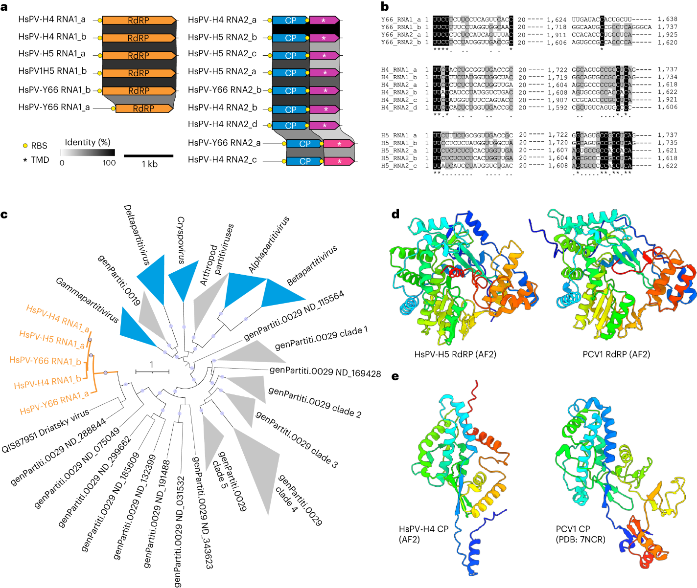**Figure 1.** A thermoacidophilic partiti-like virus. a, Genome organization and conservation of the two genome segments, RNA1 and RNA2, of HsPV. ORFs encoding homologous proteins are shown as arrows with identical colours. Yellow circles represent predicted SD RBS. Asterisks denote putative genes encoding predicted TMD-containing proteins. b, Sequence alignment of the 5ʹ- and 3ʹ-terminal regions of the coding strands of reconstructed genome segments. Black shading, 100% nucleotide identity; grey shading, >50% nucleotide identity. c, Maximum-likelihood phylogeny of the RdRP proteins from representative members of the family *Partitiviridae* and related sequences (including all HsPV strains, shown in orange). Clades corresponding to the official *Partitiviridae* genera are shown in blue, whereas those corresponding to unclassified groups are in grey. Node supports were assessed using the SH-aLRT; circles indicate nodes with ≥90% supports. The scale bar represents the number of substitutions per site. d, Comparison of the RdRP from HsPV1 (HsPV-H5) with a homologue from deltapartitivirid PCV1. e, Comparison of the CP from HsPV-H4 with a homologue from deltapartitivirid PCV1. The structures are coloured using the rainbow scheme, from blue N terminus to red C terminus.