

The International Committee on Taxonomy of Viruses
Taxonomy Proposal Form, 2026

Part 1a: Details of taxonomy proposals

Title: | Create seven new species in the genus Idaeovirus (Mayoviridae)
Code assigned: | 2026.030P.N.v1.Mayoviridae_Idaeovirus_7nsp

Author(s), affiliation and email address(es):
Given name (+middle initial(s)) | Surname | Affiliation | Email address | Corr. author(s)
Nina | Aboughanem-Sabanadzovic | Institute for Genomics, Biocomputing and Biotechnology, Mississippi State University, Mississippi State, MS, USA | nja62@msstate.edu
Luisa | Rubino | CNR, Istituto per la Protezione Sostenibile delle Piante, Bari, Italy | luisa.rubino@cnr.it
Sead | Sabanadzovic | Department of Agricultural Science and Plant Protection, Mississippi State University, Mississippi State, MS, USA | ssabanadzovic@entomology.msstate.edu | X

Part 1b: Taxonomy Proposal Submission
ICTV Subcommittee:
Animal DNA Viruses and Retroviruses |  | Bacterial viruses
Animal minus-strand and dsRNA viruses |  | Fungal and protist viruses
Animal positive-strand RNA viruses |  | Plant viruses | X
Archaeal viruses |  | General -

List the ICTV Study Group(s) that have seen or have been involved in creating this proposal:
Optional – complete only if formally voted on by an ICTV Study Group:
Study Group | Number of members
Study Group | Votes in support | Votes against | No vote

Submission date: | 30/09/2026

Part 1c: Feedback from ICTV Executive Committee (EC) meeting
Executive Committee Meeting Decision code: | X
A – Accept
Ac – Accept subject to revision by relevant subcommittee chair. No further vote required
U – Accept without revision but with re-evaluation and email vote by the EC
Uc – Accept subject to revision and re-evaluation and email vote by the EC
Ud – Deferred to the next EC meeting, with an invitation to revise based on EC comments
J - Reject
W - Withdrawn

Comments from the Executive Committee:

Part 1d: Revised Taxonomy Proposal Submission
Response of proposer:
Revision date:

Part 3: TAXONOMIC PROPOSAL

Taxonomic changes proposed:
Establish new taxon | X | Split taxon
Abolish taxon |  | Merge taxon
Move taxon |  | Promote taxon
Rename taxon |  | Demote taxon
Move and rename

Etymology (origin) of proposed taxonomic names:
Taxon name | Etymology of the term
“Idaeovirus actinidiae” | Species epithet derived from the genus of the host (Actinidia spp.)
“Idaeovirus betulae” | Species epithet derived from the genus of the host (Betula sp.)
“Idaeovirus camelliae” | Species epithet derived from the genus of the host (Camellia spp.)
“Idaeovirus cynanchi” | Species epithet derived from the genus of the host (Cynanchum rostellatum)
“Idaeovirus mori” | Species epithet derived from the genus of the host (Morus nigra)
“Idaeovirus ribis” | Species epithet derived from the genus of the host (Ribes nigrum)
“Idaeovirus zanthoxyli” | Species epithet derived from the genus of the host (Zanthoxylum armatum)

Permission for use of names derived from a living person:
Taxon name | Full name of person from whom the name is derived | Attached
N/A

Abstract of Taxonomy Proposal:
Description of current taxonomy:
Genus Idaeovirus is one of the two genera of family Mayoviridae (order Martellivirales). It currently comprises two species (Idaeovirus ligustri and Idaeovirus rubi).

Proposed taxonomic change(s):
Create seven new species in the genus Idaeovirus to classify several recently characterized viruses from different plant hosts.

Demarcation criteria for new taxon/taxa:
Currently valid species demarcation criteria in the genera of the family Mayoviridae are:
- differences in amino acid content of viral RdRP domain exceeding 15%
- differences in host range

Justification:
All members of seven proposed new species are related, but distinct from members of the two currently recognized species in the genus Idaeovirus. In phylogenetic analyses of viral replicases they group together forming a well-supported monophyletic clade. Pairwise comparisons show mutual identity levels below the species demarcation thresholds. Complete/coding-complete genome sequences of all exemplar isolates of the seven new species are available in GenBank. Characterization of each exemplar isolate for seven new species is well-documented in peer-reviewed literature.

- Text of Taxonomy proposal:

Description of current taxonomy:
Idaeovirus is one of the two genera of family Mayoviridae (order Martellivirales) [1]. It currently comprises two species to classify plant-infecting viruses with quasi-isometric virions and bisegmented (+)ssRNA genomes. Raspberry bushy dwarf virus (RBDV; species Idaeovirus rubi) is a well-characterized virus infecting Rubus spp. and grapevines [2-4]. It is transmitted in nature via pollen [2], while privet leaf blotch-associated virus (PrLBaV; species Idaeovirus ligustri) was reported in 2017 from Italy [4].

Proposed taxonomic change(s):
Since the last reorganization of the genus in 2019 [1], based on scientific literature review, searches in GenBank (as of 10/08/2026) and a comprehensive ad hoc analysis of data for the purpose of this proposal, we found support for its expansion by seven species. Only viruses with complete or coding-complete genome sequences publicly accessible in NCBI/GenBank and with associated peer-reviewed scientific publications were taken in consideration at this time.
New and distinct idaeoviruses have been described from various hosts (e.g., kiwifruit, camellia, blackcurrant, black mulberry, birch, etc) from various parts of the world (Türkiye, China, US, Germany) [6-12]. All these viruses have bisegmented (+)ssRNA genomes with size and architecture typical of idaeoviruses (Figure 1). Their RNAs1 are approximately 5.5 kb in size and monocistronic in most of the analyzed viruses. A large ORF encompassing >90% of RNAs1 codes for ~200 kDa “alphavirus-like” replication-associated protein (replicase) with methyltransferase, helicase and RNA-dependent RNA polymerase functional domains. RNAs 2 of all viruses are 2.2 kb in size and bicistronic. ORF2a codes for a movement protein (MP), while ORF2b encodes a structural protein (coat protein, CP) (Figure 1).
Phylogenetic analysis based on viral replicases placed seven new viruses in the same clade with RBDV and PrLBaV, indicating their relationships with idaeoviruses (Figure 2).
Pairwise alignments of replicases showed that levels of mutual identities among these viruses and members of the two currently recognized species vary from 47-48%, up to a maximum of 75% (not shown). These values are clearly below the species demarcation threshold proposed for this genus and justify classifying these recently characterized viruses in seven new species in the genus Idaeovirus.

Demarcation criteria for new taxon/taxa:
Currently valid species demarcation criteria in the genera of the family Mayoviridae are:
- differences in amino acid content of viral RdRP domain exceeding 15%
- differences in host range
Viruses proposed to represent seven new species comply with these demarcation criteria.

Justification:

The proposed expansion of the genus Idaeovirus by establishing seven new species is based upon proper review of the literature and ad hoc analyses for the purpose of this proposal. All viruses proposed to represent seven new species have typical properties of the genus [plant host, bipartite (+)ssRNA genome, genome architecture and coding capacity, presence of oligo C stretch at the 3’ends, etc]. Amino acid identity levels of viral replicases of members of new species are below the currently valid threshold for this taxon. Info on seven new species is summarized in Table1.

References:
- Aboughanem-Sabanadzovic N, Valverde RA, DiSerio F, Sabanadzovic S. Create new family Mayoviridae and genus Pteridovirus. 2019.025P.A.v2.Mayoviridae_new_fam.docx
- Jones AT, Mayo MA Raspberry bushy dwarf virus. CMI/AAB Description of Plant Viruses,1998 no. 360.
- Ziegler A, Natsuaki T, Mayo MA, Jolly CA, Murant AF. The nucleotide sequence of RNA-1 of raspberry bushy dwarf virus. J Gen Virol. 1992 Dec;73:3213-3218. doi: 10.1099/0022-1317-73-12-3213. PMID: 1469359.
- Natsuaki T, Mayo MA, Jolly CA, Murant AF. Nucleotide sequence of raspberry bushy dwarf virus RNA-2: a bicistronic component of a bipartite genome. J Gen Virol. 1991 Sep;72: 2183-2189. doi: 10.1099/0022-1317-72-9-2183. PMID: 1895055.
- Navarro B, Loconsole G, Giampetruzzi A, Aboughanem-Sabanadzovic N, Ragozzino A, Ragozzino E, Di Serio F. Identification and characterization of privet leaf blotch-associated virus, a novel idaeovirus. Mol Plant Pathol. 2017 Sep;18(7):925-936. doi: 10.1111/mpp.12450. Epub 2016 Aug 8. PMID: 27349357; PMCID: PMC6638295.
- James D, Phelan J. Complete genome sequence and analysis of blackcurrant leaf chlorosis associated virus, a new member of the genus Idaeovirus. Arch Virol. 2017 Jun;162(6):1705-1709. doi: 10.1007/s00705-017-3257-9. Epub 2017 Feb 11. PMID: 28190194.
- Zhang S, Yang L, Ma L, Tian X, Li R, Zhou C, Cao M. Virome of Camellia japonica: Discovery of and Molecular Characterization of New Viruses of Different Taxa in Camellias. Front Microbiol. 2020 May 15;11:945. doi: 10.3389/fmicb.2020.00945. PMID: 32499772; PMCID: PMC7243478.
- Rumbou A, Candresse T, Marais A, Svanella-Dumas L, Landgraf M, von Bargen S, Büttner C. Unravelling the virome in birch: RNA-Seq reveals a complex of known and novel viruses. PLoS One. 2020 Jun 26;15(6):e0221834. doi: 10.1371/journal.pone.0221834. PMID: 32589631; PMCID: PMC7319284.
- Cao M, Zhang S, Li M, Liu Y, Dong P, Li S, Kuang M, Li R, Zhou Y. Discovery of Four Novel Viruses Associated with Flower Yellowing Disease of Green Sichuan Pepper (Zanthoxylum Armatum) by Virome Analysis. Viruses. 2019 Jul 31;11(8):696. doi: 10.3390/v11080696. PMID: 31370205; PMCID: PMC6723833.
- Gürcan K, Turan S, Teber S, Kılınçer İ, Uz İ, Tamisier L, Massart S, Çağlayan K. Molecular and biological characterization of a new mulberry idaeovirus. Virus Res. 2021 Jun;298:198411. doi: 10.1016/j.virusres.2021.198411. Epub 2021 Apr 3. PMID: 33823226.
- Zhao L, Wang J, Sujata S, Sun J, Wang Y, Hou C, Cao M, Wu Y. Viromics Reveals the Viral Diversity in Cultivated and Wild Kiwifruit. Plant Dis. 2022 Dec;106(12):3120-3126. doi: 10.1094/PDIS-03-22-0669-RE. Epub 2022 Nov 20. PMID: 35522957.
- Bai X, Yang C, Wang J, Zhang S, Cao M. Complete genome sequence of a putative new idaeovirus identified in Cynanchum rostellatum in China. Arch Virol. 2025 Sep 27;170(10):214. doi: 10.1007/s00705-025-06418-y. PMID: 41014364.
- Wong TKF, Ly-Trong N, Ren H, Demotte P, Baños H, Roger AJ, Susko E, Bielow C, De Maio N, Goldman N, Hahn MW, Dos Reis M, Vinh LS, Huttley G, Lanfear R, Minh BQ. IQ-TREE 3: phylogenomic inference software using complex evolutionary models. Mol Biol Evol. 2026 May 1;43(5):msag117. doi: 10.1093/molbev/msag117. PMID: 42085559; PMCID: PMC13191116.
- Letunic I, Bork P. Interactive Tree of Life (iTOL) v6: recent updates to the phylogenetic tree display and annotation tool. Nucleic Acids Res. 2024 Jul 5;52(W1):W78-W82. doi: 10.1093/nar/gkae268. PMID: 38613393; PMCID: PMC11223838.

Accompanying files:
Filename | Description of contents

Tables, Figures:

<Start here>

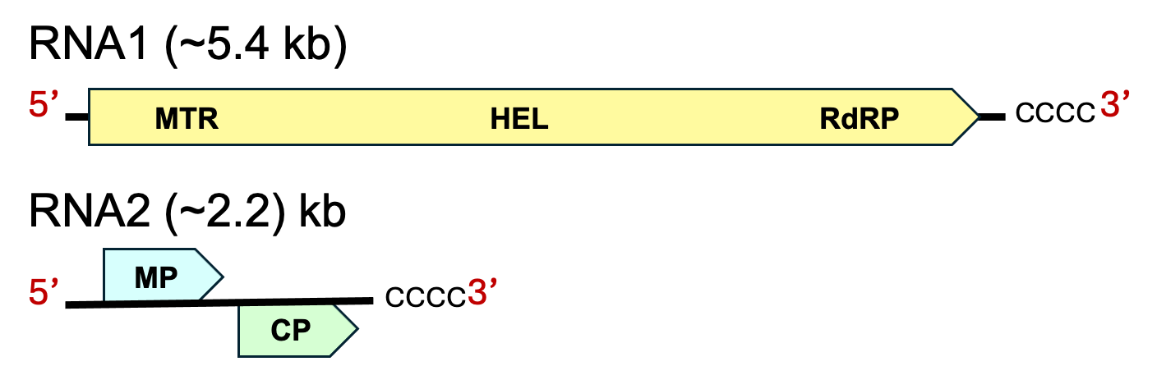

Figure 1. Schematic representation of general genome organization of seven viruses, representative of proposed new idaeovirus species. (MTR = methyltransferase, Hel = helicase, RdRP = RNA-dependent RNA Polymerase, MP = movement protein, CP = coat protein)

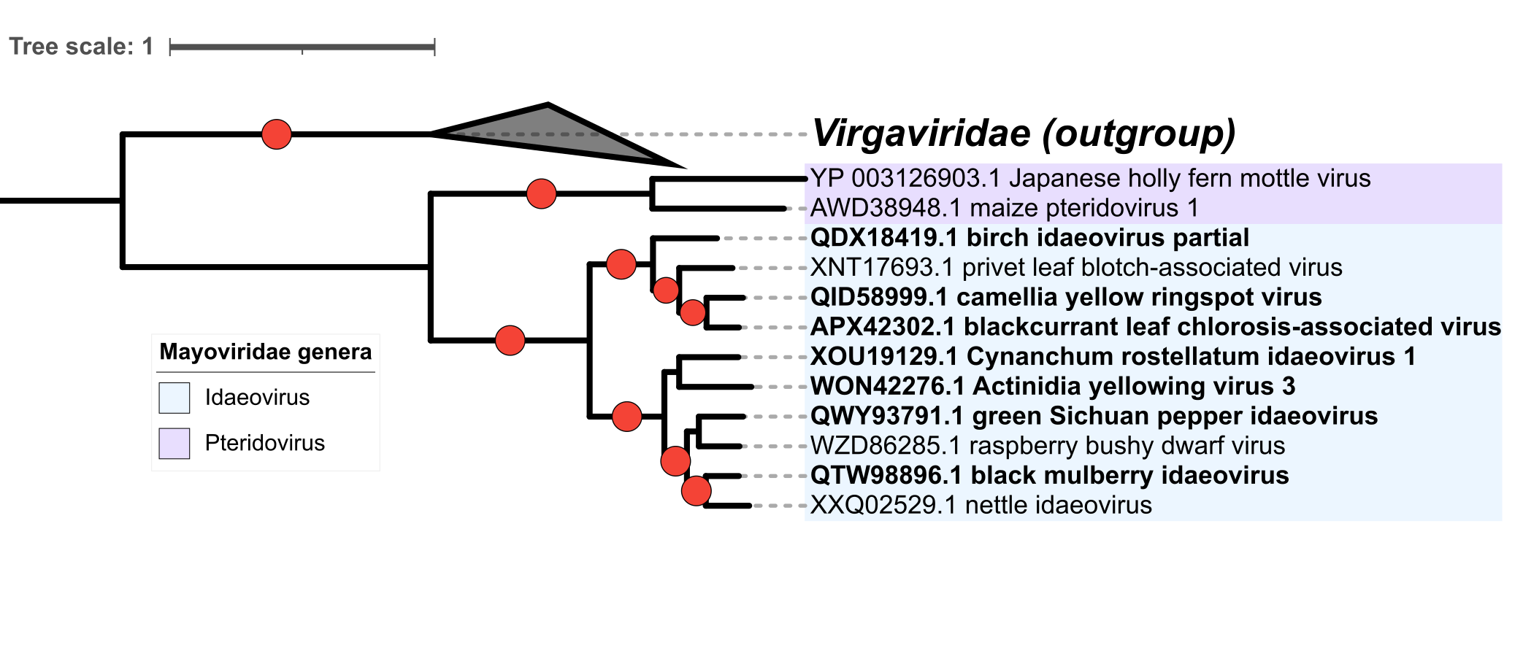
Figure 2. Maximum-likelihood phylogenetic tree showing relationships among members of the family Mayoviridae with clades corresponding to two genera shaded in lilac (Pteridovirus) and cian (Idaeovirus). Representatives of seven proposed new species in the genus Idaeovirus are reported in bold. Members of the family Virgaviridae are used as an outgroup. The tree was inferred from ClustalOmega-aligned amino acid sequences of viral replicases, using IQ-TREE v3.01[13], under the best-fit model LG+F+I+R3 and tested with 1,000 ultrafast bootstrap replicates [3]. The tree was generated with iTOL v7 [14]. GenBank accession numbers of proteins and corresponding virus names are shown at the branch tips. Ultrafast bootstrap support values >99% are indicated by red circles.

Table 1. List of the proposed seven new species in the genus Idaeovirus along with exemplar virus data (name, acronym and GenBank accessions).

Species name | Virus name | Acronym | GenBank
“Idaeovirus actinidiae” | Actinidia yellowing virus 3 | AcYV3 | OL581736.1; OL581737.1
“Idaeovirus betulae” | birch idaeovirus | BIV | PQ867863.1; PQ867864.1
“Idaeovirus camelliae” | camellia yellow ringspot virus | CaYRSV | MT036046.1; MT036047.1
“Idaeovirus cynanchi” | Cynanchum rostellatum idaeovirus 1 | CRIV | PQ195646.1; PQ195647.1
“Idaeovirus mori” | black mulberry idaeovirus | BMIV | MW017545.1; MW017538.1
“Idaeovirus ribis” | blackcurrant leaf chlorosis associated virus | BCLCaV | KX838923.1; KX838924.1
“Idaeovirus zanthoxyli” | green Sichuan pepper idaeovirus | GSPIdV | MH323432.1; MH323433.1

