

The International Committee on Taxonomy of Viruses
Taxonomy Proposal Form, 2026

Part 1a: Details of taxonomy proposals

Title: | Create 14 new species and abolish 3 species in the genus Tequatrovirus (class Caudoviricetes, order Pantevenvirales, family Straboviridae, subfamily Tevenvirinae)
Code assigned: | 2026.085B

Author(s), affiliation and email address(es):
Given name (+middle initial(s)) | Surname | Affiliation | Email address | Corr. author(s)
Michał J. | Wójcicki | Bacteriophage Laboratory, Department of Phage Therapy, Hirszfeld Institute of Immunology and Experimental Therapy, Polish Academy of Sciences, Wroclaw, Poland | michal.wojcicki@hirszfeld.pl | X
Martyna A. | Cieślik | Bacteriophage Laboratory, Department of Phage Therapy, Hirszfeld Institute of Immunology and Experimental Therapy, Polish Academy of Sciences, Wroclaw, Poland | martyna.cieslik@hirszfeld.pl
Paulina | Średnicka | Department of Microbiology, Prof. Wacław Dąbrowski Institute of Agricultural and Food Biotechnology - State Research Institute, Warsaw, Poland | paulina.srednicka@ibprs.pl
Iwona | Gientka | Department of Biotechnology and Food Microbiology, Institute of Food Sciences, Warsaw University of Life Sciences (WULS-SGGW), Warsaw, Poland | iwona_gientka@sggw.edu.pl

Part 1b: Taxonomy Proposal Submission
ICTV Subcommittee:
Animal DNA Viruses and Retroviruses |  | Bacterial viruses | X
Animal minus-strand and dsRNA viruses |  | Fungal and protist viruses
Animal positive-strand RNA viruses |  | Plant viruses
Archaeal viruses |  | General

List the ICTV Study Group(s) that have seen or have been involved in creating this proposal:
Caudoviricetes Study Group

Optional – complete only if formally voted on by an ICTV Study Group:
Study Group | Number of members
Study Group | Votes in support | Votes against | No vote

Submission date: | 21/06/2026

Part 1c: Feedback from ICTV Executive Committee (EC) meeting
Executive Committee Meeting Decision code: | X
A – Accept
Ac – Accept subject to revision by relevant subcommittee chair. No further vote required
U – Accept without revision but with re-evaluation and email vote by the EC
Uc – Accept subject to revision and re-evaluation and email vote by the EC
Ud – Deferred to the next EC meeting, with an invitation to revise based on EC comments
J - Reject
W - Withdrawn

Comments from the Executive Committee:

Part 1d: Revised Taxonomy Proposal Submission
Response of proposer:
Revision date:

Part 3: TAXONOMIC PROPOSAL

Taxonomic changes proposed:
Establish new taxon | X | Split taxon
Abolish taxon | X | Merge taxon
Move taxon |  | Promote taxon
Rename taxon |  | Demote taxon
Move and rename

Etymology (origin) of proposed taxonomic names:
Taxon name | Etymology of the term
Tequatrovirus Ecol030PP | species name derived from the phage name in the GenBank database – Escherichia phage 235Ecol030PP
Tequatrovirus ECW154 | species name derived from the phage name in the GenBank database – Escherichia phage EC.W15-4
Tequatrovirus EcoTB37 | species name derived from the phage name in the GenBank database – Escherichia phage vB_Eco_TB37
Tequatrovirus OESC3 | species name derived from the phage name in the GenBank database – Escherichia phage OES_C-3
Tequatrovirus shinka | species name derived from the phage name in the GenBank database – Escherichia phage vB_EcoM_Shinka
Tequatrovirus GADU22 | species name derived from the phage name in the GenBank database – Escherichia phage GADU22
Tequatrovirus i11m | species name derived from the phage name in the GenBank database – Escherichia phage i11m
Tequatrovirus ev240 | species name derived from the phage name in the GenBank database – Escherichia phage T4_ev240
Tequatrovirus killian | species name derived from the phage name in the GenBank database – Escherichia phage Killian
Tequatrovirus EPIMAM01 | species name derived from the phage name in the GenBank database – Escherichia phage EPIMAM01
Tequatrovirus C600147 | species name derived from the phage name in the GenBank database – Phage 3_C600_14/7
Tequatrovirus UAB60 | species name derived from the phage name in the GenBank database – Salmonella phage UAB_60
Tequatrovirus L14 | species name derived from the phage name in the GenBank database – Escherichia phage L14
Tequatrovirus EcoMFT | species name derived from the phage name in the GenBank database – Escherichia phage vB_EcoM_FT

Permission for use of names derived from a living person:
Taxon name | Full name of person from whom the name is derived | Attached

Abstract of Taxonomy Proposal:
Description of current taxonomy:
The genus Tequatrovirus genus includes 83 species.

Proposed taxonomic change(s):
We propose to create 14 new species and abolish three species (i.e., Tequatrovirus SHBML501, Tequatrovirus yueel1, Tequatrovirus fps65) in the genus Tequatrovirus.

Demarcation criteria for new taxon/taxa:
Species demarcation criteria: Two phages are assigned to the same species if their genomes are more than 95% identical over their genome length for isolates.

Genus demarcation criteria: In search for criteria that create cohesive and distinct genera that are reproducible and monophyletic, the Bacterial Viruses Subcommittee has established 70% nucleotide identity of the genome length as the cut-off for genera. Genus-level groupings should always be monophyletic in the signature genes, as tested with a phylogenetic tree.

Justification:
Based on DNA and protein similarity, the 14 proposed new species are coherent and together with another known species can be classified in the genus Tequatrovirus. The species Tequatrovirus SHBML501, Tequatrovirus yueel1, and Tequatrovirus fps65 are proposed for removal since the representative genomes share >95% intergenomic nucleotide sequence similarity with other existing species in the genus. The proposed taxa conform to the demarcation criteria employed by the ICTV Bacterial Viruses Subcommittee.

Text of Taxonomy proposal:
Description of current taxonomy:
Currently, the Tequatrovirus genus includes 83 species

Proposed taxonomic change(s):
We performed a genomic analysis of phages deposited in the NCBI database. We propose to create 14 new species and abolish three species (i.e., Tequatrovirus SHBML501, Tequatrovirus yueel1, Tequatrovirus fps65) in the genus Tequatrovirus.

Demarcation criteria for new taxon/taxa:
Species demarcation criteria: Two phages are assigned to the same species if their genomes are more than 95% identical over their genome length for isolates.
These values can be calculated by several tools, such as BLASTn [1] – usually calculated using the intergenomic distance calculator VIRIDIC [2].

Genus demarcation criteria: In search for criteria that create cohesive and distinct genera that are reproducible and monophyletic, the Bacterial Viruses Subcommittee has established 70% nucleotide identity of the genome length as the cut-off for genera. Genus-level groupings should always be monophyletic in the signature genes, as tested with a phylogenetic tree [3].

Justification:
Based on DNA and protein similarity, the 14 proposed new species are coherent and together with another known species can be classified in the genus Tequatrovirus. The species Tequatrovirus SHBML501, Tequatrovirus yueel1, and Tequatrovirus fps65 are proposed for removal since the representative genomes share >95% intergenomic nucleotide sequence similarity with other existing species in that genus. The proposed taxa conform to the demarcation criteria employed by the ICTV Bacterial Viruses Subcommittee.

References:
- Sayers EW, Beck J, Bolton EE, Bourexis D, Brister JR, Canese K, Comeau DC, Funk K, Kim S, Klimke W, Marchler-Bauer A, Landrum M, Lathrop S, Lu Z, Madden TL, O'Leary N, Phan L, Rangwala SH, Schneider VA, Skripchenko Y, Wang J, Ye J, Trawick BW, Pruitt KD, Sherry ST. Database resources of the National Center for Biotechnology Information. Nucleic Acids Res. 2021, 49(D1):D10-D17.
- Moraru C, Varsani A, Kropinski AM. VIRIDIC - a novel tool to calculate the intergenomic similarities of prokaryote-infecting viruses. Viruses 2020, 12(11):1268.
- Turner D, Kropinski AM, Adriaenssens EM. A roadmap for genome-based phage taxonomy. Viruses 2021, 13(3):506.
- Nishimura Y, Yoshida T, Kuronishi M, Uehara H, Ogata H, Goto S. ViPTree: the viral proteomic tree server. Bioinformatics 2017, 33(15):2379-2380.
- Rohwer F, Edwards R. The Phage Proteomic Tree: a genome-based taxonomy for phage. J. Bacteriol. 2002, 184(16):4529-35.
- Turner D, Reynolds D, Seto D, Mahadevan P. CoreGenes3.5: a webserver for the determination of core genes from sets of viral and small bacterial genomes. BMC Res. Notes. 2013, 6:140.

Accompanying files:

Filename | Description of contents
Tequatrovirus_14ns_3rms.xlsx | To present the proposed taxonomic changes as a comparison of new taxonomic structures.

Tables, Figures:

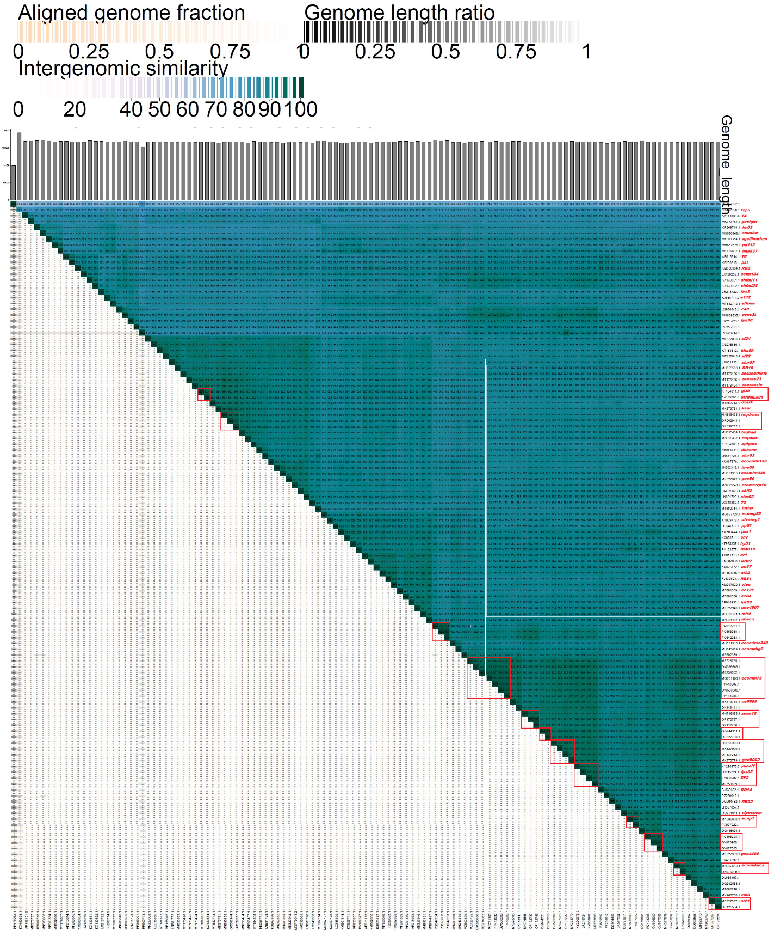

Figure 1. VIRIDIC heat map: VIRIDIC (Virus Intergenomic Distance Calculator [2]; http://rhea.icbm.uni-oldenburg.de/VIRIDIC/) computes pairwise intergenomic distances/similarities amongst phage genomes. Phages belonging to the same species (nucleotide similarity above 95%) are marked with a red frame. The currently distinguished 83 species belonging to the genus Tequatrovirus are marked in red font.

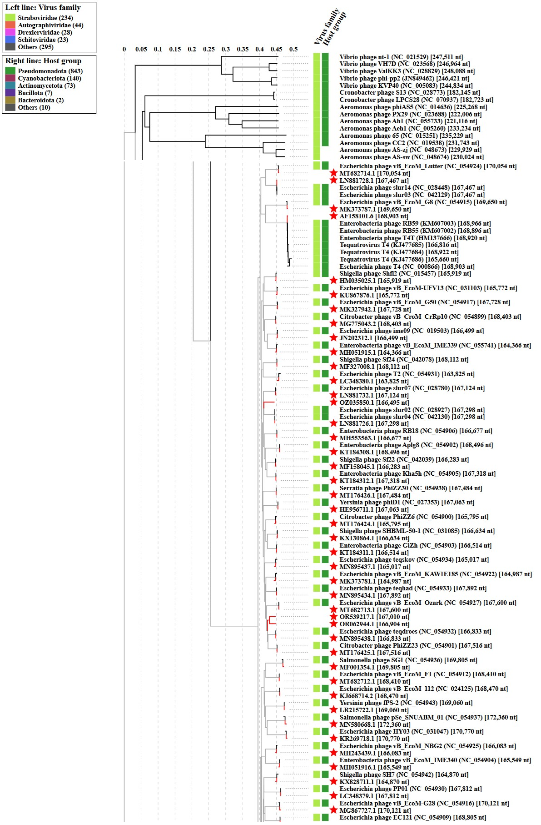

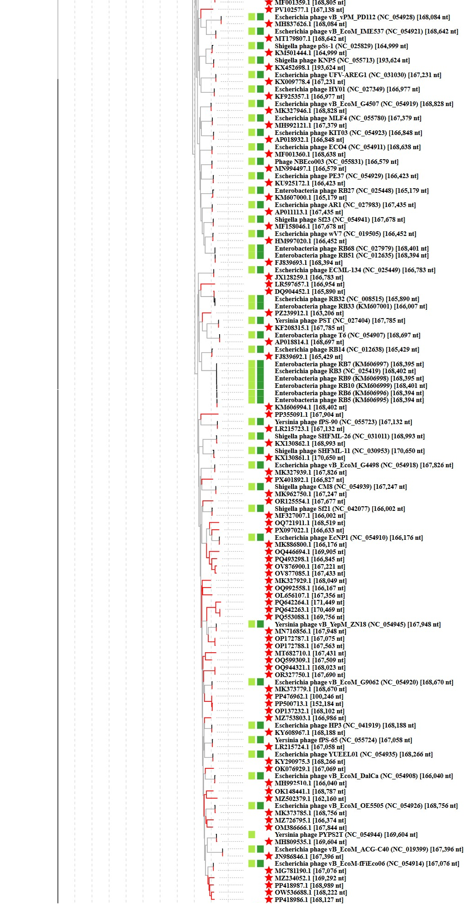

Figure 2. ViPTree analysis*: ViPTree analysis (https://www.genome.jp/viptree/; [4]) is based upon Rohwer and Edwards (2002) Phage Proteomic Tree [5]. The phages of interest are indicated with a red stars.
* The Autographiviridae family shown in Figure 2 (automatically labeled by the software) is outdated. In 2025, the Autographiviridae family was elevated to the rank of order and renamed Autographivirales.

Genome summary:

- To create new species

Phage name | RefSeq No. | INSDC | Size (bp) | GC% | Protein | Overall % DNA sequence identity (*) | Overall % homologous proteins (**)
Shigella phage Sf21 (Tequatrovirus sf21; reference genome) | MF327007.1 | MF327007 | 166,002 | 35.5 | 266 | 100.0 | 100.00
Escherichia phage 235Ecol030PP |  | PP355091 | 167,904 | 35.4 | 275 | 90.2 | 94.36
Escherichia phage EC.W15-4 |  | PP500713 | 152,184 | 35.3 | 237 | 88.6 | 83.46
Escherichia phage vB_Eco_TB37 |  | OZ035850 | 166,495 | 35.5 | 281 | 90.2 | 96.24
Escherichia phage OES_C-3 |  | PQ642264 | 171,449 | 35.2 | 275 | 88.7 | 95.49
Escherichia phage vB_EcoM_Shinka |  | MZ502379 | 162,160 | 35.4 | 250 | 90.7 | 88.35
Escherichia phage GADU22 |  | OQ944321 | 168,023 | 35.3 | 287 | 92.9 | 95.49
Escherichia phage i11m |  | PZ239912 | 163,206 | 35.4 | 259 | 90.7 | 92.11
Escherichia phage T4_ev240 |  | LR597657 | 166,954 | 35.4 | 267 | 91.3 | 93.98
Escherichia phage Killian |  | OQ446694 | 169,905 | 35.4 | 269 | 91.3 | 94.74
Escherichia phage EPIMAM01 |  | PQ493298 | 166,845 | 35.4 | 264 | 93.8 | 95.86
Phage 3_C600_14/7 |  | PX401892 | 166,827 | 35.4 | 280 | 92.9 | 94.36
Salmonella phage UAB_60 |  | OL656107 | 167,356 | 35.4 | 266 | 94.0 | 94.36
Escherichia phage L14 |  | OQ992558 | 166,167 | 35.4 | 265 | 94.1 | 94.36
Escherichia phage vB_EcoM_FT |  | MT682710 | 167,431 | 35.3 | 267 | 92.2 | 93.98
(*) determined using VIRIDIC [2]
(**) determined using CoreGenes 3.5 [6]

- To remove species

Phage name | RefSeq No. | INSDC | Size (bp) | GC% | Overall % DNA sequence identity (*)
Enterobacteria phage GiZh (Tequatrovirus gizh;  reference genome) | KT184311.1 | KT184311 | 166,514 | 35.5 | 100.0
Shigella virus SHBML501 (Tequatrovirus SHBML501) |  | KX130864 | 166,634 | 35.4 | 95.1

Phage name | RefSeq No. | INSDC | Size (bp) | GC% | Overall % DNA sequence identity (*)
Escherichia phage HP3 (Tequatrovirus CF2;  reference genome) | KY608967.1 | KY608967 | 168,188 | 35.4 | 100.0
Escherichia phage YUEEL01 (Tequatrovirus yueel1) |  | KY290975 | 168,266 | 35.4 | 95.0
Yersinia phage fPS-65 (Tequatrovirus fps65) |  | LR215724 | 167,058 | 35.3 | 95.5
(*) determined using VIRIDIC [2]

