

The International Committee on Taxonomy of Viruses
Taxonomy Proposal Form, 2026

Part 1a: Details of taxonomy proposals

Title: | Create two new species in the genus Koutsourovirus (class Caudoviricetes, order Autographivirales, family Autoscriptoviridae, subfamily Slopekvirinae)
Code assigned: | 2026.083B

Author(s), affiliation and email address(es):
Given name (+middle initial(s)) | Surname | Affiliation | Email address | Corr. author(s)
Michał J. | Wójcicki | Bacteriophage Laboratory, Department of Phage Therapy, Hirszfeld Institute of Immunology and Experimental Therapy, Polish Academy of Sciences, Wroclaw, Poland | michal.wojcicki@hirszfeld.pl | X
Martyna A. | Cieślik | Bacteriophage Laboratory, Department of Phage Therapy, Hirszfeld Institute of Immunology and Experimental Therapy, Polish Academy of Sciences, Wroclaw, Poland | martyna.cieslik@hirszfeld.pl
Paulina | Średnicka | Department of Microbiology, Prof. Wacław Dąbrowski Institute of Agricultural and Food Biotechnology - State Research Institute, Warsaw, Poland | paulina.srednicka@ibprs.pl
Iwona | Gientka | Department of Biotechnology and Food Microbiology, Institute of Food Sciences, Warsaw University of Life Sciences (WULS-SGGW), Warsaw, Poland | iwona_gientka@sggw.edu.pl

Part 1b: Taxonomy Proposal Submission
ICTV Subcommittee:
Animal DNA Viruses and Retroviruses |  | Bacterial viruses | X
Animal minus-strand and dsRNA viruses |  | Fungal and protist viruses
Animal positive-strand RNA viruses |  | Plant viruses
Archaeal viruses |  | General

List the ICTV Study Group(s) that have seen or have been involved in creating this proposal:
Caudoviricetes Study Group

Optional – complete only if formally voted on by an ICTV Study Group:
Study Group | Number of members
Study Group | Votes in support | Votes against | No vote

Submission date: | 09/06/2026

Part 1c: Feedback from ICTV Executive Committee (EC) meeting
Executive Committee Meeting Decision code: | X
A – Accept
Ac – Accept subject to revision by relevant subcommittee chair. No further vote required
U – Accept without revision but with re-evaluation and email vote by the EC
Uc – Accept subject to revision and re-evaluation and email vote by the EC
Ud – Deferred to the next EC meeting, with an invitation to revise based on EC comments
J - Reject
W - Withdrawn

Comments from the Executive Committee:

Part 1d: Revised Taxonomy Proposal Submission
Response of proposer:
Revision date:

Part 3: TAXONOMIC PROPOSAL

Taxonomic changes proposed:
Establish new taxon | X | Split taxon
Abolish taxon |  | Merge taxon
Move taxon |  | Promote taxon
Rename taxon |  | Demote taxon
Move and rename

Etymology (origin) of proposed taxonomic names:
Taxon name | Etymology of the term
Koutsourovirus PL43 | species name derived from the phage name in the GenBank database – Enterobacter phage ISKB_PL43
Koutsourovirus Entb48 | species name derived from the phage name in the GenBank database – Enterobacter phage Entb_48

Permission for use of names derived from a living person:
Taxon name | Full name of person from whom the name is derived | Attached

Abstract of Taxonomy Proposal:
Description of current taxonomy:
The order Autographivirales includes 4 families, 13 subfamilies, 229 genera, and 1005 species. The family Autoscriptoviridae includes 5 subfamilies, 38 genera, and 311 species. The subfamily Slopekvirinae includes 10 genera, and 118 species. Currently, the Koutsourovirus genus includes four species: Koutsourovirus EhYP, Koutsourovirus KDA1, Koutsourovirus KKP3828, and Koutsourovirus Pec.

Proposed taxonomic change(s):
We propose to create two new species in the genus Koutsourovirus.

Demarcation criteria for new taxon/taxa:
Species demarcation criteria: Two phages are assigned to the same species if their genomes are more than 95% identical over their genome length for isolates.
These values can be calculated by several tools, such as BLASTn [1] – usually calculated using the intergenomic distance calculator VIRIDIC [2].

Genus demarcation criteria: In search for criteria that create cohesive and distinct genera that are reproducible and monophyletic, the Bacterial Viruses Subcommittee has established 70% nucleotide identity of the genome length as the cut-off for genera. Genus-level groupings should always be monophyletic in the signature genes, as tested with a phylogenetic tree [3].

Justification:
Based on DNA and protein similarity, the 2 proposed new species are coherent and together with the four known species (Koutsourovirus EhYP, Koutsourovirus KDA1, Koutsourovirus KKP3828, and Koutsourovirus Pec) can be classified in the genus Koutsourovirus. The proposed taxa conform to the demarcation criteria employed by the ICTV Bacterial Viruses Subcommittee.

Text of Taxonomy proposal:
Description of current taxonomy:
Currently, the order Autographivirales includes 4 families, 13 subfamilies, 229 genera, and 1005 species. The family Autoscriptoviridae includes 5 subfamilies, 38 genera, and 311 species. The subfamily Slopekvirinae includes 10 genera, and 118 species. Currently, the Koutsourovirus genus includes four species: Koutsourovirus EhYP, Koutsourovirus KDA1, Koutsourovirus KKP3828, and Koutsourovirus Pec.

Proposed taxonomic change(s):
We performed a genomic analysis of phages deposited in the NCBI database. We propose to create 2 new species in the genus Koutsourovirus.

Demarcation criteria for new taxon/taxa:
Species demarcation criteria: Two phages are assigned to the same species if their genomes are more than 95% identical over their genome length for isolates.
These values can be calculated by several tools, such as BLASTn [1] – usually calculated using the intergenomic distance calculator VIRIDIC [2].

Genus demarcation criteria: In search for criteria that create cohesive and distinct genera that are reproducible and monophyletic, the Bacterial Viruses Subcommittee has established 70% nucleotide identity of the genome length as the cut-off for genera. Genus-level groupings should always be monophyletic in the signature genes, as tested with a phylogenetic tree [3].

Justification:
Based on DNA and protein similarity, the 2 proposed new species are coherent and together with the four known species (Koutsourovirus EhYP, Koutsourovirus KDA1, Koutsourovirus KKP3828, and Koutsourovirus Pec) can be classified in the genus Koutsourovirus. The proposed taxa conform to the demarcation criteria employed by the ICTV Bacterial Viruses Subcommittee.

References:
- Sayers EW, Beck J, Bolton EE, Bourexis D, Brister JR, Canese K, Comeau DC, Funk K, Kim S, Klimke W, Marchler-Bauer A, Landrum M, Lathrop S, Lu Z, Madden TL, O'Leary N, Phan L, Rangwala SH, Schneider VA, Skripchenko Y, Wang J, Ye J, Trawick BW, Pruitt KD, Sherry ST. Database resources of the National Center for Biotechnology Information. Nucleic Acids Res. 2021, 49(D1):D10-D17.
- Moraru C, Varsani A, Kropinski AM. VIRIDIC - a novel tool to calculate the intergenomic similarities of prokaryote-infecting viruses. Viruses 2020, 12(11):1268.
- Turner D, Kropinski AM, Adriaenssens EM. A roadmap for genome-based phage taxonomy. Viruses 2021, 13(3):506.
- Nishimura Y, Yoshida T, Kuronishi M, Uehara H, Ogata H, Goto S. ViPTree: the viral proteomic tree server. Bioinformatics 2017, 33(15):2379-2380.
- Rohwer F, Edwards R. The Phage Proteomic Tree: a genome-based taxonomy for phage. J. Bacteriol. 2002, 184(16):4529-35.
- Turner D, Reynolds D, Seto D, Mahadevan P. CoreGenes3.5: a webserver for the determination of core genes from sets of viral and small bacterial genomes. BMC Res. Notes. 2013, 6:140.

Accompanying files:

Filename | Description of contents
Koutsourovirus_2ns.xlsx | To present the proposed taxonomic changes as a comparison of new taxonomic structures.

Tables, Figures:

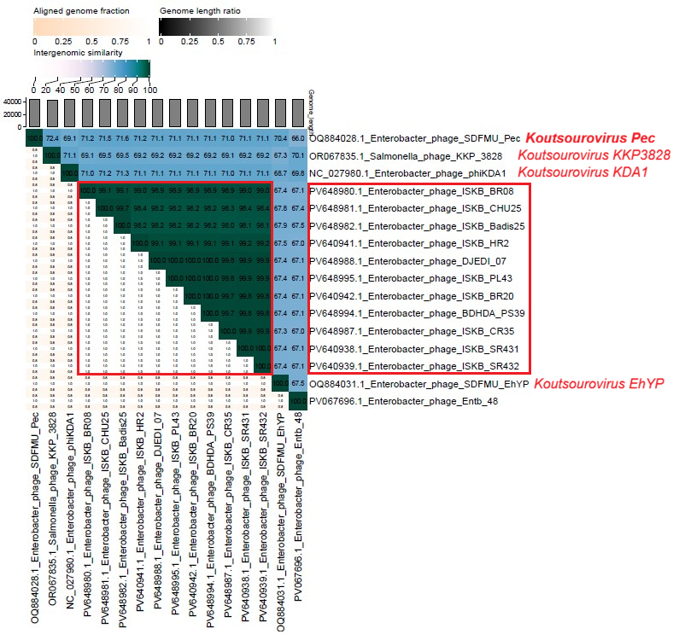

Figure 1. VIRIDIC heat map: VIRIDIC (Virus Intergenomic Distance Calculator [2]; http://rhea.icbm.uni-oldenburg.de/VIRIDIC/) computes pairwise intergenomic distances/similarities amongst phage genomes. Phages belonging to the same species (nucleotide similarity above 95%) are marked with a red frame. The currently distinguished four species belonging to the genus Koutsourovirus are marked in red font.

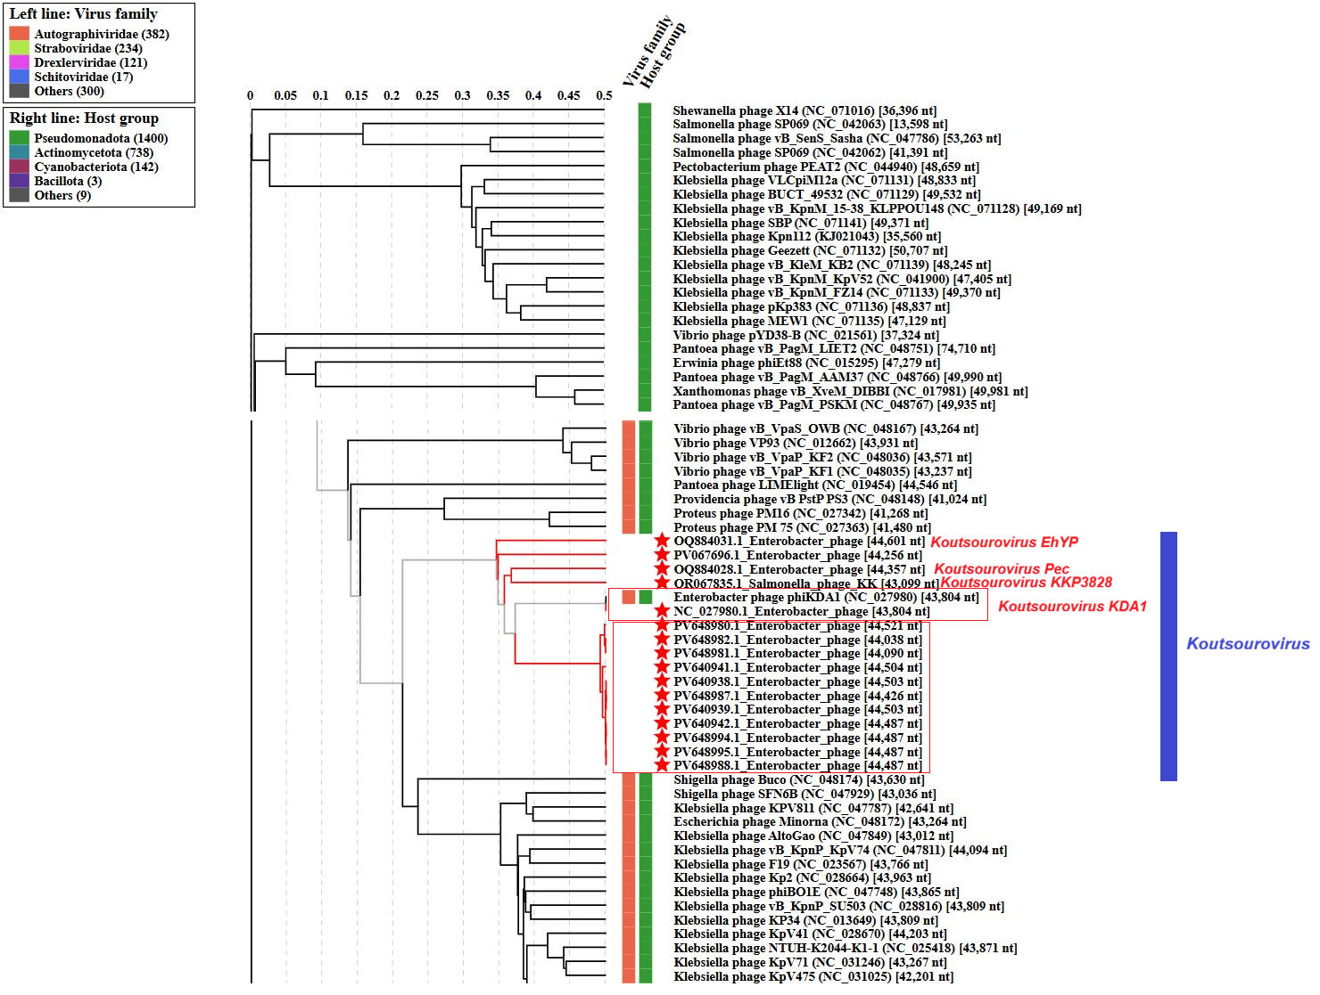
Figure 2. ViPTree analysis*: ViPTree analysis (https://www.genome.jp/viptree/; [4]) is based upon Rohwer and Edwards (2002) Phage Proteomic Tree [5]. The phages of interest are indicated with a red stars and a blue bar.

* The Autographiviridae family shown in Figure 2 (automatically labeled by the software) is outdated. In 2025, the Autographiviridae family was elevated to the rank of order and renamed Autographivirales.

Genome summary:

Phage name | RefSeq No. | INSDC | Size (bp) | GC% | Protein | Overall % DNA sequence identity (*) | Overall % homologous proteins (**)
Enterobacter phage phiKDA1  (Koutsourovirus KDA1; reference genome) | NC_027980.1 | NC_027980 | 43,804 | 51.7 | 62 | 100.0 | 100.00
Enterobacter phage ISKB_PL43 |  | PV648995 | 44,487 | 52.0 | 66 | 71.1 | 80.65
Enterobacter phage Entb_48 |  | PV067696 | 44,256 | 52.0 | 65 | 69.8 | 75.81
(*) determined using VIRIDIC [2]
(**) determined using CoreGenes 3.5 [6]

