

The International Committee on Taxonomy of Viruses
Taxonomy Proposal Form, 2026

Part 1a: Details of taxonomy proposals

Title: | Create 35 new species in the genus Dhillonvirus (class Caudoviricetes)
Code assigned: | 2026.080B

Author(s), affiliation and email address(es):
Given name (+middle initial(s)) | Surname | Affiliation | Email address | Corr. author(s)
Michał J. | Wójcicki | Bacteriophage Laboratory, Department of Phage Therapy, Hirszfeld Institute of Immunology and Experimental Therapy, Polish Academy of Sciences, Wroclaw, Poland | michal.wojcicki@hirszfeld.pl | X
Martyna A. | Cieślik | Bacteriophage Laboratory, Department of Phage Therapy, Hirszfeld Institute of Immunology and Experimental Therapy, Polish Academy of Sciences, Wroclaw, Poland | martyna.cieslik@hirszfeld.pl
Dziyana | Shymialevich | Department of Microbiology, Prof. Wacław Dąbrowski Institute of Agricultural and Food Biotechnology - State Research Institute, Warsaw, Poland | diana.szymielewicz@ibprs.pl
Iwona | Gientka | Department of Biotechnology and Food Microbiology, Institute of Food Sciences, Warsaw University of Life Sciences (WULS-SGGW), Warsaw, Poland | iwona_gientka@sggw.edu.pl

Part 1b: Taxonomy Proposal Submission
ICTV Subcommittee:
Animal DNA Viruses and Retroviruses |  | Bacterial viruses | X
Animal minus-strand and dsRNA viruses |  | Fungal and protist viruses
Animal positive-strand RNA viruses |  | Plant viruses
Archaeal viruses |  | General

List the ICTV Study Group(s) that have seen or have been involved in creating this proposal:
Caudoviricetes Study Group

Optional – complete only if formally voted on by an ICTV Study Group:
Study Group | Number of members
Study Group | Votes in support | Votes against | No vote

Submission date: | 19/06/2026

Part 1c: Feedback from ICTV Executive Committee (EC) meeting
Executive Committee Meeting Decision code: | X
A – Accept
Ac – Accept subject to revision by relevant subcommittee chair. No further vote required
U – Accept without revision but with re-evaluation and email vote by the EC
Uc – Accept subject to revision and re-evaluation and email vote by the EC
Ud – Deferred to the next EC meeting, with an invitation to revise based on EC comments
J - Reject
W - Withdrawn

Comments from the Executive Committee:

Part 1d: Revised Taxonomy Proposal Submission
Response of proposer:
Revision date:

Part 3: TAXONOMIC PROPOSAL

Taxonomic changes proposed:
Establish new taxon | X | Split taxon
Abolish taxon |  | Merge taxon
Move taxon |  | Promote taxon
Rename taxon |  | Demote taxon
Move and rename

Etymology (origin) of proposed taxonomic names:
Taxon name | Etymology of the term
Dhillonvirus PEC9 | species name derived from the phage name in the GenBank database – Escherichia phage PEC9
Dhillonvirus SMS22 | species name derived from the phage name in the GenBank database – Escherichia phage SM_S22
Dhillonvirus SMA8 | species name derived from the phage name in the GenBank database – Escherichia phage SM_A8
Dhillonvirus SMW22 | species name derived from the phage name in the GenBank database – Escherichia phage SM_W22
Dhillonvirus KSS9 | species name derived from the phage name in the GenBank database – Escherichia phage KS_S9
Dhillonvirus UHP65 | species name derived from the phage name in the GenBank database – Escherichia phage UHP65
Dhillonvirus SMS24 | species name derived from the phage name in the GenBank database – Escherichia phage SM_S24
Dhillonvirus UDS3lw | species name derived from the phage name in the GenBank database – Escherichia phage vB_EcoS-UDS3lw
Dhillonvirus Zumzum | species name derived from the phage name in the GenBank database – Escherichia phage Zumzum
Dhillonvirus yaya006 | species name derived from the phage name in the GenBank database – Escherichia phage yaya_006
Dhillonvirus DruSM5 | species name derived from the phage name in the GenBank database – Escherichia phage Dru_SM5
Dhillonvirus SP1 | species name derived from the phage name in the GenBank database – Escherichia phage SP1
Dhillonvirus HH3 | species name derived from the phage name in the GenBank database – Escherichia phage HH3
Dhillonvirus Char31A | species name derived from the phage name in the GenBank database – Escherichia phage Char3.1A
Dhillonvirus AV129 | species name derived from the phage name in the GenBank database – Escherichia phage AV129
Dhillonvirus KCP094 | species name derived from the phage name in the GenBank database – Escherichia phage KCP_094
Dhillonvirus phiEco273 | species name derived from the phage name in the GenBank database – Escherichia phage phiEco273
Dhillonvirus JunoodPK1 | species name derived from the phage name in the GenBank database – Escherichia phage Junood_PK1
Dhillonvirus RBW1 | species name derived from the phage name in the GenBank database – Escherichia phage C-a_RBW-1
Dhillonvirus McMelon | species name derived from the phage name in the GenBank database – Escherichia phage McMelon
Dhillonvirus KenyaK19 | species name derived from the phage name in the GenBank database – Salmonella phage Kenya-K19
Dhillonvirus BMA1 | species name derived from the phage name in the GenBank database – Escherichia phage BMA1
Dhillonvirus PS2 | species name derived from the phage name in the GenBank database – Escherichia phage vB_EcoS_PS2
Dhillonvirus Henu51 | species name derived from the phage name in the GenBank database – Escherichia phage Henu5_1
Dhillonvirus NHEP3 | species name derived from the phage name in the GenBank database – Escherichia phage NHEP3
Dhillonvirus BEK22 | species name derived from the phage name in the GenBank database – Escherichia phage BEK2-2
Dhillonvirus Ecol81 | species name derived from the phage name in the GenBank database – Escherichia phage Ecol_81
Dhillonvirus Pandora71 | species name derived from the phage name in the GenBank database – Escherichia phage Pandora71
Dhillonvirus SD276 | species name derived from the phage name in the GenBank database – Escherichia phage vB_EcoS_SD276
Dhillonvirus Psq1 | species name derived from the phage name in the GenBank database – Escherichia phage Psq-1
Dhillonvirus AMO3640 | species name derived from the phage name in the GenBank database – Escherichia phage vB_EcoS_AMO3640
Dhillonvirus NJ01 | species name derived from the phage name in the GenBank database – Acinetobacter phage NJ01
Dhillonvirus HK1 | species name derived from the phage name in the GenBank database – Escherichia phage HK1
Dhillonvirus LzuP1 | species name derived from the phage name in the GenBank database – Escherichia phage vB_Eco_Lzu_P1
Dhillonvirus P78 | species name derived from the phage name in the GenBank database – Escherichia phage vB_EcoS_P78

Permission for use of names derived from a living person:
Taxon name | Full name of person from whom the name is derived | Attached

Abstract of Taxonomy Proposal:
Description of current taxonomy:
The genus Dhillonvirus was renamed in 2018 by proposal 2018.007B.A.v4.rename137gen6sp.zip The genus currently includes 49 species.

Proposed taxonomic change(s):
We performed a genomic analysis of phages deposited in the NCBI database. We propose to create 35 new species in the genus Dhillonvirus.

Demarcation criteria for new taxon/taxa:
Species demarcation criteria: Two phages are assigned to the same species if their genomes are more than 95% identical over their genome length for isolates.
These values can be calculated by several tools, such as BLASTn [1] – usually calculated using the intergenomic distance calculator VIRIDIC [2].

Genus demarcation criteria: In search for criteria that create cohesive and distinct genera that are reproducible and monophyletic, the Bacterial Viruses Subcommittee has established 70% nucleotide identity of the genome length as the cut-off for genera. Genus-level groupings should always be monophyletic in the signature genes, as tested with a phylogenetic tree [3].

Justification:
Based on DNA and protein similarity, the 35 proposed new species are coherent and together with the 49 known species can be classified in the genus Dhillonvirus. The proposed taxa conform to the demarcation criteria employed by the ICTV Bacterial Viruses Subcommittee.

Text of Taxonomy proposal:
Description of current taxonomy:
The genus Dhillonvirus was renamed in 2018 by proposal 2018.007B.A.v4.rename137gen6sp.zip The genus currently includes 49 species.

Proposed taxonomic change(s):
We performed a genomic analysis of phages deposited in the NCBI database. We propose to create 35 new species in the genus Dhillonvirus.

Demarcation criteria for new taxon/taxa:
Species demarcation criteria: Two phages are assigned to the same species if their genomes are more than 95% identical over their genome length for isolates.
These values can be calculated by several tools, such as BLASTn [1] – usually calculated using the intergenomic distance calculator VIRIDIC [2].

Genus demarcation criteria: In search for criteria that create cohesive and distinct genera that are reproducible and monophyletic, the Bacterial Viruses Subcommittee has established 70% nucleotide identity of the genome length as the cut-off for genera. Genus-level groupings should always be monophyletic in the signature genes, as tested with a phylogenetic tree [3].

Justification:
Based on DNA and protein similarity, the 35 proposed new species are coherent and together with the 49 known species (can be classified in the genus Dhillonvirus. The proposed taxa conform to the demarcation criteria employed by the ICTV Bacterial Viruses Subcommittee.

References:
- Sayers EW, Beck J, Bolton EE, Bourexis D, Brister JR, Canese K, Comeau DC, Funk K, Kim S, Klimke W, Marchler-Bauer A, Landrum M, Lathrop S, Lu Z, Madden TL, O'Leary N, Phan L, Rangwala SH, Schneider VA, Skripchenko Y, Wang J, Ye J, Trawick BW, Pruitt KD, Sherry ST. Database resources of the National Center for Biotechnology Information. Nucleic Acids Res. 2021, 49(D1):D10-D17.
- Moraru C, Varsani A, Kropinski AM. VIRIDIC - a novel tool to calculate the intergenomic similarities of prokaryote-infecting viruses. Viruses 2020, 12(11):1268.
- Turner D, Kropinski AM, Adriaenssens EM. A roadmap for genome-based phage taxonomy. Viruses 2021, 13(3):506.
- Nishimura Y, Yoshida T, Kuronishi M, Uehara H, Ogata H, Goto S. ViPTree: the viral proteomic tree server. Bioinformatics 2017, 33(15):2379-2380.
- Rohwer F, Edwards R. The Phage Proteomic Tree: a genome-based taxonomy for phage. J. Bacteriol. 2002, 184(16):4529-35.
- Turner D, Reynolds D, Seto D, Mahadevan P. CoreGenes3.5: a webserver for the determination of core genes from sets of viral and small bacterial genomes. BMC Res. Notes. 2013, 6:140.

Accompanying files:

Filename | Description of contents
Dhillonvirus _35ns.xlsx | To present the proposed taxonomic changes as a comparison of new taxonomic structures.

Tables, Figures:

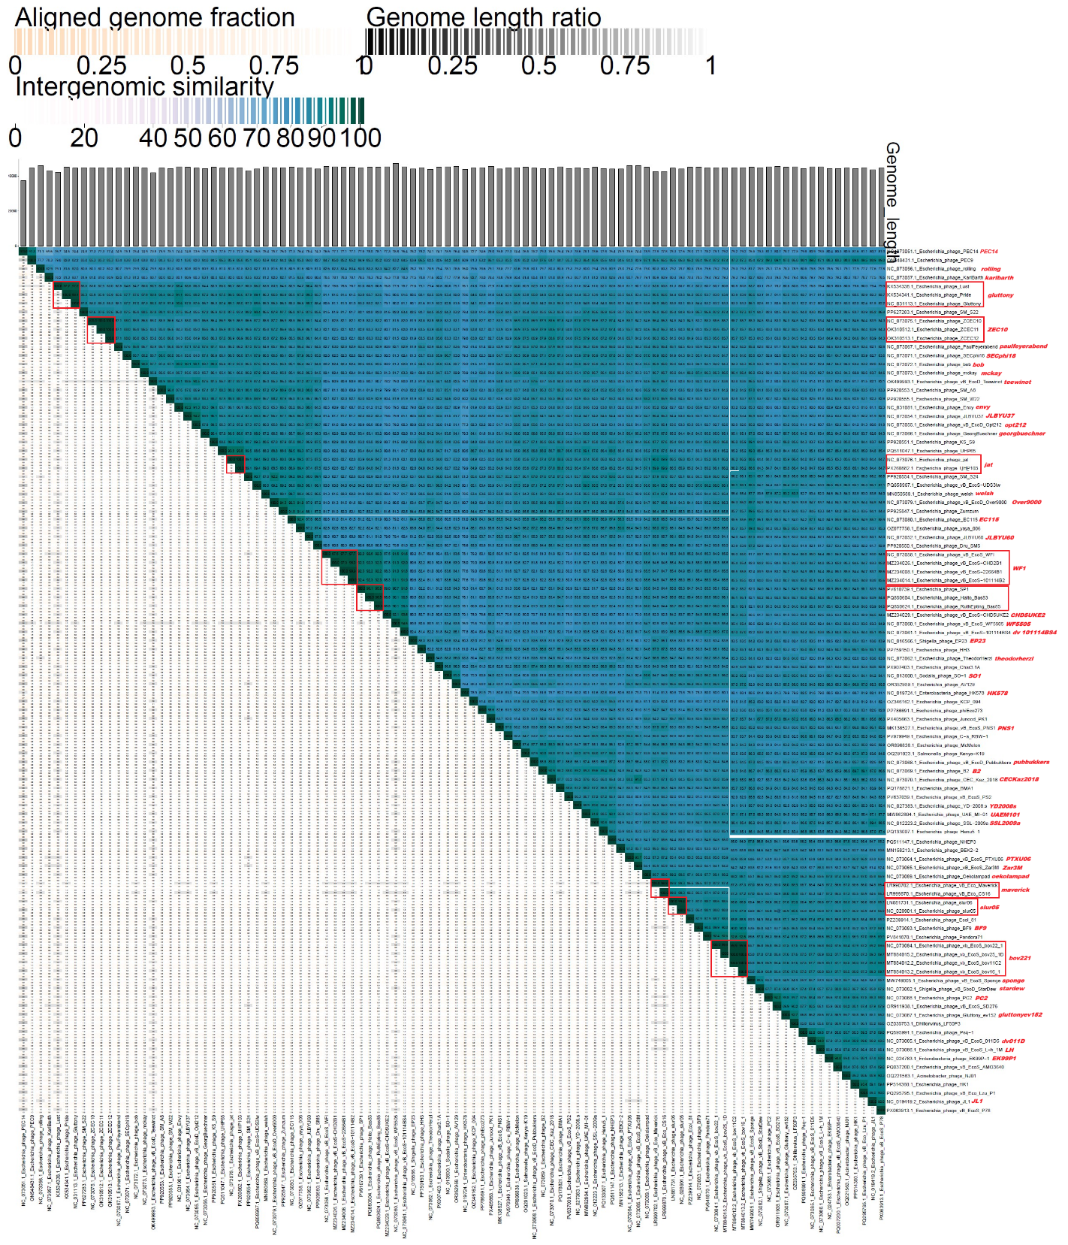
Figure 1. VIRIDIC heat map: VIRIDIC (Virus Intergenomic Distance Calculator [2]; http://rhea.icbm.uni-oldenburg.de/VIRIDIC/) computes pairwise intergenomic distances/similarities amongst phage genomes. Phages belonging to the same species (nucleotide similarity above 95%) are marked with a red frame. The currently distinguished 49 species belonging to the genus Dhillonvirus are marked in red font.

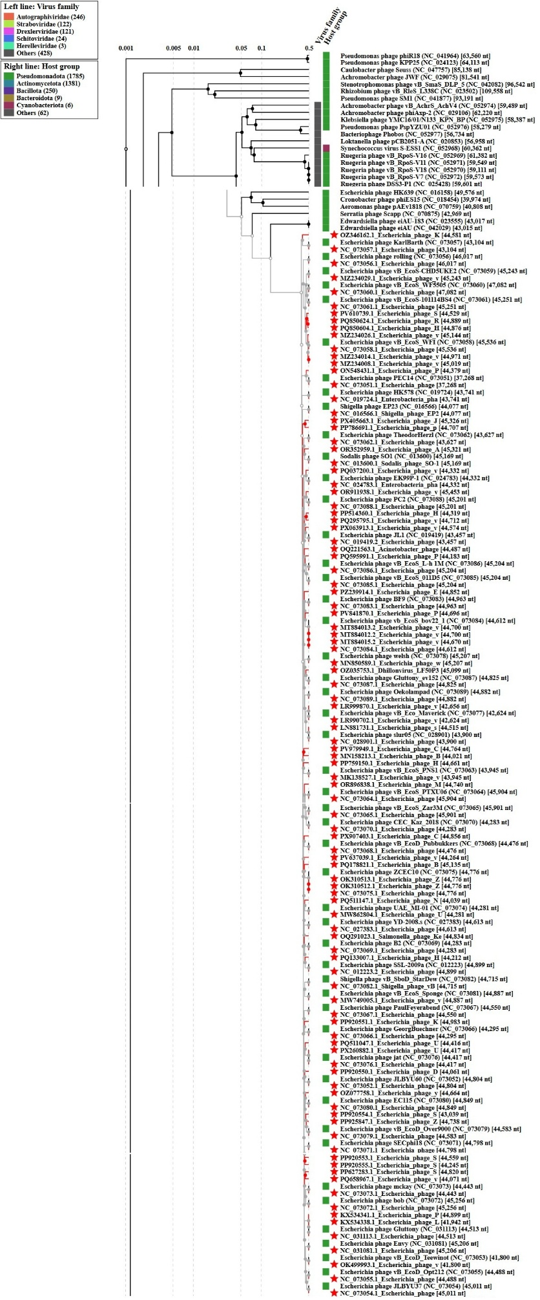
Figure 2. ViPTree analysis*: ViPTree analysis (https://www.genome.jp/viptree/; [4]) is based upon Rohwer and Edwards (2002) Phage Proteomic Tree [5]. The phages of interest are indicated with a red stars.

* The Autographiviridae family shown in Figure 2 (automatically labeled by the software) is outdated. In 2025, the Autographiviridae family was elevated to the rank of order and renamed Autographivirales.
Genome summary:

Phage name | RefSeq No. | INSDC | Size (bp) | GC% | Protein | Overall % DNA sequence identity (*) | Overall % homologous proteins (**)
Escherichia phage rolling (Dhillonvirus rolling; reference genome) | NC_073056.1 | NC_073056 | 46,017 | 54.2 | 60 | 100.0 | 100.00
Escherichia phage PEC9 |  | ON548431 | 44,379 | 54.4 | 56 | 77.7 | 83.33
Escherichia phage SM_S22 |  | PP627283 | 44,820 | 54.8 | 70 | 80.5 | 88.33
Escherichia phage SM_A8 |  | PP920553 | 44,559 | 54.5 | 60 | 80.5 | 88.33
Escherichia phage SM_W22 |  | PP920555 | 44,245 | 54.4 | 57 | 81.3 | 91.67
Escherichia phage KS_S9 |  | PP920551 | 44,983 | 54.7 | 59 | 81.3 | 90.00
Escherichia phage UHP65 |  | PQ511047 | 44,416 | 54.6 | 61 | 81.0 | 90.00
Escherichia phage SM_S24 |  | PP920554 | 43,039 | 54.6 | 59 | 83.0 | 90.00
Escherichia phage vB_EcoS-UDS3lw |  | PQ658967 | 44,071 | 54.7 | 58 | 82.7 | 93.33
Escherichia phage Zumzum |  | PP925847 | 44,738 | 54.6 | 71 | 81.8 | 93.33
Escherichia phage yaya_006 |  | OZ077758 | 44,664 | 54.7 | 58 | 81.6 | 90.00
Escherichia phage Dru_SM5 |  | PP920550 | 44,061 | 54.6 | 61 | 81.0 | 86.67
Escherichia phage SP1 |  | PV610739 | 44,529 | 54.4 | 58 | 83.0 | 86.67
Escherichia phage HH3 |  | PP759150 | 44,661 | 54.5 | 61 | 78.1 | 86.67
Escherichia phage Char3.1A |  | PX907403 | 44,856 | 54.5 | 70 | 79.4 | 88.33
Escherichia phage AV129 |  | OR352959 | 45,321 | 54.5 | 63 | 78.5 | 90.00
Escherichia phage KCP_094 |  | OZ346162 | 44,581 | 54.3 | 58 | 79.6 | 90.00
Escherichia phage phiEco273 |  | PP786691 | 44,707 | 54.5 | 59 | 78.6 | 88.33
Escherichia phage Junood_PK1 |  | PX405663 | 45,326 | 54.7 | 35 | 79.1 | 53.33
Escherichia phage C-a_RBW-1 |  | PV979949 | 44,764 | 54.5 | 57 | 77.7 | 83.33
Escherichia phage McMelon |  | OR896838 | 44,740 | 54.4 | 67 | 81.6 | 86.67
Salmonella phage Kenya-K19 |  | OQ291023 | 44,834 | 54.8 | 64 | 79.8 | 95.00
Escherichia phage BMA1 |  | PQ178821 | 45,135 | 54.5 | 61 | 80.5 | 91.67
Escherichia phage vB_EcoS_PS2 |  | PV637039 | 44,264 | 54.5 | 61 | 79.3 | 90.00
Escherichia phage Henu5_1 |  | PQ133007 | 44,212 | 54.8 | 60 | 79.8 | 78.33
Escherichia phage NHEP3 |  | PQ511147 | 44,039 | 54.6 | 65 | 80.9 | 86.67
Escherichia phage BEK2-2 |  | MN158213 | 44,021 | 54.4 | 59 | 78.0 | 88.33
Escherichia phage Ecol_81 |  | PZ239914 | 44,852 | 54.7 | 57 | 80.5 | 86.67
Escherichia phage Pandora71 |  | PV841870 | 44,696 | 54.4 | 62 | 79.6 | 85.00
Escherichia phage vB_EcoS_SD276 |  | OR911938 | 45,453 | 54.6 | 54 | 77.6 | 83.33
Escherichia phage Psq-1 |  | PQ595991 | 44,183 | 54.5 | 55 | 80.5 | 85.00
Escherichia phage vB_EcoS_AMO3640 |  | PQ037200 | 44,332 | 54.5 | 61 | 78.1 | 85.00
Acinetobacter phage NJ01 |  | OQ221563 | 44,487 | 54.6 | 61 | 79.1 | 88.33
Escherichia phage HK1 |  | PP514360 | 44,319 | 54.6 | 57 | 77.9 | 85.00
Escherichia phage vB_Eco_Lzu_P1 |  | PQ295795 | 44,712 | 54.6 | 56 | 77.7 | 81.67
Escherichia phage vB_EcoS_P78 |  | PX063913 | 44,574 | 54.7 | 58 | 77.8 | 83.33
(*) determined using VIRIDIC [2]
(**) determined using CoreGenes 3.5 [6]

