

The International Committee on Taxonomy of Viruses
Taxonomy Proposal Form, 2026

Part 1a: Details of taxonomy proposals

Title: | Create one new order, Jiaomingvirales, with four new families of viruses associated with Patescibacteria
Code assigned: | 2026.078B

Author(s), affiliation and email address(es):
Given name (+middle initial(s)) | Surname | Affiliation | Email address | Corr. author(s)
Huahua | Jian | School of Life Sciences and Biotechnology, Shanghai Jiao Tong University, Shanghai, China | jiandy@sjtu.edu.cn | X
Xiang | Xiao | School of Life Sciences and Biotechnology, Shanghai Jiao Tong University, Shanghai, China |  | X
Chengrui | Zhu | School of Life Sciences and Biotechnology, Shanghai Jiao Tong University, Shanghai, China | zhuchengrui@sjtu.edu.cn
Qinyuan | Cao | School of Life Sciences and Biotechnology, Shanghai Jiao Tong University, Shanghai, China | caoqinyuan@sjtu.edu.cn
Qingyang | Sun | School of Life Sciences and Biotechnology, Shanghai Jiao Tong University, Shanghai, China | sunqingyang@sjtu.edu.cn
Yecheng | Wang | School of Life Sciences and Biotechnology, Shanghai Jiao Tong University, Shanghai, China | wangyecheng@sjtu.edu.cn
Yi | Yi | School of Life Sciences and Biotechnology, Shanghai Jiao Tong University, Shanghai, China | kaixinbei132@sjtu.edu.cn
Mujie | Zhang | School of Life Sciences and Biotechnology, Shanghai Jiao Tong University, Shanghai, China | zhangmujie@sjtu.edu.cn
Zihang | Zhang | School of Life Sciences and Biotechnology, Shanghai Jiao Tong University, Shanghai, China | zhangzihang@sjtu.edu.cn
Yikang | Yu | School of Life Sciences and Biotechnology, Shanghai Jiao Tong University, Shanghai, China | anthonyryrbio@sjtu.edu.cn

Part 1b: Taxonomy Proposal Submission
ICTV Subcommittee:
Animal DNA Viruses and Retroviruses |  | Bacterial viruses | X
Animal minus-strand and dsRNA viruses |  | Fungal and protist viruses
Animal positive-strand RNA viruses |  | Plant viruses
Archaeal viruses |  | General -

List the ICTV Study Group(s) that have seen or have been involved in creating this proposal:
Caudoviricetes Study Group

Optional – complete only if formally voted on by an ICTV Study Group:
Study Group | Number of members
Study Group | Votes in support | Votes against | No vote

Submission date: | 28/05/2026

Part 1c: Feedback from ICTV Executive Committee (EC) meeting
Executive Committee Meeting Decision code: | X
A – Accept
Ac – Accept subject to revision by relevant subcommittee chair. No further vote required
U – Accept without revision but with re-evaluation and email vote by the EC
Uc – Accept subject to revision and re-evaluation and email vote by the EC
Ud – Deferred to the next EC meeting, with an invitation to revise based on EC comments
J - Reject
W - Withdrawn

Comments from the Executive Committee:

Part 1d: Revised Taxonomy Proposal Submission
Response of proposer:
Revision date:

Part 3: TAXONOMIC PROPOSAL
https://ictv.global/taxonomy/templates

Taxonomic changes proposed:
Establish new taxon |  | Split taxon
Abolish taxon |  | Merge taxon
Move taxon |  | Promote taxon
Rename taxon |  | Demote taxon
Move and rename

Etymology (origin) of proposed taxonomic names:
Taxon name | Etymology of the term
Jiaomingvirales | from Jiāomíng (焦螟), an extremely tiny insect that lives on a mosquito's eyelashes according to the ancient Chinese mythological text Liezi·Tang Wen, much like the parasitic relationship between the virus and its host, where the host is often unaware of its presence; the suffix -virales for order taxa
Jiaomingboviridae | “Jiaoming” (焦螟) continues the mythological reference. “Bo” corresponds to the highest position in the ancient Chinese brotherly sequence (“Bo, Zhong, Shu, Ji”). This family ranks first because it contains the largest number of genomes among the proposed families; the suffix -viridae for family taxa.
Jiaomingzhongviridae | “Jiaoming” (焦螟) continues the mythological reference. “Zhong” corresponds to the second position in the ancient Chinese brotherly sequence. This family ranks second based on the number of genomes; the suffix -viridae for family taxa.
Jiaomingshuviridae | “Jiaoming” (焦螟) continues the mythological reference. “Shu” corresponds to the third position in the ancient Chinese brotherly sequence. This family ranks third based on the number of genomes; the suffix -viridae for family taxa.
Jiaomingjiviridae | “Jiaoming” (焦螟) continues the mythological reference. “Ji” corresponds to the fourth and lowest position in the ancient Chinese brotherly sequence. This family ranks fourth because it contains the fewest genomes among the proposed families; the suffix -viridae for family taxa.

Permission for use of names derived from a living person:
Taxon name | Full name of person from whom the name is derived | Attached

Abstract of Taxonomy Proposal:
Description of current taxonomy:
In this viral group, current taxonomic assignment is limited to the class Caudoviricetes, with no further classification at lower taxonomic ranks.

Proposed taxonomic change(s):
To create a new order, “Jiaomingvirales”, comprising four new families, “Jiaomingboviridae”, “Jiaomingzhongviridae”, “Jiaomingshuviridae” and “Jiaomingjiviridae”.

Demarcation criteria for new taxon/taxa:
Families were demarcated when candidate viruses: (i) shared <5% orthologous fraction with known ICTV-classified viruses and formed a single cluster; (ii) clustered monophyletically with bacterial/archaeal viruses in ViPTree before the 0.05 branch-length threshold; and (iii) remained unclassified by the viral taxonomic workflow.

Orders were demarcated when candidate viruses: (i) formed a single ViPTree cluster with bacterial/archaeal viruses before the 0.05 threshold; and (ii) remained unclassified by the viral taxonomic workflow.

Justification:
At an orthologous fraction threshold of >10%, 15 Patesciphage-only clusters showed no links to known viruses. Proteome-based phylogeny placed these clusters on independent branches with internal root lengths <0.05, and marker-protein phylogenies further supported their distinctiveness. Based on established criteria, these clusters represent six putative novel viral families. Four families formed a coherent higher-level lineage, for which we propose the candidate order Jiaomingvirales, comprising Jiaomingboviridae, Jiaomingzhongviridae, Jiaomingshuviridae, and Jiaomingjiviridae. Representative genomes encoded canonical dsDNA tailed-phage hallmark proteins, including HK97-fold major capsid proteins and conserved tail/connector modules, confirming their Caudoviricetes-like identity. Compared with abundant Caudoviricetes orders, Jiaomingvirales displayed smaller genomes and fewer encoded proteins, suggesting potential genome streamlining among Patesciphages.

- Text of Taxonomy proposal:

Description of current taxonomy:
Currently, all viruses assigned to the putative order Jiaomingvirales could only be classified as members of the class Caudoviricetes after the taxonomic classification workflow described below, with no further assignments at lower taxonomic ranks.

Proposed taxonomic change(s):
We propose the creation of one new order, “Jiaomingvirales”, comprising four new families, “Jiaomingboviridae”, “Jiaomingzhongviridae”, “Jiaomingshuviridae” and “Jiaomingjiviridae”

Demarcation criteria for new taxon/taxa:
Phage sequences were clustered into vOTUs using the methods and parameters provided in the CheckV codebase (https://bitbucket.org/berkeleylab/checkv/src/master/)¹. Specifically, pairwise average nucleotide identity (ANI) was calculated via all-vs-all BLASTn, followed by CD-HIT-like clustering of phage sequences using the Minimum Information about an Uncultivated Viral Genome (MIUViG) recommended parameters (95% ANI and 85% alignment fraction for shorter sequences)². To ensure the reliability of taxonomic assignments for highly novel viruses, we evaluated multiple classification tools. Subsequently, taxonomic annotation for the clustered vOTUs was performed using a hybrid strategy: (1) potential viral sequences were primarily classified using the robust pipeline provided by the MetaVR study, utilizing a database constructed from the recent ICTV (MSL40) release³; (2) the remaining unannotated viruses were assigned taxonomy based on the classification information provided by geNomad (v1.11.1)⁴. Additionally, vConTACT3 (v3.0.0b78) with its prokaryotic database (v223) was applied as an auxiliary method for taxonomic clustering⁵. The classification results were visualized as network graphs using the edge-weighted spring-embedded layout algorithm implemented in Cytoscape (v3.10.0)⁶. To investigate the genetic novelty of complete but unclassified viral genomes, we applied a strict filtration strategy⁷. We selected putative phage sequences that met three criteria: (1) estimated as 100% completeness by CheckV, (2) classified within the class Caudoviricetes, and (3) completely lacking order-level annotations. For this highly novel complete subset, the proportion of homologous gene fragments shared with ICTV reference phage proteins, defined as the Orthologous Fraction (OF)⁸, was calculated using CompareM (v0.1.2) with the parameters -evalue 1e-5 -identity 30^{7,9}. Gene clusters containing Patesciphages that exhibited extreme genetic isolation (OF < 10) were subsequently visualized using Cytoscape⁶. Simultaneously, ViPTreeGen (v1.1.2) with default parameters was used to perform whole-genome phylogenetic analysis between Patesciphages not clustered with reference sequences and ICTV bacterial and archaeal viruses^{7,10}. The resulting phylogenetic tree was visualized and annotated using iTOL (v7.2.2)¹¹.

For the delineation of putative novel families and orders, candidate viral groups were evaluated using combined protein-sharing, phylogenomic, and taxonomic criteria⁷. Putative families were defined when candidate viruses shared <5% orthologous fraction (OF) with known ICTV-classified viruses, formed a single cluster, clustered monophyletically with known bacterial/archaeal viruses in the ViPTree analysis with the root node occurring before the 0.05 branch-length threshold, and remained unclassified after the viral taxonomic classification workflow. Putative orders were delineated when candidate viruses and known bacterial/archaeal viruses formed a single ViPTree cluster before the 0.05 branch-length threshold and likewise remained unclassified by the viral taxonomic workflow.

Justification:
Using multiple high-quality public databases, we systematically identified phages infecting Patescibacteria—hereafter referred to as "Patesciphages"—using a dual strategy combining phage prediction and CRISPR spacer targeting. After a stringent two-step quality control pipeline, we obtained 18,876 Patesciphage genomes, forming the Patesciphages genome dataset (PPGD). Within this dataset, 27.79% (n = 5,246) of genomes had completeness exceeding 50%, and 99.6% (n = 18,808) were free of contamination, providing a high-quality foundation for subsequent analyses.
To further resolve the taxonomic diversity of Patesciphages, we employed a whole-genome-based orthologous fraction (OF) analysis. We selected 1,802 complete Patesciphage genomes, as validated by CheckV, and computed OF values against all bacterial and archaeal viruses in the ICTV database. At an OF threshold of >10%, 15 virus clusters composed solely of Patesciphages showed no connection to any known viruses (Figure 1d). In a predicted proteome-based phylogenetic analysis, these clusters formed independent evolutionary branches with internal root branch lengths less than 0.05 (Figure 1e). Phylogenies of multiple marker proteins also supported their distinctiveness (Figure 2). Following established criteria (Methods), we determined that these Patesciphages represent 7 potential novel virus families. Four of these families clustered together in the phylogenetic tree, and we propose grouping them into a new potential viral order, named Jiaomingvirales. In descending order of the number of genomes per family, the four families are named Jiaomingboviridae, Jiaomingzhongviridae, Jiaomingshuviridae, and Jiaomingjiviridae. Genomic analyses of representative members of the proposed order Jiaomingvirales across its candidate families revealed that they encode classic viral hallmark proteins, including the HK97-fold major capsid protein, alongside conserved tail and connector structural modules (Figure 3). These genomic architectures confirm their identities as typical double-stranded DNA (dsDNA) tailed phages. Furthermore, compared with the highly abundant orders within Caudoviricetes, Jiaomingvirales exhibited relatively smaller genome sizes, shorter genome lengths, and fewer encoded proteins (Figure 4), potentially reflecting a widespread trend of genome streamlining in Patesciphages.

References:
[1].Nayfach, Stephen, et al. "CheckV assesses the quality and completeness of metagenome-assembled viral genomes." Nature biotechnology 39.5 (2021): 578-585.
[2].Roux, Simon, et al. "Minimum information about an uncultivated virus genome (MIUViG)." Nature biotechnology 37.1 (2019): 29-37.
[3].Fiamenghi, Mateus B., et al. "Meta-virus resource (MetaVR): expanding the frontiers of viral diversity with 24 million uncultivated virus genomes." Nucleic Acids Research 54.D1 (2026): D801-D812.
[4].Camargo, Antonio Pedro, et al. "Identification of mobile genetic elements with geNomad." Nature biotechnology 42.8 (2024): 1303-1312.
[5].Bolduc, Benjamin, et al. "Machine learning enables scalable and systematic hierarchical virus taxonomy." Nature Biotechnology (2025): 1-10.
[6].Shannon, Paul, et al. "Cytoscape: a software environment for integrated models of biomolecular interaction networks." Genome research 13.11 (2003): 2498.
[7].Wu, Zongzhi, Shufeng Liu, and Jinren Ni. "Metagenomic characterization of viruses and mobile genetic elements associated with the DPANN archaeal superphylum." Nature Microbiology 9.12 (2024): 3362-3375.
[8].Lefkowitz, Elliot J., et al. "Virus taxonomy: the database of the International Committee on Taxonomy of Viruses (ICTV)." Nucleic acids research 46.D1 (2018): D708-D717.
[9].dparks1134. “GitHub - Dparks1134/CompareM.” GitHub, 2025, github.com/dparks1134/CompareM.
[10].Nishimura, Yosuke, et al. "ViPTree: the viral proteomic tree server." Bioinformatics 33.15 (2017): 2379-2380.
[11].Letunic, Ivica, and Peer Bork. "Interactive Tree of Life (iTOL) v6: recent updates to the phylogenetic tree display and annotation tool." Nucleic acids research 52.W1 (2024): W78-W82.

Accompanying files:
Filename | Description of contents

Tables, Figures:

<Start here>

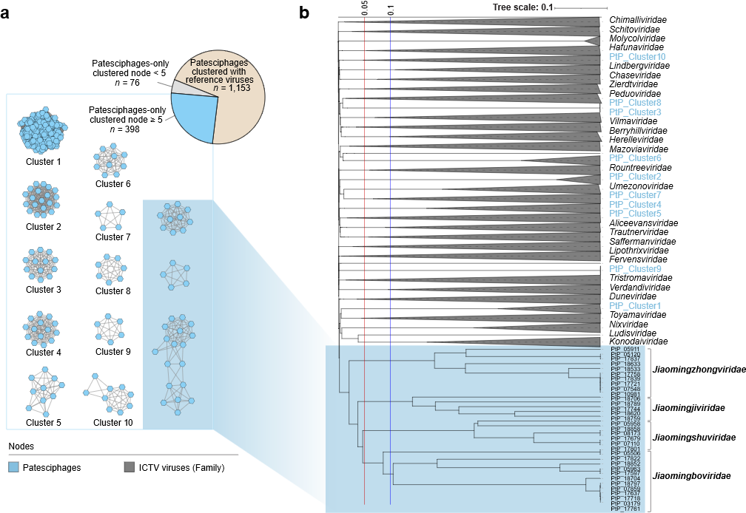
Figure 1. Patesciphages represent a vast unknown viral diversity.
a, The upper-right pie chart summarizes the non-singleton categories in the orthologous fraction (OF)-based clustering analysis of genomes with 100% CheckV-estimated completeness that were either classified as Caudoviricetes without order-level assignments or lacked viral taxonomic assignments. It includes 1,153 Patesciphages sharing an OF greater than 10% with at least one bacterial or archaeal virus from the ICTV database (v40; yellow), 76 Patesciphages lacking such ICTV matches and belonging to Patesciphage-only clusters containing fewer than five nodes (grey), and 398 Patesciphages lacking such ICTV matches and belonging to Patesciphage-only clusters containing at least five nodes (blue). The 10 generic blue-category clusters are shown in the lower panel; the four candidate Jiaomingvirales family-level groups are addressed in panel b. Connections are drawn if two genomes share an OF greater than 10% (calculated based on quality-controlled predicted proteins). b, Predicted proteome-based phylogenetic tree. This tree shows the phylogenetic relationships between representative Patesciphages (n = 232) from the candidate families in panel d and all bacterial and archaeal viruses from the ICTV database (v40). Patesciphage branches are highlighted in blue. Reference virus branches unrelated to these Patesciphages were removed; the remaining reference branches are collapsed at the family (gray) level. The red and blue vertical lines indicate branch-length thresholds of 0.05 and 0.1, respectively, and are provided to facilitate virus classification.
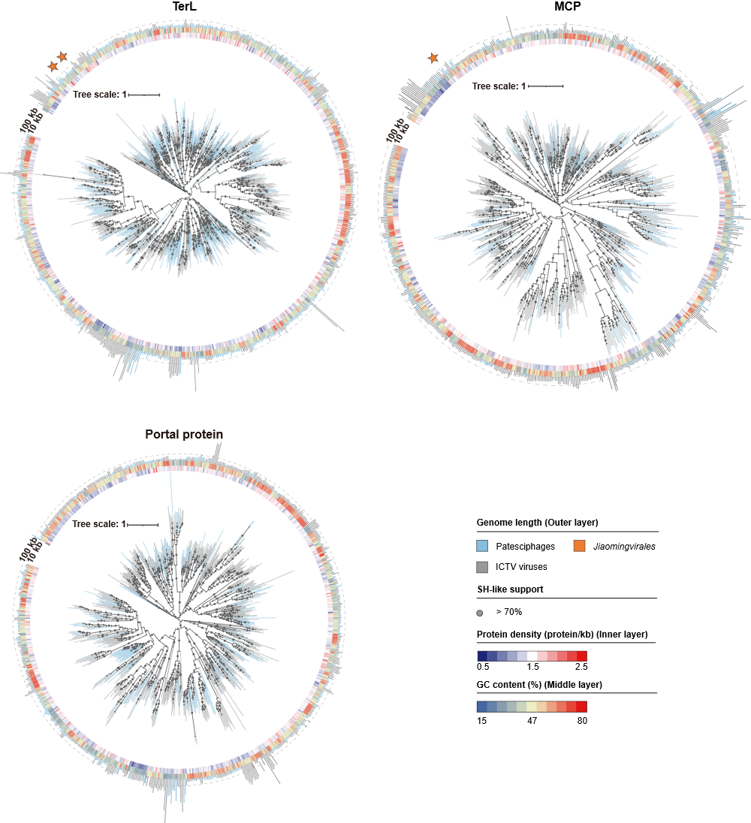

Figure 2. Phylogenetic analysis of marker proteins for Patesciphages and their proposed new order, Jiaomingvirales. Three separate maximum-likelihood marker-protein trees were constructed based on the large terminase subunit (TerL), major capsid protein (MCP), and portal protein, respectively. Reference viruses include all viruses from the ICTV database (v40). Leaf and outermost ring colors distinguish different taxa: gray for reference viruses, blue for Patesciphages, and orange for the proposed Jiaomingvirales; stars mark representative Jiaomingvirales sequences where present. Gray dots at branch nodes indicate SH-like support ≥70%. The rings from inside out show: protein density heatmap, GC content heatmap, and genome length bar plot. The dashed lines in the genome length bar plot indicate 10 kb and 100 kb positions.

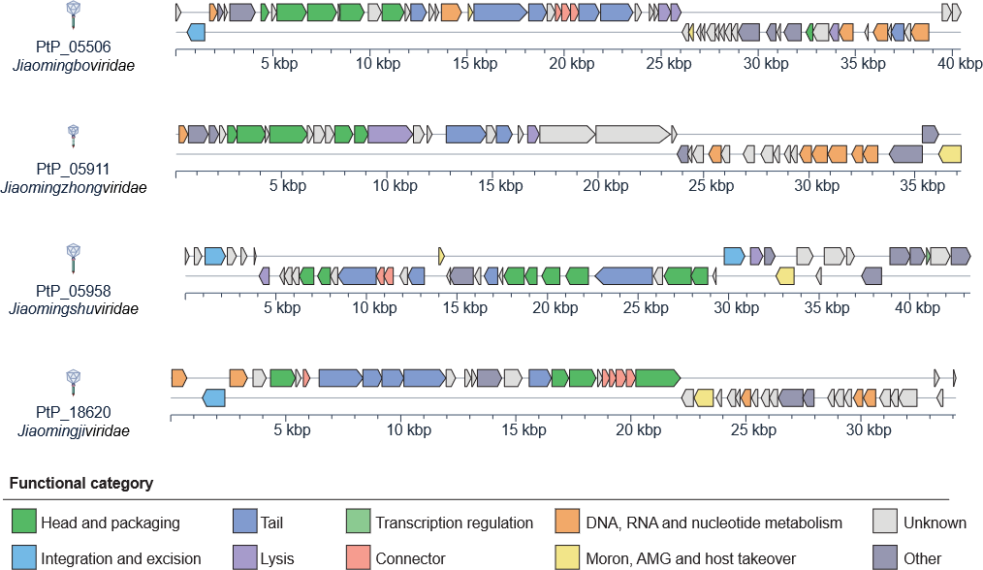

Figure 3. Genomic maps of representative viruses from the proposed order Jiaomingvirales. Genomes of representative viruses from four candidate novel families within the proposed order Jiaomingvirales are shown. The arrows depict the location and direction of predicted proteins on the phage genomes, and the fill colors indicate different functional categories of genes, as indicated in the legend. Virion schematics are drawn with head sizes proportional to their genome sizes and tail lengths based on the length of their tail length tape measure protein genes.
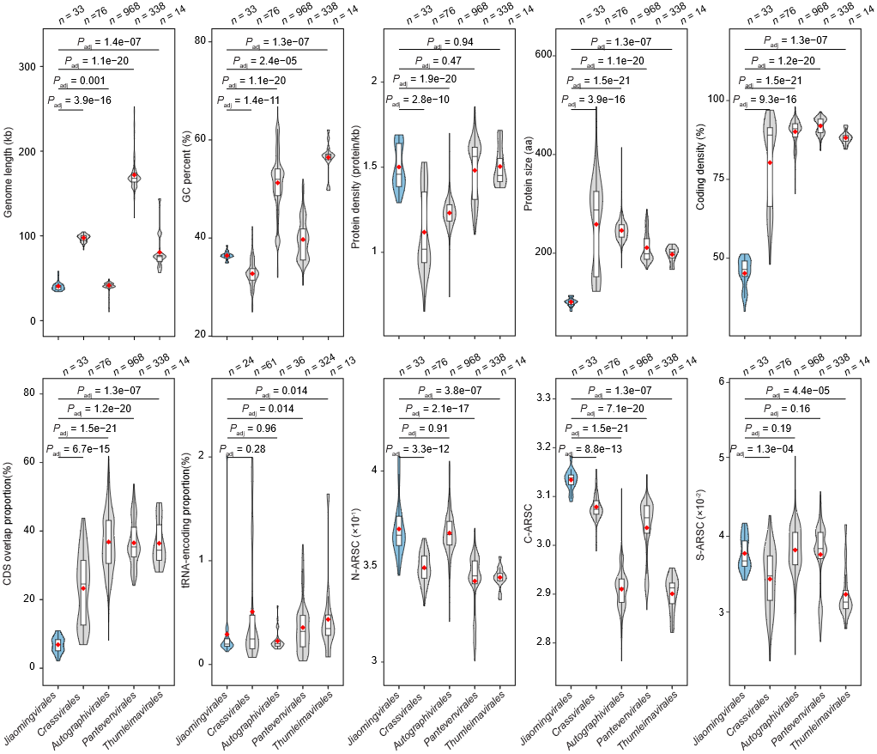
Figure 4. Comparative genomics reveals the distinctive miniaturized architecture of Jiaomingvirales. Violin plots compare genome-level distributions between the proposed order Jiaomingvirales and the four established orders within Caudoviricetes—Autographivirales, Crassvirales, Pantevenvirales, and Thumleimavirales—across genome length, GC content, protein density, mean protein length, coding density, the proportion of overlapping ORFs/CDSs, tRNA-encoding proportion, and average numbers of nitrogen, carbon and sulfur atoms in amino acid residue side chains (N-ARSC, C-ARSC and S-ARSC, respectively), each plotted value represents an individual genome/contig, and sample sizes indicate the number of non-missing genome-level observations for each metric and group. Group differences were assessed using two-sided Wilcoxon rank-sum tests comparing Jiaomingvirales with each reference order, with Benjamini–Hochberg correction applied across all 40 tests (10 metrics × 4 reference orders). Red diamonds indicate means; boxes show medians and interquartile ranges (IQRs), and whiskers extend to 1.5 × IQR.

