

The International Committee on Taxonomy of Viruses
Taxonomy Proposal Form, 2026

Part 1a: Details of taxonomy proposals

Title: | Create one new family (Symbioviridae), one new genus, and one new species in the class Caudoviricetes
Code assigned: | 2026.077B

Author(s), affiliation and email address(es):
Given name (+middle initial(s)) | Surname | Affiliation | Email address | Corr. author(s)
Sarah | Bordenstein | Departments of Biology & Entomology, The Pennsylvania State University, University Park, PA, USA | srb6253@psu.edu | X
Seth | Bordenstein | Departments of Biology & Entomology, The Pennsylvania State University, University Park, PA, USA | s.bordenstein@psu.edu | X
Part 1b: Taxonomy Proposal Submission
ICTV Subcommittee:
Animal DNA Viruses and Retroviruses |  | Bacterial viruses | X
Animal minus-strand and dsRNA viruses |  | Fungal and protist viruses
Animal positive-strand RNA viruses |  | Plant viruses
Archaeal viruses |  | General -

List the ICTV Study Group(s) that have seen or have been involved in creating this proposal:
Optional – complete only if formally voted on by an ICTV Study Group:
Study Group | Number of members
Study Group | Votes in support | Votes against | No vote

Submission date: | 14/09/2026

Part 1c: Feedback from ICTV Executive Committee (EC) meeting
Executive Committee Meeting Decision code: | X
A – Accept
Ac – Accept subject to revision by relevant subcommittee chair. No further vote required
U – Accept without revision but with re-evaluation and email vote by the EC
Uc – Accept subject to revision and re-evaluation and email vote by the EC
Ud – Deferred to the next EC meeting, with an invitation to revise based on EC comments
J - Reject
W - Withdrawn

Comments from the Executive Committee:

Part 1d: Revised Taxonomy Proposal Submission
Response of proposer:
N/A

Revision date: | N/A

Part 3: TAXONOMIC PROPOSAL
https://ictv.global/taxonomy/templates

Taxonomic changes proposed:
Establish new taxon | X | Split taxon
Abolish taxon |  | Merge taxon
Move taxon |  | Promote taxon
Rename taxon |  | Demote taxon
Move and rename

Etymology (origin) of proposed taxonomic names:
Taxon name | Etymology of the term
Symbioviridae | Derived from the Ancient Green word, symbiosis. References the endosymbiotic lifestyle of their bacterial hosts.
Wovirus | Highlights the first described bacterial host of these taxa, Wolbachia; ensures consistency with the standing body of literature that collectively refers to Wolbachia phages as phage WO.
Wovirus wovita1 | References the published common name (WOVitA1); indicates a Wovirus from wVitA, a Wolbachia endosymbiont of Nasonia vitripennis.

Permission for use of names derived from a living person:
Taxon name | Full name of person from whom the name is derived | Attached
Abstract of Taxonomy Proposal:
Description of current taxonomy:
Within Caudoviricetes, the only ratified taxon for a phage of a heritable intracellular symbiont, to our knowledge, is the genus Sendosyvirus, itself unassigned to a family. Unrelated, virus-like particles were observed in association with Wolbachia by electron microscopy in 1978, and phage WO, named in 2000, has been cited extensively since, yet these genomes remain unassigned in the ICTV taxonomy.

Proposed taxonomic change(s):
Create one new family, "Symbioviridae", in the class Caudoviricetes (realm Duplodnaviria, kingdom Heunggongvirae, phylum Uroviricota). The family comprises two new monophyletically-related genera: "Wovirus", for phages of the arthropod endosymbiont Wolbachia, and "Undavirus", for phages of Holospora, an endosymbiont of Paramecium, together with related viruses assembled from aquatic metagenomes. One new representative species is created in "Wovirus"; others will be forthcoming in the next submission cycle as TPA records are processed.

Demarcation criteria for new taxon/taxa:
We propose a 95% sequence identity threshold for new species, keeping consistency with other prokaryotic virus classification criteria.

Justification:
Phage WO has been studied for nearly five decades without a formal taxonomy, leaving a substantial literature without stable nomenclature. Members of "Wovirus" encode cytoplasmic incompatibility factors underlying Wolbachia-based vector control and carry a Eukaryotic Association Module (EAM), a syntenic block of eukaryotic-homology genes consistent with a life cycle traversing host cells; this module distinguishes "Wovirus" from "Undavirus". Both genera share Caudoviricetes hallmark genes but little other similarity with classified viruses.

- Text of Taxonomy proposal:

Description of current taxonomy:
Wolbachia is a genus of obligate intracellular bacteria found in approximately half of all arthropod species worldwide. Every sequenced Wolbachia genome from an arthropod host contains either intact prophage genomes or remnants of former phage infections. These dsDNA phages, collectively termed phage WO, were first identified in 1978 [1] and later purified in 2004 [2]. In 2016, the first complete genome sequences from purified phage particles revealed the packaging of a Eukaryotic Association Module (EAM) rich in ankyrin repeats and encoding highly polymorphic peptides that are often eukaryotic-like in length, origin, and/or function [3]. Prophages carrying orthologous WO genes have since been identified in other symbionts, including Holospora [4], Candidatus Paracaedibacteraceae, and multiple metagenomic assemblies from aquatic environments (Figure 1).
Despite nearly five decades of study and an extensive body of literature, no ICTV taxon has been established for these viruses at any rank. Records in sequence databases assigning phage WO genomes to the class Caudoviricetes reflect tailed virion morphology and hallmark gene content rather than any ratified classification.
No existing taxon accommodates these viruses. Within Caudoviricetes, the genus Sendosyvirus was created in 2020 for APSE of Hamiltonella defensa, a heritable symbiont of aphids; following abolishment of the morphology-based families, it remains unassigned to a family. Taxa for phages of other obligate intracellular bacteria lie outside Duplodnaviria: for example, Chlamydiaunovirus and Chlamydiaduovirus each comprise two species of small ssDNA viruses in the family Betagokushoviridae (realm Volvereviria), sharing neither virion architecture nor replication strategy with the viruses proposed here. Proteomic tree analysis of 1,387 sequences [5] places the closest classified outgroup as temperate Acidithiobacillus phage AcaML1 [6], a virus of a free-living, extremely acidophilic sulfur oxidizer, underscoring the absence of any established taxon encompassing phages of endosymbiotic bacteria (Figure 2).
A taxonomic framework for these viruses was proposed by us in the primary literature on the basis of comparative genomic and proteomic analyses, proposing a family “Symbioviridae” containing the proposed genera “Wovirus” and “Undavirus” [7]. That framework has been adopted in subsequent work, but it has never been submitted to the ICTV. The present proposal formalizes it.
Proposed taxonomic change(s):
We propose the creation of one new family, "Symbioviridae", within the class Caudoviricetes (realm Duplodnaviria, kingdom Heunggongvirae, phylum Uroviricota), unassigned to an order (Figure 3). The family comprises two new genera, "Wovirus" and "Undavirus", and one representative species (Table 1) with more forthcoming in the next submission cycle. Species assignment and accession number are listed in the accompanying Excel module.

We propose the family name "Symbioviridae" because all described taxa to date are isolated from symbiotic bacteria. Prophages from fully sequenced genomes infect endosymbionts: the obligate intracellular endosymbiont Wolbachia (host: arthropods), the endosymbiont Candidatus Paracaedibacteraceae (host: protists, including Acanthamoeba), and the endonuclear symbiont Holospora (host: Paramecium). The name reflects more than host origin. Members of the Wolbachia-associated phages package a Eukaryotic Association Module (EAM) [3], a genomic feature consistent with a lifecycle situated at the interface between bacterial and eukaryotic cells. Among the genes in the Eukaryotic Association Module are cifA, cifB, and wmk, which underlie Wolbachia's manipulation of arthropod reproduction [7, 8]. These viruses are thus not merely residents in symbioses but participants in them, contributing genes that shape the relationship between their bacterial hosts and the eukaryotes those bacteria inhabit. Should future studies identify related phages from free-living bacteria, the family name remains applicable, recognizing the discovery and first characterization of these viruses in symbionts.

We propose the genus name "Wovirus" to reflect the first described bacterial host of these taxa, Wolbachia [8]. The genus is not restricted to phages of this host; a similar virus infects Candidatus Mesenet longicola [9], though that genome is incomplete due to assembly gaps and is not included here. Most importantly, the name ensures consistency with the standing body of literature that collectively refers to Wolbachia phages as phage WO.

We propose the genus name "Undavirus" (unda, Latin for water in motion, or wave) to recognize the aquatic environment of the first sequenced prophages of this genus. Members are identified in Holospora [4], endonuclear symbionts of Paramecium (HOUnd1); Candidatus Paracaedibacteraceae, an endosymbiont of Acanthamoeba (PRO19, from activated sludge of wastewater treatment plants); and metagenomic assemblies from unidentified hosts (e.g., MCMEDG24, from marine aquaculture).

Species epithet derives from the naming convention established in the Wolbachia literature, which encodes the identity of the bacterial host and, through it, the eukaryotic host — acknowledging the fundamental tripartite association of these viruses with their hosts (dsDNA phage » bacterial host » eukaryotic host). Wolbachia strains are designated in the literature by a lowercase italicized w followed by an abbreviation referencing the host species, strain, and/or collection location. Their phages take an uppercase WO prefix with the same abbreviation, plus a number or letter denoting variants within a strain. Thus wVitA, the Wolbachia endosymbiont of Nasonia vitripennis, carries prophages WOVitA1, WOVitA2, and WOVitA4.

Species names are the Latinized form of these historical common names, ensuring continuity with the existing literature. Following ICTV guidelines for binomial nomenclature, epithets are rendered in lowercase italics. The prophage commonly named WOVitA1 becomes “Wovirus wovita1”. The epithet remains parseable: wovita1 resolves to WO (phage) + VitA (Wolbachia strain wVitA of N. vitripennis) + 1 (first prophage variant).

We recommend that future proposals within "Symbioviridae" follow this convention, and that species names be referenced in the corresponding literature, particularly where they deviate from the proposed etymology.

Demarcation criteria for new taxon/taxa:
Family. Viruses of the proposed family "Symbioviridae" infect symbiotic bacteria. To date, these bacteria are all endosymbionts ranging from protozoan to arthropod hosts. Most are classified from prophage sequences integrated in the bacterial chromosome, a consequence of host bacteria that cannot be cultured in cell-free media and/or genetically modified. Members share a conserved structural architecture: orthologous genes form monophyletic clades in the replication, head, connector/baseplate, tail fiber, and contractile tail modules, and gene synteny is conserved across the four structural modules (Figure 1B). This shared architecture is reflected at the whole-proteome level, where members form a single monophyletic group in ViPTree [5] against 1,387 related dsDNA prokaryotic virus sequences (Figure 2).

Family Criterion: Members of "Symbioviridae" form a monophyletic group in the proteome-based clustering tool ViPTree [5].

Genus. The two proposed genera are distinguished by the presence ("Wovirus") or absence ("Undavirus") of the Eukaryotic Association Module (EAM), ankyrin repeat–containing proteins, and module WO-PC2 containing HTH_XRE transcriptional regulators (Figure 1A). Both genera encode a putative lytic cassette with orthologous holin-like genes, but “woviruses” encode a patatin-like phospholipase whereas “undaviruses” encode a glycoside hydrolase family 108 (GH108)-like lysozyme (Figure 4). These presence/absence differences reflect substantive differences in the biology of each genus, particularly their association with bacterial and possibly eukaryotic hosts.

Each “Wovirus” encodes a unique EAM accounting for up to 60% of the genome [3]. EAM regions are hotspots of insertion and deletion and rearrange rapidly through intra- and intergenic recombination, generating sequence characters that are not phylogenetically informative. Applying a nucleotide threshold to complete genomes would therefore assign nearly every variant to its own genus. Therefore, we accordingly define the "core prophage" genome as the unit of measurement: all conserved modules (recombinase, replication and repair, head, connector/baseplate, tail fiber, tail, lysis) together with all genes located between the recombinase and the patatin, excluding the EAM (blue shading, Figures 1 and 4). A 1:1 BLASTN analysis [10] of representative “Wovirus” and “Undavirus” genomes shows a distinct nucleotide demarcation at the genus level (Table 2). Where individual "Wovirus":"Undavirus" comparisons exceed 70% identity, alignment coverage falls below 50% of the core prophage genome, so the coverage term forms part of the criterion.

Genus assignment is further supported by phylogenies of the proposed "Symbioviridae" typing genes, minor capsid orf7 [8] and DUF4815-containing putative tail fiber gp17 [11]. Trees rooted with Acidithiobacillus phage AcaML1 [14] resolve two distinct clades corresponding to the proposed genera (Figure 5).

Genus Criterion: Members of a genus (i) share >70% nucleotide identity at >50% coverage across the "core prophage" genome as defined above, rather than across the complete genome, and (ii) form a distinct phylogenetic clade based on the amino acid sequence of minor capsid orf7 and/or DUF4815-containing putative tail fiber gp17.

Species. Species demarcation follows a Bacterial Viruses Subcommittee guideline, under which two phages belong to the same species if their genomes are more than 95% identical over their genome length [12]. Values are calculated using BLASTN [10] and the intergenomic distance calculator VIRIDIC [13]. “Wovirus wovitA1” represents a unique species (Figure 6) with additional taxa to be proposed in the next submission cycle.

Species Criterion: Members of a species share >95% nucleotide identity across the genome length.

Justification:
Prophage-derived exemplars. The bacterial hosts of these viruses cannot be cultured in cell-free media and, to date, cannot be genetically modified. Classification from prophage sequences integrated in the bacterial chromosome is therefore not a matter of convenience but the only route available; the alternative is that these viruses remain permanently outside virus taxonomy. Prophage boundaries are not merely inferred: the complete WOVitA1 genome has been sequenced from purified phage particles [3] and is flanked by portions of a disrupted VNTR-105 repeat when integrated in the Wolbachia chromosome [14], allowing att sites to be identified and boundaries assigned in related prophages on the same basis. Likewise, the complete WOCauB3 is flanked by a disrupted magnesium chelatase gene [3].

The core prophage genome as the unit of measurement. All proposed "Wovirus" genomes carry a Eukaryotic Association Module (EAM) accounting for up to 60% of the genome [3]. The EAM comprises genes that are eukaryotic-like in length, origin, and/or function, containing hypervariable peptides with diverse domain arrangements formed by rampant recombination and frequently associated with transposases. It is unclear whether these genes originated prior to integration or travel with the phage as a result of headful packaging.

Prophage WOHa2 illustrates what follows from including this region. Two of its 56 genes, encoding a eukaryotic secA homolog [15] within the EAM, account for 22% of its genome (Figure 4). Measured across the complete genome, WOHa2 (“Wovirus woha2”) is a novel genus; measured across the “core prophage” genome, however, it shares 85% identity with “Wovirus wovita1” and belongs to the same genus (Table 2). Phylogenetic analyses of structural genes support the latter placement (Figure 5). The future “Wovirus woha2” classification thus depends entirely on whether two accessory genes are counted.

Three considerations support excluding the EAM in nucleotide identity-based criterion:
- The core prophage genome shares >70% identity across Wolbachia's prophages, consistent with the Bacterial Viruses Subcommittee former genus demarcation criterion [12]. The departure is in what is measured, not in the threshold applied.
- Including the EAM would produce overwhelming numbers of genera containing a single species each. EAM regions are hotspots of insertion and deletion that rearrange rapidly through intra- and intergenic recombination, generating characters that are not phylogenetically informative. As Wolbachia infects approximately half of all arthropod species and each strain carries at least one “Wovirus”-associated region, an EAM-inclusive criterion could yield thousands to millions of monotypic genera. This would not reflect the relatedness of these phages.
- A separate genus for each variant would misalign “Wovirus” from standard phage taxonomy and deter the scientific community from adopting the classification.

Nomenclatural stability and community adoption. These viruses have been referred to as phage WO since 2000, across an extensive body of literature. Adopting "Wovirus" integrates the formal name with existing usage, ensuring ready recognition and uptake. A taxonomy that fragmented the group into per-variant genera, or that renamed it independently of established usage, would be unlikely to be used by the field it serves.

Biological and applied significance. Prophage WO genes underlie Wolbachia's manipulation of arthropod reproduction: cifA and cifB are the cytoplasmic incompatibility factors, and wmk is implicated in male killing [16, 17]. Cytoplasmic incompatibility is the mechanism exploited in Wolbachia-based control of arboviral disease vectors. A stable taxonomy for these viruses therefore serves an applied literature as well as a descriptive one.

Family coherence. "Wovirus" and "Undavirus" differ substantially in gene content, most conspicuously in the presence or absence of the EAM, and their bacterial hosts span arthropod endosymbionts, protist endosymbionts, and unidentified bacteria from aquatic metagenomes. Family assignment nonetheless rests on positive evidence: orthologous genes forming monophyletic clades across the replication, head, connector/baseplate, tail fiber, and contractile tail modules; conserved synteny across the four major structural modules (Figure 1); and monophyly in proteomic tree analysis against 1,387 related sequences, with the nearest classified relative a phage of a free-living acidophile (Figures 2) [5, 6]. Notably, the genera remain monophyletic whether complete or core prophage genomes are analyzed (Figure 2B), indicating that the grouping is not an artifact of EAM content.

Approach. Where judgment was required, we have favored simple, useful classifications over maximal splitting. The proposed taxonomy is intended to be usable by the research community that generates these sequences, and to accommodate the substantial number of additional Symbioviridae genomes expected as endosymbiont genome sequencing continues.

References:
1. Wright JD, Sjostrand FS, Portaro JK, Barr AR. The ultrastructure of the rickettsia-like microorganism Wolbachia pipientis and associated virus-like bodies in the mosquito Culex pipiens. J Ultrastruct Res. 1978;63(1):79-85. doi: 10.1016/s0022-5320(78)80046-x. PubMed PMID: 671578.
2. Fujii Y, Kubo T, Ishikawa H, Sasaki T. Isolation and characterization of the bacteriophage WO from Wolbachia, an arthropod endosymbiont. Biochem Biophys Res Commun. 2004;317(4):1183-8. doi: 10.1016/j.bbrc.2004.03.164. PubMed PMID: 15094394.
3. Bordenstein SR, Bordenstein SR. Eukaryotic association module in phage WO genomes from Wolbachia. Nat Commun. 2016;7:13155. Epub 20161011. doi: 10.1038/ncomms13155. PubMed PMID: 27727237; PubMed Central PMCID: PMCPMC5062602.
4. Dohra H, Tanaka K, Suzuki T, Fujishima M, Suzuki H. Draft genome sequences of three Holospora species (Holospora obtusa, Holospora undulata, and Holospora elegans), endonuclear symbiotic bacteria of the ciliate Paramecium caudatum. FEMS Microbiol Lett. 2014;359(1):16-8. doi: 10.1111/1574-6968.12577. PubMed PMID: 25115770.
5. Nishimura Y, Yoshida T, Kuronishi M, Uehara H, Ogata H, Goto S. ViPTree: the viral proteomic tree server. Bioinformatics. 2017;33(15):2379-80. doi: 10.1093/bioinformatics/btx157. PubMed PMID: 28379287.
6. Tapia P, Flores FM, Covarrubias PC, Acuna LG, Holmes DS, Quatrini R. Complete genome sequence of temperate bacteriophage AcaML1 from the extreme acidophile Acidithiobacillus caldus ATCC 51756. J Virol. 2012;86(22):12452-3. doi: 10.1128/JVI.02261-12. PubMed PMID: 23087115; PubMed Central PMCID: PMCPMC3486464.
7. Bordenstein SR, Bordenstein SR. Widespread phages of endosymbionts: Phage WO genomics and the proposed taxonomic classification of Symbioviridae. PLoS Genet. 2022;18(6):e1010227. Epub 20220606. doi: 10.1371/journal.pgen.1010227. PubMed PMID: 35666732; PubMed Central PMCID: PMCPMC9203015.
8. Masui S, Kamoda S, Sasaki T, Ishikawa H. Distribution and evolution of bacteriophage WO in Wolbachia, the endosymbiont causing sexual alterations in arthropods. J Mol Evol. 2000;51(5):491-7. doi: 10.1007/s002390010112. PubMed PMID: 11080372.
9. Takano SI, Gotoh Y, Hayashi T. "Candidatus Mesenet longicola": Novel Endosymbionts of Brontispa longissima that Induce Cytoplasmic Incompatibility. Microb Ecol. 2021;82(2):512-22. Epub 20210116. doi: 10.1007/s00248-021-01686-y. PubMed PMID: 33454808.
10. Johnson M, Zaretskaya I, Raytselis Y, Merezhuk Y, McGinnis S, Madden TL. NCBI BLAST: a better web interface. Nucleic Acids Res. 2008;36(Web Server issue):W5-9. Epub 20080424. doi: 10.1093/nar/gkn201. PubMed PMID: 18440982; PubMed Central PMCID: PMCPMC2447716.
11. Chafee ME, Zecher CN, Gourley ML, Schmidt VT, Chen JH, Bordenstein SR, et al. Decoupling of host-symbiont-phage coadaptations following transfer between insect species. Genetics. 2011;187(1):203-15. Epub 20101013. doi: 10.1534/genetics.110.120675. PubMed PMID: 20944019; PubMed Central PMCID: PMCPMC3018312.
12. Turner D, Kropinski AM, Adriaenssens EM. A Roadmap for Genome-Based Phage Taxonomy. Viruses. 2021;13(3). Epub 20210318. doi: 10.3390/v13030506. PubMed PMID: 33803862; PubMed Central PMCID: PMCPMC8003253.
13. Moraru C, Varsani A, Kropinski AM. VIRIDIC-A Novel Tool to Calculate the Intergenomic Similarities of Prokaryote-Infecting Viruses. Viruses. 2020;12(11). Epub 20201106. doi: 10.3390/v12111268. PubMed PMID: 33172115; PubMed Central PMCID: PMCPMC7694805.
14. Riegler M, Iturbe-Ormaetxe I, Woolfit M, Miller WJ, O'Neill SL. Tandem repeat markers as novel diagnostic tools for high resolution fingerprinting of Wolbachia. BMC Microbiol. 2012;12 Suppl 1(Suppl 1):S12. Epub 20120118. doi: 10.1186/1471-2180-12-S1-S12. PubMed PMID: 22375862; PubMed Central PMCID: PMCPMC3287509.
15. Duplouy A, Iturbe-Ormaetxe I, Beatson SA, Szubert JM, Brownlie JC, McMeniman CJ, et al. Draft genome sequence of the male-killing Wolbachia strain wBol1 reveals recent horizontal gene transfers from diverse sources. BMC Genomics. 2013;14:20. Epub 20130116. doi: 10.1186/1471-2164-14-20. PubMed PMID: 23324387; PubMed Central PMCID: PMCPMC3639933.
16. LePage DP, Metcalf JA, Bordenstein SR, On J, Perlmutter JI, Shropshire JD, et al. Prophage WO genes recapitulate and enhance Wolbachia-induced cytoplasmic incompatibility. Nature. 2017;543(7644):243-7. Epub 20170227. doi: 10.1038/nature21391. PubMed PMID: 28241146; PubMed Central PMCID: PMCPMC5358093.
17. Perlmutter JI, Bordenstein SR, Unckless RL, LePage DP, Metcalf JA, Hill T, et al. The phage gene wmk is a candidate for male killing by a bacterial endosymbiont. PLoS Pathog. 2019;15(9):e1007936. Epub 20190910. doi: 10.1371/journal.ppat.1007936. PubMed PMID: 31504075; PubMed Central PMCID: PMCPMC6736233.

Accompanying files:
Filename | Description of contents

Tables, Figures:

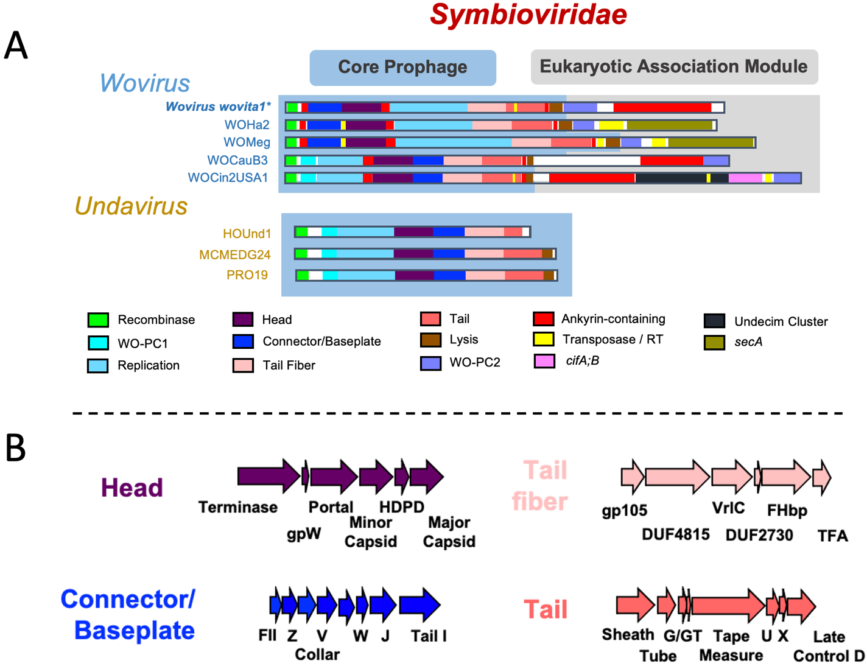

Figure 1. The “Symbioviridae” Genome. (A) Comparative genome maps of the proposed “Symbioviridae” species “Wovirus wovita1” (indicated by *) and closely related variants illustrate similarity across the core prophage genomes (region highlighted in blue), yet striking variation in the presence/absence and content of the Eukaryotic Association Module (EAM, region highlighted in gray). EAM regions are enriched with genes of eukaryotic-like length, origin, and/or function; transposases (yellow); ankyrin-repeat containing genes (red); and HTH_XRE transcriptional regulators (part of the WO-PC2 module in lavender). (B) Gene synteny is conserved within the structural modules of the “Symbioviridae” core genome.

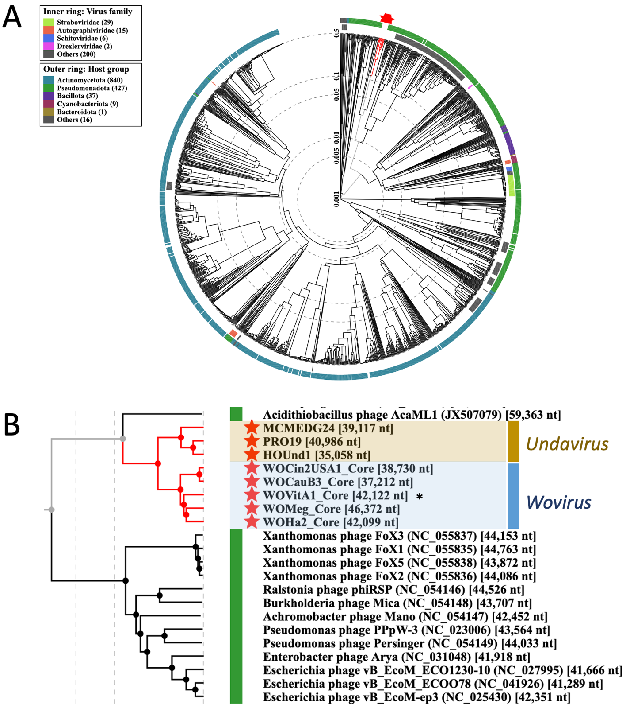

Figure 2. A viral proteomic tree shows that (A) the proposed family “Symbioviridae” (red star taxa) forms a monophyletic clade within the dsDNA viruses of prokaryotes. (B) To eliminate any potential bias from the EAM, the core prophage genomes were also analyzed and form monophyletic clades according to proposed genera. The trees were built with ViPTree [5] using “Wovirus wovita1” representative species (common name WOVitA1, indicated by *), closely related variants, and 1,387 related genomes.

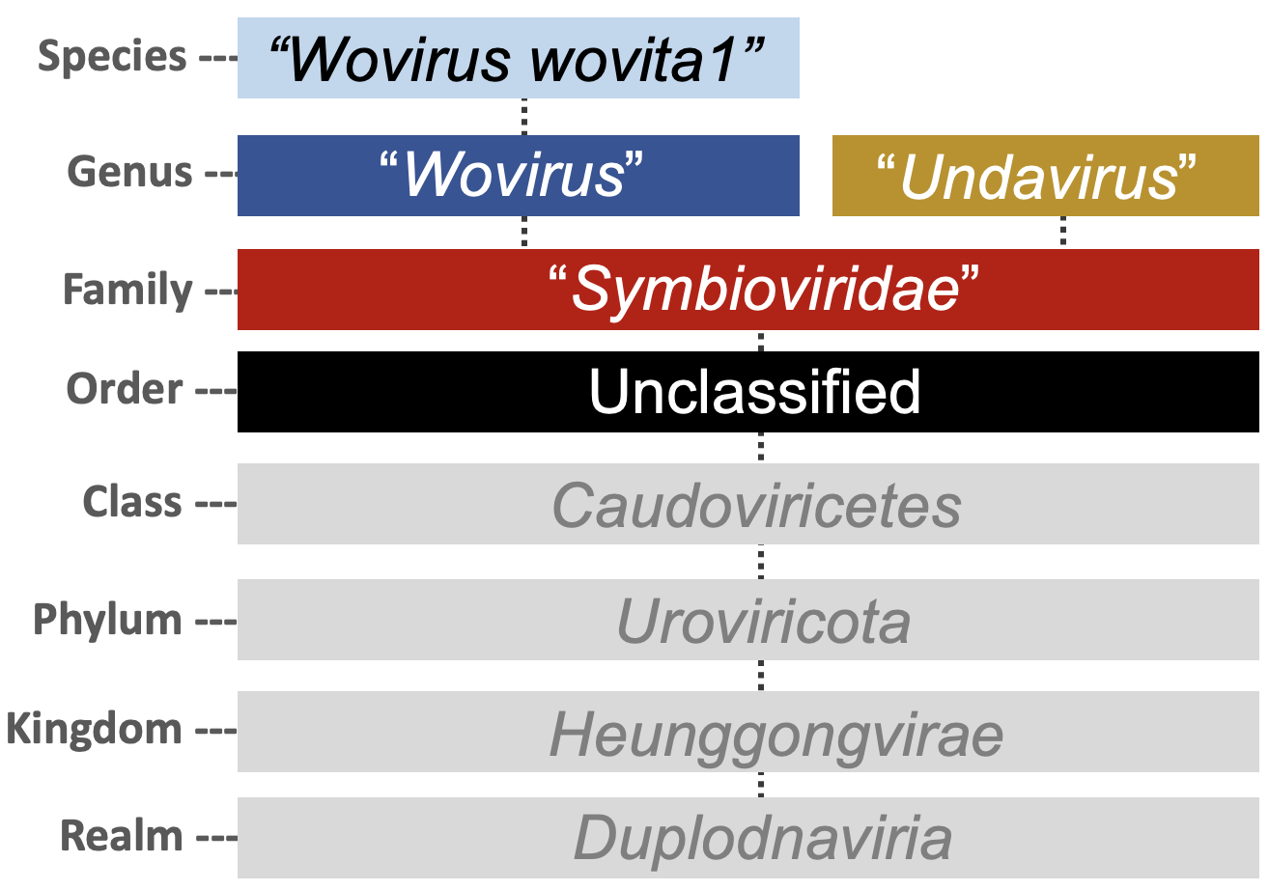

Figure 3. Proposed naming convention for the “Symbioviridae”.

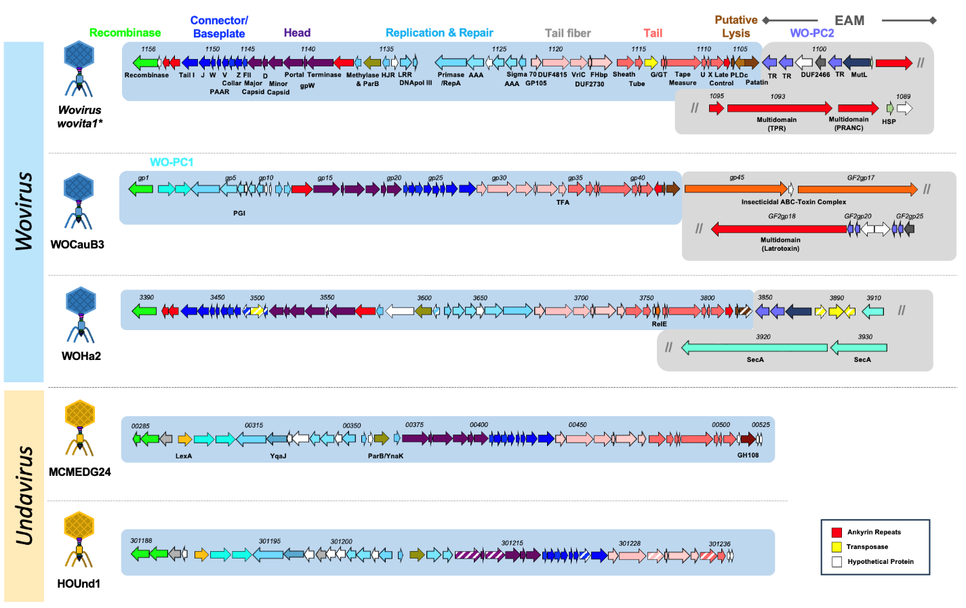

Figure 4. Conserved genomic architecture across the proposed family "Symbioviridae", as detailed in the prophage genome maps of the related variants: proposed representative species "Wovirus wovita1”, WOCauB3, WOHa2, MCMEDG24, and HOUnd1. Genes are colored by functional module: recombinase (green), WO Protein Cluster 1 (WO-PC1; cyan), replication and repair (light blue), head (purple), connector/baseplate (royal blue), tail fiber (light pink), contractile tail (dark pink), and putative lysis (brown). Blue shading denotes the "core prophage" genome; gray shading denotes the Eukaryotic Association Module (EAM). Synteny is conserved across the four structural modules (head, connector/baseplate, tail fiber, and contractile tail). The two genera are distinguished by the presence ("Wovirus") or absence ("Undavirus") of the EAM, ankyrin repeat–containing genes (red), and WO Protein Cluster 2 (WO-PC2; lavender), and by their putative lytic cassettes: woviruses encode a patatin-like phospholipase, whereas undaviruses encode a glycoside hydrolase family 108 (GH108)-like lysozyme. EAM gene content is variable between woviruses. Double slashes (//) indicate that the genome map continues on the following line.

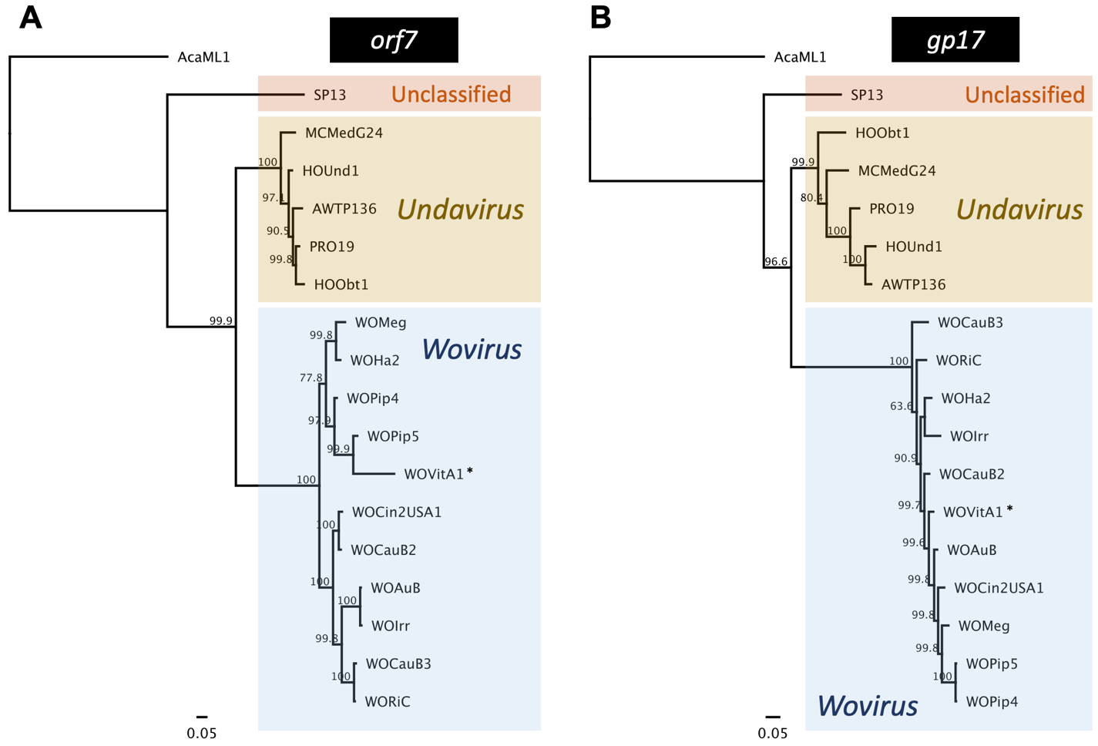

Figure 5. Phylogenetic trees of (A) minor capsid orf7 and (B) DUF4815-containing putative tail fiber gp17 illustrate the utility of these genes as “Symbioviridae”-typing tools. Using AcaML1 as an outgroup, two distinct clades represent proposed genera “Undavirus” and “Wovirus”. The trees were generated by Bayesian analysis of (A) 325 amino acids and (B) 571 amino acids using the LG-G model of evolution. Consensus support values are indicated for each branch. The representative “Wovirus wovita1” species (common name WOVitA1) is indicated by (*).

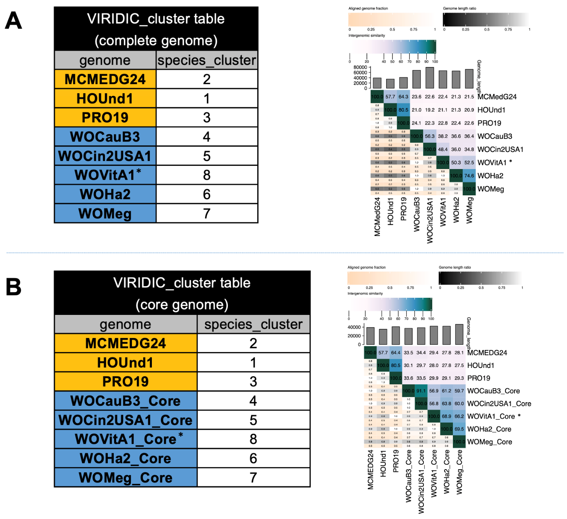

Figure 6. VIRIDIC analysis of the proposed family “Symbioviridae”. Cluster tables and heat maps of both the (A) complete prophage genomes and (B) core prophage genomes deliver the same species cluster results. Variants are color-coded according to proposed genus: “Undavirus” (gold) and “Wovirus” (blue). The representative “Wovirus wovita1” species (common name WOVitA1) is indicated by (*).

Species | Host Genome Accession | Locus  Start | Locus  Stop | Phage Genome Accession
Proposed “Wovirus” species
Wovirus wovita1* | HQ906662.1 | gwv_1156 | gwv_1089 | KX522565.1
Closely related variants referenced in the proposal
WOCauB3 | AB478516.1 | B3gp1 | GF2gp25 | TPA: SUB16472349
WOHa2 | CP003884.1 | wHa_03390 | wHa_03930 | TPA: SUB16472349
HOUnd1 | ARPM03000202.1 | K737_301188 | K737_301238 | TPA: SUB16472349
MCMEDG24 | JACESU010000001.1 | H2057_00290 | H2057_00525 | TPA: SUB16472349

Table 1. The newly proposed “Wovirus wovita1” species is listed with the NCBI accession number of the bacterial genome assembly, correlating locus tags of the integrated prophage region, and the NCBI accession number of the purified phage genome. Closely related variants are listed with submission numbers for reference Third Party (TPA) records; they will be submitted in the next submission cycle.

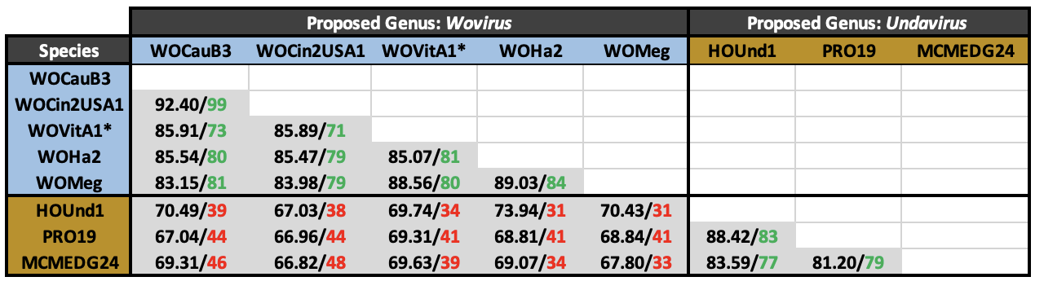

Table 2. BLASTN analysis of %identity / %coverage for each 1:1 “core prophage” comparison. Entire genomes were analyzed for “Undavirus”; recombinase thru patatin were analyzed for “Wovirus” (blue shading in Figures 1 and 4). Green highlights > 70% identity with > 50% coverage; red highlights < 50% coverage. There is a distinct nucleotide demarcation at the proposed genus level. The representative species “Wovirus wovita1” (common name WOVitA1) is indicated by (*).

