

The International Committee on Taxonomy of Viruses

Taxonomy Proposal Form, 2026

Title: | To create a new subfamily, “Anatoliavirinae”, and 9 new genera, in the class Caudoviricetes
Code assigned:

Author(s), affiliation and email address(es):
Given name (+middle initial(s)) | Surname | Affiliation | Email address | Corr. author(s)
Aylin | Üsküdar Güçlü | Baskent University, Faculty of Medicine, Department of Medical Microbiology, Ankara, Turkiye | uskudaraylin@gmail.com | X
Sezin | Ünlü Çelebi | Baskent University, Faculty of Medicine, Department of Medical Microbiology, Ankara, Turkiye | sezinnunlu@gmail.com | X

Part 1b: Taxonomy Proposal Submission
ICTV Subcommittee:
Animal DNA Viruses and Retroviruses |  | Bacterial viruses | X
Animal minus-strand and dsRNA viruses |  | Fungal and protist viruses
Animal positive-strand RNA viruses |  | Plant viruses
Archaeal viruses |  | General -

List the ICTV Study Group(s) that have seen or have been involved in creating this proposal:
Dann Turner

Optional – complete only if formally voted on by an ICTV Study Group:
Study Group | Number of members
Study Group | Votes in support | Votes against | No vote

Submission date: | 07/09/2026

Part 1c: Feedback from ICTV Executive Committee (EC) meeting
Executive Committee Meeting Decision code: | X
A – Accept
Ac – Accept subject to revision by relevant subcommittee chair. No further vote required
U – Accept without revision but with re-evaluation and email vote by the EC
Uc – Accept subject to revision and re-evaluation and email vote by the EC
Ud – Deferred to the next EC meeting, with an invitation to revise based on EC comments
J - Reject
W - Withdrawn

Comments from the Executive Committee:

Part 1d: Revised Taxonomy Proposal Submission
Response of proposer:
Revision date:

Part 3: TAXONOMIC PROPOSAL
https://ictv.global/taxonomy/templates

Taxonomic changes proposed:
Establish new taxon | X | Split taxon
Abolish taxon |  | Merge taxon
Move taxon |  | Promote taxon
Rename taxon |  | Demote taxon
Move and rename

Etymology (origin) of proposed taxonomic names:
Taxon name | Etymology of the term
“Anatoliavirinae” | From Anatolia, the historical and geographical region encompassing much of present-day Türkiye, where the representative phage was isolated
“Izmirvirus” | Named after Izmir, a city in Türkiye, where the water source from which Pseudomonas phage Baskent_P7 was isolated.
“Shipcatvirus” | Name derived from Pseudomonas phage PAShipCat1
“Marinvirus” | Name derived from Pseudomonas phage Marin
“Haboobvirus” | Name derived from Pseudomonas phage Haboob
“Daqingvirus” | Pseudomonas phage VB_EV13 was characterized at Heilongjiang Bayi Agricultural University, Daqing (People's Republic of China)
“Manzanaresvirus” | Named after the Manzanares River which flows through Madrid (Spain) where Pseudomonas phage vB_Pae_U9was characterized.
“Dokkaebivirus” | Named after the Dokkaebi (도깨비) which are mischievous, magical nature spirits from Korean folklore (Pseudomonas phages YMC/01/01/P52_PAE_BP & YMC11/07/P54_PAE_BP)
“Dorozhniivirus” | Named after Dorozhnii Projezd in Moscow where in the State Institute for Genetics and Selection of Industrial Microorganisms where Pseudomonas phage phi297 was isolated.
“Fynoctavirus” | Name derived from Pseudomonas phage Fyn8

Permission for use of names derived from a living person:
Taxon name | Full name of person from whom the name is derived | Attached

Abstract of Taxonomy Proposal:
Description of current taxonomy:
Phage PX677422.1 (Baskent_P7) and related Pseudomonas phages were identified through vConTACT3 analysis against INPHARED. The broader group includes viruses assigned to Hulijingvirus and Lishizhenvirus, as well as several unclassified genus-level lineages within Caudoviricetes.

Proposed taxonomic change(s): We propose the establishment of a new subfamily “Anatoliavirinae”, to encompass the broader monophyletic phylogenetic group comprising the existing genera Hulijingvirus, Haihevirus and Lishizhenvirus, together with the new genera: Fynoctavirus, Dorozhniivirus, Dokkaebivirus, Manzanaresvirus, Daqingvirus, Haboobvirus, Marinvirus, and Shipcatvirus. Within the proposed subfamily, we propose the establishment of the new genus Izmirvirus, with phage PX677422.1 as the exemplar, and the new species “Izmirvirus baskent_P7” for PX677422.1.

Demarcation criteria for new taxon/taxa: Species and genus demarcation are based on intergenomic nucleotide similarity, using 95% and 70% thresholds, respectively. Subfamily placement is supported by a coherent monophyletic phylogenomic group, congruent core-genome and major capsid protein (MCP) phylogenies, and conservation of a characteristic set of core proteins across the broader clade.

Justification:
The broader group forms a coherent monophyletic lineage in the six-core-protein phylogeny, with broadly congruent topology between the core-genome and MCP trees. Several well-defined genus-level groups are also evident, including the established Hulijingvirus group represented by ON778007.1 and PP740689.1, which share 73.5% intergenomic nucleotide similarity, the Lishizhenvirus lineage represented by MW748993.1 and Haihevirus. Other related genomes form distinct genus-level lineages, generally sharing less than 70% intergenomic nucleotide similarity with one another. This combination of phylogenomic coherence, conserved core proteins, MCP/core-tree congruence, and genus-level genomic divergence supports recognition of the broader clade as the proposed subfamily “Anatoliavirinae” which contains the genera we additionally defined in this proposal: “Fynoctavirus”, “Dorozhniivirus”, “Dokkaebivirus”, “Manzanaresvirus”, “Daqingvirus”, “Haboobvirus”, “Marinvirus”, and “Shipcatvirus”.

- Text of Taxonomy proposal:

Description of current taxonomy:
The proposed subfamily “Anatoliavirinae” is defined by a coherent monophyletic phylogenomic group containing the proposed genus “Izmirvirus“ together with multiple related genus-level lineages, including the established genera Hulijingvirus, Haihevirus, Lishizhenvirus and the proposed genera Fynoctavirus, Dorozhniivirus, Dokkaebivirus, Manzanaresvirus, Daqingvirus, Haboobvirus, Marinvirus, and Shipcatvirus.

Pseudomonas phage Baskent_P7 (GenBank accession PX677422.1) is currently unassigned to a genus or species within the class Caudoviricetes. Identified and analysed related Pseudomonas phages and their placement in taxonomy was given in Table 1.

Proposed taxonomic change(s):
We propose the establishment of a new subfamily “Anatoliavirinae” to encompass the broader monophyletic phylogenetic group containing Izmirvirus”, the existing genera: Hulijingvirus, Haihevirus, Lishizhenvirus, and the new genera “Fynoctavirus”, “Dorozhniivirus”, “Dokkaebivirus”, “Manzanaresvirus”, “Daqingvirus”, “Haboobvirus”, “Marinvirus”, and “Shipcatvirus”.

Demarcation criteria for new taxon/taxa:
Following the standard ICTV demarcation criteria for bacteriophages, a 95% nucleotide identity threshold is used to define species boundaries. The criteria for genus demarcation follow the ICTV-accepted threshold of 70% nucleotide sequence identity (1).

Justification:
We isolated a new bacteriophage that infects isolates of Pseudomonas aeruginosa; Baskent_P7. To identify bacteriophage genomes that exhibited similarity to Baskent_P7, vConTACT3 was used with the INPHARED (1 Jan 2026) database (2), identifying a total of 33 related phage genomes. The genomes were re-annotated with pharokka (3) and clustered with MMSeqs2 (4) using thresholds of 30% sequence minimum identity and 80% coverage. A total of six conserved core proteins (Table 1) were found to be shared across all genomes. Pairwise Jaccard similarity calculated from the proportion of shared protein clusters revealed distinct clusters of related genomes (Figure 1). The distribution of representative proteins from these clusters across the genomes was further examined using a protein cluster presence/absence analysis (Figure 2). The protein sequences were used to create a concatenated core genome phylogeny which was compared to the phylogeny of the major capsid protein using a tanglegram (Figure 3). This demonstrated that the two trees were highly congruent.

Further support was obtained using a hierarchically clustered TBLASTX distance tree which showed that the genomes described in this proposal formed a deep-branching clade (Figure 4).

To delineate genera and species, intergenomic nucleotide sequence similarities were calculated using VIRIDIC (Figure 5) (5). Within the 33 genomes assessed, a distinct clade exhibiting >29.6% similarity was identified between OR683404.1, proposed as “Haboobvirus”, and HQ711984.1, proposed as Dorozhniivirus. We suggest these phages represent a new subfamily for which we propose the name “Anatoliavirinae”. This subfamily also forms a clade in the phylogenetic analysis. Based upon the current demarcation criteria (1), assessment of intergenomic similarities revealed the presence of 9 new genera and 10 species. We propose the following names for these genera: Izmirvirus, Fynoctavirus, Dorozhniivirus, Dokkaebivirus, Manzanaresvirus, Daqingvirus, Haboobvirus, Marinvirus, and Shipcatvirus. The phages assigned to each of the proposed new genera and their corresponding genomic characteristics are summarized in Tables 2–10. The 9 proposed genera comprise 10 genomes in total: Dokkaebivirus includes two genomes, whereas each of the remaining nine proposed genera is represented by a single genome.

References:
- Turner D, Kropinski AM, Adriaenssens EM. A Roadmap for Genome-Based Phage Taxonomy. Viruses. 2021 Mar 18;13(3):506. doi: 10.3390/v13030506. PMID: 33803862; PMCID: PMC8003253.
- Bolduc B, Zablocki O, Turner D, Bin Jang H, Guo J, Adriaenssens EM, Dutilh BE, Sullivan MB. Machine learning enables scalable and systematic hierarchical virus taxonomy. Nat Biotechnol. 2025 Dec 19. doi: 10.1038/s41587-025-02946-9. Epub ahead of print. PMID: 41420049.
- Bouras G, Nepal R, Houtak G, Psaltis AJ, Wormald PJ, Vreugde S. Pharokka: a fast scalable bacteriophage annotation tool. Bioinformatics. 2023 Jan 1;39(1):btac776. doi: 10.1093/bioinformatics/btac776. PMID: 36453861; PMCID: PMC9805569.
- Steinegger M, Söding J. MMseqs2 enables sensitive protein sequence searching for the analysis of massive data sets. Nat Biotechnol. 2017 Nov;35(11):1026-1028. doi: 10.1038/nbt.3988. Epub 2017 Oct 16. PMID: 29035372.
- Moraru C, Varsani A, Kropinski AM. VIRIDIC-A Novel Tool to Calculate the Intergenomic Similarities of Prokaryote-Infecting Viruses. Viruses. 2020 Nov 6;12(11):1268. doi: 10.3390/v12111268. PMID: 33172115; PMCID: PMC7694805.

Accompanying files:
Filename | Description of contents

Tables, Figures:

<Start here>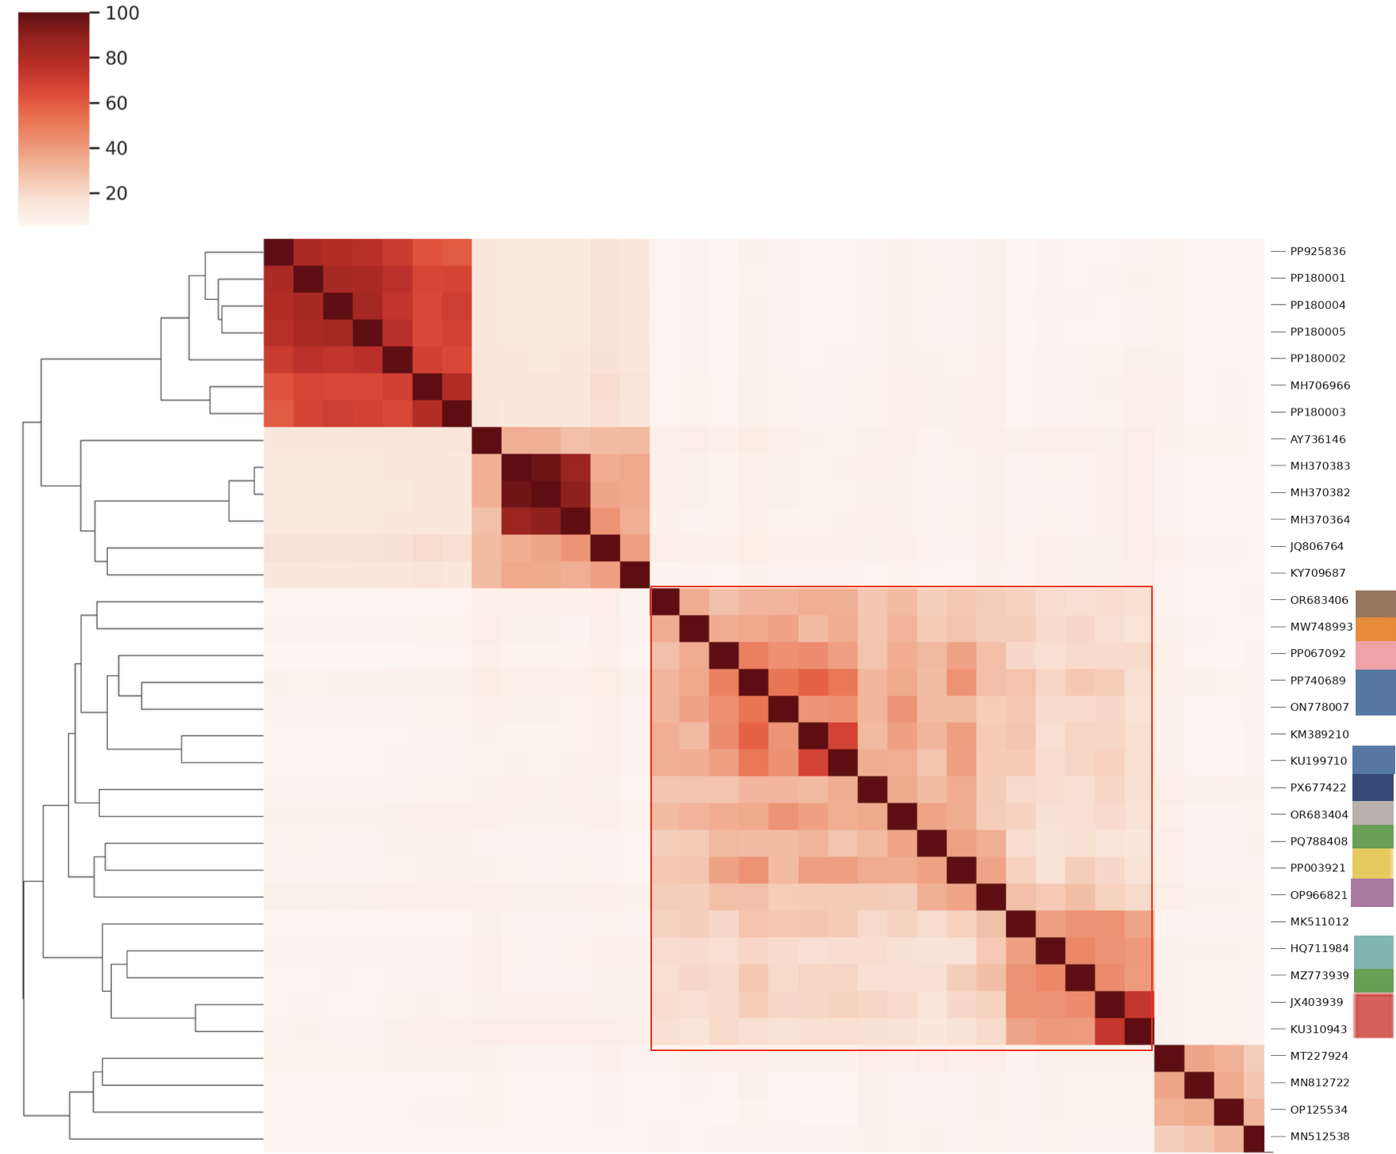
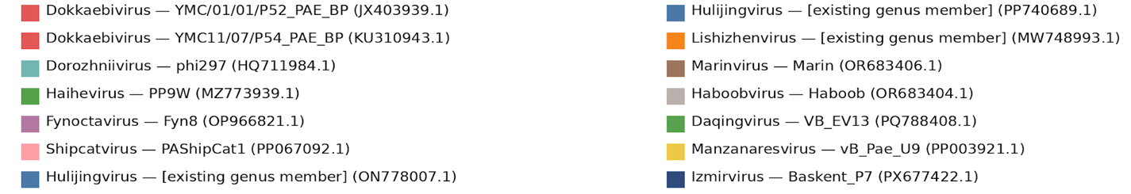
Figure 1: Jaccard similarity analysis based on shared protein clusters. Heatmap showing pairwise Jaccard similarity between the protein cluster sets of the analysed phage genomes. Jaccard similarity was calculated from the percentage of shared protein clusters between genome pairs, with higher values indicating a greater proportion of shared protein clusters. Accession numbers of the analysed genomes are shown adjacent to the heatmap.
* MK511012.1 and KM389210.1 were not included for downstream taxonomic analyses because MK511012.1 represents a partial genome and KM389210.1 is unverified. The proposed subfamily is indicated by a red box.

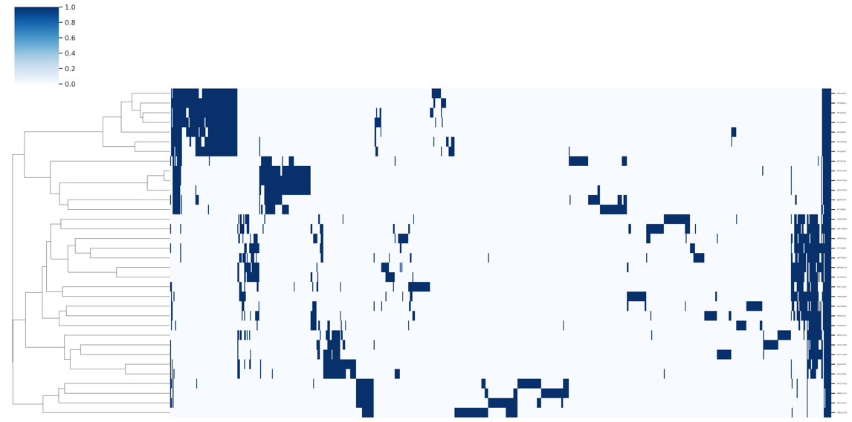
Figure 2: Protein cluster presence/absence analysis. Heatmap showing the presence and absence of representative proteins from the identified protein clusters across the analysed phage genomes. Genomes are shown as rows and protein clusters as columns. Blue indicates the presence of a representative protein in a given genome, whereas white indicates its absence.

Table 1. Conserved genes across all genomes analysed in this proposal.

Predicted function | % conservation | No. of genomes | Average percentage identity | Average length (aa)
head decoration | 100 | 34 | 45.39 | 145.38
virion structural protein | 100 | 34 | 74.54 | 360.26
hypothetical protein | 100 | 34 | 80.53 | 133
hypothetical protein | 100 | 34 | 58.81 | 423.76
hypothetical protein | 100 | 34 | 57.26 | 113.18
portal protein | 100 | 34 | 64.41 | 455.12
head morphogenesis | 94 | 32 | 55.29 | 309.59

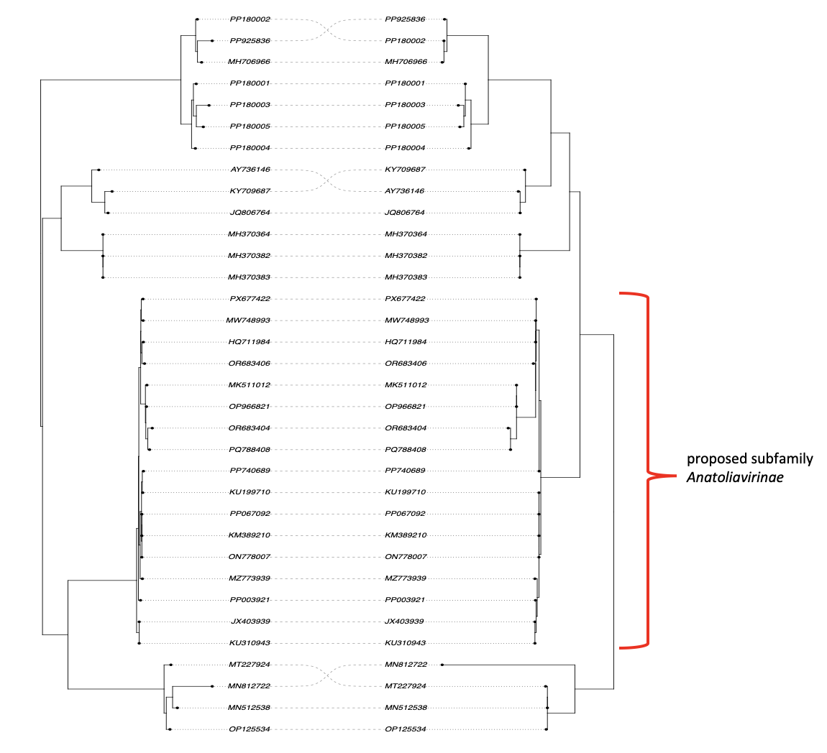
Figure 3. Six-core-protein and major capsid protein (MCP) phylogenies. Comparison of the phylogenetic relationships inferred from six conserved core proteins and the MCP. The two phylogenies show broadly congruent topologies and support the phylogenetic coherence of the broader clade proposed as Anatoliavirinae.

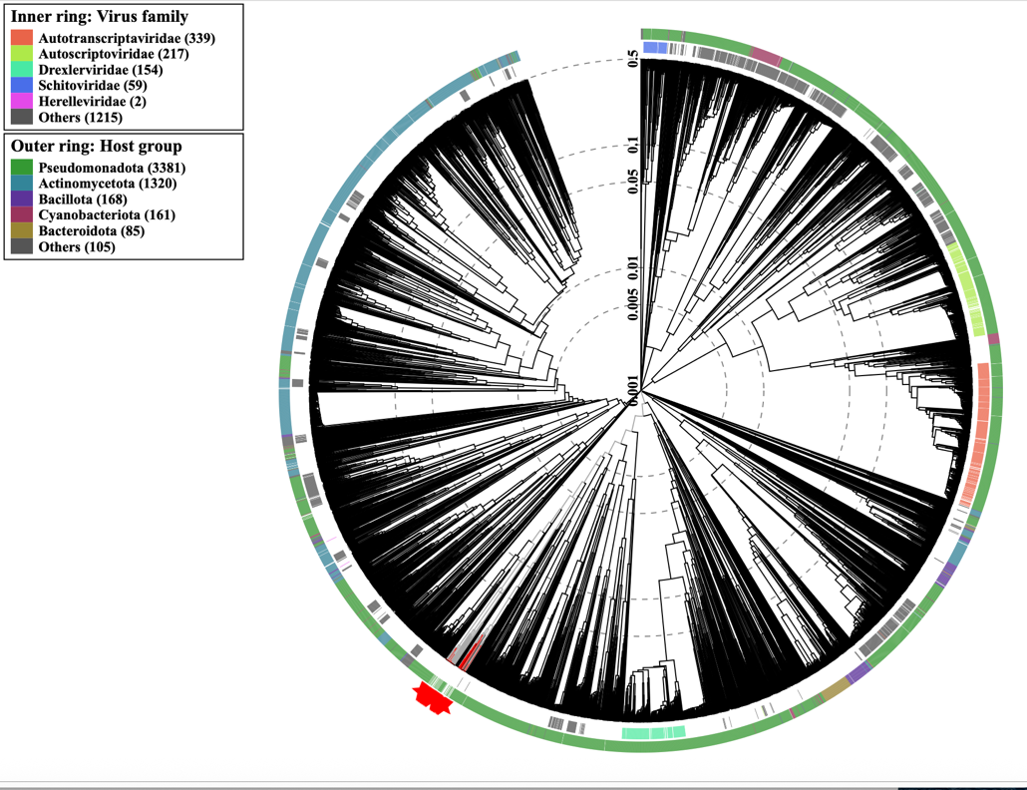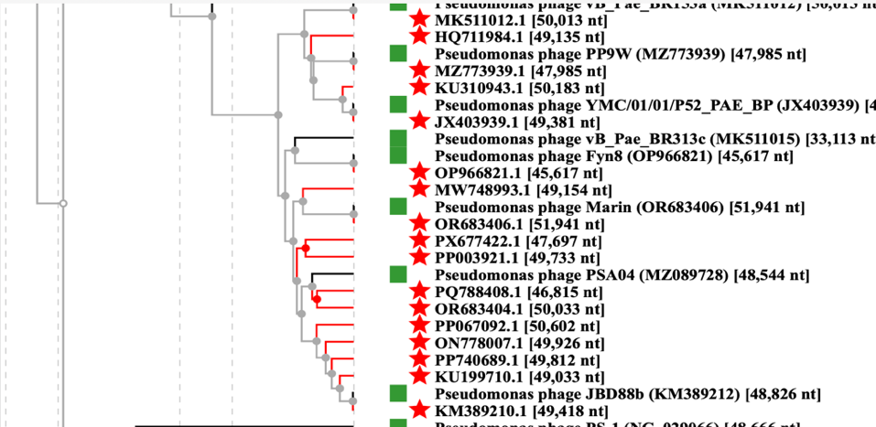

Figure 4: ViPTree proteomic phylogeny of the analysed phage genomes. ViPTree phylogeny showing the relationships among the analysed phage genomes based on genome-wide proteomic similarity. The analysis places these genomes included in the proposed Anatoliavirinae subfamily within a coherent phylogenetic lineage.

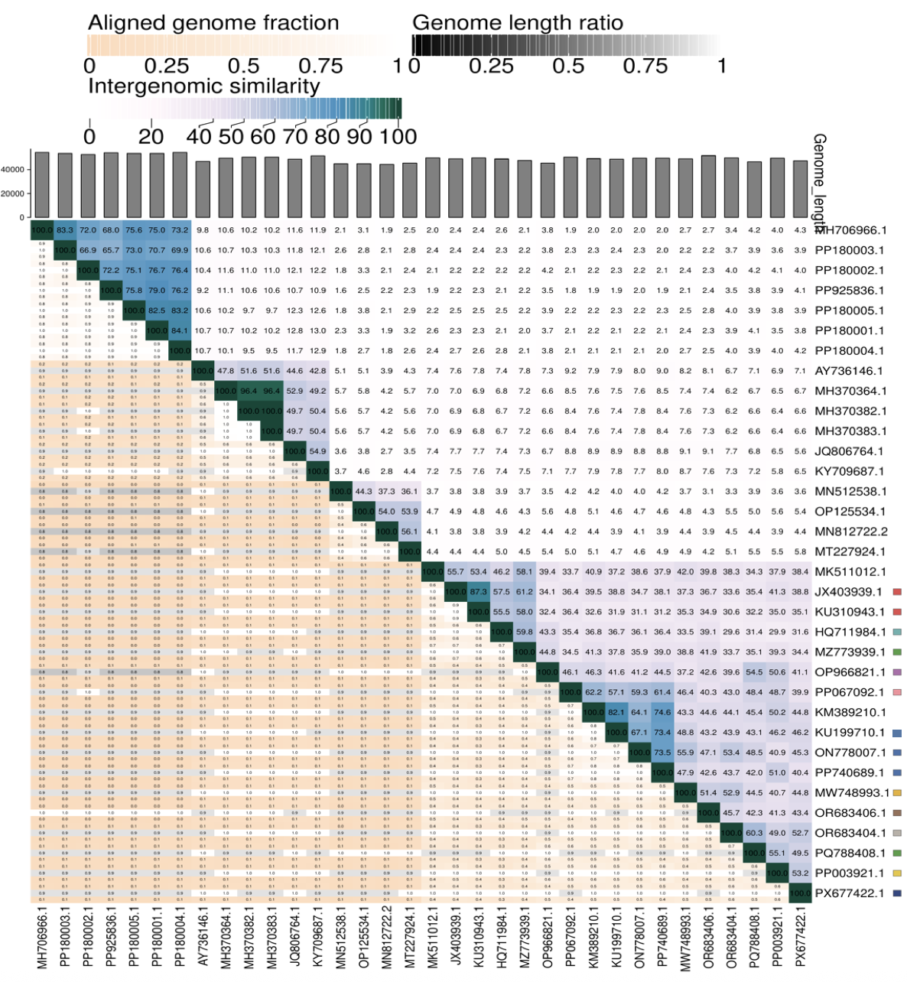
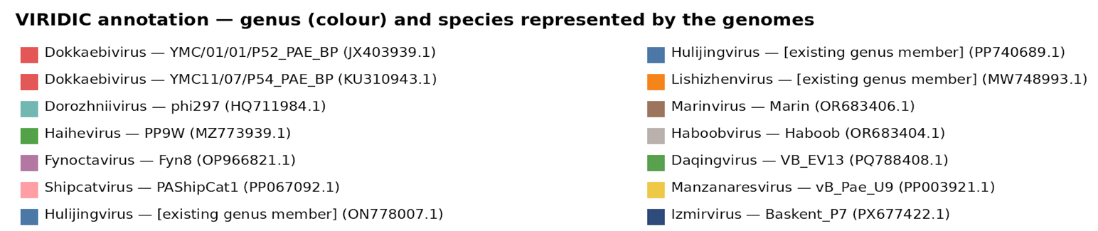Figure 5. VIRIDIC intergenomic nucleotide similarity analysis. Heatmap showing pairwise intergenomic nucleotide similarities among the phages included in the analysis. Genomes belonging to established genera Hulijingvirus and Lishizhenvirus and the proposed genera within the Anatoliavirinae subfamily are indicated by colour-coded annotations. The analysis was used to assess genus- and species-level relationships according to the established 70% and 95% intergenomic nucleotide similarity thresholds, respectively.
* KM389210.1 is unverified and MK511012.1 represents a partial genome.

Table 2. Characteristics of the phages described in the proposal which belong to the genus "Shipcatvirus"

Phage name | Host | Morphotype | Lifestyle | Accession No. | Genome size | %G+C | No. proteins | No. tRNA
Pseudomonas phage PAShipCat1 | Pseudomonas aeruginosa | Siphovirus | Temperate | PP067092 | 50602 bp | 59.3 | 82 | 1
Specific reference: Rimon A, Yerushalmy O, Belin J, Alkalay-Oren S, Gavish L, Coppenhagen-Glazer S, Hazan R. Six Novel Pseudomonas aeruginosa Phages: Genomic Insights and Therapeutic Potential. Phage (New Rochelle). 2025 Mar 17;6(1):32-40. doi: 10.1089/phage.2024.0037. PMID: 40351405; PMCID: PMC12060848.

Table 3. Characteristics of the phages described in the proposal which belong to the genus "Marinvirus"

Phage name | Host | Morphotype | Lifestyle | Accession No. | Genome size | %G+C | No. proteins | No. tRNA
Pseudomonas phage Marin | Pseudomonas aeruginosa F002 | Siphovirus | Temperate | OR683406 | 51941 bp | 59.9 | 83 | 3

Table 4. Characteristics of the phages described in the proposal which belong to the genus "Haboobvirus"

Phage name | Host | Morphotype | Lifestyle | Accession No. | Genome size | %G+C | No. proteins | No. tRNA
Pseudomonas phage Haboob | Pseudomonas aeruginosa 382 | Siphovirus | Temperate | OR683404 | 50033 bp | 59.7 | 85 | 4

Table 5. Characteristics of the phages described in the proposal which belong to the genus "Daqingvirus"

Phage name | Host | Morphotype | Lifestyle | Accession No. | Genome size | %G+C | No. proteins | No. tRNA
Pseudomonas phage VB_EV13 | Pseudomonas aeruginosa Tclvp1-3 | Siphovirus | Temperate | PQ788408 | 46815 bp | 59.5 | 74 | 0

Table 6. Characteristics of the phages described in the proposal which belong to the genus "Manzanaresvirus"

Phage name | Host | Morphotype | Lifestyle | Accession No. | Genome size | %G+C | No. proteins | No. tRNA
Pseudomonas phage vB_Pae_U9 | Pseudomonas aeruginosa ST773 (NDM-1-producing) | Siphovirus | Temperate | PP003921 | 49733 bp |  | 85 | 1
Specific reference: Hernández-García M, González de Aledo M, Ponce-Alonso M, González-Blanco B, Viedma E, Villa J, Tomás M, Hendrickx APA, Ruiz-Garbajosa P, Cantón R. Simultaneous clonal spread of NDM-1-producing Pseudomonas aeruginosa ST773 from Ukrainian patients in the Netherlands and Spain. IJID Reg. 2024 Jul 30;12:100415. doi: 10.1016/j.ijregi.2024.100415. PMID: 39253689; PMCID: PMC11381890.

Table 7. Characteristics of the phages described in the proposal which belong to the genus "Izmirvirus"

Phage name | Host | Morphotype | Lifestyle | Accession No. | Genome size | %G+C | No. proteins | No. tRNA
Pseudomonas phage Baskent_P7 | Pseudomonas aeruginosa | Siphovirus | Temperate | PX677422 | 47697 bp | 59.7 | 79 | 4

Table 8. Characteristics of the phages described in the proposal which belong to the genus "Dokkaebivirus"

Phage name | Host | Morphotype | Lifestyle | Accession No. | Genome size | %G+C | No. proteins | No. tRNA
Pseudomonas phage YMC/01/01/P52_PAE_BP | Pseudomonas aeruginosa YMC/01/01/P52 | Siphovirus | Temperate | JX403939 | 49381 bp | 62.2 | 72 | 0
Pseudomonas phage YMC11/07/P54_PAE_BP | carbapenem-resistant Pseudomonas aeruginosa  YMC11/07/P54 | Siphovirus | Temperate | KU310943 | 50183 bp | 62.2 | 73 | 0
Specific reference: Jeon J, Kim JW, Yong D, Lee K, Chong Y. Complete genome sequence of the bacteriophage YMC01/01/P52 PAE BP, which causes lysis of verona integron-encoded metallo-β-lactamase-producing, carbapenem-resistant Pseudomonas aeruginosa. J Virol. 2012 Dec;86(24):13876-7. doi: 10.1128/JVI.02730-12. PMID: 23166271; PMCID: PMC3503104.

Table 9. Characteristics of the phages described in the proposal which belong to the genus "Dorozhniivirus"

Phage name | Host | Morphotype | Lifestyle | Accession No. | Genome size | %G+C | No. proteins | No. tRNA
Pseudomonas phage phi297 | Pseudomonas aeruginosa | Siphovirus | Temperate | HQ711984 | 49135 bp | 62.1 | 69 | 0
Specific references: Krylov SV, Kropinski AM, Shaburova OV, Miroshnikov KA, Chesnokova EN, Krylov VN. [New temperate Pseudomonas aeruginosa phage, phi297: specific features of genome structure]. Genetika. 2013 Aug;49(8):930-42. Russian. PMID: 25474880. (and) Burkal'tseva MV, Krylov SV, Kropinskiĭ AM, Pletneva EA, Shaburova OV, Krylov VN. [Bacteriophage phi297--the new species of temperate phages Pseudomonas aeruginosa with a mosaic genome: potential use in phagotherapy]. Genetika. 2011 Jul;47(7):900-4. Russian. PMID: 21938953.

Table 10. Characteristics of the phages described in the proposal which belong to the genus "Fynoctavirus"

Phage name | Host | Morphotype | Lifestyle | Accession No. | Genome size | %G+C | No. proteins | No. tRNA
Pseudomonas phage Fyn8 | Pseudomonas aeruginosa PAO1 | Siphovirus | Temperate | OP966821 | 45617 bp | 59.9 | 66 | 2

