

The International Committee on Taxonomy of Viruses
Taxonomy Proposal Form, 2026

Part 1a: Details of taxonomy proposals

Title: | Create one new genus, “Hapetrivirus”, with two new species, in the class Caudoviricetes
Code assigned:

Author(s), affiliation and email address(es):
Given name (+middle initial(s)) | Surname | Affiliation | Email address | Corr. author(s)
Jinlong | Ru | Prevention of Microbial Diseases, TUM School of Life Sciences, Technical University of Munich, Freising, Germany; Institute of Virology, Helmholtz Munich, Neuherberg, Germany | jinlong.ru@tum.de | X
Li | Deng | Prevention of Microbial Diseases, TUM School of Life Sciences, Technical University of Munich, Freising, Germany; Institute of Virology, Helmholtz Munich, Neuherberg, Germany | li.deng@tum.de | X
Gaoxue | Wang | College of Animal Science and Technology, Northwest A&F University, Yangling, China; Hainan Institute of Northwest A&F University, Sanya, China | wanggaoxue@126.com
Changshuai | Liang | College of Animal Science and Technology, Northwest A&F University, Yangling, China | liangchangshuai@nwafu.edu.cn
YiLin | Zhang | College of Animal Science and Technology, Northwest A&F University, Yangling, China | 756728804@qq.com
Jinling | Xue | Prevention of Microbial Diseases, TUM School of Life Sciences, Technical University of Munich, Freising, Germany | jinling.xue@tum.de
Haowei | Zhang | College of Animal Science and Technology, Northwest A&F University, Yangling, China | 2024050595@nwafu.edu.cn
Zhangsendi | Chen | Prevention of Microbial Diseases, TUM School of Life Sciences, Technical University of Munich, Freising, Germany | zhangsendi.chen@tum.de
Fei | Ling | College of Animal Science and Technology, Northwest A&F University, Yangling, China | feiling@nwsuaf.edu.cn

Part 1b: Taxonomy Proposal Submission
ICTV Subcommittee:
Animal DNA Viruses and Retroviruses |  | Bacterial viruses | X
Animal minus-strand and dsRNA viruses |  | Fungal and protist viruses
Animal positive-strand RNA viruses |  | Plant viruses
Archaeal viruses |  | General -

List the ICTV Study Group(s) that have seen or have been involved in creating this proposal:
None. The proposal was not evaluated by an ICTV Study Group before submission; comments from the relevant Study Group(s) are welcome.

Optional – complete only if formally voted on by an ICTV Study Group:
Study Group | Number of members
Study Group | Votes in support | Votes against | No vote

Submission date: | 14/09/2026

Part 1c: Feedback from ICTV Executive Committee (EC) meeting
Executive Committee Meeting Decision code: | X
A – Accept
Ac – Accept subject to revision by relevant subcommittee chair. No further vote required
U – Accept without revision but with re-evaluation and email vote by the EC
Uc – Accept subject to revision and re-evaluation and email vote by the EC
Ud – Deferred to the next EC meeting, with an invitation to revise based on EC comments
J - Reject
W - Withdrawn

Comments from the Executive Committee:

Part 1d: Revised Taxonomy Proposal Submission
Response of proposer:
Revision date:

Part 3: TAXONOMIC PROPOSAL
https://ictv.global/taxonomy/templates

Taxonomic changes proposed:
Establish new taxon | X | Split taxon
Abolish taxon |  | Merge taxon
Move taxon |  | Promote taxon
Rename taxon |  | Demote taxon
Move and rename

Etymology (origin) of proposed taxonomic names:
Taxon name | Etymology of the term
“Hapetrivirus” | From 'Hp3', the designation of the exemplar isolate Aeromonas phage Hp3 (vB_AhyM_Hp3), rendered as 'Hapetri', with the genus suffix -virus.
“Hapetrivirus hp3” | Freeform epithet from the designation of the exemplar isolate, Aeromonas phage Hp3 (vB_AhyM_Hp3), in lowercase.
“Hapetrivirus hj05” | Freeform epithet from the designation of the exemplar isolate, Aeromonas phage HJ05, in lowercase.

Permission for use of names derived from a living person:
Taxon name | Full name of person from whom the name is derived | Attached

Abstract of Taxonomy Proposal:
Description of current taxonomy:
The bacteriophages described in this proposal are currently unclassified.

Proposed taxonomic change(s):
Create one new genus, “Hapetrivirus”, in the class Caudoviricetes, with two new species: “Hapetrivirus hp3” and “Hapetrivirus hj05”.

Demarcation criteria for new taxon/taxa:
Genus: Hp3 and HJ05 share 83.65% VIRIDIC intergenomic similarity, above the 70% genus and below the 95% species benchmarks of the Bacterial Viruses Subcommittee (Turner et al. 2021, 2023). In an amino-acid VICTOR/GBDP analysis (formula D6) with representatives of eight Caudoviricetes families, they form a clade (pseudo-bootstrap 100) and an exclusive genus-level OPTSIL cluster; in a terminase large-subunit phylogeny they form an exclusive clade (UFBoot 100). Among the 226 other complete Aeromonas phage genomes (40-200 kb) in GenBank, HJ05 alone shares Mash k-mer hashes with Hp3.
Species: <95% VIRIDIC intergenomic similarity.

Justification:
Hp3 and HJ05 are close relatives of each other and have no close relative among the other Aeromonas phage genomes or the 5,632 ViPTree reference viruses. They therefore require a new genus; family placement is deferred until further members are sampled, as for other deeply divergent Caudoviricetes genera.

- Text of Taxonomy proposal:

Description of current taxonomy:
The bacteriophages described in this proposal are currently unclassified.

Proposed taxonomic change(s):
Create one new genus, “Hapetrivirus”, in the class Caudoviricetes, with two new species: “Hapetrivirus hp3” and “Hapetrivirus hj05”.

Demarcation criteria for new taxon/taxa:
Genus: Hp3 and HJ05 share 83.65% VIRIDIC intergenomic similarity, above the 70% genus and below the 95% species benchmarks of the Bacterial Viruses Subcommittee (Turner et al. 2021, 2023). In an amino-acid VICTOR/GBDP analysis (formula D6) with representatives of eight Caudoviricetes families, they form a clade (pseudo-bootstrap 100) and an exclusive genus-level OPTSIL cluster; in a terminase large-subunit phylogeny they form an exclusive clade (UFBoot 100). Among the 226 other complete Aeromonas phage genomes (40-200 kb) in GenBank, HJ05 alone shares Mash k-mer hashes with Hp3.
Species: <95% VIRIDIC intergenomic similarity.

Justification:
Aeromonas phage Hp3 (vB_AhyM_Hp3) was isolated from municipal sewage in Freising, Germany, on Aeromonas hydrophila strain MS01, a pathogen of largemouth bass (Micropterus salmoides). Its complete genome (GenBank PX754746) is a double-stranded DNA molecule of 84,750 bp (G+C 59.0%) with 105 annotated CDS. The genome encodes a class II holin, an amidase-family endolysin and a candidate i-spanin whose start codon overlaps the endolysin stop codon, together with a UvsX-like recombinase and two Holliday-junction resolvases; it carries no integrase, lysogenic repressor, known antimicrobial-resistance gene or established virulence determinant. Virions have an icosahedral capsid of about 85 nm and a contractile tail of about 138 nm (negative-stain TEM). Aeromonas phage HJ05 (GenBank OQ594355; 79,124 bp, G+C 58.6%, 94 annotated CDS) was isolated from natural water on A. hydrophila AH10 (CCTCC AB2014155) and described in a preprint (Huang et al. 2023). Neither phage is classified below the class Caudoviricetes in the current Master Species List (MSL41).

In an amino-acid genome-BLAST distance phylogeny (VICTOR, formula D6; Meier-Kolthoff and Göker 2017), Hp3 and HJ05 form a clade with pseudo-bootstrap support of 100 and an exclusive genus-level OPTSIL cluster (Figure 1). The analysis included their nearest unclassified neighbors from ViPTree (Rhizobium phage vB_RleS_L338C, NC_023502; Sinorhizobium phage SM1, NC_041877; Stenotrophomonas phage vB_SmaS_DLP_5, NC_042082; Ochrobactrum phage POA1180, NC_070931; Acidithiobacillus phage AcaML1, JX507079) and representatives of eight Caudoviricetes families (Ackermannviridae, Straboviridae, Demerecviridae, Herelleviridae, Autographiviridae, Schitoviridae, Drexlerviridae, Peduoviridae). In a maximum-likelihood phylogeny of the terminase large subunit, Hp3 and HJ05 form an exclusive clade (UFBoot support 100%) on a long branch (Figure 2). The tree includes representatives of seven of these families (except Schitoviridae, whose representative N4 has no terminase annotated in its GenBank record) and was inferred from MAFFT v7.526 alignment (Katoh and Standley 2013) with IQ-TREE v3.1.2 (Wong et al. 2025) under the best-fit model LG+I+G4 selected by ModelFinder (Kalyaanamoorthy et al. 2017), with 1,000 ultrafast bootstrap replicates (Hoang et al. 2018). In a Mash v2.3 comparison (Ondov et al. 2016; k = 21, sketch 1,000) with the 227 complete Aeromonas phage genome records retrieved from GenBank on 7 September 2026 (query 'Aeromonas phage[Title] AND complete[Title] AND 40000:200000[SLEN]'), Hp3 shares k-mer hashes only with HJ05 (distance 0.122; 40 of 1,000 hashes) and with its own GenBank record; its distance to each of the other 225 genomes is 1.0.

In a ViPTree whole-proteome tree of 5,632 reference prokaryotic dsDNA viruses (Nishimura et al. 2017), Hp3 branches as an isolated deep lineage whose highest genomic similarity to any reference is S_G = 0.073 (to the unclassified Rhizobium phage vB_RleS_L338C; Figure 3). In the vConTACT3 protein-sharing network against NCBI viral RefSeq v230 (Bolduc et al. 2025), Hp3, HJ05 and, more distantly, L338C form a cluster separated from all established families in the network; the link to L338C rests on a few shared protein clusters and corresponds to approximately 3% VIRIDIC intergenomic similarity. The family-level OPTSIL partition of the VICTOR analysis is uninformative at this divergence: it merges the representatives of Straboviridae, Ackermannviridae, Demerecviridae and Herelleviridae into one cluster, and it places Hp3 and HJ05 in a family-rank cluster with the unclassified phages L338C, SM1 and DLP5, which share only about 3% VIRIDIC intergenomic similarity with them. These analyses provide no support for placing the genus in an existing family.

In summary, Hp3 and HJ05 are close relatives of each other (83.65% VIRIDIC intergenomic similarity; congruent genus-level clustering by VICTOR, TerL phylogeny and Mash), share no Mash k-mer hashes with any of the other 225 complete Aeromonas phage genome records in GenBank, and have no close relative among the 5,632 ViPTree reference viruses (highest S_G = 0.073). They therefore require a new genus. Both exemplar genomes are complete, annotated GenBank records (PX754746.1, 105 CDS; OQ594355.1, 94 CDS). The lineage has applied interest: Hp3 improved survival of largemouth bass after lethal A. hydrophila challenge (Liang et al. 2026, manuscript in preparation). Sampling of further members will allow family-rank placement to be revisited.
References:
Bolduc B, Zablocki O, Turner D, et al. (2025) Machine learning enables scalable and systematic hierarchical virus taxonomy. Nature Biotechnology. https://doi.org/10.1038/s41587–025–02946–9
Hoang DT, Chernomor O, von Haeseler A, Minh BQ, Vinh LS (2018) UFBoot2: improving the ultrafast bootstrap approximation. Molecular Biology and Evolution 35:518–522. https://doi.org/10.1093/molbev/msx281
Huang J, Xu N, Liu L, Lu L (2023) Isolation and characterization of the lytic Aeromonas phage HJ05, a new member of Caudovirales. Research Square (preprint). https://doi.org/10.21203/rs.3.rs-2852353/v1
Kalyaanamoorthy S, Minh BQ, Wong TKF, von Haeseler A, Jermiin LS (2017) ModelFinder: fast model selection for accurate phylogenetic estimates. Nature Methods 14:587–589. https://doi.org/10.1038/nmeth.4285
Katoh K, Standley DM (2013) MAFFT multiple sequence alignment software version 7: improvements in performance and usability. Molecular Biology and Evolution 30:772–780. https://doi.org/10.1093/molbev/mst010
Liang C, Zhang Y, Xue J, et al. (2026) Isolation and characterization of vB_AhyM_Hp3, a lytic Aeromonas hydrophila phage from a proposed new Caudoviricetes genus with therapeutic efficacy in largemouth bass. Manuscript in preparation.
Meier-Kolthoff JP, Göker M (2017) VICTOR: genome-based phylogeny and classification of prokaryotic viruses. Bioinformatics 33:3396–3404. https://doi.org/10.1093/bioinformatics/btx440
Moraru C, Varsani A, Kropinski AM (2020) VIRIDIC—a novel tool to calculate the intergenomic similarities of prokaryote-infecting viruses. Viruses 12:1268. https://doi.org/10.3390/v12111268
Nishimura Y, Yoshida T, Kuronishi M, Uehara H, Ogata H, Goto S (2017) ViPTree: the viral proteomic tree server. Bioinformatics 33:2379–2380. https://doi.org/10.1093/bioinformatics/btx157
Ondov BD, Treangen TJ, Melsted P, et al. (2016) Mash: fast genome and metagenome distance estimation using MinHash. Genome Biology 17:132. https://doi.org/10.1186/s13059–016–0997-x
Turner D, Kropinski AM, Adriaenssens EM (2021) A roadmap for genome-based phage taxonomy. Viruses 13:506. https://doi.org/10.3390/v13030506
Turner D, Shkoporov AN, Lood C, et al. (2023) Abolishment of morphology-based taxa and change to binomial species names: 2022 taxonomy update of the ICTV bacterial viruses subcommittee. Archives of Virology 168:74. https://doi.org/10.1007/s00705–022–05694–2
Wong TKF, Ly-Trong N, Ren H, et al. (2025) IQ-TREE 3: phylogenomic inference software using complex evolutionary models. EcoEvoRxiv (preprint). https://doi.org/10.32942/X2P62N

Accompanying files:
Filename | Description of contents
VICTOR_aa_D6_tree.pdf | Amino-acid VICTOR/GBDP tree (formula D6, midpoint-rooted, pseudo-bootstrap support): page 1, full-size version of Figure 1 with accession-bearing tip labels; page 2, the original VICTOR output with OPTSIL cluster blocks at family, subfamily, genus and species rank
TerL_ML_tree.pdf | Terminase large-subunit maximum-likelihood phylogeny (Figure 2): methods, table of the nine TerL sequences with GenBank accessions, the Newick tree, the IQ-TREE model report (excerpt) and the MAFFT alignment
Hapetrivirus_supporting_tables.xlsx | Sheets: VICTOR OPTSIL cluster table; VIRIDIC intergenomic similarities (Hp3, HJ05, L338C); Mash distances of Hp3 to the 227 complete Aeromonas phage genome records (40-200 kb) retrieved from GenBank on 7 September 2026 (226 non-self records); ViPTree S_G of Hp3 to 5,632 reference viruses (data of Figure 3); machine-readable copies of the TerL Newick tree, the MAFFT alignment and the full IQ-TREE report

Tables, Figures:

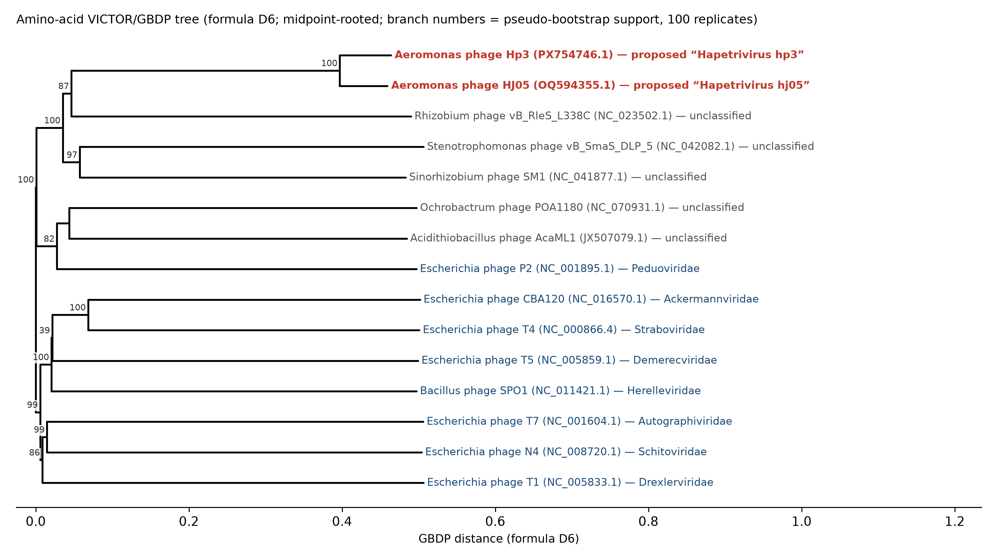
Figure 1. Amino-acid genome-BLAST distance phylogeny (VICTOR, formula D6, midpoint-rooted) of Hp3, HJ05, their nearest unclassified neighbors and representatives of eight Caudoviricetes families. Tip labels give the virus name, its INSDC accession and its current family or proposed taxon; numbers on branches are pseudo-bootstrap values (100 replicates). Hp3 and HJ05 form a clade with pseudo-bootstrap support of 100 and share a genus-rank OPTSIL cluster that includes no other genome (cluster table in Hapetrivirus_supporting_tables.xlsx; the original VICTOR output with the OPTSIL cluster blocks is page 2 of VICTOR_aa_D6_tree.pdf). The family-rank partition is uninformative at this divergence: it merges the representatives of Straboviridae, Ackermannviridae, Demerecviridae and Herelleviridae, and places Hp3 and HJ05 with the unclassified L338C, SM1 and DLP5.
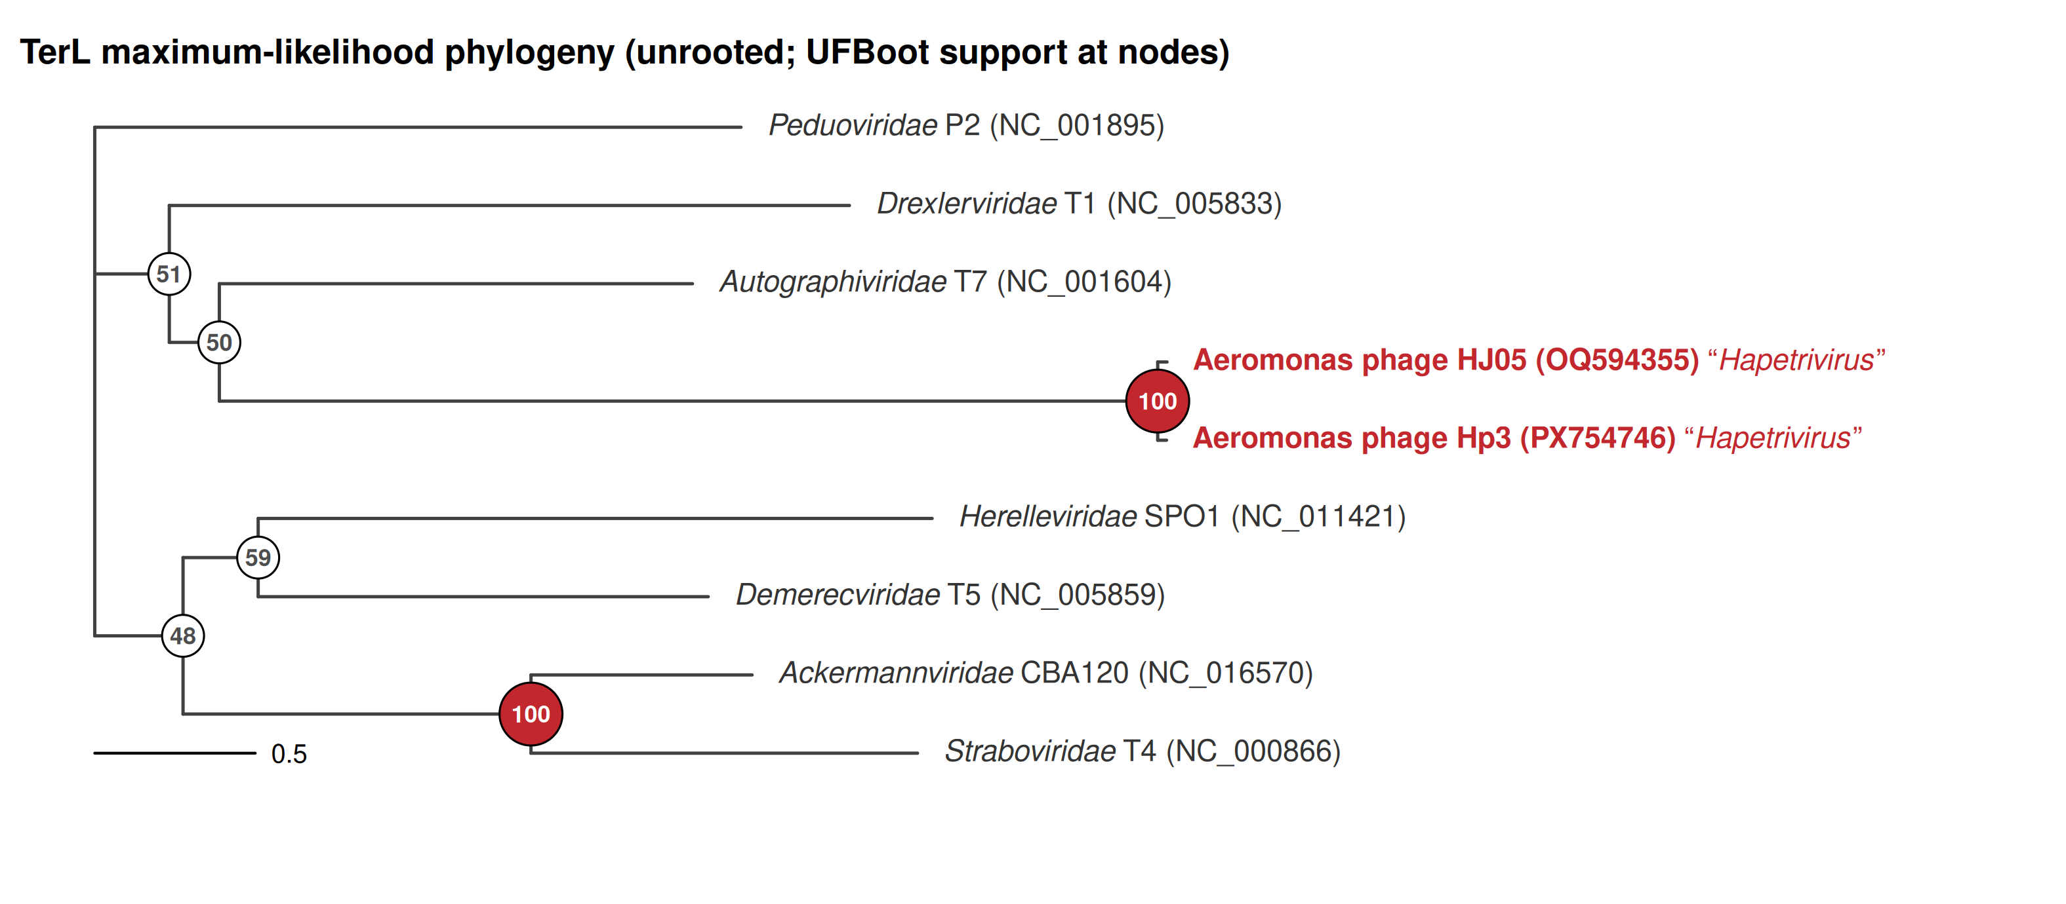
Figure 2. Maximum-likelihood phylogeny of the terminase large subunit of Hp3, HJ05 and representatives of seven Caudoviricetes families (MAFFT v7.526 alignment; IQ-TREE v3.1.2, best-fit model LG+I+G4 by ModelFinder, 1,000 ultrafast bootstrap replicates; unrooted, ladderized). Tip labels give the virus, its family and the GenBank accession; Hp3 and HJ05 are labelled with the proposed genus name. Node values are UFBoot support, filled circles mark support of 95 or above. Hp3 and HJ05 form an exclusive clade (UFBoot 100) on a long stem; the internodes separating the family representatives from one another have UFBoot support of 43-60, apart from the T4-CBA120 pairing (100). Scale bar, 0.5 substitutions per site.
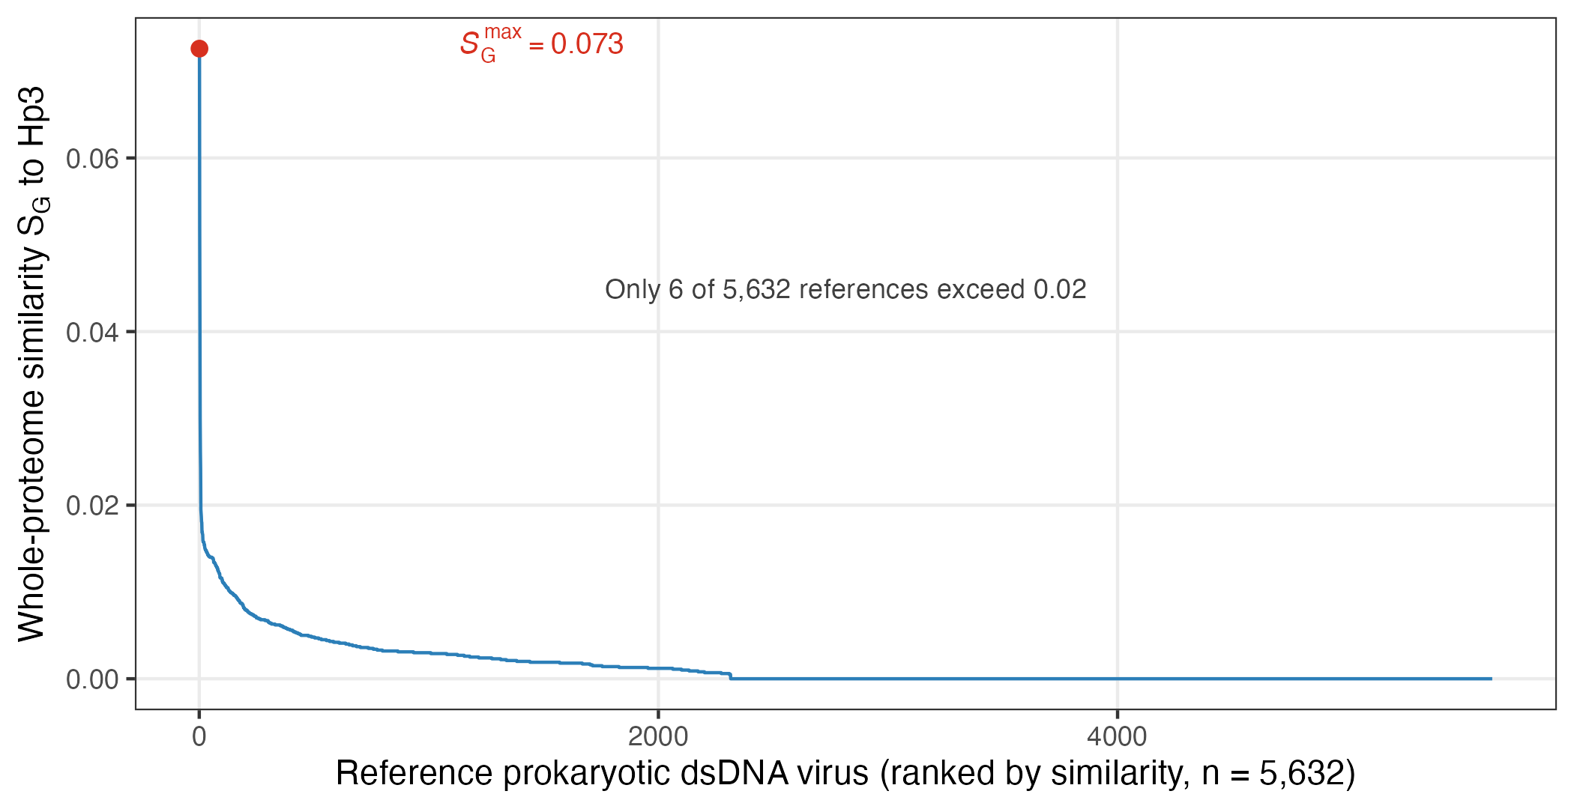
Figure 3. Whole-proteome genomic similarity (S_G, normalized tBLASTx score) of Hp3 to 5,632 reference prokaryotic dsDNA viruses in ViPTree. The highest value, 0.073, is to the unclassified Rhizobium phage vB_RleS_L338C; the highest value to a member of an established family is 0.016 (Pseudomonas phage vB_Pae_BR319a, Peduoviridae).

