

The International Committee on Taxonomy of Viruses
Taxonomy Proposal Form, 2026

Part 1a: Details of taxonomy proposals

Title: | To create a new family, Morriganviridae, of jumbo phages (Caudoviricetes)
Code assigned:

Author(s), affiliation and email address(es):
Given name (+middle initial(s)) | Surname | Affiliation | Email address | Corr. author(s)
Andrew | Millard | Department of Genetics and Genome Biology, University of Leicester, UK | adm39@leicester.ac.uk | X
Jason | Gill | Center for Phage Technology, Texas A&M University, College Station, TX, USA | jason.gill@tamu.edu
Cristina M. | Moraru | Department of Chemistry, Environmental Metagenomics,  University of Duisburg-Essen,  D-45141 Essen,  Germany | lilianacristina.moraru@uni-due.de
Andrew M. | Kropinski | University of Guelph, Guelph, Ontario, Canada N1G2W1 | Phage.Canada@gmail.com | x

Part 1b: Taxonomy Proposal Submission
ICTV Subcommittee:
Animal DNA Viruses and Retroviruses |  | Bacterial viruses | x
Animal minus-strand and dsRNA viruses |  | Fungal and protist viruses
Animal positive-strand RNA viruses |  | Plant viruses
Archaeal viruses |  | General -

List the ICTV Study Group(s) that have seen or have been involved in creating this proposal:
Caudoviricetes Study Group

Optional – complete only if formally voted on by an ICTV Study Group:
Study Group | Number of members
Study Group | Votes in support | Votes against | No vote

Submission date: | 25/05/2026

Part 1c: Feedback from ICTV Executive Committee (EC) meeting
Executive Committee Meeting Decision code: | X
A – Accept
Ac – Accept subject to revision by relevant subcommittee chair. No further vote required
U – Accept without revision but with re-evaluation and email vote by the EC
Uc – Accept subject to revision and re-evaluation and email vote by the EC
Ud – Deferred to the next EC meeting, with an invitation to revise based on EC comments
J - Reject
W - Withdrawn

Comments from the Executive Committee:

Part 1d: Revised Taxonomy Proposal Submission
Response of proposer:
Revision date:

Part 3: TAXONOMIC PROPOSAL

Taxonomic changes proposed:
Establish new taxon | x | Split taxon
Abolish taxon |  | Merge taxon
Move taxon |  | Promote taxon
Rename taxon |  | Demote taxon
Move and rename

Etymology (origin) of proposed taxonomic names:
Taxon name | Etymology of the term
Morriganviridae | Named after The Morrígan ("the great queen" or "phantom queen"), a Celtic triple goddess associated with war, fate and sovereignty
Machavirinae | Named after Macha, a sister of The Morrígan and goddess of sovereignty, war, fertility, and horses
Nemainvirinae | Named after Nemain, a sister of The Morrígan and goddess of battle frenzy, panic, and the chaotic havoc of war
Vltavavirus | Name after the Vltava River which flows through České Budějovice where phage Turkey5 was isolated
Irgollvirus | In Irish Mythology Irgoll is the father of Bres (an early king of the Fomorians) and a prominent combatant in ancient lore
Kaldavassvirus | Named after Erwinia phage Kaldavass
Dangunvirus | Named after the first king in Korean myth since Escherichia phage EJP2 was isolated in South Korea
Hallingskeidvirus | Named after Erwinia phage Hallingskeid

Permission for use of names derived from a living person:
Taxon name | Full name of person from whom the name is derived | Attached

Abstract of Taxonomy Proposal:

Description of current taxonomy:
ICTV has recognized the following genera: Alcyoneusvirus (2018.024B.A.v2.Alcyoneusvirus) with two species; Asteriusvirus (2018.025B.A.v1.Asteriusvirus) with two species; Eneladusvirus (2018.026B.A.v1.Eneladusvirus) with two species and Mimasvirus (2018.027B.A.v1.Mimasvirus) with two species.

Proposed taxonomic change(s):
We propose to create a new family, Morriganviridae, with two subfamilies called Machavirinae and Nemainvirinae for these jumbo phages

Demarcation criteria for new taxon/taxa:

Family demarcation criteria: The family is represented by a cohesive and monophyletic group in the main predicted proteome-based clustering tools (VirClust, ViPTree, GRAViTy dendrogram, vConTACT3 network). Members of the family share a significant number of orthologous genes (the number will depend on the genome sizes and number of coding sequences of members of the family). [6]

Subfamily demarcation criteria: Subfamilies are to be created when two or more genera are related below the family level. In practical terms, this usually means that they share a low degree of sequence similarity (usually about 40-50%) and that the genera form a clade in a marker tree phylogeny [6].

Genus demarcation criteria: An intergenomic similarity cut-off of 70%, a combination of average nucleotide identity and alignment fraction, is used to determine genera demarcation. Members of the same genus have >70% intergenomic similarity and cluster tightly in marker gene phylogenies.

Species demarcation criteria: A demarcation value of 95% intergenomic similarity was used to define different species according to intergenomic similarity. Members of the same genus have >95% intergenomic similarity [6].

Justification:
Each of the proposed genera and species exhibit similarity which satisfy the demarcation criteria established by the Bacterial Viruses Subcommittee. Phylogenetic analyses of the major capsid protein and TBLASTX distance analysis using ViPTree demonstrate that these bacteriophages form a cohesive clade at the family level. CoreGenes 5 analysis revealed that representative species of this subfamily all share 180 (36%) common proteins that include the major capsid, portal vertex, large terminase subunit proteins and a capsid maturation protease.

Text of Taxonomy proposal:
Description of current taxonomy:
ICTV has recognized the following genera: Alcyoneusvirus (2018.024B.A.v2.Alcyoneusvirus) with two species; Asteriusvirus (2018.025B.A.v1.Asteriusvirus) with two species; Eneladusvirus (2018.026B.A.v1.Eneladusvirus) with two species and Mimasvirus (2018.027B.A.v1.Mimasvirus) with two species.

Proposed taxonomic change(s):
We propose to create a new family, Morriganviridae, with two subfamilies called Machavirinae and Nemainvirinae for these jumbo phages

Demarcation criteria for new taxon/taxa:

Family demarcation criteria: The family is represented by a cohesive and monophyletic group in the main predicted proteome-based clustering tools (VirClust, ViPTree, GRAViTy dendrogram, vConTACT3 network). Members of the family share a significant number of orthologous genes (the number will depend on the genome sizes and number of coding sequences of members of the family). [6]

Subfamily demarcation criteria: Subfamilies are to be created when two or more genera are related below the family level. In practical terms, this usually means that they share a low degree of sequence similarity (usually about 40-50%) and that the genera form a clade in a marker tree phylogeny [6].

Genus demarcation criteria: An intergenomic similarity cut-off of 70%, a combination of average nucleotide identity and alignment fraction, is used to determine genera demarcation. Members of the same genus have >70% intergenomic similarity and cluster tightly in marker gene phylogenies.

Species demarcation criteria: A demarcation value of 95% intergenomic similarity was used to define different species according to intergenomic similarity. Members of the same genus have >95% intergenomic similarity [6].

Justification:
BLASTN searches and protein clustering identified a dataset of 59 genomes that appeared to exhibit a close relationship at the nucleotide and protein level. To assess this relationship, whole proteome comparisons were performed using the tool ViPTree to create a TBLASTX proteomic distance tree where these genomes formed a deep-branching clade. Protein content analysis of the genomes using CoreGenes5 and VirCLUST revealed that these phages share 180 protein homologs (30% homologous proteins) that include the large terminase subunit, portal protein, major capsid protein and head maturation protease, alongside a number of genes involve in genome replication and nucleotide metabolism. At the genus and species level, intergenomic nucleotide sequence similarities identified the presence of two new subfamilies and seven new genera alongside the existing genera Alcyoneusvirus, Eneladusvirus and Mimasvirus. Collectively these data support the creation of a new family, for which we propose the name “Morriganviridae” to include two new subfamilies, seven new genera and 25 new species.

References:
1. Moraru C, Varsani A, Kropinski AM. VIRIDIC-A Novel Tool to Calculate the Intergenomic Similarities of Prokaryote-Infecting Viruses. Viruses. 2020 Nov 6;12(11):1268. doi: 10.3390/v12111268. PMID: 33172115; PMCID: PMC7694805. http://kronos.icbm.uni-oldenburg.de/viridic/
2. Nishimura Y, Yoshida T, Kuronishi M, Uehara H, Ogata H, Goto S. ViPTree: the viral proteomic tree server. Bioinformatics. 2017; 33(15):2379-2380. doi:10.1093/bioinformatics/btx157. PubMed PMID: 28379287. https://www.genome.jp/viptree/
3. Rohwer F, Edwards R. The Phage Proteomic Tree: a genome-based taxonomy for phage. J Bacteriol. 2002 Aug;184(16):4529-35. PubMed PMID: 12142423
4. Turner D, Reynolds D, Seto D, Mahadevan P. CoreGenes3.5: a webserver for the determination of core genes from sets of viral and small bacterial genomes. BMC Res Notes. 2013;6:140. doi: 10.1186/1756-0500-6-140. PMID: 23566564.
5. Davis P, Seto D, Mahadevan P. CoreGenes5.0: An Updated User-Friendly Webserver for the Determination of Core Genes from Sets of Viral and Bacterial Genomes. Viruses. 2022 Nov 16;14(11):2534. doi: 10.3390/v14112534. PMID: 36423143; PMCID: PMC9693508.
6. Turner D, Kropinski AM, Adriaenssens EM. A Roadmap for Genome-Based Phage Taxonomy. Viruses. 2021 Mar 18;13(3):506. doi: 10.3390/v13030506. PMID: 33803862; PMCID: PMC8003253.
Lemoine F, Correia D, Lefort V, Doppelt-Azeroual O, Mareuil F, Cohen-Boulakia S, Gascuel O. NGPhylogeny.fr: new generation phylogenetic services for non-specialists. Nucleic Acids Res. 2019 Jul 2;47(W1):W260-W265. doi: 10.1093/nar/gkz303. PMID: 31028399; PMCID: PMC6602494.
7. Letunic I, Bork P. Interactive Tree Of Life (iTOL): an online tool for phylogenetic tree display and annotation. Bioinformatics. 2007 Jan 1;23(1):127-8. doi: 10.1093/bioinformatics/btl529. Epub 2006 Oct 18. PMID: 17050570.
8. Zhou T, Xu K, Zhao F, Liu W, Li L, Hua Z, Zhou X. itol.toolkit accelerates working with iTOL (Interactive Tree of Life) by an automated generation of annotation files. Bioinformatics. 2023 Jun 1;39(6):btad339. doi: 10.1093/bioinformatics/btad339. PMID: 37225402; PMCID: PMC10243930
9. Dereeper A, Guignon V, Blanc G, Audic S, Buffet S, Chevenet F, Dufayard JF, Guindon S, Lefort V, Lescot M, Claverie JM, Gascuel O. Phylogeny.fr: robust phylogenetic analysis for the non-specialist. Nucleic Acids Res. 2008 Jul 1;36(Web Server issue):W465-9. doi: 10.1093/nar/gkn180. Epub 2008 Apr 19. PMID: 18424797; PMCID: PMC2447785.

Accompanying files:
Filename | Description of contents
Morriganviridae_1nf_2nsf_7ng_25nsp_VIRIDIC | Matrix of intergenomic nucleotide similarities
Morriganviridae_1nf_2nsf_7ng_25nsp_VirCLUST_heatmap | VirCLUST distance heatmap of shared protein clusters
Morriganviridae_1nf_2nsf_7ng_25nsp_VirCLUST_binary | VirCLUST binary presence/absence heatmap of protein clusters

Tables, Figures:

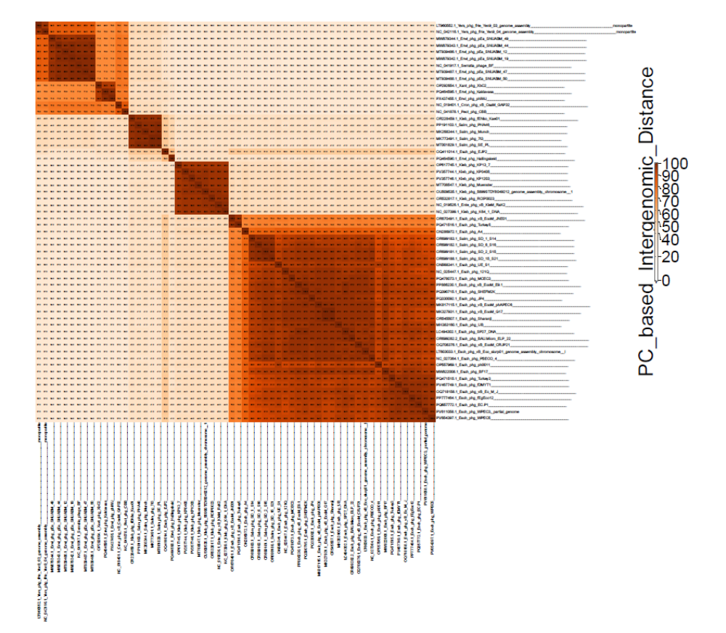
Figure 1. Heatmap of protein cluster based intergenomic distance. The heatmap was calculated using VirCLUST [].

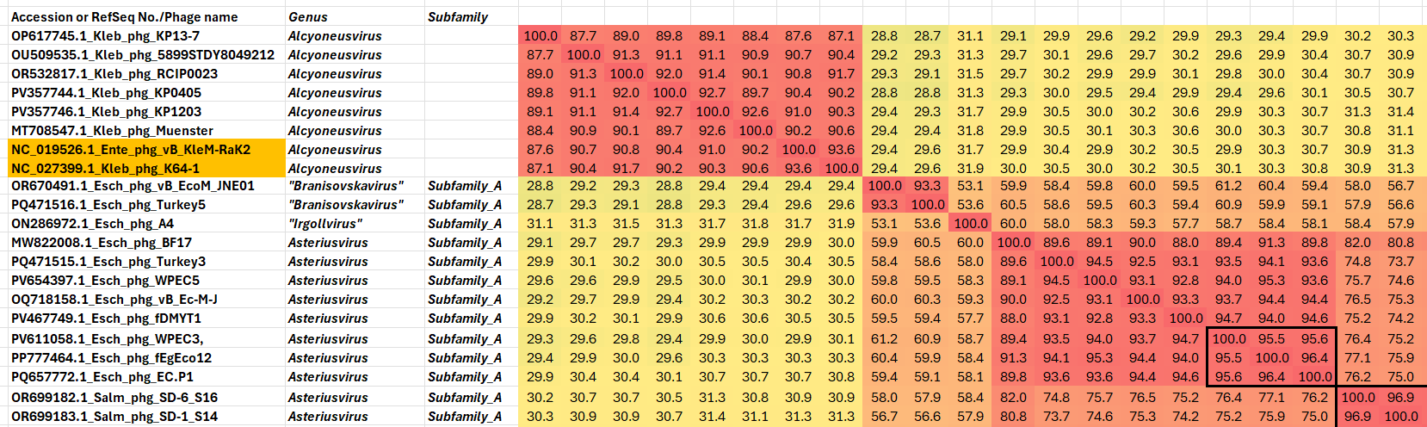

Figure 2. Partial VIRIDIC heatmap of this group of phages. VIRIDIC (Virus Intergenomic Distance Calculator; VIRIDIC (Virus Intergenomic Distance Calculator; [1]; http://rhea.icbm.uni-oldenburg.de/VIRIDIC/) computes pairwise intergenomic distances/similarities amongst phage genomes. Data values which are bordered in black correspond to strains. Abbreviations: phg = phage; Kleb = Klebsiella; Esch = Escherichia; Salm = Salmonella; Erwi = Erwinia; Serr = Serratia; Yers = Yersinia; Xant = Xanthomonas; Cron = Cronobacter; Pect = Pectobacterium. Because this diagram is somewhat difficult to read we have attached the full-sized Excel spread sheet.
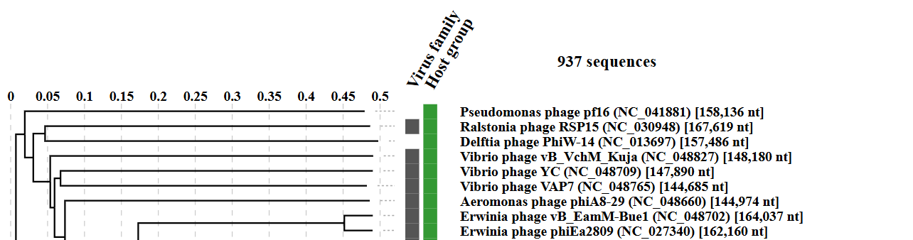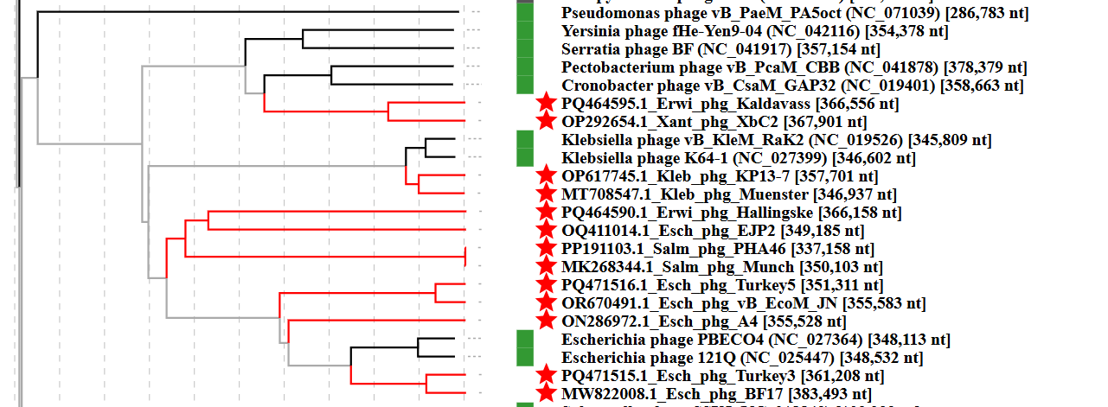

Figure 3. ViPTree analysis: ViPTree analysis (https://www.genome.jp/viptree/; [2]) is based upon Rohwer and Edwards (2002) Phage Proteomic Tree [3]. The taxons under discussion are indicated with red bars and stars. Abbreviations: phg = phage; Kleb = Klebsiella; Esch = Escherichia; Salm = Salmonella; Erwi = Erwinia; Serr = Serratia; Yers = Yersinia; Xant = Xanthomonas; Cron = Cronobacter; Pect = Pectobacterium.
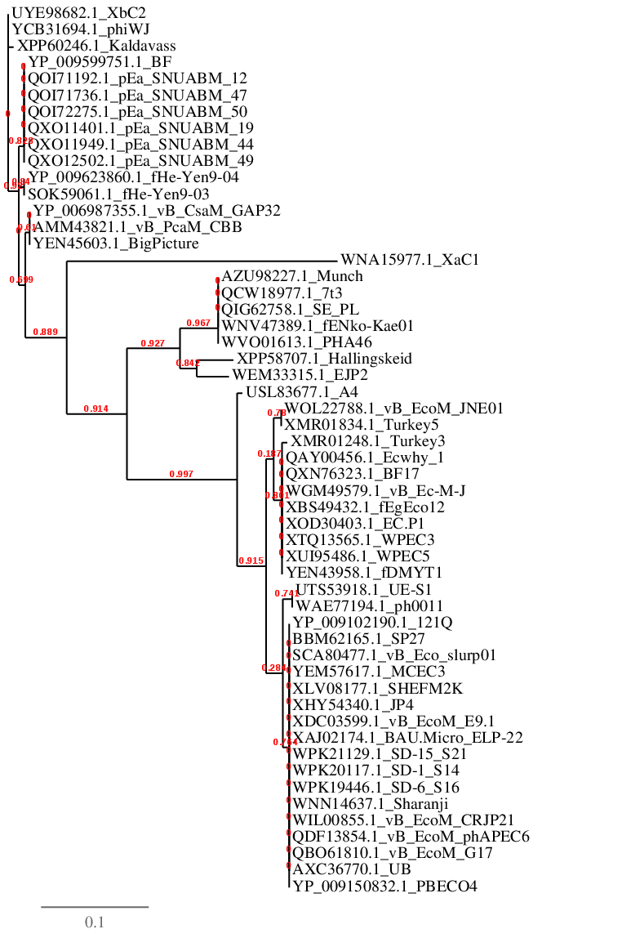
Figure 4. Phylogenetic tree constructed with the major capsid proteins from these phages using “One Click” Phylogeny.fr [9] at https://www.phylogeny.fr.

- To create six new species in the genus Alcyoneusvirus
Exemplar | Accesion No. | Taxon
Klebsiella phage KP13-7 | OP617745 | Alcyoneusvirus KP13-7
Klebsiella phage 5899STDY8049212 | OU509535 | Alcyoneusvirus 5899STDY8049212
Klebsiella phage RCIP0023 | OR532817 | Alcyoneusvirus RCIP0023
Klebsiella phage KP0405 | PV357744 | Alcyoneusvirus KP0405
Klebsiella phage KP1203 | PV357746 | Alcyoneusvirus KP1203
Klebsiella phage Muenster | MT708547 | Alcyoneusvirus muenster

- To create 10 new species in the genus Asteriusvirus

Exemplar | Accession No. | Taxon
Escherichia phage BF17 | MW822008 | Asteriusvirus BF17
Escherichia phage Turkey3 | PQ471515 | Asteriusvirus turkey3
Escherichia phage WPEC5 | PV654397 | Asteriusvirus WPEC5
Escherichia phage vB_Ec-M-J | OQ718158 | Asteriusvirus EcMJ
Escherichia phage fDMYT1 | PV467749 | Asteriusvirus fDMYT1
Escherichia phage WPEC3 | PV611058 | Asteriusvirus WPEC3
Escherichia phage Sharanji | OR545507 | Asteriusvirus sharanji
Escherichia phage JP4 | PQ330092 | Asteriusvirus JP4
Escherichia phage UE-S1 | ON568341 | Asteriusvirus UES1
Escherichia phage ph0011 | OP557969 | Asteriusvirus ph0011

Table 1. Characteristics of a new genus "Vltavavirus"

Phage name | Host | Morphotype | Lifestyle | Accession No. | Genome size | %G+C | No. proteins | No. tRNA
Escherichia phage vB_EcoM_JNE01 | Escherichia coli O157:H7 | Myovirus | Lytic | OR670491 | 355,583 bp | 36.3 | 576 | 5
Escherichia phage Turkey5 | Escherichia coli Tur5 | Myovirus | Lytic | PQ471516 | 351,311 bp | 36.4 | 578 | 6
Specific reference: Wang X, Wei X, Zhang Q, Li L, Liu Z, Chen Y, Liu Y, Cai Y. Genome sequence of Shiga toxin-producing Escherichia coli jumbo bacteriophage vB_EcoM_JNE01. Microbiol Resour Announc. 2024 Feb 15;13(2):e0114523. doi: 10.1128/mra.01145-23. Epub 2024 Jan 24. PMID: 38265225; PMCID: PMC10868205.

Table 2. Characteristics of a new genus "Irgollvirus"

Phage name | Host | Morphotype | Lifestyle | Accession No. | Genome size | %G+C | No. proteins | No. tRNA
Escherichia phage A4 | Escherichia coli LF82 | Myovirus | Lytic | ON286972 | 355528 bp | 35.2 | 591 | 5

Table 3. Characteristics of a new genus " Kaldavassvirus"

Phage name | Host | Morphotype | Lifestyle | Accession No. | Genome size | %G+C | No. proteins | No. tRNA
Xanthomonas phage XbC2 | Xanthomonas vesicatoria | Myovirus | Lytic | OP292654 | 367,901 bp | 37.5 | 557 | 36
Erwinia phage Kaldavass | Erwinia aphidicola W09_2 | Myovirus | Lytic | PQ464595 | 366,556 bp | 38.4 | 627 | 34
Erwinia phage phiWJ | Erwinia sp. 6-1 | Myovirus | Lytic | PX437455 | 364,537 bp | 38.4 | 576 | 35
Specific reference: Dougherty PE, Pedersen MS, Forero-Junco LM, Carstens AB, Raaijmakers JM, Riber L, Hansen LH. Novel bacteriophages targeting wheat phyllosphere bacteria carry DNA modifications and single-strand breaks. Virus Res. 2025 Feb;352:199524. doi: 10.1016/j.virusres.2024.199524. Epub 2025 Jan 8. PMID: 39742975; PMCID: PMC11780129.

Table 4. Characteristics of a new genus "Munchvirus"

Phage name | Host | Morphotype | Lifestyle | Accession No. | Genome size | %G+C | No. proteins | No. tRNA
Salmonella phage Munch | Salmonella | Myovirus | Lytic | MK268344 | 350,103 bp | 35.5 | 538 | 12
Specific reference: Xie Y, Thompson T, O'Leary C, Crosby S, Nguyen QX, Liu M, Gill JJ. Differential Bacteriophage Efficacy in Controlling Salmonella in Cattle Hide and Soil Models. Front Microbiol. 2021 Jun 28;12:657524. doi: 10.3389/fmicb.2021.657524. PMID: 34262535; PMCID: PMC8273493.

Table 5. Characteristics of a new genus "Dangunvirus"

Phage name | Host | Morphotype | Lifestyle | Accession No. | Genome size | %G+C | No. proteins | No. tRNA
Escherichia phage EJP2 | Escherichia coli FORC82 | Myovirus | Lytic | OQ411014 | 349,185 bp | 37.8 | 540 | 7
Specific reference: Jo D, Kim H, Lee Y, Kim J, Ryu S. Characterization and genomic study of EJP2, a novel jumbo phage targeting antimicrobial resistant Escherichia coli. Front Microbiol. 2023 May 12;14:1194435. doi: 10.3389/fmicb.2023.1194435. PMID: 37250060; PMCID: PMC10213699.

Table 6. Characteristics of a new genus "Hallingskeidvirus"

Phage name | Host | Morphotype | Lifestyle | Accession No. | Genome size | %G+C | No. proteins | No. tRNA
Erwinia phage Hallingskeid | Erwinia aphidicola B01_10 | Myovirus | Lytic | PQ464590 | 366,158 bp | 39.5 | 675 | 8
Specific reference: Dougherty, P.E., Pedersen, M.S., Forero-Junco, L.M., Carstens, A.B., Raaijmakers, J.M., Riber, L. & Hansen, L.H. 2024. Novel bacteriophages targeting wheat phyllosphere bacteria carry DNA modifications and single-strand breaks. bioRxiv. 2024.10.22.619576; doi: https://doi.org/10.1101/2024.10.22.619576
Now published in Virus Research doi: 10.1016/j.virusres.2024.199524

- To create a new subfamily Machavirinae
This subfamily includes three genera: "Vltavavirus", "Irgollvirus" and
Asteriusvirus
- To create a new subfamily Nemainvirinae
This subfamily includes three genera: Eneladusvirus, "Kaldavassvirus" and Mimasvirus

- To create a new family Morriganviridae
This family includes the above-mentioned subfamilies and the orphan genera "Munchvirus", "Dangunvirus" and “Hallingskeidvirus"

CoreGenes 5.0 analysis: CoreGenes5 analysis reveals that these phages share 180 homologs (30% homologous proteins) including: anaerobic ribonucleoside-triphosphate reductase, ribonucleotide reductase large subunit, ribonucleotide reductase small subunit, DNA primase, DNA helicase, DNA polymerase, large terminase protein, RecA proein, DNA gyrase subunit B, DNA ligase, head maturation protease, deoxynucleoside monophosphate kinase, tail sheath protein, thymidylate synthase, baseplate hub subunit and tail lysozyme, portal protein, and major capsid protein

