

The International Committee on Taxonomy of Viruses
Taxonomy Proposal Form, 2026

Part 1a: Details of taxonomy proposals

Title: | To create a new genus (Thanatosvirus) of Shewanella siphoviruses with three species (family Straboviridae)
Code assigned: | 2026.070B

Author(s), affiliation and email address(es):
Given name (+middle initial(s)) | Surname | Affiliation | Email address | Corr. author(s)
Cristina M. | Moraru | Department of Chemistry, Environmental Metagenomics,  University of Duisburg-Essen,  D-45141 Essen,  Germany | lilianacristina.moraru@uni-due.de
Andrew M. | Kropinski | University of Guelph,  Dept. Pathobiology  University of Guelph, Ontario, Canada N1G2W1 | Phage.Canada@gmail.com | x
Andrew | Millard | Dept Genetics and Genome Biology,  University of Leicester, Leicester, LE1 7HA, UK | adm39@leicester.ac.uk | X

Part 1b: Taxonomy Proposal Submission
ICTV Subcommittee:
Animal DNA Viruses and Retroviruses |  | Bacterial viruses | x
Animal minus-strand and dsRNA viruses |  | Fungal and protist viruses
Animal positive-strand RNA viruses |  | Plant viruses
Archaeal viruses |  | General -

List the ICTV Study Group(s) that have seen or have been involved in creating this proposal:
Straboviridae and Kyanoviridae Study Group
Optional – complete only if formally voted on by an ICTV Study Group:
Study Group | Number of members
Study Group | Votes in support | Votes against | No vote

Submission date: | March 22, 2026

Part 1c: Feedback from ICTV Executive Committee (EC) meeting
Executive Committee Meeting Decision code: | X
A – Accept
Ac – Accept subject to revision by relevant subcommittee chair. No further vote required
U – Accept without revision but with re-evaluation and email vote by the EC
Uc – Accept subject to revision and re-evaluation and email vote by the EC
Ud – Deferred to the next EC meeting, with an invitation to revise based on EC comments
J - Reject
W - Withdrawn

Comments from the Executive Committee:

Part 1d: Revised Taxonomy Proposal Submission
Response of proposer:
Revision date:

Part 3: TAXONOMIC PROPOSAL

Taxonomic changes proposed:
Establish new taxon | x | Split taxon
Abolish taxon |  | Merge taxon
Move taxon |  | Promote taxon
Rename taxon |  | Demote taxon
Move and rename

Etymology (origin) of proposed taxonomic names:
Taxon name | Etymology of the term
Thanatosvirus | Named directly after Shewanella phage Thanatos-1

Permission for use of names derived from a living person:
Taxon name | Full name of person from whom the name is derived | Attached

Abstract of Taxonomy Proposal:

Description of current taxonomy:
None of these phages have been classified by ICTV.

Proposed taxonomic change(s):
We propose to create a genus, Thanatosvirus with three species. This new genus is part of the subfamily Tevenvirinae, family Straboviridae order Pantevenvirales

Demarcation criteria for new taxon/taxa:
Genus demarcation criteria: An intergenomic similarity cut-off of 70%, a combination of average nucleotide identity and alignment fraction, is used to determine genera demarcation. Members of the same genus have >70% intergenomic similarity and cluster tightly in marker gene phylogenies.

Species demarcation criteria: A demarcation value of 95% intergenomic similarity was used to define different species according to intergenomic similarity. Members of the same genus have >95% intergenomic similarity [6].

Justification:
Bacteriophage Thanatos-1 infects a species of Shewanella oneidensis and possesses a 160.6 kbp genome. Searches conducted using BLASTN identified it exhibits a low level of intergenomic similarity viruses belonging to the Jiansuvirus and Gelderlandvirus genera (Figure 1). This relationship is further supported by whole genome TBLASTX distance analysis (Figure 2) and phylogenetic analysis of the major capsid precursor protein (Figure 3).

Text of Taxonomy proposal:
Description of current taxonomy:
None of these phages have been classified by ICTV.

Proposed taxonomic change(s):
We propose to create a genus, Thanatosvirus with three species. This new genus is part of the subfamily Tevenvirinae, family Straboviridae order Pantevenvirales

Demarcation criteria for new taxon/taxa:
Genus demarcation criteria: An intergenomic similarity cut-off of 70%, a combination of average nucleotide identity and alignment fraction, is used to determine genera demarcation. Members of the same genus have >70% intergenomic similarity and cluster tightly in marker gene phylogenies.

Species demarcation criteria: A demarcation value of 95% intergenomic similarity was used to define different species according to intergenomic similarity. Members of the same genus have >95% intergenomic similarity [6].

Justification:
Bacteriophage Thanatos-1 infects a species of Shewanella oneidensis and possesses a 160.6 kbp genome. Searches conducted using BLASTN identified it exhibits a low level of intergenomic similarity viruses belonging to the Jiansuvirus and Gelderlandvirus genera (Figure 1). This relationship is further supported by whole genome TBLASTX distance analysis (Figure 2) and phylogenetic analysis of the major capsid precursor protein (Figure 3).

References:
1. Moraru C, Varsani A, Kropinski AM. VIRIDIC-A Novel Tool to Calculate the Intergenomic Similarities of Prokaryote-Infecting Viruses. Viruses. 2020 Nov 6;12(11):1268. doi: 10.3390/v12111268. PMID: 33172115; PMCID: PMC7694805. http://kronos.icbm.uni-oldenburg.de/viridic/
2. Nishimura Y, Yoshida T, Kuronishi M, Uehara H, Ogata H, Goto S. ViPTree: the viral proteomic tree server. Bioinformatics. 2017; 33(15):2379-2380. doi:10.1093/bioinformatics/btx157. PubMed PMID: 28379287. https://www.genome.jp/viptree/
3. Rohwer F, Edwards R. The Phage Proteomic Tree: a genome-based taxonomy for phage. J Bacteriol. 2002 Aug;184(16):4529-35. PubMed PMID: 12142423
4. Turner D, Reynolds D, Seto D, Mahadevan P. CoreGenes3.5: a webserver for the determination of core genes from sets of viral and small bacterial genomes. BMC Res Notes. 2013;6:140. doi: 10.1186/1756-0500-6-140. PMID: 23566564.
5. Davis P, Seto D, Mahadevan P. CoreGenes5.0: An Updated User-Friendly Webserver for the Determination of Core Genes from Sets of Viral and Bacterial Genomes. Viruses. 2022 Nov 16;14(11):2534. doi: 10.3390/v14112534. PMID: 36423143; PMCID: PMC9693508.
6. Turner D, Kropinski AM, Adriaenssens EM. A Roadmap for Genome-Based Phage Taxonomy. Viruses. 2021 Mar 18;13(3):506. doi: 10.3390/v13030506. PMID: 33803862; PMCID: PMC8003253.
Lemoine F, Correia D, Lefort V, Doppelt-Azeroual O, Mareuil F, Cohen-Boulakia S, Gascuel O. NGPhylogeny.fr: new generation phylogenetic services for non-specialists. Nucleic Acids Res. 2019 Jul 2;47(W1):W260-W265. doi: 10.1093/nar/gkz303. PMID: 31028399; PMCID: PMC6602494.
7. Letunic I, Bork P. Interactive Tree Of Life (iTOL): an online tool for phylogenetic tree display and annotation. Bioinformatics. 2007 Jan 1;23(1):127-8. doi: 10.1093/bioinformatics/btl529. Epub 2006 Oct 18. PMID: 17050570.
8. Zhou T, Xu K, Zhao F, Liu W, Li L, Hua Z, Zhou X. itol.toolkit accelerates working with iTOL (Interactive Tree of Life) by an automated generation of annotation files. Bioinformatics. 2023 Jun 1;39(6):btad339. doi: 10.1093/bioinformatics/btad339. PMID: 37225402; PMCID: PMC10243930
9. Dereeper A, Guignon V, Blanc G, Audic S, Buffet S, Chevenet F, Dufayard JF, Guindon S, Lefort V, Lescot M, Claverie JM, Gascuel O. Phylogeny.fr: robust phylogenetic analysis for the non-specialist. Nucleic Acids Res. 2008 Jul 1;36(Web Server issue):W465-9. doi: 10.1093/nar/gkn180. Epub 2008 Apr 19. PMID: 18424797; PMCID: PMC2447785.

Accompanying files:
Filename | Description of contents
Thanatosvirus_1ng_3nsp | Excel spreadsheet associated with this TaxoProp

Tables, Figures:

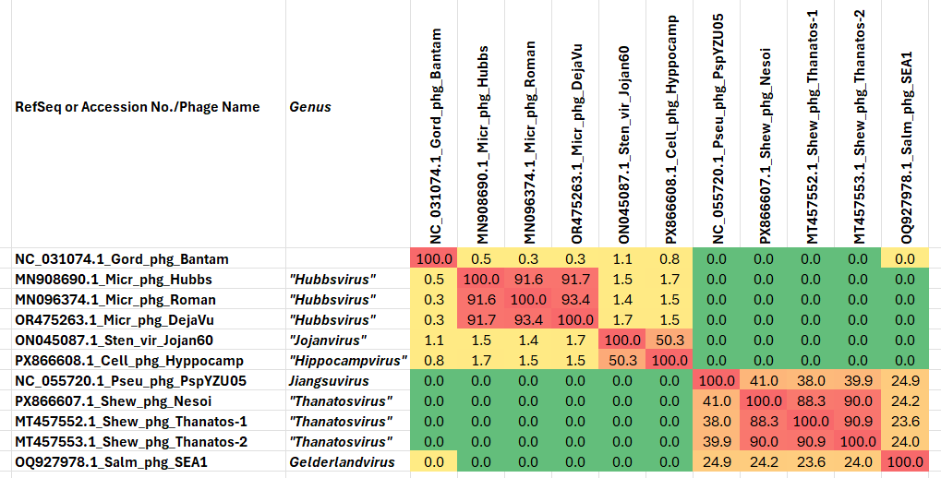

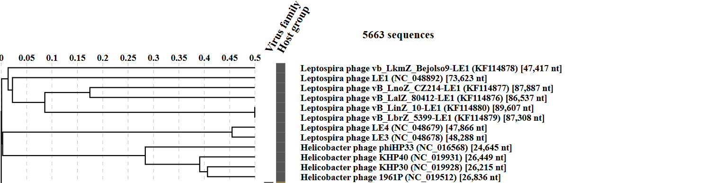
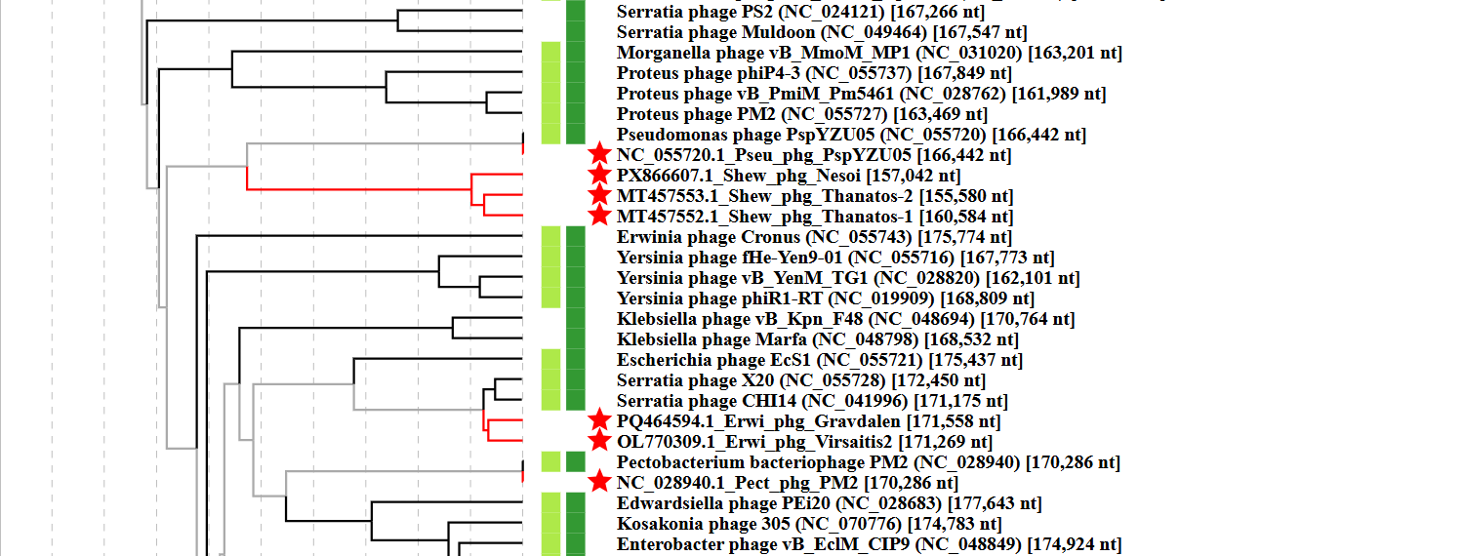
Figure 1. VIRIDIC heatmap of this group of phages. VIRIDIC (Virus Intergenomic Distance Calculator; VIRIDIC (Virus Intergenomic Distance Calculator; [1]; http://rhea.icbm.uni-oldenburg.de/VIRIDIC/) computes pairwise intergenomic distances/similarities amongst phage genomes. Abbreviations: phg = phage; Cell = Cellulosimicrobium; Salm = Salmonella; Pseu = Pseudomonas; Sten = Stenotrophomonas; Micr = Microbacterium; Gord = Gordonia.

Figure 2. ViPTree analysis: ViPTree analysis (https://www.genome.jp/viptree/; [2]) is based upon Rohwer and Edwards (2002) Phage Proteomic Tree [3]. The taxons under discussion are indicated with red bars and stars. Abbreviations: phg = phage; Cell = Cellulosimicrobium; Salm = Salmonella; Pseu = Pseudomonas; Sten = Stenotrophomonas; Micr = Microbacterium; Gord = Gordonia.
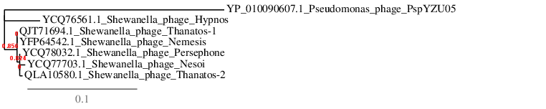
Figure 3. Phylogenetic tree constructed with the major capsid proteins from these and related phages using “One Click” Phylogeny.fr [9] at http://phylogeny.lirmm.fr/phylo_cgi/simple_phylogeny.cgi using the major capsid protein from Pseudomonas phage PsoYZU05 as an outlier.

Table 1. Characteristics of the three phages in the genus Thanatosvirus.

Phage name | Host | Morphotype | Lifestyle | Accession No. | Genome size | %G+C | No. proteins | No. tRNA
Shewanella phage Nesoi | Shewanella oneidensis MR-1" | Myovirus | Lytic | PX866607 | 157,042 bp | 34.8 | 198 | 2
Shewanella phage Thanatos-1 | Shewanella oneidensis | Myovirus | Lytic | MT457552 | 160,584 bp | 34.5 | 206 | 2
Shewanella phage Thanatos-2 | Shewanella oneidensis | Myovirus | Lytic | MT457553 | 155,580 bp | 34.8 | 193 | 2
Specific references:
Kreienbaum M, Dörrich AK, Brandt D, Schmid NE, Leonhard T, Hager F, Brenzinger S, Hahn J, Glatter T, Ruwe M, Briegel A, Kalinowski J, Thormann KM. Isolation and Characterization of Shewanella Phage Thanatos Infecting and Lysing Shewanella oneidensis and Promoting Nascent Biofilm Formation. Front Microbiol. 2020 Sep 18;11:573260. doi: 10.3389/fmicb.2020.573260. PMID: 33072035; PMCID: PMC7530303.

Brandt D, Dörrich AK, Persicke M, Kemmler A, Leonhard T, Haak M, Nölting S, Ruwe M, Schmid N, Thormann KM, Kalinowski J. A pentose, as a cytosine nucleobase modification in Shewanella phage Thanatos genomic DNA, mediates enhanced resistance toward host restriction systems. Appl Environ Microbiol. 2026 Jan 27;92(1):e0133325. doi: 10.1128/aem.01333-25. Epub 2025 Dec 29. PMID: 41457318; PMCID: PMC12838424.

- Shewanella phage Thanatos-1 possesses a prolate icosahedral capsule of about 110 nm in height and 70 nm in width and a tail of about 95 nm in length.
- “In addition to an adenine methylation, the data indicated an additional, much more substantial nucleobase modification. Using liquid chromatography-mass spectrometry (LC-MS), we identified an unknown configuration of a deoxypentose attached to cytosine as an undiscovered modification of phage DNA, which is present in Thanatos genomic DNA and likely mediates resistance to restriction endonucleases”

