

The International Committee on Taxonomy of Viruses
Taxonomy Proposal Form, 2026

Part 1a: Details of taxonomy proposals

Title: | To create a new family, Szybalskiviridae in the class Caudoviricetes
Code assigned: | 2026.069B

Author(s), affiliation and email address(es):
Given name (+middle initial(s)) | Surname | Affiliation | Email address | Corr. author(s)
Małgorzata | Łobocka | Institute of Biochemistry and Biophysics  Polish Academy of Sciences, Warsaw 02-106, Poland | lobocka@ibb.waw.pl
Ipek | Kurtböke | University of the Sunshine Coast, Australia | ikurtbok@usc.edu.au
Cristina M. | Moraru | Department of Chemistry, Environmental Metagenomics,  University of Duisburg-Essen,  D-45141 Essen,  Germany | lilianacristina.moraru@uni-due.de
Andrew M. | Kropinski | University of Guelph, Guelph, Ontario, Canada N1G2W1 | Phage.Canada@gmail.com | x

Part 1b: Taxonomy Proposal Submission
ICTV Subcommittee:
Animal DNA Viruses and Retroviruses |  | Bacterial viruses | x
Animal minus-strand and dsRNA viruses |  | Fungal and protist viruses
Animal positive-strand RNA viruses |  | Plant viruses
Archaeal viruses |  | General -

List the ICTV Study Group(s) that have seen or have been involved in creating this proposal:
Actinophage Study Group

Optional – complete only if formally voted on by an ICTV Study Group:
Study Group | Number of members
Study Group | Votes in support | Votes against | No vote

Submission date: | 22/07/2026

Part 1c: Feedback from ICTV Executive Committee (EC) meeting
Executive Committee Meeting Decision code: | X
A – Accept
Ac – Accept subject to revision by relevant subcommittee chair. No further vote required
U – Accept without revision but with re-evaluation and email vote by the EC
Uc – Accept subject to revision and re-evaluation and email vote by the EC
Ud – Deferred to the next EC meeting, with an invitation to revise based on EC comments
J - Reject
W - Withdrawn

Comments from the Executive Committee:

Part 1d: Revised Taxonomy Proposal Submission
Response of proposer:
Revision date:

Part 3: TAXONOMIC PROPOSAL

Taxonomic changes proposed:
Establish new taxon | x | Split taxon
Abolish taxon | x | Merge taxon
Move taxon | x | Promote taxon
Rename taxon |  | Demote taxon
Move and rename

Etymology (origin) of proposed taxonomic names:
Taxon name | Etymology of the term
Szybalskiviridae | Named in honour of Professor Wacław Tadeusz Szybalski (deceased)

Permission for use of names derived from a living person:
Taxon name | Full name of person from whom the name is derived | Attached

Abstract of Taxonomy Proposal:

Description of current taxonomy:
The phages in this proposal are either unclassified or belong to the genera Getseptimavirus, Tinduovirus, Montyvirus, Woesvirus, Docdeeseptimavirus and Demosthenesvirus

Proposed taxonomic change(s):
We propose to create a new family “Szybalskiviridae” containing the genera Getseptimavirus, Tinduovirus, Montyvirus, Woesvirus, Docdeeseptimavirus and Demosthenesvirus, and one new genus “Philonvirus”.

Demarcation criteria for new taxon/taxa:
Species demarcation criteria: Two phages are assigned to the same species if their genomes are more than 95% identical over their genome length for isolates. These values can be calculated by a number of tools, such as BLASTn [1,2] – usually calculated using intergenomic distance calculator VIRIDIC [3].

Genus demarcation criteria: In search for criteria that create cohesive and distinct genera that are reproducible and monophyletic, the Bacterial Viruses Subcommittee has established 70% nucleotide identity of the genome length as the cut-off for genera. Genus-level groupings should always be monophyletic in the signature genes, as tested with a phylogenetic tree [10].

Subfamily demarcation criteria: Subfamilies are to be created when two or more genera are related below the family level. In practical terms, this usually means that they share a low degree of sequence similarity (usually about 40-50%) and that the genera form a clade in a marker tree phylogeny [10].

Family demarcation criteria: The family is represented by a cohesive and monophyletic group in the main predicted proteome-based clustering tools (VirClust, ViPTree, GRAViTy dendrogram, vConTACT2 network). Members of the family share a significant number of orthologous genes (the number will depend on the genome sizes and number of coding sequences of members of the family) [10].

Justification:
Intergenomic nucleotide similarities calculated using VIRIDIC demonstrate that these phages share at minimum 25% similarity. Each of the proposed genera and species exhibit similarity which satisfy the demarcation criteria established by the Bacterial Viruses Subcommittee. Phylogenetic analyses of the large terminase subunit and TBLASTX distance analysis using ViPTree demonstrate that these Gordonia siphoviruses form a cohesive clade at the family level. CoreGenes 5 analysis revealed that representative species of this family all share 39 (36%) common proteins which include the terminase large subunit, portal protein, head maturation protease and major head protein.

Text of Taxonomy proposal:
Description of current taxonomy:
The phages in this proposal are either unclassified or belong to the genera Getseptimavirus, Tinduovirus, Montyvirus, Woesvirus, Docdeeseptimavirus and Demosthenesvirus

Proposed taxonomic change(s):
We propose to create a new family “Szybalskiviridae” containing the genera Getseptimavirus, Tinduovirus, Montyvirus, Woesvirus, Docdeeseptimavirus and Demosthenesvirus, and one new genus “Philonvirus”.

Demarcation criteria for new taxon/taxa:
Species demarcation criteria: Two phages are assigned to the same species if their genomes are more than 95% identical over their genome length for isolates. These values can be calculated by a number of tools, such as BLASTn [1,2] – usually calculated using intergenomic distance calculator VIRIDIC [3].

Genus demarcation criteria: In search for criteria that create cohesive and distinct genera that are reproducible and monophyletic, the Bacterial Viruses Subcommittee has established 70% nucleotide identity of the genome length as the cut-off for genera. Genus-level groupings should always be monophyletic in the signature genes, as tested with a phylogenetic tree [10].

Subfamily demarcation criteria: Subfamilies are to be created when two or more genera are related below the family level. In practical terms, this usually means that they share a low degree of sequence similarity (usually about 40-50%) and that the genera form a clade in a marker tree phylogeny [10].

Family demarcation criteria: The family is represented by a cohesive and monophyletic group in the main predicted proteome-based clustering tools (VirClust, ViPTree, GRAViTy dendrogram, vConTACT2 network). Members of the family share a significant number of orthologous genes (the number will depend on the genome sizes and number of coding sequences of members of the family) [10].

Justification:
Intergenomic nucleotide similarities calculated using VIRIDIC demonstrate that these phages share at minimum 25% similarity. Each of the proposed genera and species exhibit similarity which satisfy the demarcation criteria established by the Bacterial Viruses Subcommittee. Phylogenetic analyses of the large terminase subunit and TBLASTX distance analysis using ViPTree demonstrate that these Gordonia siphoviruses form a cohesive clade at the family level. CoreGenes 5 analysis revealed that representative species of this family all share 39 (36%) common proteins which include the terminase large subunit, portal protein, head maturation protease and major head protein.
References:
1. Moraru C, Varsani A, Kropinski AM. VIRIDIC-A Novel Tool to Calculate the Intergenomic Similarities of Prokaryote-Infecting Viruses. Viruses. 2020 Nov 6;12(11):1268. doi: 10.3390/v12111268. PMID: 33172115; PMCID: PMC7694805. http://kronos.icbm.uni-oldenburg.de/viridic/
2. Nishimura Y, Yoshida T, Kuronishi M, Uehara H, Ogata H, Goto S. ViPTree: the viral proteomic tree server. Bioinformatics. 2017; 33(15):2379-2380. doi:10.1093/bioinformatics/btx157. PubMed PMID: 28379287. https://www.genome.jp/viptree/
3. Rohwer F, Edwards R. The Phage Proteomic Tree: a genome-based taxonomy for phage. J Bacteriol. 2002 Aug;184(16):4529-35. PubMed PMID: 12142423
4. Turner D, Reynolds D, Seto D, Mahadevan P. CoreGenes3.5: a webserver for the determination of core genes from sets of viral and small bacterial genomes. BMC Res Notes. 2013;6:140. doi: 10.1186/1756-0500-6-140. PMID: 23566564.
5. Davis P, Seto D, Mahadevan P. CoreGenes5.0: An Updated User-Friendly Webserver for the Determination of Core Genes from Sets of Viral and Bacterial Genomes. Viruses. 2022 Nov 16;14(11):2534. doi: 10.3390/v14112534. PMID: 36423143; PMCID: PMC9693508.
6. Turner D, Kropinski AM, Adriaenssens EM. A Roadmap for Genome-Based Phage Taxonomy. Viruses. 2021 Mar 18;13(3):506. doi: 10.3390/v13030506. PMID: 33803862; PMCID: PMC8003253.
Lemoine F, Correia D, Lefort V, Doppelt-Azeroual O, Mareuil F, Cohen-Boulakia S, Gascuel O. NGPhylogeny.fr: new generation phylogenetic services for non-specialists. Nucleic Acids Res. 2019 Jul 2;47(W1):W260-W265. doi: 10.1093/nar/gkz303. PMID: 31028399; PMCID: PMC6602494.
7. Letunic I, Bork P. Interactive Tree Of Life (iTOL): an online tool for phylogenetic tree display and annotation. Bioinformatics. 2007 Jan 1;23(1):127-8. doi: 10.1093/bioinformatics/btl529. Epub 2006 Oct 18. PMID: 17050570.
8. Zhou T, Xu K, Zhao F, Liu W, Li L, Hua Z, Zhou X. itol.toolkit accelerates working with iTOL (Interactive Tree of Life) by an automated generation of annotation files. Bioinformatics. 2023 Jun 1;39(6):btad339. doi: 10.1093/bioinformatics/btad339. PMID: 37225402; PMCID: PMC10243930
9. Dereeper A, Guignon V, Blanc G, Audic S, Buffet S, Chevenet F, Dufayard JF, Guindon S, Lefort V, Lescot M, Claverie JM, Gascuel O. Phylogeny.fr: robust phylogenetic analysis for the non-specialist. Nucleic Acids Res. 2008 Jul 1;36(Web Server issue):W465-9. doi: 10.1093/nar/gkn180. Epub 2008 Apr 19. PMID: 18424797; PMCID: PMC2447785.
10. Cook R, Brown N, Redgwell T, Rihtman B, Barnes M, Clokie M, Stekel DJ, Hobman J, Jones MA, Millard A. INfrastructure for a PHAge REference Database: Identification of Large-Scale Biases in the Current Collection of Cultured Phage Genomes. Phage (New Rochelle). 2021 Dec 1;2(4):214-223. doi: 10.1089/phage.2021.0007. Epub 2021 Dec 16. PMID: 36159887; PMCID: PMC9041510.
11. Moraru C. VirClust-A Tool for Hierarchical Clustering, Core Protein Detection and Annotation of (Prokaryotic) Viruses. Viruses. 2023 Apr 19;15(4):1007. doi: 10.3390/v15041007. PMID: 37112988; PMCID: PMC10143988.

Accompanying files:
Filename | Description of contents
Szybalskiviridae_1nf_6ng | Excel spreadsheet accompanying this TaxoProp.

Tables, Figures:

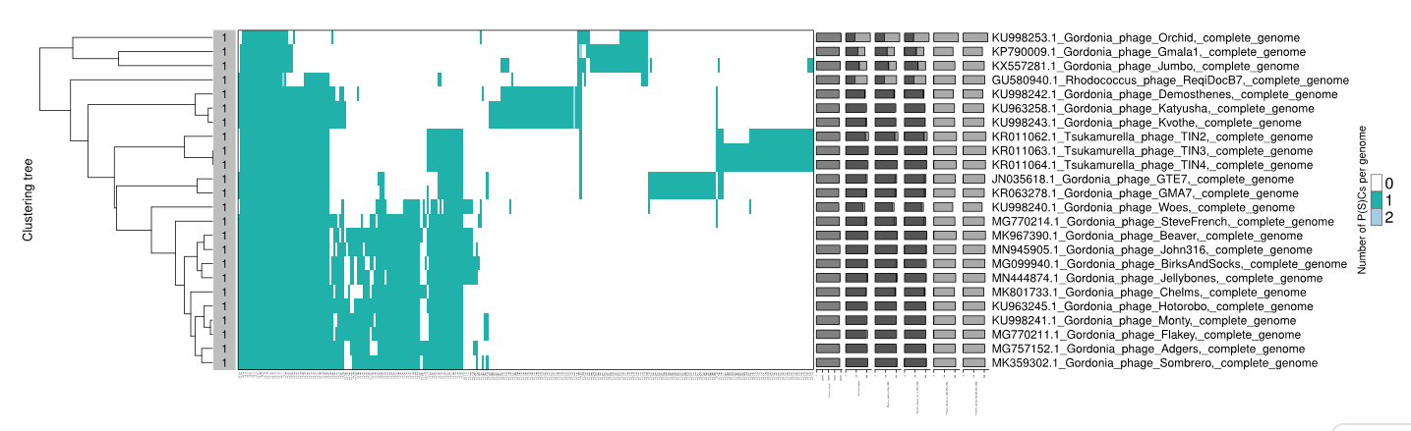

Figure 1. Presence-absence matrix of protein clusters by genome determined using VirClust [11]. Rows and columns were hierarchically clustered using the complete linkage method. Rows represent individual genomes with columns representing protein clusters. Vertical blue bars denote the presence of protein clusters in each genome.

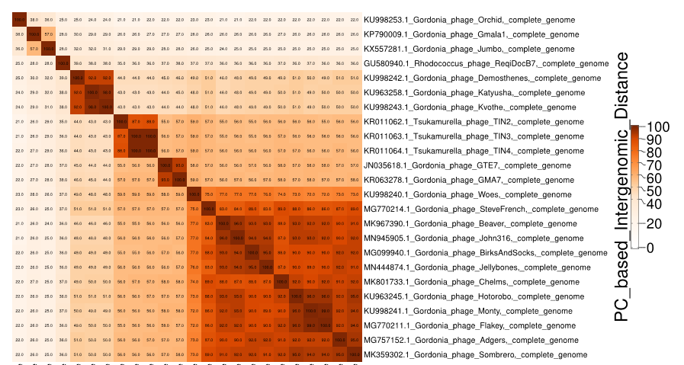
Figure 2. Heatmap of Jaccard similarity calculated from the percentage of shared protein clusters between genomes, calculated using VirClust [11].

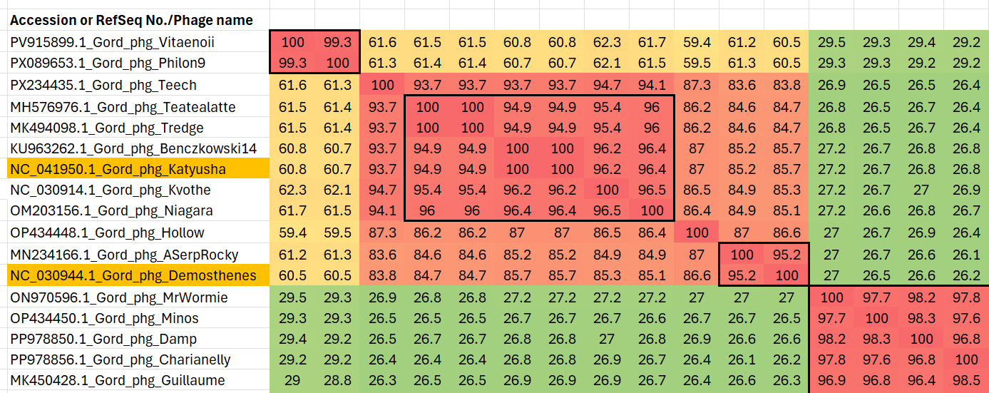
Figure 3. Partial VIRIDIC heatmap of this group of phages. VIRIDIC (Virus Intergenomic Distance Calculator; VIRIDIC (Virus Intergenomic Distance Calculator; [1]; http://rhea.icbm.uni-oldenburg.de/VIRIDIC/) computes pairwise intergenomic distances/similarities amongst phage genomes. Because the magnification makes it difficult to examine the data, the original Excel spreadsheet is attached. Names highlighted in gold correspond to existing species’ those in green are new species. Abbreviations: phg = phage; Gord = Gordonia; Rhod = Rhodococcus; Tsuk = Tsukamurella

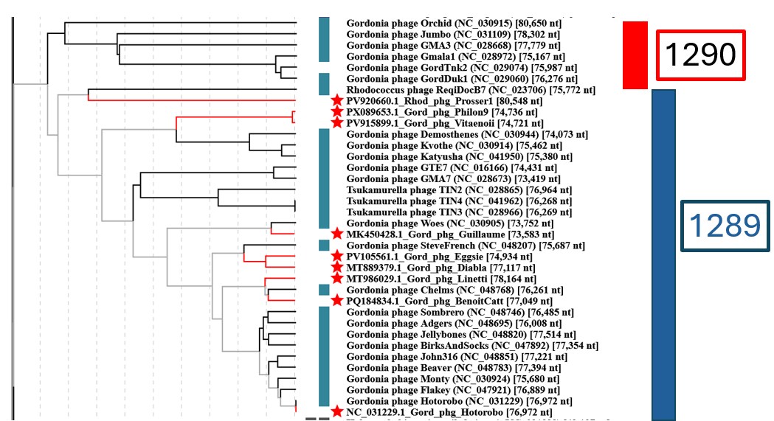
Figure 4. ViPTree analysis: ViPTree analysis (https://www.genome.jp/viptree/; [2]) is based upon Rohwer and Edwards (2002) Phage Proteomic Tree [3]. The taxons under discussion are indicated with red bars and stars. Abbreviations: phg = phage; Gord = Gordonia; Rhod = Rhodococcus.

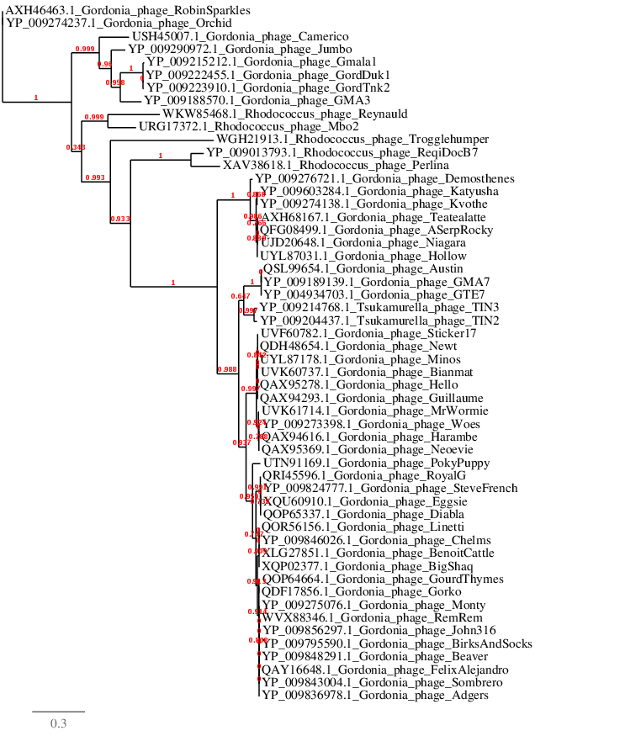

Figure 5. Phylogenetic tree constructed with the large subunit terminase proteins from these and related phages using “One Click” Phylogeny.fr [9] at http://phylogeny.lirmm.fr/phylo_cgi/simple_phylogeny.cgi. The blue bar indicates the members of this new family.

Table 3. New species in existing taxa

Accession No. | Exemplar | Taxon
PX234435 | Gordonia phage Teech | Demosthenesvirus teech
OP434448 | Gordonia phage Hollow | Demosthenesvirus hollow
PV165876 | Gordonia phage BigShaq | Montyvirus bigshaq
MT986029 | Gordonia phage Linetti | Montyvirus linetti
PQ184834 | Gordonia phage BenoitCattle | Montyvirus benoitcattle
ON456331 | Gordonia phage PokyPuppy | Montyvirus pokypuppy
MW507133 | Gordonia phage RoyalG | Montyvirus royalg
MT889379 | Gordonia phage Diabla | Montyvirus diabla
PV105561 | Gordonia phage Eggsie | Montyvirus eggsie

To create a new genus within this family – Philonvirus

Table 4. Characteristics of the phages described in the proposal which belong to "Philonvirus" While the Actinobacteriophage Database classifies these phages with what we consider to be members of the genus Demosthenesvirus they differ considerably from other members of Subcluster CS4 in their overall DNA sequence similarity.

Phage name | Host | Morphotype | Lifestyle | Accession No. | Genome size | %G+C | Genome Termini | No. proteins | No. tRNA
Gordonia phage Philon9 | Gordonia rubripertincta NRRL B-16540 | Siphovirus | Lytic | PX089653 | 74736 bp | 58.7 | 1205 bp Direct Terminal Repeat | 96 | 0

Gordonia phage Vitaenoii (PV915899) should be considered a strain within this genus.

CoreGenes 5 analysis: An analysis of the proteomes of Gordonia phages Reqi DocB7, Demosthenes, GMA7, Monty, Woes, Demosthenes and Vitaenoii revealed 36 homologs which included: terminase large subunits, portal protein, head maturation protease, major head protein, head decoration protein, head-tail adaptor, 2 tail assembly chaperones, 3 tail proteins, tail tape measure protein, 2 endolysins, holin, DNA methyltransferase, pyrophosphatase, Holliday junction resolvase, nucleoside 2-deoxyribosyltransferase, DNA polymerase processivity factor, DNA polymerase exonuclease subunit and DNA helicase & primase.
(derived from: University of Wisconsin-Madison)

Origin of the name of this taxon: This taxon is named in honour of Polish-American molecular geneticist Dr. Wacław Tadeusz Szybalski (pronunciation: Vah-tswahf Shih-BAHL-skee; b. 1921, Lwów, Poland; d. 2020, Madison WI USA) who received a BS in chemical engineering in 1944 from the Institutes of Technology in Lwów, Poland. During WWII the Szybalski family managed to survive both the Nazi and Soviet occupations of Lwow partly due to their involvement in the production of typhus vaccine at the Typhus Institute of Professor Rudolf Stefan Weigl. He received a MS in chemical engineering in 1945 in Gliwice, Poland; and defended his doctorate in chemical sciences at the Gdańsk University of Technology in 1949 under the supervision of Professor Ernest Sym. In 1950 he immigrated to the USA and found work as a scientist at Wyeth Inc., West Chester PA, and then joined Cold Spring Harbor Laboratory from 1951-1955 as a staff member.

In 1960, after several years at Rutgers University, Szybalski joined the McArdle Laboratory for Cancer Research at the University of Wisconsin - Madison and began pioneering research into viruses capable of infecting bacteria. Lambda phage became the basis of Szybalski's long-term interest in methods of gene transfer, modification and regulation. From 1960 to 2003, he was a full professor of oncology at the University of Wisconsin-Madison, actively engaged in research there together with his wife, Elizabeth. He was the recipient of the Hilldale Awards, the University of Wisconsin-Madison's highest honour. Wacław's prolific research output in the United States began with genetic studies of drug resistance that led to the use of multi-drug therapy that is now widely used to treat bacterial and viral infections and cancer. His studies of the antibiotic-producing soil microorganism, Streptomyces, yielded information that was useful in the commercial production of streptomycin, an effective therapeutic for treating tuberculosis. Wacław and his wife were the first researchers to perform gene transfer into mammalian cells (using HAT medium) and to introduce the ground-breaking idea that treatment for human genetic diseases could be made possible through gene therapy. His work laid the foundations for several Nobel Prizes won by others.

Wacław retired in 2003 holding the rank of Emeritus Professor of Oncology and of Genetics at the University of Wisconsin-Madison. He was elected a Fellow of the American Association for the Advancement of Science and was a Foreign Member of the Polish Academy of Sciences. In 2011, he received the highest honour awarded in Poland, becoming a Knight of the Order of Polonia Restituta, First Class. He also received five honorary doctorates from leading universities in Poland.

Wacław contributed to the advancement of molecular genetics both in the United States and Poland, and remained a strong patriot of both countries to the end of his life. (derived from: https://kuryerpolski.us/en/Page/View/waclaw-szybalski; https://www.cshl.edu/personal-collections/waclaw-szybalski/; https://mcardle.wisc.edu/2020/12/24/dr-waclaw-tadeusz-szybalski-september-9-1921-december-15-2020/).

