
The International Committee on Taxonomy of Viruses
Taxonomy Proposal Form, 2026
Part 1a: Details of taxonomy proposals

Title: | Create a new family, Zilberviridae, with two subfamilies Bukrinskayavirinae and Zhdanovvirinae, and 11 genera in the class Caudoviricetes.
Code assigned: | 2026.066B

Author(s), affiliation and email address(es):
Given name (+middle initial(s)) | Surname | Affiliation | Email address | Corr. author(s)
Mikhail M. | Shneider | Laboratory of molecular bioengineering, Shemyakin-Ovchinnikov Institute of Bioorganic Chemistry, Moscow, Russia | mikhailshneider@gmail.com | X
Olga Yu. | Timoshina | Laboratory of molecular bioengineering, Shemyakin-Ovchinnikov Institute of Bioorganic Chemistry, Moscow, Russia | lalatimosha@gmail.com | X
Anna A. | Lukianova | Laboratory of molecular bioengineering, Shemyakin-Ovchinnikov Institute of Bioorganic Chemistry, Moscow, Russia | a.al.lukianova@gmail.com
Vladislav V. | Babenko | Laboratory of Genomic Research and Computational Biology, Lopukhin Federal Research and Clinical Center of Physical-Chemical Medicine of Federal Medical Biological Agency, Moscow, Russia | daniorerio34@gmail.com
Konstantin A. | Miroshnikov | Laboratory of molecular bioengineering, Shemyakin-Ovchinnikov Institute of Bioorganic Chemistry, Moscow, Russia | kmi@bk.ru

Part 1b: Taxonomy Proposal Submission
ICTV Subcommittee:
Animal DNA Viruses and Retroviruses |  | Bacterial viruses | X
Animal minus-strand and dsRNA viruses |  | Fungal and protist viruses
Animal positive-strand RNA viruses |  | Plant viruses
Archaeal viruses |  | General

List the ICTV Study Group(s) that have seen or have been involved in creating this proposal:
Caudoviricetes Study Group
Optional – complete only if formally voted on by an ICTV Study Group:
Study Group | Number of members
Study Group | Votes in support | Votes against | No vote

Submission date: | 16/07/2026

Part 1c: Feedback from ICTV Executive Committee (EC) meeting
Executive Committee Meeting Decision code: | X
A – Accept
Ac – Accept subject to revision by relevant subcommittee chair. No further vote required
U – Accept without revision but with re-evaluation and email vote by the EC
Uc – Accept subject to revision and re-evaluation and email vote by the EC
Ud – Deferred to the next EC meeting, with an invitation to revise based on EC comments
J - Reject
W - Withdrawn

Comments from the Executive Committee:

Part 1d: Revised Taxonomy Proposal Submission
Response of proposer:
Revision date:

Part 3: TAXONOMIC PROPOSAL

Taxonomic changes proposed:
Establish new taxon | X | Split taxon
Abolish taxon |  | Merge taxon
Move taxon |  | Promote taxon
Rename taxon |  | Demote taxon
Move and rename

Etymology (origin) of proposed taxonomic names:
Taxon name | Etymology of the term
Zilberviridae | family name created in honor of a virologist and microbiologist Lev Aleksandrovich Zilber (1894 – 1966). He was one of the pioneering investigators in Soviet virology, who had discovered the viral nature of tick-born encephalitis and had first suggested that viruses can trigger carcinogenesis
Bukrinskayavirinae | subfamily name created in honor of a virologist and a correspondent member of the Russian Academy of Sciences, – Alisa Grigoryevna Bukrinskaya (1928 – 2019), who was one of the leading Russian virologists of the 20th century
Bukrinskayavirus | genus name created in honor of Alisa Grigoryevna Bukrinskaya
Bukrinskayavirus triton | species name derived from the phage name in the NCBI GenBank database – Acinetobacter phage Triton, - the only one representative known up to date
Zhdanovvirinae | subfamily name created in honor of a leading Russian virologist Viktor Mikhailovych Zhdanov (1914 – 1987), who played an important role in the eradication of smallpox worldwide
Yangzhouvirus | genus name derived from the city name Yangzhou, where the Acinetobacter phage AbYft_4 was initially isolated
Yangzhouvirus AbYft_4 | species name derived from the phage name in the NCBI GenBank database – Acinetobacter phage AbYft_4
Birminghamvirus | genus name derived from the city name Birmingham, where the Acinetobacter phage BS46 was initially isolated
Birminghamvirus BS46 | species name derived from the phage name in the NCBI GenBank database – Acinetobacter phage BS46
Servetusvirus | genus name created in honor of Michael Servetus (1511-1553) – a Spanish theologian, physician, cartographer, and Renaissance humanist
Servetusvirus Phab24 | species name derived from the phage name in the GenBank database – Acinetobacter phage Phab24
Biniovirus | genus name derived from the name of the only one representative known up to date - Acinetobacter phage Binio
Biniovirus binio | species name derived from the phage name in the GenBank database – Acinetobacter phage Binio
Ceccovirus | genus name created in honor of Cecco d'Ascoli (1257-1327) – a medieval Italian encyclopedist, physician and poet
Ceccovirus MD2021a | species name derived from the phage name in the GenBank database - Acinetobacter phage MD-2021a
Petersvirus | genus name derived from the name of one of the known up to date representatives - Acinetobacter phage Ab3-TPeters
Petersvirus Ab3-TPeters | species name derived from the phage name in the GenBank database - Acinetobacter phage Ab3-TPeters
Petersvirus Ab5-7 | species name derived from the phage names in the GenBank database - Acinetobacter phage Ab5 and Acinetobacter phage Ab7
Hisarvirus | genus name derived from the city name Hisar, where the Acinetobacter phage phiAB441 was initially isolated
Hisarvirus phiAB441 | species name derived from the phage name in the GenBank database - Acinetobacter phage phiAB441
Solidusvirus | genus name derived from the name of one of the known up to date representatives - Acinetobacter phage Solidus
Solidusvirus solidus | species name derived from the phage name in the GenBank database – Acinetobacter phage Solidus
Solidusvirus belisarius | species name derived from the phage name in the GenBank database – Acinetobacter phage Belisarius
Lusitaniavirus | genus name derived from Lusitania, - an ancient Roman province encompassing most of modern-day Portugal, where the Acinetobacter phage vB_AbaM_B9 was initially isolated
Lusitaniavirus vB_AbaM_B9 | species name derived from the phage name in the GenBank database – Acinetobacter phage vB_AbaM_B9
Quartzvirus | genus name derived from the name of the only one known up to date representative - Acinetobacter phage Quartz
Quartzvirus quartz | species name derived from the phage name in the NCBI GenBank database – Acinetobacter phage Quartz
Kurianovovirus | genus name derived from Kurianovo - the area in the south-east of Moscow, where the sewage water sample (from which Acinetobacter phage TaPaz was initially isolated) was collected
Kurianovovirus TaPaz | species name derived from the phage name in the NCBI GenBank database – Acinetobacter phage TaPaz

Permission for use of names derived from a living person:
Taxon name | Full name of person from whom the name is derived | Attached

Abstract of Taxonomy Proposal:
Description of current taxonomy:
To date, there are no taxonomic ranks for the group of phages under consideration.

Proposed taxonomic change(s):
We propose to create a new family Zilberviridae within the class Caudoviricetes for the group of lytic myophages infecting Acinetobacter baumannii.
We had isolated from the environmental sources five strictly lytic myophages Belisarius, Quartz, Triton, Solidus, and Binio, and had sequenced their genomes. Also, we found a number of genomes of closely related phages in the NCBI GenBank database. We have performed a bioinformatic analysis of genome similarity of all these bacteriophages. Based on the data obtained, we propose:
- To create a new family, Zilberviridae, with two subfamilies Bukrinskayavirinae and Zhdanovvirinae.
- To create a new subfamily, Bukrinskayavirinae, with one genus.
- To create a new genus, Bukrinskayavirus, with one species.
- To create a new subfamily, Zhdanovvirinae, with 11 genera.
- To create a new genus, Yangzhouvirus, with one species.
- To create a new genus, Birminghamvirus, with one species.
- To create a new genus, Vigintiquattuorvirus, with one species.
- To create a new genus, Biniovirus, with one species.
- To create a new genus, Ceccovirus, with one species.
- To create a new genus, Petersvirus, with two species.
- To create a new genus, Hisarvirus, with one species.
- To create a new genus, Solidusvirus, with two species.
- To create a new genus, Lusitaniavirus, with one species.
- To create a new genus, Quartzvirus, with one species.
- To create a new genus, Kurianovovirus, with one species.

Demarcation criteria for new taxon/taxa:
We have applied the current ICTV Bacterial Viruses Subcommittee taxonomy demarcation criteria, summarized by Turner et. al., 2021

Justification:
The analysis of intergenomic similarities and also a proteome-based distance analysis were performed for a group of A. baumannii - infecting myophages. Based on the results of these investigations, we propose the creation of a new family, Zilberviridae, consisting of two subfamilies Bukrinskayavirinae (with one genus Bukrinskayavirus) and Zhdanovvirinae (with 11 genera Yangzhouvirus, Birminghamvirus, Vigintiquattuorvirus, Biniovirus, Ceccovirus, Petersvirus, Hisarvirus, Solidusvirus, Lusitaniavirus, Quartzvirus, Kurianovovirus).

Text of Taxonomy proposal:
Description of current taxonomy:
Currently, all of the bacteriophages related to proposed Zilberviridae family do not belong to any taxonomic ranks and are marked in the NCBI GenBank database as unclassified Caudoviricetes.

Proposed taxonomic change(s):
We propose to create a new family Zilberviridae within the class Caudoviricetes, phylum Uroviricota, kingdom Heunggongvirae, realm Duplodnaviria for the group of strictly lytic myophages infecting Acinetobacter baumannii.
We assume that the Zilberviridae family comprises of two subfamilies Bukrinskayavirinae (with one genus Bukrinskayavirus) and Zhdanovvirinae (with 11 genera Yangzhouvirus, Birminghamvirus, Vigintiquattuorvirus, Biniovirus, Ceccovirus, Petersvirus, Hisarvirus, Solidusvirus, Lusitaniavirus, Quartzvirus, Kurianovovirus).
Previously, we had isolated from the environmental sources five strictly virulent myophages Belisarius, Quartz, Triton, Solidus, and Binio, and had sequenced their full genomes. Moreover, we had found a number of genomes of closely related phages in the NCBI GenBank database. Further, we have performed a bioinformatic analysis of genome similarities of all these bacteriophages. Based on the data obtained, we propose to create a new bacterial virus family along with 2 subfamilies and 12 new genera for this group of phages. Summarizing, we propose:

- To create a new family, Zilberviridae, with two subfamilies Bukrinskayavirinae and Zhdanovvirinae.
- To create a new subfamily, Bukrinskayavirinae, with one genus.
- To create a new genus, Bukrinskayavirus, with one species.
- To create a new subfamily, Zhdanovvirinae, with 11 genera.
- To create a new genus, Yangzhouvirus, with one species.
- To create a new genus, Birminghamvirus, with one species.
- To create a new genus, Vigintiquattuorvirus, with one species.
- To create a new genus, Biniovirus, with one species.
- To create a new genus, Ceccovirus, with one species.
- To create a new genus, Petersvirus, with two species.
- To create a new genus, Hisarvirus, with one species.
- To create a new genus, Solidusvirus, with two species.
- To create a new genus, Lusitaniavirus, with one species.
- To create a new genus, Quartzvirus, with one species.
- To create a new genus, Kurianovovirus, with one species.

Demarcation criteria for new taxon/taxa:
We have applied the current ICTV Bacterial Viruses Subcommittee taxonomy demarcation criteria, summarized by Turner et. al., 2021 [1].
Species demarcation criteria: Bacteriophages belong to the same species if their genomes are more than 95% identical over their full length based on average nucleotide identity (ANI) analysis.
Genus demarcation criteria: Bacteriophages belong to the same genus if their genomes have more than 70% ANI and also form a monophyletic group in the signature genes on a phylogenetic tree.
Subfamily demarcation criteria: Bacteriophages belong to the different subfamilies if they meet the same family criteria but do have a low ANI level.
Family demarcation criteria: Bacteriophages, which form a cohesive and monophyletic group by the proteome-based phylogenetic analysis, belong to the same family of viruses. Family members share a significant number of orthologous genes.

Justification:
The analysis of intergenomic similarities based on VIRIDIC tool [2] (Fig.1), Genome-BLAST Distance Distance analysis using VICTOR [3] (Fig. 2) and also a proteome-based phylogenetic analysis using VipTree [4] (Fig. 3) were performed for a group of A. baumannii infecting myophages. Moreover, we conducted an analysis to investigate the conservation and architecture of structural genes modules of these phages (Fig. 4).
Three complementary approaches consistently resolved the group of phages under study into three distinct clusters (A, B, and the singleton Triton) nested within a larger monophyletic group that also includes phages AM24, Bestia, Herod, Mithridates (cluster C) and the separate previously described family Luriaviridae.
Cluster A comprises of phages Belisarius, Quartz, Solidus, and Binio together with TaPaz, phiAB441, vB_AbaM_B9, Ab3-TPeters, Ab5, Ab7, and MD-2021a, sharing pairwise ANI >50%. Cluster A includes two subclusters (A1 and A2) with >70% intra-subcluster identity, which we propose to be the genus Petersvirus and the genus Solidusvirus, respectively. All other phages of Cluster A shared pairwise ANI <70%, so we proposed 6 new genera (Quartzvirus, Biniovirus, Kurianovovirus, Hisarvirus, Lusitaniavirus, Ceccovirus) for their taxonomic classification.
Cluster B includes phages BS46, Phab24, and AbYft_4, sharing pairwise ANI >57%, but <70%, so we proposed 3 new genera (Birminghamvirus, Vigintiquattuorvirus, Yangzhouvirus) for their taxonomic classification.
Cluster A and Cluster B viruses share pairwise ANI >30% and nest to a monophyletic group according to a proteome-based phylogenetic analysis, so we assumed them to belong to the new subfamily Zhdanovvirinae.
Phage Triton occupies a basally branching position relative to the A–B clade, exhibiting low ANI (12.9–24.7%) with all other phages, so we propose it to be the only one known to date member of genus Bukrinskayavirus within Bukrinskayavirinae subfamily.
We propose to delineate monophyletic group comprising of clusters A, B, and the singleton Triton to a new bacterial virus family Zilberviridae (named after Lev A. Zilber (1894-1966), a Soviet medical microbiologist and virologist), taking into account the major genetic and structural features that discriminate these phages from the others. T
he structural hallmarks of the Zilberviridae phages are, - the presence of three tube proteins, two tail sheath proteins and a complex adsorption apparatus consisting of several types of receptor-binding proteins (tail fibers and/or TSDs, collagen-containing fibers and short tail fibers) (Fig. 4).
In addition, all of these phages are strictly lytic and are characterized by high infection rates, what makes them good candidates for phage therapy utilization.
Based on the results of these investigations and applying the demarcation criteria employed by the ICTV Bacterial Viruses Subcommittee, we propose the creation of a new family, Zilberviridae, consisting of two subfamilies Bukrinskayavirinae (with one genera Bukrinskayavirus) and Zhdanovvirinae (with 11 genera Yangzhouvirus, Birminghamvirus, Vigintiquattuorvirus, Biniovirus, Ceccovirus, Petersvirus, Hisarvirus, Solidusvirus, Lusitaniavirus, Quartzvirus, Kurianovovirus).

References:
1. Turner, D.; Kropinski, A.M.; Adriaenssens, E.M. A Roadmap for Genome-Based Phage Taxonomy. Viruses 2021, 13, 506, doi:10.3390/v13030506.
2. Moraru, C.; Varsani, A.; Kropinski, A.M. VIRIDIC—A Novel Tool to Calculate the Intergenomic Similarities of Prokaryote-Infecting Viruses. Viruses 2020, 12, 1268, doi:10.3390/v12111268.
3. Meier-Kolthoff, J.P.; Göker, M. VICTOR: Genome-Based Phylogeny and Classification of Prokaryotic Viruses. Bioinformatics 2017, 33, 3396–3404, doi:10.1093/bioinformatics/btx440.
4. Nishimura, Y.; Yoshida, T.; Kuronishi, M.; Uehara, H.; Ogata, H.; Goto, S. ViPTree: The Viral Proteomic Tree Server. Bioinformatics 2017, 33, 2379–2380, doi:10.1093/bioinformatics/btx157.

Accompanying files:
Filename | Description of contents

Tables, Figures:
Table 1. List of Zilberviridae phages

Subfamily | Genus | Species | Virus name | Accession
Bukrinskayavirinae | Bukrinskayavirus | Bukrinskayavirus triton | Acinetobacter phage Triton | PX131140
Zhdanovvirinae | Yangzhouvirus | Yangzhouvirus AbYft_4 | Acinetobacter phage AbYft_4 | PX121510
Zhdanovvirinae | Birminghamvirus | Birminghamvirus BS46 | Acinetobacter phage BS46 | MN276049
Zhdanovvirinae | Servetusvirus | Servetusvirus Phab24 | Acinetobacter phage Phab24 | MZ477002
Zhdanovvirinae | Biniovirus | Biniovirus binio | Acinetobacter phage Binio | PX131138
Zhdanovvirinae | Ceccovirus | Ceccovirus MD2021a | Acinetobacter phage MD-2021a | CAKLQE020000001
Zhdanovvirinae | Petersvirus | Petersvirus Ab3-TPeters | Acinetobacter phage Ab3-TPeters | PP763256
Zhdanovvirinae | Petersvirus | Petersvirus Ab5-7 | Acinetobacter phage Ab5* | PP763257
Zhdanovvirinae | Petersvirus | Petersvirus Ab5-7 | Acinetobacter phage Ab7* | PP763258
Zhdanovvirinae | Hisarvirus | Hisarvirus phiAB441 | Acinetobacter phage phiAB441 | PV420835
Zhdanovvirinae | Solidusvirus | Solidusvirus solidus | Acinetobacter phage Solidus | PX123324
Zhdanovvirinae | Solidusvirus | Solidusvirus belisarius | Acinetobacter phage Belisarius | PX131137
Zhdanovvirinae | Lusitaniavirus | Lusitaniavirus vB_AbaM_B9 | Acinetobacter phage vB_AbaM_B9 | MH133207
Zhdanovvirinae | Quartzvirus | Quartzvirus quartz | Acinetobacter phage Quartz | PX131139
Zhdanovvirinae | Kurianovovirus | Kurianovovirus TaPaz | Acinetobacter phage TaPaz | MZ043613
* Bacteriophages Acinetobacter phage Ab5 and Acinetobacter phage Ab7 share 100% ANI, but have been deposed in GenBank database under different accession numbers

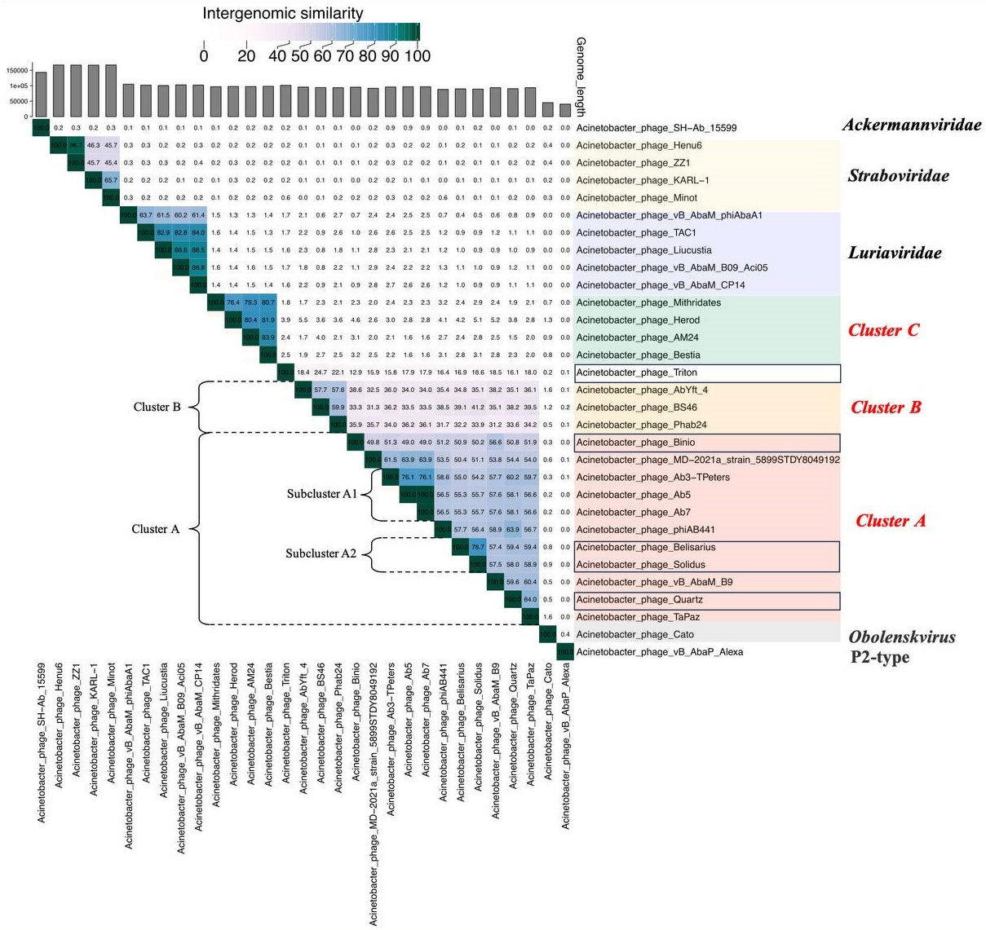

Figure 1. The VIRIDIC heatmap illustrates the percentage of intergenomic similarity (%) among the Zilberviridae phages (Cluster A, B and singleton Triton), their closest BLASTn homologs and representatives from related myophage groups. Cluster C – the group of the closest relatives: phages AM24, Bestia, Herod, Mithridates. The color gradient corresponds to the percentage of similarity, as shown in the scale. The Zilberviridae phages, which are initially isolated from the environmental samples by our research group members, are indicated by boxes.

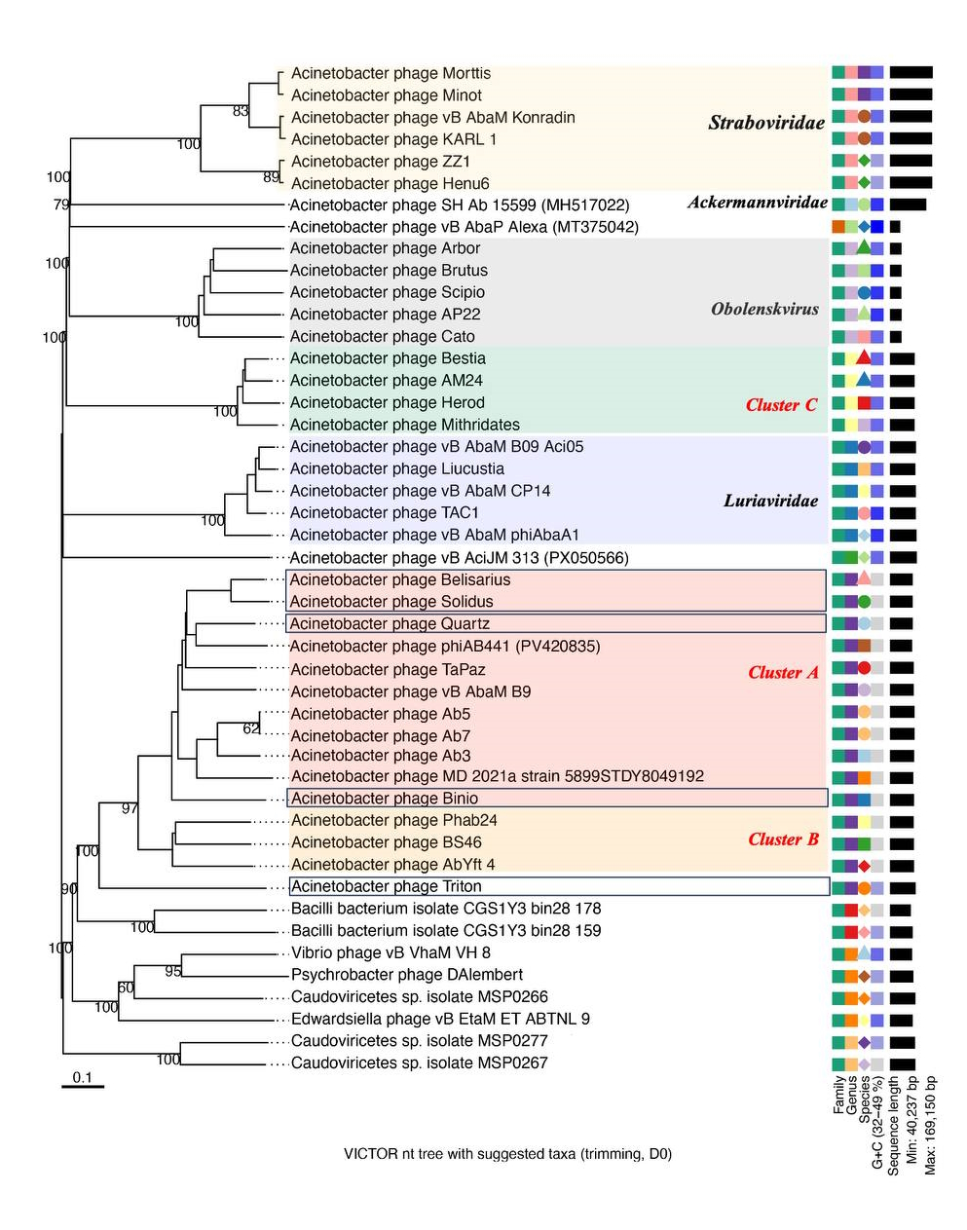
Figure 2. Genome-BLAST Distance Phylogeny analysis (VICTOR). The dendrogram was constructed using the d0 formula. The analysis supports the formation of clades corresponding to Clusters A, B and singleton Triton. Cluster C – the group of the closest relatives: phages AM24, Bestia, Herod, Mithridates. The Zilberviridae phages, which are initially isolated from the environmental samples by our research group members, are indicated by boxes.

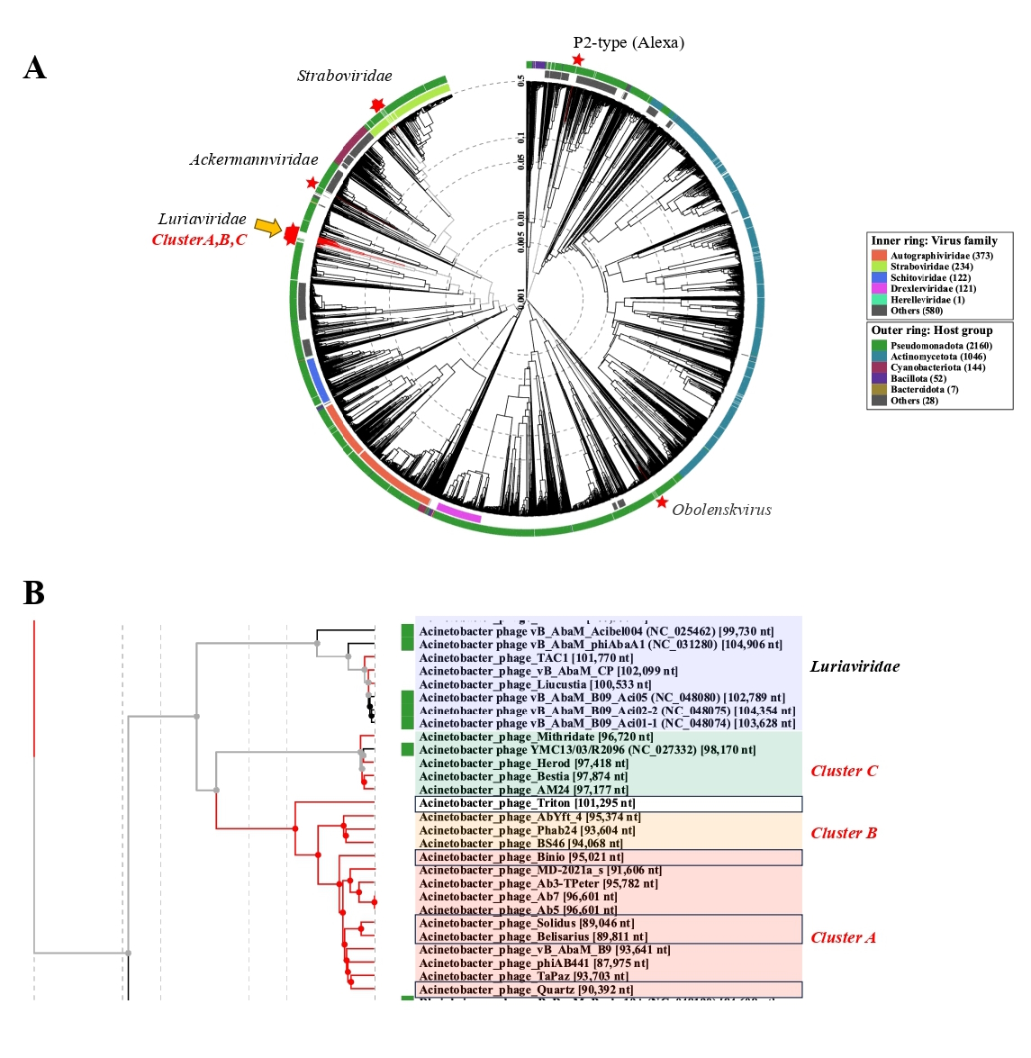 Figure 3. Proteome-based phylogenetic analysis (VipTree). (A) Circular dendrogram based on 3550 genomes (31 user-uploaded genomes marked with a star symbol*). (B) Rectangular dendrogram showing a detailed view of the phylogenetic cluster comprising Luriaviridae, and clusters A, B and singleton Triton. Cluster C – the group of the closest relatives: phages AM24, Bestia, Herod, Mithridates. The Zilberviridae phages, which are initially isolated from the environmental samples by our research group members, are indicated by boxes.

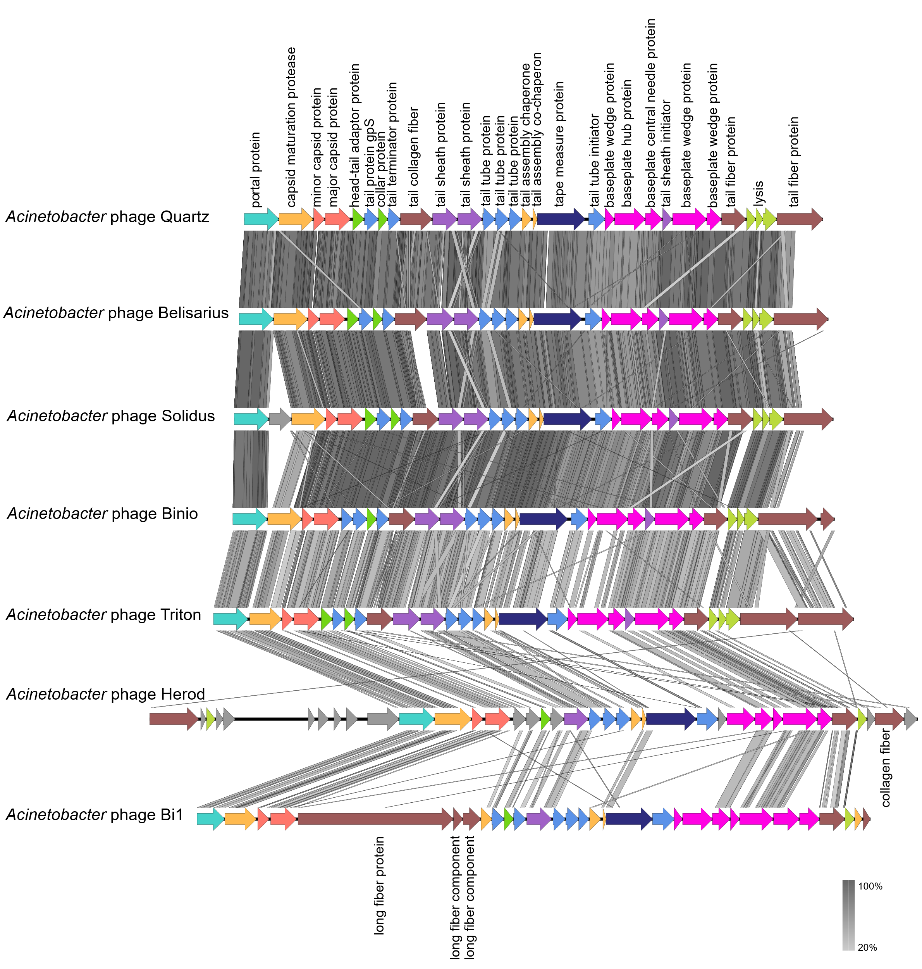
Figure 4. Comparative genomic alignment of structural gene clusters. Alignment of the structural modules of Zilberviridae phages Belisarius, Quartz, Triton, Solidus, and Binio together with representatives of closely related groups: Cluster C (phage Herod) and Luriaviridae (phage Bi1). Predicted open reading frames (ORFs) are shown as arrows, with functional annotations indicated by color. Regions of sequence similarity were identified using tBLASTx and are highlighted according to the percent identity scale.

