

The International Committee on Taxonomy of Viruses
Taxonomy Proposal Form, 2026

Part 1a: Details of taxonomy proposals

Title: | To create three new genera (Countvirus & Damascusvirus) of Microbacterium phages (Caudoviricetes)
Code assigned: | 2026.063B

Author(s), affiliation and email address(es):
Given name (+middle initial(s)) | Surname | Affiliation | Email address | Corr. author(s)
Ipek | Kurtböke | Environmental Microbiology, University of the Sunshine Coast,  School of Science, Technology and Engineering,  Maroochydore DC, Australia | IKurtbok@usc.edu.au
Cristina M. | Moraru | Department of Chemistry, Environmental Metagenomics,  University of Duisburg-Essen,  D-45141 Essen,  Germany | lilianacristina.moraru@uni-due.de
Andrew M. | Kropinski | University of Guelph, Guelph, Ontario, Canada N1G2W1 | Phage.Canada@gmail.com | x

Part 1b: Taxonomy Proposal Submission
ICTV Subcommittee:
Animal DNA Viruses and Retroviruses |  | Bacterial viruses | x
Animal minus-strand and dsRNA viruses |  | Fungal and protist viruses
Animal positive-strand RNA viruses |  | Plant viruses
Archaeal viruses |  | General -

List the ICTV Study Group(s) that have seen or have been involved in creating this proposal:
Optional – complete only if formally voted on by an ICTV Study Group:
Study Group | Number of members
Study Group | Votes in support | Votes against | No vote

Submission date: | 16/03/2026

Part 1c: Feedback from ICTV Executive Committee (EC) meeting
Executive Committee Meeting Decision code: | X
A – Accept
Ac – Accept subject to revision by relevant subcommittee chair. No further vote required
U – Accept without revision but with re-evaluation and email vote by the EC
Uc – Accept subject to revision and re-evaluation and email vote by the EC
Ud – Deferred to the next EC meeting, with an invitation to revise based on EC comments
J - Reject
W - Withdrawn

Comments from the Executive Committee:

Part 1d: Revised Taxonomy Proposal Submission
Response of proposer:
Revision date:

Part 3: TAXONOMIC PROPOSAL

Taxonomic changes proposed:
Establish new taxon | x | Split taxon
Abolish taxon |  | Merge taxon
Move taxon |  | Promote taxon
Rename taxon |  | Demote taxon
Move and rename

Etymology (origin) of proposed taxonomic names:
Taxon name | Etymology of the term
Countvirus | Named after Microbacterium phage Count
Damascusvirus | Named after Microbacterium phage Damascus

Permission for use of names derived from a living person:
Taxon name | Full name of person from whom the name is derived | Attached

Abstract of Taxonomy Proposal:
Description of current taxonomy:
These phages are peripherally related to Streptomyces phages belonging to the genus Scapunavirus

Proposed taxonomic change(s):
We propose to create three new genera: Countvirus, Camillevirus and Damascusvirus.

Demarcation criteria for new taxon/taxa:
Genus demarcation criteria: An intergenomic similarity cut-off of 70%, a combination of average nucleotide identity and alignment fraction, is used to determine genera demarcation. Members of the same genus have >70% intergenomic similarity and cluster tightly in marker gene phylogenies.

Species demarcation criteria: A demarcation value of 95% intergenomic similarity was used to define different species according to intergenomic similarity. Members of the same genus have >95% intergenomic similarity [6].

Justification:
The lytic Microbacterium phages under discussion are all classified by The Actinobacteriophage Database as members of Cluster EL. On the basis of VIRIDIC (Fig. 1), VIPTREE (Fig. 2) and phylogenetic analyses (Fig. 3) we have proposed three genera – “Camillevirus”, “Countvirus” and “Damascusvirus”. While the analyses suggest that we could construct a higher taxon uniting these viruses, there are significant differences in morphology and genome size that rule against such a move.

Text of Taxonomy proposal:
Description of current taxonomy:
These phages are peripherally related to Streptomyces phages belonging to the genus Scapunavirus

Proposed taxonomic change(s):
We propose to create three new genera: Countvirus, Camillevirus and Damascusvirus.

Demarcation criteria for new taxon/taxa:
Genus demarcation criteria: An intergenomic similarity cut-off of 70%, a combination of average nucleotide identity and alignment fraction, is used to determine genera demarcation. Members of the same genus have >70% intergenomic similarity and cluster tightly in marker gene phylogenies.

Species demarcation criteria: A demarcation value of 95% intergenomic similarity was used to define different species according to intergenomic similarity. Members of the same genus have >95% intergenomic similarity [6].

Justification:
The lytic Microbacterium phages under discussion are all classified by The Actinobacteriophage Database as members of Cluster EL. On the basis of VIRIDIC (Fig. 1), VIPTREE (Fig. 2) and phylogenetic analyses (Fig. 3) we have proposed three genera – “Camillevirus”, “Countvirus” and “Damascusvirus”. While the analyses suggest that we could construct a higher taxon uniting these viruses, there are significant differences in morphology and genome size that rule against such a move.

References:
1. Moraru C, Varsani A, Kropinski AM. VIRIDIC-A Novel Tool to Calculate the Intergenomic Similarities of Prokaryote-Infecting Viruses. Viruses. 2020 Nov 6;12(11):1268. doi: 10.3390/v12111268. PMID: 33172115; PMCID: PMC7694805. http://kronos.icbm.uni-oldenburg.de/viridic/
2. Nishimura Y, Yoshida T, Kuronishi M, Uehara H, Ogata H, Goto S. ViPTree: the viral proteomic tree server. Bioinformatics. 2017; 33(15):2379-2380. doi:10.1093/bioinformatics/btx157. PubMed PMID: 28379287. https://www.genome.jp/viptree/
3. Rohwer F, Edwards R. The Phage Proteomic Tree: a genome-based taxonomy for phage. J Bacteriol. 2002 Aug;184(16):4529-35. PubMed PMID: 12142423
4. Turner D, Reynolds D, Seto D, Mahadevan P. CoreGenes3.5: a webserver for the determination of core genes from sets of viral and small bacterial genomes. BMC Res Notes. 2013;6:140. doi: 10.1186/1756-0500-6-140. PMID: 23566564.
5. Davis P, Seto D, Mahadevan P. CoreGenes5.0: An Updated User-Friendly Webserver for the Determination of Core Genes from Sets of Viral and Bacterial Genomes. Viruses. 2022 Nov 16;14(11):2534. doi: 10.3390/v14112534. PMID: 36423143; PMCID: PMC9693508.
6. Turner D, Kropinski AM, Adriaenssens EM. A Roadmap for Genome-Based Phage Taxonomy. Viruses. 2021 Mar 18;13(3):506. doi: 10.3390/v13030506. PMID: 33803862; PMCID: PMC8003253.
Lemoine F, Correia D, Lefort V, Doppelt-Azeroual O, Mareuil F, Cohen-Boulakia S, Gascuel O. NGPhylogeny.fr: new generation phylogenetic services for non-specialists. Nucleic Acids Res. 2019 Jul 2;47(W1):W260-W265. doi: 10.1093/nar/gkz303. PMID: 31028399; PMCID: PMC6602494.
7. Letunic I, Bork P. Interactive Tree Of Life (iTOL): an online tool for phylogenetic tree display and annotation. Bioinformatics. 2007 Jan 1;23(1):127-8. doi: 10.1093/bioinformatics/btl529. Epub 2006 Oct 18. PMID: 17050570.
8. Zhou T, Xu K, Zhao F, Liu W, Li L, Hua Z, Zhou X. itol.toolkit accelerates working with iTOL (Interactive Tree of Life) by an automated generation of annotation files. Bioinformatics. 2023 Jun 1;39(6):btad339. doi: 10.1093/bioinformatics/btad339. PMID: 37225402; PMCID: PMC10243930
9. Dereeper A, Guignon V, Blanc G, Audic S, Buffet S, Chevenet F, Dufayard JF, Guindon S, Lefort V, Lescot M, Claverie JM, Gascuel O. Phylogeny.fr: robust phylogenetic analysis for the non-specialist. Nucleic Acids Res. 2008 Jul 1;36(Web Server issue):W465-9. doi: 10.1093/nar/gkn180. Epub 2008 Apr 19. PMID: 18424797; PMCID: PMC2447785.

Accompanying files:
Filename | Description of contents
Three genera Microbacterium phages 3ng_4nsp | Excel spreadsheet accompanying this proposal

Tables, Figures:

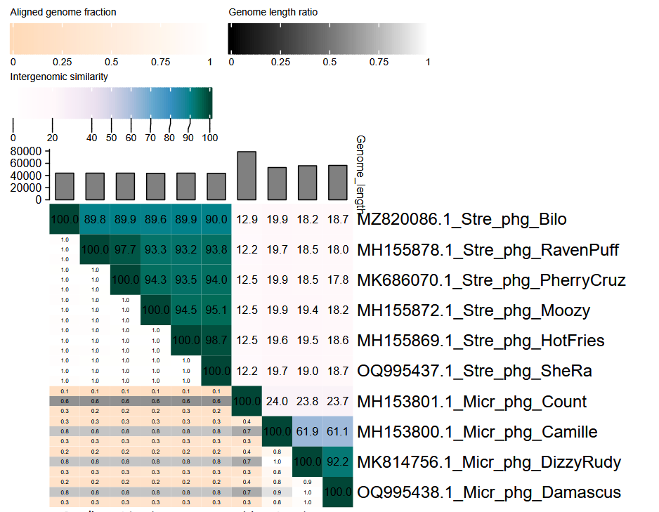
Figure 1. VIRIDIC heatmap of this group of phages. VIRIDIC (Virus Intergenomic Distance Calculator; VIRIDIC (Virus Intergenomic Distance Calculator; [1]; http://rhea.icbm.uni-oldenburg.de/VIRIDIC/) computes pairwise intergenomic distances/similarities amongst phage genomes. Data values which are bordered in black correspond to strains. AD Subcluster refers to the subcluster to which the phages belong as defined by the Actinobacteriophage Database. Abbreviations: phg = phage; Stre = Streptomyces; Micr = Microbacterium.

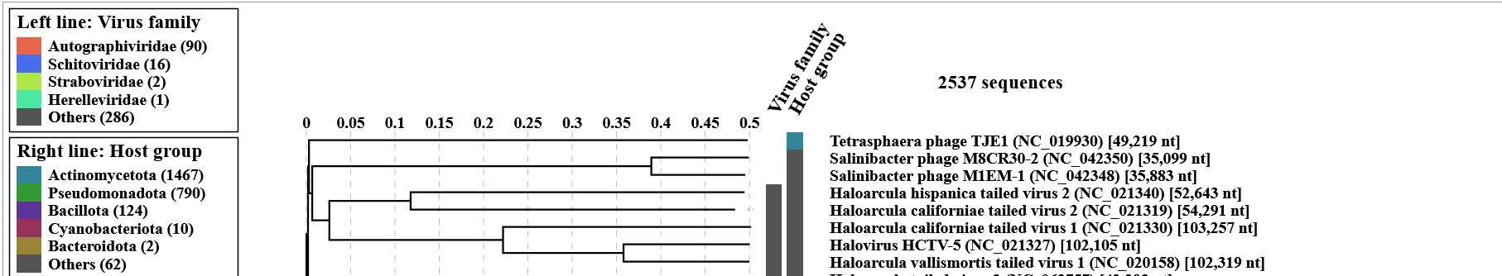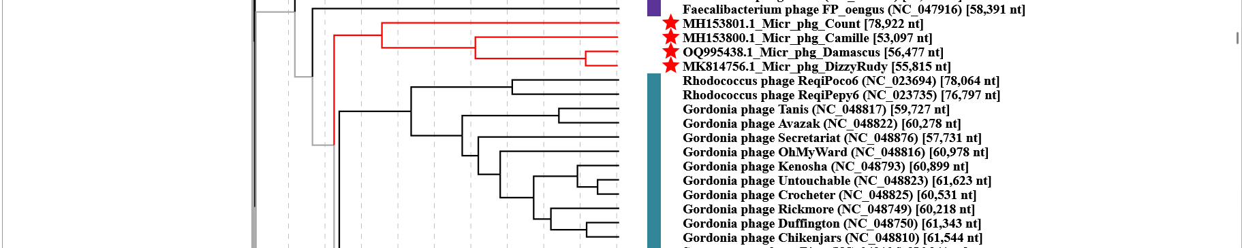
Figure 2. ViPTree analysis: ViPTree analysis (https://www.genome.jp/viptree/; [2]) is based upon Rohwer and Edwards (2002) Phage Proteomic Tree [3]. The taxons under discussion are indicated with red bars and stars. Abbreviations: phg = phage; Micr = Microbacterium; Stre = Streptomyces.

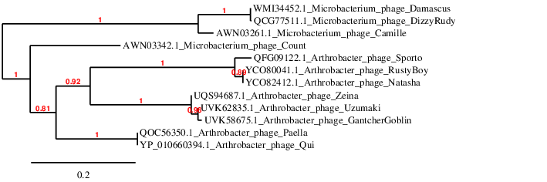

Figure 3. Phylogenetic tree constructed with the major capsid and protease fusion proteins from these and related phages using “One Click” Phylogeny.fr [9] at https://www.phylogeny.fr using the similar fusion proteins from Arthrobacter Quiviruses as outliers.

Additional data on the phages which belong to The Actinobacteriophage Database Cluster EL
Table 1. Characteristics of the phages described in the proposal which belong to Countvirus
Phage name | Host | Morphotype | Lifestyle | Accession No. | Genome size | %G+C | 3’ overhang | No. proteins | No. tRNA
Microbacterium phage Count | Microbacterium aerolatum NRRL B-24228 | Siphovirus | Lytic | MH153801.1 | 78922 bp | 51.4 | CGCCCGCCT | 131 | 2

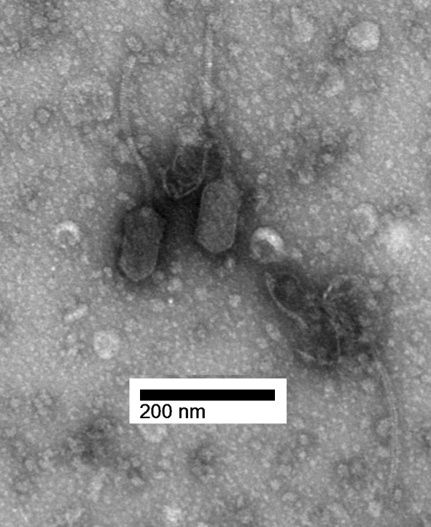
Figure 4. Electron micrograph: Electron micrograph of negatively stained Microbacterium phage Count (https://phagesdb.org/phages/Count/) . Limited permission was granted by The Actinobacteriophages Database (https://phagesdb.org/), funded by the Howard Hughes Medical Institute, to use this electron micrograph for this taxonomy proposal; it cannot be reused without permission of The Actinobacteriophages Database.

Table 2. Characteristics of the phages described in the proposal which belong to Damascusvirus
Phage name | Host | Morphotype | Lifestyle | Accession No. | Genome size | %G+C | 3’ overhang | No. proteins | No. tRNA
Microbacterium phage Damascus | Microbacterium paraoxydans NRRL B-14843 | Siphovirus | Lytic | OQ995438.1 | 56477 bp | 56.6 | CGCGTCACT | 82 | 0
Microbacterium phage DizzyRudy | Microbacterium paraoxydans NRRL B-14843 | Siphovirus | Lytic | MK814756.1 | 55815 bp | 56.4 | CGCGTCACT | 86 | 0
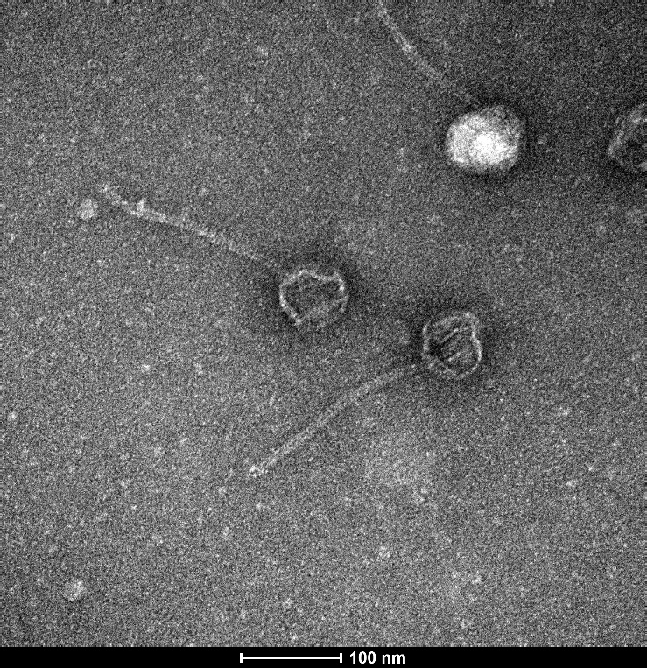Figure 5. Electron micrograph: Electron micrographs of negatively stained Microbacterium phage Damascus (https://phagesdb.org/phages/Damascus/). Limited permission was granted by The Actinobacteriophages Database (https://phagesdb.org/), funded by the Howard Hughes Medical Institute, to use this electron micrograph for this taxonomy proposal; it cannot be reused without permission of The Actinobacteriophages Database.

Table 3. Characteristics of the phages described in the proposal which belong to Camillevirus
Phage name | Host | Morphotype | Lifestyle | Accession No. | Genome size | %G+C | 3’ overhang | No. proteins | No. tRNA
Microbacterium phage Camille | Microbacterium aerolatum NRRL B-24228 | Siphovirus | Lytic | MH153800.1 | 53097 bp | 56.3 | CGCGGCCCT | 81 | 0

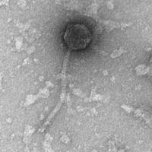
Figure 6. Electron micrographs of negatively stained Microbacterium phage Camille (https://phagesdb.org/phages/Camille/). Limited permission was granted by The Actinobacteriophages Database (https://phagesdb.org/), funded by the Howard Hughes Medical Institute, to use this electron micrograph for this taxonomy proposal; it cannot be reused without permission of The Actinobacteriophages Database.

