

The International Committee on Taxonomy of Viruses
Taxonomy Proposal Form, 2026

Part 1a: Details of taxonomy proposals

Title: | To create a new family, Sterquilinusviridae, with two new genera in the class Caudoviricetes
Code assigned: | 2026.062B

Author(s), affiliation and email address(es):
Given name (+middle initial(s)) | Surname | Affiliation | Email address | Corr. author(s)
Juntao | Shen | State Key Laboratory of Quantitative Synthetic Biology, Shenzhen Institute of Synthetic Biology, Shenzhen Institutes of Advanced Technology, Chinese Academy of Sciences, Shenzhen, China | jt.shen1@siat.ac.cn
Maja | Rupnik | Department of Microbiology, University of Maribor, Maribor, Slovenia | maja.rupnik@nlzoh.si
Cristina M. | Moraru | Department of Chemistry, Environmental Metagenomics,  University of Duisburg-Essen,  D-45141 Essen,  Germany | lilianacristina.moraru@uni-due.de
Andrew M. | Kropinski | University of Guelph, Guelph, Ontario, Canada N1G2W1 | Phage.Canada@gmail.com | x
Tomaž | Accetto | Biotechnical Faculty, University of Ljubljana, Ljubljana, Slovenia | Tomaz.Accetto@bf.uni-lj.si

Part 1b: Taxonomy Proposal Submission
ICTV Subcommittee:
Animal DNA Viruses and Retroviruses |  | Bacterial viruses | x
Animal minus-strand and dsRNA viruses |  | Fungal and protist viruses
Animal positive-strand RNA viruses |  | Plant viruses
Archaeal viruses |  | General -

List the ICTV Study Group(s) that have seen or have been involved in creating this proposal:
Caudoviricetes Study Group
Optional – complete only if formally voted on by an ICTV Study Group:
Study Group | Number of members
Study Group | Votes in support | Votes against | No vote

Submission date: | 30/07/2026

Part 1c: Feedback from ICTV Executive Committee (EC) meeting
Executive Committee Meeting Decision code: | X
A – Accept
Ac – Accept subject to revision by relevant subcommittee chair. No further vote required
U – Accept without revision but with re-evaluation and email vote by the EC
Uc – Accept subject to revision and re-evaluation and email vote by the EC
Ud – Deferred to the next EC meeting, with an invitation to revise based on EC comments
J - Reject
W - Withdrawn

Comments from the Executive Committee:

Part 1d: Revised Taxonomy Proposal Submission
Response of proposer:
Revision date:

Part 3: TAXONOMIC PROPOSAL

Taxonomic changes proposed:
Establish new taxon | x | Split taxon
Abolish taxon |  | Merge taxon
Move taxon |  | Promote taxon
Rename taxon |  | Demote taxon
Move and rename

Etymology (origin) of proposed taxonomic names:
Taxon name | Etymology of the term
"Sterquilinusviridae" | Sterquilinus is a Roman agricultural deity associated with manure, fertilizer, and the enrichment of the soil.
“Siatcasvirus” | Name derived from abbreviation of Shenzhen Institutes of Advanced Technology, Chinese Academy of Sciences
“Sargassovirus” | Named after the sources from which Croceibacter bacteriophage P2559S was isolated

Permission for use of names derived from a living person:
Taxon name | Full name of person from whom the name is derived | Attached

Abstract of Taxonomy Proposal:

Description of current taxonomy:
These phages are either unclassified or belong to the subfamily Dravavirinae which was established through Taxonomy Proposal 2025.014B.Dravavirinae_1nsf_3ng_5ns.

Proposed taxonomic change(s):
We propose to create two new genera: "Siatcasvirus" and “Sargassovirus” in a new family named “Sterquilinusviridae”

Demarcation criteria for new taxon/taxa:
Family demarcation criteria: The family is represented by a cohesive and monophyletic group in the main predicted proteome-based clustering tools (VirClust, ViPTree, GRAViTy dendrogram, vConTACT2 network). Members of the family share a significant number of orthologous genes (the number will depend on the genome sizes and number of coding sequences of members of the family).

Subfamily demarcation criteria: Subfamilies are to be created when two or more genera are related below the family level. In practical terms, this usually means that they share a low degree of sequence similarity (usually about 40-50%) and that the genera form a clade in a marker tree phylogeny.

Genus demarcation criteria: In search for criteria that create cohesive and distinct genera that are reproducible and monophyletic, the Bacterial Viruses Subcommittee established 70% nucleotide identity of the genome length as the cut-off for genera. Genus-level groupings should always be monophyletic in the signature genes, as tested with a phylogenetic tree.

Species demarcation criteria: Two phages are assigned to the same species if their genomes are more than 95% identical over their genome length for isolates. These values can be calculated by a number of tools, such as BLASTn or by using an intergenomic distance calculator such as VIRIDIC or taxMyPhage.

Justification:
These bacteriophages infect members of the bacterial genera Elizabethkingia, Bacteriodes, Parabacteriodes and Croceibacter. The genomes form a deep-rooted clade in a whole proteome TBLASTX distance tree. Analysis of the protein-encoding genes demonstrated that these bacteriophages share a total of 8 conserved protein homologs that include the portal vertex and major capsid proteins. Based on these data we propose these bacteriophages represent a new family in the class Caudoviricetes; “Sterquilinusviridae”. Analysis of intergenomic nucleotide similarities enabled the identification of two new genera for which we propose the name “Siatcasvirus” and “Sargassovirus”.

Text of Taxonomy proposal:
Description of current taxonomy:
These phages are either unclassified or belong to the subfamily Dravavirinae which was established through Taxonomy Proposal 2025.014B.Dravavirinae_1nsf_3ng_5ns

Proposed taxonomic change(s):
We propose to create two new genera: "Siatcasvirus" and “Sargassovirus” in a new family named “Sterquilinusviridae”

Demarcation criteria for new taxon/taxa:
Family demarcation criteria: The family is represented by a cohesive and monophyletic group in the main predicted proteome-based clustering tools (VirClust, ViPTree, GRAViTy dendrogram, vConTACT2 network). Members of the family share a significant number of orthologous genes (the number will depend on the genome sizes and number of coding sequences of members of the family).

Subfamily demarcation criteria: Subfamilies are to be created when two or more genera are related below the family level. In practical terms, this usually means that they share a low degree of sequence similarity (usually about 40-50%) and that the genera form a clade in a marker tree phylogeny.

Genus demarcation criteria: In search for criteria that create cohesive and distinct genera that are reproducible and monophyletic, the Bacterial Viruses Subcommittee established 70% nucleotide identity of the genome length as the cut-off for genera. Genus-level groupings should always be monophyletic in the signature genes, as tested with a phylogenetic tree [1].

Species demarcation criteria: Two phages are assigned to the same species if their genomes are more than 95% identical over their genome length for isolates. These values can be calculated by a number of tools, such as BLASTn or by using an intergenomic distance calculator such as VIRIDIC or taxMyPhage.

Justification:
These phages formed a distinct group when using a protein clustering approach using MMSeqs2 [3] with thresholds of 30% amino acid identity and 80% coverage with 28,717 genomes in the 14Apr2025 release of INPHARED [4]. To assign genomes into initial groups, a large, connected component network was created which was then partitioned using a minimum Jaccard distance threshold of 0.05. Hierarchical clustering (complete linkage) of the network was then used to segregate each group into three levels based on the proportion of shared protein clusters. At each level, the number and identity of conserved protein clusters was determined. We identified that the subfamily Dravavirinae formed a group with four other genomes which show sufficient similarity to warrant the creation of a new family (Figures 1 and 2).

Assignment of family status was supported by the hierarchically clustered TBLASTX distance tree (ViPTree) [5,6], where the genomes form a deep-branching monophyletic clade (Figure 3). The assignment of taxa was reproduced in a maximum likelihood phylogenetic tree of the eight conserved proteins identified (Figure 4). Intergenomic nucleotide similarities calculated using VIRIDIC [7] (Figure 5) indicated the presence of two new genera and four new species based on the current demarcation criteria.
References:
- Turner D, Kropinski AM, Adriaenssens EM. A Roadmap for Genome-Based Phage Taxonomy. Viruses. 2021 Mar 18;13(3):506. doi: 10.3390/v13030506. PMID: 33803862; PMCID: PMC8003253.
- Van Espen L, Bak EG, Beller L, Close L, Deboutte W, Juel HB, Nielsen T, Sinar D, De Coninck L, Frithioff-Bøjsøe C, Fonvig CE, Jacobsen S, Kjærgaard M, Thiele M, Fullam A, Kuhn M, Holm JC, Bork P, Krag A, Hansen T, Arumugam M, Matthijnssens J. A Previously Undescribed Highly Prevalent Phage Identified in a Danish Enteric Virome Catalog. mSystems. 2021 Oct 26;6(5):e0038221. doi: 10.1128/mSystems.00382-21. Epub 2021 Oct 19. PMID: 34665009; PMCID: PMC8525569.
- Steinegger M, Söding J. (2017) MMseqs2 enables sensitive protein sequence searching for the analysis of massive data sets. Nat Biotechnol. 35(11):1026-1028. doi: 10.1038/nbt.3988.
- Cook R, Brown N, Redgwell T, Rihtman B, Barnes M, Clokie M, Stekel DJ, Hobman J, Jones MA, Millard A. (2021) INfrastructure for a PHAge REference Database: Identification of Large-Scale Biases in the Current Collection of Cultured Phage Genomes. Phage 2(4):214-223. doi: 10.1089/phage.2021.0007.
- Nishimura Y, Yoshida T, Kuronishi M, Uehara H, Ogata H, Goto S. ViPTree: the viral proteomic tree server. Bioinformatics. 2017; 33(15):2379-2380. doi:10.1093/bioinformatics/btx157. PubMed PMID: 28379287. https://www.genome.jp/viptree/
- Rohwer F, Edwards R. The Phage Proteomic Tree: a genome-based taxonomy for phage. J Bacteriol. 2002 Aug;184(16):4529-35. PubMed PMID: 12142423
- Moraru C, Varsani A, Kropinski AM. VIRIDIC-A Novel Tool to Calculate the Intergenomic Similarities of Prokaryote-Infecting Viruses. Viruses. 2020 Nov 6;12(11):1268. doi: 10.3390/v12111268. PMID: 33172115; PMCID: PMC7694805. http://kronos.icbm.uni-oldenburg.de/viridic/
- Nakamura T, Yamada KD, Tomii K, Katoh K. (2018) Parallelization of MAFFT for large-scale multiple sequence alignments. Bioinformatics. 34(14):2490-2492. doi: 10.1093/bioinformatics/bty121.
- Katoh K, Standley DM. (2013) MAFFT multiple sequence alignment software version 7: improvements in performance and usability. Mol Biol Evol. 30(4):772-80. doi: 10.1093/molbev/mst010.
- Nguyen LT, Schmidt HA, von Haeseler A, and Minh BQ (2015) IQ-TREE: A fast and effective stochastic algorithm for estimating maximum likelihood phylogenies. Molecular Biology and Evolution, 32:268-274. https://doi.org/10.1093/molbev/msu300
- Kalyaanamoorthy S, Minh BQ, Wong TKF, von Haeseler A, and Jermiin JS (2017) ModelFinder: Fast Model Selection for Accurate Phylogenetic Estimates, Nature Methods, 14:587–589. https://doi.org/10.1038/nmeth.4285
- Hoang DT, Chernomor O, von Haeseler A, Minh BQ, Vinh LS (2018) UFBoot2: Improving the ultrafast bootstrap approximation. Molecular Biology and Evolution, 35:518–522. https://doi.org/10.1093/molbev/msx281
- Letunic I, Bork P. Interactive Tree Of Life (iTOL): an online tool for phylogenetic tree display and annotation. Bioinformatics. 2007 Jan 1;23(1):127-8. doi: 10.1093/bioinformatics/btl529. Epub 2006 Oct 18. PMID: 17050570.
- Zhou T, Xu K, Zhao F, Liu W, Li L, Hua Z, Zhou X. itol.toolkit accelerates working with iTOL (Interactive Tree of Life) by an automated generation of annotation files. Bioinformatics. 2023 Jun 1;39(6):btad339. doi: 10.1093/bioinformatics/btad339. PMID: 37225402; PMCID: PMC10243930.

Accompanying files:
Filename | Description of contents

Tables, Figures:

Table 1. Conserved proteins in the proposed family Sterquilinusviridae

Cluster | Predicted function | Average within cluster % identity | Average protein length (aa)
1 | hypothetical protein | 45.9 | 419.78
2 | virion structural protein | 58.61 | 313.44
3 | portal protein | 54.49 | 575.89
4 | hypothetical protein | 58.47 | 818.56
5 | virion structural protein | 54.78 | 367.44
6 | major head protein | 74.12 | 216.44
7 | virion structural protein | 62.79 | 254.67
8 | tail protein | 66.66 | 151.11

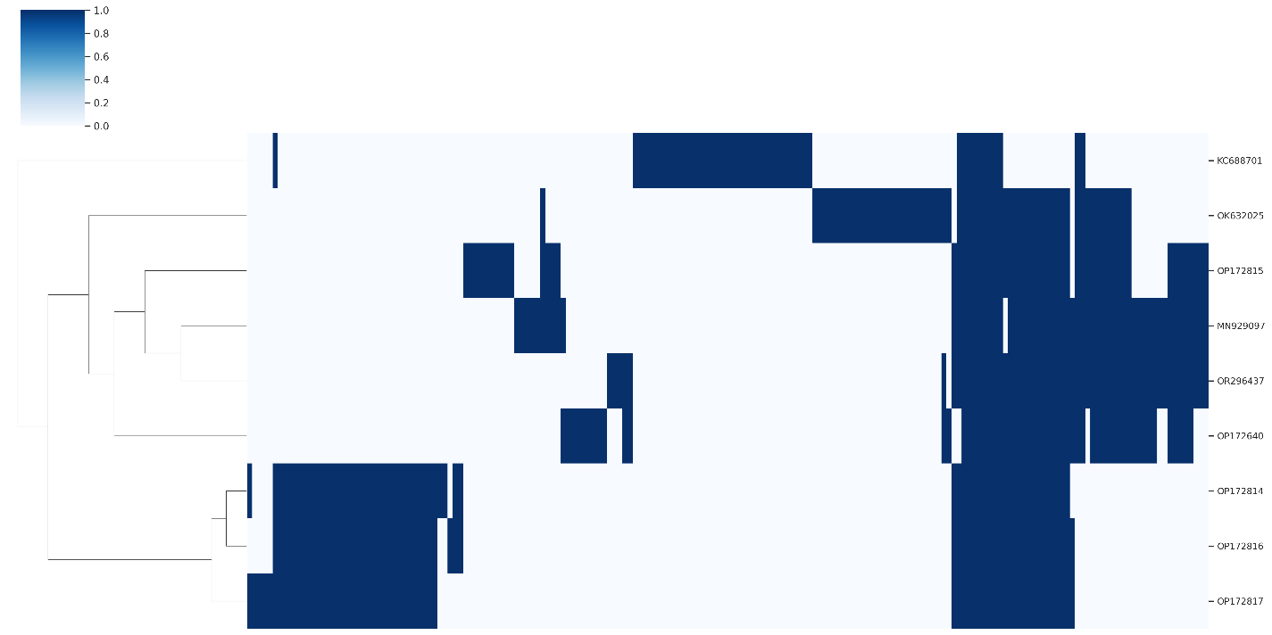

Figure 1. Presence-absence matrix of protein clusters by genome. Rows and columns were hierarchically clustered using the complete linkage method. Rows represent individual genomes with columns representing protein clusters. Vertical blue bars denote the presence of protein clusters in each genome.
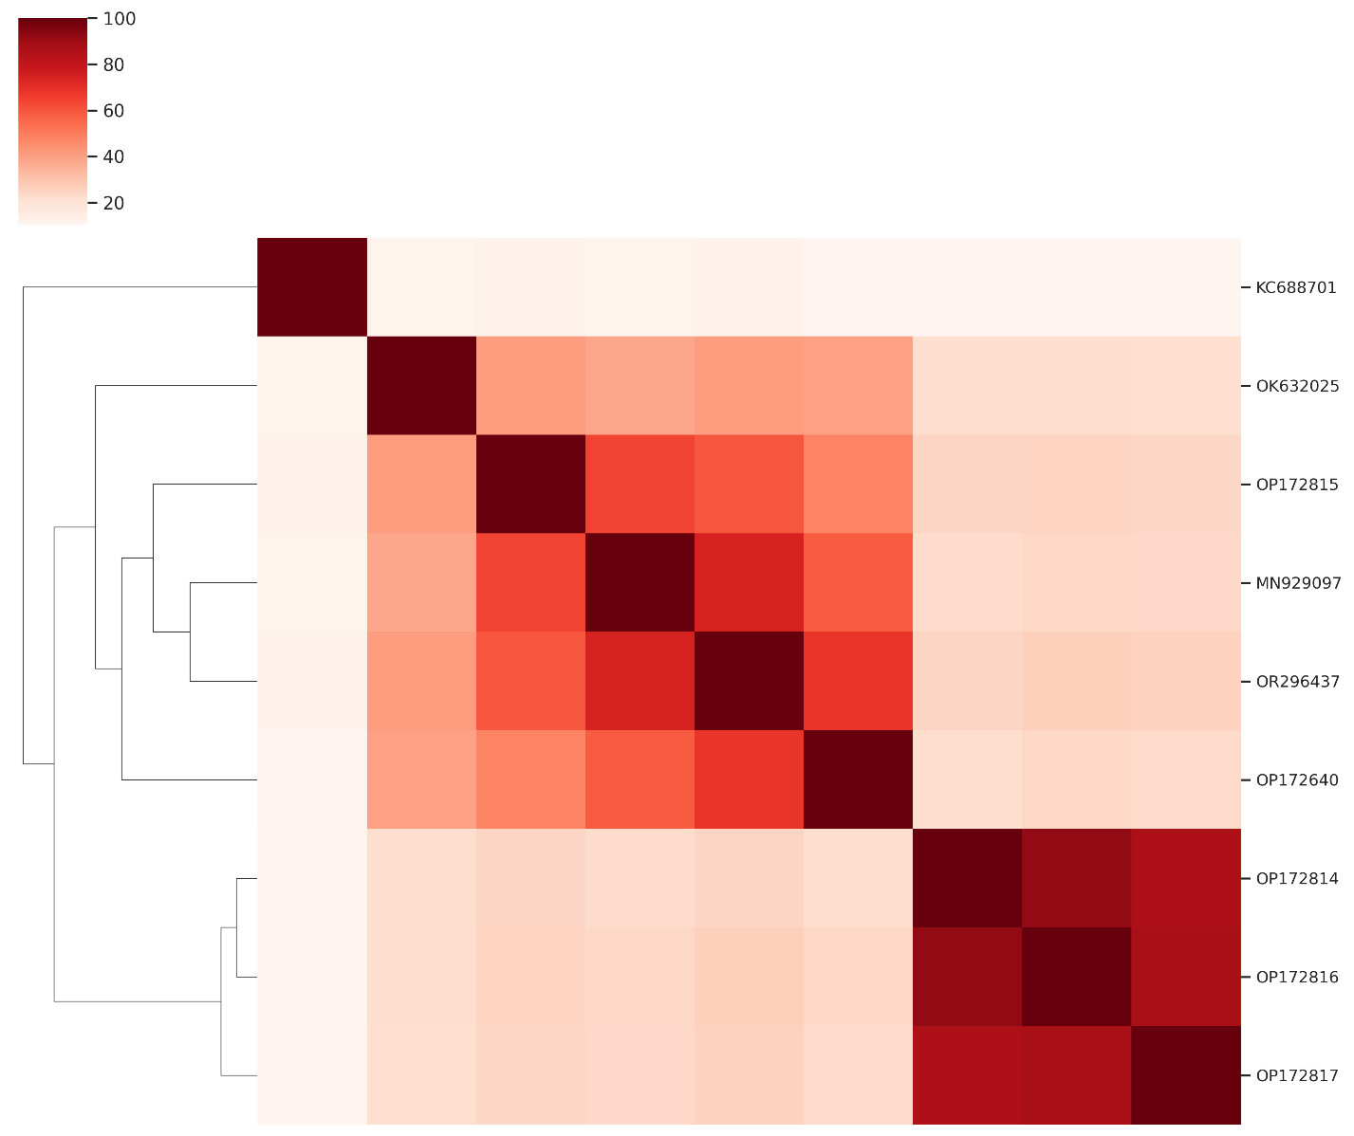

Figure 2. Heatmap of Jaccard similarity calculated from the percentage of shared protein clusters between genomes.

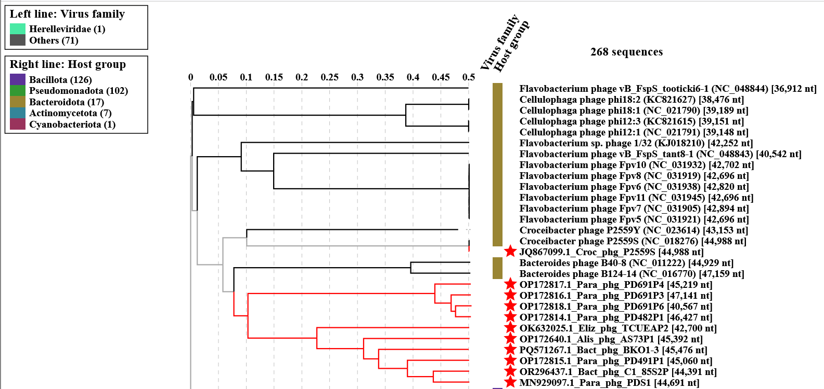

Figure 3. ViPTree analysis: ViPTree analysis (https://www.genome.jp/viptree/; [5]) is based upon Rohwer and Edwards (2002) Phage Proteomic Tree [6]. The taxa under discussion are indicated with red bars and stars. Abbreviations: phg = phage; Bact = Bacteroides; Croc = Croceibacter; Para = Parabacteroides; Eliz = Elizabethkingia; Alis = Alistipes.

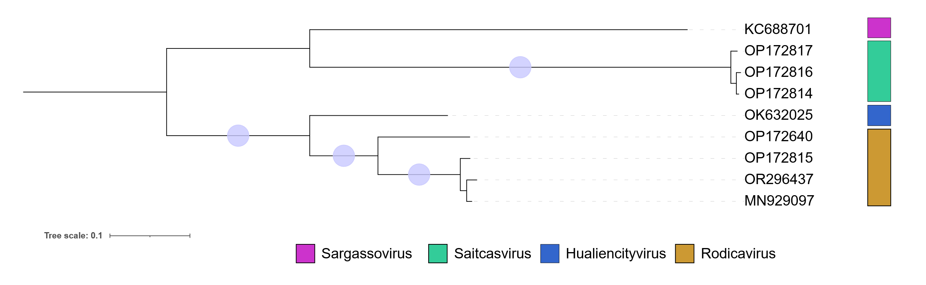
Figure 4. Concatenated core-gene maximum-likelihood phylogenetic tree. Protein clusters were aligned with MAFFT e-insi [8, 9] and trimmed with trimAl with a gap threshold of 0.5. The tree was inferred using IQTree3 [10] using a best-fit partition model inferred [11] from trees of individual protein cluster alignments and 1000 ultra-fast bootstrap [12] and SH-Alrt test replicates. The tree was rooted at the midpoint and bootstrap support ≥95% are shown as circles at branch points. The tree was visualized using iTOL [13,14].

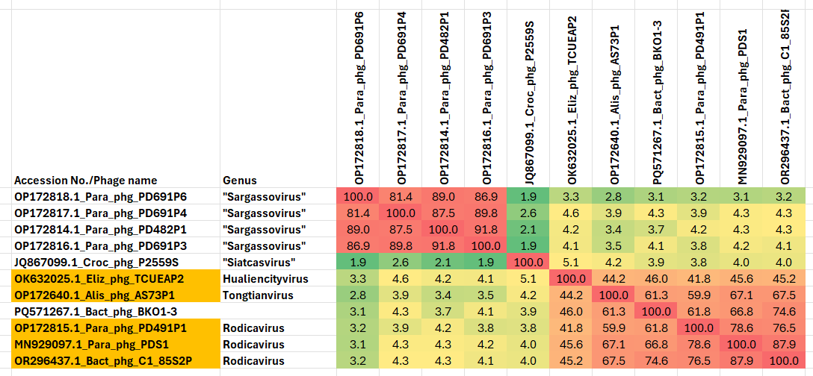

Figure 5. VIRIDIC heatmaps of this group of phages. VIRIDIC (Virus Intergenomic Distance Calculator; VIRIDIC (Virus Intergenomic Distance Calculator; [7]; http://rhea.icbm.uni-oldenburg.de/VIRIDIC/) computes pairwise intergenomic distances/similarities amongst phage genomes. Abbreviations: phg = phage; Bact = Bacteroides; Croc = Croceibacter; Para = Parabacteroides; Eliz = Elizabethkingia; Alis = Alistipes.

Table 1. Characteristics of the only phage in the genus “Saitcasvirus”.

Phage name | Host | Morphotype | Lifestyle | Accession No. | Genome size | %G+C | No. proteins | No. tRNA
Croceibacter phage P2559S | Croceibacter atlanticus HTCC2559 | Siphovirus | Lytic | JQ867099 | 44988 bp | 41.8 | 68 | 0
Specific reference: Kang I, Kang D, Cho JC. Complete genome sequence of Croceibacter bacteriophage P2559S. J Virol. 2012 Aug;86(16):8912-3. doi: 10.1128/JVI.01396-12. PMID: 22843867; PMCID: PMC3421703.

Table 2. Characteristics of the phage in the genus “Sargassovirus.”

Phage name | Host | Morphotype | Lifestyle | Accession No. | Genome size | %G+C | No. proteins | No. tRNA
Parabacteroides phage PD691P4 | Parabacteroides distasonis DA691 | Not indicted | Not indicted | OP172817 | 45,219 bp | 38.0 | 61 | 0
Parabacteroides phage PD482P1 | Parabacteroides distasonis DA482 | Not indicted | Not indicted | OP172814 | 46,427 bp | 38.7 | 60 | 0
Parabacteroides phage PD691P3 | Parabacteroides distasonis DA691 | Not indicted | Not indicted | OP172816 | 47,141 bp | 38.7 | 59 | 0
Parabacteroides phage PD691P6 | Parabacteroides distasonis DA691 | Not indicted | Not indicted | OP172818 | 40,567 bp | 38.9 | 53 | 0
Specific reference: Shen J, Zhang J, Mo L, Li Y, Li Y, Li C, Kuang X, Tao Z, Qu Z, Wu L, Chen J, Liu S, Zeng L, He Z, Chen Z, Deng Y, Zhang T, Li B, Dai L, Ma Y. Large-scale phage cultivation for commensal human gut bacteria. Cell Host Microbe. 2023 Apr 12;31(4):665-677.e7. doi: 10.1016/j.chom.2023.03.013. PMID: 37054680.

