

The International Committee on Taxonomy of Viruses
Taxonomy Proposal Form, 2026

Part 1a: Details of taxonomy proposals

Title: | To create a new subfamily (Sportogordonvirinae) for Arthrobacter phages with eight genera (Caudoviricetes)
Code assigned: | 2026.061B

Author(s), affiliation and email address(es):
Given name (+middle initial(s)) | Surname | Affiliation | Email address | Corr. author(s)
Ipek | Kurtböke | Environmental Microbiology, University of the Sunshine Coast,  School of Science, Technology and Engineering,  Maroochydore DC, Australia | IKurtbok@usc.edu.au
Cristina M. | Moraru | Department of Chemistry, Environmental Metagenomics,  University of Duisburg-Essen,  D-45141 Essen,  Germany | lilianacristina.moraru@uni-due.de
Andrew M. | Kropinski | University of Guelph, Guelph, Ontario, Canada N1G2W1 | Phage.Canada@gmail.com | x

Part 1b: Taxonomy Proposal Submission
ICTV Subcommittee:
Animal DNA Viruses and Retroviruses |  | Bacterial viruses | x
Animal minus-strand and dsRNA viruses |  | Fungal and protist viruses
Animal positive-strand RNA viruses |  | Plant viruses
Archaeal viruses |  | General -

List the ICTV Study Group(s) that have seen or have been involved in creating this proposal:
Optional – complete only if formally voted on by an ICTV Study Group:
Study Group | Number of members
Study Group | Votes in support | Votes against | No vote
Actinophage

Submission date: | March 17, 2026

Part 1c: Feedback from ICTV Executive Committee (EC) meeting
Executive Committee Meeting Decision code: | X
A – Accept
Ac – Accept subject to revision by relevant subcommittee chair. No further vote required
U – Accept without revision but with re-evaluation and email vote by the EC
Uc – Accept subject to revision and re-evaluation and email vote by the EC
Ud – Deferred to the next EC meeting, with an invitation to revise based on EC comments
J - Reject
W - Withdrawn

Comments from the Executive Committee:

Part 1d: Revised Taxonomy Proposal Submission
Response of proposer:
Revision date:

Part 3: TAXONOMIC PROPOSAL

Taxonomic changes proposed:
Establish new taxon | x | Split taxon
Abolish taxon |  | Merge taxon
Move taxon |  | Promote taxon
Rename taxon |  | Demote taxon
Move and rename

Etymology (origin) of proposed taxonomic names:
Taxon name | Etymology of the term
“Sportogordonvirinae” | Named after two of the main genera in this subfamily (“Sportovirus” & Gordonvirus)
“Sportovirus” | Named after Arthrobacter phage Sporto
“Makaivirus” | Named after Arthrobacter phage Makai
“Tokkivirus” | Named after Arthrobacter phage Tokki
“Lorettavirus” | Named after Arthrobacter phage Loretta
“Inkedvirus” | Named after Arthrobacter phage Inked
“Mediumfryvirus” | Named after Arthrobacter phage MediumFry
Gordonvirus | Existing genus established via TaxoProp 2019.004G

Permission for use of names derived from a living person:
Taxon name | Full name of person from whom the name is derived | Attached

Abstract of Taxonomy Proposal:
Description of current taxonomy: These phages are related to the phages belonging to the genus Gordonvirus

Proposed taxonomic change(s): We propose to create six new genera: “Sportovirus”, “Makaivirus”, “Tokkivirus”, “Lorettavirus”, “Inkedvirus” and “Mediumfryvirus”. Additionally, we have added Gordonvirus and its species to this new subfamily.

Demarcation criteria for new taxon/taxa: Subfamily demarcation criteria: Subfamilies are to be created when two or more genera are related below the family level. In practical terms, this usually means that they share a low degree of sequence similarity (usually about 40-50%) and that the genera form a clade in a marker tree phylogeny [6].

Genus demarcation criteria: An intergenomic similarity cut-off of 70%, a combination of average nucleotide identity and alignment fraction, is used to determine genera demarcation. Members of the same genus have >70% intergenomic similarity and cluster tightly in marker gene phylogenies.

Species demarcation criteria: A demarcation value of 95% intergenomic similarity was used to define different species according to intergenomic similarity. Members of the same species have >95% intergenomic similarity [6].

Justification: The Actinobacteriophage Database classifies these lytic Arthrobacter siphophages into Cluster AU (Makai, Tokki, Loretta, Inked MediumFry and Gordon) and AW (Sporto). This is the first time that we have proposed a taxon which unites Clusters. Intergenomic nucleotide similarities calculated using VIRIDIC demonstrate that these phages share at minimum 30% similarity (Figure 1). Each of the proposed genera and species exhibit similarity which satisfy the demarcation criteria established by the Bacterial Viruses Subcommittee. Phylogenetic analyses of the terminase large subunit proteins and TBLASTX distance analysis using ViPTree (Figure 2) demonstrate that these lytic Arhtobacter siphoviruses form a cohesive clade at the subfamily level. CoreGenes3.5 analysis revealed that representative species of this subfamily all share 43 (47%) common proteins.

Text of Taxonomy proposal:
Description of current taxonomy: These phages are related to the phages belonging to the genus Gordonvirus

Proposed taxonomic change(s): We propose to create six new genera: “Sportovirus”, “Makaivirus”, “Tokkivirus”, “Lorettavirus”, “Inkedvirus” and “Mediumfryvirus”

Demarcation criteria for new taxon/taxa: Subfamily demarcation criteria: Subfamilies are to be created when two or more genera are related below the family level. In practical terms, this usually means that they share a low degree of sequence similarity (usually about 40-50%) and that the genera form a clade in a marker tree phylogeny [6].

Genus demarcation criteria: An intergenomic similarity cut-off of 70%, a combination of average nucleotide identity and alignment fraction, is used to determine genera demarcation. Members of the same genus have >70% intergenomic similarity and cluster tightly in marker gene phylogenies.

Species demarcation criteria: A demarcation value of 95% intergenomic similarity was used to define different species according to intergenomic similarity. Members of the same species have >95% intergenomic similarity [6].

Justification: The Actinobacteriophage Database classifies these lytic Arthrobacter siphophages into Cluster AU (Makai, Tokki, Loretta, Inked MediumFry and Gordon) and AW (Sporto). This is the first time that we have proposed a taxon which unites Clusters. Intergenomic nucleotide similarities calculated using VIRIDIC demonstrate that these phages share at minimum 30% similarity (Figure 1). Each of the proposed genera and species exhibit similarity which satisfy the demarcation criteria established by the Bacterial Viruses Subcommittee. Phylogenetic analyses of the terminase large subunit proteins and TBLASTX distance analysis using ViPTree (Figure 2) demonstrate that these lytic Arhtobacter siphoviruses form a cohesive clade at the subfamily level. CoreGenes3.5 analysis revealed that representative species of this subfamily all share 43 (47%) common proteins.
References:
1. Moraru C, Varsani A, Kropinski AM. VIRIDIC-A Novel Tool to Calculate the Intergenomic Similarities of Prokaryote-Infecting Viruses. Viruses. 2020 Nov 6;12(11):1268. doi: 10.3390/v12111268. PMID: 33172115; PMCID: PMC7694805. http://kronos.icbm.uni-oldenburg.de/viridic/
2. Nishimura Y, Yoshida T, Kuronishi M, Uehara H, Ogata H, Goto S. ViPTree: the viral proteomic tree server. Bioinformatics. 2017; 33(15):2379-2380. doi:10.1093/bioinformatics/btx157. PubMed PMID: 28379287. https://www.genome.jp/viptree/
3. Rohwer F, Edwards R. The Phage Proteomic Tree: a genome-based taxonomy for phage. J Bacteriol. 2002 Aug;184(16):4529-35. PubMed PMID: 12142423
4. Turner D, Reynolds D, Seto D, Mahadevan P. CoreGenes3.5: a webserver for the determination of core genes from sets of viral and small bacterial genomes. BMC Res Notes. 2013;6:140. doi: 10.1186/1756-0500-6-140. PMID: 23566564.
5. Davis P, Seto D, Mahadevan P. CoreGenes5.0: An Updated User-Friendly Webserver for the Determination of Core Genes from Sets of Viral and Bacterial Genomes. Viruses. 2022 Nov 16;14(11):2534. doi: 10.3390/v14112534. PMID: 36423143; PMCID: PMC9693508.
6. Turner D, Kropinski AM, Adriaenssens EM. A Roadmap for Genome-Based Phage Taxonomy. Viruses. 2021 Mar 18;13(3):506. doi: 10.3390/v13030506. PMID: 33803862; PMCID: PMC8003253.
Lemoine F, Correia D, Lefort V, Doppelt-Azeroual O, Mareuil F, Cohen-Boulakia S, Gascuel O. NGPhylogeny.fr: new generation phylogenetic services for non-specialists. Nucleic Acids Res. 2019 Jul 2;47(W1):W260-W265. doi: 10.1093/nar/gkz303. PMID: 31028399; PMCID: PMC6602494.
7. Letunic I, Bork P. Interactive Tree Of Life (iTOL): an online tool for phylogenetic tree display and annotation. Bioinformatics. 2007 Jan 1;23(1):127-8. doi: 10.1093/bioinformatics/btl529. Epub 2006 Oct 18. PMID: 17050570.
8. Zhou T, Xu K, Zhao F, Liu W, Li L, Hua Z, Zhou X. itol.toolkit accelerates working with iTOL (Interactive Tree of Life) by an automated generation of annotation files. Bioinformatics. 2023 Jun 1;39(6):btad339. doi: 10.1093/bioinformatics/btad339. PMID: 37225402; PMCID: PMC10243930
9. Dereeper A, Guignon V, Blanc G, Audic S, Buffet S, Chevenet F, Dufayard JF, Guindon S, Lefort V, Lescot M, Claverie JM, Gascuel O. Phylogeny.fr: robust phylogenetic analysis for the non-specialist. Nucleic Acids Res. 2008 Jul 1;36(Web Server issue):W465-9. doi: 10.1093/nar/gkn180. Epub 2008 Apr 19. PMID: 18424797; PMCID: PMC2447785.

Accompanying files:
Filename | Description of contents
New Arthrobacter phage subfamily, Sportogordonvirinae _1nsf_5ng_10nsp | Excel spreadsheet accompanying this proposal

Tables, Figures:

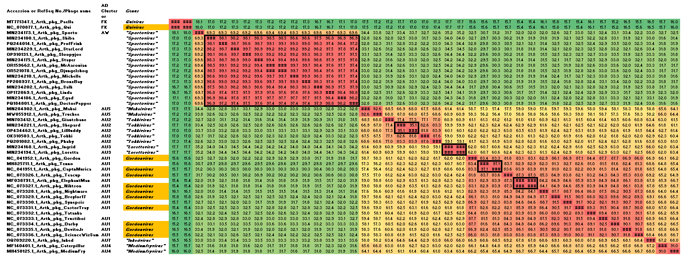

Figure 1. VIRIDIC heatmap of this group of phages. VIRIDIC (Virus Intergenomic Distance Calculator; VIRIDIC (Virus Intergenomic Distance Calculator; [1]; http://rhea.icbm.uni-oldenburg.de/VIRIDIC/) computes pairwise intergenomic distances/similarities amongst phage genomes. Data values which are bordered in black correspond to strains. AD Subcluster refers to the subcluster to which the phages belong as defined by the Actinobacteriophage Database. Abbreviations: phg = phage; Arth = Arthrobacter. Because of problems in visualizing this figure we have attached the complete VIRIDIC heatmap in Excel format.

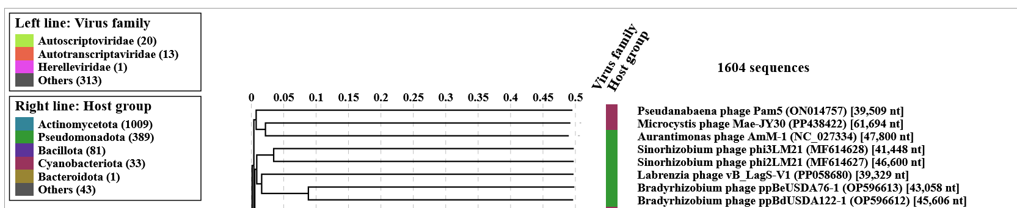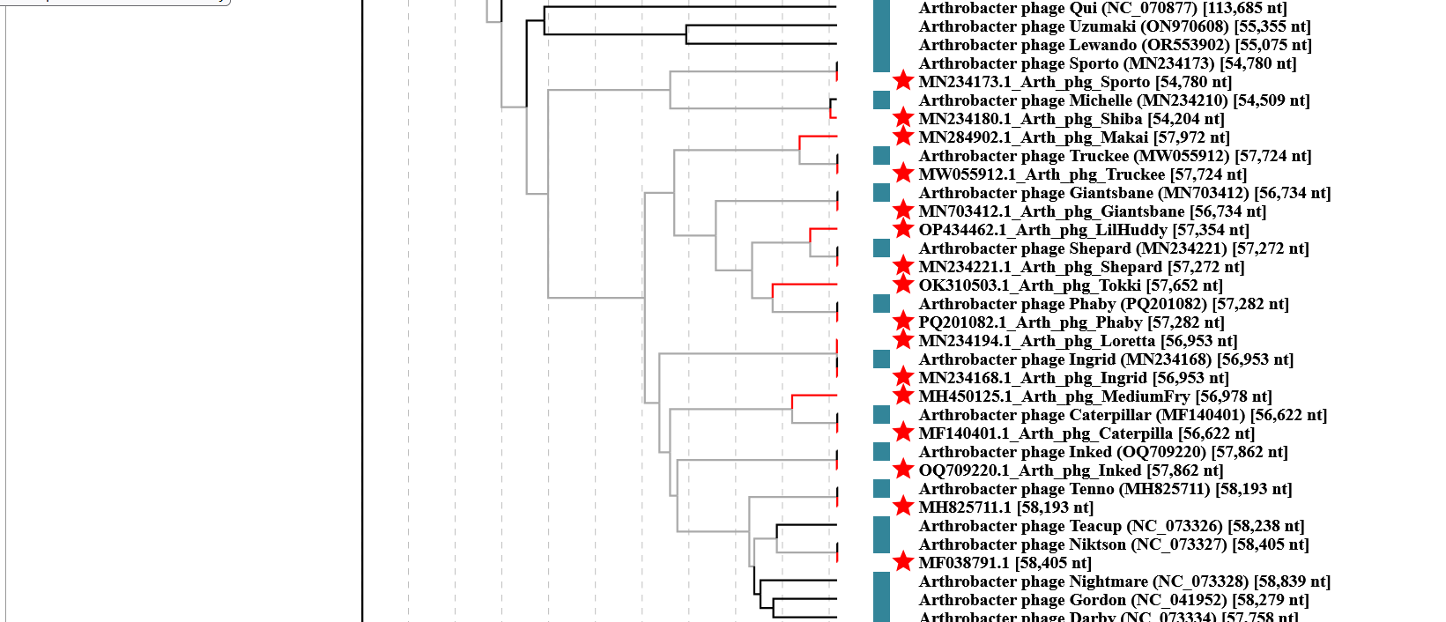
Figure 2. ViPTree analysis: ViPTree analysis (https://www.genome.jp/viptree/; [2]) is based upon Rohwer and Edwards (2002) Phage Proteomic Tree [3]. The taxons under discussion are indicated with red bars and stars. Abbreviations: phg = phage; Arth = Arthrobacter.

Figure 3. Phylogenetic tree constructed with the large subunit terminase proteins from these and related phages using “One Click” Phylogeny.fr [9] at http://phylogeny.lirmm.fr/phylo_cgi/simple_phylogeny.cgi using the similar fusion proteins from Streptomyces phages as outliers.

Additional data on the phages which belong to The Actinobacteriophage Database Clusters AW and AU

Table 1. Characteristics of the phages described in the proposal which belong to “Sportovirus”

Phage name | Host | Morphotype | Lifestyle | Accession No. | Genome size | %G+C | 3’ overhang | No. proteins | No. tRNA
Arthrobacter phage Sporto | Arthrobacter globiformis B-2979 | Siphovirus | Lytic | MN234173.1 | 54780 bp | 51.6 | CGCCGACCT | 84 | 0
Arthrobacter phage Shiba | Arthrobacter globiformis B-2979 | Siphovirus | Lytic | MN234180 | 54204 bp | 51.7 | CGCCGACCT | 86 | 0
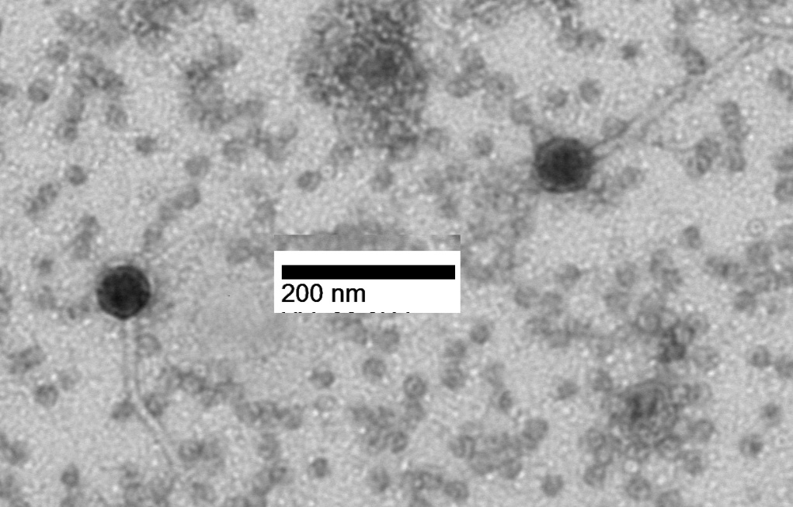Figure 4. Electron micrograph: Electron micrographs of negatively stained Arthrobacter phages Sporto (https://phagesdb.org/phages/Sporto/). Limited permission was granted by The Actinobacteriophage Database (https://phagesdb.org/), funded by the Howard Hughes Medical Institute, to use this electron micrograph for this taxonomy proposal; it cannot be reused without permission of The Actinobacteriophage Database.
Table 2. Characteristics of the phages described in the proposal which belong to "Makaivirus"
Phage name | Host | Morphotype | Lifestyle | Accession No. | Genome size | %G+C | 3’ overhang | No. proteins | No. tRNA
Arthrobacter phage Makai | Arthrobacter globiformis B-2979 | Siphovirus | Lytic | MN284902.1 | 57972 bp | 50.3 | CGCCGGTCC | 92 | 0
Arthrobacter phage Truckee | Arthrobacter globiformis B-2979 | Siphovirus | Lytic | MW055912.1 | 57724 bp | 50.5 | CGCCGGCCC | 89 | 0

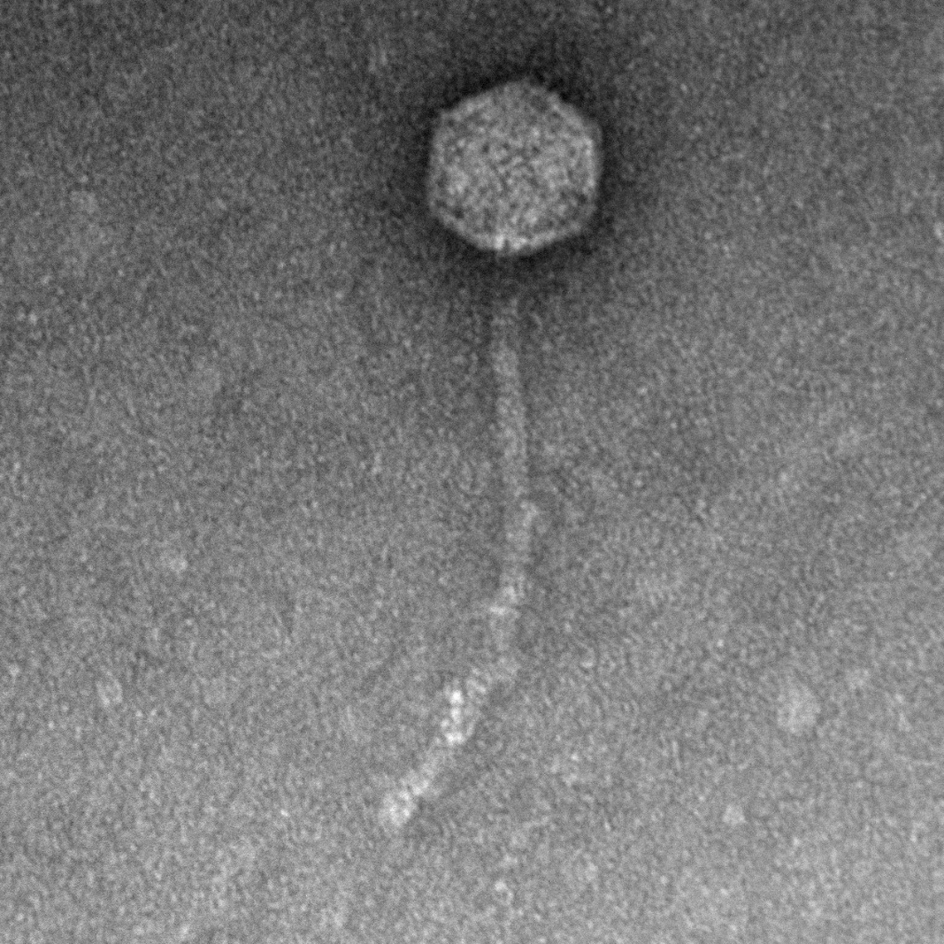
Figure 5. Electron micrograph: Electron micrographs of negatively stained Arthrobacter phages Makai (https://phagesdb.org/phages/Makai/) . Limited permission was granted by The Actinobacteriophage Database (https://phagesdb.org/), funded by the Howard Hughes Medical Institute, to use this electron micrograph for this taxonomy proposal; it cannot be reused without permission of The Actinobacteriophage Database.

Table 3. Characteristics of the phages described in the proposal which belong to "Tokkivirus"
Phage name | Host | Morphotype | Lifestyle | Accession No. | Genome size | %G+C | 3’ overhang | No. proteins | No. tRNA
Arthrobacter phage Tokki | Arthrobacter globiformis B-2979 | Siphovirus | Lytic | OK310503.1 | 57652 bp | 50.3 | CGCCGGCCC | 98 | 0
Arthrobacter phage Phaby | Arthrobacter globiformis B-2979 | Siphovirus | Lytic | PQ201082.1 | bp | 50.3 | CGCCGGCCC | 92 | 0
Arthrobacter phage Giantsbane | Arthrobacter globiformis B-2979 | Siphovirus | Lytic | MN703412.1 | 56734 bp | 50.1 | CGCCGGCCT | 94 | 0
Arthrobacter phage LilHuddy | Arthrobacter globiformis B-2979 | Siphovirus | Lytic | OP434462.1 | 57354 bp | 51.7 | CGCCGGCCC | 92 | 0

Figure 6. Electron micrograph: Electron micrographs of negatively stained Arthrobacter phages Tokki (https://phagesdb.org/phages/Tokki/) . Limited permission was granted by The Actinobacteriophage Database (https://phagesdb.org/), funded by the Howard Hughes Medical Institute, to use this electron micrograph for this taxonomy proposal; it cannot be reused without permission of The Actinobacteriophage Database.

Table 4. Characteristics of the phages described in the proposal which belong to "Lorettavirus"
Phage name | Host | Morphotype | Lifestyle | Accession No. | Genome size | %G+C | 3’ overhang | No. proteins | No. tRNA
Arthrobacter phage Loretta | Arthrobacter globiformis B-2979 | Siphovirus | Lytic | MN234194.1 | 56953 bp | 50.7 | CGCCGGCCT | 91 | 0

Figure 7. Electron micrograph: Electron micrographs of negatively stained Arthrobacter phages Loretta (https://phagesdb.org/phages/Loretta/) . Limited permission was granted by The Actinobacteriophage Database (https://phagesdb.org/), funded by the Howard Hughes Medical Institute, to use this electron micrograph for this taxonomy proposal; it cannot be reused without permission of The Actinobacteriophage Database.

Table 5. Characteristics of the phages described in the proposal which belong to "Inkedvirus"
Phage name | Host | Morphotype | Lifestyle | Accession No. | Genome size | %G+C | 3’ overhang | No. proteins | No. tRNA
Arthrobacter phage Inked | Arthrobacter sp. ATCC 21022 | Siphovirus | Lytic | OQ709220.1 | 57862 bp | 51.8 | CGCCGGCCT | 95 | 0

Table 6. Characteristics of the phages described in the proposal which belong to "Mediumfryvirus"
Phage name | Host | Morphotype | Lifestyle | Accession No. | Genome size | %G+C | 3’ overhang | No. proteins | No. tRNA
Arthrobacter phage MediumFry | Arthrobacter sp. ATCC 21022 | Siphovirus | Lytic | MH450125.1 | bp | 50.9 | CGCCGGCCC | 85 | 0

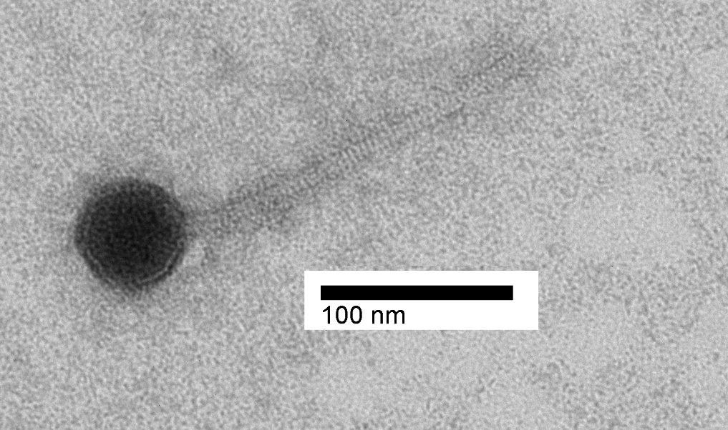
Figure 8. Electron micrograph: Electron micrographs of negatively stained Arthrobacter phages Caterpillar (https://phagesdb.org/phages/Caterpillar/) . Limited permission was granted by The Actinobacteriophage Database (https://phagesdb.org/), funded by the Howard Hughes Medical Institute, to use this electron micrograph for this taxonomy proposal; it cannot be reused without permission of The Actinobacteriophage Database.

Table 7. Characteristics of the two new phages which belong to the genus Gordonvirus
Phage name | Host | Morphotype | Lifestyle | Accession No. | Genome size | %G+C | 3’ overhang | No. proteins | No. tRNA
Arthrobacter phage Tenno | Arthrobacter sp. ATCC 21022 | Siphovirus | Lytic | MH825711 | 58193 bp | 49.6 | CGCCGGCCT | 92 | 0
Arthrobacter phage ElephantMan | Arthrobacter sp. ATCC 21022 | Siphovirus | Lytic | MF038791 | 58405 bp | 49.9 | CGCCGGCCT | 93 | 0

CoreGenes 5.0 analysis [5] reveals that this group of viruses shares 43 homologs (ca. 47%) including two HNH endonuclease, lysin A, terminase, portal, major capsid and protease fusion protein, tail terminator, major tail protein, major tail protein, four minor tail proteins, tail tapemeasure protein, DNA primase/polymerase, DNA helicase, VRR-Nuc domain protein, Cas4 family exonuclease and helix-turn-helix DNA-binding domain protein

