

The International Committee on Taxonomy of Viruses
Taxonomy Proposal Form, 2026

https://ictv.global/taxonomy/templatesPart 1a: Details of taxonomy proposals

Title: | Create one new species in the genus Skatevirus, class Caudoviricetes
Code assigned: | 2026.060B

Author(s), affiliation and email address(es):
Given name (+middle initial(s)) | Surname | Affiliation | Email address | Corr. author(s)
Jinquan | Li | Huazhong Agricultural University, Wuhan, China | lijinquan2017@163.com | X
Yang | Zhou | Huazhong Agricultural University, Wuhan, China | zhouyang@mail.hzau.edu.cn
Shan | Wang | Huazhong Agricultural University, Wuhan, China | shanwang@mai.hzau.edu.cn
Zhechang | Li | Huazhong Agricultural University, Wuhan, China
Yating | Guo | Huazhong Agricultural University, Wuhan, China | guoyating0626@126.com
Wenhao | Miao | Huazhong Agricultural University, Wuhan, China | miao_wen_hao@163.com

Part 1b: Taxonomy Proposal Submission
ICTV Subcommittee:
Animal DNA Viruses and Retroviruses |  | Bacterial viruses | X
Animal minus-strand and dsRNA viruses |  | Fungal and protist viruses
Animal positive-strand RNA viruses |  | Plant viruses
Archaeal viruses |  | General -

List the ICTV Study Group(s) that have seen or have been involved in creating this proposal: https://ictv.global/sc
Bacterial Viruses
Optional – complete only if formally voted on by an ICTV Study Group:
Study Group | Number of members
Study Group | Votes in support | Votes against | No vote

Submission date: | 27/04/2026

Part 1c: Feedback from ICTV Executive Committee (EC) meeting
Executive Committee Meeting Decision code: | X
A – Accept
Ac – Accept subject to revision by relevant subcommittee chair. No further vote required
U – Accept without revision but with re-evaluation and email vote by the EC
Uc – Accept subject to revision and re-evaluation and email vote by the EC
Ud – Deferred to the next EC meeting, with an invitation to revise based on EC comments
J - Reject
W - Withdrawn

Comments from the Executive Committee:

Part 1d: Revised Taxonomy Proposal Submission
Response of proposer:
Revision date:

Part 3: TAXONOMIC PROPOSAL
https://ictv.global/taxonomy/templates

Taxonomic changes proposed:
Establish new taxon | X | Split taxon
Abolish taxon |  | Merge taxon
Move taxon |  | Promote taxon
Rename taxon |  | Demote taxon
Move and rename

Etymology (origin) of proposed taxonomic names:
Taxon name | Etymology of the term
Skatevirus LPST49 | The species epithet is derived from the name of the bacteriophage, Salmonella phage LPST49

Permission for use of names derived from a living person:
Taxon name | Full name of person from whom the name is derived | Attached

Abstract of Taxonomy Proposal:
Description of current taxonomy:
The genus Skatevirus was established in 2021 (proposal 2021.078B.R.Siphoviridae_new_genera) and consists of seven species.

Proposed taxonomic change(s):
Add one new species, “Skatevirus LPST49” to the genus Skatevirus.

Demarcation criteria for new taxon/taxa:
Species demarcation: Two phages are assigned to the same species if their genomes are more than 95% identical over their genome length for isolates. These values can be calculated by a number of tools, such as BLASTn – usually calculated using intergenomic distance calculator VIRIDIC [1].
Genus demarcation: The Bacterial Viruses Subcommittee has established 70% nucleotide identity of the genome length as the cut-off for genera. Genus-level groupings should always be monophyletic in the signature genes, as tested with a phylogenetic tree.

Justification:
A TBLASTX distance tree of Salmonella phage LPST49 was constructed using VIPTree. LPST49, along with 19 other phages formed a single clade were selected for VIRIDIC analysis. VIRIDIC analysis computed the pairwise intergenomic similarities between the phage genomes, revealing that LPST49 exhibited less than 95% similarity with other species classified within the genus. Furthermore, a maximum-likelihood (ML) tree was constructed using the terminase large subunit of the 10 phages, with 1000 bootstrap replicates. In conclusion, we propose a new species, Skatevirus LPST49.

- Text of Taxonomy proposal:

Description of current taxonomy:
The genus Skatevirus was established in 2021 (proposal 2021.078B.R.Siphoviridae_new_genera and consists of seven species.

Proposed taxonomic change(s):
Add one new species, “Skatevirus LPST49” to the genus Skatevirus.

Demarcation criteria for new taxon/taxa:
Species demarcation: Two phages are assigned to the same species if their genomes are more than 95% identical over their genome length for isolates. These values can be calculated by a number of tools, such as BLASTn – usually calculated using intergenomic distance calculator VIRIDIC [1].
Genus demarcation: The Bacterial Viruses Subcommittee has established 70% nucleotide identity of the genome length as the cut-off for genera. Genus-level groupings should always be monophyletic in the signature genes, as tested with a phylogenetic tree. [2]

Justification:
A TBLASTX distance tree of Salmonella phage LPST49 was constructed using VIPTree [3-4] (Figure 1). LPST49, along with 19 other phages formed a single clade were selected for VIRIDIC analysis. VIRIDIC analysis computed the pairwise intergenomic similarities between the phage genomes, revealing that LPST49 exhibited less than 95% similarity with other species classified within the genus (Figure 2). Furthermore, a maximum-likelihood (ML) tree was constructed using the terminase large subunit of the 10 phages, with 1000 bootstrap replicates [5-6] (Figure 3). In conclusion, we propose a new species, Skatevirus LPST49.
References:
- Moraru C, Varsani A, Kropinski AM (2020) VIRIDIC-A Novel Tool to Calculate the Intergenomic Similarities of Prokaryote-Infecting Viruses. Viruses 12(11):1268. PMID: 33172115 / PMCID: PMC7694805 doi: 10.3390/v12111268.
- Turner D, Kropinski AM, Adriaenssens EM (2021) A Roadmap for Genome-Based Phage Taxonomy. Viruses 13(3):506. PMID: 33803862 / PMCID: PMC8003253 doi: 10.3390/v13030506.
- Nishimura Y, Yoshida T, Kuronishi M et al (2017) ViPTree: the viral proteomic tree server. Bioinformatics 33(15):2379-2380. PMID: 28379287. doi: 10.1093/bioinformatics/btx157.
- Rohwer F, Edwards R (2002) The Phage Proteomic Tree: a genome-based taxonomy for phage. J Bacteriol 184(16):4529-35. PMID: 12142423 / PMCID: PMC135240. doi: 10.1128/jb.184.16.4529-4535.2002.
- Nishijima S, Nagata N, Kiguchi Y et al (2022) Extensive gut virome variation and its associations with host and environmental factors in a population-level cohort. Nat Commun 13(1):5252. PMID: 36068216 / PMCID: PMC9448778 doi: 10.1038/s41467-022-32832-w
- L. Nguyen, H.A. Schmidt, A. von Haeseler, B.Q. Minh (2015) IQ-TREE: A Fast and Effective Stochastic Algorithm for Estimating Maximum-Likelihood Phylogenies. Mol. Biol. and Evol., 32:268-274.

Accompanying files:
Filename | Description of contents

Tables, Figures:

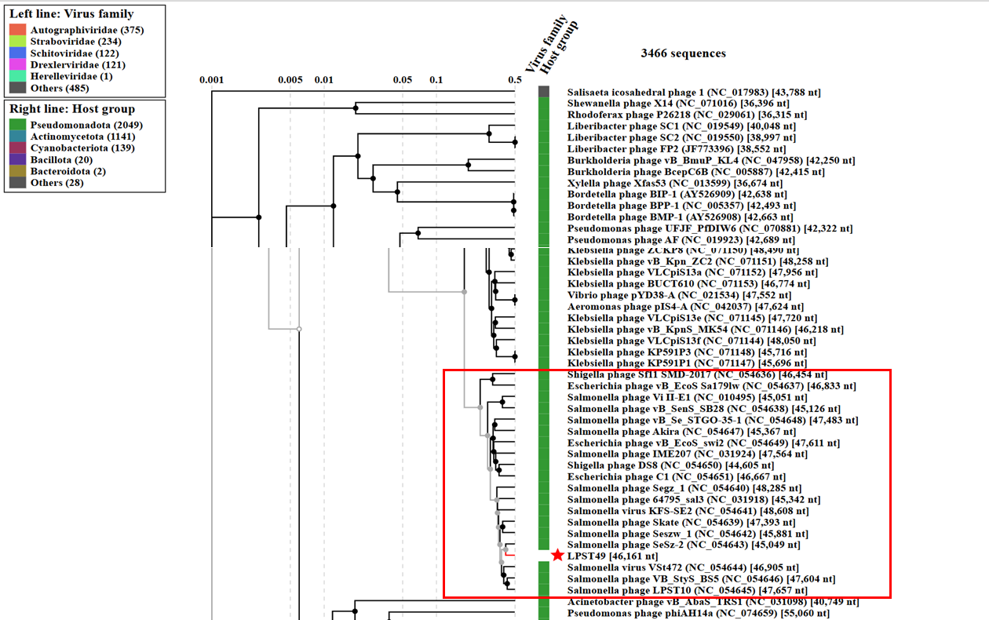

Figure 1. ViPTree analysis: ViPTree analysis (https://www.genome.jp/viptree/; [3]) is based upon Rohwer and Edwards (2002) famous Phage Proteomic Tree [4]. The phages of interest are indicated with red box and LPST49 by a red star.

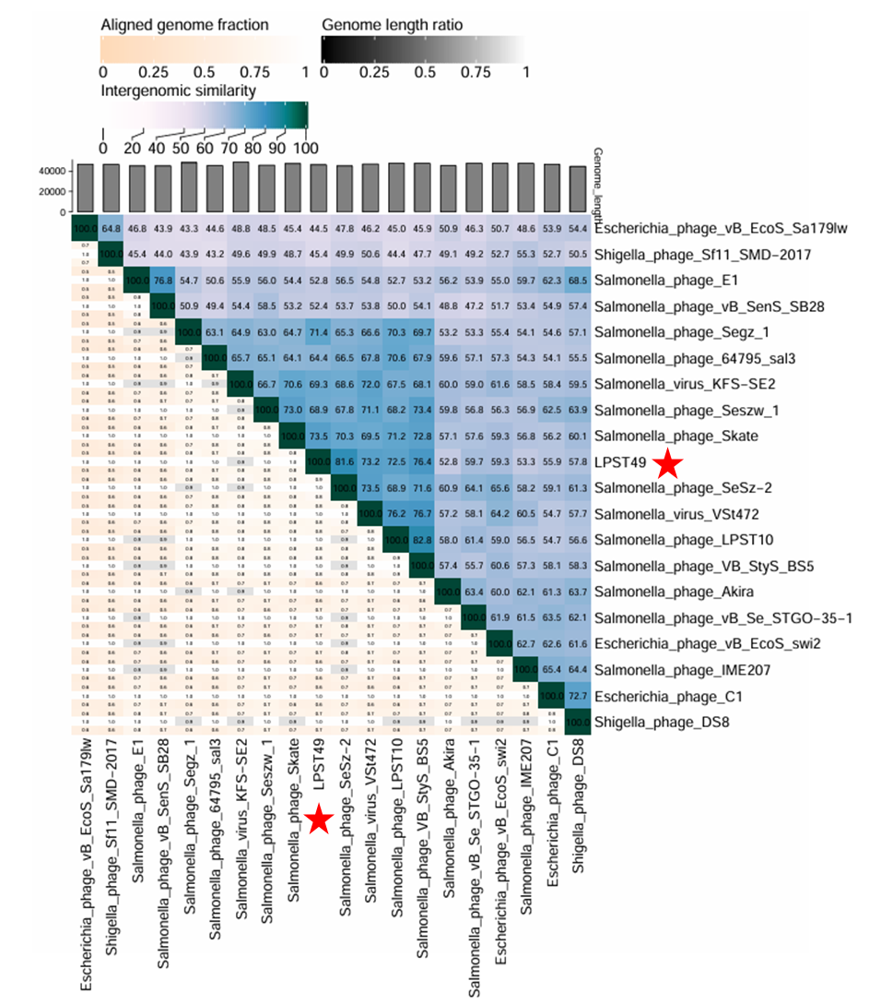Figure 2. VIRIDIC heat map: VIRIDIC (Virus Intergenomic Distance Calculator [1]; http://rhea.icbm.uni-oldenburg.de/VIRIDIC/) computes pairwise intergenomic distances/similarities amongst phage genomes.

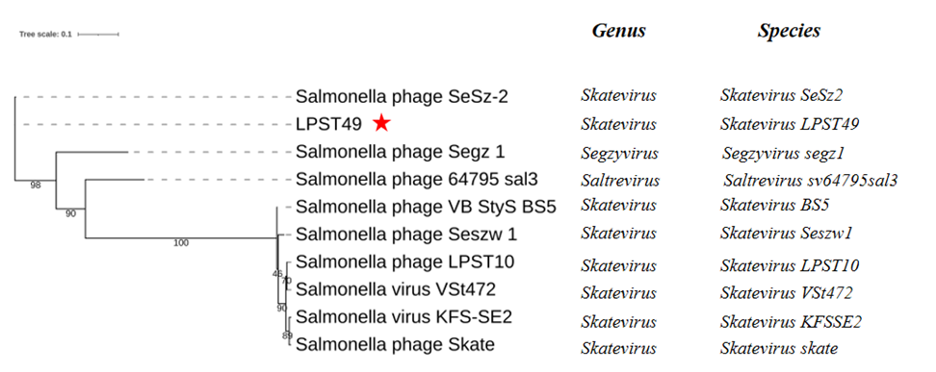Figure 3. Phylogeny: The phylogenetic tree was constructed using the major head protein of phages. Clustal Omega was used for multiple alignment and IQ-TREE was used for inferring the phylogenetic tree using the maximum-likelihood method with 1000 bootstrap replicates. The tree is rooted at the mid-point.

Historical aspects: Salmonella phage LPST49 was isolated in 2016 by Huazhong Agricultural University, using Salmonella as the host bacterium.

Genome summary:
Phage name | INSDC | Size (Kb) | GC% | Protein | tRNA
Skatevirus LPST49 | PV112475.1 | 46161 | 45.69 | 78 | 0

