

The International Committee on Taxonomy of Viruses
Taxonomy Proposal Form, 2026

Part 1a: Details of taxonomy proposals

Title: | To create a new subfamily, Simoliunasvirinae containing a new genus, Kirkilaivirus, and the genus Motookavirus (Caudoviricetes)
Code assigned: | 2026.059B

Author(s), affiliation and email address(es):
Given name (+middle initial(s)) | Surname | Affiliation | Email address | Corr. author(s)
Sigitas | Šulčius | Laboratory of Algology and Microbial Ecology, Nature Research Centre, Vilnius, Lithuania. | sigitas.sulcius@gamtc.lt | X
Ayesha | Lone | Guelph Research and Development Centre, Agriculture and Agri-Food Canada, Guelph, Ontario, Canada | ayesha.lone@agr.gc.ca
Saleh F. | AlAli | Guelph Research and Development Centre, Agriculture and Agri-Food Canada, Guelph, Ontario, Canada; College of Life Sciences, Department of Food Science and Nutrition, Kuwait University, Sabah Al Salem University City, Kuwait. | saleh.ali2@ku.edu.kw
Jakub | Barylski | Institute of Experimental Biology, Department of Molecular Virology, Adam Mickiewicz University,  Poznań, Poland | jakub.barylski@gmail.com
Cristina M. | Moraru | Department of Chemistry, Environmental Metagenomics,  University of Duisburg-Essen,  D-45141 Essen,  Germany | lilianacristina.moraru@uni-due.de
Andrew M. | Kropinski | University of Guelph, Guelph, Ontario, Canada N1G2W1 | Phage.Canada@gmail.com
Hany | Anany | Guelph Research and Development Centre, Agriculture and Agri-Food Canada, Guelph, Ontario, Canada | hany.anany@agr.gc.ca | x

Part 1b: Taxonomy Proposal Submission
ICTV Subcommittee:
Animal DNA Viruses and Retroviruses |  | Bacterial viruses | x
Animal minus-strand and dsRNA viruses |  | Fungal and protist viruses
Animal positive-strand RNA viruses |  | Plant viruses
Archaeal viruses |  | General -

List the ICTV Study Group(s) that have seen or have been involved in creating this proposal:
Herelleviridae Study Group

Optional – complete only if formally voted on by an ICTV Study Group:
Study Group | Number of members
Study Group | Votes in support | Votes against | No vote

Submission date: | 03/04/2026

Part 1c: Feedback from ICTV Executive Committee (EC) meeting
Executive Committee Meeting Decision code: | X
A – Accept
Ac – Accept subject to revision by relevant subcommittee chair. No further vote required
U – Accept without revision but with re-evaluation and email vote by the EC
Uc – Accept subject to revision and re-evaluation and email vote by the EC
Ud – Deferred to the next EC meeting, with an invitation to revise based on EC comments
J - Reject
W - Withdrawn

Comments from the Executive Committee:

Part 1d: Revised Taxonomy Proposal Submission
Response of proposer:
Revision date:

Part 3: TAXONOMIC PROPOSAL

Taxonomic changes proposed:
Establish new taxon | x | Split taxon
Abolish taxon |  | Merge taxon
Move taxon |  | Promote taxon
Rename taxon |  | Demote taxon
Move and rename

Etymology (origin) of proposed taxonomic names:
Taxon name | Etymology of the term
Simoliunasvirinae | Named in honour of Eugenijus Šimoliūnas (†)
Kirkilaivirus | This name derives from Lake Kirkilai in the Biržai District of northern Lithuania from whence the first virus of its type was isolated

Permission for use of names derived from a living person:
Taxon name | Full name of person from whom the name is derived | Attached

Abstract of Taxonomy Proposal:

Description of current taxonomy:
The genus Motookavirus was created by Taxonomy Protocol 2025.046B.Motookavirus_1ng_2ns and includes two species.

Proposed taxonomic change(s):
We propose to create a new subfamily called Simoliunasvirinae containing Motookavirus and one new genus "Kirkilaivirus".

Demarcation criteria for new taxon/taxa:
Subfamily demarcation criteria: Subfamilies are to be created when two or more genera are related below the family level. In practical terms, this usually means that they share a low degree of sequence similarity (usually about 40-50%) and that the genera form a clade in a marker tree phylogeny [6].

Genus demarcation criteria: An intergenomic similarity cut-off of 70%, a combination of average nucleotide identity and alignment fraction, is used to determine genera demarcation. Members of the same genus have >70% intergenomic similarity and cluster tightly in marker gene phylogenies.

Species demarcation criteria: A demarcation value of 95% intergenomic similarity was used to define different species according to intergenomic similarity. Members of the same genus have >95% intergenomic similarity [6].

Justification:
These bacteriophages of Bacillus spp. form a single clade in a whole genome proteomic TBLASTX distance tree. Examination of intergenomic nucleotide sequence similarities demonstrated that the two genera share ~11% similarity. These relationships were also confirmed by the phylogeney of the major capsid protein and through pangenome analysis where 105 proteins were shared between all of the genomes, representing ~35% of the total coding sequences of each bacteriophage. On this basis, we propose a new subfamily with two genera and three species.

Text of Taxonomy proposal:
Description of current taxonomy:
The genus Motookavirus was created by Taxonomy Protocol 2025.046B.Motookavirus_1ng_2ns and includes two species.

Proposed taxonomic change(s):
We propose to create a new subfamily called Simoliunasvirinae containing Motookavirus and one new genus "Kirkilaivirus".

Demarcation criteria for new taxon/taxa:
Subfamily demarcation criteria: Subfamilies are to be created when two or more genera are related below the family level. In practical terms, this usually means that they share a low degree of sequence similarity (usually about 40-50%) and that the genera form a clade in a marker tree phylogeny [6].

Genus demarcation criteria: An intergenomic similarity cut-off of 70%, a combination of average nucleotide identity and alignment fraction, is used to determine genera demarcation. Members of the same genus have >70% intergenomic similarity and cluster tightly in marker gene phylogenies.

Species demarcation criteria: A demarcation value of 95% intergenomic similarity was used to define different species according to intergenomic similarity. Members of the same genus have >95% intergenomic similarity [6].

Justification:
These bacteriophages of Bacillus spp. form a single clade in a whole genome proteomic TBLASTX distance tree (Figure 2) [2,3]. Examination of intergenomic nucleotide sequence similarities demonstrated that the two genera share ~11% similarity (Figure 1) [1]. These relationships were also confirmed by the phylogeney of the major capsid protein (Figure 3) [9] and through pangenome analysis using CoreGenes 5 [4,5] where 105 proteins were shared between all of the genomes, representing ~35% of the total coding sequences of each bacteriophage. On this basis, we propose a new subfamily with two genera and three species.

References:
1. Moraru C, Varsani A, Kropinski AM. VIRIDIC-A Novel Tool to Calculate the Intergenomic Similarities of Prokaryote-Infecting Viruses. Viruses. 2020 Nov 6;12(11):1268. doi: 10.3390/v12111268. PMID: 33172115; PMCID: PMC7694805. http://kronos.icbm.uni-oldenburg.de/viridic/
2. Nishimura Y, Yoshida T, Kuronishi M, Uehara H, Ogata H, Goto S. ViPTree: the viral proteomic tree server. Bioinformatics. 2017; 33(15):2379-2380. doi:10.1093/bioinformatics/btx157. PubMed PMID: 28379287. https://www.genome.jp/viptree/
3. Rohwer F, Edwards R. The Phage Proteomic Tree: a genome-based taxonomy for phage. J Bacteriol. 2002 Aug;184(16):4529-35. PubMed PMID: 12142423
4. Turner D, Reynolds D, Seto D, Mahadevan P. CoreGenes3.5: a webserver for the determination of core genes from sets of viral and small bacterial genomes. BMC Res Notes. 2013;6:140. doi: 10.1186/1756-0500-6-140. PMID: 23566564.
5. Davis P, Seto D, Mahadevan P. CoreGenes5.0: An Updated User-Friendly Webserver for the Determination of Core Genes from Sets of Viral and Bacterial Genomes. Viruses. 2022 Nov 16;14(11):2534. doi: 10.3390/v14112534. PMID: 36423143; PMCID: PMC9693508.
6. Turner D, Kropinski AM, Adriaenssens EM. A Roadmap for Genome-Based Phage Taxonomy. Viruses. 2021 Mar 18;13(3):506. doi: 10.3390/v13030506. PMID: 33803862; PMCID: PMC8003253.
7.Lemoine F, Correia D, Lefort V, Doppelt-Azeroual O, Mareuil F, Cohen-Boulakia S, Gascuel O. NGPhylogeny.fr: new generation phylogenetic services for non-specialists. Nucleic Acids Res. 2019 Jul 2;47(W1):W260-W265. doi: 10.1093/nar/gkz303. PMID: 31028399; PMCID: PMC6602494.
8. Letunic I, Bork P. Interactive Tree Of Life (iTOL): an online tool for phylogenetic tree display and annotation. Bioinformatics. 2007 Jan 1;23(1):127-8. doi: 10.1093/bioinformatics/btl529. Epub 2006 Oct 18. PMID: 17050570.
9. Zhou T, Xu K, Zhao F, Liu W, Li L, Hua Z, Zhou X. itol.toolkit accelerates working with iTOL (Interactive Tree of Life) by an automated generation of annotation files. Bioinformatics. 2023 Jun 1;39(6):btad339. doi: 10.1093/bioinformatics/btad339. PMID: 37225402; PMCID: PMC10243930
10. Dereeper A, Guignon V, Blanc G, Audic S, Buffet S, Chevenet F, Dufayard JF, Guindon S, Lefort V, Lescot M, Claverie JM, Gascuel O. Phylogeny.fr: robust phylogenetic analysis for the non-specialist. Nucleic Acids Res. 2008 Jul 1;36(Web Server issue):W465-9. doi: 10.1093/nar/gkn180. Epub 2008 Apr 19. PMID: 18424797; PMCID: PMC2447785.

Accompanying files:
Filename | Description of contents
Simoliunasvirinae _2ng_3nsp | Excel portion of this TaxoProp

Tables, Figures:

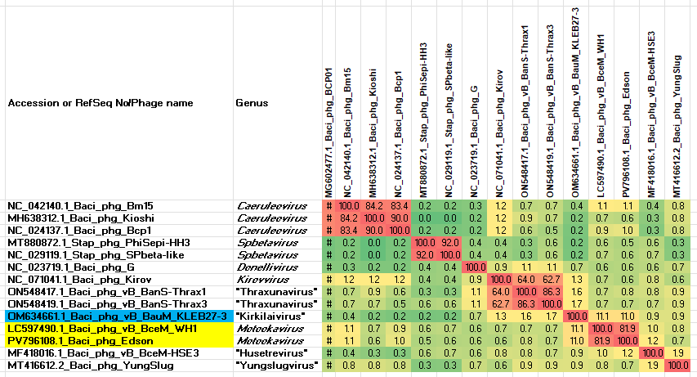

Figure 1. VIRIDIC heatmap of this group of phages. VIRIDIC (Virus Intergenomic Distance Calculator; VIRIDIC (Virus Intergenomic Distance Calculator; [1]; http://rhea.icbm.uni-oldenburg.de/VIRIDIC/) computes pairwise intergenomic distances/similarities amongst phage genomes. Abbreviations: phg = phage; Baci = Bacillus.
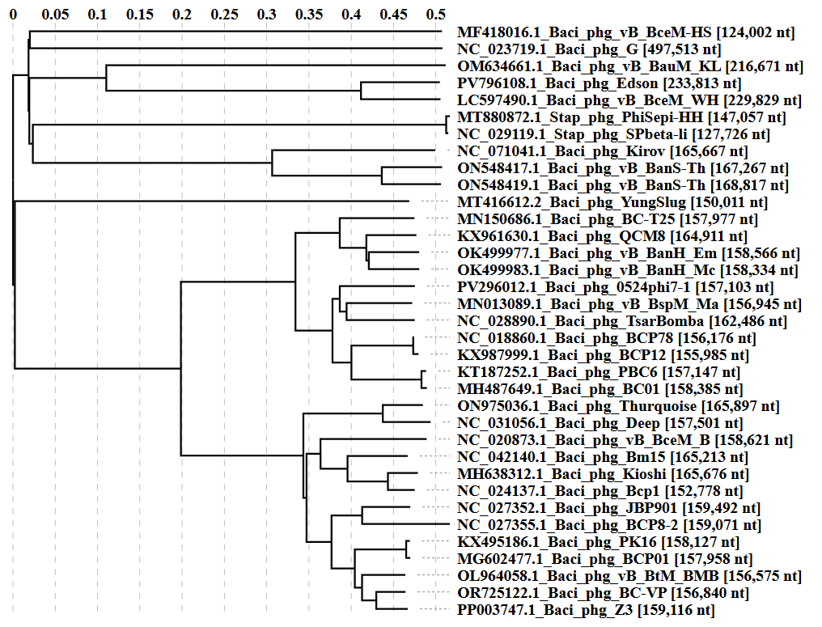

Figure 2. ViPTree analysis: ViPTree analysis (https://www.genome.jp/viptree/; [2]) is based upon Rohwer and Edwards (2002) Phage Proteomic Tree [3]. The taxons under discussion are indicated with a red arrowhead. Abbreviations: phg = phage; Baci = Bacillus.
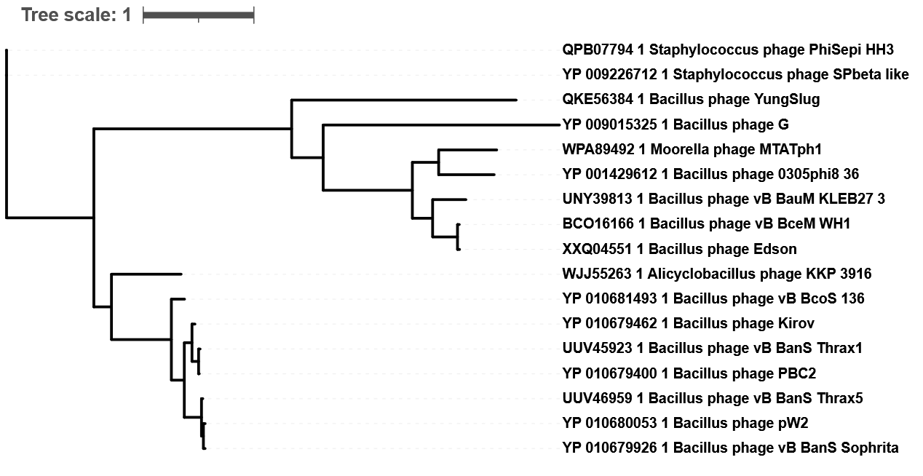Figure 3. A phylogenetic tree was constructed using the major capsid proteins from these and related phages with NGPhylogeny.fr in “one click” mode [7]. The alignment was exported to iTOL v7 [8,9]. The red arrowhead indicates the phages of interest. using the homologous proteins from Bacillus phage Sophrita as an outlier.

Table 1. Characteristics of a new phage which belongs to the genus Kirkilaivirus.

Phage name | Host | Morphotype | Lifestyle | Accession No. | Genome size | %G+C | No. proteins | No. tRNA
Bacillus phage vB_BauM_KLEB27-3 | Bacillus australimaris sKR4M-27 | Myovirus | Lytic | OM634661 | 216,671bp | 33.5 | 297 | 2

CoreGenes 5.0 analysis [5] revealed that the phages within this proposed subfamily share 105 protein homologs (35%).

(Figure 4 photograph derived from: https://www.gmc.vu.lt/en/research/researcher-profiles/dr-eugenijus-simoliunas)
This subfamily is named in honour of Eugenijus Šimoliūnas (b. 1985 d. 2025; pronounced: eh-oo-GEN-ee-yoos shee-moh-LYOO-nahs) who devoted his scientific career to studying the genetic and structural diversity of bacteriophages. He graduated in biology and biochemistry from Vilnius University in Lithuania and obtained his PhD in 2016 in the laboratory of prof. Rolandas Meškys, where he investigated the application of structural bacteriophage proteins for the construction of hybrid multifunctional nanostructures [9, 14]. In his research, Šimoliūnas focused on the isolation and molecular characterization of novel phages with unusual structure, host range, and physiology, including viruses infecting members of the genera Arthrobacter [3, 7], Bacillus [12] and Pantoea [8, 13, 15], among others. He made substantial contributions to the field of virology by expanding our knowledge of the genome complexity of jumbo phages infecting Klebsiella [5, 6], identifying and characterizing novel DNA modifications in Pantoea phages [13] that may confer resistance to host restriction-modification systems [1], and by advancing comparative virology of actinobacteriophages through the annotation of numerous structural proteins [3, 7]. His work also encompassed the development of phage-based tools for genome engineering and industry application of lytic bacteriophages [2, 4]. Eugenijus was relentless in his exploration of the “viral unknown”, seeking out the most enigmatic cases in the viral world – giant and singleton phages [5, 16], thermophilic viruses [10] and cold-adapted phages [11], thereby providing important reference information for future virologists.

1. Hutinet G, Kot W, Cui L, Hillebrand R, Balamkundu S, Gnanakalai S, Neelakandan R, Carstens AB, Fa Lui C, Tremblay D, Jacobs-Sera D, Sassanfar M, Lee YJ, Weigele P, Moineau S, Hatfull GF, Dedon PC, Hansen LH, de Crécy-Lagard V (2019) 7-Deazaguanine modifications protect phage DNA from host restriction systems. Nat Commun 10:5442. doi:10.1038/s41467-019-13384-y
2. Imklin N, Chaengphaniad P, Šimoliūnas E, Nasanit R (2023) A novel Staphylococcus phage, vB_Sau-RP15, and its application in contaminated milk. Lett Appl Microbiol 76 doi:10.1093/lambio/ovac003
3. Kaliniene L, Šimoliūnas E, Truncaitė L, Zajančkauskaitė A, Nainys J, Kaupinis A, Valius M, Meškys R (2017) Molecular Analysis of Arthrobacter Myovirus vB_ArtM-ArV1: We Blame It on the Tail. J Virol 91 doi:10.1128/jvi.00023-17
4. Labutytė G, Povilonienė S, Šimoliūnas E, Gabrielaitis D, Skapas M, Noreika A, Meškys R, Časaitė V (2021) Functionalized Protein Nanotubes Based on the Bacteriophage vB_KleM-RaK2 Tail Sheath Protein. Nanomaterials (Basel) 11 doi:10.3390/nano11113031
5. Simoliūnas E, Kaliniene L, Truncaitė L, Zajančkauskaitė A, Staniulis J, Kaupinis A, Ger M, Valius M, Meškys R (2013) Klebsiella phage vB_KleM-RaK2 - a giant singleton virus of the family Myoviridae. PLoS One 8:e60717. doi:10.1371/journal.pone.0060717
6. Šimoliūnas E, Kaliniene L, Truncaite L, Klausa V, Zajančkauskaite A, Meškys R (2012) Genome of Klebsiella sp.-infecting bacteriophage vB_KleM_RaK2. J Virol 86:5406. doi:10.1128/jvi.00347-12
7. Šimoliūnas E, Kaliniene L, Stasilo M, Truncaitė L, Zajančkauskaitė A, Staniulis J, Nainys J, Kaupinis A, Valius M, Meškys R (2014) Isolation and characterization of vB_ArS-ArV2 - first Arthrobacter sp. infecting bacteriophage with completely sequenced genome. PLoS One 9:e111230. doi:10.1371/journal.pone.0111230
8. Šimoliūnas E, Šimoliūnienė M, Kaliniene L, Zajančkauskaitė A, Skapas M, Meškys R, Kaupinis A, Valius M, Truncaitė L (2018) Pantoea Bacteriophage vB_PagS_Vid5: A Low-Temperature Siphovirus That Harbors a Cluster of Genes Involved in the Biosynthesis of Archaeosine. Viruses 10 doi:10.3390/v10110583
9. Šimoliūnas E, Truncaitė L, Rutkienė R, Povilonienė S, Goda K, Kaupinis A, Valius M, Meškys R (2019) The Robust Self-Assembling Tubular Nanostructures Formed by gp053 from Phage vB_EcoM_FV3. Viruses 11 doi:10.3390/v11010050
10. Šimoliūnas E, Šimoliūnienė M, Laskevičiūtė G, Kvederavičiūtė K, Skapas M, Kaupinis A, Valius M, Meškys R, Kuisienė N (2023) Geobacillus Bacteriophages from Compost Heaps: Representatives of Three New Genera within Thermophilic Siphoviruses. Viruses 15 doi:10.3390/v15081691
11. Šimoliūnienė M, Truncaitė L, Petrauskaitė E, Zajančkauskaitė A, Meškys R, Skapas M, Kaupinis A, Valius M, Šimoliūnas E (2020) Pantoeaagglomerans-Infecting Bacteriophage vB_PagS_AAS21: A Cold-Adapted Virus Representing a Novel Genus within the Family Siphoviridae. Viruses 12 doi:10.3390/v12040479
12. Šimoliūnienė M, Tumėnas D, Kvederavičiūtė K, Meškys R, Šulčius S, Šimoliūnas E (2020) Complete Genome Sequence of Bacillus cereus Bacteriophage vB_BceS_KLEB30-3S. Microbiol Resour Announc 9 doi:10.1128/mra.00348-20
13. Šimoliūnienė M, Žukauskienė E, Truncaitė L, Cui L, Hutinet G, Kazlauskas D, Kaupinis A, Skapas M, Crécy-Lagard V, Dedon PC, Valius M, Meškys R, Šimoliūnas E (2021) Pantoea Bacteriophage vB_PagS_MED16-A Siphovirus Containing a 2'-Deoxy-7-amido-7-deazaguanosine-Modified DNA. Int J Mol Sci 22 doi:10.3390/ijms22147333
14. Špakova A, Šimoliūnas E, Batiuškaitė R, Pajeda S, Meškys R, Petraitytė-Burneikienė R (2019) Self-Assembly of Tail Tube Protein of Bacteriophage vB_EcoS_NBD2 into Extremely Long Polytubes in E. coli and S. cerevisiae. Viruses 11 doi:10.3390/v11030208
15. Truncaitė L, Šimoliūnienė M, Alijošius L, Petrauskaitė E, Kiaušaitė L, Meškys R, Skapas M, Šimoliūnas E (2020) Complete genome analysis of Pantoea agglomerans-infecting bacteriophage vB_PagM_AAM22. Arch Virol 165:2111–2114. doi:10.1007/s00705-020-04705-4
16. Žukauskienė E, Šimoliūnienė M, Truncaitė L, Skapas M, Kaupinis A, Valius M, Meškys R, Šimoliūnas E (2021) Bacteriophage vB_PagS_AAS23: A Singleton of the Genus Sauletekiovirus. Microorganisms 9 doi: 10.3390/microorganisms9030668

