

The International Committee on Taxonomy of Viruses
Taxonomy Proposal Form, 2026

Part 1a: Details of taxonomy proposals

Title: | To create a new family, Shennongviridae in the class Caudoviricetes
Code assigned: | 2026.058B

Author(s), affiliation and email address(es):
Given name (+middle initial(s)) | Surname | Affiliation | Email address | Corr. author(s)
Zhe | Liu | School of Basic Medical Sciences, Tsinghua University, Beijing, China. | liu-z20@mails.tsinghua.edu.cn
Yaoyu | Yang | School of Basic Medical Sciences, Tsinghua University, Beijing, China. | yang-yy21@mails.tsinghua.edu.cn
Yuyu | Yuan | School of Basic Medical Sciences, Tsinghua University, Beijing, China. | yuyuyuna@163.com
Ye | Xiang | School of Basic Medical Sciences, Tsinghua University, Beijing, China. | yxiang@mail.tsinghua.edu.cn | X
Juntao | Shen | State Key Laboratory of Quantitative Synthetic Biology, Shenzhen Institute of Synthetic Biology, Shenzhen Institutes of Advanced Technology, Chinese Academy of Sciences, Shenzhen, China | jt.shen1@siat.ac.cn
Tomaž | Accetto | Biotechnical Faculty, University of Ljubljana, Ljubljana, Slovenia | Tomaz.Accetto@bf.uni-lj.si
Maja | Rupnik | Department of Microbiology, University of Maribor, Maribor, Slovenia | maja.rupnik@nlzoh.si
Andrew M. | Kropinski | Department of Pathobiology, University of Guelph, Guelph, Ontario, Canada | Phage.Canada@gmail.com | x

Part 1b: Taxonomy Proposal Submission
ICTV Subcommittee:
Animal DNA Viruses and Retroviruses |  | Bacterial viruses | x
Animal minus-strand and dsRNA viruses |  | Fungal and protist viruses
Animal positive-strand RNA viruses |  | Plant viruses
Archaeal viruses |  | General -

List the ICTV Study Group(s) that have seen or have been involved in creating this proposal:
Caudoviricetes Study Group

Optional – complete only if formally voted on by an ICTV Study Group:
Study Group | Number of members
Study Group | Votes in support | Votes against | No vote

Submission date: | 26/07/2026

Part 1c: Feedback from ICTV Executive Committee (EC) meeting
Executive Committee Meeting Decision code: | X
A – Accept
Ac – Accept subject to revision by relevant subcommittee chair. No further vote required
U – Accept without revision but with re-evaluation and email vote by the EC
Uc – Accept subject to revision and re-evaluation and email vote by the EC
Ud – Deferred to the next EC meeting, with an invitation to revise based on EC comments
J - Reject
W - Withdrawn

Comments from the Executive Committee:

Part 1d: Revised Taxonomy Proposal Submission
Response of proposer:
Revision date:

Part 3: TAXONOMIC PROPOSAL

Taxonomic changes proposed:
Establish new taxon | x | Split taxon
Abolish taxon | x | Merge taxon
Move taxon | x | Promote taxon
Rename taxon |  | Demote taxon
Move and rename

Etymology (origin) of proposed taxonomic names:
Taxon name | Etymology of the term
“Shennongviridae” | Shennong (神農), variously translated as "Divine Farmer" or "Divine Husbandman", was a mythological Chinese ruler known as the first Yan Emperor who has become a deity in Chinese folk religion.
"Xuanwuvirinae" | Xuanwu (玄武) is a deity in Chinese religion and one of the higher-ranking deities in Taoism. He is identified as the god of the north, associated with water, winter, and the Black Turtle-Snake — one of the Four Symbols of the Chinese constellations. He is particularly revered by practitioners of martial arts and as a protective deity against evil and disease.
"Tsinghuavirus" | Named after Tsinghua University (Beijing, China), where in the School of Basic Medical Sciences the first phage of its type was isolated
"Nuwavirus" | Nüwa (女媧) is a mother goddess, culture hero, and/or member of the Three Sovereigns of Chinese mythology. She is a goddess in Chinese folk religion, Chinese Buddhism, Confucianism and Taoism. She is credited with creating humanity.
"Xueyuanvirus" | Named after the address (Xueyuan Boulevard) of the Shenzhen Institute of Synthetic Biology, Shenzhen Institutes of Advanced Technology, Chinese Academy of Sciences where the first phage of its type was isolated
"Fuxivirus" | Fuxi (伏羲) is a culture hero in Chinese mythology, credited along with his sister and wife Nüwa with creating humanity and the invention of music, hunting, fishing, domestication, and cooking, as well as the Cangjie system of writing Chinese characters around 2900 BC or 2000 BC

Permission for use of names derived from a living person:
Taxon name | Full name of person from whom the name is derived | Attached

Abstract of Taxonomy Proposal:

Description of current taxonomy:
The phages in this proposal are either unclassified or belong to the subfamilies Jianjiangvirinae (2025.027B.Jianjiangvirinae_1nsf_2ng_22ns) and Pearlrivervirinae (2025.057B.Pearlrivervirinae_1nsf_2ng_16ns) or the genus Lingdingyangvirus (2025.037B.Lingdingyangvirus_1ng_22ns).

Proposed taxonomic change(s):
We propose to create a new family Shennongviridae containing subfamilies Jianjiangvirinae, Pearlrivervirinae and the genus Lingdingyangvirus. Additionally, we propose four new genera ("Tsinghuavirus," "Nuwavirus," "Xueyuanvirus" and "Fuxivirus") plus a new subfamily, "Xuanwuvirinae" including the genera Lingdingyangvirus and "Tsinghuavirus."

Demarcation criteria for new taxon/taxa:
Family demarcation criteria: The family is represented by a cohesive and monophyletic group in the main predicted proteome-based clustering tools (VirClust, ViPTree, GRAViTy dendrogram, vConTACT2 network). Members of the family share a significant number of orthologous genes (the number will depend on the genome sizes and number of coding sequences of members of the family).

Subfamily demarcation criteria: Subfamilies are to be created when two or more genera are related below the family level. In practical terms, this usually means that they share a low degree of sequence similarity (usually about 40-50%) and that the genera form a clade in a marker tree phylogeny.

Genus demarcation criteria: In search for criteria that create cohesive and distinct genera that are reproducible and monophyletic, the Bacterial Viruses Subcommittee established 70% nucleotide identity of the genome length as the cut-off for genera. Genus-level groupings should always be monophyletic in the signature genes, as tested with a phylogenetic tree.

Species demarcation criteria: Two phages are assigned to the same species if their genomes are more than 95% identical over their genome length for isolates. These values can be calculated by a number of tools, such as BLASTn – usually calculated using intergenomic distance calculator VIRIDIC.

Justification:
Using BLASTN and protein clustering a group of 127 bacteriophages was identified. These bacteriophages infect the bacteria genera Bacteriodes, Parabacteriodes and Phocaeicola. Electron microscopy of representative members revealed a consistent morphology characterized by an icosahedral capsid approximately 65 nm in diameter and a non-contractile tail approximately 120 nm in length. The dsDNA genomes average 36.6 kbp in length with a 45.41 mol%G+C content. Phages in this family are predicted to use a pac-type headful packaging strategy, as indicated by PhageTerm analysis [2]. The genomes form a deep-branching clade in the TBLASTX distance tree and are predicted to share five conserved proteins including a virion structural protein, portal vertex, helicase, DNA polymerase and a single-stranded DNA binding protein. Intergenomic nucleotide sequence similarity indicated the presence of four new genera and 26 new species.

Based on these data we propose a new family, “Shennongviridae” that includes three subfamilies and eight genera.

Text of Taxonomy proposal:
Description of current taxonomy:
The phages in this proposal are either unclassified or belong to the subfamilies Jianjiangvirinae (2025.027B.Jianjiangvirinae_1nsf_2ng_22ns) and Pearlrivervirinae (2025.057B.Pearlrivervirinae_1nsf_2ng_16ns) or the genus Lingdingyangvirus (2025.037B.Lingdingyangvirus_1ng_22ns).

Proposed taxonomic change(s):
We propose to create a new family Shennongviridae containing subfamilies Jianjiangvirinae, Pearlrivervirinae and the genus Lingdingyangvirus. Additionally, we propose four new genera ("Tsinghuavirus," "Nuwavirus," "Xueyuanvirus" and "Fuxivirus") plus a new subfamily, "Xuanwuvirinae" including the genera Lingdingyangvirus and "Tsinghuavirus."

Demarcation criteria for new taxon/taxa:
Family demarcation criteria: The family is represented by a cohesive and monophyletic group in the main predicted proteome-based clustering tools (VirClust, ViPTree, GRAViTy dendrogram, vConTACT2 network). Members of the family share a significant number of orthologous genes (the number will depend on the genome sizes and number of coding sequences of members of the family).

Subfamily demarcation criteria: Subfamilies are to be created when two or more genera are related below the family level. In practical terms, this usually means that they share a low degree of sequence similarity (usually about 40-50%) and that the genera form a clade in a marker tree phylogeny.

Genus demarcation criteria: In search for criteria that create cohesive and distinct genera that are reproducible and monophyletic, the Bacterial Viruses Subcommittee established 70% nucleotide identity of the genome length as the cut-off for genera. Genus-level groupings should always be monophyletic in the signature genes, as tested with a phylogenetic tree [1].

Species demarcation criteria: Two phages are assigned to the same species if their genomes are more than 95% identical over their genome length for isolates. These values can be calculated by a number of tools, such as BLASTn or by using an intergenomic distance calculator such as VIRIDIC or taxMyPhage.

Justification:
These bacteriophages infect the bacteria genera Bacteriodes, Parabacteriodes and Phocaeicola. Electron microscopy of representative members (Figure 1) revealed a consistent morphology characterized by an icosahedral capsid approximately 65 nm in diameter and a non-contractile tail approximately 120 nm in length. The dsDNA genomes average 36.6 kbp in length with a 45.41 mol%G+C content. Phages in this family are predicted to use a pac-type headful packaging strategy, as indicated by PhageTerm analysis [2].

Using a protein clustering approach to identify related genomes from the 28,717 genomes in the 14Apr2025 release of INPHARED [3] we identified a total of 127 genomes. In this approach, proteins were clustered using MMSeqs2 [4] with parameters set to a minimum sequence identity of ≥30% sequence identity and an ≥80% coverage threshold. The pipeline converted the number of shared protein clusters between genomes into an all-vs-all Jaccard distance matrix, which formed the basis of a connected-component network. The network was split into discrete islands using a minimum Jaccard similarity of 0.05 and subsequently hierarchically clustered at set distance thresholds. At each level, the number and identity of conserved protein clusters was determined.

The 127 genomes exhibit a total of five conserved signature proteins including a virion structural protein, portal vertex, helicase, DNA polymerase and a single-stranded DNA binding protein (Table 1, Figures 1 and 2). This number is low for a family-level relationship, particularly as each bacteriophage encodes an average of 48 protein coding sequences.

In the proteomic TBLASTX distance tree [5,6] (Figure 4), these phages form a deep-branching clade. A sister clade is present which branches at a distance of approximately 0.02 but which was predicted to form a separate family based on the protein clustering approach. Further work is required to assess whether these clades form single or separate families.

At the subfamily, genus and species levels, intergenomic nucleotide sequence comparisons were performed with VIRIDIC [7] (Figure 5). These data indicated the presence of four new genera and 26 new species. Three subfamilies were delineated; Jianjiangvirinae, Pearlrivervirinae and "Xuanwuvirinae". The subfamilies Jianjiangvirinae and "Xuanwuvirinae" exhibit a minimum of 10% intergenomic similarity. The subfamily Pearlrivervirinae shows between 5-10% similarity to Jianjiangvirinae and "Xuanwuvirinae". However, comparing the number of shared protein clusters within and between taxa in the proposed family demonstrated that each subfamily shared approximately 20% of protein clusters (Figure 7). Between genera, these values ranged between 15 and 65%, suggesting the assignment of these taxa is relatively robust (Figure 8).

Based on these data we propose a new family, “Shennongviridae” that includes three subfamilies and eight genera.

References:
- Turner D, Kropinski AM, Adriaenssens EM. A Roadmap for Genome-Based Phage Taxonomy. Viruses. 2021 Mar 18;13(3):506. doi: 10.3390/v13030506. PMID: 33803862; PMCID: PMC8003253.
- Garneau JR, Depardieu F, Fortier LC, Bikard D, Monot M. PhageTerm: a tool for fast and accurate determination of phage termini and packaging mechanism using next-generation sequencing data. Sci Rep. 2017 Aug 15;7(1):8292. doi: 10.1038/s41598-017-07910-5. PMID: 28811656; PMCID: PMC5557969.
- Cook R, Brown N, Redgwell T, Rihtman B, Barnes M, Clokie M, Stekel DJ, Hobman J, Jones MA, Millard A. (2021) INfrastructure for a PHAge REference Database: Identification of Large-Scale Biases in the Current Collection of Cultured Phage Genomes. Phage 2(4):214-223. doi: 10.1089/phage.2021.0007.
- Steinegger M, Söding J. (2017) MMseqs2 enables sensitive protein sequence searching for the analysis of massive data sets. Nat Biotechnol. 35(11):1026-1028. doi: 10.1038/nbt.3988.
- Nishimura Y, Yoshida T, Kuronishi M, Uehara H, Ogata H, Goto S. ViPTree: the viral proteomic tree server. Bioinformatics. 2017; 33(15):2379-2380. doi:10.1093/bioinformatics/btx157. PubMed PMID: 28379287. https://www.genome.jp/viptree/
- Rohwer F, Edwards R. The Phage Proteomic Tree: a genome-based taxonomy for phage. J Bacteriol. 2002 Aug;184(16):4529-35. PubMed PMID: 12142423
- Moraru C, Varsani A, Kropinski AM. VIRIDIC-A Novel Tool to Calculate the Intergenomic Similarities of Prokaryote-Infecting Viruses. Viruses. 2020 Nov 6;12(11):1268. doi: 10.3390/v12111268. PMID: 33172115; PMCID: PMC7694805. http://kronos.icbm.uni-oldenburg.de/viridic/
- Zhou T, Xu K, Zhao F, Liu W, Li L, Hua Z, Zhou X. itol.toolkit accelerates working with iTOL (Interactive Tree of Life) by an automated generation of annotation files. Bioinformatics. 2023
- Bin Jang H, Bolduc B, Zablocki O, Kuhn JH, Roux S, Adriaenssens EM, et al. Taxonomic assignment of uncultivated prokaryotic virus genomes is enabled by gene-sharing networks. Nat Biotechnol 2019; 37:632-9.

Accompanying files:
Filename | Description of contents
Shennongviridae_1nf_1nsf_4ng_31nsp _VIRIDIC_heatmap | Details of Figure 3

Tables, Figures:

Table 1. Conserved proteins in the proposed family Shennongviridae.

Cluster | Predicted function | No. of genomes | Percentage of genomes | Average within cluster % identity | Average protein length (aa)
1 | DNA helicase | 127 | 100% | 55.11 | 799.88
2 | Gp2.5-like ssDNA binding protein | 127 | 100% | 60.34 | 184.8
3 | portal protein | 127 | 100% | 66.8 | 384.2
4 | DNA polymerase | 127 | 100% | 63.82 | 668.35
5 | virion structural protein | 127 | 100% | 41.61 | 176.42
6 | hypothetical protein | 126 | 99.21% | 59.79 | 144.57
7 | endonuclease | 126 | 99.21% | 69.4 | 106.2
8 | hypothetical protein | 126 | 99.21% | 51.33 | 337.97
9 | hypothetical protein | 125 | 98.43% | 72.54 | 316.78
10 | exonuclease | 125 | 98.43% | 55.27 | 392.93
11 | hypothetical protein | 125 | 98.43% | 48.27 | 134.84
12 | DNA helicase | 124 | 97.64% | 73.86 | 463.76
13 | tape measure protein | 122 | 96.06% | 56.69 | 839.84
14 | terminase large subunit | 116 | 91.34% | 68.81 | 387.14

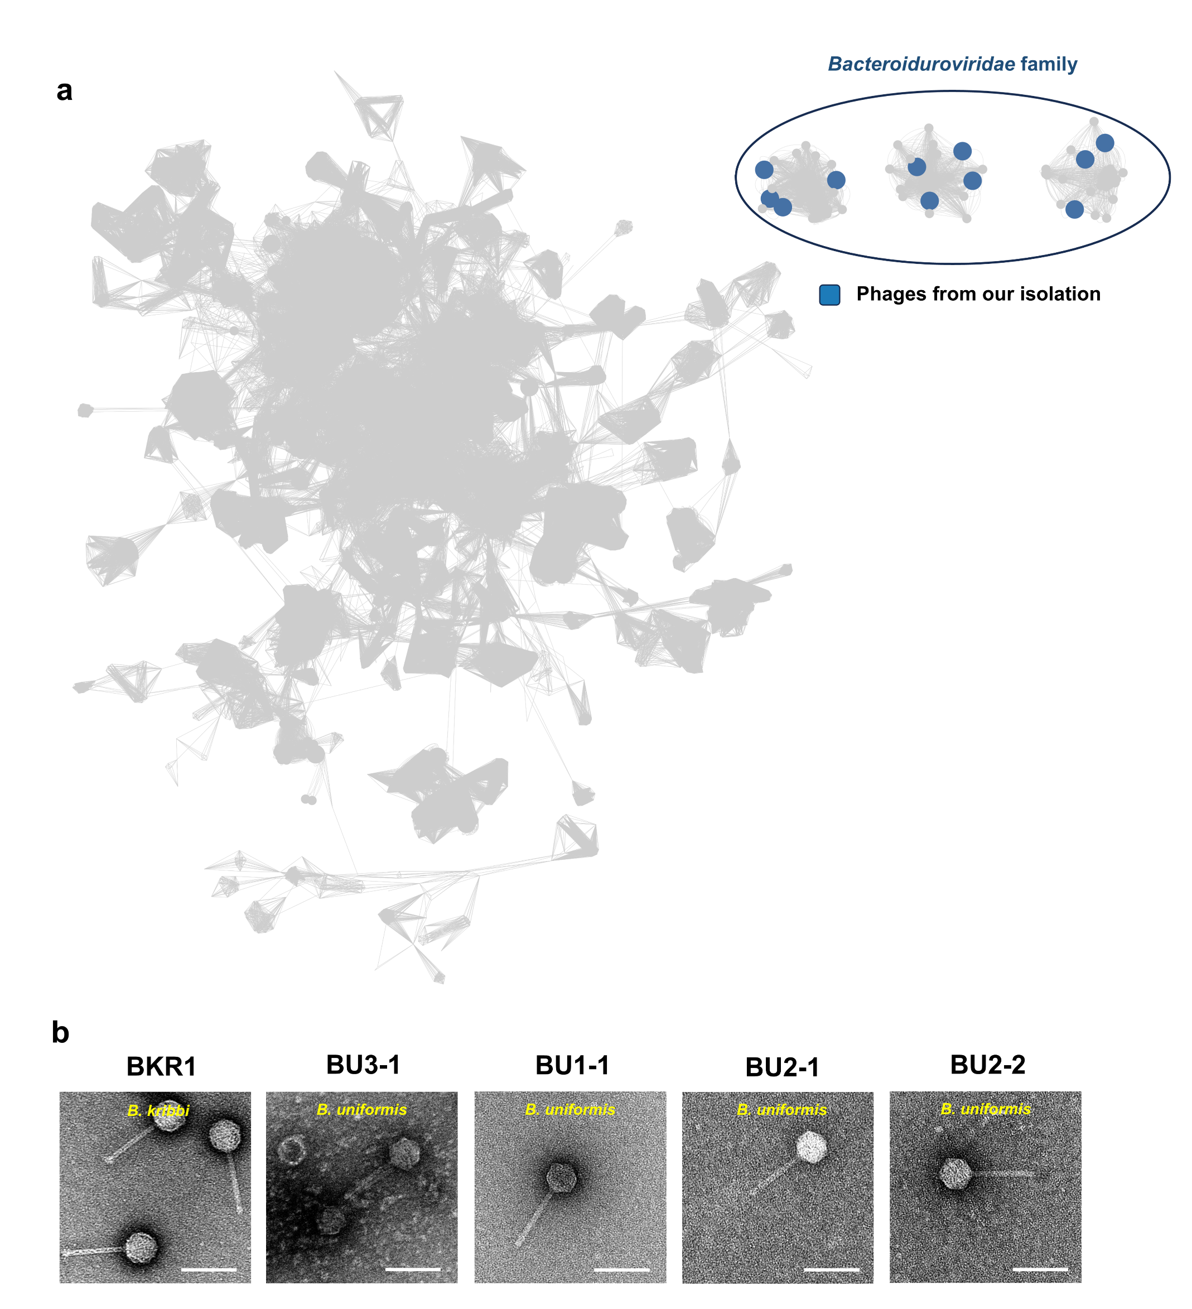
Figure 1. Representative negative staining transmission electron microscopy micrographs of the isolated phages from this family are presented. The bacterial host targeted by the phage is indicated in each micrograph. The scale bars represent 100 nm.

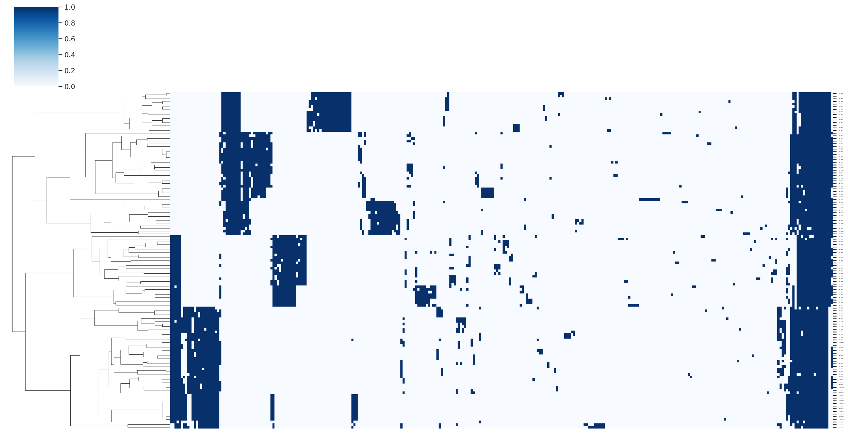

Figure 2. Presence-absence matrix of protein clusters by genome. Rows and columns were hierarchically clustered using the complete linkage method. Rows represent individual genomes with columns representing protein clusters. Vertical blue bars denote the presence of protein clusters in each genome.

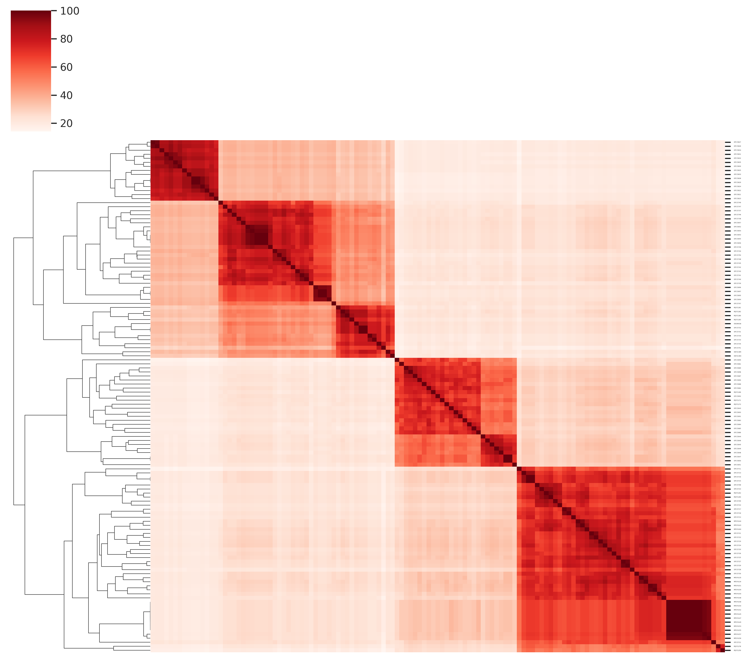
Figure 3. Heatmap of Jaccard similarity calculated from the percentage of shared protein clusters between genomes.

Figure 4. Analysis of viral clusters for the phages from the Tsinghua University collection. The phage genomes from our collection and the INfrastructure for a PHAge REference database was merged to construct a gene-sharing network utilizing vConTACT2. To facilitate the analysis of the Tsinghua University collection, clusters containing these phages and their connections are shown with the phages from our collection are marked in blue. Other phage genomes from the INPHARED database are colored light gray.

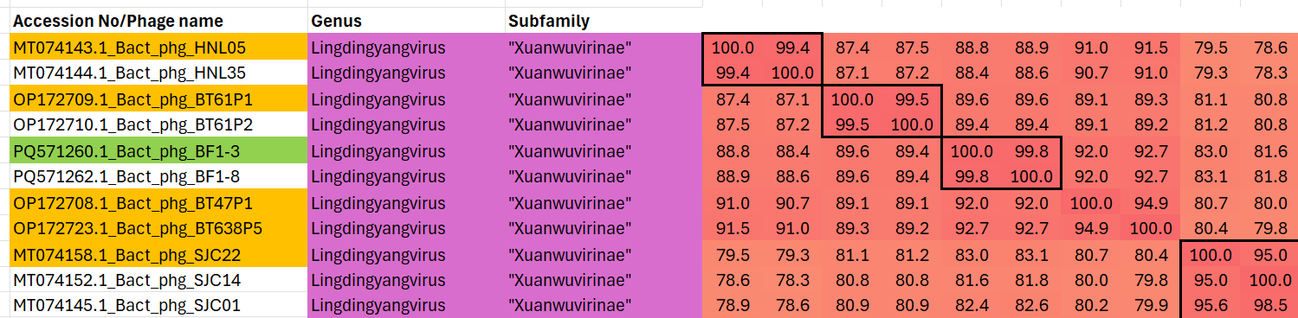
Figure 5. Partial VIRIDIC heatmap of this group of phages. VIRIDIC (Virus Intergenomic Distance Calculator; VIRIDIC (Virus Intergenomic Distance Calculator; [1]; http://rhea.icbm.uni-oldenburg.de/VIRIDIC/) computes pairwise intergenomic distances/similarities amongst phage genomes. Because the magnification makes it difficult to examine the data, the original Excel spreadsheet is attached. Names highlighted in gold correspond to existing species, while those in green are new species. Abbreviations: phg = phage; Bact = Bacteroides; Para = Parabacteroides; Phoc = Phocaeicola

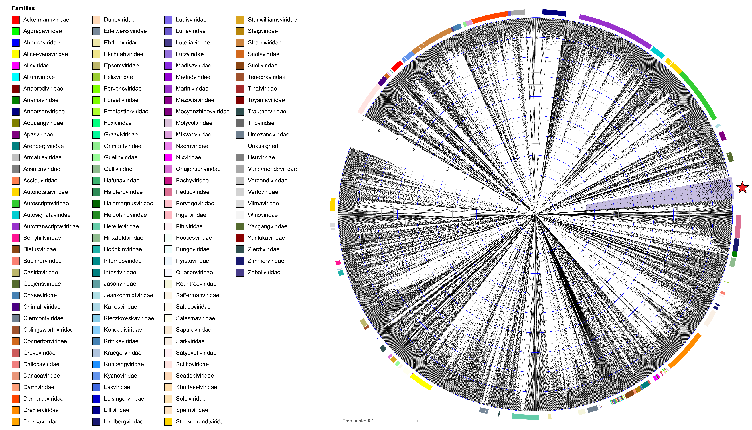
Figure 6. ViPTree analysis: ViPTree analysis (https://www.genome.jp/viptree/; [5]) is based upon Rohwer and Edwards (2002) Phage Proteomic Tree [6]. The tree is comprised of all species classified within the class Caudoviricetes in the Virus Metadata Resource version 41. The colours in the outer ring denote ratified family classifications in the class. The proposed family Shennongviridae is marked with a red star.

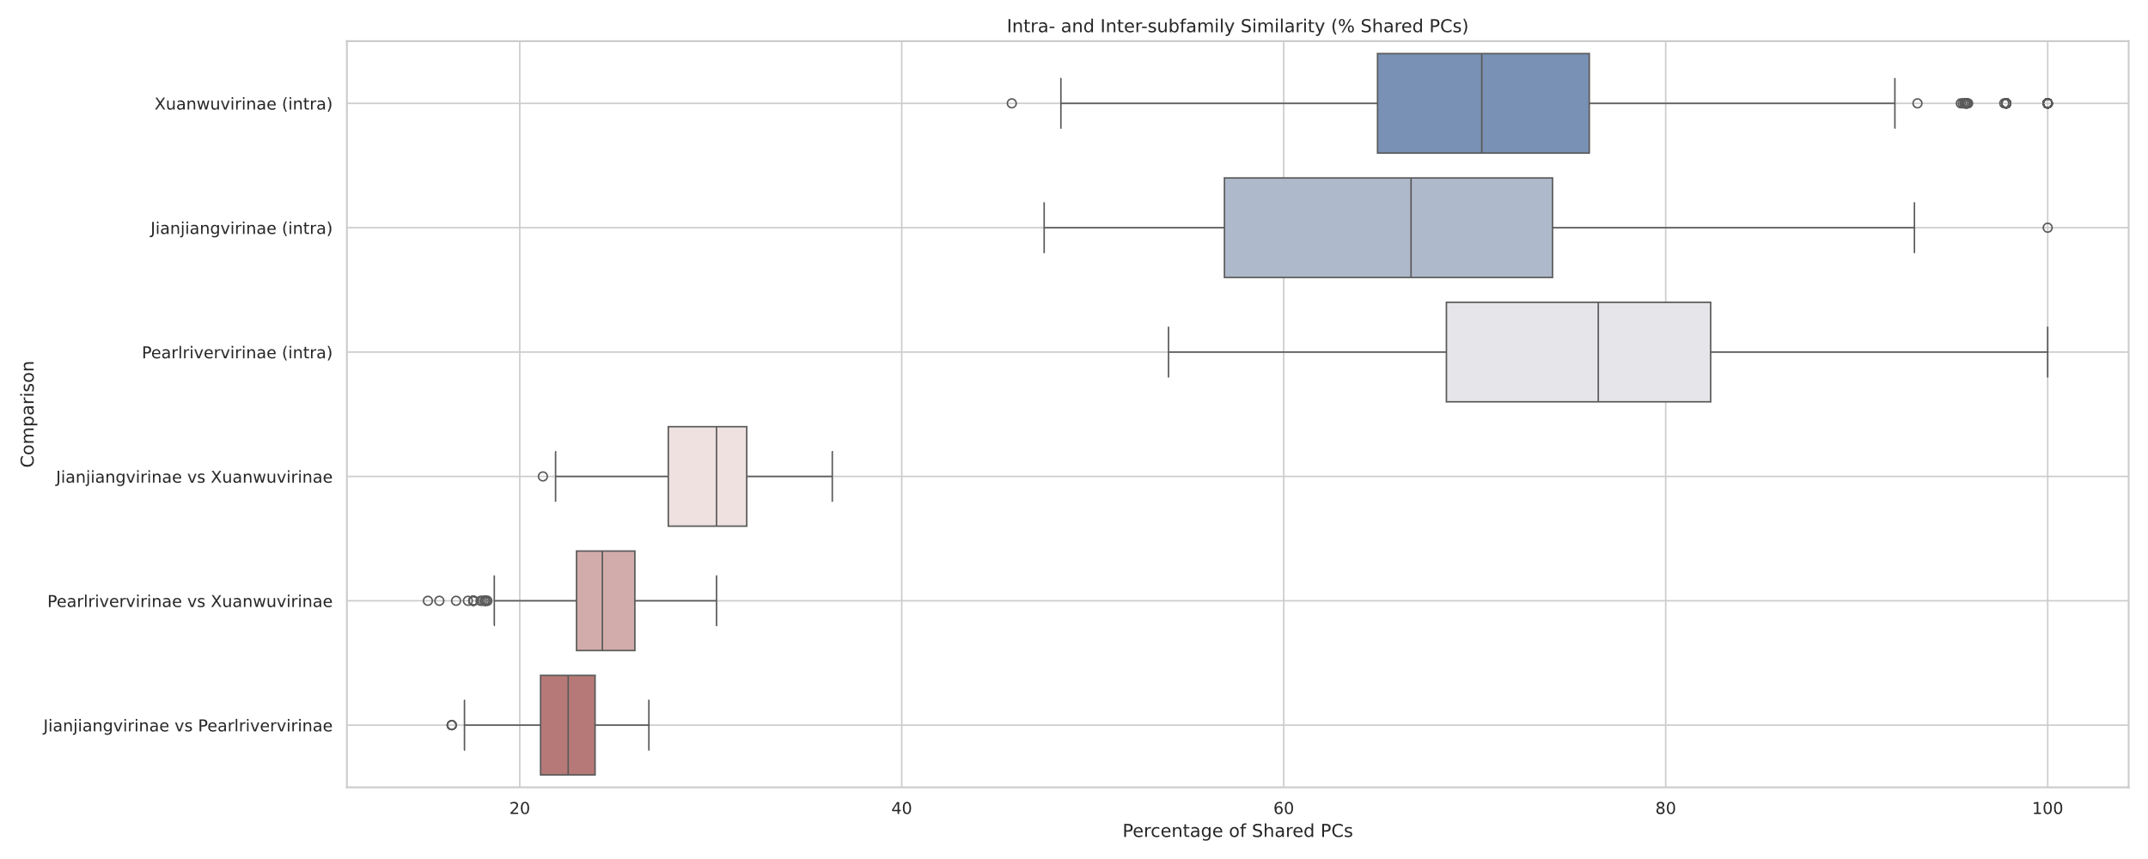
Figure 7. Comparison of the percentage of protein clusters within and between subfamilies in the proposed family Shennongviridae.

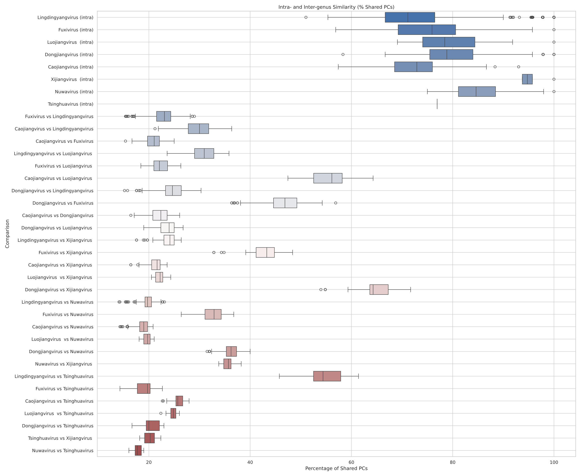
Figure 8. Comparison of the percentage of protein clusters within and between genera in the proposed family Shennongviridae.

Table 2. To create a new genus, "Tsinghuavirus”, with two species

Phage name | Host | Morphotype | Lifestyle | Accession No. | Genome size | %G+C | No. proteins | No. tRNA
Bacteroides phage BF1-2 | Bacteroides fragilis BL19 | Siphovirus | Lytic | PQ571259 | 37,895 bp | 46.4 | 47 | 0
Bacteroides phage BT2 | Bacteroides thetaiotaomicron BG12 | Siphovirus | Lytic | PQ571278 | 38,002 bp | 46.2 | 50 | 0

Table 3. To create a new subfamily, "Xuanwuvirinae”, with the "Tsinghuavirus” and Lingdingyangvirus and add three new species to the latter genus.

Accession No. | Exemplar | Taxon
PQ571260 | Bacteroides phage BF1-3 | Lingdingyangvirus BF13
OP172711 | Bacteroides phage BT401P1 | Lingdingyangvirus BT401P1
OP172712 | Bacteroides phage BT401P2 | Lingdingyangvirus BT401P2

Table 4. To add one new species to the genus Luojiangvirus

Accession No. | Exemplar | Taxon
OP172650 | Bacteroides phage BC679P4 | Luojiangvirus BC679P4

Table 5. To add two new species to the genus Caojiangvirus

Accession No. | Exemplar | Taxon
PQ571272 | Bacteroides phage BO1 | Caojiangvirus BO1
PQ571266 | Bacteroides phage BKO1-1 | Caojiangvirus BKO11

Table 6. To create a new genus “Nuwavirus” with eight species

Phage name | Host | Morphotype | Lifestyle | Accession No. | Genome size | %G+C | No. proteins | No. tRNA
Parabacteroides phage PM708P3 | Parabacteroides merdae DA708 | Not listed | Not listed | OP172834 | 34,883 bp | 44.2 | 49 | 0
Parabacteroides phage PM116P6 | Parabacteroides merdae DA116 | Not listed | Not listed | OP172828 | 35,326 bp | 44.0 | 49 | 0
Parabacteroides phage PM116P4 | Parabacteroides merdae DA116 | Not listed | Not listed | OP172826 | 35,731 bp | 43.9 | 49 | 0
Parabacteroides phage PM708P2 | Parabacteroides merdae DA708 | Not listed | Not listed | OP172833 | 34,551 bp | 44.3 | 48 | 0
Parabacteroides phage PM116P1 | Parabacteroides merdae DA116 | Not listed | Not listed | OP172824 | 33,452 bp | 44.2 | 47 | 0
Parabacteroides phage PM93P1 | Parabacteroides merdae BSC93 | Not listed | Not listed | OP172823 | 35,765 bp | 44.1 | 50 | 0
Parabacteroides phage PM21P1 | Parabacteroides merdae DA21 | Not listed | Not listed | OP172821 | 36,579 bp | 44.1 | 50 | 0
Parabacteroides phage PM21P2 | Parabacteroides merdae DA21 | Not listed | Not listed | OP172822 | 35,126 bp | 43.8 | 50 | 0

Table 7. To create two new species in the genus Dongjiangvirus

Accession No. | Exemplar | Taxon
OP172742 | Phocaeicola phage BV283P2 | Dongjiangvirus BV283P2
OP172741 | Phocaeicola phage BV283P1 | Dongjiangvirus BV283P1

Table 8. To create a single species "Xueyuanvirus"

Phage name | Host | Morphotype | Lifestyle | Accession No. | Genome size | %G+C | No. proteins | No. tRNA
Bacteroides phage BS162P3 | Bacteroides salyersiae BSC162 | Not listed | Not listed | OP172707 | 37030 bp | 45.4 | 50 | 0

Table 9. To create a new genus, “Fuxivirus”, with nine species

Phage name | Host | Morphotype | Lifestyle | Accession No. | Genome size | %G+C | No. proteins | No. tRNA
Bacteroides phage BU730P1 | Bacteroides uniformis DA730 | Not listed | Not listed | OP172735 | 35,882 bp | 45.8 | 50 | 0
Bacteroides phage EMB1 | Bacteroides uniformis | Siphovirus | Lytic | ON721384 | 34,204 bp | 45.5 | 48 | 0
Bacteroides phage EMB2 | Bacteroides uniformis | Siphovirus | Lytic | ON721385 | 34,008 bp | 45.8 | 47 | 0
Bacteroides phage C2_18_80S2P | Bacteroides uniformis MB18-80 | Siphovirus | Lytic | OR296438 | 33,770 bp | 45.8 | 46 | 0
Bacteroides phage BU241P1 | Bacteroides uniformis DA241 | Not listed | Not listed | OP172733 | 34,519 bp | 45.9 | 50 | 0
Bacteroides phage BU241P2 | Bacteroides uniformis DA241 | Not listed | Not listed | OP172734 | 34,573 bp | 46.1 | 50 | 0
Bacteroides phage BU183P1 | Bacteroides uniformis DA183 | Not listed | Not listed | OP172731 | 34,746 bp | 45.8 | 49 | 0
Bacteroides phage BU1-1 | Bacteroides uniformis BG16 | Siphovirus | Lytic | PQ571280 | 33,561 bp | 45.9 | 46 | 0
Bacteroides phage BU2-1 | Bacteroides uniformis BG2 | Siphovirus | Lytic | PQ571281 | 35,276 bp | 45.5 | 50 | 0
Specific references: Bean EM, Morella NM, Dey N. Complete Genome Sequences of Two Bacteroides uniformis Bacteriophages. Microbiol Resour Announc. 2022 Oct 20;11(10):e0061022. doi: 10.1128/mra.00610-22. Epub 2022 Sep 19. PMID: 36121235; PMCID: PMC9584325.

Hedžet S, Rupnik M, Accetto T. Broad host range may be a key to long-term persistence of bacteriophages infecting intestinal Bacteroidaceae species. Sci Rep. 2022 Dec 6;12(1):21098. doi: 10.1038/s41598-022-25636-x. PMID: 36473906; PMCID: PMC9727126.

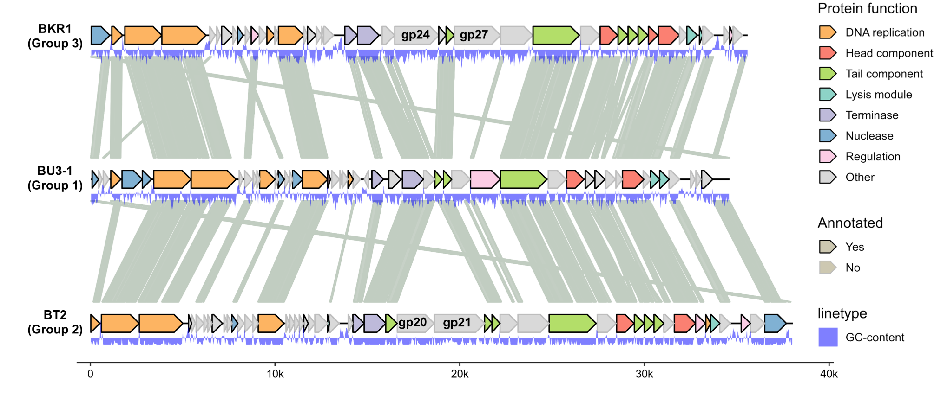
Figure 9. Genome comparisons of representative phages within this family. A diagram showing genome comparisons of representative phages (BKR1, BU3-1, BT2) from representative members of the Shennongviridae family. The comparisons are performed based on amino acid identity using tBLASTx. The CDSs were colored according to the annotated functions by GPnote (https://github.com/MaoSihong/GPnote).

