

The International Committee on Taxonomy of Viruses
Taxonomy Proposal Form, 2026

Part 1a: Details of taxonomy proposals

Title: | Create thirteen (13) new genera and forty-six (46) new species in the family Schitoviridae (Class Caudoviricetes)
Code assigned: | 2026.057B

Author(s), affiliation and email address(es):
Given name (+middle initial(s)) | Surname | Affiliation | Email address | Corr. author(s)
Johannes | Wittmann | Leibniz Institute DSMZ – German Collection of Microorganisms and Cell Cultures GmbH, Braunschweig, Germany | Johannes.Wittmann@dsmz.de | x
Dann | Turner | School of Applied Sciences, University of the West of England, Bristol, UK | Dann2.Turner@uwe.ac.uk

Part 1b: Taxonomy Proposal Submission
ICTV Subcommittee:
Animal DNA Viruses and Retroviruses |  | Bacterial viruses | x
Animal minus-strand and dsRNA viruses |  | Fungal and protist viruses
Animal positive-strand RNA viruses |  | Plant viruses
Archaeal viruses |  | General -

List the ICTV Study Group(s) that have seen or have been involved in creating this proposal:
Schitoviridae Study Group
Caudoviricetes Study Group

Optional – complete only if formally voted on by an ICTV Study Group:
Study Group | Number of members
Study Group | Votes in support | Votes against | No vote

Submission date: | 31/08/2026

Part 1c: Feedback from ICTV Executive Committee (EC) meeting
Executive Committee Meeting Decision code: | X
A – Accept
Ac – Accept subject to revision by relevant subcommittee chair. No further vote required
U – Accept without revision but with re-evaluation and email vote by the EC
Uc – Accept subject to revision and re-evaluation and email vote by the EC
Ud – Deferred to the next EC meeting, with an invitation to revise based on EC comments
J - Reject
W - Withdrawn

Comments from the Executive Committee:

Part 1d: Revised Taxonomy Proposal Submission
Response of proposer:
Revision date:

Part 3: TAXONOMIC PROPOSAL
https://ictv.global/taxonomy/templates

Taxonomic changes proposed:
Establish new taxon | x | Split taxon
Abolish taxon |  | Merge taxon
Move taxon |  | Promote taxon
Rename taxon |  | Demote taxon
Move and rename

Etymology (origin) of proposed taxonomic names:
Taxon name | Etymology of the term
Bevigintiduovirus | The name is derived from the name of the first isolated phage of this type, Stenotrophomonas phage BCVI_sma-b22phi
Bevigintiunusvirus | The name is derived from the name of the first isolated phage of this type, Stenotrophomonas phage BCVI_sma-b21phi
Chanunavirus | The name is derived from the name of the first isolated phage of this type, Vibrio phage vB_VpaP_Chan1
Chongqingvirus | The name is derived from the location where the first member of this genus, Ectopseudomonas phage vB_Eckh_PLZ24, was isolated
Circevirus | The name is derived from the name of the first isolated phage of this type, Caulobacter phage Circe
Covelinhasvirus | The name is derived from the location where the first member of this genus, Schitoviridae sp. Isolate BPhage_xjL5, was isolated from
Guangdongvirus | The name is derived from the location where the first member of this genus, Vibrio phage vB_ValP-R39Z, was isolated from
Jaygeekayunavirus | The name is derived from the name of the first isolated phage of this type, Escherichia phage Jgk1
Kuerlevirus | Derived from the name of Erwinia phage Kuerle
Mearavirus | The name is derived from the name of the first isolated phage of this type, Pseudomonas phage Meara
Sapvirus | The name is derived from the name of the first isolated phage of this type, Shewanella phage SA-P
Subiacovirus | The name is derived from the location where the first member of this genus, Acinetobacter phage C5MA, was isolated from
Zedexvirus | The name is derived from the name of the first isolated phage of this type, Ochrobactrum phage ZX86

Permission for use of names derived from a living person:
Taxon name | Full name of person from whom the name is derived | Attached

Abstract of Taxonomy Proposal:
Description of current taxonomy:
The family Schitoviridae was created in 2020 (Taxonomy Proposal 2020.146B.R.Schitoviridae). The family is comprised of 13 subfamilies, 73 genera and 184 species.

Proposed taxonomic change(s):

Create thirteen (13) new genera with fifteen (17) new species, “Bevigintiduovirus” (2 species), “Bevigintiunusvirus” (1 species), “Chanunavirus” (1 species), “Chongqingvirus” (1 species), “Circevirus” (1 species), “Covelinhasvirus” (1 species), “Guangdongvirus” (1 species), “Jaygeekayvirus” (3 species), Kuerlevirus (2 species), “Mearavirus” (1 species), “Sapvirus” (1 species), Subiacovirus (1 species), “Zedexvirus” (1 species).

Create 29 (twenty-nine) new species in the genera Efbeekayvirus (7 species), Sabivirus (1 species), Litunavirus (2 species), Waedenswilvirus (1 species), Pokkenvirus (1 species), Kapoctavirus (2 species), Gamaleyavirus (11 species), Moovirus (1 species), Exceevirus (1 species), Pylasvirus (1 species) and Triduovirus (1 species).

Demarcation criteria for new taxon/taxa:
With 70% DNA sequence identity and 95% DNA sequence identity as the criterion for demarcation of genera and species, respectively, each of the proposed species differs from the others with more than 5% at the DNA level as confirmed with VIRIDIC.

Justification:
The evolutionary relationships between 46 bacteriophage genomes were investigated. Based on proteomic and nucleotide analysis we propose a genus-level taxonomy for these phages. Using different tools like VIRIDIC or ViPTree for pairwise intergenomic nucleotide similarity or whole genome TBLASTX distance analysis of schitoviruses we propose to create thirteen new genera, “Bevigintiduovirus”, “Bevigintiunusvirus”, “Chanunavirus”, “Chongqingvirus”, “Circevirus”, “Covelinhasvirus”, “Guangdongvirus”, “Jaygeekayvirus”, “Kuerlevirus”, “Mearavirus”, “Sapvirus”, “Subiacovirus”, “Zedexvirus”S including 15 of the analysed genomes. Furthermore, 31 phage genomes represent new species in the genera Efbeekayvirus, Sabivirus, Litunavirus, Waedenswilvirus, Kuerlevirus, Pokkenvirus, Kapoctavirus, Gamaleyavirus, Moovirus, Exceevirus, Pylasvirus and Triduovirus.
We note that the branching point in the TBLASTX distance tree falls below a distance of 0.05 from the root, a threshold which has been used in the delineation of other families of bacteriophages. It is therefore likely that the Schitoviridae represents an order that includes multiple families. We intend to conduct a more detailed analysis and prepare a proposal to present a revised taxonomy in the near future.

- Text of Taxonomy proposal:

Description of current taxonomy:
The family Schitoviridae was created in 2020 (Taxonomy Proposal 2020.146B.R.Schitoviridae). The family is comprised of 13 subfamilies, 73 genera and 184 species.

Proposed taxonomic change(s):

Create twelve (12) new genera with fifteen (15) new species, “Bevigintiduovirus” (2 species), “Bevigintiunusvirus” (1 species), “Chanunavirus” (1 species), “Chongqingvirus” (1 species), “Circevirus” (1 species), “Covelinhasvirus” (1 species), “Guangdongvirus” (1 species), “Jaygeekayvirus” (3 species), “Mearavirus” (1 species), “Sapvirus” (1 species), Subiacovirus (1 species), “Zedexvirus” (1 species).

Create 30 (thirty) new species in the genera Efbeekayvirus (7 species), Sabivirus (1 species), Litunavirus (2 species), Waedenswilvirus (1 species), Kuerlevirus (1 species), Pokkenvirus (1 species), Kapoctavirus (2 species), Gamaleyavirus (11 species), Moovirus (1 species), Exceevirus (1 species), Pylasvirus (1 species) and Triduovirus (1 species).

Demarcation criteria for new taxon/taxa:
With 70% DNA sequence identity and 95% DNA sequence identity as the criterion for demarcation of genera and species (Taxonomy Proposal 2020.146B.R.Schitoviridae), respectively, each of the proposed species differs from the others with more than 5% at the DNA level as confirmed with VIRIDIC.

Justification:
The evolutionary relationships between 46 bacteriophage genomes were investigated. Based on proteomic and nucleotide analysis we propose a genus-level taxonomy for these phages. Using different tools like VIRIDIC [1] or ViPTree] [2] for pairwise intergenomic nucleotide similarity or whole genome TBLASTX distance analysis of schitoviruses we propose to create thirteen new genera, “Bevigintiduovirus”, “Bevigintiunusvirus”, “Chanunavirus”, “Chongqingvirus”, “Circevirus”, “Covelinhasvirus”, “Guangdongvirus”, “Jaygeekayvirus”, “Kuerlevirus”, “Mearavirus”, “Sapvirus”, “Subiacovirus”, “Zedexvirus”S including 15 of the analysed genomes. Furthermore, 31 phage genomes represent new species in the genera Efbeekayvirus, Sabivirus, Litunavirus, Waedenswilvirus, Kuerlevirus, Pokkenvirus, Kapoctavirus, Gamaleyavirus, Moovirus, Exceevirus, Pylasvirus and Triduovirus.

We note that the branching point in the TBLASTX distance tree falls below a distance of 0.05 from the root, a threshold which has been used in the delineation of other families of bacteriophages. It is therefore likely that the Schitoviridae represents an order that includes multiple families. We intend to conduct a more detailed analysis and prepare a proposal to present a revised taxonomy in the near future.

References:
- Moraru C, Varsani A, Kropinski AM. VIRIDIC-A Novel Tool to Calculate the Intergenomic Similarities of Prokaryote-Infecting Viruses. Viruses. 2020 Nov 6;12(11):1268. doi: 10.3390/
- Nishimura Y, Yoshida T, Kuronishi M, Uehara H, Ogata H, Goto S. ViPTree: the viral proteomic tree server. Bioinformatics. 2017 Aug 1;33(15):2379-2380. doi: 10.1093/bioinformatics/btx157. PMID: 28379287.
- McLaughlin M, Barger K, Barron C, Fisher M, Kohn L, Mac-Kittah P, Fiebig A, Crosson S. An N4-like Caulobacter phage requires host smooth lipopolysaccharide biosynthesis for infection. J Bacteriol. 2026 Mar 19;208(3):e0048825. doi: 10.1128/jb.00488-25. Epub 2026 Feb 25. PMID: 41738918
- Basler N, De Smet L, Bouras G, Swinnen J, Pranga K, Brussaard CPD, Vandamme P, de Graaf DC, Matthijnssens J. The honey bee triad: a comprehensive catalogue of phages in the Apis mellifera gut microbiome. Nat Commun. 2026 May 8;17(1):6231. doi: 10.1038/s41467-026-72757-2. PMID: 42103708
- Li C, Yue Y, Yin R, Zhao J, Wang Z, Nair S, Zhang Y. Two novel polyvalent phages: a promising approach for cross-order pathogen control in aquaculture. Virol J. 2025 Jun 7;22(1):187. doi: 10.1186/s12985-025-02817-4. PMID: 40483502

Accompanying files:
Filename | Description of contents
VIRIDIC_analysis_Schitoviridae_2026.xlsx | Viridic analysis of schitoviruses

Tables, Figures:

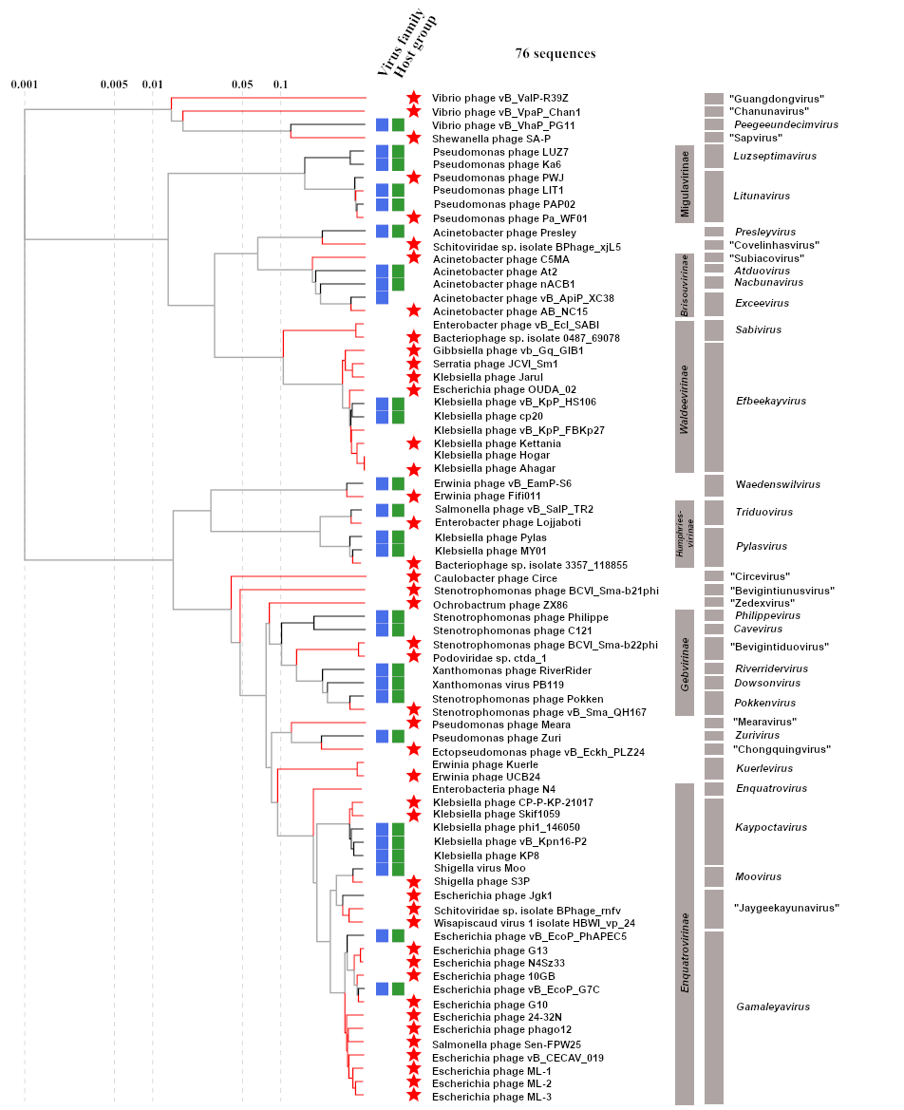Fig. 1 Proteomic tree analysis using ViPTree including members of newly proposed genera and species in the Schitoviridae family.

