

The International Committee on Taxonomy of Viruses
Taxonomy Proposal Form, 2026

Part 1a: Details of taxonomy proposals

Title: | To create four new genera of Rhodococcus siphoviruses and five new species in the class Caudoviricetes
Code assigned: | 2026.056B

Author(s), affiliation and email address(es):
Given name (+middle initial(s)) | Surname | Affiliation | Email address | Corr. author(s)
Ipek | Kurtböke | Environmental Microbiology, University of the Sunshine Coast,  School of Science, Technology and Engineering,  Maroochydore DC, Australia | IKurtbok@usc.edu.au
Cristina M. | Moraru | Department of Chemistry, Environmental Metagenomics,  University of Duisburg-Essen,  D-45141 Essen,  Germany | lilianacristina.moraru@uni-due.de
Andrew M. | Kropinski | University of Guelph, Guelph, Ontario, Canada N1G2W1 | Phage.Canada@gmail.com | x

Part 1b: Taxonomy Proposal Submission
ICTV Subcommittee: Enter an "X" against the subcommittee(s) most appropriate to deal with the taxonomy proposal. If in doubt, contact the appropriate subcommittee chair for clarification (see https://ictv.global/sc).
Animal DNA Viruses and Retroviruses |  | Bacterial viruses | x
Animal minus-strand and dsRNA viruses |  | Fungal and protist viruses
Animal positive-strand RNA viruses |  | Plant viruses
Archaeal viruses |  | General -Submit to Proposals Secretary

List the ICTV Study Group(s) that have seen or have been involved in creating this proposal: A list of study groups and their members is provided at https://ictv.global/sc.
Actinophage

Optional – complete only if formally voted on by an ICTV Study Group: <To be completed by Study Group>
Study Group | Number of members
Study Group | Votes in support | Votes against | No vote

Submission date: | 12/04/2026

Part 1c: Feedback from ICTV Executive Committee (EC) meeting
Executive Committee Meeting Decision code: | X
A – Accept
Ac – Accept subject to revision by relevant subcommittee chair. No further vote required
U – Accept without revision but with re-evaluation and email vote by the EC
Uc – Accept subject to revision and re-evaluation and email vote by the EC
Ud – Deferred to the next EC meeting, with an invitation to revise based on EC comments
J - Reject
W - Withdrawn

Comments from the Executive Committee:

Part 1d: Revised Taxonomy Proposal Submission
Response of proposer: Please describe in detail how you have responded to the EC meeting feedback
Revision date:

Part 3: TAXONOMIC PROPOSAL

Taxonomic changes proposed: Enter an "X" against one or more actions
Establish new taxon | x | Split taxon
Abolish taxon |  | Merge taxon
Move taxon |  | Promote taxon
Rename taxon |  | Demote taxon
Move and rename

Etymology (origin) of proposed taxonomic names: Briefly describe the origin and rationale for each proposed taxonomic name in the proposal. A longer explanation can be provided in the main section of the taxonomy proposal if required. Use one row for each taxonomic name; additional rows can be inserted where needed. See examples for existing names in https://ictv.global/taxonomy/etymology.
Taxon name | Etymology of the term
Nicehousevirus" | Named directly after Rhodococcus phage Nicehouse
Shagratvirus | Named directly after Rhodococcus phage Shagrat
Requnavirus | Named directly after Rhodococcus phage REQ1
Captvirus | Name derived from Center for Phage Technology where this virus was isolated

Permission for use of names derived from a living person: If you propose taxon name(s) which are derived from the name of a living person or persons, you must attach documents to verify that permission has been obtained from those persons and that they agree to the form in which their name or an element of it is to be used. These documents should be listed in the Accompanying Files table below. The documents will not be posted online but will be retained by ICTV as evidence of authorization.
Taxon name | Full name of person from whom the name is derived | Attached X

Abstract of Taxonomy Proposal:

Description of current taxonomy:
The bacteriophages described in this proposal are currently unclassified

Proposed taxonomic change(s):
We propose to create four new genera, "Nicehousevirus", "Shagratvirus", "Requnavirus", “Captvirus", and five new species.

Demarcation criteria for new taxon/taxa:
Genus demarcation criteria: An intergenomic similarity cut-off of 70%, a combination of average nucleotide identity and alignment fraction, is used to determine genera demarcation. Members of the same genus have >70% intergenomic similarity and cluster tightly in marker gene phylogenies.

Species demarcation criteria: A demarcation value of 95% intergenomic similarity was used to define different species according to intergenomic similarity. Members of the same genus have >95% intergenomic similarity [6].

Justification:
These bacteriophages which infect Rhodococcus sp. exhibit a siphovirus morphology. Pairwise comparison of genome sequences and BLASTN searches showed that they exhibit no significant similarity to other bacteriophages in the INSDC. Based on the results obtained using VIRIDIC, VIPTREE and phylogenetic analyses of the large terminase subunit, we propose to classify these bacteriophages into four new genera and five new species.

Text of Taxonomy proposal:
Description of current taxonomy:
The bacteriophages described in this proposal are currently unclassified

Proposed taxonomic change(s):
We propose to create four new genera, "Nicehousevirus", "Shagratvirus", "Requnavirus", “Captvirus", and five new species.

Demarcation criteria for new taxon/taxa:
Genus demarcation criteria: An intergenomic similarity cut-off of 70%, a combination of average nucleotide identity and alignment fraction, is used to determine genera demarcation. Members of the same genus have >70% intergenomic similarity and cluster tightly in marker gene phylogenies.

Species demarcation criteria: A demarcation value of 95% intergenomic similarity was used to define different species according to intergenomic similarity. Members of the same genus have >95% intergenomic similarity [6].

Justification:
These bacteriophages which infect Rhodococcus sp. exhibit a siphovirus morphology. Pairwise comparison of genome sequences and BLASTN searches showed that they exhibit no significant similarity to other bacteriophages in the INSDC . Based on the results obtained using VIRIDIC (Figure 1), VIPTREE (Figure 2) and phylogenetic analyses of the large terminase subunit (Figure 3), we propose to classify these bacteriophages into four new genera and five new species.

References:
1. Moraru C, Varsani A, Kropinski AM. VIRIDIC-A Novel Tool to Calculate the Intergenomic Similarities of Prokaryote-Infecting Viruses. Viruses. 2020 Nov 6;12(11):1268. doi: 10.3390/v12111268. PMID: 33172115; PMCID: PMC7694805. http://kronos.icbm.uni-oldenburg.de/viridic/
2. Nishimura Y, Yoshida T, Kuronishi M, Uehara H, Ogata H, Goto S. ViPTree: the viral proteomic tree server. Bioinformatics. 2017; 33(15):2379-2380. doi:10.1093/bioinformatics/btx157. PubMed PMID: 28379287. https://www.genome.jp/viptree/
3. Rohwer F, Edwards R. The Phage Proteomic Tree: a genome-based taxonomy for phage. J Bacteriol. 2002 Aug;184(16):4529-35. PubMed PMID: 12142423
4. Turner D, Reynolds D, Seto D, Mahadevan P. CoreGenes3.5: a webserver for the determination of core genes from sets of viral and small bacterial genomes. BMC Res Notes. 2013;6:140. doi: 10.1186/1756-0500-6-140. PMID: 23566564.
5. Davis P, Seto D, Mahadevan P. CoreGenes5.0: An Updated User-Friendly Webserver for the Determination of Core Genes from Sets of Viral and Bacterial Genomes. Viruses. 2022 Nov 16;14(11):2534. doi: 10.3390/v14112534. PMID: 36423143; PMCID: PMC9693508.
6. Turner D, Kropinski AM, Adriaenssens EM. A Roadmap for Genome-Based Phage Taxonomy. Viruses. 2021 Mar 18;13(3):506. doi: 10.3390/v13030506. PMID: 33803862; PMCID: PMC8003253.
Lemoine F, Correia D, Lefort V, Doppelt-Azeroual O, Mareuil F, Cohen-Boulakia S, Gascuel O. NGPhylogeny.fr: new generation phylogenetic services for non-specialists. Nucleic Acids Res. 2019 Jul 2;47(W1):W260-W265. doi: 10.1093/nar/gkz303. PMID: 31028399; PMCID: PMC6602494.
7. Letunic I, Bork P. Interactive Tree Of Life (iTOL): an online tool for phylogenetic tree display and annotation. Bioinformatics. 2007 Jan 1;23(1):127-8. doi: 10.1093/bioinformatics/btl529. Epub 2006 Oct 18. PMID: 17050570.
8. Zhou T, Xu K, Zhao F, Liu W, Li L, Hua Z, Zhou X. itol.toolkit accelerates working with iTOL (Interactive Tree of Life) by an automated generation of annotation files. Bioinformatics. 2023 Jun 1;39(6):btad339. doi: 10.1093/bioinformatics/btad339. PMID: 37225402; PMCID: PMC10243930
9. Dereeper A, Guignon V, Blanc G, Audic S, Buffet S, Chevenet F, Dufayard JF, Guindon S, Lefort V, Lescot M, Claverie JM, Gascuel O. Phylogeny.fr: robust phylogenetic analysis for the non-specialist. Nucleic Acids Res. 2008 Jul 1;36(Web Server issue):W465-9. doi: 10.1093/nar/gkn180. Epub 2008 Apr 19. PMID: 18424797; PMCID: PMC2447785.

Accompanying files:

Filename | Description of contents

Tables, Figures:

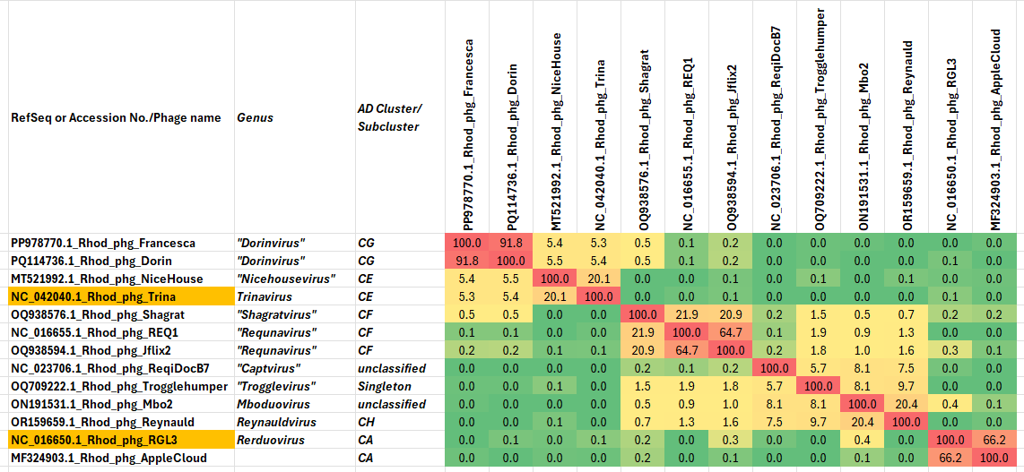

Figure 1. VIRIDIC heatmap of this group of phages. VIRIDIC (Virus Intergenomic Distance Calculator; VIRIDIC (Virus Intergenomic Distance Calculator; [1]; http://rhea.icbm.uni-oldenburg.de/VIRIDIC/) computes pairwise intergenomic distances/similarities amongst phage genomes. Abbreviations: phg = phage; Rhod = Rhodococcus

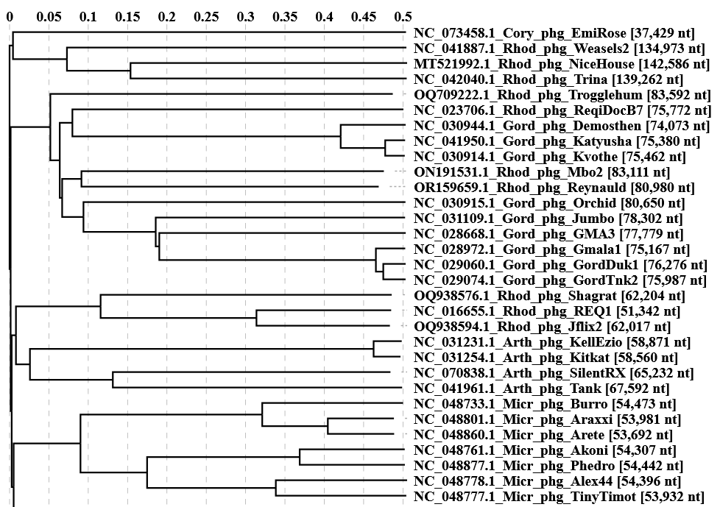

Figure 2. ViPTree analysis: ViPTree analysis (https://www.genome.jp/viptree/; [2]) is based upon Rohwer and Edwards (2002) Phage Proteomic Tree [3]. The taxons under discussion are indicated with blue arrowheads. Abbreviations: phg = phage; Rhod = Rhodococcus; Cory = Corynebacterium; Micr = Microbacterium; Gord = Gordonia.

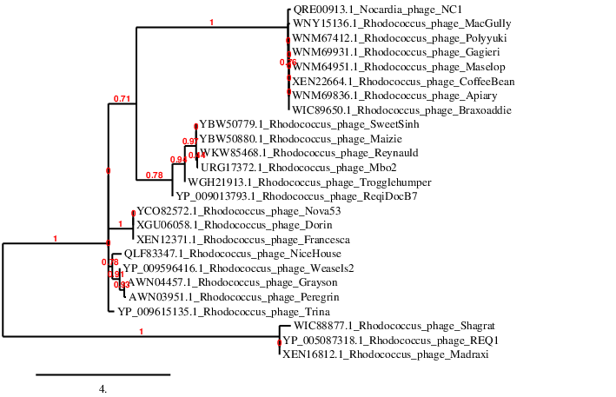
Figure 3. Phylogenetic tree constructed with the large subunit terminase proteins from these and related phages using “One Click” Phylogeny.fr [9] at https://www.phylogeny.fr using the TerL proteins from Rhodobacter phage REQ1 as an outlier.

Table 1. Characteristics of the only phage in the genus Nicehousevirus

Phage name | Host | Morphotype | Lifestyle | Accession No. | Genome size | %G+C | Termini | No. proteins | No. tRNA
Rhodococcus phage Nicehouse | Rhodococcus erythropolis NRRL B-1574 | Siphovirus | Lyic | MT521992 | 142586  bp | 44.9 | DTR 5291 bp | 229 | 31

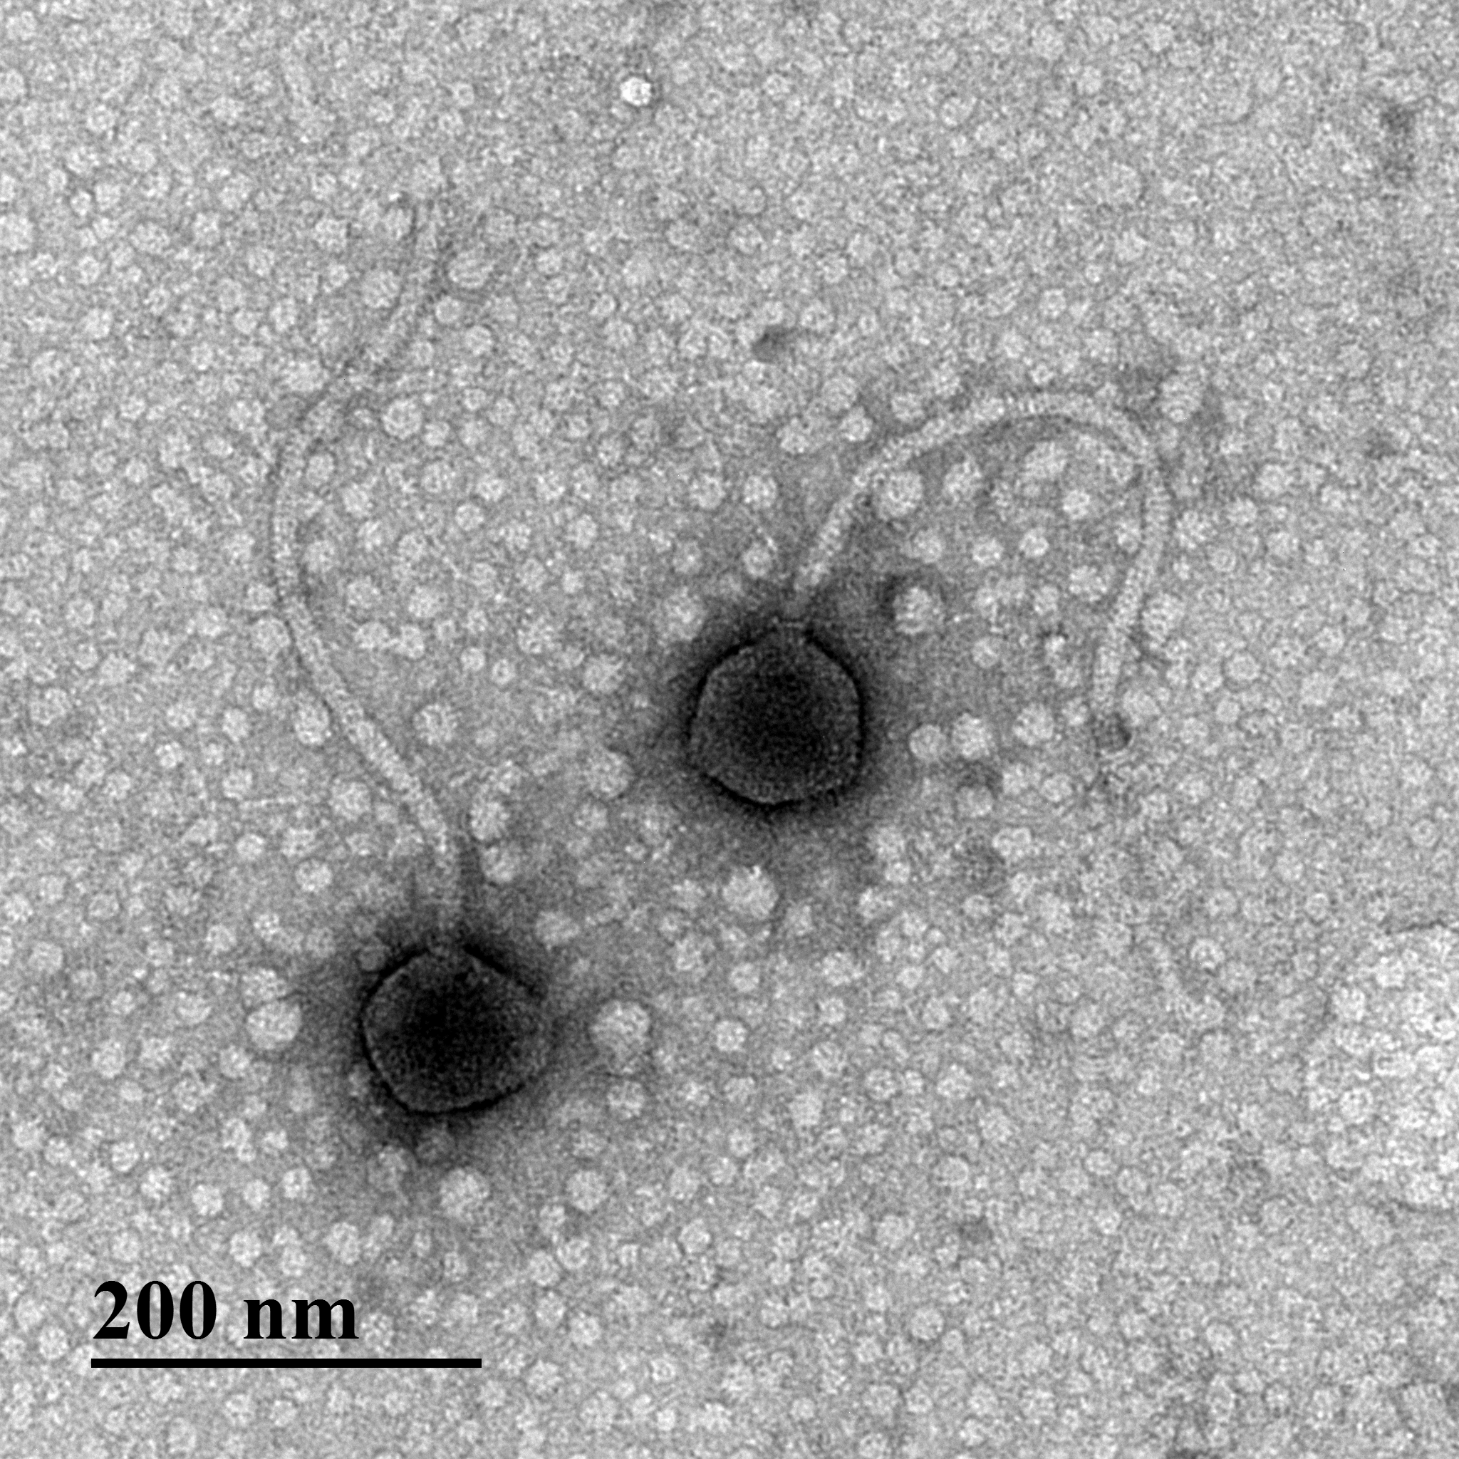

Figure 4. Electron micrograph: Electron micrograph of negatively stained Rhodococcus phage NiceHouse (https://phagesdb.org/phages/NiceHouse/). Limited permission was granted by The Actinobacteriophage Database (https://phagesdb.org/), funded by the Howard Hughes Medical Institute, to use this electron micrograph for this taxonomy proposal; it cannot be reused without permission of The Actinobacteriophage Database.

Table 2. Characteristics of the only phage in the genus Shagratvirus

Phage name | Host | Morphotype | Lifestyle | Accession No. | Genome size | %G+C | 3’-cohesive ends | No. proteins | No. tRNA
Rhodococcus phage Shagrat | Rhodococcus equi NRRL B-16538 | Siphovirus | Temperate | OQ938576 | bp | 63.9 | CCACT | 114 | 0

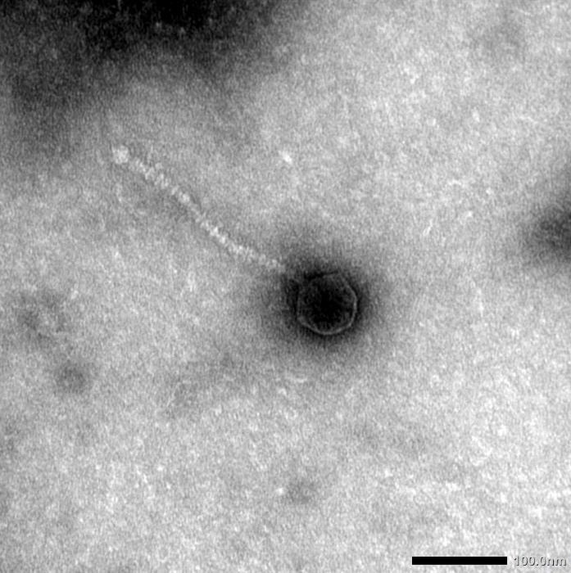

Figure 5. Electron micrograph: Electron micrograph of negatively stained Rhodococcus phage Shagrat (https://phagesdb.org/phages/Shagrat/). Limited permission was granted by The Actinobacteriophage Database (https://phagesdb.org/), funded by the Howard Hughes Medical Institute, to use this electron micrograph for this taxonomy proposal; it cannot be reused without permission of The Actinobacteriophage Database.

Table 3. Characteristics of the two phages in the genus Requnavirus

Phage name | Host | Morphotype | Lifestyle | Accession No. | Genome size | %G+C | 3’-cohesive ends | No. proteins | No. tRNA
Rhodococcus phage REQ1 | Rhodococcus equi | Siphovirus | Lytic | JN116825 | 51342 bp | 66.3 | ND | 85 | 0
Rhodococcus phage Jflix2 | Rhodococcus equi NRRL B-16538 | Siphovirus | Temperate | OQ938594 | 62017 bp | 66.5 | CCCGCT | 106 | 0
Specific reference: Petrovski S, Seviour RJ, Tillett D. Genome sequence and characterization of a Rhodococcus equi phage REQ1. Virus Genes. 2013 Jun;46(3):588-90. doi: 10.1007/s11262-013-0887-1. Epub 2013 Feb 5. PMID: 23381579.

Table 4. Characteristics of the only phage in the genus Captvirus

Phage name | Host | Morphotype | Lifestyle | Accession No. | Genome size | %G+C | Termini | No. proteins | No. tRNA
Rhodococcus phage ReqiDocB7 | Rhodococcus equi | Siphovirus | Temperate | GU580940 | 75772 bp | 56.7 | ND | 105 | 0
Specific reference: Summer EJ, Liu M, Gill JJ, Grant M, Chan-Cortes TN, Ferguson L, Janes C, Lange K, Bertoli M, Moore C, Orchard RC, Cohen ND, Young R. Genomic and functional analyses of Rhodococcus equi phages ReqiPepy6, ReqiPoco6, ReqiPine5, and ReqiDocB7. Appl Environ Microbiol. 2011 Jan;77(2):669-83. doi: 10.1128/AEM.01952-10. Epub 2010 Nov 19. PMID: 21097585; PMCID: PMC3020559.

