

The International Committee on Taxonomy of Viruses
Taxonomy Proposal Form, 2026

Part 1a: Details of taxonomy proposals

Title: | To create a new family, Qebehsenuefviridae in the class Caudoviricetes
Code assigned: | 2026.055B

Author(s), affiliation and email address(es):
Given name (+middle initial(s)) | Surname | Affiliation | Email address | Corr. author(s)
Simon R. | Carding | Food, Microbiome, & Health Research Programme, Quadram Institute Bioscience, Norwich, UK AND Norwich Medical School, University of East Anglia, Norwich, UK | simon.carding@quadram.ac.uk
Tomaž | Accetto | Biotechnical Faculty, University of Ljubljana, Ljubljana, Slovenia | Tomaz.Accetto@bf.uni-lj.si
Ramy K. | Aziz | Microbiology & Immunology, Faculty of Pharmacy, Cairo University, Cairo, Egypt | ramy.aziz@pharma.cu.edu.eg
Nina | Chanishvili | Eliava Institute of Bacteriophage, Microbiology & Virology, Tbilisi, Geotrgia | nina.chanishvili@gmail.com
Sofia | Dahlman | School of Biological Sciences, Monash University, Melbourne, Victoria, Australia | sofia.dahlman1@monash.edu
Ayman | El-Shibiny | Center for Microbiology and Phage Therapy, Zewail City of Science, Technology and Innovation, Giza 12573, Egypt | aelshibiny@zewailcity.edu.eg
Zainab K. | Hammouda | Center for Microbiology and Phage Therapy, Zewail City of Science, Technology and Innovation, Giza 12573, Egypt | zhammouda@zewailcity.edu.eg
Andrew M. | Kropinski | Department of Pathobiology, University of Guelph, Guelph, Ontario, Canada | Phage.Canada@gmail.com | X
Ayesha | Lone | Agriculture & Agri-Food Canada, Guelph, Ontario, Canada | ayesha.lone@agr.gc.ca
Liliana Cristina | Moraru | Microbial Systems Ecology, University of Duisburg-Essen, D-45141 Essen, Germany | lilianacristina.moraru@uni-due.de
Maja | Rupnik | Department of Microbiology, University of Maribor, Maribor, Slovenia | maja.rupnik@nlzoh.si
Bishoy M. | Zaki | Bioscience Research Laboratories Department, MARC for Medical Services and Scientific Research, Giza, Egypt | bishoy.mb551@gmail.com
Juntao | Shen | State Key Laboratory of Quantitative Synthetic Biology, Shenzhen Institute of Synthetic Biology, Shenzhen Institutes of Advanced Technology, Chinese Academy of Sciences, Shenzhen, China | jt.shen1@siat.ac.cn

Part 1b: Taxonomy Proposal Submission
ICTV Subcommittee:
Animal DNA Viruses and Retroviruses |  | Bacterial viruses | x
Animal minus-strand and dsRNA viruses |  | Fungal and protist viruses
Animal positive-strand RNA viruses |  | Plant viruses
Archaeal viruses |  | General -

List the ICTV Study Group(s) that have seen or have been involved in creating this proposal: https://ictv.global/sc
Caudoviricetes Study Group

Optional – complete only if formally voted on by an ICTV Study Group:
Study Group | Number of members
Study Group | Votes in support | Votes against | No vote

Submission date: | 24/07/2026

Part 1c: Feedback from ICTV Executive Committee (EC) meeting
Executive Committee Meeting Decision code: | X
A – Accept
Ac – Accept subject to revision by relevant subcommittee chair. No further vote required
U – Accept without revision but with re-evaluation and email vote by the EC
Uc – Accept subject to revision and re-evaluation and email vote by the EC
Ud – Deferred to the next EC meeting, with an invitation to revise based on EC comments
J - Reject
W - Withdrawn

Comments from the Executive Committee:

Part 1d: Revised Taxonomy Proposal Submission
Response of proposer:
Revision date:

Part 3: TAXONOMIC PROPOSAL

Taxonomic changes proposed:
Establish new taxon | x | Split taxon
Abolish taxon | x | Merge taxon
Move taxon | x | Promote taxon
Rename taxon |  | Demote taxon
Move and rename

Etymology (origin) of proposed taxonomic names:
Taxon name | Etymology of the term
“Qebehsenuefviridae” | Qebehsenuef [𓏂𓌢𓌢𓌢𓆑 pronounced: Qebeḥ-senuef] is the ancient Egyptian falcon-headed god responsible for protecting the intestines of the deceased

Permission for use of names derived from a living person:
Taxon name | Full name of person from whom the name is derived | Attached

Abstract of Taxonomy Proposal:

Description of current taxonomy:
The phages in this proposal all belong to the subfamily Cardingvirinae which was established by Taxonomy Proposal 2025.007B.Cardingvirinae_1nsf_2ng_18ns.

Proposed taxonomic change(s):
We propose to create a new family Qebehsenuefviridae containing the existing subfamily, Cardingvirinae; and to update the constituent genera: Gotuavirus and Kherlenvirus.

Demarcation criteria for new taxon/taxa:
Family demarcation criteria: The family is represented by a cohesive and monophyletic group in whole-genome proteome-based clustering tools (e.g. VirClust, ViPTree, GRAViTy v2, vConTACT3). Members of the family share a significant number of orthologous genes, the number of which will vary depending on the genome sizes and number of coding sequences of members of the family.

Subfamily demarcation criteria: Subfamilies are to be created when two or more genera are related below the family level. In practical terms, this usually means that they share a low degree of sequence similarity (usually about 40-50%) and that the genera form a clade in a marker tree phylogeny.

Genus demarcation criteria: In search for criteria that create cohesive and distinct genera that are reproducible and monophyletic, the Bacterial Viruses Subcommittee established 70% nucleotide identity of the genome length as the cut-off for genera. Genus-level groupings should always be monophyletic in the signature genes, as tested with a phylogenetic tree.

Species demarcation criteria: Two phages are assigned to the same species if their genomes are more than 95% identical over their genome length for isolates. These values can be calculated by a number of tools, such as BLASTn – usually calculated using intergenomic distance calculator VIRIDIC.

Justification:
Genomes in the subfamily Cardingvirinae cluster as a deep-branching clade in whole proteome TBLAST distance analysis. Comparisons to other phages in the INSDC using a global protein clustering approach indicate that these phages represent a distinct evolutionary lineage in the class Caudoviricetes which we propose represents a new family: Qebehsenuefviridae. A further 19 new species are proposed on the basis of intergenomic nucleotide similarities, which can be classified into the genera Gotuavirus and Kherlenvirus.

Text of Taxonomy proposal:
Description of current taxonomy:
The phages in this proposal all belong to the subfamily Cardingvirinae which was established by Taxonomy Proposal 2025.007B.Cardingvirinae_1nsf_2ng_18ns. This subfamily includes two genera and 18 species.

Proposed taxonomic change(s):
We propose to create a new family “Qebehsenuefviridae” containing the existing subfamily, Cardingvirinae; and to update the constituent genera: Gotuavirus and Kherlenvirus.

Demarcation criteria for new taxon/taxa:
Family demarcation criteria: The family is represented by a cohesive and monophyletic group in whole-genome proteome-based clustering tools (e.g. VirClust, ViPTree, GRAViTy v2, vConTACT3). Members of the family share a significant number of orthologous genes, the number of which will vary depending on the genome sizes and number of coding sequences of members of the family.

Subfamily demarcation criteria: Subfamilies are to be created when two or more genera are related below the family level. In practical terms, this usually means that they share a low degree of sequence similarity (usually about 40-50%) and that the genera form a clade in a marker tree phylogeny.

Genus demarcation criteria: In search for criteria that create cohesive and distinct genera that are reproducible and monophyletic, the Bacterial Viruses Subcommittee established 70% nucleotide identity of the genome length as the cut-off for genera. Genus-level groupings should always be monophyletic in the signature genes, as tested with a phylogenetic tree [1].

Species demarcation criteria: Two phages are assigned to the same species if their genomes are more than 95% identical over their genome length for isolates. These values can be calculated by a number of tools, such as BLASTn – usually calculated using intergenomic distance calculator VIRIDIC.

Justification:
To identify related genomes in the INSDC, a protein clustering approach was employed using a custom Python pipeline with 28,717 genomes in the 14Apr2025 release of INPHARED [2] as input. Briefly, proteins were clustered using MMSeqs2 [3] with parameters set to a minimum sequence identity of ≥30% sequence identity and an ≥80% coverage threshold. The pipeline converted the number of shared protein clusters between genomes into an all-vs-all Jaccard distance matrix, which formed the basis of a connected-component network. The network was split into discrete islands using a minimum Jaccard similarity of 0.05 and subsequently hierarchically clustered at set distance thresholds. At each level, the number and identity of conserved protein clusters was determined.

Genomes representing species in the subfamily Cardingvirinae were found to form a distinct clade based on the Jaccard similarity calculated from shared protein clusters, exhibiting 32 protein homologs common to all genomes (Figures 1 and 2). This clade, for which we propose new family, “Cardingvirinae”, was supported by the hierarchically clustered TBLASTX distance tree (ViPTree) [5,6], where the subfamily form a deep-branching clade (Figure 3). The structure of the proposed family was reinforced using a concatenated core-gene maximum likelihood phylogeny (Figure 4). Intergenomic nucleotide similarities calculated using VIRIDIC [7] (Figure 5) support the creation of 19 new species within the genera Gotuavirus and Kherlenvirus.

References:
- Turner D, Kropinski AM, Adriaenssens EM. A Roadmap for Genome-Based Phage Taxonomy. Viruses. 2021 Mar 18;13(3):506. doi: 10.3390/v13030506. PMID: 33803862; PMCID: PMC8003253.
- Cook R, Brown N, Redgwell T, Rihtman B, Barnes M, Clokie M, Stekel DJ, Hobman J, Jones MA, Millard A. (2021) INfrastructure for a PHAge REference Database: Identification of Large-Scale Biases in the Current Collection of Cultured Phage Genomes. Phage 2(4):214-223. doi: 10.1089/phage.2021.0007.
- Steinegger M, Söding J. (2017) MMseqs2 enables sensitive protein sequence searching for the analysis of massive data sets. Nat Biotechnol. 35(11):1026-1028. doi: 10.1038/nbt.3988.
- Nishimura Y, Yoshida T, Kuronishi M, Uehara H, Ogata H, Goto S. ViPTree: the viral proteomic tree server. Bioinformatics. 2017; 33(15):2379-2380. doi:10.1093/bioinformatics/btx157. PubMed PMID: 28379287. https://www.genome.jp/viptree/
- Rohwer F, Edwards R. The Phage Proteomic Tree: a genome-based taxonomy for phage. J Bacteriol. 2002 Aug;184(16):4529-35. PubMed PMID: 12142423
- Moraru C, Varsani A, Kropinski AM. VIRIDIC-A Novel Tool to Calculate the Intergenomic Similarities of Prokaryote-Infecting Viruses. Viruses. 2020 Nov 6;12(11):1268. doi: 10.3390/v12111268. PMID: 33172115; PMCID: PMC7694805. http://kronos.icbm.uni-oldenburg.de/viridic/
- Nakamura T, Yamada KD, Tomii K, Katoh K. (2018) Parallelization of MAFFT for large-scale multiple sequence alignments. Bioinformatics. 34(14):2490-2492. doi: 10.1093/bioinformatics/bty121.
- Katoh K, Standley DM. (2013) MAFFT multiple sequence alignment software version 7: improvements in performance and usability. Mol Biol Evol. 30(4):772-80. doi: 10.1093/molbev/mst010.
- Nguyen LT, Schmidt HA, von Haeseler A, and Minh BQ (2015) IQ-TREE: A fast and effective stochastic algorithm for estimating maximum likelihood phylogenies. Molecular Biology and Evolution, 32:268-274. https://doi.org/10.1093/molbev/msu300
- Kalyaanamoorthy S, Minh BQ, Wong TKF, von Haeseler A, and Jermiin JS (2017) ModelFinder: Fast Model Selection for Accurate Phylogenetic Estimates, Nature Methods, 14:587–589. https://doi.org/10.1038/nmeth.4285
- Hoang DT, Chernomor O, von Haeseler A, Minh BQ, Vinh LS (2018) UFBoot2: Improving the ultrafast bootstrap approximation. Molecular Biology and Evolution, 35:518–522. https://doi.org/10.1093/molbev/msx281
- Letunic I, Bork P. Interactive Tree Of Life (iTOL): an online tool for phylogenetic tree display and annotation. Bioinformatics. 2007 Jan 1;23(1):127-8. doi: 10.1093/bioinformatics/btl529. Epub 2006 Oct 18. PMID: 17050570.
- Zhou T, Xu K, Zhao F, Liu W, Li L, Hua Z, Zhou X. itol.toolkit accelerates working with iTOL (Interactive Tree of Life) by an automated generation of annotation files. Bioinformatics. 2023

Accompanying files:
Filename | Description of contents
Qebehsenuefviridae_1nf_19nsp_VIRIDIC_heatmap | Details of Figure 3

Tables, Figures:

Table 1. Conserved proteins present in all bacteriophages within the proposed family Qebehsenuefviridae

Cluster | Predicted function | Average within cluster % identity | Average protein length (aa)
1 | major head protein | 81.11 | 213.16
2 | hypothetical protein | 45.37 | 92.95
3 | replication initiation protein | 75.76 | 314.89
4 | virion structural protein | 80.61 | 249.37
5 | hypothetical protein | 80.72 | 212.26
6 | pyrophosphatase | 73.49 | 197.47
7 | single strand DNA binding protein | 82.09 | 152
8 | Rnase E | 86.04 | 195.79
9 | hypothetical protein | 62.64 | 93.47
10 | hypothetical protein | 83.61 | 190
11 | virion structural protein | 78.46 | 306
12 | hypothetical protein | 67.75 | 117.32
13 | hypothetical protein | 77.64 | 314.16
14 | Erf-like ssDNA annealing protein | 77.54 | 208.32
15 | hypothetical protein | 79.3 | 83.68
16 | thymidylate synthase | 86.63 | 266.58
17 | hypothetical protein | 69.36 | 138.89
18 | hypothetical protein | 83.23 | 146.53
19 | Holliday junction resolvase | 74.76 | 202
20 | hypothetical protein | 73.56 | 132.47
21 | hypothetical protein | 81.23 | 107.11
22 | hypothetical protein | 84.58 | 726.68
23 | portal protein | 84.64 | 562.47
24 | RecE-like recombination exonuclease | 84.26 | 314.47
25 | hypothetical protein | 83.72 | 436.42
26 | tail length tape measure protein | 87.07 | 1045.53
27 | hypothetical protein | 73.72 | 65.05
28 | tail protein | 93.17 | 151
29 | HNH endonuclease | 90.96 | 145.16
30 | virion structural protein | 86.26 | 439
31 | hypothetical protein | 56.79 | 67.84
32 | hypothetical protein | 72.9 | 128.32

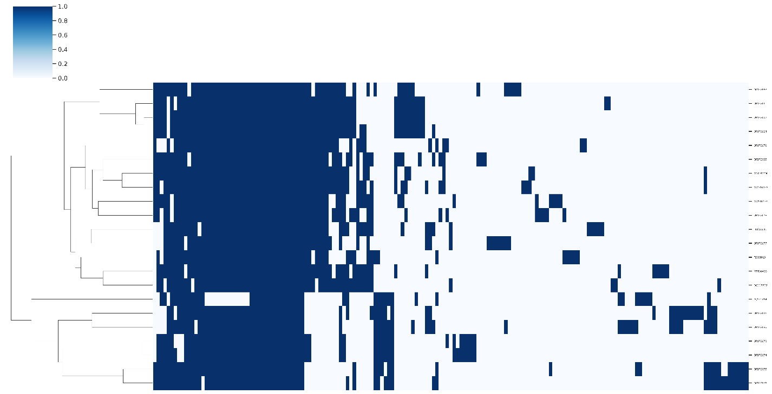

Figure 1. Presence-absence matrix of protein clusters by genome. Rows and columns were hierarchically clustered using the complete linkage method. Rows represent individual genomes with columns representing protein clusters. Vertical blue bars denote the presence of protein clusters in each genome.
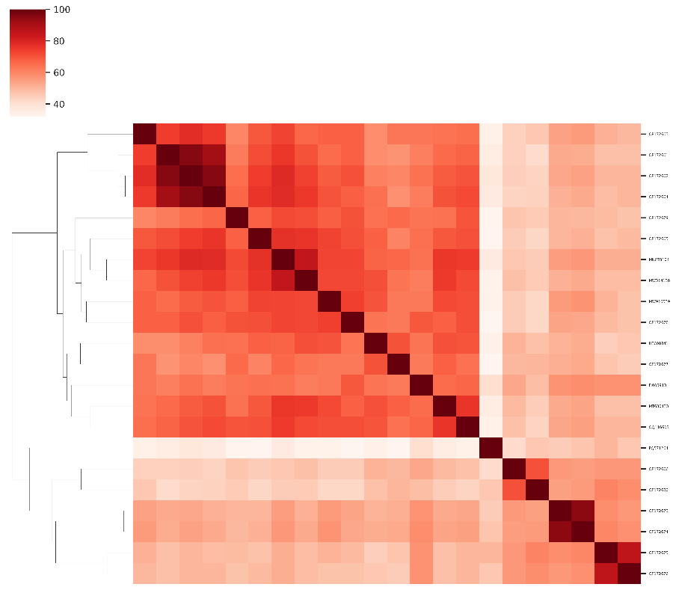
Figure 2. Heatmap of Jaccard similarity calculated from the percentage of shared protein clusters between genomes.

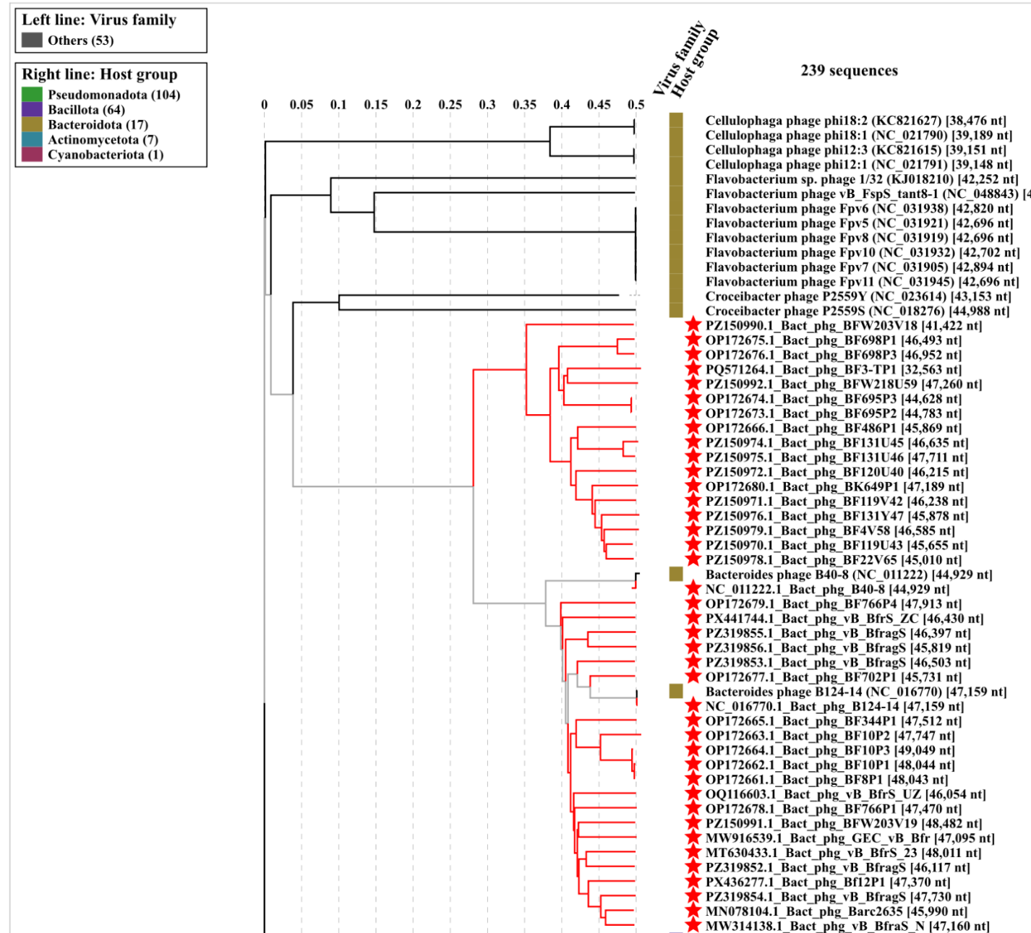

Figure 3. ViPTree analysis: ViPTree analysis (https://www.genome.jp/viptree/; [4]) is based upon Rohwer and Edwards (2002) Phage Proteomic Tree [5]. The taxons under discussion are indicated with red bars and stars. Abbreviations: phg = phage; Bact = Bacteroides.

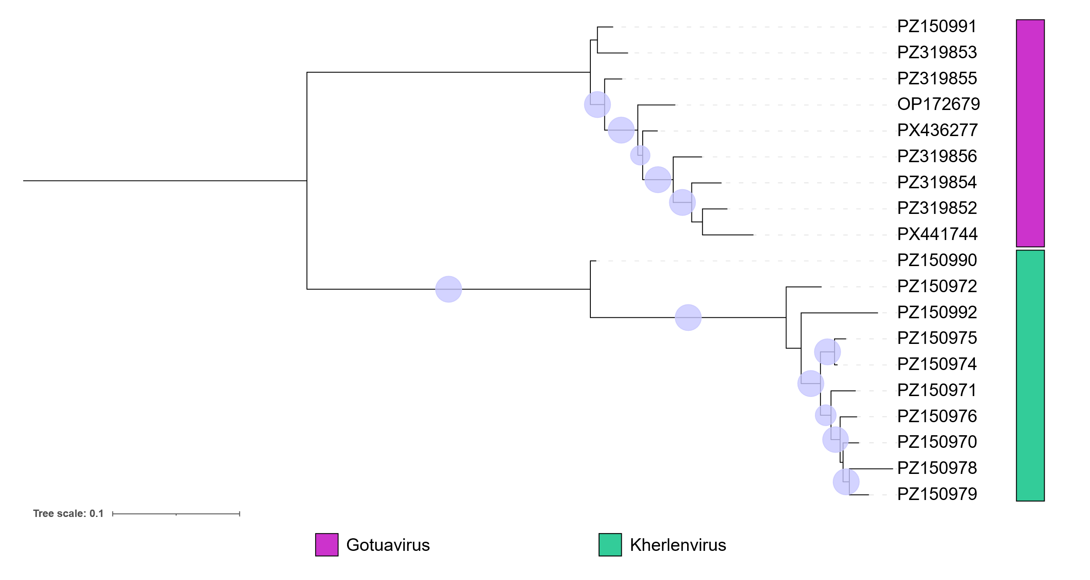
Figure 4. Concatenated core-gene maximum likelihood phylogeny of 19 new species proposed in the genera Gotuavirus and Kherlenvirus. Protein clusters were aligned with MAFFT e-insi [7, 8] and trimmed with trimAl with a gap threshold of 0.5. The tree was inferred using IQTree3 [9] using a best-fit partition model inferred [10] from trees of individual protein cluster alignments and branch support was tested 1000 ultra-fast bootstrap [11] and SH-Alrt test replicates. The tree was rooted at the midpoint and bootstrap support ≥95% are shown as circles at branch points. The tree was visualized using iTOL [12,13].

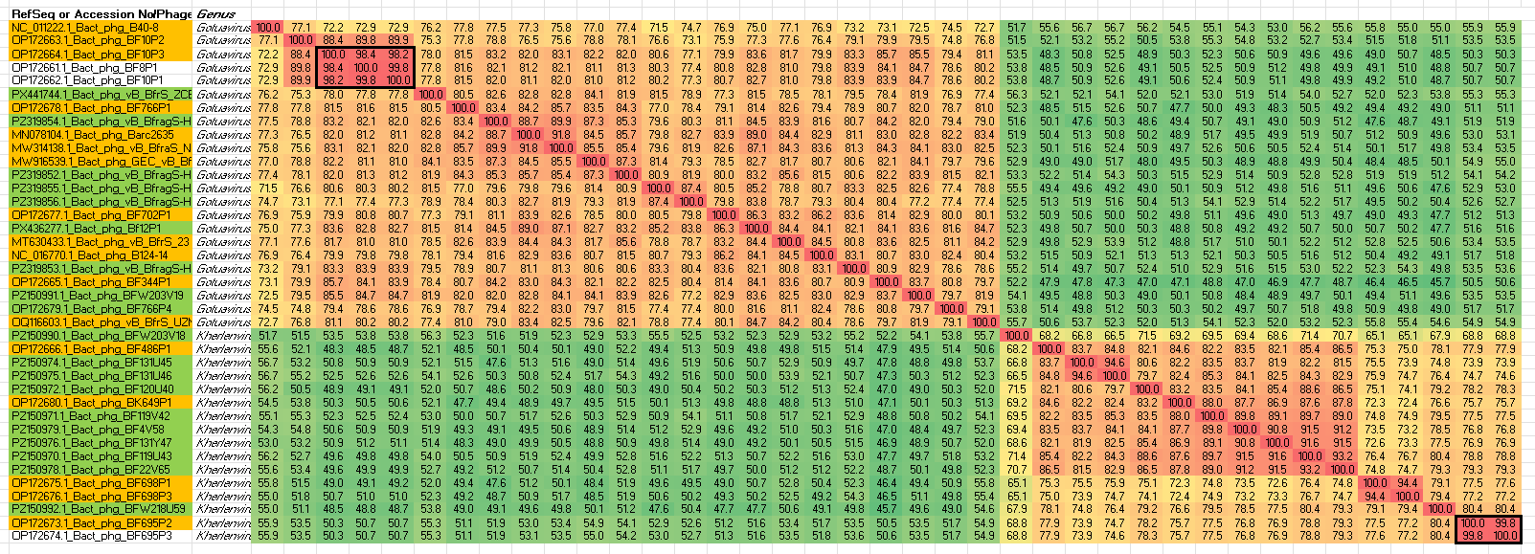
Figure 5. VIRIDIC heatmap of this group of phages. VIRIDIC (Virus Intergenomic Distance Calculator; VIRIDIC (Virus Intergenomic Distance Calculator; [6]; http://rhea.icbm.uni-oldenburg.de/VIRIDIC/) computes pairwise intergenomic distances/similarities amongst phage genomes. Because the magnification makes it difficult to examine the data, the original Excel spreadsheet is attached. Names highlighted in gold correspond to existing species, while those in green are new species. Abbreviations: phg = phage; Bact = Bacteroides

Table 2. To create nine new species in the genus Gotuavirus

Accession No. | Exemplar | Taxon
PX441744 | Bacteroides phage vB_BfrS_ZCBF01 | Gotuavirus ZCBF01
PZ319854 | Bacteroides phage vB_BfragS-HLBF003 | Gotuavirus HLBF003
PZ319852 | Bacteroides phage vB_BfragS-HLBF001 | Gotuavirus HLBF001
PZ319855 | Bacteroides phage vB_BfragS-HLBF004 | Gotuavirus HLBF004
PZ319856 | Bacteroides phage vB_BfragS-HLBF005 | Gotuavirus HLBF005
PX436277 | Bacteroides phage Bf12P1 | Gotuavirus Bf12P1
PZ319853 | Bacteroides phage vB_BfragS-HLBF002 | Gotuavirus HLBF002
PZ150991 | Bacteroides phage BFW203V19 | Gotuavirus BFW203V19
OP172679 | Bacteroides phage BF766P4 | Gotuavirus BF766P4

Table 3. To create 10 new species in the genus Kherlenvirus

Accession No. | Exemplar | Taxon
PZ150990 | Bacteroides phage BFW203V18 | Kherlenvirus BFW203V18
PZ150974 | Bacteroides phage BF131U45 | Kherlenvirus BF131U45
PZ150975 | Bacteroides phage BF131U46 | Kherlenvirus BF131U46
PZ150972 | Bacteroides phage BF120U40 | Kherlenvirus BF120U40
PZ150971 | Bacteroides phage BF119V42 | Kherlenvirus BF119V42
PZ150979 | Bacteroides phage BF4V58 | Kherlenvirus BF4V58
PZ150976 | Bacteroides phage BF131Y47 | Kherlenvirus BF131Y47
PZ150970 | Bacteroides phage BF119U43 | Kherlenvirus BF119U43
PZ150978 | Bacteroides phage BF22V65 | Kherlenvirus BF22V65
PZ150992 | Bacteroides phage BFW218U59 | Kherlenvirus BFW218U59

