

The International Committee on Taxonomy of Viruses
Taxonomy Proposal Form, 2026
Part 1a: Details of taxonomy proposals

Title: | Create a new family, Kaverinviridae, with one genus Kaverinvirus for a group of Acinetobacter baumannii-infecting lytic bacteriophages (class Caudoviricetes).
Code assigned: | <to be assigned by ICTV officers>

Author(s), affiliation and email address(es):
Given name (+middle initial(s)) | Surname | Affiliation | Email address | Corr. author(s)
Mikhail M. | Shneider | Laboratory of molecular bioengineering, Shemyakin-Ovchinnikov Institute of Bioorganic Chemistry, Moscow, Russia | mikhailshneider@gmail.com | X
Olga Yu. | Timoshina | Laboratory of molecular bioengineering, Shemyakin-Ovchinnikov Institute of Bioorganic Chemistry, Moscow, Russia | lalatimosha@gmail.com | X
Anna A. | Lukianova | Laboratory of molecular bioengineering, Shemyakin-Ovchinnikov Institute of Bioorganic Chemistry, Moscow, Russia | a.al.lukianova@gmail.com
Konstantin A. | Miroshnikov | Laboratory of molecular bioengineering, Shemyakin-Ovchinnikov Institute of Bioorganic Chemistry, Moscow, Russia | kmi@bk.ru

Part 1b: Taxonomy Proposal Submission
ICTV Subcommittee:
Animal DNA Viruses and Retroviruses |  | Bacterial viruses | X
Animal minus-strand and dsRNA viruses |  | Fungal and protist viruses
Animal positive-strand RNA viruses |  | Plant viruses
Archaeal viruses |  | General

List the ICTV Study Group(s) that have seen or have been involved in creating this proposal:
Caudoviricetes Study Group
Optional – complete only if formally voted on by an ICTV Study Group:
Study Group | Number of members
Study Group | Votes in support | Votes against | No vote

Submission date: | 15/09/2026

Part 1c: Feedback from ICTV Executive Committee (EC) meeting <To be completed by the subcommittee chair after EC evaluation>
Executive Committee Meeting Decision code: | X
A – Accept
Ac – Accept subject to revision by relevant subcommittee chair. No further vote required
U – Accept without revision but with re-evaluation and email vote by the EC
Uc – Accept subject to revision and re-evaluation and email vote by the EC
Ud – Deferred to the next EC meeting, with an invitation to revise based on EC comments
J - Reject
W - Withdrawn

Comments from the Executive Committee:

Part 1d: Revised Taxonomy Proposal Submission <To be completed for the revised version>
Response of proposer: Please describe in detail how you have responded to the EC meeting feedback
Revision date:

Enter date of the revised version (DD/MM/YYYY).

Part 3: TAXONOMIC PROPOSAL

Taxonomic changes proposed:
Establish new taxon | X | Split taxon
Abolish taxon |  | Merge taxon
Move taxon |  | Promote taxon
Rename taxon |  | Demote taxon
Move and rename

Etymology (origin) of proposed taxonomic names:
Taxon name | Etymology of the term
Kaverinviridae | family name created in honor of Russian and Soviet virologist Nikolai V. Kaverin (1933 – 2014), whose scientific works are devoted to the molecular-biological aspects of virology and to the studies of biosynthesis of viral RNAs (paramyxoviruses, influenza viruses).
Kaverinvirus | genus name created in accordance with the viral family name, since this genus is the first and, at present, the only one within the family Kaverinviridae.
Kaverinvirus Mithridates | species name derived from the phage name in the NCBI GenBank database – Acinetobacter phage Mithridates, - the only one representative known up to date
Kaverinvirus AM24 | species name derived from the phage name in the NCBI GenBank database – Acinetobacter phage AM24, - the only one representative known up to date
Kaverinvirus Bestia | species name derived from the phage name in the NCBI GenBank database – Acinetobacter phage Bestia, - the only one representative known up to date
Kaverinvirus ABc79VSh | species name derived from the phage name in the NCBI GenBank database – Acinetobacter phage sp.A.bc79V-Sh, - the only one representative known up to date
Kaverinvirus AbYfo2 | species name derived from the phage name in the NCBI GenBank database – Acinetobacter phage AbYfo_2, - the only one representative known up to date
Kaverinvirus Ab15 | species name derived from the phage name in the NCBI GenBank database – Acinetobacter phage Ab15, - the only one representative known up to date
Kaverinvirus Herod | species name derived from the phage name in the NCBI GenBank database – Acinetobacter phage Herod, - the only one representative known up to date
Kaverinvirus Argenteus | species name derived from the phage name in the NCBI GenBank database – Acinetobacter phage Argenteus, - the only one representative known up to date
Kaverinvirus R2096 | species name derived from the phage name in the NCBI GenBank database – Acinetobacter phage YMC13/03/R2096

Permission for use of names derived from a living person:
Taxon name | Full name of person from whom the name is derived | Attached

Abstract of Taxonomy Proposal:
Description of current taxonomy:
To date, there are no taxonomic ranks for the group of phages under consideration.

Proposed taxonomic change(s):
We propose to create a new family Kaverinviridae (containing one genus Kaverinvirus) within the class Caudoviricetes for the group of lytic myophages infecting Acinetobacter baumannii.
We had isolated from the sewage water samples four strictly lytic phages Mithridates, Bestia, Herod and Argenteus, and had sequenced their genomes. Alongside, we have found 6 complete genomes of closely related phages in the NCBI GenBank database. We have performed a bioinformatic analysis of genome similarity for all these bacteriophages. Based on the data obtained, we propose:
- To create a new family, Kaverinviridae.
- To create a new genus, Kaverinvirus, with 9 species.

Demarcation criteria for new taxon/taxa:
We have applied the current ICTV Bacterial Viruses Subcommittee taxonomy demarcation criteria, summarized by Turner et. al., 2021

Justification:
The analysis of intergenomic similarities (VIRIDIC), genome-BLAST distance phylogeny analysis (VICTOR) and also a proteome-based phylogenetic analysis (VipTree) were performed for a group of A. baumannii - infecting myophages. Based on the results of these investigations, we propose the creation of a new family, Kaverinviridae, consisting of one genus Kaverinvirus with 9 species.

Text of Taxonomy proposal:
Description of current taxonomy:
Currently, all of the bacteriophages related to proposed Zilberviridae family do not belong to any taxonomic ranks and are marked in the NCBI GenBank database as unclassified Caudoviricetes.

Proposed taxonomic change(s):
We propose to create a new family Kaverinviridae within the class Caudoviricetes, phylum Uroviricota, kingdom Heunggongvirae, realm Duplodnaviria for the group of strictly lytic myophages infecting A. baumannii.
We assume that the Kaverinviridae family include one genus Kaverinvirus.
Previously, we had isolated from the sewage water samples collected in Moscow region (Russian Federation) four strictly virulent myophages Mithridates, Bestia, Herod and Argenteus, and had sequenced their genomes on the MiSeq platform (IIllumina, San Diego, CA, USA).
In addition, we have found a number of genomes of closely related phages in the NCBI GenBank database. After that, we have performed a bioinformatic analysis of genome similarity and phylogenetic analysis for these sequences. Based on the data obtained, we propose to create a new bacterial virus family consisting one new genus for this group of phages. Summarizing, we propose:

- To create a new family, Kaverinviridae.
- To create a new genus, Kaverinvirus, with 9 species.

Demarcation criteria for new taxon/taxa:
We have applied the current ICTV Bacterial Viruses Subcommittee taxonomy demarcation criteria, summarized by Turner et. al., 2021 [1].
Species demarcation criteria: Bacteriophages belong to the same species if their genomes are more than 95% identical over their full length based on average nucleotide identity (ANI) analysis.
Genus demarcation criteria: Bacteriophages belong to the same genus if their genomes have more than 70% ANI and also form a monophyletic group in the signature genes on a phylogenetic tree.
Family demarcation criteria: Bacteriophages, which form a cohesive and monophyletic group by the proteome-based phylogenetic analysis, belong to the same family of viruses. Family members share a significant number of orthologous genes.

Justification:
The analysis of intergenomic similarities using VIRIDIC tool [2] (Fig.1), Genome-BLAST Distance Phylogeny analysis using VICTOR [3] (Fig. 2) and a proteome-based phylogenetic analysis using VipTree [4] (Fig. 3) were performed for a group of A. baumannii infecting myophages.
Three complementary approaches consistently resolved the group of phages under study into one monophyletic group. The closest previously registered in ICTV group of bacteriophages was the Luriaviridae family, however, the similarity between the genomes of Kaverinviridae phages and Luriaviridae phages was relatively low. At the same time, the most closely related group of phages is the proposed Zilberviridae family (see our group’s previous ICTV Taxonomy Proposal Form dated 16.07.26).
All of the phages under study share >70% of genomic similarities, so we propose to delineate this monophyletic group a new bacterial virus family Kaverinviridae (named after Russian and Soviet virologist Nikolai V. Kaverin (1933 – 2014)) taking into account the major genetic and structural features that discriminate these phages from the others.
The structural hallmarks of the Kaverinviridae phages are, - the presence of three tube proteins, one tail sheath protein and a complex adsorption apparatus consisting of three types of receptor-binding proteins: tail spike with polysaccharide depolymerase activity, collagen-containing fiber and short tail fiber.
Based on the results of these investigations and applying the demarcation criteria employed by the ICTV Bacterial Viruses Subcommittee, we propose the creation of a new family, Kaverinviridae, comprising 1 genus Kaverinvirus with 9 species.

References:
1. Turner, D.; Kropinski, A.M.; Adriaenssens, E.M. A Roadmap for Genome-Based Phage Taxonomy. Viruses 2021, 13, 506, doi:10.3390/v13030506.
2. Moraru, C.; Varsani, A.; Kropinski, A.M. VIRIDIC—A Novel Tool to Calculate the Intergenomic Similarities of Prokaryote-Infecting Viruses. Viruses 2020, 12, 1268, doi:10.3390/v12111268.
3. Meier-Kolthoff, J.P.; Göker, M. VICTOR: Genome-Based Phylogeny and Classification of Prokaryotic Viruses. Bioinformatics 2017, 33, 3396–3404, doi:10.1093/bioinformatics/btx440.
4. Nishimura, Y.; Yoshida, T.; Kuronishi, M.; Uehara, H.; Ogata, H.; Goto, S. ViPTree: The Viral Proteomic Tree Server. Bioinformatics 2017, 33, 2379–2380, doi:10.1093/bioinformatics/btx157.

Accompanying files:

Filename | Description of contents

Tables, Figures:

Table 1. List of Kaverinviridae phages

Family | Genus | Species | Virus name | Accession
Kaverinviridae | Kaverinvirus | Kaverinvirus Mithridates | Acinetobacter phage Mithridates | MW316731
Kaverinviridae | Kaverinvirus | Kaverinvirus AM24 | Acinetobacter phage AM24 | KY000079
Kaverinviridae | Kaverinvirus | Kaverinvirus Bestia | Acinetobacter phage Bestia | MW316733
Kaverinviridae | Kaverinvirus | Kaverinvirus ABc79V-Sh | Acinetobacter phage sp.A.bc79V-Sh | PZ362306
Kaverinviridae | Kaverinvirus | Kaverinvirus AbYfo_2 | Acinetobacter phage AbYfo_2 | PX121509
Kaverinviridae | Kaverinvirus | Kaverinvirus Ab15 | Acinetobacter phage Ab15 | PP763259
Kaverinviridae | Kaverinvirus | Kaverinvirus Herod | Acinetobacter phage Herod | MW316732
Kaverinviridae | Kaverinvirus | Kaverinvirus Argenteus | Acinetobacter phage Argenteus | PX131141
Kaverinviridae | Kaverinvirus | Kaverinvirus YMC13/03/R2096 | Acinetobacter phage YMC13/03/R2096 | KM672662
Kaverinviridae | Kaverinvirus | Kaverinvirus YMC13/03/R2096 | Acinetobacter phage P577 | OR180307

* Bacteriophages Acinetobacter phage YMC13/03/R2096 and Acinetobacter phage P577 share 100% ANI, but have been deposed in GenBank database under different accession numbers

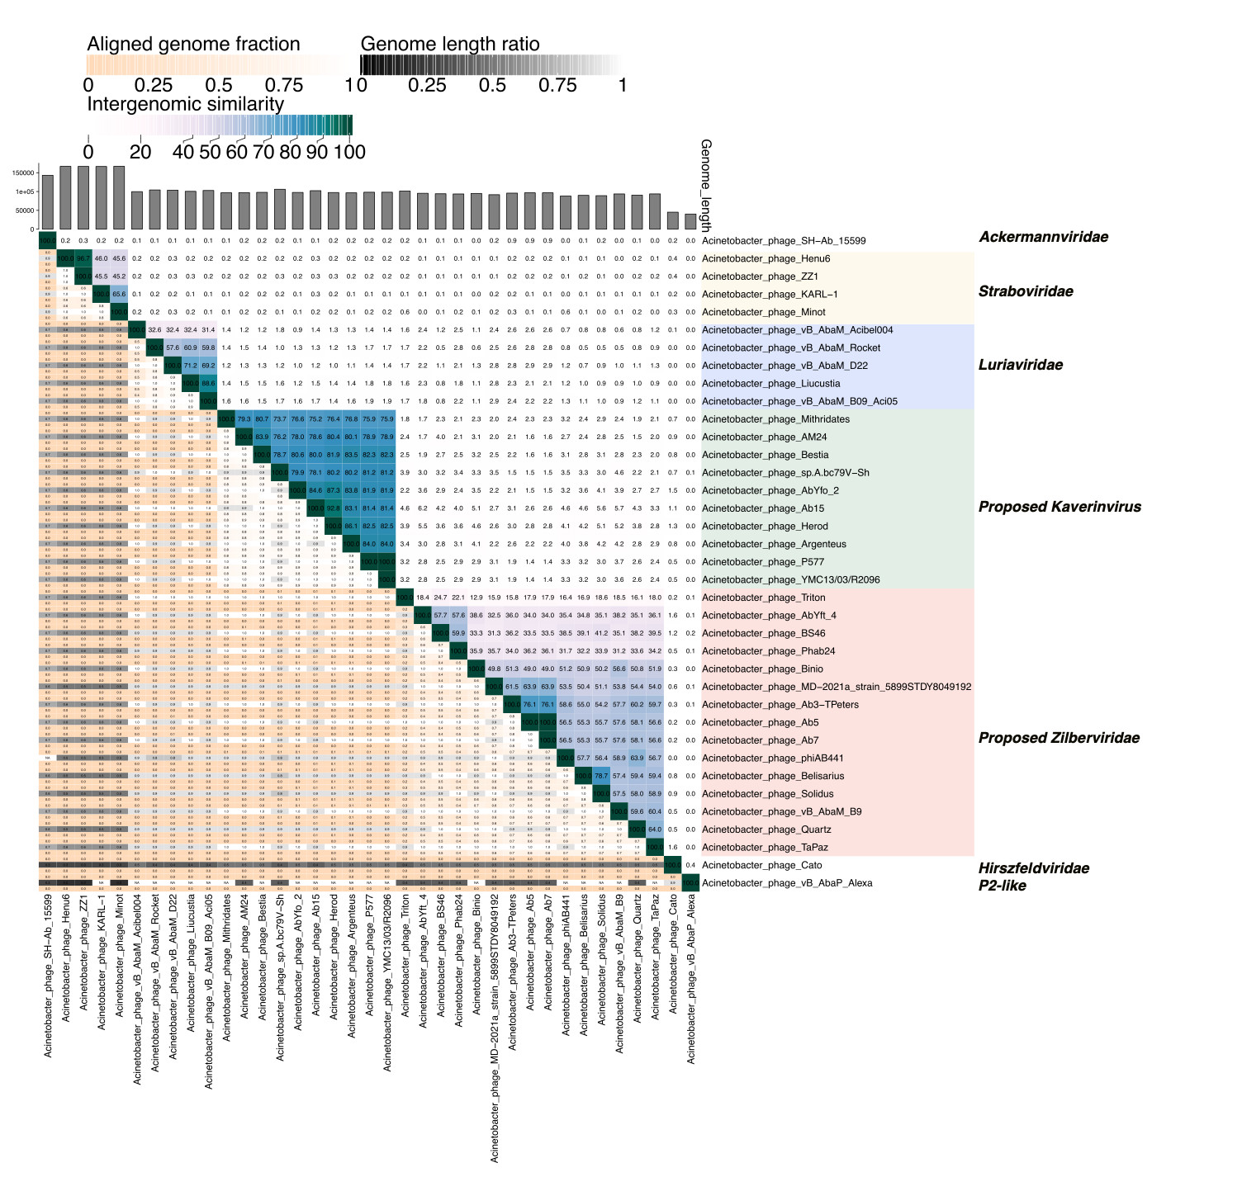

Figure 1. The VIRIDIC heatmap of intergenomic similarity (%) among the Kaverinviridae (Kaverinvirus) phages, their closest BLASTn homologs and representatives from related groups of A. baumannii infecting myophages. The color gradient corresponds to the percentage of similarity, as shown in the scale.

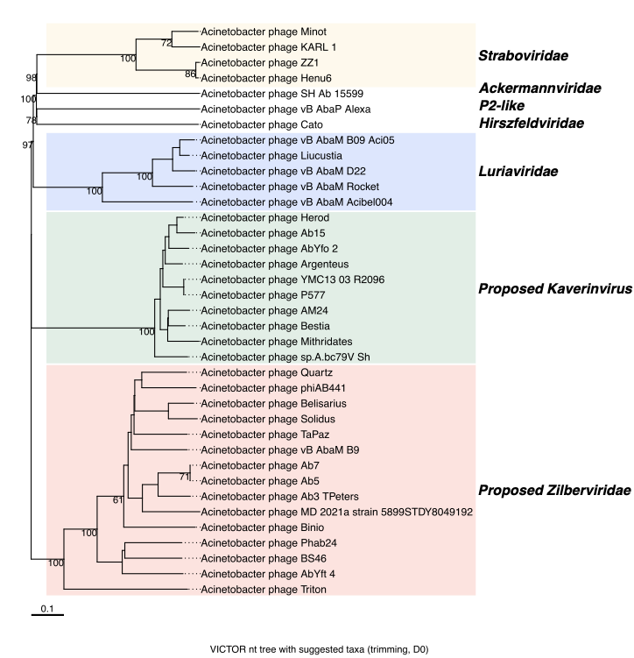
Figure 2. Genome-BLAST Distance Phylogeny analysis (VICTOR) presented for Kaverinviridae (Kaverinvirus) phages and for representatives of related myophage groups. The dendrogram was constructed using the d0 formula.

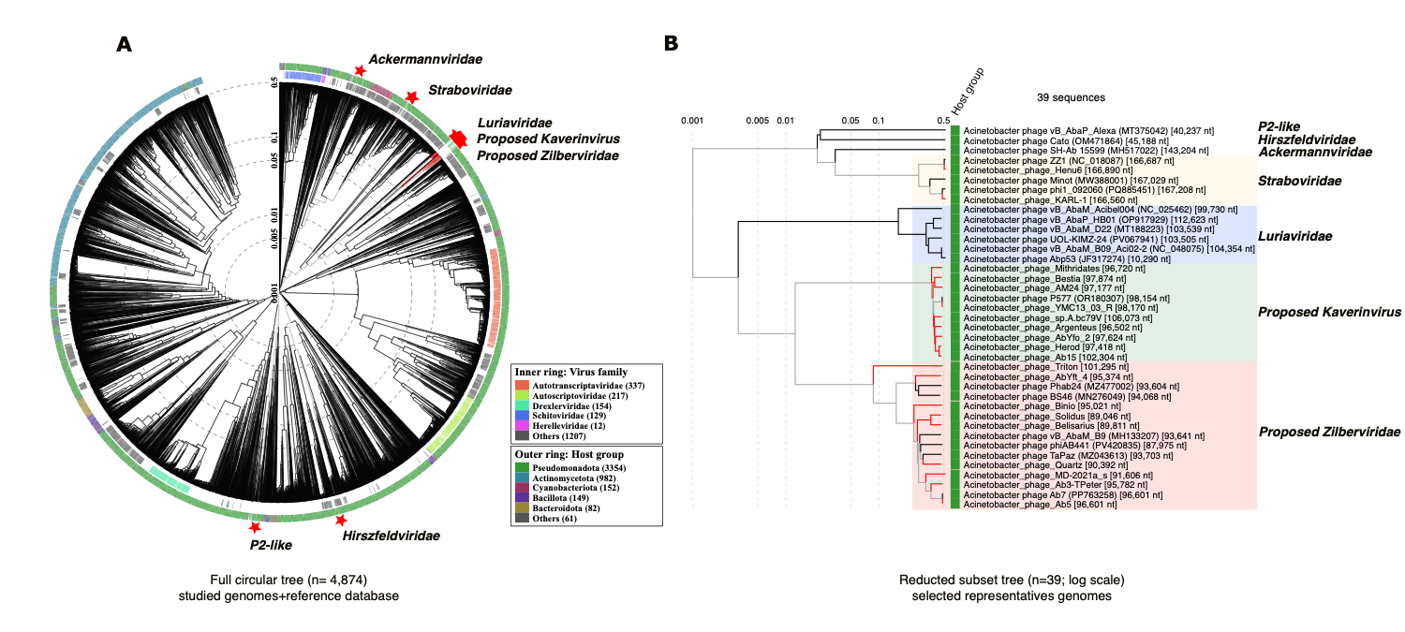
Figure 3. Proteome-based phylogenetic analysis (VipTree). (A) Circular dendrogram based on 4874 genomes (39 user-uploaded genomes marked with a star symbol*). (B) Rectangular dendrogram showing a detailed view of the phylogenetic cluster comprising proposed Kaverinviridae and proposed Zilberviridae phages, alongside with Luriaviridae phages, and representatives of other widely distributed groups of A. baumannii infecting phages.

