

The International Committee on Taxonomy of Viruses
Taxonomy Proposal Form, 2026

Part 1a: Details of taxonomy proposals

Title: | To create 11 new genera of temperate Pseudomonas phages in the class Caudoviricetes
Code assigned: | 2026.053B

Author(s), affiliation and email address(es):
Given name (+middle initial(s)) | Surname | Affiliation | Email address | Corr. author(s)
Cristina M. | Moraru | Department of Chemistry, Environmental Metagenomics,  University of Duisburg-Essen,  D-45141 Essen,  Germany | lilianacristina.moraru@uni-due.de
Andrew M. | Kropinski | University of Guelph, Guelph, Ontario, Canada N1G2W1 | Phage.Canada@gmail.com | x

Part 1b: Taxonomy Proposal Submission
ICTV Subcommittee:
Animal DNA Viruses and Retroviruses |  | Bacterial viruses | x
Animal minus-strand and dsRNA viruses |  | Fungal and protist viruses
Animal positive-strand RNA viruses |  | Plant viruses
Archaeal viruses |  | General -

List the ICTV Study Group(s) that have seen or have been involved in creating this proposal:
Caudoviricetes Study Group
Optional – complete only if formally voted on by an ICTV Study Group:
Study Group | Number of members
Study Group | Votes in support | Votes against | No vote
Submission date: | 10/07/2026

Part 1c: Feedback from ICTV Executive Committee (EC) meeting
Executive Committee Meeting Decision code: | X
A – Accept
Ac – Accept subject to revision by relevant subcommittee chair. No further vote required
U – Accept without revision but with re-evaluation and email vote by the EC
Uc – Accept subject to revision and re-evaluation and email vote by the EC
Ud – Deferred to the next EC meeting, with an invitation to revise based on EC comments
J - Reject
W - Withdrawn

Comments from the Executive Committee:

Part 1d: Revised Taxonomy Proposal Submission
Response of proposer:
Revision date:

Part 3: TAXONOMIC PROPOSAL

Taxonomic changes proposed:
Establish new taxon | x | Split taxon
Abolish taxon |  | Merge taxon
Move taxon |  | Promote taxon
Rename taxon |  | Demote taxon
Move and rename

Etymology (origin) of proposed taxonomic names:
Taxon name | Etymology of the term
Eweseptimavirus | Name derived from Pseudomonas phage vB_Pae_U7
Kirochnayavirus | Named after the street in Moscow where at the North-Western State Medical University Pseudomonas phage 5371 was isolated
Callanroadvirus | Named after the road in Dan Diego where at Synthetic Genomics Vaccines, Inc Pseudomonas phage phi1 was characterized
Shanxivirus | Named after Shanxi University where Pseudomonas phage P7869 was characterized
Vandermaaswegvirus | Named after the street in Delft where at TU Delft Pseudomonas phage vB_PeaS_FBPa47 was characterized
Pajuduovirus | Name derived from Pseudomonas phage PAJU2
Ebrievirus | Named after the Ébrié Lagoon lies in Ivory Coast where on the phages were isolated
Yatrevirus | Name derived from Pseudomonas phage YA3
Shamalvirus | Name derived from Pseudomonas phage Shamal
Humberrivervirus | Named after the Humber River in Toronto, Canada
Rataevirus | Ratae Corieltauvorum (or simply Ratae) was the Roman name for the modern city of Leicester where Pseudomonas phage GAS_0134 was characterized

Permission for use of names derived from a living person:
Taxon name | Full name of person from whom the name is derived | Attached

Abstract of Taxonomy Proposal:

Description of current taxonomy:
While none of these phages have been classified by ICTV they are peripherally related to the existing genera Lishizhenvirus, Detrevirus and Bugaksanvirus.

Proposed taxonomic change(s):
We propose the creation of 11 new genera: "Eweseptimavirus", "Kirochnayavirus", "Callanroadvirus", "Shanxivirus", "Vandermaaswegvirus", "Pajuduovirus", "Ebrievirus", "Yatrevirus", "Shamalvirus", "Humberrivervirus”, and "Rataevirus”

Demarcation criteria for new taxon/taxa:

Genus demarcation criteria: An intergenomic similarity cut-off of 70%, a combination of average nucleotide identity and alignment fraction, is used to determine genera demarcation. Members of the same genus have >70% intergenomic similarity and cluster tightly in marker gene phylogenies.

Species demarcation criteria: A demarcation value of 95% intergenomic similarity was used to define different species according to intergenomic similarity. Members of the same genus have >95% intergenomic similarity [6].

Justification:
On the basis of whole genome intergenomic similarity, the proteome TBLAST distance tree and phylogenetic analysis of the major capsid protein these temperate Pseudomonas phages can be classified into 11 new genera and 13 new species. All proposed genera, aside from “Rataevirus” contain a single species.

Text of Taxonomy proposal:
Description of current taxonomy:
While none of these phages have been classified by ICTV they are peripherally related to the existing genera Lishizhenvirus, Detrevirus and Bugaksanvirus. Furthermore, INPHARED [10] recognizes them as part of several, as yet unnamed, families.

Proposed taxonomic change(s):
Most of these viruses are temperate siphoviruses or prophages of Pseudomonas aeruginosa. We propose the creation of 11 new genera: "Eweseptimavirus", "Kirochnayavirus", "Callanroadvirus", "Shanxivirus", "Vandermaaswegvirus", "Pajuduovirus", "Ebrievirus", "Yatrevirus", "Shamalvirus", "Humberrivervirus”, and "Rataevirus”

Demarcation criteria for new taxon/taxa:
Genus demarcation criteria: An intergenomic similarity cut-off of 70%, a combination of average nucleotide identity and alignment fraction, is used to determine genera demarcation. Members of the same genus have >70% intergenomic similarity and cluster tightly in marker gene phylogenies.

Species demarcation criteria: A demarcation value of 95% intergenomic similarity was used to define different species according to intergenomic similarity. Members of the same genus have >95% intergenomic similarity [6].

Justification:
On the basis of whole genome intergenomic similarity, the proteome TBLAST distance tree and phylogenetic analysis of the major capsid protein these temperate Pseudomonas phages can be classified into 11 new genera and 13 new species. All proposed genera, aside from “Rataevirus” contain a single species.
References:
1. Moraru C, Varsani A, Kropinski AM. VIRIDIC-A Novel Tool to Calculate the Intergenomic Similarities of Prokaryote-Infecting Viruses. Viruses. 2020 Nov 6;12(11):1268. doi: 10.3390/v12111268. PMID: 33172115; PMCID: PMC7694805. http://kronos.icbm.uni-oldenburg.de/viridic/
2. Nishimura Y, Yoshida T, Kuronishi M, Uehara H, Ogata H, Goto S. ViPTree: the viral proteomic tree server. Bioinformatics. 2017; 33(15):2379-2380. doi:10.1093/bioinformatics/btx157. PubMed PMID: 28379287. https://www.genome.jp/viptree/
3. Rohwer F, Edwards R. The Phage Proteomic Tree: a genome-based taxonomy for phage. J Bacteriol. 2002 Aug;184(16):4529-35. PubMed PMID: 12142423
4. Turner D, Reynolds D, Seto D, Mahadevan P. CoreGenes3.5: a webserver for the determination of core genes from sets of viral and small bacterial genomes. BMC Res Notes. 2013;6:140. doi: 10.1186/1756-0500-6-140. PMID: 23566564.
5. Davis P, Seto D, Mahadevan P. CoreGenes5.0: An Updated User-Friendly Webserver for the Determination of Core Genes from Sets of Viral and Bacterial Genomes. Viruses. 2022 Nov 16;14(11):2534. doi: 10.3390/v14112534. PMID: 36423143; PMCID: PMC9693508.
6. Turner D, Kropinski AM, Adriaenssens EM. A Roadmap for Genome-Based Phage Taxonomy. Viruses. 2021 Mar 18;13(3):506. doi: 10.3390/v13030506. PMID: 33803862; PMCID: PMC8003253.
Lemoine F, Correia D, Lefort V, Doppelt-Azeroual O, Mareuil F, Cohen-Boulakia S, Gascuel O. NGPhylogeny.fr: new generation phylogenetic services for non-specialists. Nucleic Acids Res. 2019 Jul 2;47(W1):W260-W265. doi: 10.1093/nar/gkz303. PMID: 31028399; PMCID: PMC6602494.
7. Letunic I, Bork P. Interactive Tree Of Life (iTOL): an online tool for phylogenetic tree display and annotation. Bioinformatics. 2007 Jan 1;23(1):127-8. doi: 10.1093/bioinformatics/btl529. Epub 2006 Oct 18. PMID: 17050570.
8. Zhou T, Xu K, Zhao F, Liu W, Li L, Hua Z, Zhou X. itol.toolkit accelerates working with iTOL (Interactive Tree of Life) by an automated generation of annotation files. Bioinformatics. 2023 Jun 1;39(6):btad339. doi: 10.1093/bioinformatics/btad339. PMID: 37225402; PMCID: PMC10243930
9. Dereeper A, Guignon V, Blanc G, Audic S, Buffet S, Chevenet F, Dufayard JF, Guindon S, Lefort V, Lescot M, Claverie JM, Gascuel O. Phylogeny.fr: robust phylogenetic analysis for the non-specialist. Nucleic Acids Res. 2008 Jul 1;36(Web Server issue):W465-9. doi: 10.1093/nar/gkn180. Epub 2008 Apr 19. PMID: 18424797; PMCID: PMC2447785.
10. Cook R, Brown N, Redgwell T, Rihtman B, Barnes M, Clokie M, Stekel DJ, Hobman J, Jones MA, Millard A. INfrastructure for a PHAge REference Database: Identification of Large-Scale Biases in the Current Collection of Cultured Phage Genomes. Phage (New Rochelle). 2021 Dec 1;2(4):214-223. doi: 10.1089/phage.2021.0007. Epub 2021 Dec 16. PMID: 36159887; PMCID: PMC9041510.

Accompanying files:
Filename | Description of contents

Tables, Figures:

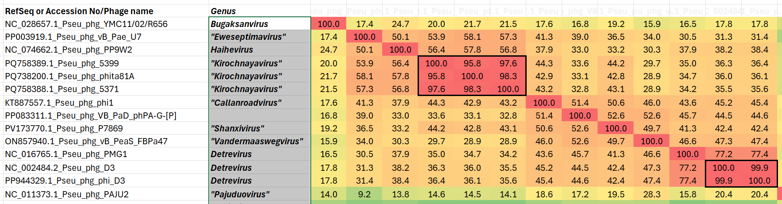

Figure 1. Partial VIRIDIC heatmap of this group of phages. The complete heatmap is appended to this proposal. VIRIDIC (Virus Intergenomic Distance Calculator; VIRIDIC (Virus Intergenomic Distance Calculator; [1]; http://rhea.icbm.uni-oldenburg.de/VIRIDIC/) computes pairwise intergenomic distances/similarities amongst phage genomes. Data values which are bordered in black correspond to strains. Abbreviations: phg = phage; Pseu = Pseudomonas; -[P] = partial genome
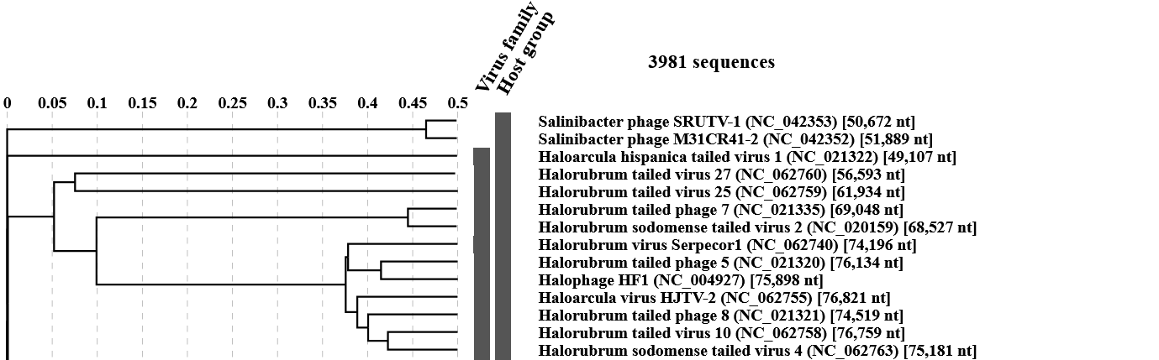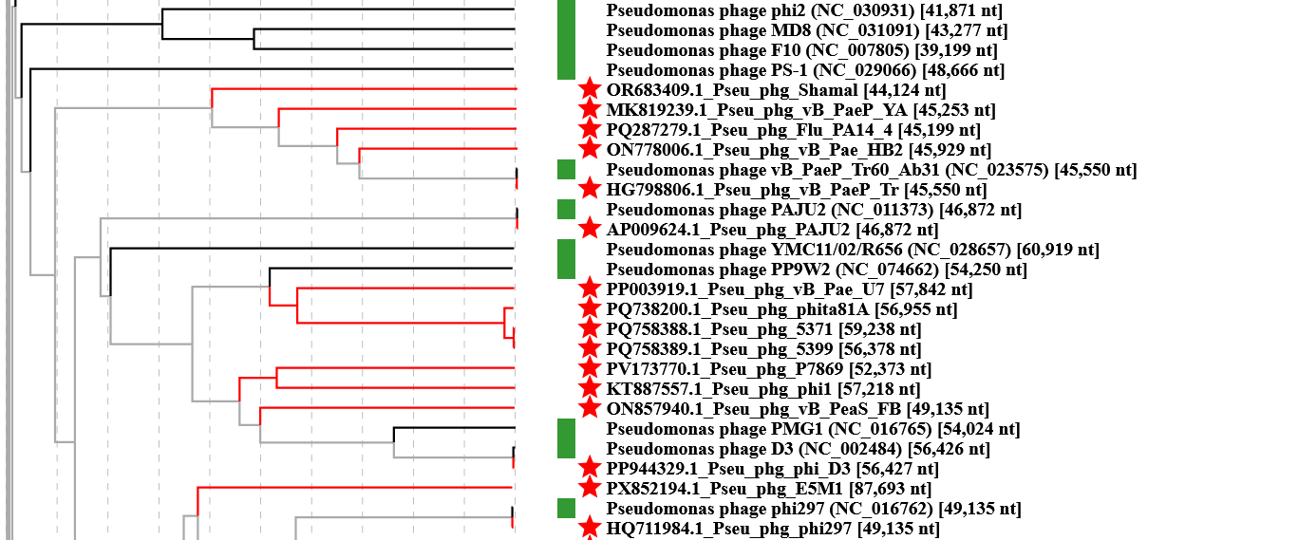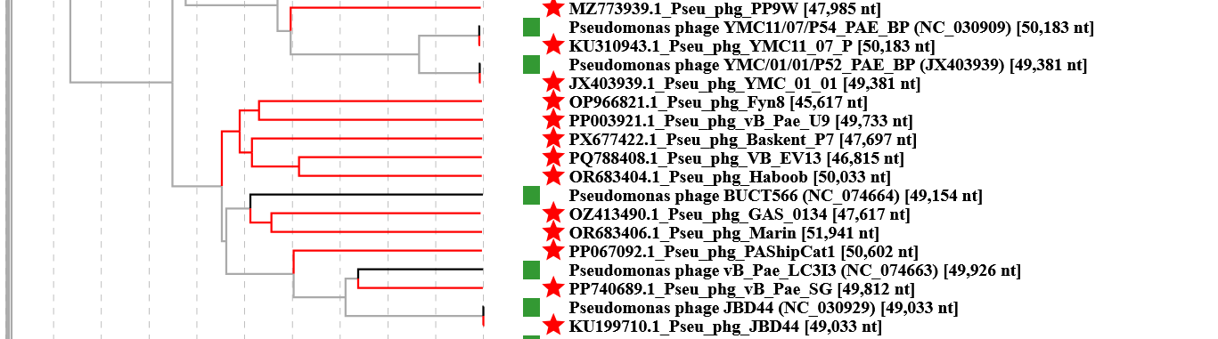Figure 2. ViPTree analysis: ViPTree analysis (https://www.genome.jp/viptree/; [2]) is based upon Rohwer and Edwards (2002) Phage Proteomic Tree [3]. The taxons under discussion are indicated with red bars and stars. Abbreviations: phg = phage; Pseu = Pseudomonas.
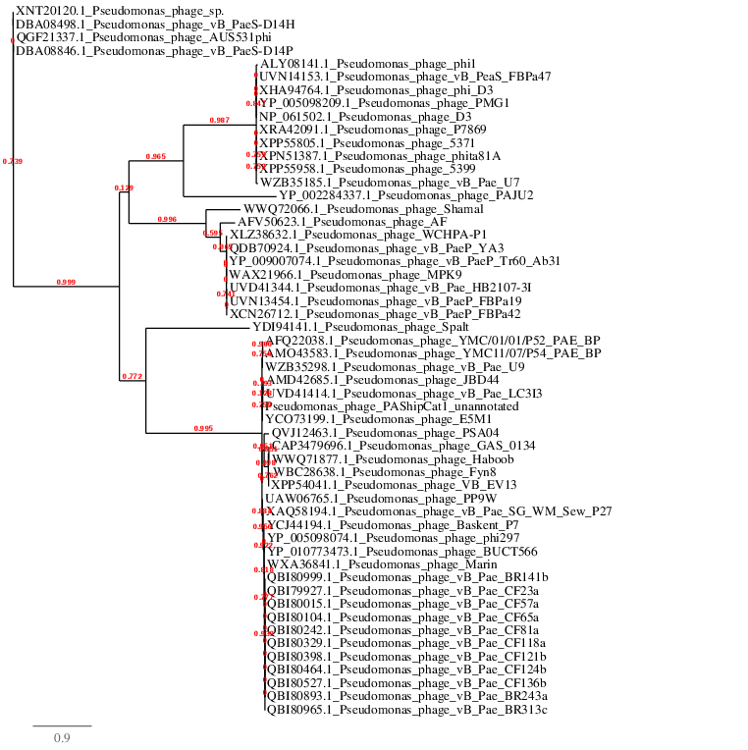Figure 3. Phylogenetic tree constructed with the major capsid proteins from these and related phages using “One Click” Phylogeny.fr [9] at http://phylogeny.lirmm.fr/phylo_cgi/simple_phylogeny.cgi.

Table 1. Characteristics of the phage described in the proposal which belong to the genus "Eweseptimavirus"

Phage name | Host | Morphotype | Lifestyle | Accession No. | Genome size | %G+C | No. proteins | No. tRNA
Pseudomonas phage vB_Pae_U7 | Pseudomonas aeruginosa ST773 (NDM-1-producing) | Siphovirus | Temperate | PP003919 | 57842 bp | 58.9 | 100 | 3
Specific reference: Hernández-García M, González de Aledo M, Ponce-Alonso M, González-Blanco B, Viedma E, Villa J, Tomás M, Hendrickx APA, Ruiz-Garbajosa P, Cantón R. Simultaneous clonal spread of NDM-1-producing Pseudomonas aeruginosa ST773 from Ukrainian patients in the Netherlands and Spain. IJID Reg. 2024 Jul 30;12:100415. doi: 10.1016/j.ijregi.2024.100415. PMID: 39253689; PMCID: PMC11381890.

Table 2. Characteristics of the phage described in the proposal which belong to the genus "Kirochnayavirus"

Phage name | Host | Morphotype | Lifestyle | Accession No. | Genome size | %G+C | No. proteins | No. tRNA
Pseudomonas phage 5371 | Pseudomonas aeruginosa 147 | Siphovirus | Temperate | PQ758388 | 59238 bp | 58.9 | 101 | 1

Table 3. Characteristics of the phage described in the proposal which belong to the genus "Callanroadvirus"

Phage name | Host | Morphotype | Lifestyle | Accession No. | Genome size | %G+C | No. proteins | No. tRNA
Pseudomonas phage phi1 | Pseudomonas aeruginosa WH-SGI-V-07651 | Siphovirus | Temperate | KT887557 | 57218 bp | 57.5 | 69(*) | 2(**)
Specific reference: van Belkum A, Soriaga LB, LaFave MC, Akella S, Veyrieras JB, Barbu EM, Shortridge D, Blanc B, Hannum G, Zambardi G, Miller K, Enright MC, Mugnier N, Brami D, Schicklin S, Felderman M, Schwartz AS, Richardson TH, Peterson TC, Hubby B, Cady KC. Phylogenetic Distribution of CRISPR-Cas Systems in Antibiotic-Resistant Pseudomonas aeruginosa. mBio. 2015 Nov 24;6(6):e01796-15. doi: 10.1128/mBio.01796-15. PMID: 26604259; PMCID: PMC4669384.
(*) possibly underannotated
(**) none indicated in GenBank file; two identified using tRNAscan-SE v. 2.0

Table 4. Characteristics of the phage described in the proposal which belong to the genus "Shanxivirus"

Phage name | Host | Morphotype | Lifestyle | Accession No. | Genome size | %G+C | No. proteins | No. tRNA
Pseudomonas phage P7869 | Pseudomonas aeruginosa 7869 | Siphovirus | Temperate | PV173770 | 52373 bp | 58.3 | 94 | 3

Table 5. Characteristics of the phage described in the proposal which belong to the genus "Vandermaaswegvirus"

Phage name | Host | Morphotype | Lifestyle | Accession No. | Genome size | %G+C | No. proteins | No. tRNA
Pseudomonas phage vB_PeaS_FBPa47 | Pseudomonas sp. | Siphovirus | Temperate | ON857940 | 49135 bp | 58.2 | 80 | 4
Reference: https://www.fagenbank.nl/english/

Table 6. Characteristics of the phage described in the proposal which belong to the genus "Pajuduovirus"

Phage name | Host | Morphotype | Lifestyle | Accession No. | Genome size | %G+C | No. proteins | No. tRNA
Pseudomonas phage PAJU2 | Pseudomonas aeruginosa | Siphovirus | Temperate | AP009624 | 46872 bp | 56.3 | 79 | 0
Specific reference: Uchiyama J, Rashel M, Matsumoto T, Sumiyama Y, Wakiguchi H, Matsuzaki S. Characteristics of a novel Pseudomonas aeruginosa bacteriophage, PAJU2, which is genetically related to bacteriophage D3. Virus Res. 2009 Jan;139(1):131-4. doi: 10.1016/j.virusres.2008.10.005. Epub 2008 Dec 2. PMID: 19010363.

N.B. Possesses a highly elongated head unlike phage D3

Table 7. Characteristics of the phages described in the proposal which belong to the genus "Ebrievirus"

Phage name | Host | Morphotype | Lifestyle | Accession No. | Genome size | %G+C | No. proteins | No. tRNA
Pseudomonas phage vB_PaeP_Tr60_Ab31 | Pseudomonas aeruginosa | Siphovirus | Temperate | HG798806 | 45550 bp | 57.1 | 69 | 0
Pseudomonas phage Flu_PA14_4 | Pseudomonas aeruginosa PA14 | Siphovirus | Temperate | PQ287279 | 45199 bp | 57.2 | 74 | 0
Pseudomonas phage vB_Pae_HB2107-3I | Pseudomonas aeruginosa PA14 | Siphovirus | Temperate | ON778006 | 45929 bp | 56.9 | 72 | 0
Specific reference: Latino L, Essoh C, Blouin Y, Vu Thien H, Pourcel C. A novel Pseudomonas aeruginosa bacteriophage, Ab31, a chimera formed from temperate phage PAJU2 and P. putida lytic phage AF: characteristics and mechanism of bacterial resistance. PLoS One. 2014 Apr 3;9(4):e93777. doi: 10.1371/journal.pone.0093777. PMID: 24699529; PMCID: PMC3974807.

Table 8. Characteristics of the phage described in the proposal which belong to the genus "Yatrevirus"

Phage name | Host | Morphotype | Lifestyle | Accession No. | Genome size | %G+C | No. proteins | No. tRNA
Pseudomonas phage vB_PaeP_YA3 | Pseudomonas aeruginosa UCBPP-PA14 | Podovirus | Temperate | MK819239 | 45253 bp | 57.2 | 65 | 0
Specific reference: Yu X, Xu J, Gu Y, Zhang R, Zhu Y, Liu X. Molecular Characterization and Comparative Genomic Analysis of vB_PaeP_YA3, a Novel Temperate Bacteriophage of Pseudomonas aeruginosa. Front Microbiol. 2020 Jun 3;11:947. doi: 10.3389/fmicb.2020.00947. PMID: 32655502; PMCID: PMC7326022.

Table 9. Characteristics of the phage described in the proposal which belong to the genus "Shamalvirus"

Phage name | Host | Morphotype | Lifestyle | Accession No. | Genome size | %G+C | No. proteins | No. tRNA
Pseudomonas phage Shamal | Pseudomonas aeruginosa F002 | Siphovirus | Temperate | OR683409 | 44124 bp | 57.3 | 76 | 1

Table 10. Characteristics of the phage described in the proposal which belong to the genus "Humberrivervirus"

Phage name | Host | Morphotype | Lifestyle | Accession No. | Genome size | %G+C | No. proteins | No. tRNA
Pseudomonas phage JBD44 | Pseudomonas aeruginosa PA14 | Siphovirus | Temperate | KU199710 | 49033 bp | 58.5 | 80 | 0

Table 11. Characteristics of the phage described in the proposal which belong to the genus "Rataevirus"

Phage name | Host | Morphotype | Lifestyle | Accession No. | Genome size | %G+C | No. proteins | No. tRNA
Pseudomonas phage GAS_0134 | NA | Siphovirus | Temperate | OZ413490 | 47617 bp | 60.2 | 71 | 3

