

The International Committee on Taxonomy of Viruses
Taxonomy Proposal Form, 2026

Part 1a: Details of taxonomy proposals

Title: | Create 20 new species and abolish 1 species in the genus Phapecoctavirus (class Caudoviricetes, subfamily Stephanstirmvirinae)
Code assigned: | 2026.052B

Author(s), affiliation and email address(es):
Given name (+middle initial(s)) | Surname | Affiliation | Email address | Corr. author(s)
Michał J. | Wójcicki | Bacteriophage Laboratory, Department of Phage Therapy, Hirszfeld Institute of Immunology and Experimental Therapy, Polish Academy of Sciences, Wroclaw, Poland | michal.wojcicki@hirszfeld.pl | X
Małgorzata | Łobocka | Laboratory of Bacteriophage Biology, Institute of Biochemistry and Biophysics, Polish Academy of Sciences, Warsaw, Poland | lobocka@ibb.waw.pl | X

Part 1b: Taxonomy Proposal Submission
ICTV Subcommittee:
Animal DNA Viruses and Retroviruses |  | Bacterial viruses | X
Animal minus-strand and dsRNA viruses |  | Fungal and protist viruses
Animal positive-strand RNA viruses |  | Plant viruses
Archaeal viruses |  | General

List the ICTV Study Group(s) that have seen or have been involved in creating this proposal:
Caudoviricetes Study Group

Optional – complete only if formally voted on by an ICTV Study Group:
Study Group | Number of members
Study Group | Votes in support | Votes against | No vote

Submission date: | 30/08/2026

Part 1c: Feedback from ICTV Executive Committee (EC) meeting
Executive Committee Meeting Decision code: | X
A – Accept
Ac – Accept subject to revision by relevant subcommittee chair. No further vote required
U – Accept without revision but with re-evaluation and email vote by the EC
Uc – Accept subject to revision and re-evaluation and email vote by the EC
Ud – Deferred to the next EC meeting, with an invitation to revise based on EC comments
J - Reject
W - Withdrawn

Comments from the Executive Committee:

Part 1d: Revised Taxonomy Proposal Submission
Response of proposer:
Revision date:

Part 3: TAXONOMIC PROPOSAL

Taxonomic changes proposed:
Establish new taxon | X | Split taxon
Abolish taxon | X | Merge taxon
Move taxon |  | Promote taxon
Rename taxon |  | Demote taxon
Move and rename

Etymology (origin) of proposed taxonomic names:
Taxon name | Etymology of the term
Phapecoctavirus EP57 | species name derived from the phage name in the GenBank database – Escherichia phage vB_EcoM_EP57
Phapecoctavirus WPEC1 | species name derived from the phage name in the GenBank database – Escherichia phage WPEC1
Phapecoctavirus EC001 | species name derived from the phage name in the GenBank database – Escherichia phage iGC_PHA_EC001
Phapecoctavirus EF11 | species name derived from the phage name in the GenBank database – Escherichia phage EF1-1
Phapecoctavirus SF11 | species name derived from the phage name in the GenBank database – Shigella phage SF1-1
Phapecoctavirus ECML1832 | species name derived from the phage name in the GenBank database – Escherichia phage ECML-183-2
Phapecoctavirus EcoA1D1 | species name derived from the phage name in the GenBank database – Escherichia phage vB_EcoA_1D1
Phapecoctavirus DE16 | species name derived from the phage name in the GenBank database – Escherichia phage vB_EcoM_DE16
Phapecoctavirus ECO340P2 | species name derived from the phage name in the GenBank database – Escherichia phage ECO340P2
Phapecoctavirus ECPPW15 | species name derived from the phage name in the GenBank database – Escherichia phage vECPPW15
Phapecoctavirus ETECTG | species name derived from the phage name in the GenBank database – Escherichia phage ETEC-TG
Phapecoctavirus Esher1 | species name derived from the phage name in the GenBank database – Escherichia phage MirsaeidiM_Esher1
Phapecoctavirus JunoodPK3 | species name derived from the phage name in the GenBank database – Escherichia phage Junood_PK_3
Phapecoctavirus P3322 | species name derived from the phage name in the GenBank database – Escherichia phage vB_EcoM-P3322
Phapecoctavirus SKA64 | species name derived from the phage name in the GenBank database – Escherichia phage SKA64
Phapecoctavirus KKP3954 | species name derived from the phage name in the GenBank database – Escherichia phage KKP 3954
Phapecoctavirus A1SANWU | species name derived from the phage name in the GenBank database – Escherichia phage vB_EcoM_3A1_SA_NWU
Phapecoctavirus AV126 | species name derived from the phage name in the GenBank database – Escherichia phage AV126
Phapecoctavirus AV125 | species name derived from the phage name in the GenBank database – Escherichia phage AV125
Phapecoctavirus EcG1 | species name derived from the phage name in the GenBank database – Escherichia phage vB_Ec-G1

Permission for use of names derived from a living person:
Taxon name | Full name of person from whom the name is derived | Attached

Abstract of Taxonomy Proposal:
Description of current taxonomy:
The subfamily Stephanstirmvirinae currently includes two genera: Justusliebigvirus and
Phapecoctavirus. The genus Phapecoctavirus genus includes 13 species.

Proposed taxonomic change(s):
We performed a genomic analysis of phages deposited in the NCBI database. Based on the demarcation criteria of intergenomic similarity for the delineation of species, we propose to create 20 new species and abolish one species in the genus Phapecoctavirus.

Demarcation criteria for new taxon/taxa:
Species demarcation criteria: Two phages are assigned to the same species if their genomes are more than 95% identical over their genome length for isolates.
These values can be calculated by several tools, such as BLASTn [1] – usually calculated using the intergenomic distance calculator VIRIDIC [2].

Genus demarcation criteria: In search for criteria that create cohesive and distinct genera that are reproducible and monophyletic, the Bacterial Viruses Subcommittee has established 70% nucleotide identity of the genome length as the cut-off for genera. Genus-level groupings should always be monophyletic in the signature genes, as tested with a phylogenetic tree [3].

Justification:
Based on DNA and protein similarity, the 20 proposed new species are coherent and together with the 13 known species can be classified in the genus Phapecoctavirus. In addition, we propose the abolishment of one species, Phapecoctavirus schickermooser, which shows 96.2% similarity over the entire genome length with the species Phapecoctavirus ESCO13. The proposed taxa conform to the demarcation criteria employed by the ICTV Bacterial Viruses Subcommittee.

Text of Taxonomy proposal:
Description of current taxonomy:
The subfamily Stephanstirmvirinae currently includes two genera: Justusliebigvirus and
Phapecoctavirus. The genus Phapecoctavirus genus includes 13 species.

Proposed taxonomic change(s):
We performed a genomic analysis of phages deposited in the NCBI database. Based on the demarcation criteria of intergenomic similarity for the delineation of species, we propose to create 20 new species and abolish one species in the genus Phapecoctavirus.

Demarcation criteria for new taxon/taxa:
Species demarcation criteria: Two phages are assigned to the same species if their genomes are more than 95% identical over their genome length for isolates.
These values can be calculated by several tools, such as BLASTn [1] – usually calculated using the intergenomic distance calculator VIRIDIC [2].

Genus demarcation criteria: In search for criteria that create cohesive and distinct genera that are reproducible and monophyletic, the Bacterial Viruses Subcommittee has established 70% nucleotide identity of the genome length as the cut-off for genera. Genus-level groupings should always be monophyletic in the signature genes, as tested with a phylogenetic tree [3].

Justification:
Based on DNA and protein similarity, the 20 proposed new species are coherent and together with the 13 known species can be classified in the genus Phapecoctavirus (Figure 1). In addition, we propose the abolishment of one species, Phapecoctavirus schickermooser, which shows 96.2% similarity over the entire genome length with the species Phapecoctavirus ESCO13. The proposed taxa conform to the demarcation criteria employed by the ICTV Bacterial Viruses Subcommittee.

References:
- Sayers EW, Beck J, Bolton EE, Bourexis D, Brister JR, Canese K, Comeau DC, Funk K, Kim S, Klimke W, Marchler-Bauer A, Landrum M, Lathrop S, Lu Z, Madden TL, O'Leary N, Phan L, Rangwala SH, Schneider VA, Skripchenko Y, Wang J, Ye J, Trawick BW, Pruitt KD, Sherry ST. Database resources of the National Center for Biotechnology Information. Nucleic Acids Res. 2021, 49(D1):D10-D17.
- Moraru C, Varsani A, Kropinski AM. VIRIDIC - a novel tool to calculate the intergenomic similarities of prokaryote-infecting viruses. Viruses 2020, 12(11):1268.
- Turner D, Kropinski AM, Adriaenssens EM. A roadmap for genome-based phage taxonomy. Viruses 2021, 13(3):506.
- Turner D, Reynolds D, Seto D, Mahadevan P. CoreGenes3.5: a webserver for the determination of core genes from sets of viral and small bacterial genomes. BMC Res. Notes. 2013, 6:140.

Accompanying files:
Filename | Description of contents
Phapecoctavirus_20ns_1as.xlsx | To present the proposed taxonomic changes as a comparison of new taxonomic structures.
Tables, Figures:

Proposals data:

- To create 20 new species in the genus Phapecoctavirus.
- To abolish one species in the genus Phapecoctavirus.

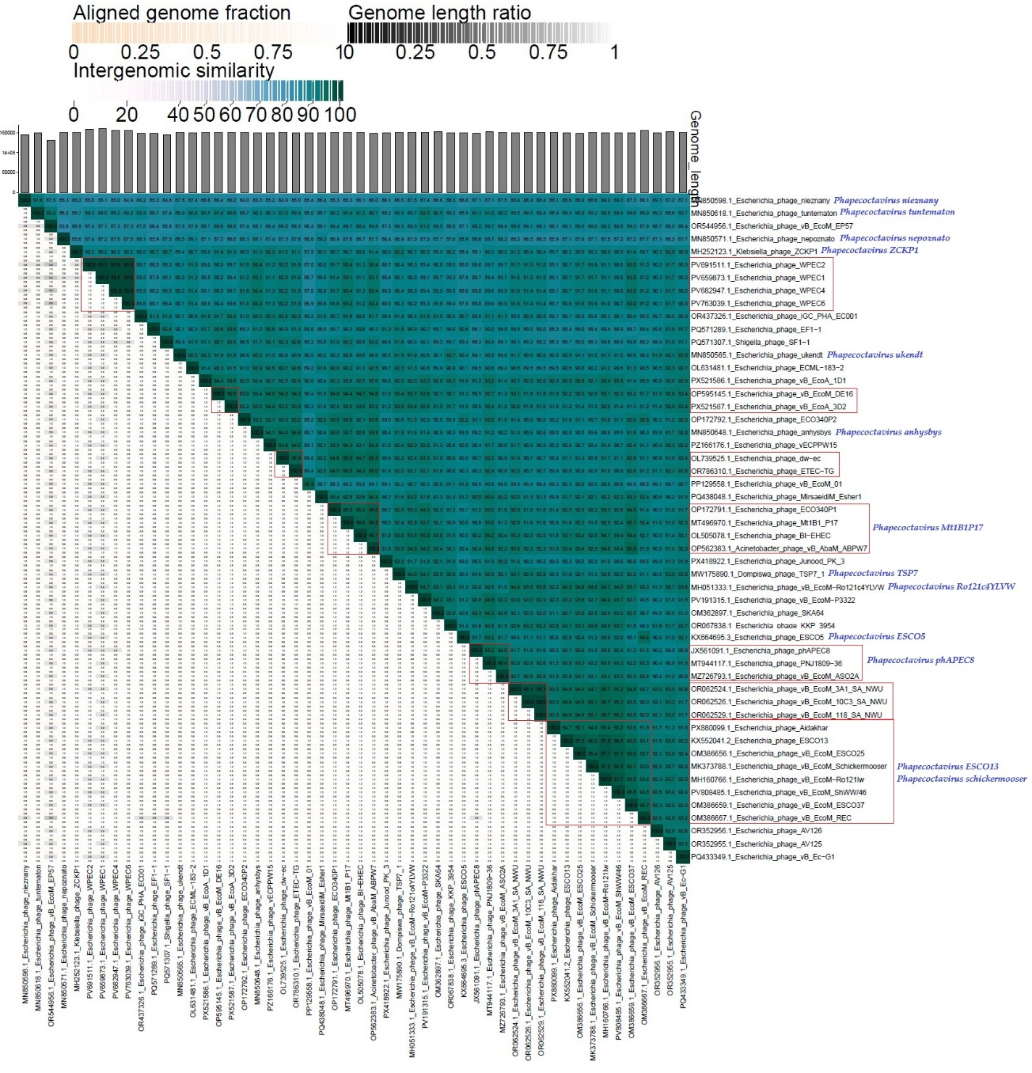
Figure 1. VIRIDIC heat map: VIRIDIC (Virus Intergenomic Distance Calculator [2]; http://rhea.icbm.uni-oldenburg.de/VIRIDIC/) computes pairwise intergenomic distances/similarities amongst phage genomes. Phages belonging to the same species (nucleotide similarity above 95%) are marked with a red frame. The currently distinguished 13 species belonging to the genus Phapecoctavirus are marked in blue font.

- To create 20 new species in the genus Phapecoctavirus.

Genome summary:

Phage name | RefSeq No. | INSDC | Size (bp) | GC% | Protein | Overall % DNA sequence identity (*) | Overall % homologous proteins (**)
Escherichia phage nieznany  (Phapecoctavirus nieznany; reference genome) | NC_052659.1 | MN850598 | 144,998 | 39.1 | 256 | 100.0 | 100.00
Escherichia phage vB_EcoM_EP57 |  | OR544956 | 130,723 | 39.0 | 293 | 87.5 | 85.94
Escherichia phage WPEC1 |  | PV659873 | 161,280 | 38.9 | 369 | 85.1 | 89.06
Escherichia phage iGC_PHA_EC001 |  | OR437326 | 148,445 | 39.1 | 269 | 86.2 | 91.41
Escherichia phage EF1-1 |  | PQ571289 | 147,884 | 39.1 | 260 | 85.3 | 89.06
Shigella phage SF1-1 |  | PQ571307 | 145,957 | 38.9 | 263 | 84.8 | 88.67
Escherichia phage ECML-183-2 |  | OL631481 | 149,818 | 39.0 | 230 | 87.4 | 79.69
Escherichia phage vB_EcoA_1D1 |  | PX521586 | 150,823 | 39.2 | 275 | 86.6 | 91.80
Escherichia phage vB_EcoM_DE16 |  | OP595145 | 151,363 | 39.1 | 276 | 86.4 | 91.41
Escherichia phage ECO340P2 |  | OP172792 | 151,993 | 38.9 | 274 | 84.0 | 91.02
Escherichia phage vECPPW15 |  | PZ166176 | 149,378 | 39.1 | 273 | 85.2 | 92.19
Escherichia phage ETEC-TG |  | OR786310 | 149,880 | 39.1 | 305 | 85.0 | 90.62
Escherichia phage MirsaeidiM_Esher1 |  | PQ438048 | 149,951 | 39.0 | 160 | 86.4 | 57.03
Escherichia phage Junood_PK_3 |  | PX418922 | 149,814 | 39.0 | 265 | 86.1 | 88.67
Escherichia phage vB_EcoM-P3322 |  | PV191315 | 151,674 | 39.1 | 279 | 87.4 | 93.36
Escherichia phage SKA64 |  | OM362897 | 152,401 | 39.2 | 261 | 86.6 | 87.50
Escherichia phage KKP 3954 |  | OR067838 | 149,856 | 39.1 | 286 | 88.3 | 92.19
Escherichia phage vB_EcoM_3A1_SA_NWU |  | OR062524 | 150,431 | 39.1 | 271 | 88.4 | 91.80
Escherichia phage AV126 |  | OR352956 | 149,254 | 39.1 | 270 | 89.1 | 91.02
Escherichia phage AV125 |  | OR352955 | 152,808 | 39.0 | 276 | 87.2 | 91.41
Escherichia phage vB_Ec-G1 |  | PQ433349 | 151,245 | 39.0 | 274 | 87.1 | 92.19
(*) determined using VIRIDIC [2]
(**) determined using CoreGenes 3.5 [4]

- To abolish one species in the genus Phapecoctavirus.

We propose the abolish of one species, Phapecoctavirus schickermooser, which shows 96.2% similarity over the entire genome length with the species Phapecoctavirus ESCO13.

Genome summary:

Phage name | RefSeq No. | INSDC | Size (bp) | GC% | Protein | Overall % DNA sequence identity (*) | Overall % homologous proteins (**)
Escherichia phage ESCO13  (Phapecoctavirus ESCO13; reference genome) | NC_047770.1 | KX552041 | 149,813 | 39.1 | 281 | 100.0 | 100.00
Escherichia phage vB_EcoM_Schickermooser (Phapecoctavirus schickermooser) |  | MK373788 | 151,194 | 39.0 | 284 | 96.2 | 96.09
(*) determined using VIRIDIC [2]
(**) determined using CoreGenes 3.5 [4]

