

The International Committee on Taxonomy of Viruses
Taxonomy Proposal Form, 2026

Part 1a: Details of taxonomy proposals

Title: | Create one new species in the genus Pahexavirus (class Caudoviricetes)
Code assigned: | 2026.051B

Author(s), affiliation and email address(es):
Given name (+middle initial(s)) | Surname | Affiliation | Email address | Corr. author(s)
Jinquan | Li | Huazhong Agricultural University, Wuhan, China | lijinquan2017@163.com | X
Yating | Guo | Huazhong Agricultural University, Wuhan, China | guoyating0626@126.com
Yang | Zhou | Huazhong Agricultural University, Wuhan, China | zhouyang@mail.hzau.edu.cn
Shan | Wang | Huazhong Agricultural University, Wuhan, China | shanwang@mai.hzau.edu.cn
Wenhao | Miao | Huazhong Agricultural University, Wuhan, China | miaowenhao27@gmail.com
Meijun | Jin | Huazhong Agricultural University, Wuhan, China | jinmeijun0745@163.com
Qing | Li | Huazhong Agricultural University, Wuhan, China | liqingchem@webmail.hzau.edu.cn

Part 1b: Taxonomy Proposal Submission
ICTV Subcommittee:
Animal DNA Viruses and Retroviruses |  | Bacterial viruses | X
Animal minus-strand and dsRNA viruses |  | Fungal and protist viruses
Animal positive-strand RNA viruses |  | Plant viruses
Archaeal viruses |  | General -

List the ICTV Study Group(s) that have seen or have been involved in creating this proposal:
Optional – complete only if formally voted on by an ICTV Study Group:
Study Group | Number of members
Study Group | Votes in support | Votes against | No vote

Submission date: | 14/05/2026

Part 1c: Feedback from ICTV Executive Committee (EC) meeting
Executive Committee Meeting Decision code: | X
A – Accept
Ac – Accept subject to revision by relevant subcommittee chair. No further vote required
U – Accept without revision but with re-evaluation and email vote by the EC
Uc – Accept subject to revision and re-evaluation and email vote by the EC
Ud – Deferred to the next EC meeting, with an invitation to revise based on EC comments
J - Reject
W - Withdrawn

Comments from the Executive Committee:

Part 1d: Revised Taxonomy Proposal Submission
Response of proposer:
Revision date:

Part 3: TAXONOMIC PROPOSAL
https://ictv.global/taxonomy/templates
Taxonomic changes proposed:
Establish new taxon | X | Split taxon
Abolish taxon |  | Merge taxon
Move taxon |  | Promote taxon
Rename taxon |  | Demote taxon
Move and rename

Etymology (origin) of proposed taxonomic names:
Taxon name | Etymology of the term
Pahexavirus LPPA1 | The species epithet LPPA1 is derived from the isolate designation of the exemplar phage, Cutibacterium phage LPPA1.

Permission for use of names derived from a living person:
Taxon name | Full name of person from whom the name is derived | Attached

Abstract of Taxonomy Proposal:
Description of current taxonomy:
The genus Pahexavirus was established in 2016 under the name Pa6virus. The genus currently has 9 classified species.

Proposed taxonomic change(s):
Create one new species “Pahexavirus LPPA1” in the genus Pahexavirus.

Demarcation criteria for new taxon/taxa:
Species demarcation criteria: Two phages are assigned to the same species if their genomes are more than 95% identical over their genome length for isolates. These values can be calculated by a number of tools, such as BLASTn – usually calculated using intergenomic distance calculator VIRIDIC [1].
Genus demarcation criteria: The Bacterial Viruses Subcommittee has established 70% nucleotide identity of the genome length as the cut-off for genera. Genus-level groupings should always be monophyletic in the signature genes, as tested with a phylogenetic tree [2].

Justification:
We isolated a new Cutibacterium phage named LPPA1. VIRIDIC and ViPTree analysis showed that LPPA1 has 89% similarity with the representative of the species Pahexavirus ouroboros. Based on the comparison of intergenomic nucleotide similarity and current demarcation criteria, Cutibacterium phage LPPA1 represents a new species of this genus.

- Text of Taxonomy proposal:

Description of current taxonomy:
The genus Pahexavirus was established in 2016 under the name Pa6virus. The genus currently has 9 classified species.

Proposed taxonomic change(s):
Create one new species “Pahexavirus LPPA1” in the genus Pahexavirus.

Demarcation criteria for new taxon/taxa:
Species demarcation criteria: Two phages are assigned to the same species if their genomes are more than 95% identical over their genome length for isolates. These values can be calculated by a number of tools, such as BLASTn – usually calculated using intergenomic distance calculator VIRIDIC [1].
Genus demarcation criteria: The Bacterial Viruses Subcommittee has established 70% nucleotide identity of the genome length as the cut-off for genera. Genus-level groupings should always be monophyletic in the signature genes, as tested with a phylogenetic tree [2].

Justification:
A hierarchically clustered TBLAST distance tree of Cutibacterium phage LPPA1 and other phages was constructed using ViPTree [3,4] (Figure 1). Based on the ViPTree distance tree, phages clustering within the same evolutionary clade as LPPA1 were selected for analysis of intergenomic nucleotide similarity using VIRIDIC. The computed pairwise intergenomic similarities among these phage genomes and showed that LPPA1 exhibits the greatest similarity to the exemplar representative of the species Pahexavirus ouroboros (NC_027630) (Figure 2). Furthermore, a maximum-likelihood tree was constructed using the major head protein sequences of related phages with 500 bootstrap replicates [5,6] (Fig. 3). The topology of the maximum-likelihood tree was consistent with the ViPTree-based placement of LPPA1. In conclusion, we propose the creation of a new species, “Pahexavirus LPPA1”, within the genus Pahexavirus.
References:
1. Moraru C, Varsani A, Kropinski AM (2020) VIRIDIC-A Novel Tool to Calculate the Intergenomic Similarities of Prokaryote-Infecting Viruses. Viruses 12(11):1268. PMID: 33172115 / PMCID: PMC7694805 doi: 10.3390/v12111268.
2. Turner D, Kropinski AM, Adriaenssens EM (2021) A Roadmap for Genome-Based Phage Taxonomy. Viruses 13(3):506. PMID: 33803862 / PMCID: PMC8003253 doi: 10.3390/v13030506.
3. Nishimura Y, Yoshida T, Kuronishi M et al (2017) ViPTree: the viral proteomic tree server. Bioinformatics 33(15):2379-2380. PMID: 28379287. doi: 10.1093/bioinformatics/btx157.
4. Rohwer F, Edwards R (2002) The Phage Proteomic Tree: a genome-based taxonomy for phage. J Bacteriol 184(16):4529-35. PMID: 12142423 / PMCID: PMC135240. doi: 10.1128/jb.184.16.4529-4535.2002.
5. Nishijima S, Nagata N, Kiguchi Y et al (2022) Extensive gut virome variation and its associations with host and environmental factors in a population-level cohort. Nat Commun 13(1):5252. PMID: 36068216 / PMCID: PMC9448778 doi: 10.1038/s41467-022-32832-w
6.L. Nguyen, H.A. Schmidt, A. von Haeseler, B.Q. Minh (2015) IQ-TREE: A Fast and Effective Stochastic Algorithm for Estimating Maximum-Likelihood Phylogenies. Mol. Biol. and Evol., 32:268-274.

Accompanying files:
Filename | Description of contents

Tables, Figures:

<Start here>

Tables, Figures:
ViPTree analysis: ViPTree analysis (https://www.genome.jp/viptree/; [3]) is based upon Rohwer and Edwards (2002) Phage Proteomic Tree [4]. LPPA1 is indicated by red star, and the phylogenetically related phages selected for VIRIDIC analysis is enclosed in red box.
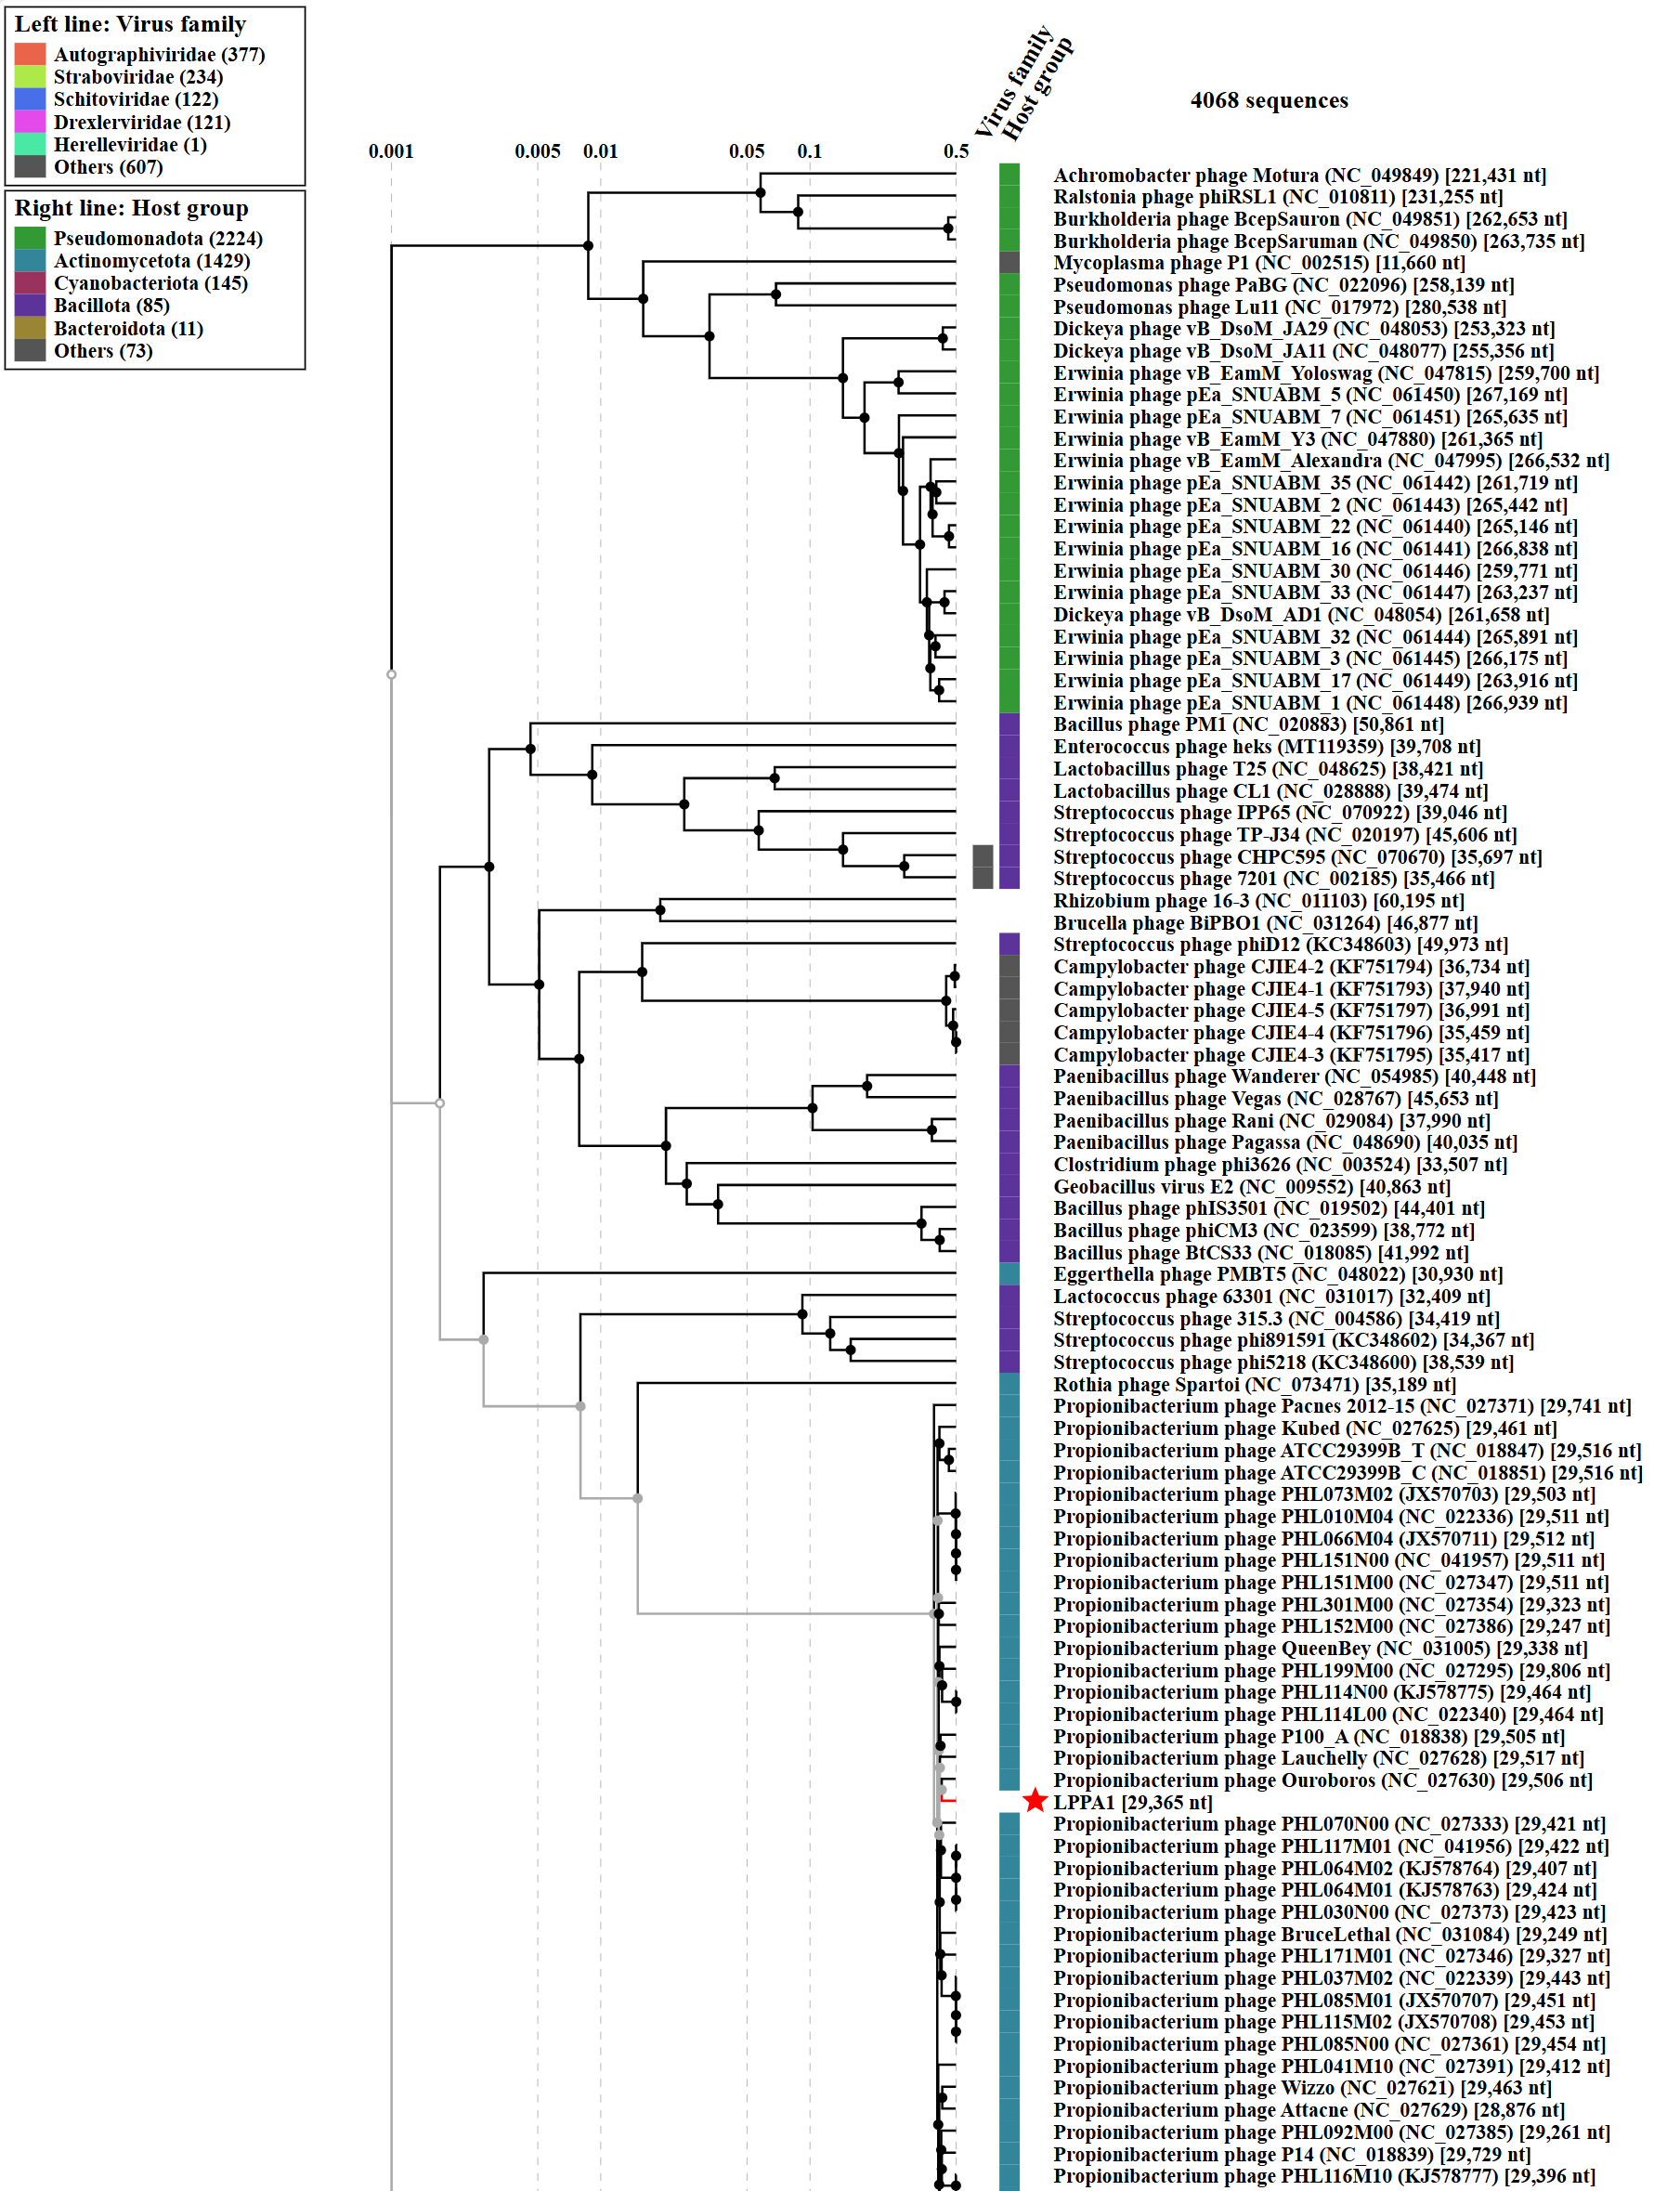Fig. 1. ViPTree-based phylogenetic placement of LPPA1.
Genome-wide proteomic tree analysis was performed using ViPTree. LPPA1 is indicated by red stars, and phylogenetically related reference phages selected for subsequent VIRIDIC analysis are enclosed in red dashed boxes.

VIRIDIC heat map: VIRIDIC (Virus Intergenomic Distance Calculator [1]; http://rhea.icbm.uni-oldenburg.de/VIRIDIC/) computes pairwise intergenomic distances/similarities amongst phage genomes. LPPA1 is indicated with red star.
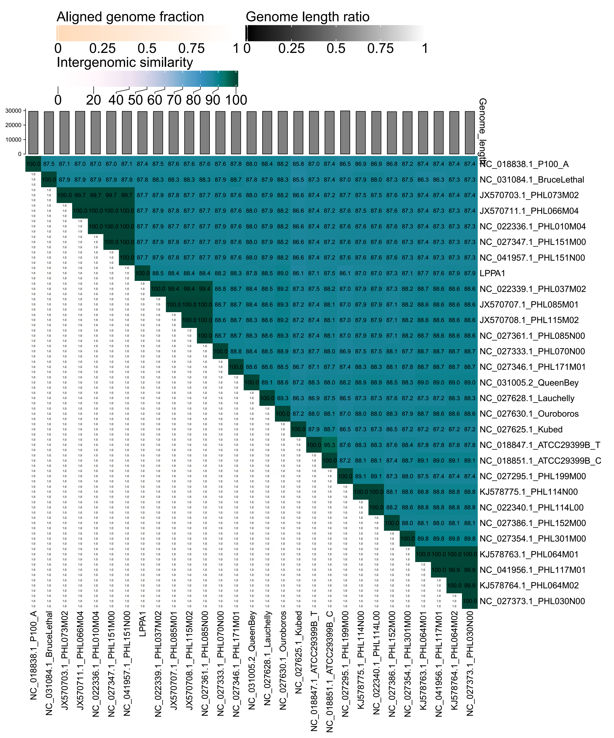Fig. 2. VIRIDIC heat maps showing pairwise intergenomic similarities between the five candidate Salmonella phages and related reference phages selected based on ViPTree analysis.
LPPA1 is indicated by red star. The similarity values support the separation of the candidate phages from their closest species-level relatives using the 95% species demarcation threshold.

Phylogeny: The phylogenetic tree was constructed using the major head proteins of phages. Clustal Omega was used for multiple alignment and RAxML-NG was used for building phylogenetic tree using maximum-likelihood method with 500 bootstraps. LPPA1 is indicated with the red star.
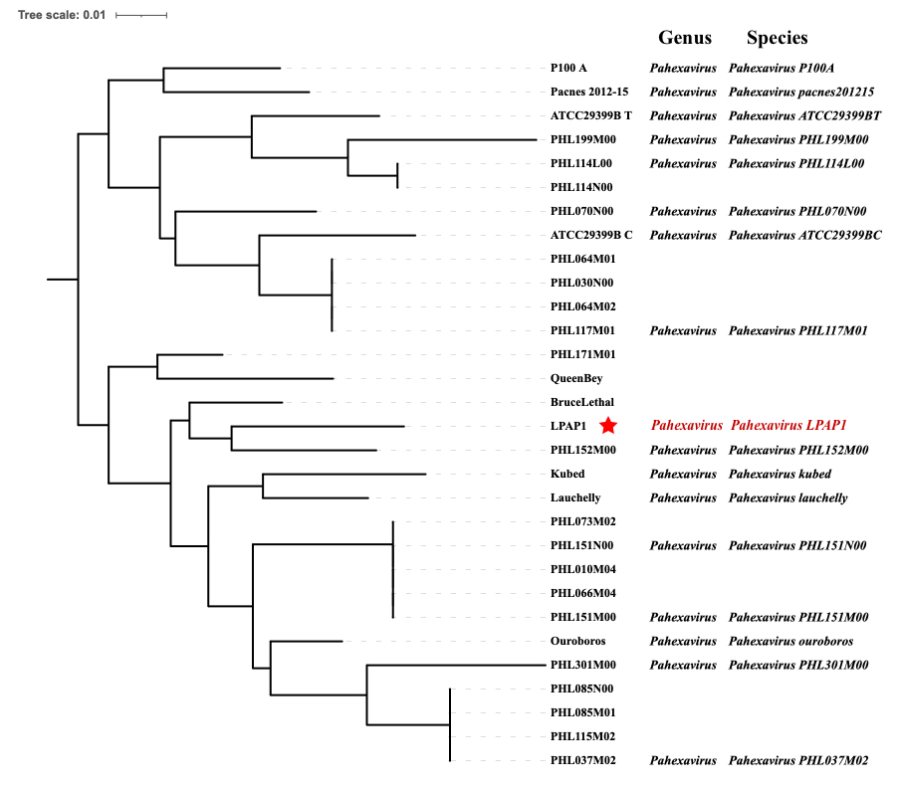
Fig. 3. Maximum-likelihood phylogenetic tree based on major head protein sequences of LPPA1 and related phages. The tree was constructed using RAxML-NG with 500 bootstrap replicates after multiple sequence alignment with Clustal Omega. LPPA1 is indicated by a red star.

Origin of the name of this taxon: The proposed species names are derived from the genus names and the isolate designations of the corresponding exemplar phages, as described in the Etymology table above.
Historical aspects: Cutibacterium phage LPPA1 was isolated by Huazhong Agricultural University in 2022 from skin samples collected in Wuhan, Hubei, China.
Specific References: None
Genome summary:
Phage name | INSDC | Size (Kb) | GC% | Protein | tRNA
Cutibacterium phage LPPA1 | PP895300 | 29,365 | 54% | 52 | 0
Pairwise intergenomic similarity summary:
Proposed species | Exemplar phage | Assigned genus | Closest related phage (GenBank) | VIRIDIC similarity / interpretation
Pahexavirus LPPA1 | Cutibacterium phage LPPA1 | Pahexavirus | Pahexavirus ouroboros (NC_027630) | 89%; below 95% species threshold and above 70% genus threshold

