

The International Committee on Taxonomy of Viruses
Taxonomy Proposal Form, 2026

Part 1a: Details of taxonomy proposals

Title: | To create a new genus of Arthrobacter phages, Ottawavirus in the class Caudoviricetes
Code assigned: | 2026.050B

Author(s), affiliation and email address(es):
Given name (+middle initial(s)) | Surname | Affiliation | Email address | Corr. author(s)
Ipek | Kurtböke | Environmental Microbiology, University of the Sunshine Coast,  School of Science, Technology and Engineering,  Maroochydore DC, Australia | IKurtbok@usc.edu.au
Cristina M. | Moraru | Department of Chemistry, Environmental Metagenomics,  University of Duisburg-Essen,  D-45141 Essen,  Germany | lilianacristina.moraru@uni-due.de
Andrew M. | Kropinski | University of Guelph, Guelph, Ontario, Canada N1G2W1 | Phage.Canada@gmail.com | x

Part 1b: Taxonomy Proposal Submission
ICTV Subcommittee:
Animal DNA Viruses and Retroviruses |  | Bacterial viruses | x
Animal minus-strand and dsRNA viruses |  | Fungal and protist viruses
Animal positive-strand RNA viruses |  | Plant viruses
Archaeal viruses |  | General -

List the ICTV Study Group(s) that have seen or have been involved in creating this proposal:
Actinophage
Optional – complete only if formally voted on by an ICTV Study Group:
Study Group | Number of members
Study Group | Votes in support | Votes against | No vote

Submission date: | 05/08/2026

Part 1c: Feedback from ICTV Executive Committee (EC) meeting
Executive Committee Meeting Decision code: | X
A – Accept
Ac – Accept subject to revision by relevant subcommittee chair. No further vote required
U – Accept without revision but with re-evaluation and email vote by the EC
Uc – Accept subject to revision and re-evaluation and email vote by the EC
Ud – Deferred to the next EC meeting, with an invitation to revise based on EC comments
J - Reject
W - Withdrawn

Comments from the Executive Committee:

Part 1d: Revised Taxonomy Proposal Submission
Response of proposer:
Revision date:

Part 3: TAXONOMIC PROPOSAL

Taxonomic changes proposed:
Establish new taxon | x | Split taxon
Abolish taxon |  | Merge taxon
Move taxon |  | Promote taxon
Rename taxon |  | Demote taxon
Move and rename

Etymology (origin) of proposed taxonomic names:
Taxon name | Etymology of the term
Ottawavirus | Named after Arthrobacter phage Ottawa

Permission for use of names derived from a living person:
Taxon name | Full name of person from whom the name is derived | Attached

Abstract of Taxonomy Proposal:

Description of current taxonomy:
The bacteriophage described in this proposal is currently unclassified.

Proposed taxonomic change(s):
We propose to create a genus, Ottawavirus and one new species.

Demarcation criteria for new taxon/taxa:
Genus demarcation criteria: An intergenomic similarity cut-off of 70%, a combination of average nucleotide identity and alignment fraction, is used to determine genera demarcation. Members of the same genus have >70% intergenomic similarity and cluster tightly in marker gene phylogenies.

Species demarcation criteria: A demarcation value of 95% intergenomic similarity was used to define different species according to intergenomic similarity. Members of the same genus have >95% intergenomic similarity.

Justification:
Bacteriophage Ottawa infects the species Arthrobacter globiformis B-2980 and
possesses a 63.5 kbp genome. It is assigned to cluster FM in the Actinobacteriophage Database. It is distantly related to members of the genus Laroyevirus and the newly proposed subfamily “Dimmickvirinae”. Assignment of this bacteriophage as a new single species genus is supported by intergenomic nucleotide similarity, whole genome TBLASTX distance analysis and phylogenetic analysis of the large terminase subunit.

Text of Taxonomy proposal:
Description of current taxonomy:
The bacteriophage described in this proposal is currently unclassified.

Proposed taxonomic change(s):
We propose to create a genus, Ottawavirus and one new species.

Demarcation criteria for new taxon/taxa:
Genus demarcation criteria: An intergenomic similarity cut-off of 70%, a combination of average nucleotide identity and alignment fraction, is used to determine genera demarcation. Members of the same genus have >70% intergenomic similarity and cluster tightly in marker gene phylogenies.

Species demarcation criteria: A demarcation value of 95% intergenomic similarity was used to define different species according to intergenomic similarity. Members of the same genus have >95% intergenomic similarity [6].

Justification:
Arthrobacter phage Ottawa is assigned to cluster FM in the Actinobacteriophage Database. Searches conducted using BLASTN identified it exhibits a low level of similarity to members of the genus Laroyevirus and the newly proposed subfamily “Dimmickvirinae”. Assignment of this bacteriophage as a new single species genus is supported by intergenomic nucleotide similarity (Figure 1) [1], whole genome TBLASTX distance analysis (Figure 2) [2.3] and phylogenetic analysis of the large terminase subunit (Figure 3) [9].

References:
1. Moraru C, Varsani A, Kropinski AM. VIRIDIC-A Novel Tool to Calculate the Intergenomic Similarities of Prokaryote-Infecting Viruses. Viruses. 2020 Nov 6;12(11):1268. doi: 10.3390/v12111268. PMID: 33172115; PMCID: PMC7694805. http://kronos.icbm.uni-oldenburg.de/viridic/
2. Nishimura Y, Yoshida T, Kuronishi M, Uehara H, Ogata H, Goto S. ViPTree: the viral proteomic tree server. Bioinformatics. 2017; 33(15):2379-2380. doi:10.1093/bioinformatics/btx157. PubMed PMID: 28379287. https://www.genome.jp/viptree/
3. Rohwer F, Edwards R. The Phage Proteomic Tree: a genome-based taxonomy for phage. J Bacteriol. 2002 Aug;184(16):4529-35. PubMed PMID: 12142423
4. Turner D, Reynolds D, Seto D, Mahadevan P. CoreGenes3.5: a webserver for the determination of core genes from sets of viral and small bacterial genomes. BMC Res Notes. 2013;6:140. doi: 10.1186/1756-0500-6-140. PMID: 23566564.
5. Davis P, Seto D, Mahadevan P. CoreGenes5.0: An Updated User-Friendly Webserver for the Determination of Core Genes from Sets of Viral and Bacterial Genomes. Viruses. 2022 Nov 16;14(11):2534. doi: 10.3390/v14112534. PMID: 36423143; PMCID: PMC9693508.
6. Turner D, Kropinski AM, Adriaenssens EM. A Roadmap for Genome-Based Phage Taxonomy. Viruses. 2021 Mar 18;13(3):506. doi: 10.3390/v13030506. PMID: 33803862; PMCID: PMC8003253.
Lemoine F, Correia D, Lefort V, Doppelt-Azeroual O, Mareuil F, Cohen-Boulakia S, Gascuel O. NGPhylogeny.fr: new generation phylogenetic services for non-specialists. Nucleic Acids Res. 2019 Jul 2;47(W1):W260-W265. doi: 10.1093/nar/gkz303. PMID: 31028399; PMCID: PMC6602494.
7. Letunic I, Bork P. Interactive Tree Of Life (iTOL): an online tool for phylogenetic tree display and annotation. Bioinformatics. 2007 Jan 1;23(1):127-8. doi: 10.1093/bioinformatics/btl529. Epub 2006 Oct 18. PMID: 17050570.
8. Zhou T, Xu K, Zhao F, Liu W, Li L, Hua Z, Zhou X. itol.toolkit accelerates working with iTOL (Interactive Tree of Life) by an automated generation of annotation files. Bioinformatics. 2023 Jun 1;39(6):btad339. doi: 10.1093/bioinformatics/btad339. PMID: 37225402; PMCID: PMC10243930
9. Dereeper A, Guignon V, Blanc G, Audic S, Buffet S, Chevenet F, Dufayard JF, Guindon S, Lefort V, Lescot M, Claverie JM, Gascuel O. Phylogeny.fr: robust phylogenetic analysis for the non-specialist. Nucleic Acids Res. 2008 Jul 1;36(Web Server issue):W465-9. doi: 10.1093/nar/gkn180. Epub 2008 Apr 19. PMID: 18424797; PMCID: PMC2447785.

Accompanying files:
Filename | Description of contents

Tables, Figures:

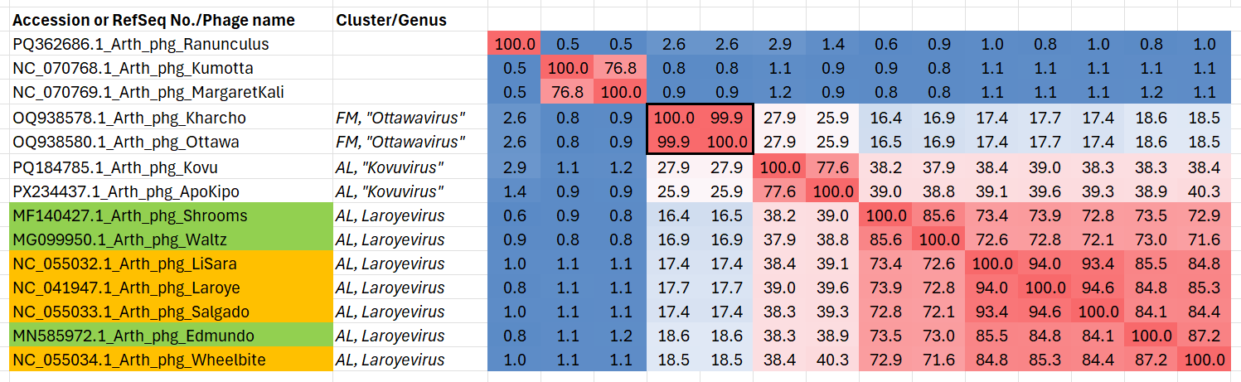

Figure 1. VIRIDIC heatmap of this group of phages. VIRIDIC (Virus Intergenomic Distance Calculator; VIRIDIC (Virus Intergenomic Distance Calculator; [1]; http://rhea.icbm.uni-oldenburg.de/VIRIDIC/) computes pairwise intergenomic distances/similarities amongst phage genomes. Data values which are bordered in black correspond to strains. Abbreviations: phg = phage; Arth = Arthrobacter.

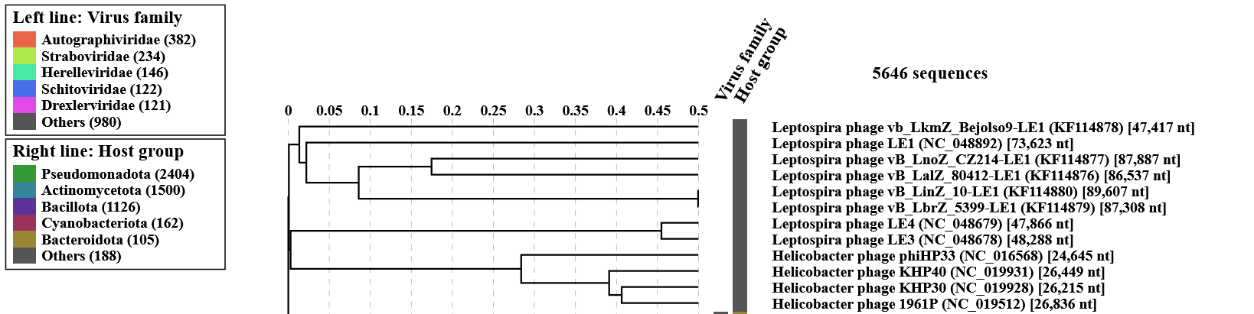
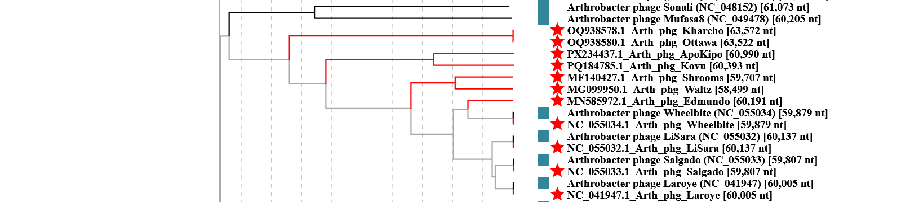

Figure 2. ViPTree analysis: ViPTree analysis (https://www.genome.jp/viptree/; [2]) is based upon Rohwer and Edwards (2002) Phage Proteomic Tree [3]. The taxons under discussion are indicated with red bars and stars and a blue arrowhead. Abbreviations: phg = phage; Arth = Arthrobacter.
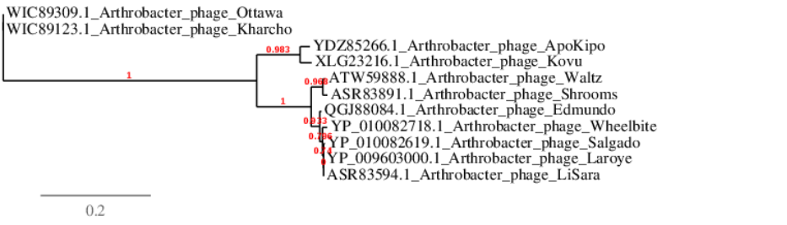
Figure 3. Phylogenetic tree constructed with the large subunit terminase proteins from these and related phages using “One Click” Phylogeny.fr [9] at http://phylogeny.lirmm.fr/phylo_cgi/simple_phylogeny.cgi

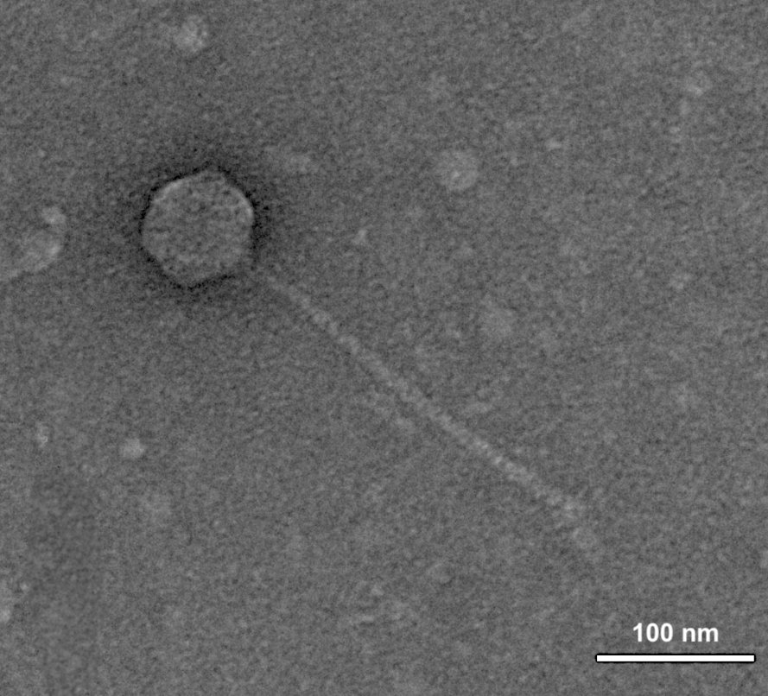
Figure 4. Electron micrograph: Electron micrograph of negatively stained Arthrobacter phage Ottawa (https://phagesdb.org/phages/Ottawa/). Limited permission was granted by The Actinobacteriophage Database (https://phagesdb.org/), funded by the Howard Hughes Medical Institute, to use this electron micrograph for this taxonomy proposal; it cannot be reused without permission of The Actinobacteriophage Database.

Table 1. Characteristics of Arthrobacter phage Ottawa in the genus Ottawavirus.

Phage name | Host | Morphotype | Lifestyle | Accession No. | Genome size | %G+C | Termini | No. proteins | No. tRNA
Arthrobacter phage Ottawa | Arthrobacter globiformis B-2980 | Siphovirus | Lytic | OQ938580 | 63522 bp | 65.2 | 952 bp DTR | 105 | 0
DTR = direct terminal repeats

