

The International Committee on Taxonomy of Viruses
Taxonomy Proposal Form, 2026

Part 1a: Details of taxonomy proposals

Title: | To create a new genus, Obliviatevirus with 25 species of Gordonia phages in the class Caudoviricetes
Code assigned: | 2026.049B

Author(s), affiliation and email address(es):
Given name (+middle initial(s)) | Surname | Affiliation | Email address | Corr. author(s)
Ipek | Kurtböke | Environmental Microbiology, University of the Sunshine Coast,  School of Science, Technology and Engineering,  Maroochydore DC, Australia | IKurtbok@usc.edu.au
Cristina M. | Moraru | Department of Chemistry, Environmental Metagenomics,  University of Duisburg-Essen,  D-45141 Essen,  Germany | lilianacristina.moraru@uni-due.de
Andrew M. | Kropinski | University of Guelph, Guelph, Ontario, Canada N1G2W1 | Phage.Canada@gmail.com | x

Part 1b: Taxonomy Proposal Submission
ICTV Subcommittee:
Animal DNA Viruses and Retroviruses |  | Bacterial viruses | x
Animal minus-strand and dsRNA viruses |  | Fungal and protist viruses
Animal positive-strand RNA viruses |  | Plant viruses
Archaeal viruses |  | General -

List the ICTV Study Group(s) that have seen or have been involved in creating this proposal:
Actinophages

Optional – complete only if formally voted on by an ICTV Study Group:
Study Group | Number of members
Study Group | Votes in support | Votes against | No vote

Submission date: | March 24, 2026

Part 1c: Feedback from ICTV Executive Committee (EC) meeting
Executive Committee Meeting Decision code: | X
A – Accept
Ac – Accept subject to revision by relevant subcommittee chair. No further vote required
U – Accept without revision but with re-evaluation and email vote by the EC
Uc – Accept subject to revision and re-evaluation and email vote by the EC
Ud – Deferred to the next EC meeting, with an invitation to revise based on EC comments
J - Reject
W - Withdrawn

Comments from the Executive Committee:

Part 1d: Revised Taxonomy Proposal Submission
Response of proposer:
Revision date:

Part 3: TAXONOMIC PROPOSAL

Taxonomic changes proposed:
Establish new taxon | x | Split taxon
Abolish taxon |  | Merge taxon
Move taxon |  | Promote taxon
Rename taxon |  | Demote taxon
Move and rename

Etymology (origin) of proposed taxonomic names:
Taxon name | Etymology of the term
Obliviatevirus | Named after Gordonia phage Obliviate

Permission for use of names derived from a living person:
Taxon name | Full name of person from whom the name is derived | Attached

Abstract of Taxonomy Proposal:

Description of current taxonomy:
The bacterial viruses described in this proposal are currently unclassified. These viruses correspond to a group of temperate Gordonia siphoviruses that are related to members of the genera Jujuvirus and Fairfaxidumvirus.

Proposed taxonomic change(s):
We propose to create a new genus “Obliviatevirus” with 25 species.

Demarcation criteria for new taxon/taxa:
Genus demarcation criteria: An intergenomic similarity cut-off of 70%, a combination of average nucleotide identity and alignment fraction, is used to determine genera demarcation. Members of the same genus have >70% intergenomic similarity and cluster tightly in marker gene phylogenies. Because these phages are temperate and show higher rates of recombination, we have been more relaxed in drawing the genus boundaries.

Species demarcation criteria: A demarcation value of 95% intergenomic similarity was used to define different species according to intergenomic similarity. Members of the same genus have >95% intergenomic similarity.

Justification:
These bacteriophages are temperate viruses that infect Gordonia sp. Analysis of intergenomic nucleotide sequence similarities shows that the 21 proposed species form a single genus that shows approximately 50% similarity to species in the genera Jujuvirus and Fairfaxidumvirus, suggesting that these genera could be grouped into a subfamily. The creation of a new genera is also supported by the TBLASTX distance tree and phylogenetic analysis of the large terminase subunit.

Text of Taxonomy proposal:
Description of current taxonomy:
The bacterial viruses described in this proposal are currently unclassified. These viruses correspond to a group of temperate Gordonia siphoviruses that are related to members of the genera Jujuvirus and Fairfaxidumvirus.

Proposed taxonomic change(s):
We propose to create a new genus “Obliviatevirus” with 25 new species.

Demarcation criteria for new taxon/taxa:
Genus demarcation criteria: An intergenomic similarity cut-off of 70%, a combination of average nucleotide identity and alignment fraction, is used to determine genera demarcation. Members of the same genus have >70% intergenomic similarity and cluster tightly in marker gene phylogenies. Because these phages are temperate, we have been more liberal in drawing the genus boundaries.

Species demarcation criteria: A demarcation value of 95% intergenomic similarity was used to define different species according to intergenomic similarity. Members of the same genus have >95% intergenomic similarity [6].

Justification:
These bacteriophages are temperate viruses that infect Gordonia sp. Analysis of intergenomic nucleotide sequence similarities (Figure 1) [1] shows that the 21 proposed species form a single genus that shows approximately 50% similarity to species in the genera Jujuvirus and Fairfaxidumvirus, suggesting that these genera could be grouped into a subfamily. The creation of a new genera is also supported by the TBLASTX distance tree (Figure 2) [2,3]and phylogenetic analysis of the large terminase subunit (Figure 3) [9].

References:
1. Moraru C, Varsani A, Kropinski AM. VIRIDIC-A Novel Tool to Calculate the Intergenomic Similarities of Prokaryote-Infecting Viruses. Viruses. 2020 Nov 6;12(11):1268. doi: 10.3390/v12111268. PMID: 33172115; PMCID: PMC7694805. http://kronos.icbm.uni-oldenburg.de/viridic/
2. Nishimura Y, Yoshida T, Kuronishi M, Uehara H, Ogata H, Goto S. ViPTree: the viral proteomic tree server. Bioinformatics. 2017; 33(15):2379-2380. doi:10.1093/bioinformatics/btx157. PubMed PMID: 28379287. https://www.genome.jp/viptree/
3. Rohwer F, Edwards R. The Phage Proteomic Tree: a genome-based taxonomy for phage. J Bacteriol. 2002 Aug;184(16):4529-35. PubMed PMID: 12142423
4. Turner D, Reynolds D, Seto D, Mahadevan P. CoreGenes3.5: a webserver for the determination of core genes from sets of viral and small bacterial genomes. BMC Res Notes. 2013;6:140. doi: 10.1186/1756-0500-6-140. PMID: 23566564.
5. Davis P, Seto D, Mahadevan P. CoreGenes5.0: An Updated User-Friendly Webserver for the Determination of Core Genes from Sets of Viral and Bacterial Genomes. Viruses. 2022 Nov 16;14(11):2534. doi: 10.3390/v14112534. PMID: 36423143; PMCID: PMC9693508.
6. Turner D, Kropinski AM, Adriaenssens EM. A Roadmap for Genome-Based Phage Taxonomy. Viruses. 2021 Mar 18;13(3):506. doi: 10.3390/v13030506. PMID: 33803862; PMCID: PMC8003253.
Lemoine F, Correia D, Lefort V, Doppelt-Azeroual O, Mareuil F, Cohen-Boulakia S, Gascuel O. NGPhylogeny.fr: new generation phylogenetic services for non-specialists. Nucleic Acids Res. 2019 Jul 2;47(W1):W260-W265. doi: 10.1093/nar/gkz303. PMID: 31028399; PMCID: PMC6602494.
7. Letunic I, Bork P. Interactive Tree Of Life (iTOL): an online tool for phylogenetic tree display and annotation. Bioinformatics. 2007 Jan 1;23(1):127-8. doi: 10.1093/bioinformatics/btl529. Epub 2006 Oct 18. PMID: 17050570.
8. Zhou T, Xu K, Zhao F, Liu W, Li L, Hua Z, Zhou X. itol.toolkit accelerates working with iTOL (Interactive Tree of Life) by an automated generation of annotation files. Bioinformatics. 2023 Jun 1;39(6):btad339. doi: 10.1093/bioinformatics/btad339. PMID: 37225402; PMCID: PMC10243930
9. Dereeper A, Guignon V, Blanc G, Audic S, Buffet S, Chevenet F, Dufayard JF, Guindon S, Lefort V, Lescot M, Claverie JM, Gascuel O. Phylogeny.fr: robust phylogenetic analysis for the non-specialist. Nucleic Acids Res. 2008 Jul 1;36(Web Server issue):W465-9. doi: 10.1093/nar/gkn180. Epub 2008 Apr 19. PMID: 18424797; PMCID: PMC2447785.

Accompanying files:
Filename | Description of contents

Tables, Figures:

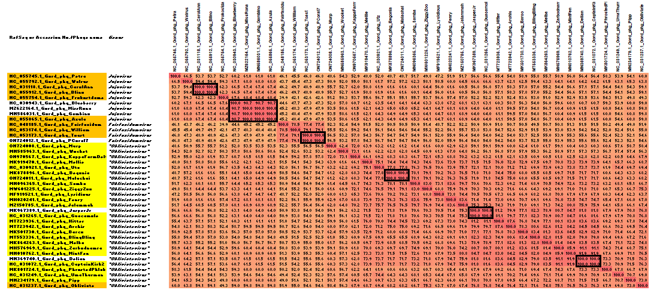

Figure 1. VIRIDIC heatmap of this group of phages. VIRIDIC (Virus Intergenomic Distance Calculator; VIRIDIC (Virus Intergenomic Distance Calculator; [1]; http://rhea.icbm.uni-oldenburg.de/VIRIDIC/) computes pairwise intergenomic distances/similarities amongst phage genomes. Data values which are bordered in black correspond to strains. Phage names with golden backgrounds are existing species while those highlighted in yellow are new species (exception Obliviate). Abbreviations: phg = phage; Gord = Gordonia. Because this diagram is somewhat difficult to read we have attached the full-sized Excel spread sheet.
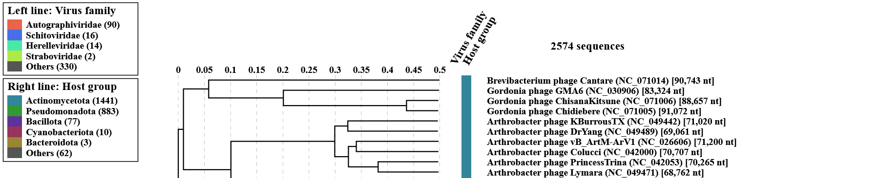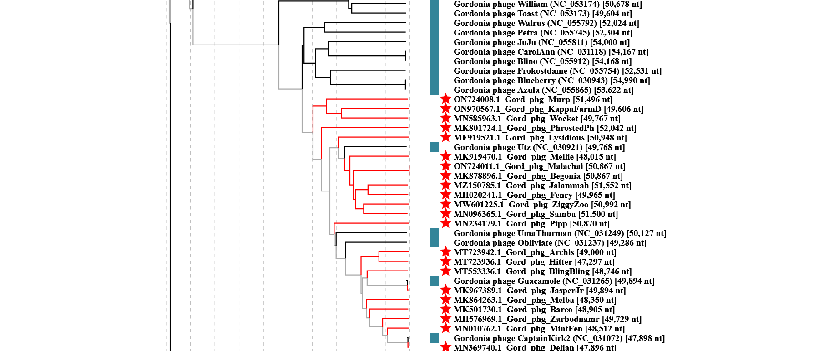Figure 2. ViPTree analysis: ViPTree analysis (https://www.genome.jp/viptree/; [2]) is based upon Rohwer and Edwards (2002) Phage Proteomic Tree [3]. The taxons under discussion are indicated with red bars and stars. Abbreviations: phg = phage; Gord = Gordonia.
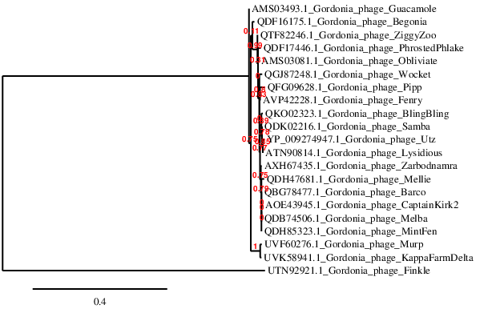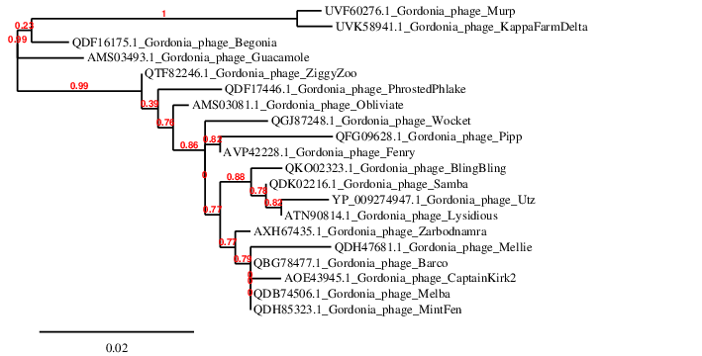Figure 3. Phylogenetic tree constructed with the large subunit terminase proteins from these and related phages using “One Click” Phylogeny.fr [9] at https://www.phylogeny.fr using the TerL protein from Gordonia phage Finkle as an outlier (Left). Below is the tree calculated without an outlier.
Table 1. List of species in the new genus Obliviatevirus
Accession No. | Phage name | Taxon
ON724008.1 | Gordonia phage Murp | Obliviatevirus murp
MN585963.1 | Gordonia phage Wocket | Obliviatevirus wocket
ON970567.1 | Gordonia phage KappaFarmDelta | Obliviatevirus kappafarmdelta
MK919470.1 | Gordonia phage Mellie | Obliviatevirus mellie
KU998248.1 | Gordonia phage Utz | Obliviatevirus utz
MK878896.1 | Gordonia phage Begonia | Obliviatevirus begonia
ON724011.1 | Gordonia phage Malachai | Obliviatevirus malachai
MN096365.1 | Gordonia phage Samba | Obliviatevirus samba
MW601225.1 | Gordonia phage ZiggyZoo | Obliviatevirus ziggyzoo
MF919521.1 | Gordonia phage Lysidious | Obliviatevirus lysidious
MH020241.1 | Gordonia phage Fenry | Obliviatevirus fenry
MZ150785.1 | Gordonia phage Jalammah | Obliviatevirus jalammah
KU963259.1 | Gordonia phage Guacamole | Obliviatevirus guacamole
MT723936.1 | Gordonia phage Hitter | Obliviatevirus hitter
MT723942.1 | Gordonia phage Archis | Obliviatevirus archis
MK501730.1 | Gordonia phage Barco | Obliviatevirus barco
MT553336.1 | Gordonia phage BlingBling | Obliviatevirus blingbling
MK864263.1 | Gordonia phage Melba | Obliviatevirus melba
MH576969.1 | Gordonia phage Zarbodnamra | Obliviatevirus zarbodnamra
MN010762.1 | Gordonia phage MintFen | Obliviatevirus mintfen
KX557274.1 | Gordonia phage CaptainKirk2 | Obliviatevirus captainkirk2
MK801724.1 | Gordonia phage PhrostedPhlake | Obliviatevirus phrostedphlake
KU963251.1 | Gordonia phage UmaThurman | Obliviatevirus Thurman (*)
MN234179.1 | Gordonia phage Pipp | Obliviatevirus pipp
KU963254.1 | Gordonia phage Obliviate | Obliviatevirus obliviate
(*) Taxon renamed because the phage was named after a living person

