

The International Committee on Taxonomy of Viruses
Taxonomy Proposal Form, 2026

Part 1a: Details of taxonomy proposals

Title: | Create 6 new genera and 17 new species in the family Rountreeviridae (class Caudoviricetes)
Code assigned: | 2026.076B

Author(s), affiliation and email address(es):
Given name (+middle initial(s)) | Surname | Affiliation | Email address | Corr. author(s)
Agata | Jurczak-Kurek | Department of Evolutionary Genetics and Biosystematics, Faculty of Biology, Univerity of Gdańsk, Gdańsk, Poland | agata.jurczak-kurek@ug.edu.pl | X
Małgorzata | Łobocka | Laboratory of Bacteriophage Biology, Institute of Biochemistry and Biophysics, Polish Academy of Sciences, Warsaw, Poland | lobocka@ibb.waw.pl | x
Marcin | Górniak | Department of Evolutionary Genetics and Biosystematics, Faculty of Biology, Univerity of Gdańsk, Gdańsk, Poland | marcin.gorniak@biol.ug.edu.pl
Takura | Wakinaka | Manufacturing Division, Yamasa Corporation, Choshi, Japan | wakinaka@yamasa.com | x
Minenosuke | Matsutani | Faculty of Bioindustry, Tokyo University of Agriculture, Abashiri, Japan | mm207299@nodai.ac.jp
Jun | Watanabe | Manufacturing Division, Yamasa Corporation, Choshi, Japan | j_watanabe@yamasa.com
Masafumi | Tokuoka | Faculty of Applied Bioscience, Tokyo University of Agriculture, Tokyo, Japan | m3tokuok@nodai.ac.jp
Akihiro | Ohnishi | Faculty of Applied Bioscience, Tokyo University of Agriculture, Tokyo, Japan | a1ohnish@nodai.ac.jp
‍Elena | Gómez-Sanz | Division of Molecular Bacterial Epidemiology & Infectious Diseases, Institute of Veterinary Bacteriology, University of Bern, Bern, Switzerland | elena.gomezsanz@unibe.ch | X
‍Sandra | Pérez-Jiménez | Division of Molecular Bacterial Epidemiology & Infectious Diseases, Institute of Veterinary Bacteriology, University of Bern, Bern, Switzerland | sandra.perezjimenez@unibe.ch
‍Dominque | Lorgé | Division of Molecular Bacterial Epidemiology & Infectious Diseases, Institute of Veterinary Bacteriology, University of Bern, Bern, Switzerland | dominique.lorge@unibe.ch
‍Dann | Turner | School of Applied Sciences, College of Health, Science and Society, University of the West of England, Bristol, UK | dann2.turner@uwe.ac.uk
Andrew | Kropinski | University of Guelph, Guelph, Ontario, Canada N1G2W1 | phage.canada@gmail.com

Part 1b: Taxonomy Proposal Submission
ICTV Subcommittee:
Animal DNA Viruses and Retroviruses |  | Bacterial viruses | X
Animal minus-strand and dsRNA viruses |  | Fungal and protist viruses
Animal positive-strand RNA viruses |  | Plant viruses
Archaeal viruses |  | General

List the ICTV Study Group(s) that have seen or have been involved in creating this proposal:
Caudoviricetes Study Group

Optional – complete only if formally voted on by an ICTV Study Group:
Study Group | Number of members
Study Group | Votes in support | Votes against | No vote

Submission date: | 15/09/2026

Part 1c: Feedback from ICTV Executive Committee (EC) meeting
Executive Committee Meeting Decision code: | X
A – Accept
Ac – Accept subject to revision by relevant subcommittee chair. No further vote required
U – Accept without revision but with re-evaluation and email vote by the EC
Uc – Accept subject to revision and re-evaluation and email vote by the EC
Ud – Deferred to the next EC meeting, with an invitation to revise based on EC comments
J - Reject
W - Withdrawn

Comments from the Executive Committee:

Part 1d: Revised Taxonomy Proposal Submission
Response of proposer:
Revision date:

Part 3: TAXONOMIC PROPOSAL

Taxonomic changes proposed:
Establish new taxon | X | Split taxon
Abolish taxon |  | Merge taxon
Move taxon |  | Promote taxon
Rename taxon |  | Demote taxon
Move and rename

Etymology (origin) of proposed taxonomic names:
Taxon name | Etymology of the term
Kagoshimavirus | Genus name derived from Kagoshima in Japan, where the exemplar virus, Streptococcus phage SG005, was isolated from drainage water collected at Kagoshima University School of Dentistry (Fujiki et al., 2021; doi:10.3390/v13101964).
Kagoshimavirus SG005 | Species name derived from the phage name in the GenBank database – Streptococcus phage SG005
Choshivirus | Named after the place where the first virus of this genus was isolated (Choshi city, Chiba, Japan).
Choshivirus WJ7 | Species name derived from the phage name in the GenBank database – Tetragenococcus phage phiWJ7
Choshivirus YA5n2 | Species name derived from the phage name in the GenBank database – Tetragenococcus phage phiYA5_2
Taylorvirus | Named to honor the late Polish molecular biologist and bacteriophage researcher Professor Karol Taylor (1928–1997), for his contribution to studies on molecular biology of lambda phage.
Taylorvirus KgiMP1 | Species name derived from the phage name in the GenBank database – Kurthia phage vB_KgiM_P1
Rumenvirus | Genus name Rumenvirus derived from “rumen”, as rumen fluid served as a source of exemplar viruses vB_SbRt-pBovineB21 and vB_SbRt-pBovineS21 isolation (Park et al., 2023; doi:10.1038/s41598-023-36306-x).
Rumenvirus B21 | Species name derived from the phage name in the GenBank database – Streptococcus phage vB_SbRt-pBovineB21
Rumenvirus S21 | Species name derived from the phage name in the GenBank database – Streptococcus phage vB_SbRt-pBovineS21
Andhravirus Ph32 | Species name derived from the phage name in the GenBank database – Staphylococcus phage S-CoN_Ph32
Andhravirus Ph34 | Species name derived from the phage name in the GenBank database – Staphylococcus phage S-CoN_Ph34
Andhravirus Ph35 | Species name derived from the phage name in the GenBank database – Staphylococcus phage S-CoN_Ph35
Andhravirus Ph36 | Species name derived from the phage name in the GenBank database – Staphylococcus phage S-CoN_Ph36
‍Andhravirus PG59 | Species name derived from the phage name in the GenBank database – Staphylococcus phage PG_59
‍Andhravirus v1sc05 | Species name derived from the phage name in the GenBank database – Staphylococcus phage vB_ScaM-V1SC05
Copernicusvirus N13 | Species name derived from the phage name in the GenBank database – Enterococcus phage N13
Minhovirus SHEF14 | Species name derived from the phage name in the GenBank database – Enterococcus phage phiSHEF14
Minhovirus Ump | Species name derived from the phage name in the GenBank database – Enterococcus phage vB_OCPT_Ump
Canivirus | Genus name derived from the Latin name of dog (canis), referring to the canine origin of exemplar virus DSP1, which was isolated from a dog’s skin sample (Maresso et al., 2022; doi:10.3390/v14091954).
Canivirus DSP1 | Species name derived from the phage name in the GenBank database – Staphylococcus phage vB_SpsX-DSP1
Chromogenesvirus | Genus name derived from Staphylococcus chromogenes, the bacterial host used for isolation of exemplar virus PT1-9 (Li et al., 2024; doi:10.1016/j.vetmic.2024.110133).
Chromogenesvirus PT1-9 | Species name derived from the phage name in the GenBank database – Staphylococcus phage PT1-9

Permission for use of names derived from a living person:
Taxon name | Full name of person from whom the name is derived | Attached
 |  | NA

Abstract of Taxonomy Proposal:
Description of current taxonomy:
At present the family Rountreeviridae is divided into two subfamilies; Rakietenvirinae and Sarlesvirinae and two additional genera Fischettivirus and Negarvirus, each containing one species, that are not assigned to a subfamily. Subfamily Rakietenvirinae contains 22 species grouped into two genera: Andhravirus with four species and Rosenblumvirus with 18 species. Subfamily Sarlesvirinae contains 15 species grouped into two genera: Copernicusvirus with 13 species and Minhovirus with two species.

Proposed taxonomic change(s):
We performed a genomic analysis of phages deposited in the NCBI database and identified 17 unclassified bacteriophages with genomes similar to species in the family Rountreeviridae. Based on their level of similarity to each other and to other phages of Rountreeviridae family, and using the BVS recommended demarcation criteria we propose to:
1) Create six new species in the genus Andhravirus; “Andhravirus Ph32”, “Andhravirus Ph34”, “Andhravirus Ph35”, “Andhravirus Ph36”, “Andhravirus PG59”, and “Andhravirus v1sc05”.
2) Create one new species in the genus Copernicusvirus (subfamily Sarlesvirinae); “Copernicusvirus N13”
3) Create two new species, “Minhovirus SHEF14” and “Minhovirus Ump”, in the genus Minhovirus (subfamily Sarlesvirinae) )
4) Create two new genera in the subfamily Rakietenvirinae: “Canivirus” with one species (“Canivirus DSP1”), and “Chromogenesvirus” with one species (“Chromogenesvirus PN19”)
5) Create four new genera in the family Rountreeviridae:
- “Kagoshimavirus” with one species (“Kagoshimavirus SG005”)
- “Choshivirus” with two species (“Choshivirus WJ7” and “Choshivirus YA5n2”)
- “Taylorvirus” with one species (“Taylorvirus KgiMP1”)
- “Rumenvirus” with two species (“Rumenvirus B21” and “Rumenvirus S21”)

Demarcation criteria for new taxon/taxa:
Species demarcation criteria: Two phages are assigned to the same species if their genomes are more than 95% identical over their genome length for isolates.

Genus demarcation criteria: In search for criteria that create cohesive and distinct genera that are reproducible and monophyletic, the Bacterial Viruses Subcommittee has established 70% nucleotide similarity over the genome length as the cut-off for genera. Genus-level groupings should always be monophyletic in the signature genes, as tested with a phylogenetic tree.

Justification:
Based on DNA and protein similarity, and on the ICTV recommended demarcation criteria for species, genera and subfamilies, nine new species can be proposed in existing genera in the family Rountreeviridae. We also propose creating six new genera with eight new species. The exemplar genomes for species in the genera “Canisvirus” and “Chromogenesvirus” exhibit over 48% intergenomic similarity with species of the genus Andhravirus, supporting their inclusion in the subfamily Rakietenvirinae, The genera “Choshivirus”, “Kogashimavirus”, “Taylorvirus” and “Rumenvirus” exhibit low intergenomic nucleotide sequence similarity to existing genera in the family, but are supported by the structure of the TBLASTX distance tree and phylogenetic analysis of the major capsid protein, portal vertex and DNA polymerase.

Text of Taxonomy proposal:
Description of current taxonomy:
The family Rountreeviridae includes two subfamilies; Rakietenvirinae and Sarlesvirinae and two genera, Fischettivirus and Negarvirus, which are not assigned to a subfamily. Subfamily Rakietenvirinae contains 22 species grouped into two genera: Andhravirus with four species and Rosenblumvirus with 18 species. Subfamily Sarlesvirinae contains 15 species grouped into two genera: Copernicusvirus with 13 species and Minhovirus with two species.

Proposed taxonomic change(s):
We performed a genomic analysis of phages deposited in the NCBI database and found 17 unclassified bacteriophages with genomes similar to the genomes of Rountreeviridae phages. Based on their level of similarity to each other and to other phages of Rountreeviridae family, and on demarcation criteria for phages representing different species, genera and subfamilies we propose to:
1) Add six new species to the genus Andhravirus; “Andhravirus Ph32”, “Andhravirus Ph34”, “Andhravirus Ph35”, “Andhravirus Ph36”, “Andhravirus PG59”, and “Andhravirus v1sc05”
2) Create one new species, “Copernicusvirus N13”
3) Create two new species in the genus Minhovirus ; “Minhovirus SHEF14” and “Minhovirus Ump”
4) Create two new genera in the subfamily Rakietenvirinae: “Canivirus” with one species (“Canivirus DSP1”), and “Chromogenesvirus” with one species (“Chromogenesvirus PN19”)
5) Create four new genera in the family Rountreeviridae:
- “Kagoshimavirus” with one new species (“Kagoshimavirus SG005”)
- “Choshivirus” genus with two new species (“Choshivirus WJ7” and “Choshivirus YA5n2”)
- “Taylorvirus” genus with one new species (“Taylorvirus KgiMP1”)
- “Rumenvirus” genus with two new species (“Rumenvirus B21” and “Rumenvirus S21”)

Demarcation criteria for new taxon/taxa:
Species demarcation criteria: Two phages are assigned to the same species if their genomes are more than 95% identical over their genome length for isolates.
These values can be calculated by several tools, such as BLASTn [1] – usually calculated using the intergenomic distance calculator VIRIDIC [2].

Genus demarcation criteria: In search for criteria that create cohesive and distinct genera that are reproducible and monophyletic, the Bacterial Viruses Subcommittee has established 70% nucleotide similarity over the genome length as the cut-off for genera. Genus-level groupings should always be monophyletic in the signature genes, as tested with a phylogenetic tree [3].

Justification:
Based on DNA and protein similarity, and on the ICTV recommended demarcation criteria, the proposed new species exhibit significant relationships with the 39 known species of the family Rountreeviridae. Based on genomic similarity of phages representing the proposed new species to each other and to the classified members of Rountreeviridae family, the proposed new species can be classified to 9 genera.
1) Phages of proposed “Andhravirus Ph32”, “Andhravirus Ph34”, “Andhravirus Ph35”, “Andhravirus Ph36”, “Andhravirus PG59”, and “Andhravirus v1sc05” species share over 70% intergenomic nucleotide similarity over the genome length with phages of Anhravirus genus and are proposed to be classified as new species of this genus.
2) The exemplar of the proposed species “Copernicusvirus N13” shares over 70% intergenomic nucleotide similarity over the genome length with phages of Copernicusvirus genus and thus is proposed to be classified as new species of this genus.
3) Phages of proposed “Minhovirus SHEF14” and “Minhovirus Ump” species share over 70% intergenomic nucleotide similarity over the genome length with phages of Minhovirus genus and thus are proposed to be classified as new species of Minhovirus genus.
4) Phage of proposed “Canivirus DSP1” species shares less than 70% intergenomic nucleotide similarity over the genome length with classified phages of Rountreeviridae family, but over 52% genomic sequence with Andhravirus genus phages of Rakietenvirinae subfamily of Rountreeviridae, which justifies the classification of “Canivirus DSP1” species to proposed new genus “Canivirus” of subfamily Rakietenvirinae.
5) Phage of proposed “Chromogenesvirus PT19” species shares less than 70% intergenomic nucleotide similarity over the genome length with classified phages of Rountreeviridae family, but over 48% sequence with Andhravirus genus phages of Rakietenvirinae subfamily of Rountreeviridae, which justifies inclusion of the proposed genus “Chromogenesvirus” to Rakietenvirinae subfamily.
6) The proposed species “Choshivirus WJ7” and “Choshivirus YA5n2” share over 70% intergenomic nucleotide similarity over the genome length. The closest relatives of these phages in GenBank are phages of the family Rountreeviridae, but these species share only 3.7-7% genomic similarity with existing taxa in the family. The best matching regions of coverage include the major capsid protein gene, DNA polymerase and terminase encoding genes. The predicted structures of the proposed “Choshivirus” genus phages major capsid protein, and upper and lower collar protein are most similar to known structures of these proteins in phages of Rountreeviridae family. The assignment of “Choshivirus” to the family is supported by the structure of the TBLASTX distance tree and phylogenetic analysis (Figures 2-5).
7) The representative species of the proposed genus “Kogashimavirus” exhibits limited nucleotide sequence similarity (5-8%) to members of the Rountreeviridae. The best matching genomic regions include genes encoding the major capsid protein, DNA polymerase and terminase subunits. Despite this limited similarity, the structure of the TBLASTX distance tree and phylogenetic analysis supports the inclusion of “Kogashimavirus” in the family (Figures 2-5).
8) The best homologs of phage of proposed “Taylorvirus KgiMP1” species (proposed “Taylorvirus” genus) are phages of Rontreeviridae family, but it shares only 5-8% genomic sequence with classified phages of this family. The best matching regions include capsid and scaffold protein, DNA polymerase and collar protein genes. In the viruses TBLASTX distance tree phage of “Taylorvirus KgiMP1” species forms with phages of proposed “Choshivirus” genus a separate branch of close relatives of Rosenblumgenus phages of Rakietenvirinae subfamily of Rountreeviridae. Additionally, phylogenetic analysis of the major capsid protein supports the inclusion of “Taylorvirus” genus to Rountreeviridae family.
9) Phages of proposed “Rumenvirus B21” and “Rumenvirus S21” species share over 70% intergenomic nucleotide similarity over the genome length, which justifies their inclusion to one proposed genus, “Rumenvirus”. The best homolog of these phages in GenBank is Streptococcus phage SG005, which is proposed in this proposal to be classified to new genus “Kogashimavirus”. Sequences of proposed “Rumenvirus” genus phages are in 12% identical to the sequence of this phage. Slightly lower similarities are to the genomes of other Rountreeviridae phages. Taken together this justifies the classification of genus Rumenvirus as a new genus of Rountreeviridae family.

All proposed taxa conform to the demarcation criteria employed by the ICTV Bacterial Viruses Subcommittee.

References:
- Sayers EW, Beck J, Bolton EE, Bourexis D, Brister JR, Canese K, Comeau DC, Funk K, Kim S, Klimke W, Marchler-Bauer A, Landrum M, Lathrop S, Lu Z, Madden TL, O'Leary N, Phan L, Rangwala SH, Schneider VA, Skripchenko Y, Wang J, Ye J, Trawick BW, Pruitt KD, Sherry ST. Database resources of the National Center for Biotechnology Information. Nucleic Acids Res. 2021, 49(D1):D10-D17.
- Moraru C, Varsani A, Kropinski AM. VIRIDIC - a novel tool to calculate the intergenomic similarities of prokaryote-infecting viruses. Viruses 2020, 12(11):1268.
- Turner D, Kropinski AM, Adriaenssens EM. A roadmap for genome-based phage taxonomy. Viruses 2021, 13(3):506.
- Turner D, Reynolds D, Seto D, Mahadevan P. CoreGenes3.5: a webserver for the determination of core genes from sets of viral and small bacterial genomes. BMC Res. Notes. 2013, 6:140.
- Nishimura Y, Yoshida T, Kuronishi M, Uehara H, Ogata H, Goto S. ViPTree: the viral proteomic tree server. Bioinformatics. 2017; 33(15):2379-2380. doi:10.1093/bioinformatics/btx157. PubMed PMID: 28379287. https://www.genome.jp/viptree/
- Gouy M, Tannier E, Comte N, Parsons DP. 2021. Seaview Version 5: A Multiplatform Software for Multiple Sequence Alignment, Molecular Phylogenetic Analyses, and Tree Reconciliation. Methods Mol Biol 2231:241-260.
- Minh BQ, Schmidt HA, Chernomor O, Schrempf D, Woodhams MD, von Haeseler A, Lanfear R.2020. IQ-TREE 2: New Models and Efficient Methods for Phylogenetic Inference in the Genomic Era. Mol Biol Evol 37:1530-1534.

Accompanying files:

Filename | Description of contents
Tables, Figures:

Proposals data:

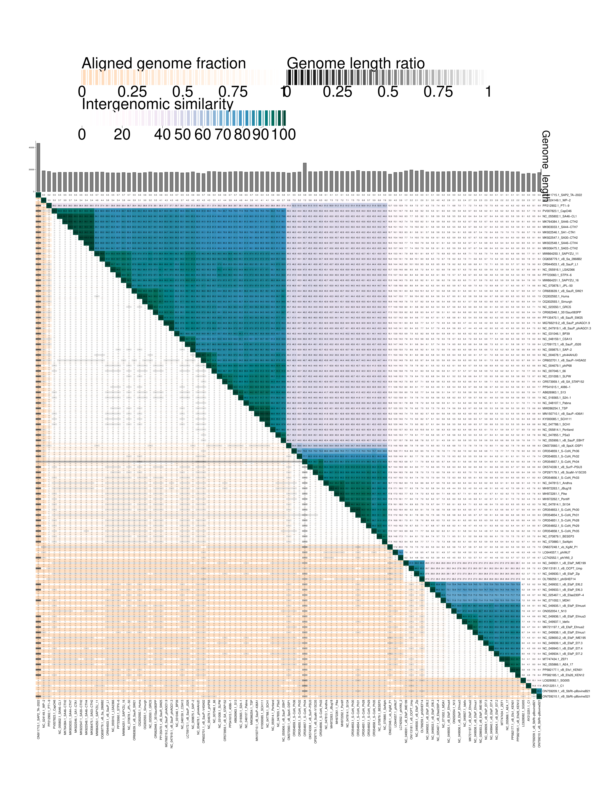
Figure 1. VIRIDIC heat map of Rountreeviridae family genomic sequences. VIRIDIC (Virus Intergenomic Distance Calculator [2]; http://rhea.icbm.uni-oldenburg.de/VIRIDIC/) computes pairwise intergenomic distances/similarities amongst phage genomes. Phages belonging to the same species share above 95% genomic sequences. Phages belonging to the same genus share above 70% of genomic sequences.

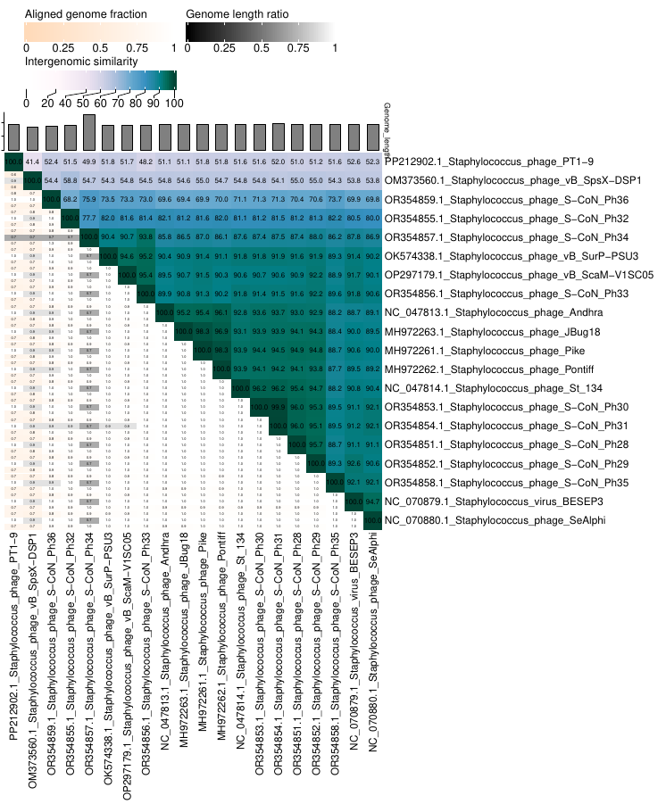
Figure 1A

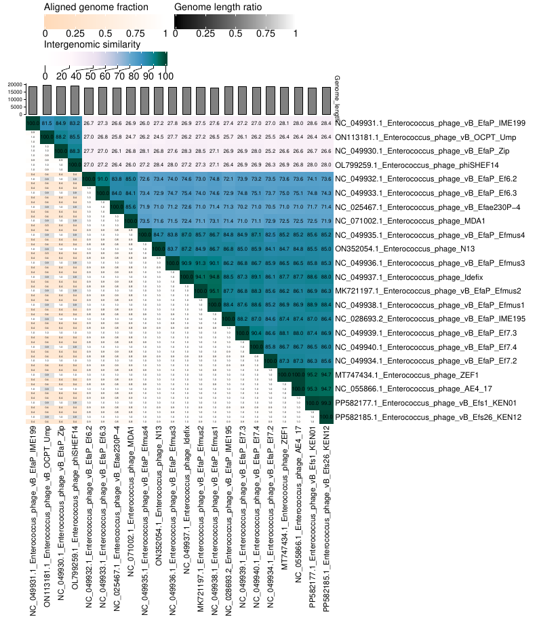
Figure 1B.

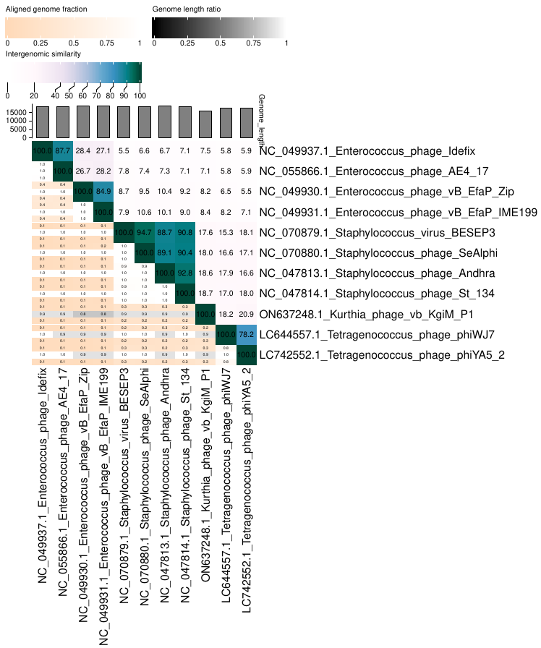

Figure 1C

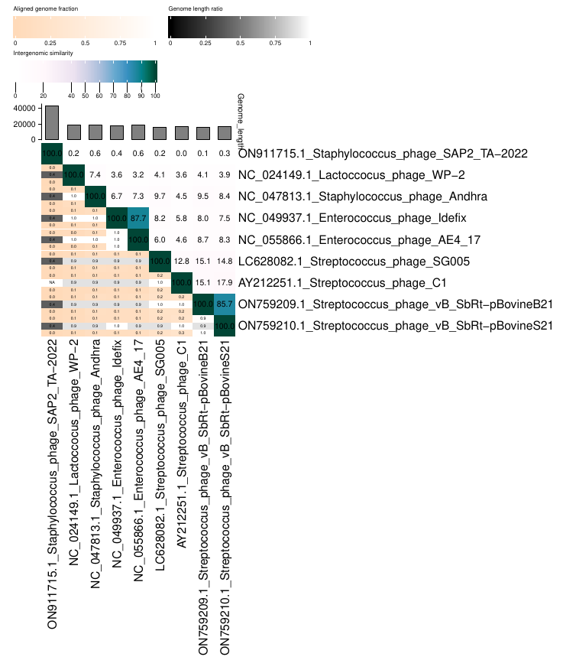

Figure 1D

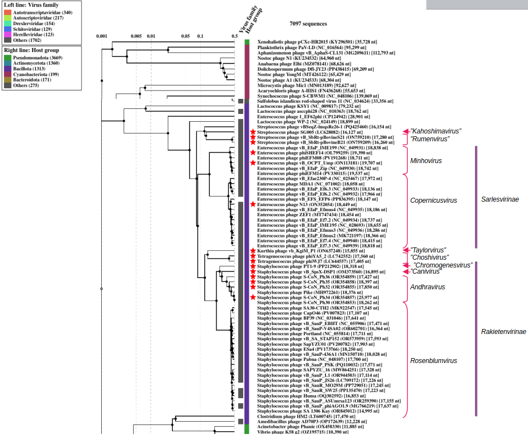

Figure 2. ViPTree analysis: ViPTree analysis (https://www.genome.jp/viptree/; [4]) is based upon Rohwer and Edwards (2002) Phage Proteomic Tree [5]. The phages of interest are indicated with red stars.

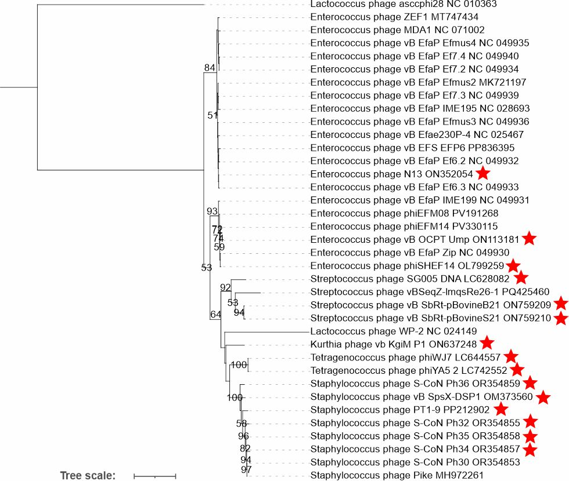ies

Figure 3. Phylogenetic tree of major capsid proteins from bacteriophages of the family Rountreeviridae. The tree was inferred using the maximum-likelihood (ML) method implemented in IQ-TREE. Branch lengths are proportional to the number of substitutions per site. Protein sequences were aligned using the MUSCLE algorithm implemented in SeaView v5.0.5 [6,7], and the alignment was subsequently adjusted manually. Phylogenetic analyses were performed using the maximum-likelihood method in IQ-TREE v2.2.2.6 [2]. The best-fit evolutionary model was selected using ModelFinder implemented in IQ-TREE according to the Akaike information criterion (AIC). Node support was assessed by bootstrap analysis with 500 replicates. Phages of new proposed species are marked with asterisks. The sequence of Lactococcus phage asccphi28 (NC010363) major capsid protein was used as an outgroup.

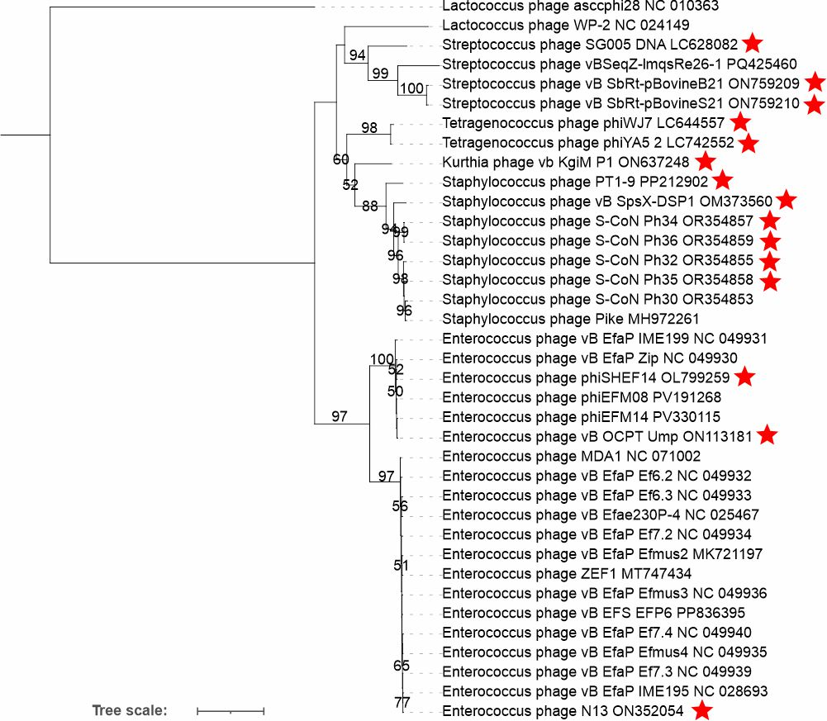

Figure 4. Phylogenetic tree of DNA polymerase proteins from bacteriophages of the family Rountreeviridae. The tree was inferred using the maximum-likelihood (ML) method implemented in IQ-TREE. Branch lengths are proportional to the number of substitutions per site. Protein sequences were aligned using the MUSCLE algorithm implemented in SeaView v5.0.5 [6,7], and the alignment was subsequently adjusted manually. Phylogenetic analyses were performed using the maximum-likelihood method in IQ-TREE v2.2.2.6 [2]. The best-fit evolutionary model was selected using ModelFinder implemented in IQ-TREE according to the Akaike information criterion (AIC). Node support was assessed by bootstrap analysis with 500 replicates. Phages of new proposed species are marked with asterisks. The sequence of Lactococcus phage asccphi28 (NC010363) DNA polymerase was used as an outgroup.

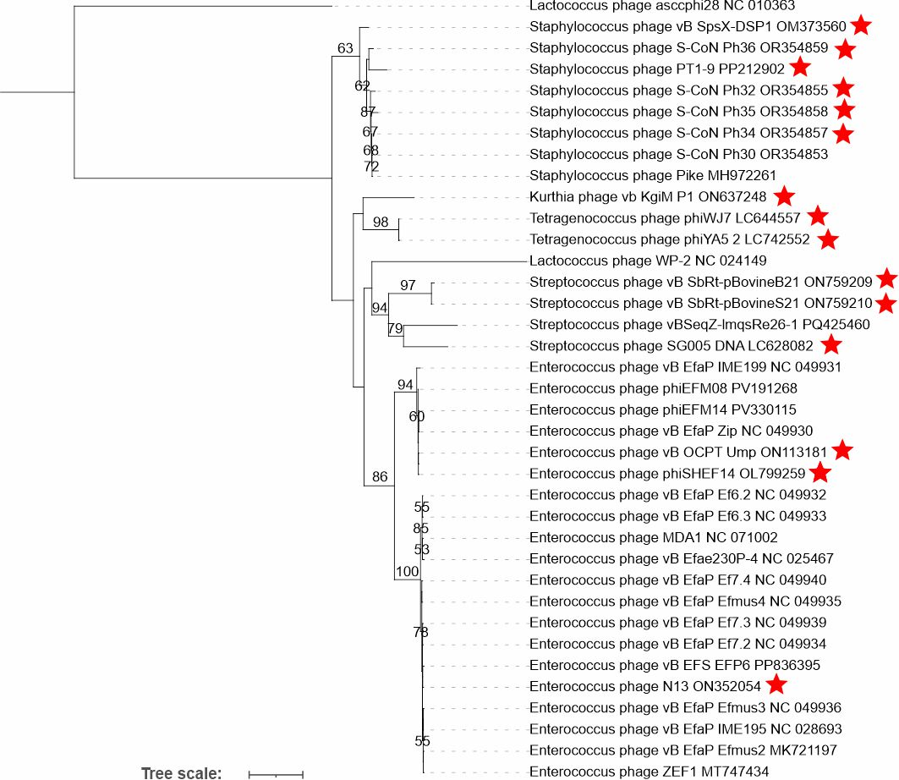

Figure 5. Phylogenetic tree of portal proteins from bacteriophages of the family Rountreeviridae. The tree was inferred using the maximum-likelihood (ML) method implemented in IQ-TREE. Branch lengths are proportional to the number of substitutions per site. Protein sequences were aligned using the MUSCLE algorithm implemented in SeaView v5.0.5 [6,7], and the alignment was subsequently adjusted manually. Phylogenetic analyses were performed using the maximum-likelihood method in IQ-TREE v2.2.2.6 [2]. The best-fit evolutionary model was selected using ModelFinder implemented in IQ-TREE according to the Akaike information criterion (AIC). Node support was assessed by bootstrap analysis with 500 replicates. Phages of new proposed species are marked with asterisks. The sequence of Lactococcus phage asccphi28 (NC010363) portal protein was used as an outgroup.

