

The International Committee on Taxonomy of Viruses
Taxonomy Proposal Form, 2026

Part 1a: Details of taxonomy proposals

Title: | Create four new genera of lytic Mycobacterium siphophages in the class Caudoviricetes
Code assigned: | <to be assigned by ICTV officers>

Author(s), affiliation and email address(es):
Given name (+middle initial(s)) | Surname | Affiliation | Email address | Corr. author(s)
Ipek | Kurtböke | Environmental Microbiology, University of the Sunshine Coast,  School of Science, Technology and Engineering,  Maroochydore DC, Australia | IKurtbok@usc.edu.au
Cristina M. | Moraru | Department of Chemistry, Environmental Metagenomics,  University of Duisburg-Essen,  D-45141 Essen,  Germany | lilianacristina.moraru@uni-due.de
Andrew M. | Kropinski | University of Guelph, Guelph, Ontario, Canada N1G2W1 | Phage.Canada@gmail.com | x

Part 1b: Taxonomy Proposal Submission
ICTV Subcommittee: Enter an "X" against the subcommittee(s) most appropriate to deal with the taxonomy proposal. If in doubt, contact the appropriate subcommittee chair for clarification (see https://ictv.global/sc).
Animal DNA Viruses and Retroviruses |  | Bacterial viruses | x
Animal minus-strand and dsRNA viruses |  | Fungal and protist viruses
Animal positive-strand RNA viruses |  | Plant viruses
Archaeal viruses |  | General -Submit to Proposals Secretary

List the ICTV Study Group(s) that have seen or have been involved in creating this proposal: A list of study groups and their members is provided at https://ictv.global/sc.
Actinophage

Optional – complete only if formally voted on by an ICTV Study Group: <To be completed by Study Group>
Study Group | Number of members
Study Group | Votes in support | Votes against | No vote

Submission date: | June 4, 2026

Part 1c: Feedback from ICTV Executive Committee (EC) meeting
Executive Committee Meeting Decision code: | X
A – Accept
Ac – Accept subject to revision by relevant subcommittee chair. No further vote required
U – Accept without revision but with re-evaluation and email vote by the EC
Uc – Accept subject to revision and re-evaluation and email vote by the EC
Ud – Deferred to the next EC meeting, with an invitation to revise based on EC comments
J - Reject
W - Withdrawn

Comments from the Executive Committee:

Part 1d: Revised Taxonomy Proposal Submission
Response of proposer: Please describe in detail how you have responded to the EC meeting feedback
Revision date:

Part 3: TAXONOMIC PROPOSAL

Taxonomic changes proposed: Enter an "X" against one or more actions
Establish new taxon | x | Split taxon
Abolish taxon |  | Merge taxon
Move taxon |  | Promote taxon
Rename taxon |  | Demote taxon
Move and rename

Etymology (origin) of proposed taxonomic names: Briefly describe the origin and rationale for each proposed taxonomic name in the proposal. A longer explanation can be provided in the main section of the taxonomy proposal if required. Use one row for each taxonomic name; additional rows can be inserted where needed. See examples for existing names in https://ictv.global/taxonomy/etymology.
Taxon name | Etymology of the term
Indlovuvirus | Named directly after Mycobacterium phage Indlovu
Knockervirus | Named directly after Mycobacterium phage Knocker
Funsizedvirus | Named directly after Mycobacterium phage Funsized
Kayachovirus | Named directly after Mycobacterium phage KayaCho

Permission for use of names derived from a living person: If you propose taxon name(s) which are derived from the name of a living person or persons, you must attach documents to verify that permission has been obtained from those persons and that they agree to the form in which their name or an element of it is to be used. These documents should be listed in the Accompanying Files table below. The documents will not be posted online but will be retained by ICTV as evidence of authorization.
Taxon name | Full name of person from whom the name is derived | Attached X

Abstract of Taxonomy Proposal:

Description of current taxonomy:
All these phages are related to viruses in the Bclasvirinae (2016.005a-yB.A.v2.Bclasvirinae). This subfamily currently includes 12 genera and 42 species. The Actinobacteriophage Database assigns them to several subclusters in Cluster B

Proposed taxonomic change(s):
We propose to create four new genera "Indlovuvirus", "Knockervirus", "Funsizedvirus" and "Kayachovirus" with six new species.

Demarcation criteria for new taxon/taxa:
Genus demarcation criteria: An intergenomic similarity cut-off of 70%, a combination of average nucleotide identity and alignment fraction, is used to determine genera demarcation. Members of the same genus have >70% intergenomic similarity and cluster tightly in marker gene phylogenies.

Species demarcation criteria: A demarcation value of 95% intergenomic similarity was used to define different species according to intergenomic similarity. Members of the same genus have >95% intergenomic similarity.

Justification:
Pairwise comparison of intergenomic nucleotide sequence similarity with other species classified in the subfamily Bclasvirinae showed that these bacteriophages infecting Mycobacterium sp. form four new genera and seven new species in accordance with the current demarcation criteria. This assignment was further supported in the whole genome TBLASTX distance tree and phylogenetic analysis of the large terminase subunit.

Text of Taxonomy proposal:
Description of current taxonomy:
All these phages are related to viruses in the Bclasvirinae (2016.005a-yB.A.v2.Bclasvirinae). This subfamily currently includes 12 genera and 42 species. The Actinobacteriophage Database assigns them to several subclusters in Cluster B

Proposed taxonomic change(s):
We propose to create four new genera "Indlovuvirus", "Knockervirus", "Funsizedvirus" and "Kayachovirus" with six new species.

Demarcation criteria for new taxon/taxa:
Genus demarcation criteria: An intergenomic similarity cut-off of 70%, a combination of average nucleotide identity and alignment fraction, is used to determine genera demarcation. Members of the same genus have >70% intergenomic similarity and cluster tightly in marker gene phylogenies.

Species demarcation criteria: A demarcation value of 95% intergenomic similarity was used to define different species according to intergenomic similarity. Members of the same genus have >95% intergenomic similarity [6].

Justification:
Pairwise comparison of intergenomic nucleotide sequence similarity (Figure 1) [1] with other species classified in the subfamily Bclasvirinae showed that these bacteriophages infecting Mycobacterium sp. form four new genera and seven new species in accordance with the current demarcation criteria. This assignment was further supported in the whole genome TBLASTX distance tree (Figure 2) [2,3] and phylogenetic analysis of the large terminase subunit (Figure 3) [9].

References:
1. Moraru C, Varsani A, Kropinski AM. VIRIDIC-A Novel Tool to Calculate the Intergenomic Similarities of Prokaryote-Infecting Viruses. Viruses. 2020 Nov 6;12(11):1268. doi: 10.3390/v12111268. PMID: 33172115; PMCID: PMC7694805. http://kronos.icbm.uni-oldenburg.de/viridic/
2. Nishimura Y, Yoshida T, Kuronishi M, Uehara H, Ogata H, Goto S. ViPTree: the viral proteomic tree server. Bioinformatics. 2017; 33(15):2379-2380. doi:10.1093/bioinformatics/btx157. PubMed PMID: 28379287. https://www.genome.jp/viptree/
3. Rohwer F, Edwards R. The Phage Proteomic Tree: a genome-based taxonomy for phage. J Bacteriol. 2002 Aug;184(16):4529-35. PubMed PMID: 12142423
4. Turner D, Reynolds D, Seto D, Mahadevan P. CoreGenes3.5: a webserver for the determination of core genes from sets of viral and small bacterial genomes. BMC Res Notes. 2013;6:140. doi: 10.1186/1756-0500-6-140. PMID: 23566564.
5. Davis P, Seto D, Mahadevan P. CoreGenes5.0: An Updated User-Friendly Webserver for the Determination of Core Genes from Sets of Viral and Bacterial Genomes. Viruses. 2022 Nov 16;14(11):2534. doi: 10.3390/v14112534. PMID: 36423143; PMCID: PMC9693508.
6. Turner D, Kropinski AM, Adriaenssens EM. A Roadmap for Genome-Based Phage Taxonomy. Viruses. 2021 Mar 18;13(3):506. doi: 10.3390/v13030506. PMID: 33803862; PMCID: PMC8003253.
Lemoine F, Correia D, Lefort V, Doppelt-Azeroual O, Mareuil F, Cohen-Boulakia S, Gascuel O. NGPhylogeny.fr: new generation phylogenetic services for non-specialists. Nucleic Acids Res. 2019 Jul 2;47(W1):W260-W265. doi: 10.1093/nar/gkz303. PMID: 31028399; PMCID: PMC6602494.
7. Letunic I, Bork P. Interactive Tree Of Life (iTOL): an online tool for phylogenetic tree display and annotation. Bioinformatics. 2007 Jan 1;23(1):127-8. doi: 10.1093/bioinformatics/btl529. Epub 2006 Oct 18. PMID: 17050570.
8. Zhou T, Xu K, Zhao F, Liu W, Li L, Hua Z, Zhou X. itol.toolkit accelerates working with iTOL (Interactive Tree of Life) by an automated generation of annotation files. Bioinformatics. 2023 Jun 1;39(6):btad339. doi: 10.1093/bioinformatics/btad339. PMID: 37225402; PMCID: PMC10243930
9. Dereeper A, Guignon V, Blanc G, Audic S, Buffet S, Chevenet F, Dufayard JF, Guindon S, Lefort V, Lescot M, Claverie JM, Gascuel O. Phylogeny.fr: robust phylogenetic analysis for the non-specialist. Nucleic Acids Res. 2008 Jul 1;36(Web Server issue):W465-9. doi: 10.1093/nar/gkn180. Epub 2008 Apr 19. PMID: 18424797; PMCID: PMC2447785.

Accompanying files:

Filename | Description of contents
Tables, Figures:

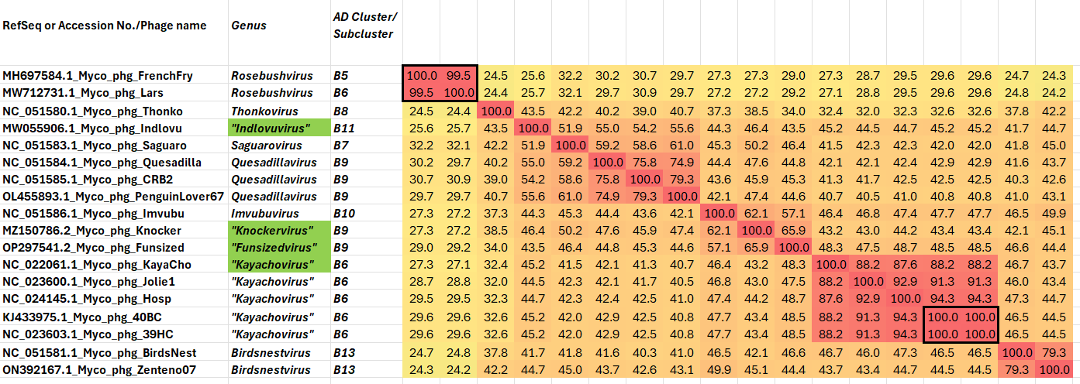

Figure 1. VIRIDIC heatmaps of this group of phages. VIRIDIC (Virus Intergenomic Distance Calculator; VIRIDIC (Virus Intergenomic Distance Calculator; [1]; http://rhea.icbm.uni-oldenburg.de/VIRIDIC/) computes pairwise intergenomic distances/similarities amongst phage genomes. The green highlighted Accession numbers represent new species. Data values which are bordered in black correspond to strains. Abbreviations: phg = phage; Myco = Mycobacterium

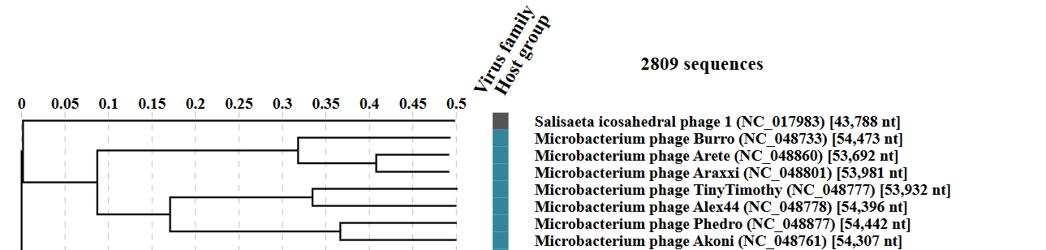
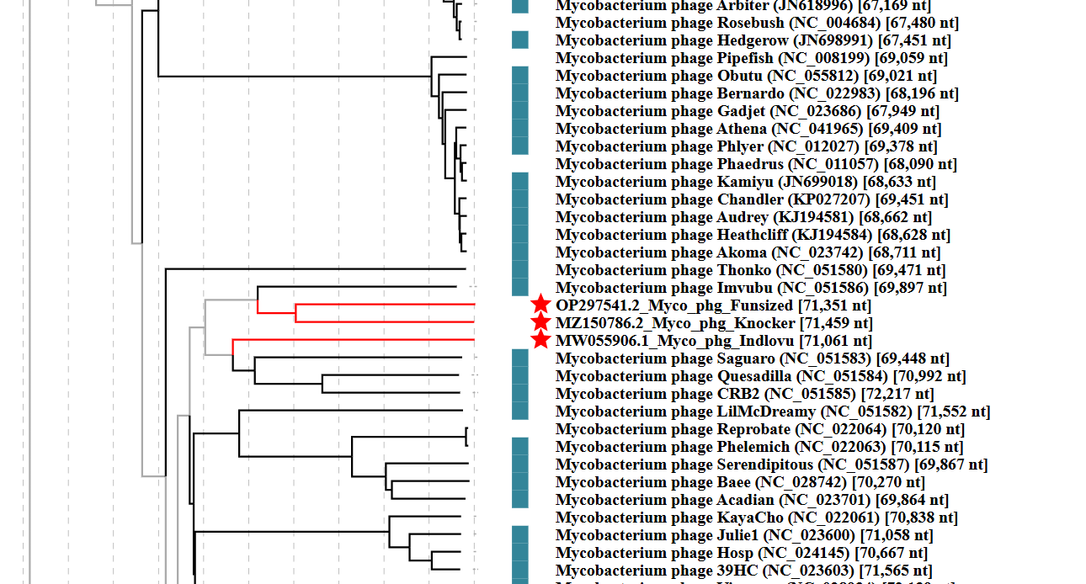

Figure 2. ViPTree analysis: ViPTree analysis (https://www.genome.jp/viptree/; [2]) is based upon Rohwer and Edwards (2002) Phage Proteomic Tree [3]. The taxons under discussion are indicated with red bars and stars. Abbreviations: phg = phage; Myco = Mycobacterium.

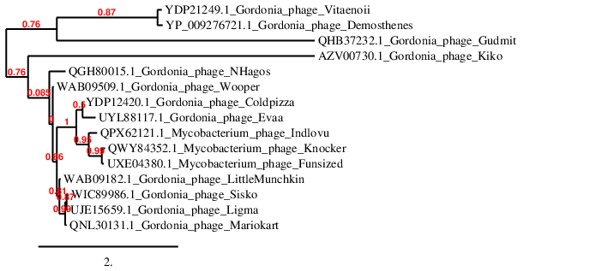

Figure 3. Phylogenetic tree constructed with the large subunit terminase proteins from these and related phages using “One Click” Phylogeny.fr [9] at https://www.phylogeny.fr using the TerL protein from Gordonia phage Kiko as an outlier.

Table 1. Characteristics of the phage in the genus Indlovuvirus.

Phage name | Host | Morphotype | Lifestyle | Accession No. | Genome size | %G+C | Termini | No. proteins | No. tRNA
Mycobacterium phage Indlovu | Mycobacterium smegmatis mc²155 | Siphovirus | Lytic | MW055906 | 71061 bp | 69.4 | Circularly Permuted | 95 | 0

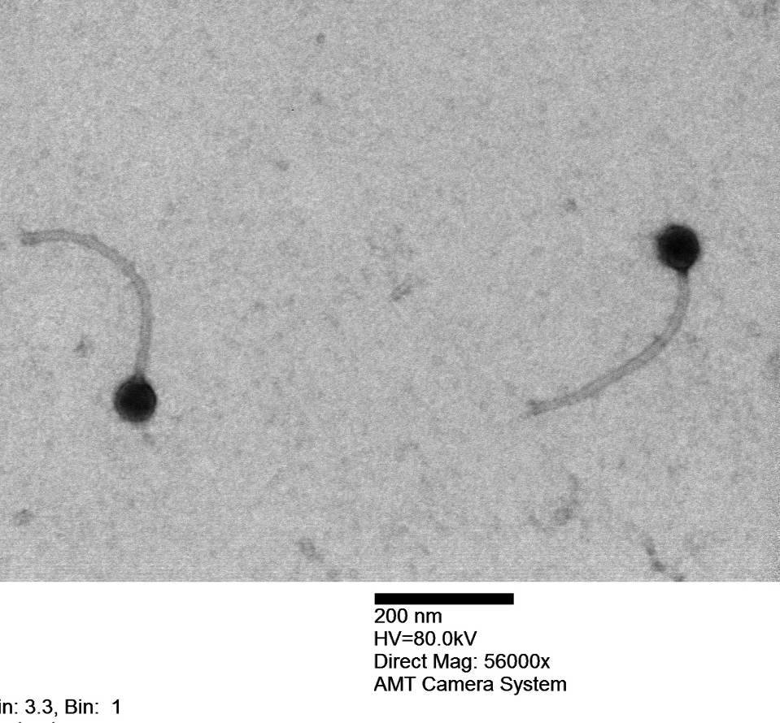

Figure 4. Electron micrograph: Electron micrograph of negatively stained Mycobacterium phage Indlovu (https://phagesdb.org/phages/Indlovu/). Limited permission was granted by The Actinobacteriophage Database (https://phagesdb.org/), funded by the Howard Hughes Medical Institute, to use this electron micrograph for this taxonomy proposal; it cannot be reused without permission of The Actinobacteriophage Database.

Table 2. Characteristics of the phage in the genus Knockervirus.

Phage name | Host | Morphotype | Lifestyle | Accession No. | Genome size | %G+C | Termini | No. proteins | No. tRNA
Mycobacterium phage Knocker | Mycobacterium smegmatis mc²155 | Siphovirus | Lytic | MZ150786 | 71459 bp | 69.7 | Circularly Permuted | 97 | 1

Table 3. Characteristics of the phage in the genus Funsizedvirus.

Phage name | Host | Morphotype | Lifestyle | Accession No. | Genome size | %G+C | Termini | No. proteins | No. tRNA
Mycobacterium phage Funsized | Mycobacterium smegmatis mc²155 | Siphovirus | Lytic | OP297541 | 71351 bp | 70.2 | Circularly permutted | 94 | 0

Table 4. Characteristics of the phage in the genus Kayachovirus.

Phage name | Host | Morphotype | Lifestyle | Accession No. | Genome size | %G+C | Termini | No. proteins | No. tRNA
Mycobacterium phage KayaCho | Mycobacterium smegmatis mc²155 | Siphovirus | Lytic | KF024729 | 70838 bp | 70.0 | Circularly permuted | 95 | 0
Mycobacterium phage Hosp | Mycobacterium smegmatis mc²155 | Siphovirus | Lytic | KJ433974 | 70667 bp | 69.9 | Circularly permuted | 97 | 0
Mycobacterium phage 39HC | Mycobacterium smegmatis mc²155 | Siphovirus | Lytic | KJ433973 | 71565 bp | 70.0 | Circularly permuted | 100 | 0

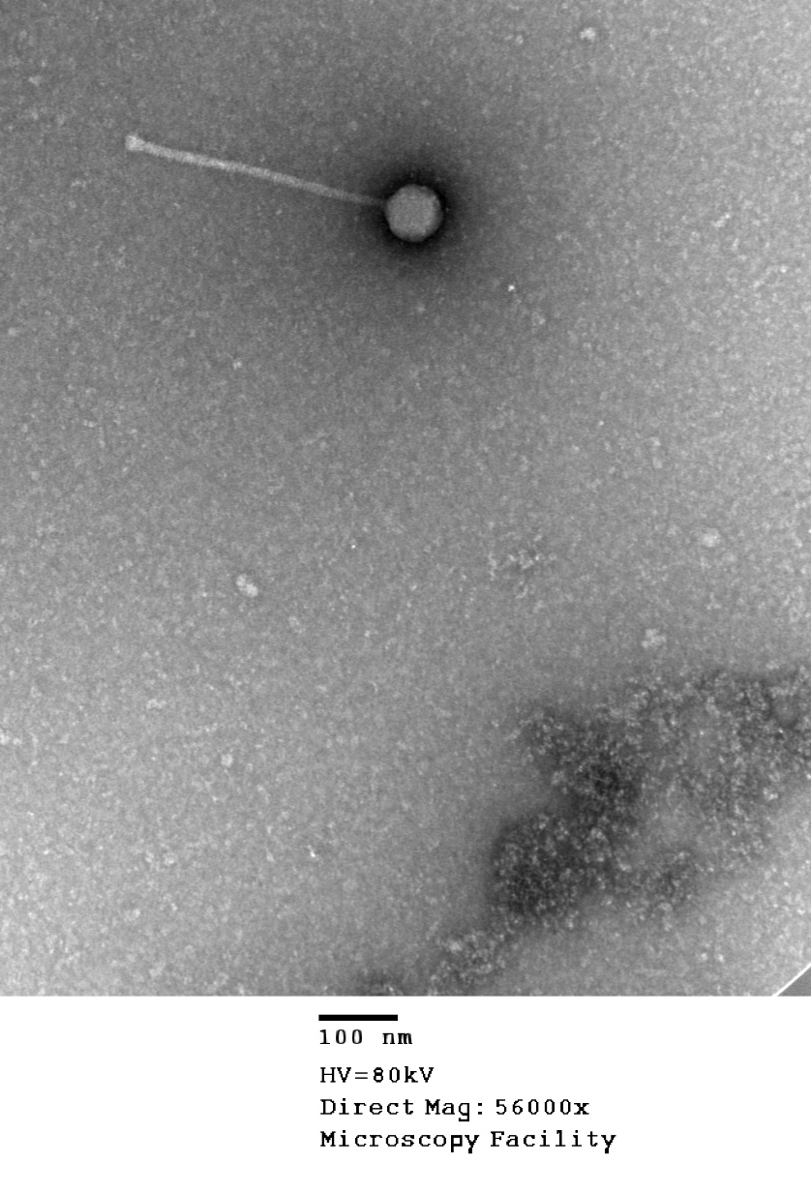

Figure 5. Electron micrograph: Electron micrograph of negatively stained Mycobacterium phage KayaCho (https://phagesdb.org/phages/KayaCho/). Limited permission was granted by The Actinobacteriophage Database (https://phagesdb.org/), funded by the Howard Hughes Medical Institute, to use this electron micrograph for this taxonomy proposal; it cannot be reused without permission of The Actinobacteriophage Database.

