

The International Committee on Taxonomy of Viruses
Taxonomy Proposal Form, 2026

Part 1a: Details of taxonomy proposals

Title: | To create a new subfamily, Mulveyvirinae with two genera, Purpuravirus and Atceavirus in the class Caudoviricetes
Code assigned: | 2026.046B

Author(s), affiliation and email address(es):
Given name (+middle initial(s)) | Surname | Affiliation | Email address | Corr. author(s)
Ella R. | Rotman | Department of Microbiology; University of Chicago; Chicago, IL, USA | erotman@uchicago.edu | x
Mark | Mimee | Department of Microbiology; University of Chicago; Chicago, IL, USA | mmimee@uchicago.edu | x
Alexey | Kazakov | Environmental Genomics and Systems Biology division; Lawrence Berkeley National Laboratory; Berkely, CA, USA | aekazakov@lbl.gov
Cristina M. | Moraru | Department of Chemistry, Environmental Metagenomics,  University of Duisburg-Essen,  D-45141 Essen,  Germany | lilianacristina.moraru@uni-due.de
Andrew M. | Kropinski | University of Guelph, Guelph, Ontario, Canada N1G2W1 | Phage.Canada@gmail.com | x

Part 1b: Taxonomy Proposal Submission
ICTV Subcommittee:
Animal DNA Viruses and Retroviruses |  | Bacterial viruses | x
Animal minus-strand and dsRNA viruses |  | Fungal and protist viruses
Animal positive-strand RNA viruses |  | Plant viruses
Archaeal viruses |  | General -

List the ICTV Study Group(s) that have seen or have been involved in creating this proposal:
Caudoviricetes Study Group

Optional – complete only if formally voted on by an ICTV Study Group:
Study Group | Number of members
Study Group | Votes in support | Votes against | No vote

Submission date: | 27/05/2026

Part 1c: Feedback from ICTV Executive Committee (EC) meeting
Executive Committee Meeting Decision code: | X
A – Accept
Ac – Accept subject to revision by relevant subcommittee chair. No further vote required
U – Accept without revision but with re-evaluation and email vote by the EC
Uc – Accept subject to revision and re-evaluation and email vote by the EC
Ud – Deferred to the next EC meeting, with an invitation to revise based on EC comments
J - Reject
W - Withdrawn

Comments from the Executive Committee:

Part 1d: Revised Taxonomy Proposal Submission
Response of proposer:
Revision date:

Part 3: TAXONOMIC PROPOSAL

Taxonomic changes proposed:
Establish new taxon | x | Split taxon
Abolish taxon |  | Merge taxon
Move taxon |  | Promote taxon
Rename taxon |  | Demote taxon
Move and rename

Etymology (origin) of proposed taxonomic names:
Taxon name | Etymology of the term
“Mulveyvirinae” | Named in honour of Dr. Michael R. Mulvey (†)
“Purpuravirus” | Derived from the Latin word for “Purple” referring to a group of phages described in Rotman et al. 2024
“Atceavirus” | Derived from the names of Klebsiella phages ATCEA23 and ATCEA85

Permission for use of names derived from a living person:
Taxon name | Full name of person from whom the name is derived | Attached

Abstract of Taxonomy Proposal:

Description of current taxonomy:
The bacteriophages described within this proposal have not been classified by the ICTV.

Proposed taxonomic change(s):
We propose to create a new subfamily named “Mulveyvirinae” containing the following two new genera: “Purpuravirus” and “Atceavirus” and 22 new species

Demarcation criteria for new taxon/taxa:
Subfamily demarcation criteria: Subfamilies are to be created when two or more genera are related below the family level. In practical terms, this usually means that they share a low degree of sequence similarity (usually about 40-50%) and that the genera form a clade in a marker tree phylogeny [6].

Genus demarcation criteria: An intergenomic similarity cut-off of 70%, a combination of average nucleotide identity and alignment fraction, is used to determine genera demarcation. Members of the same genus have >70% intergenomic similarity and cluster tightly in marker gene phylogenies.

Species demarcation criteria: A demarcation value of 95% intergenomic similarity was used to define different species according to intergenomic similarity. Members of the same genus have >95% intergenomic similarity [6].

Justification:
These bacteriophages infect Klebsiella sp. One bacteriophage is named Enterobacter phage ATCEA23 with the host qualifier field as Klebsiella aerogenes, this is due to the reassignment of E. aerogenes to the genus Klebsiella in bacterial taxonomy. Pairwise intergenomic nucleotide similarity analysis identified a total of two new genera and 22 new species using the current demarcation criteria recommended by the BVS. The two genera exhibit >48% intergenomic similarity, commensurate with a subfamily level relationship. In both the TBLASTX distance tree and the major capsid protein phylogeny, the proposed taxa form distinct clades that share a common root. All representative genomes share 24 proteins in common that include the terminase large subunit, major head protein and major tail protein.

Text of Taxonomy proposal:
Description of current taxonomy:
The bacteriophages described within this proposal have not been classified by the ICTV.

Proposed taxonomic change(s):
We propose to create a new subfamily named “Mulveyvirinae” containing the following two new genera: “Purpuravirus” and “Atceavirus” and 22 new species

Demarcation criteria for new taxon/taxa:
Subfamily demarcation criteria: Subfamilies are to be created when two or more genera are related below the family level. In practical terms, this usually means that they share a low degree of sequence similarity (usually about 40-50%) and that the genera form a clade in a marker tree phylogeny [6].

Genus demarcation criteria: An intergenomic similarity cut-off of 70%, a combination of average nucleotide identity and alignment fraction, is used to determine genera demarcation. Members of the same genus have >70% intergenomic similarity and cluster tightly in marker gene phylogenies.

Species demarcation criteria: A demarcation value of 95% intergenomic similarity was used to define different species according to intergenomic similarity. Members of the same genus have >95% intergenomic similarity [6].

Justification:
These bacteriophages infect Klebsiella sp. One bacteriophage is named Enterobacter phage ATCEA23 with the host qualifier field as Klebsiella aerogenes, this is due to the reassignment of E. aerogenes to the genus Klebsiella in bacterial taxonomy. Pairwise intergenomic nucleotide similarity analysis [1] identified a total of two new genera and 22 new species using the current demarcation criteria recommended by the BVS (Figure 1). The two genera exhibit >48% intergenomic similarity, commensurate with a subfamily level relationship (Figure 1). In both the TBLASTX distance tree [2, 3] (Figure 2) and the major capsid protein phylogeny [9] (Figure 3), the proposed taxa form distinct clades that share a common root. All representative genomes share 24 proteins in common [5] that include the terminase large subunit, major head protein and major tail protein.

References:
1. Moraru C, Varsani A, Kropinski AM. VIRIDIC-A Novel Tool to Calculate the Intergenomic Similarities of Prokaryote-Infecting Viruses. Viruses. 2020 Nov 6;12(11):1268. doi: 10.3390/v12111268. PMID: 33172115; PMCID: PMC7694805. http://kronos.icbm.uni-oldenburg.de/viridic/
2. Nishimura Y, Yoshida T, Kuronishi M, Uehara H, Ogata H, Goto S. ViPTree: the viral proteomic tree server. Bioinformatics. 2017; 33(15):2379-2380. doi:10.1093/bioinformatics/btx157. PubMed PMID: 28379287. https://www.genome.jp/viptree/
3. Rohwer F, Edwards R. The Phage Proteomic Tree: a genome-based taxonomy for phage. J Bacteriol. 2002 Aug;184(16):4529-35. PubMed PMID: 12142423
4. Turner D, Reynolds D, Seto D, Mahadevan P. CoreGenes3.5: a webserver for the determination of core genes from sets of viral and small bacterial genomes. BMC Res Notes. 2013;6:140. doi: 10.1186/1756-0500-6-140. PMID: 23566564.
5. Davis P, Seto D, Mahadevan P. CoreGenes5.0: An Updated User-Friendly Webserver for the Determination of Core Genes from Sets of Viral and Bacterial Genomes. Viruses. 2022 Nov 16;14(11):2534. doi: 10.3390/v14112534. PMID: 36423143; PMCID: PMC9693508.
6. Turner D, Kropinski AM, Adriaenssens EM. A Roadmap for Genome-Based Phage Taxonomy. Viruses. 2021 Mar 18;13(3):506. doi: 10.3390/v13030506. PMID: 33803862; PMCID: PMC8003253.
Lemoine F, Correia D, Lefort V, Doppelt-Azeroual O, Mareuil F, Cohen-Boulakia S, Gascuel O. NGPhylogeny.fr: new generation phylogenetic services for non-specialists. Nucleic Acids Res. 2019 Jul 2;47(W1):W260-W265. doi: 10.1093/nar/gkz303. PMID: 31028399; PMCID: PMC6602494.
7. Letunic I, Bork P. Interactive Tree Of Life (iTOL): an online tool for phylogenetic tree display and annotation. Bioinformatics. 2007 Jan 1;23(1):127-8. doi: 10.1093/bioinformatics/btl529. Epub 2006 Oct 18. PMID: 17050570.
8. Zhou T, Xu K, Zhao F, Liu W, Li L, Hua Z, Zhou X. itol.toolkit accelerates working with iTOL (Interactive Tree of Life) by an automated generation of annotation files. Bioinformatics. 2023 Jun 1;39(6):btad339. doi: 10.1093/bioinformatics/btad339. PMID: 37225402; PMCID: PMC10243930
9. Dereeper A, Guignon V, Blanc G, Audic S, Buffet S, Chevenet F, Dufayard JF, Guindon S, Lefort V, Lescot M, Claverie JM, Gascuel O. Phylogeny.fr: robust phylogenetic analysis for the non-specialist. Nucleic Acids Res. 2008 Jul 1;36(Web Server issue):W465-9. doi: 10.1093/nar/gkn180. Epub 2008 Apr 19. PMID: 18424797; PMCID: PMC2447785.

Accompanying files:
Filename | Description of contents
Mulveyvirinae_VIRIDIC_heatmap | Excel spreadsheet of intergenomic nucleotide sequence similarities accompanying this proposal

Tables, Figures:

History: Phages of the proposed Mulveyvirinae subfamily are viruses that infect Klebsiella pneumoniae. The Mimee group has isolated and continue to isolate dozens of these phages from Chicago area sewage, of which 10 have been deposited to GenBank. These phages have a siphovirus morphology with an icosahedral head and a long flexible tail. They are approximately 45-49 kb in size and contain a large ~10 kb tail gene.

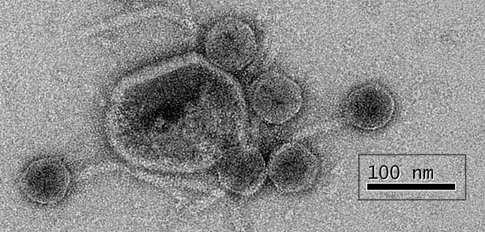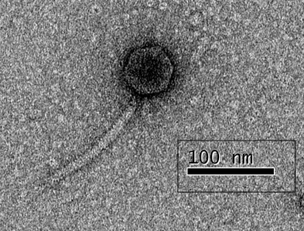

Figure 1: Electron micrographs of negatively stained preparations of Klebsiella phages vB_KpnS_Fuzzy_ER39 (Left) and vB_KpnS_Border_ER3 (Right)

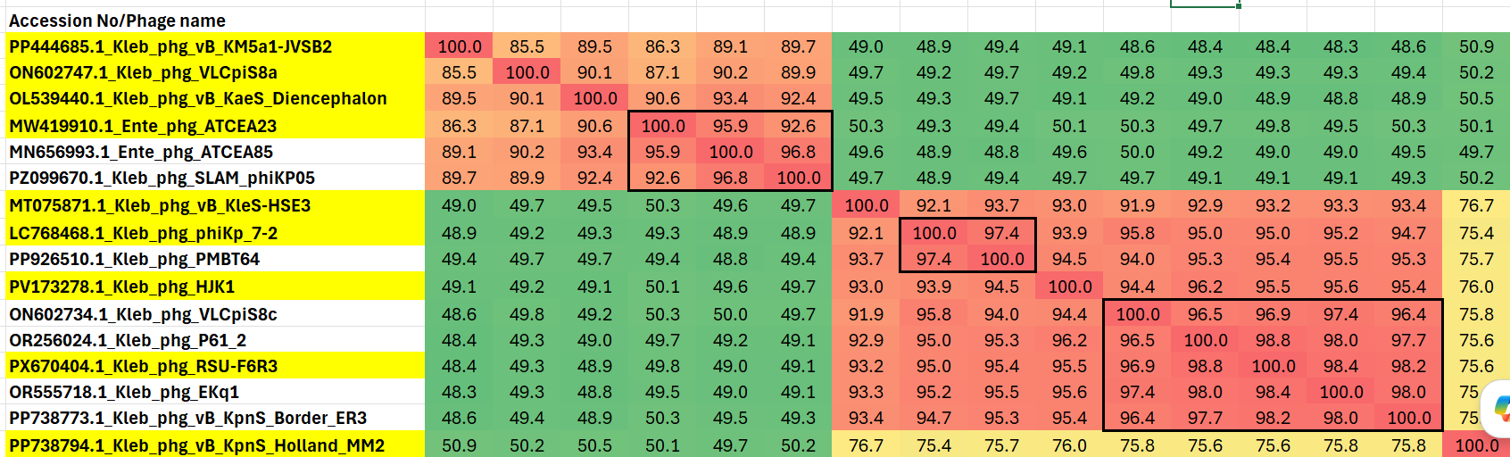

Figure 2. Partial VIRIDIC heatmap of this group of phages. VIRIDIC (Virus Intergenomic Distance Calculator; VIRIDIC (Virus Intergenomic Distance Calculator; [1]; http://rhea.icbm.uni-oldenburg.de/VIRIDIC/) computes pairwise intergenomic distances/similarities amongst phage genomes. Data values which are bordered in black correspond to strains. The complete Excel spreadsheet is attached. Abbreviations: phg = phage; Kleb = Klebsiella; Ente = Enterobacter
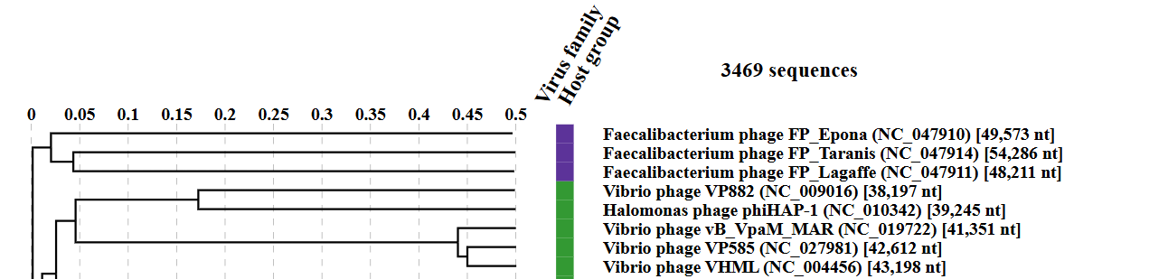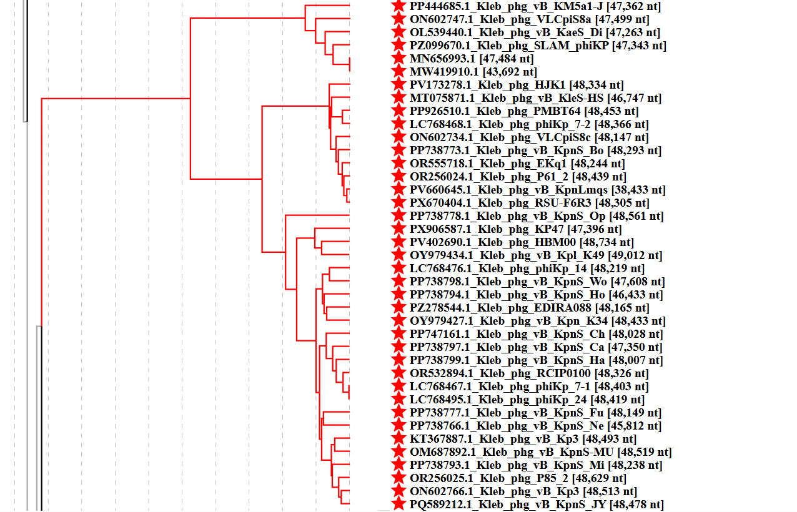Figure 3. ViPTree analysis: ViPTree analysis (https://www.genome.jp/viptree/; [2]) is based upon Rohwer and Edwards (2002) Phage Proteomic Tree [3]. The taxons under discussion are indicated with red bars and stars. Abbreviations: phg = phage; Kleb = Klebsiella; Ente = Enterobacter
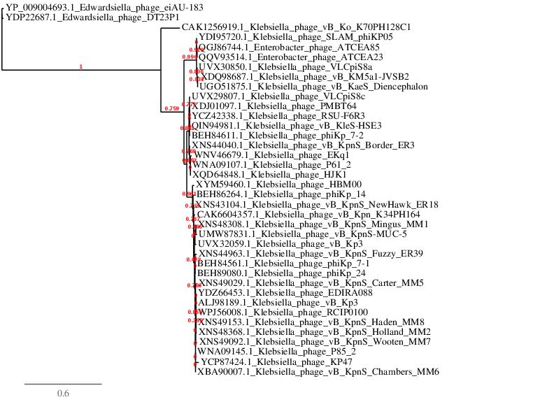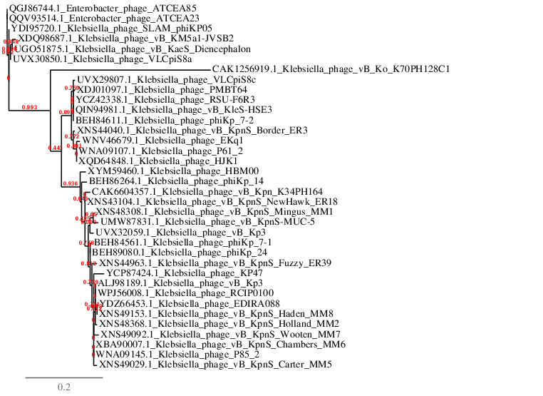Figure 4. Phylogenetic tree constructed with the major capsid proteins (MCP) from these and related phages using “One Click” Phylogeny.fr [9] at https://www.phylogeny.fr using the MCP from Edwardsiella phages as outliers (TOP) and without (BOTTOM).

Table 1. Phages belonging to these two genera

Exemplar | Accession No. | Taxon
Klebsiella phage vB_KM5a1-JVSB2 | PP444685 | Atceavirus JVSB2
Klebsiella phage VLCpiS8a | ON602747 | Atceavirus VLCpiS8a
Klebsiella phage vB_KaeS_Diencephalon | OL539440 | Atceavirus diencephalon
Enterobacter phage ATCEA23 | MW419910 | Atceavirus ATCEA23
Klebsiella phage vB_KleS-HSE3 | MT075871 | Pupuravirus HSE3
Klebsiella phage phiKp_7-2 | LC768468 | Pupuravirus Kp72
Klebsiella phage HJK1 | PV173278 | Pupuravirus HJK1
Klebsiella phage RSU-F6R3 | PX670404 | Pupuravirus RSUF6R3
Klebsiella phage vB_KpnS_Holland_MM2 | PP738794 | Pupuravirus hollandMM2
Klebsiella phage vB_KpnS_Fuzzy_ER39 | PP738777 | Pupuravirus fuzzy_ER39
Klebsiella phage vB_KpnS_Mingus_MM1 | PP738793 | Pupuravirus mingusMM1
Klebsiella phage vB_KpnS_NewHawk_ER18 | PP738766 | Pupuravirus newhawkER18
Klebsiella phage RCIP0100 | OR532894 | Pupuravirus RCIP0100
Klebsiella phage phiKp_14 | LC768476 | Pupuravirus Kp14
Klebsiella phage vB_KpnS_Wooten_MM7 | PP738798 | Pupuravirus wootenMM7
Klebsiella phage vB_Kpn_K34PH164 | OY979427 | Pupuravirus K34PH164
Klebsiella phage vB_KpnS_Chambers_MM6 | PP747161 | Pupuravirus chambersMM6
Klebsiella phage EDIRA088 | PZ278544 | Pupuravirus EDIRA088
Klebsiella phage vB_KpnS_Op1_ER4 | PP738778 | Pupuravirus Op1ER4
Klebsiella phage KP47 | PX906587 | Pupuravirus KP47
Klebsiella phage vB_Kpl_K49PH164C2 | OY979434 | Pupuravirus K49PH164C2
Klebsiella phage HBM00 | PV402690 | Pupuravirus HBM00

Table 2. Characteristics of two phages from the genus “Atceavirus”

Phage name | Host | Morphotype | Lifestyle | Accession No. | Genome size | %  G+C | No. proteins | No. tRNA
Klebsiella phage vB_KM5a1-JVSB2 | Klebsiella sp. M5a1 | Siphovirus | Lytic | PP444685 | 47362 bp | 56.4 | 65 | 0
Klebsiella phage vB_KaeS_Diencephalon | Klebsiella pneumoniae | Siphovirus | Lytic | OL539440 | 47263 bp | 56.2 | 64 | 0

Table 3. Characteristics of two phages from the genus "Pupuravirus"

Phage name | Host | Morphotype | Lifestyle | Accession No. | Genome size | %  G+C | No. proteins | No. tRNA
Klebsiella phage vB_KleS-HSE3 | Klebsiella pneumoniae 1025 | Siphovirus | Lytic | MT075871 | 46747 bp | 56.5 | 61 | 0
Klebsiella phage vB_KpnS_Fuzzy_ER39 | Klebsiella pneumoniae MH258 | Siphovirus | Lytic | PP738777 | 48149 bp | 56.8 | 62 | 0
Specific references: Peng Q, Fang M, Liu X, Zhang C, Liu Y, Yuan Y. Isolation and Characterization of a Novel Phage for Controlling Multidrug-Resistant Klebsiella pneumoniae. Microorganisms. 2020 Apr 9;8(4):542. doi: 10.3390/microorganisms8040542. PMID: 32283667; PMCID: PMC7232175

Rotman E, McClure S, Glazier J, Fuerte-Stone J, Foldi J, Erani A, McGann R, Arnold J, Lin H, Valaitis S, Mimee M. Rapid design of bacteriophage cocktails to suppress the burden and virulence of gut-resident carbapenem-resistant Klebsiella pneumoniae. Cell Host Microbe. 2024 Nov 13;32(11):1988-2003.e8. doi: 10.1016/j.chom.2024.09.004. Epub 2024 Oct 4. PMID: 39368473; PMCID: PMC11563920.


(photo from: https://www.researchgate.net/profile/Michael-Mulvey-3)
This taxon is named in honour of Dr. Michael Richard Mulvey (b. 1963, Winnipeg, Manitoba, Canada' d. 2023, Winnipeg) a renowned expert on antimicrobial resistance (AMR). He earned a PhD in Microbiology from the University of Manitoba in 1990 with a thesis on "Cloning and characterization of katF, a gene controlling a novel regulon in Escherichia coli”. “In 1996 he started working for Health Canada, now the National Microbiology Laboratory (NML), Public Health Agency of Canada (PHAC) where he established and was the Chief of the Antimicrobial Resistance and Nosocomial Infections (ARNI) Laboratory. He was also responsible for establishing The Canadian Integrated Program on Antimicrobial Resistance Surveillance (CIPARS, 2002); and Streptococcal and Sexually Transmitted Infections Laboratory Surveillance. He also established NML’s Wasterwater Surveillance Laboratory, National Reference Laboratory for Mycology and a new national surveillance program to capture electronic AMR data generated from human and veterinary laboratories called AMRNet.

He generously volunteered his time on many AMR expert committees including the: Canadian Public Health Laboratory Network Working Group on AMR; Executive Board of the Canadian Committee on Antimicrobial Susceptibility Testing (CANCAST); European Committee on Antimicrobial Susceptibility Testing (EUCAST); US National Antimicrobial Resistance Monitoring System; two Transatlantic Task Force on AMR working groups; Medical Countermeasures Consortium (UK/US/Canada/Australia) Task Group on AMR; Canadian Institutes for Health Research Institute of Infection and Immunity Institute Advisory Board. Dr. Mulvey received numerous awards including the 2022 PHAC CPHO award, 2020 CACMID John G. FitzGerald Award, 2015 Honorary Membership in the Association of Medical Microbiology and Infectious Diseases (AMMI Canada) and the 2016 University of Manitoba Faculty of Science Honoured Alumni of the Year, among others.” (https://cacmid.ca/dr-michael-r-mulvey-cacmid-studentship-award/)

This honour is bestowed because of Dr. Mulvey's belief in phage therapy and his drive to establish a Phage Biobank at NML. This occurred after his premature death from cancer.

CoreGenes 5.0 analysis [5] revealed 24 common proteins (38.1% homologous) including terminase large subunit, major head protein, major tail protein, tail length tape measure protein, tail assembly protein, tail fiber protein, single-stranded DNA-binding protein, recombinase, exodeoxyribonuclease, DNA helicase, and 2 DNA methyltransferases.

