

The International Committee on Taxonomy of Viruses
Taxonomy Proposal Form, 2026

Part 1a: Details of taxonomy proposals

Title: | To create a new subfamily (Marilynmonkvirinae) with eight new genera and 14 species (Caudoviricetes)
Code assigned: | 2026.045B

Author(s), affiliation and email address(es):
Given name (+middle initial(s)) | Surname | Affiliation | Email address | Corr. author(s)
Cristina M. | Moraru | Department of Chemistry, Environmental Metagenomics,  University of Duisburg-Essen,  D-45141 Essen,  Germany | lilianacristina.moraru@uni-due.de
Andrew M. | Kropinski | University of Guelph, Guelph, Ontario, Canada N1G2W1 | Phage.Canada@gmail.com | x

Part 1b: Taxonomy Proposal Submission
ICTV Subcommittee:
Animal DNA Viruses and Retroviruses |  | Bacterial viruses | x
Animal minus-strand and dsRNA viruses |  | Fungal and protist viruses
Animal positive-strand RNA viruses |  | Plant viruses
Archaeal viruses |  | General -

List the ICTV Study Group(s) that have seen or have been involved in creating this proposal:
Optional – complete only if formally voted on by an ICTV Study Group:
Study Group | Number of members
Study Group | Votes in support | Votes against | No vote

Submission date: | March 17, 2026

Part 1c: Feedback from ICTV Executive Committee (EC) meeting
Executive Committee Meeting Decision code: | X
A – Accept
Ac – Accept subject to revision by relevant subcommittee chair. No further vote required
U – Accept without revision but with re-evaluation and email vote by the EC
Uc – Accept subject to revision and re-evaluation and email vote by the EC
Ud – Deferred to the next EC meeting, with an invitation to revise based on EC comments
J - Reject
W - Withdrawn

Comments from the Executive Committee:

Part 1d: Revised Taxonomy Proposal Submission
Response of proposer:
Revision date:

Part 3: TAXONOMIC PROPOSAL

Taxonomic changes proposed:
Establish new taxon | x | Split taxon
Abolish taxon |  | Merge taxon
Move taxon |  | Promote taxon
Rename taxon |  | Demote taxon
Move and rename

Etymology (origin) of proposed taxonomic names:
Taxon name | Etymology of the term
"Huazhongvirus" | Named in honour of Huazhong Agricultural University where the first phage of its type was isolated
"Midoctavirus" | Named after Pseudomonas phage M8 - M plus i plus octa (8) plus virus
"Salfordvirus" | Named in honour of University of Salford where the first phage of its type was isolated
"Ostrovvirus" | Directly named after Pseudomonas phage Ostrov
"Cockcroftvirus" | Named after the Cockcroft Building, University of Salford where the first phage of its type was isolated
"Bogotavirus" | Named after the city where in the Universidad de los Andes the first phage of its type was isolated
"Montgomeryvirus" | Name after Montgomery County where at The J. Craig Venter Institute the first phage of its type was isolated.
"Solanovirus" | Directly named after Pseudomonas phage Solano

Permission for use of names derived from a living person:
Taxon name | Full name of person from whom the name is derived | Attached
Marilynmonkvirinae | Professor Marilyn Monk | x

Abstract of Taxonomy Proposal:

Description of current taxonomy: None of these phages have been classified by ICTV. They belong to a large group of classically temperate Pseudomonas phages/prophages possessing integrases and C1-like repressors. The presence of long tail tapemeasure proteins suggest that they are all siphoviruses which was confirmed by electron microscopy of phage F10 (H-W Ackermann, https://www.phage.ulaval.ca/en/phages/11).

Proposed taxonomic change(s): We propose to create a new subfamily called Marilynmonkvirinae containing the following new genera: “Huazhongvirus", "Midoctavirus","Salfordvirus","Ostrovvirus", "Cockcroftvirus","Bogotavirus","Montgomeryvirus", and "Solanovirus". With the exception of “Ostrovvirus “(6 species) and “Solanovirus” (2 species) all the other are single species genera.

Demarcation criteria for new taxon/taxa:
Subfamily demarcation criteria: Subfamilies are to be created when two or more genera are related below the family level. In practical terms, this usually means that they share a low degree of sequence similarity (usually about 40-50%) and that the genera form a clade in a marker tree phylogeny [6].

Genus demarcation criteria: An intergenomic similarity cut-off of 70%, a combination of average nucleotide identity and alignment fraction, is used to determine genera demarcation. Members of the same genus have >70% intergenomic similarity and cluster tightly in marker gene phylogenies.

Species demarcation criteria: A demarcation value of 95% intergenomic similarity was used to define different species according to intergenomic similarity. Members of the same genus have >95% intergenomic similarity [6].

Justification: On the basis of VIRIDIC, VIPTREE (& CoreGenes 5) and phylogenetic analyses these temperate Pseudomonas siphoviruses form a cohesive clade at the subfamily level. Of the 12 (18% common) proteins which these phages share only the large subunit terminase and portal proteins are named.

Additional note: Pseudomonas phage ΦPan70 is described as a myovirus in its associated manuscript (Holguin et al. 2015). This is not supported by its genomic analysis which fails to show a tail sheath protein.

Holguín AV, Rangel G, Clavijo V, Prada C, Mantilla M, Gomez MC, Kutter E, Taylor C, Fineran PC, Barrios AF, Vives MJ. Phage ΦPan70, a Putative Temperate Phage, Controls Pseudomonas aeruginosa in Planktonic, Biofilm and Burn Mouse Model Assays. Viruses. 2015 Aug 12;7(8):4602-23. doi: 10.3390/v7082835. PMID: 26274971; PMCID: PMC4576196.

Text of Taxonomy proposal:
Description of current taxonomy: None of these phages have been classified by ICTV. They belong to a large group of classically temperate Pseudomonas phages/prophages possessing integrases and C1-like repressors. The presence of long tail tapemeasure proteins suggest that they are all siphoviruses which was confirmed by electron microscopy of phage F10 (H-W Ackermann, https://www.phage.ulaval.ca/en/phages/11).

Proposed taxonomic change(s): We propose to create a new subfamily called Marilynmonkvirinae containing the following new genera: “Huazhongvirus", "Midoctavirus","Salfordvirus","Ostrovvirus", "Cockcroftvirus","Bogotavirus","Montgomeryvirus", and "Solanovirus". With the exception of “Ostrovvirus “(6 species) and “Solanovirus” (2 species) all the other are single-species genera.

Demarcation criteria for new taxon/taxa: Subfamily demarcation criteria: Subfamilies are to be created when two or more genera are related below the family level. In practical terms, this usually means that they share a low degree of sequence similarity (usually about 40-50%) and that the genera form a clade in a marker tree phylogeny [6].

Genus demarcation criteria: An intergenomic similarity cut-off of 70%, a combination of average nucleotide identity and alignment fraction, is used to determine genera demarcation. Members of the same genus have >70% intergenomic similarity and cluster tightly in marker gene phylogenies.

Species demarcation criteria: A demarcation value of 95% intergenomic similarity was used to define different species according to intergenomic similarity. Members of the same genus have >95% intergenomic similarity [6].

Justification: On the basis of VIRIDIC, VIPTREE (& CoreGenes 5) and phylogenetic analyses these temperate Pseudomonas siphoviruses form a cohesive clade at the subfamily level. Of the 12 (18% common) proteins which these phages share only the large subunit terminase and portal proteins are named.

Additional note: Pseudomonas phage ΦPan70 is described as a myovirus in its associated manuscript (Holguin et al. 2015). This is not supported by its genomic analysis which fails to show a tail sheath protein.

Holguín AV, Rangel G, Clavijo V, Prada C, Mantilla M, Gomez MC, Kutter E, Taylor C, Fineran PC, Barrios AF, Vives MJ. Phage ΦPan70, a Putative Temperate Phage, Controls Pseudomonas aeruginosa in Planktonic, Biofilm and Burn Mouse Model Assays. Viruses. 2015 Aug 12;7(8):4602-23. doi: 10.3390/v7082835. PMID: 26274971; PMCID: PMC4576196.

References:
1. Moraru C, Varsani A, Kropinski AM. VIRIDIC-A Novel Tool to Calculate the Intergenomic Similarities of Prokaryote-Infecting Viruses. Viruses. 2020 Nov 6;12(11):1268. doi: 10.3390/v12111268. PMID: 33172115; PMCID: PMC7694805. http://kronos.icbm.uni-oldenburg.de/viridic/
2. Nishimura Y, Yoshida T, Kuronishi M, Uehara H, Ogata H, Goto S. ViPTree: the viral proteomic tree server. Bioinformatics. 2017; 33(15):2379-2380. doi:10.1093/bioinformatics/btx157. PubMed PMID: 28379287. https://www.genome.jp/viptree/
3. Rohwer F, Edwards R. The Phage Proteomic Tree: a genome-based taxonomy for phage. J Bacteriol. 2002 Aug;184(16):4529-35. PubMed PMID: 12142423
4. Turner D, Reynolds D, Seto D, Mahadevan P. CoreGenes3.5: a webserver for the determination of core genes from sets of viral and small bacterial genomes. BMC Res Notes. 2013;6:140. doi: 10.1186/1756-0500-6-140. PMID: 23566564.
5. Davis P, Seto D, Mahadevan P. CoreGenes5.0: An Updated User-Friendly Webserver for the Determination of Core Genes from Sets of Viral and Bacterial Genomes. Viruses. 2022 Nov 16;14(11):2534. doi: 10.3390/v14112534. PMID: 36423143; PMCID: PMC9693508.
6. Turner D, Kropinski AM, Adriaenssens EM. A Roadmap for Genome-Based Phage Taxonomy. Viruses. 2021 Mar 18;13(3):506. doi: 10.3390/v13030506. PMID: 33803862; PMCID: PMC8003253.
Lemoine F, Correia D, Lefort V, Doppelt-Azeroual O, Mareuil F, Cohen-Boulakia S, Gascuel O. NGPhylogeny.fr: new generation phylogenetic services for non-specialists. Nucleic Acids Res. 2019 Jul 2;47(W1):W260-W265. doi: 10.1093/nar/gkz303. PMID: 31028399; PMCID: PMC6602494.
7. Letunic I, Bork P. Interactive Tree Of Life (iTOL): an online tool for phylogenetic tree display and annotation. Bioinformatics. 2007 Jan 1;23(1):127-8. doi: 10.1093/bioinformatics/btl529. Epub 2006 Oct 18. PMID: 17050570.
8. Zhou T, Xu K, Zhao F, Liu W, Li L, Hua Z, Zhou X. itol.toolkit accelerates working with iTOL (Interactive Tree of Life) by an automated generation of annotation files. Bioinformatics. 2023 Jun 1;39(6):btad339. doi: 10.1093/bioinformatics/btad339. PMID: 37225402; PMCID: PMC10243930
9. Dereeper A, Guignon V, Blanc G, Audic S, Buffet S, Chevenet F, Dufayard JF, Guindon S, Lefort V, Lescot M, Claverie JM, Gascuel O. Phylogeny.fr: robust phylogenetic analysis for the non-specialist. Nucleic Acids Res. 2008 Jul 1;36(Web Server issue):W465-9. doi: 10.1093/nar/gkn180. Epub 2008 Apr 19. PMID: 18424797; PMCID: PMC2447785.

Accompanying files:
Filename | Description of contents
Marilynmonkvirinae_1nsf_8ng_14nsp | Excel spreadsheet associated with this proposal

Tables, Figures:

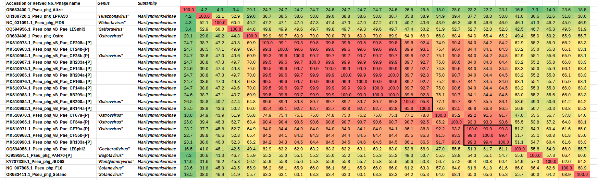

Figure 1. VIRIDIC heatmap of this group of phages. VIRIDIC (Virus Intergenomic Distance Calculator; VIRIDIC (Virus Intergenomic Distance Calculator; [1]; http://rhea.icbm.uni-oldenburg.de/VIRIDIC/) computes pairwise intergenomic distances/similarities amongst phage genomes. Data values which are bordered in black correspond to strains. Abbreviations: phg = phage; Pseu = Pseudomonas. Because this diagram is somewhat difficult to read we have attached the full-sized Excel spread sheet.

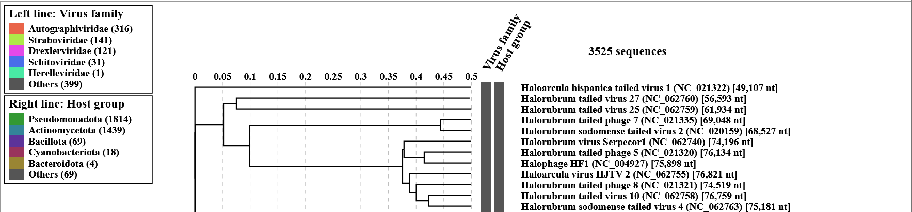
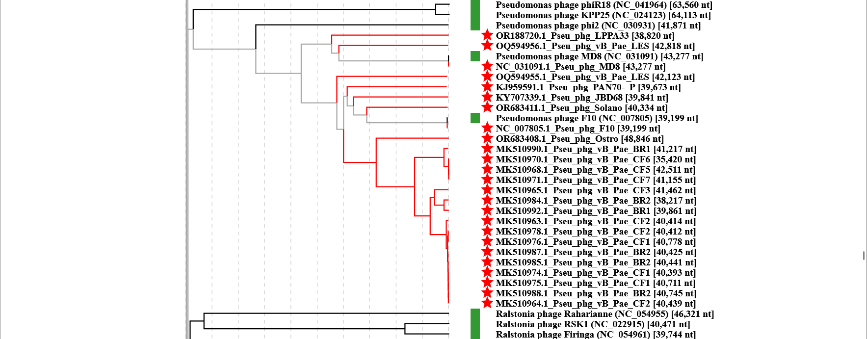

Figure 2. ViPTree analysis: ViPTree analysis (https://www.genome.jp/viptree/; [2]) is based upon Rohwer and Edwards (2002) Phage Proteomic Tree [3]. The taxons under discussion are indicated with red bars and stars. Abbreviations: phg = phage; Pseu = Pseudomonas.

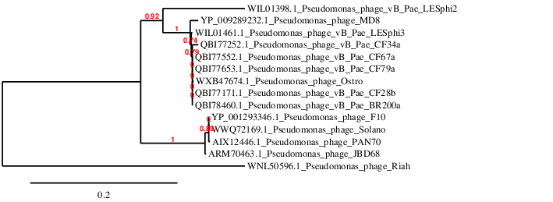

Figure 3. Phylogenetic tree constructed with the large subunit terminase proteins from these and related phages using “One Click” Phylogeny.fr [9] at https://www.phylogeny.fr using the TerL protein from Pseudomonas phage Riah as an outlier.


Figure 4. Professor Marilyn Monk (photograph taken from https://widerhorizons.events/portfolio-items/professor-marilyn-monk/)

This taxon in named in honour of Marilyn Monk (b. 1938) who is Emeritus Professor of Molecular Embryology at University College, London (UK). She has researched life at the molecular and cellular levels. For 15 years she studied genetics of bacteria (Pseudomonas and Escherichia coli) and their viruses, their DNA replication and repair and gene transfer cell to cell. Then, armed with her extensive molecular biology experience, she moved to amoeboid cell signaling and aggregation, and from there to mammalian molecular biology - X-chromosome inactivation, and cellular epigenetic programming of gene expression in early human and mouse embryos and their germ lines. A major contribution from her laboratory was the first development of single cell molecular biology to originate studies on gene transcription, modification and mutation, in single cells in mouse and human embryonic development and the germ line. Her molecular analyses of biopsied single embryonic cells from human embryos - and the first polar body of the egg - pioneered the field of preimplantation diagnosis of genetic disease in human reproduction. Her work continued with the creation of libraries of expressed genes in early human embryos and germ cells and identification of new embryo/cancer genes towards development of a prophylactic cancer vaccine.

