

The International Committee on Taxonomy of Viruses
Taxonomy Proposal Form, 2026

Part 1a: Details of taxonomy proposals

Title: | To create a new subfamily, Mankiewiczvirinae, containing Bippervirus and Typhavirus (class Caudoviricetes)
Code assigned: | 2026.044B

Author(s), affiliation and email address(es):
Given name (+middle initial(s)) | Surname | Affiliation | Email address | Corr. author(s)
Ipek | Kurtböke | Environmental Microbiology, University of the Sunshine Coast,  School of Science, Technology and Engineering,  Maroochydore DC, Australia | IKurtbok@usc.edu.au
Cristina M. | Moraru | Department of Chemistry, Environmental Metagenomics,  University of Duisburg-Essen,  D-45141 Essen,  Germany | lilianacristina.moraru@uni-due.de
Andrew M. | Kropinski | University of Guelph, Guelph, Ontario, Canada N1G2W1 | Phage.Canada@gmail.com | x

Part 1b: Taxonomy Proposal Submission
ICTV Subcommittee:
Animal DNA Viruses and Retroviruses |  | Bacterial viruses | x
Animal minus-strand and dsRNA viruses |  | Fungal and protist viruses
Animal positive-strand RNA viruses |  | Plant viruses
Archaeal viruses |  | General -

List the ICTV Study Group(s) that have seen or have been involved in creating this proposal:
Optional – complete only if formally voted on by an ICTV Study Group:
Study Group | Number of members
Study Group | Votes in support | Votes against | No vote
Actinophages

Submission date: | 20/03/2026

Part 1c: Feedback from ICTV Executive Committee (EC) meeting
Executive Committee Meeting Decision code: | X
A – Accept
Ac – Accept subject to revision by relevant subcommittee chair. No further vote required
U – Accept without revision but with re-evaluation and email vote by the EC
Uc – Accept subject to revision and re-evaluation and email vote by the EC
Ud – Deferred to the next EC meeting, with an invitation to revise based on EC comments
J - Reject
W - Withdrawn

Comments from the Executive Committee:

Part 1d: Revised Taxonomy Proposal Submission
Response of proposer:
Revision date:

Part 3: TAXONOMIC PROPOSAL

Taxonomic changes proposed:
Establish new taxon | x | Split taxon
Abolish taxon |  | Merge taxon
Move taxon |  | Promote taxon
Rename taxon |  | Demote taxon
Move and rename

Etymology (origin) of proposed taxonomic names:
Taxon name | Etymology of the term
Mankiewiczvirinae | Named in honour of Edith Mankiewicz (†)

Permission for use of names derived from a living person:
Taxon name | Full name of person from whom the name is derived | Attached

Abstract of Taxonomy Proposal:

Description of current taxonomy:
The ICTV has recognized two genera that contain species assigned to Cluster Y of the Actinobacteriophages Database; Bippervirus (2021.011B.R.Bippervirus) and Typhavirus (2021.087B.R.Typhavirus).

Proposed taxonomic change(s):
We propose to create a new subfamily called "Mankiewiczvirinae" and move the genera Bippervirus and Typhavirus into the subfamily along with one new species.

Demarcation criteria for new taxon/taxa: Subfamily demarcation criteria: Subfamilies are to be created when two or more genera are related below the family level. In practical terms, this usually means that they share a low degree of sequence similarity (usually about 40-50%) and that the genera form a clade in a marker tree phylogeny [6].

Genus demarcation criteria: An intergenomic similarity cut-off of 70%, a combination of average nucleotide identity and alignment fraction, is used to determine genera demarcation. Members of the same genus have >70% intergenomic similarity and cluster tightly in marker gene phylogenies.

Species demarcation criteria: A demarcation value of 95% intergenomic similarity was used to define different species according to intergenomic similarity. Members of the same genus have >95% intergenomic similarity [6].

Justification:
Intergenomic nucleotide similarities calculated using VIRIDIC demonstrate that phages within the genera Bippervirus and Typhavirus share at minimum 53% similarity. Each of the proposed genera and species exhibit similarity which satisfy the demarcation criteria established by the Bacterial Viruses Subcommittee. Phylogenetic analyses of the large terminase subunit protein and TBLASTX distance analysis using ViPTree demonstrate that these Mycobacterium phages form a cohesive clade at the subfamily level. CoreGenes3.5 analysis revealed that representative species of this subfamily all share 87 common proteins.

Text of Taxonomy proposal:
Description of current taxonomy:
The ICTV has recognized two genera that contain species assigned to Cluster Y of the Actinobacteriophages Database; Bippervirus (2021.011B.R.Bippervirus) and Typhavirus (2021.087B.R.Typhavirus).

Proposed taxonomic change(s):
We propose to create a new subfamily called "Mankiewiczvirinae" and move the genera Bippervirus and Typhavirus into the subfamily along with one new species.

Demarcation criteria for new taxon/taxa: Subfamily demarcation criteria: Subfamilies are to be created when two or more genera are related below the family level. In practical terms, this usually means that they share a low degree of sequence similarity (usually about 40-50%) and that the genera form a clade in a marker tree phylogeny [6].

Genus demarcation criteria: An intergenomic similarity cut-off of 70%, a combination of average nucleotide identity and alignment fraction, is used to determine genera demarcation. Members of the same genus have >70% intergenomic similarity and cluster tightly in marker gene phylogenies.

Species demarcation criteria: A demarcation value of 95% intergenomic similarity was used to define different species according to intergenomic similarity. Members of the same genus have >95% intergenomic similarity [6].

Justification:
Intergenomic nucleotide similarities calculated using VIRIDIC demonstrate that phages within the genera Bippervirus and Typhavirus share at minimum 53% similarity (Figure 1). Each of the proposed genera and species exhibit similarity which satisfy the demarcation criteria established by the Bacterial Viruses Subcommittee. Phylogenetic analyses of the large terminase subunit protein (Figure 3) and TBLASTX distance analysis (Figure 2) using ViPTree demonstrate that these Mycobacterium phages form a cohesive clade at the subfamily level. CoreGenes3.5 analysis revealed that representative species of this subfamily all share 87 common proteins.

References:
1. Moraru C, Varsani A, Kropinski AM. VIRIDIC-A Novel Tool to Calculate the Intergenomic Similarities of Prokaryote-Infecting Viruses. Viruses. 2020 Nov 6;12(11):1268. doi: 10.3390/v12111268. PMID: 33172115; PMCID: PMC7694805. http://kronos.icbm.uni-oldenburg.de/viridic/
2. Nishimura Y, Yoshida T, Kuronishi M, Uehara H, Ogata H, Goto S. ViPTree: the viral proteomic tree server. Bioinformatics. 2017; 33(15):2379-2380. doi:10.1093/bioinformatics/btx157. PubMed PMID: 28379287. https://www.genome.jp/viptree/
3. Rohwer F, Edwards R. The Phage Proteomic Tree: a genome-based taxonomy for phage. J Bacteriol. 2002 Aug;184(16):4529-35. PubMed PMID: 12142423
4. Turner D, Reynolds D, Seto D, Mahadevan P. CoreGenes3.5: a webserver for the determination of core genes from sets of viral and small bacterial genomes. BMC Res Notes. 2013;6:140. doi: 10.1186/1756-0500-6-140. PMID: 23566564.
5. Davis P, Seto D, Mahadevan P. CoreGenes5.0: An Updated User-Friendly Webserver for the Determination of Core Genes from Sets of Viral and Bacterial Genomes. Viruses. 2022 Nov 16;14(11):2534. doi: 10.3390/v14112534. PMID: 36423143; PMCID: PMC9693508.
6. Turner D, Kropinski AM, Adriaenssens EM. A Roadmap for Genome-Based Phage Taxonomy. Viruses. 2021 Mar 18;13(3):506. doi: 10.3390/v13030506. PMID: 33803862; PMCID: PMC8003253.
Lemoine F, Correia D, Lefort V, Doppelt-Azeroual O, Mareuil F, Cohen-Boulakia S, Gascuel O. NGPhylogeny.fr: new generation phylogenetic services for non-specialists. Nucleic Acids Res. 2019 Jul 2;47(W1):W260-W265. doi: 10.1093/nar/gkz303. PMID: 31028399; PMCID: PMC6602494.
7. Letunic I, Bork P. Interactive Tree Of Life (iTOL): an online tool for phylogenetic tree display and annotation. Bioinformatics. 2007 Jan 1;23(1):127-8. doi: 10.1093/bioinformatics/btl529. Epub 2006 Oct 18. PMID: 17050570.
8. Zhou T, Xu K, Zhao F, Liu W, Li L, Hua Z, Zhou X. itol.toolkit accelerates working with iTOL (Interactive Tree of Life) by an automated generation of annotation files. Bioinformatics. 2023 Jun 1;39(6):btad339. doi: 10.1093/bioinformatics/btad339. PMID: 37225402; PMCID: PMC10243930
9. Dereeper A, Guignon V, Blanc G, Audic S, Buffet S, Chevenet F, Dufayard JF, Guindon S, Lefort V, Lescot M, Claverie JM, Gascuel O. Phylogeny.fr: robust phylogenetic analysis for the non-specialist. Nucleic Acids Res. 2008 Jul 1;36(Web Server issue):W465-9. doi: 10.1093/nar/gkn180. Epub 2008 Apr 19. PMID: 18424797; PMCID: PMC2447785.

Accompanying files:
Filename | Description of contents

Tables, Figures:

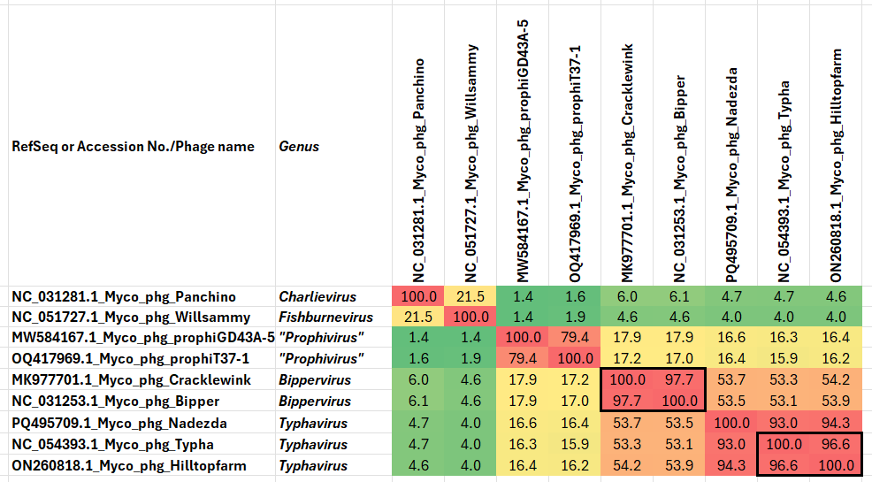

Figure 1. VIRIDIC heatmap of this group of phages. VIRIDIC (Virus Intergenomic Distance Calculator; VIRIDIC (Virus Intergenomic Distance Calculator; [1]; http://rhea.icbm.uni-oldenburg.de/VIRIDIC/) computes pairwise intergenomic distances/similarities amongst phage genomes. Data values which are bordered in black correspond to strains. Abbreviations: phg = phage; Pseu = Pseudomonas. Because this diagram is somewhat difficult to read we have attached the full-sized Excel spread sheet.
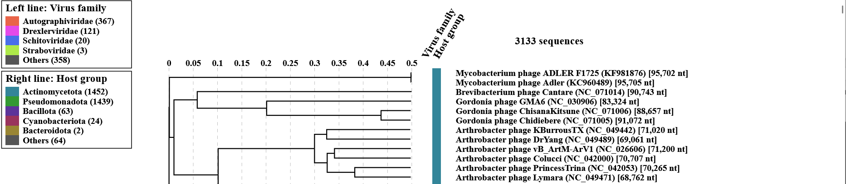

Figure 2. ViPTree analysis: ViPTree analysis (https://www.genome.jp/viptree/; [2]) is based upon Rohwer and Edwards (2002) Phage Proteomic Tree [3]. The taxons under discussion are indicated with red bars and stars. Abbreviations: phg = phage; Myco = Mycobacterium.
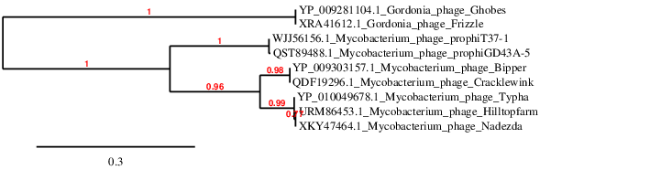Figure 3. Phylogenetic tree constructed with the large subunit terminase proteins from these and related phages using “One Click” Phylogeny.fr [9] at https://www.phylogeny.fr using the TerL proteins from Gordonia phages Gobes and Frizzle as outliers.

Table 1. Characteristics of a new phage which belongs to the genus Typhavirus.

Phage name | Host | Morphotype | Lifestyle | Accession No. | Genome size | %G+C | Genome Termini | No. proteins | No. tRNA (***)
Mycobacterium phage Nadezda (*) | Mycobacterium smegmatis mc(2)155 | Siphovirus | Temperate | PQ495709 | 75356 bp | 66.0 | 12 nt 3' Sticky Overhang (**) | 125 | 2
(*) Unclassified in the Actinobacteriophage Database, isolated in Russia; (**) probable based upon sequence of phage Bipper; (***) Not given in GenBank, determined using https://rna.usegalaxy.eu/

CoreGenes 5.0 analysis [5] revealed that the phages within this proposed subfamily possessed 87 common proteins (74% similar). These included integrase, ParB-like partition protein, portal, major capsid & tail proteins, tail tapemeasure protein, eight minor tail proteins, holin and a queuine biosynthetic operon for tRNA modification.

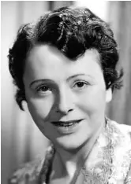
(Figure 5 photograph derived from: https://www.pressreader.com/canada/montreal-gazette/20061126/281719790089416?srsltid=AfmBOooSA_8oNQDyUNZH5VZTPl8u8fiN3e90tYJm8mrzbshWgDyksKwh )
This taxon is named in honour of Dr. Edith Marion Mankiewicz M.SC., D.SC., M.D., C.S.P. Dr. Mankiewicz was born in Leipzig, Germany (1910) and died in Montreal (QC) Canada (2006). A fearless pioneer in microbiology, her area of specialization was in the exploration of pulmonary disease. She twice contracted tuberculosis, yet each time she returned to do further research in its diagnosis and treatment. Her work resulted in crucial contributions to the global eradication of the disease. In 1933, she married Harald (Rene) Mankiewicz, a young judge in Germany at the time. When he sentenced supporters of the Nazi regime to jail, the couple's life was placed in grave danger and they were forced into exile. They received a warm welcome in France where both repeated their studies and graduated with honours. Both were mobilized during the war. Dr. Mankiewicz was appointed director of a hospital for children who had been evacuated to the French countryside. During the German occupation, they were blacklisted and forced to move again - - this time to the French quarter of Shanghai, where Dr. Mankiewicz became a Professor of Medicine at the Université Aurore, and Interim Director of the Pasteur Institute. Dr. Mankiewicz also established a private medical laboratory to provide work opportunities to Jewish physicians who otherwise could not leave their enclave in the outskirts of Shanghai. For her work during the war, she was awarded the Croix de Lorraine by the representative of General Charles de Gaulle. At the end of the war, Dr. Mankiewicz emigrated to Canada with her husband and two young children. At the age of 36, she was forced to start life anew - - re-doing her medical studies to become certified as a doctor in Canada and then rising to become the Director of Laboratories at the Montreal Chest Hospital. Later, she became Director of the Microbiology Laboratory at the Lakeshore General Hospital, where she worked until she was over 80. She also lectured at both McGill University and Université de Montreal and was co-founder of the Association for the Study of Pulmonary Cancer. (quoted from: https://www.legacy.com/ca/obituaries/theglobeandmail/name/edith-mankiewicz-obituary?id=41619276). She developed phage typing schemes for Mycobacterium.

