

The International Committee on Taxonomy of Viruses
Taxonomy Proposal Form, 2026

Part 1a: Details of taxonomy proposals

Title: | Create one new genus, Jinjijuvirus, including one new species in the class Caudoviricetes
Code assigned: | 2026.043B

Author(s), affiliation and email address(es):
Given name (+middle initial(s)) | Surname | Affiliation | Email address | Corr. author(s)
Jinquan | Li | Huazhong Agricultural University, Wuhan, China | lijinquan2017@163.com | X
Yang | Zhou | Huazhong Agricultural University, Wuhan, China | zhouyang@mail.hzau.edu.cn
Geng | Zou | Huazhong Agricultural University, Wuhan, China | zougeng19900918@126.com
Renwei | Wu | Huazhong Agricultural University, Wuhan, China | wurenwei@mail.hzau.edu.cn
Zhechang | Li | Huazhong Agricultural University, Wuhan, China | 1353357093@qq.com
Yating | Guo | Huazhong Agricultural University, Wuhan, China | guoyating0626@126.com

Part 1b: Taxonomy Proposal Submission
ICTV Subcommittee:
Animal DNA Viruses and Retroviruses |  | Bacterial viruses | X
Animal minus-strand and dsRNA viruses |  | Fungal and protist viruses
Animal positive-strand RNA viruses |  | Plant viruses
Archaeal viruses |  | General -

List the ICTV Study Group(s) that have seen or have been involved in creating this proposal:
Caudoviricetes Study Group
Optional – complete only if formally voted on by an ICTV Study Group:
Study Group | Number of members
Study Group | Votes in support | Votes against | No vote

Submission date: | 25/05/2026

Part 1c: Feedback from ICTV Executive Committee (EC) meeting
Executive Committee Meeting Decision code: | X
A – Accept
Ac – Accept subject to revision by relevant subcommittee chair. No further vote required
U – Accept without revision but with re-evaluation and email vote by the EC
Uc – Accept subject to revision and re-evaluation and email vote by the EC
Ud – Deferred to the next EC meeting, with an invitation to revise based on EC comments
J - Reject
W - Withdrawn

Comments from the Executive Committee:

Part 1d: Revised Taxonomy Proposal Submission
Response of proposer:
Revision date:

Part 3: TAXONOMIC PROPOSAL
https://ictv.global/taxonomy/templates
Taxonomic changes proposed:
Establish new taxon | X | Split taxon
Abolish taxon |  | Merge taxon
Move taxon |  | Promote taxon
Rename taxon |  | Demote taxon
Move and rename

Etymology (origin) of proposed taxonomic names:
Taxon name | Etymology of the term
Jinjijuvirus | This genus is named after Coreopsis grandiflora, an ornamental flower belonging to the Asteraceae family. Coreopsis grandiflora is known in Chinese as Dahua Jinjiju (大花金鸡菊).

Permission for use of names derived from a living person:
Taxon name | Full name of person from whom the name is derived | Attached

Abstract of Taxonomy Proposal:
Description of current taxonomy:
The bacterial viruses described in this proposal are currently unclassified

Proposed taxonomic change(s):
We propose the creation of a new genus “Jinjijuvirus” with a single species

Justification:
We isolated a new Listeria phage LPLM20. Based on whole genome analysis of VIRIDIC and ViPTree, LPLM20 was sufficiently different to warrent the proposal of a new genus under the current demarcation criteria. Thus, we propose to create a new genus “Jinjijuvirus”, containing one new species, “Jinjijuvirus LPLM20”.

- Text of Taxonomy proposal:

Description of current taxonomy:
The bacterial viruses described in this proposal are currently unclassified

Proposed taxonomic change(s):
We propose the creation of a new genus “Jinjijuvirus” with one new species

Demarcation criteria:
Species demarcation criteria: Two phages are assigned to the same species if their genomes are more than 95% identical over their genome length for isolates. These values can be calculated by a number of tools, such as BLASTn – usually calculated using intergenomic distance calculator VIRIDIC [1].
Genus demarcation criteria: The Bacterial Viruses Subcommittee has established 70% nucleotide identity of the genome length as the cut-off for genera. Genus-level groupings should always be monophyletic in the signature genes, as tested with a phylogenetic tree. [2]

Justification:
A TBLASTX distance tree of Listeria phage LPLM20 was constructed using VIPTree [3-4] (Figure 1). LPLM20, along with 14 other Listeria phages in the class Caudoviricetes formed a deep branching clade. These genomes were subsequently selected for VIRIDIC analysis. VIRIDIC analysis computed the pairwise genomic similarities between the phage genomes, revealing significant divergence between LPLM20 from the phages of other genera, with nucleotide similarity below 70% (Figure 2). Furthermore, a maximum-likelihood (ML) tree was constructed using the terminase large subunit of the 20 phages, with 1000 bootstrap replicates [5-6] (Figure 3). In summary, these data support the proposal of a new genus, “Jinjijuvirus”, containing one new species, “Jinjijuvirus LPLM20”.

References:
- Moraru C, Varsani A, Kropinski AM (2020) VIRIDIC-A Novel Tool to Calculate the Intergenomic Similarities of Prokaryote-Infecting Viruses. Viruses 12(11):1268. PMID: 33172115 / PMCID: PMC7694805 doi: 10.3390/v12111268.
- Turner D, Kropinski AM, Adriaenssens EM (2021) A Roadmap for Genome-Based Phage Taxonomy. Viruses 13(3):506. PMID: 33803862 / PMCID: PMC8003253 doi: 10.3390/v13030506.
- Nishimura Y, Yoshida T, Kuronishi M et al (2017) ViPTree: the viral proteomic tree server. Bioinformatics 33(15):2379-2380. PMID: 28379287. doi: 10.1093/bioinformatics/btx157.
- Rohwer F, Edwards R (2002) The Phage Proteomic Tree: a genome-based taxonomy for phage. J Bacteriol 184(16):4529-35. PMID: 12142423 / PMCID: PMC135240. doi: 10.1128/jb.184.16.4529-4535.2002.
- Nishijima S, Nagata N, Kiguchi Y et al (2022) Extensive gut virome variation and its associations with host and environmental factors in a population-level cohort. Nat Commun 13(1):5252. PMID: 36068216 / PMCID: PMC9448778 doi: 10.1038/s41467-022-32832-w
- L. Nguyen, H.A. Schmidt, A. von Haeseler, B.Q. Minh (2015) IQ-TREE: A Fast and Effective Stochastic Algorithm for Estimating Maximum-Likelihood Phylogenies. Mol. Biol. and Evol., 32:268-274.

Accompanying files:
Filename | Description of contents

Tables, Figures:
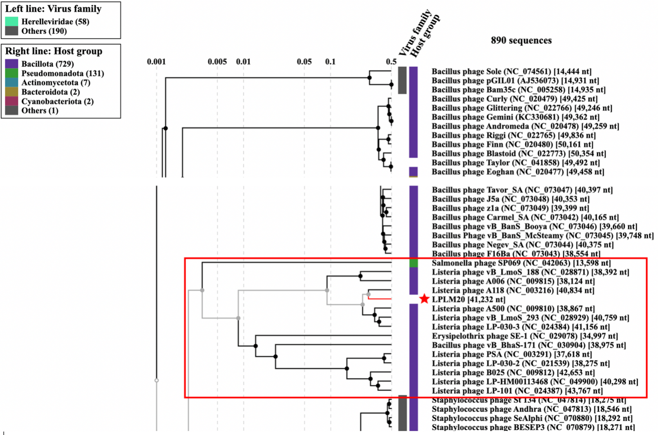
<Start here>
Figure 1. ViPTree analysis: ViPTree analysis (https://www.genome.jp/viptree/; [3]) is based upon Rohwer and Edwards (2002) famous Phage Proteomic Tree [4]. The phages of interest are indicated with red box and LPLM20 by a red star.

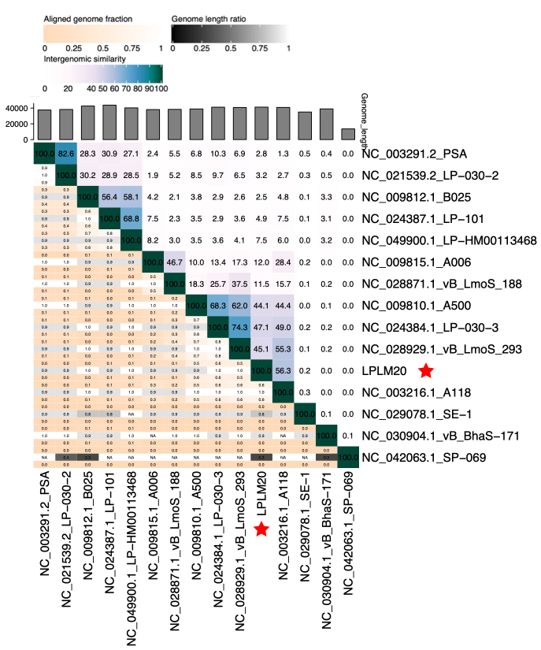
Figure 2. VIRIDIC heat map: VIRIDIC (Virus Intergenomic Distance Calculator [1]; http://rhea.icbm.uni-oldenburg.de/VIRIDIC/) computes pairwise intergenomic distances/similarities amongst phage genomes.

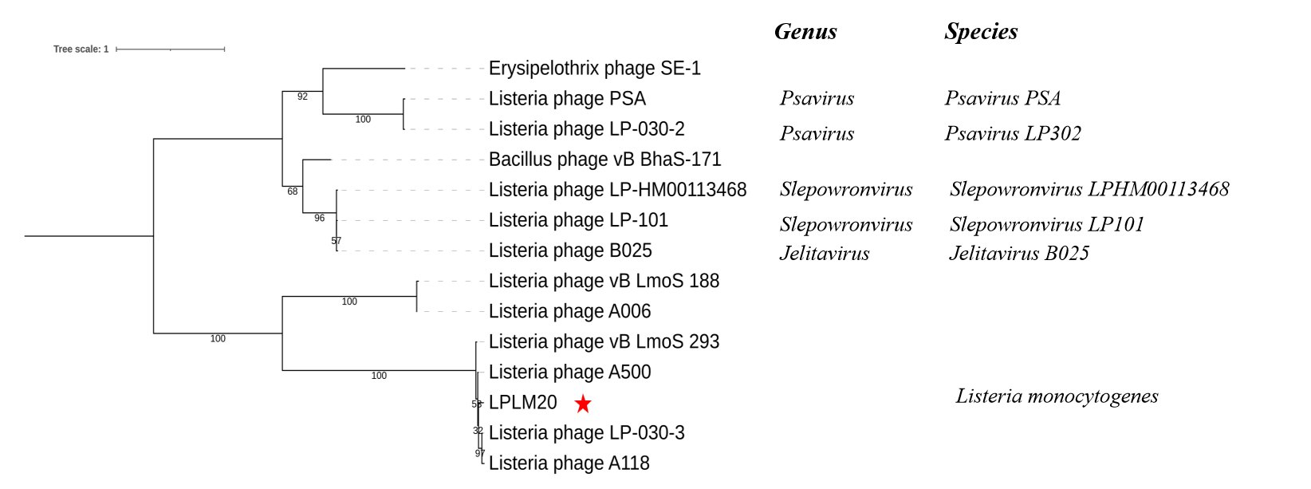Figure 3. Phylogeny: The phylogenetic tree was constructed using the major head protein of phages. Clustal Omega was used for multiple alignment and IQ-TREE was used for inferring the phylogenetic tree using the maximum-likelihood method with 1000 bootstrap replicates. The tree is rooted at the mid-point.

Origin of the name of this taxon: Origin of the name of this taxon: This genus is named after Coreopsis grandiflora, an ornamental flower belonging to the Asteraceae family. Coreopsis grandiflora is known in Chinese as Dahua Jinjiju (大花金鸡菊), which translates directly to "large-flowered Coreopsis”.

Historical aspects: Listeria phage LPLM20 was isolated in 2024 by Chaozhou, using Listeria monocytogenes as the host bacterium.

Genome summary:

Phage name | INSDC | Size (Kb) | GC% | Protein | tRNA
Listeria phage LPLM20 | PP895302 | 41,232 | 36.6 | 67 | 0

