

The International Committee on Taxonomy of Viruses
Taxonomy Proposal Form, 2026

Part 1a: Details of taxonomy proposals

Title: | To create a new subfamily of Curtobacterium phages, Komagatavirinae with two new genera in the class Caudoviricetes
Code assigned: | 2026.041B

Author(s), affiliation and email address(es):
Given name (+middle initial(s)) | Surname | Affiliation | Email address | Corr. author(s)
Ipek | Kurtböke | Environmental Microbiology, University of the Sunshine Coast,  School of Science, Technology and Engineering,  Maroochydore DC, Australia | IKurtbok@usc.edu.au
Cristina M. | Moraru | Department of Chemistry, Environmental Metagenomics,  University of Duisburg-Essen,  D-45141 Essen,  Germany | lilianacristina.moraru@uni-due.de
Andrew M. | Kropinski | University of Guelph, Guelph, Ontario, Canada N1G2W1 | Phage.Canada@gmail.com | x

Part 1b: Taxonomy Proposal Submission
ICTV Subcommittee:
Animal DNA Viruses and Retroviruses |  | Bacterial viruses | x
Animal minus-strand and dsRNA viruses |  | Fungal and protist viruses
Animal positive-strand RNA viruses |  | Plant viruses
Archaeal viruses |  | General -

List the ICTV Study Group(s) that have seen or have been involved in creating this proposal:
Actinophages

Optional – complete only if formally voted on by an ICTV Study Group:
Study Group | Number of members
Study Group | Votes in support | Votes against | No vote

Submission date: | March 22, 2026

Part 1c: Feedback from ICTV Executive Committee (EC) meeting
Executive Committee Meeting Decision code: | X
A – Accept
Ac – Accept subject to revision by relevant subcommittee chair. No further vote required
U – Accept without revision but with re-evaluation and email vote by the EC
Uc – Accept subject to revision and re-evaluation and email vote by the EC
Ud – Deferred to the next EC meeting, with an invitation to revise based on EC comments
J - Reject
W - Withdrawn

Comments from the Executive Committee:

Part 1d: Revised Taxonomy Proposal Submission
Response of proposer:
Revision date:

Part 3: TAXONOMIC PROPOSAL

Taxonomic changes proposed:
Establish new taxon | x | Split taxon
Abolish taxon |  | Merge taxon
Move taxon |  | Promote taxon
Rename taxon |  | Demote taxon
Move and rename

Etymology (origin) of proposed taxonomic names:
Taxon name | Etymology of the term
Komagatavirinae | Named in honour of Professor Kazuo Komagata (†)
Addirosevirus | Named after Curtobacterium phage AddiRose
Joylinvirus | Named after Curtobacterium phage JoyLin

Permission for use of names derived from a living person:
Taxon name | Full name of person from whom the name is derived | Attached

Abstract of Taxonomy Proposal:

Description of current taxonomy:
None of these phages have been classified by the ICTV. They are assigned to cluster JA in the Actinobacteriophage Database

Proposed taxonomic change(s):
We propose to create a new subfamily named “Komagatavirinae” containing the following new genera: “Addirosevirus” and “Joylinvirus”

Demarcation criteria for new taxon/taxa:
Subfamily demarcation criteria: Subfamilies are to be created when two or more genera are related below the family level. In practical terms, this usually means that they share a low degree of sequence similarity (usually about 40-50%) and that the genera form a clade in a marker tree phylogeny.

Genus demarcation criteria: An intergenomic similarity cut-off of 70%, a combination of average nucleotide identity and alignment fraction, is used to determine genera demarcation. Members of the same genus have >70% intergenomic similarity and cluster tightly in marker gene phylogenies.

Species demarcation criteria: A demarcation value of 95% intergenomic similarity was used to define different species according to intergenomic similarity. Members of the same genus have >95% intergenomic similarity.

Justification:
These bacteriophages exhibit a lytic lifecycle and infect members of the genus Curtobacterium. Whole genome comparison of intergenomic nucleotide sequence similarity indicates that these bacteriophages form two new genera and four new species. Each of the genera exhibit >38% intergenomic similarity, supporting the creation of a new subfamily. These assignments are also supported by the TBLASTX distance tree and phylogenetic analysis of the large terminase subunit. The representative genomes share 58% of proteins in common. Collectively the evidence supports the proposal of a new subfamily which we have named “Komagatavirinae” and two new genera “Addirosevirus” and “Joylinvirus”.

Text of Taxonomy proposal:
Description of current taxonomy:
None of these phages have been classified by the ICTV. They are assigned to cluster JA in the Actinobacteriophage Database

Proposed taxonomic change(s):
We propose to create a new subfamily named “Komagatavirinae” containing the following new genera: “Addirosevirus” and “Joylinvirus”

Demarcation criteria for new taxon/taxa:
Subfamily demarcation criteria: Subfamilies are to be created when two or more genera are related below the family level. In practical terms, this usually means that they share a low degree of sequence similarity (usually about 40-50%) and that the genera form a clade in a marker tree phylogeny.

Genus demarcation criteria: An intergenomic similarity cut-off of 70%, a combination of average nucleotide identity and alignment fraction, is used to determine genera demarcation. Members of the same genus have >70% intergenomic similarity and cluster tightly in marker gene phylogenies.

Species demarcation criteria: A demarcation value of 95% intergenomic similarity was used to define different species according to intergenomic similarity. Members of the same genus have >95% intergenomic similarity.

Justification:
These bacteriophages exhibit a lytic lifecycle and infect members of the genus Curtobacterium. Whole genome comparison of intergenomic nucleotide sequence similarity (Figure 1) [1] indicates that these bacteriophages form two new genera and four new species. Each of the genera exhibit >38% intergenomic similarity, supporting the creation of a new subfamily. These assignments are also supported by the TBLASTX distance tree (Figure 2) [2.3] and phylogenetic analysis of the large terminase subunit (Figure 3) [9]. The representative genomes share 58% of proteins in common. Collectively, the evidence supports the proposal of a new subfamily which we have named “Komagatavirinae” and two new genera “Addirosevirus” and “Joylinvirus”.

References:
1. Moraru C, Varsani A, Kropinski AM. VIRIDIC-A Novel Tool to Calculate the Intergenomic Similarities of Prokaryote-Infecting Viruses. Viruses. 2020 Nov 6;12(11):1268. doi: 10.3390/v12111268. PMID: 33172115; PMCID: PMC7694805. http://kronos.icbm.uni-oldenburg.de/viridic/
2. Nishimura Y, Yoshida T, Kuronishi M, Uehara H, Ogata H, Goto S. ViPTree: the viral proteomic tree server. Bioinformatics. 2017; 33(15):2379-2380. doi:10.1093/bioinformatics/btx157. PubMed PMID: 28379287. https://www.genome.jp/viptree/
3. Rohwer F, Edwards R. The Phage Proteomic Tree: a genome-based taxonomy for phage. J Bacteriol. 2002 Aug;184(16):4529-35. PubMed PMID: 12142423
4. Turner D, Reynolds D, Seto D, Mahadevan P. CoreGenes3.5: a webserver for the determination of core genes from sets of viral and small bacterial genomes. BMC Res Notes. 2013;6:140. doi: 10.1186/1756-0500-6-140. PMID: 23566564.
5. Davis P, Seto D, Mahadevan P. CoreGenes5.0: An Updated User-Friendly Webserver for the Determination of Core Genes from Sets of Viral and Bacterial Genomes. Viruses. 2022 Nov 16;14(11):2534. doi: 10.3390/v14112534. PMID: 36423143; PMCID: PMC9693508.
6. Turner D, Kropinski AM, Adriaenssens EM. A Roadmap for Genome-Based Phage Taxonomy. Viruses. 2021 Mar 18;13(3):506. doi: 10.3390/v13030506. PMID: 33803862; PMCID: PMC8003253.
Lemoine F, Correia D, Lefort V, Doppelt-Azeroual O, Mareuil F, Cohen-Boulakia S, Gascuel O. NGPhylogeny.fr: new generation phylogenetic services for non-specialists. Nucleic Acids Res. 2019 Jul 2;47(W1):W260-W265. doi: 10.1093/nar/gkz303. PMID: 31028399; PMCID: PMC6602494.
7. Letunic I, Bork P. Interactive Tree Of Life (iTOL): an online tool for phylogenetic tree display and annotation. Bioinformatics. 2007 Jan 1;23(1):127-8. doi: 10.1093/bioinformatics/btl529. Epub 2006 Oct 18. PMID: 17050570.
8. Zhou T, Xu K, Zhao F, Liu W, Li L, Hua Z, Zhou X. itol.toolkit accelerates working with iTOL (Interactive Tree of Life) by an automated generation of annotation files. Bioinformatics. 2023 Jun 1;39(6):btad339. doi: 10.1093/bioinformatics/btad339. PMID: 37225402; PMCID: PMC10243930
9. Dereeper A, Guignon V, Blanc G, Audic S, Buffet S, Chevenet F, Dufayard JF, Guindon S, Lefort V, Lescot M, Claverie JM, Gascuel O. Phylogeny.fr: robust phylogenetic analysis for the non-specialist. Nucleic Acids Res. 2008 Jul 1;36(Web Server issue):W465-9. doi: 10.1093/nar/gkn180. Epub 2008 Apr 19. PMID: 18424797; PMCID: PMC2447785.

Accompanying files:
Filename | Description of contents

Tables, Figures:

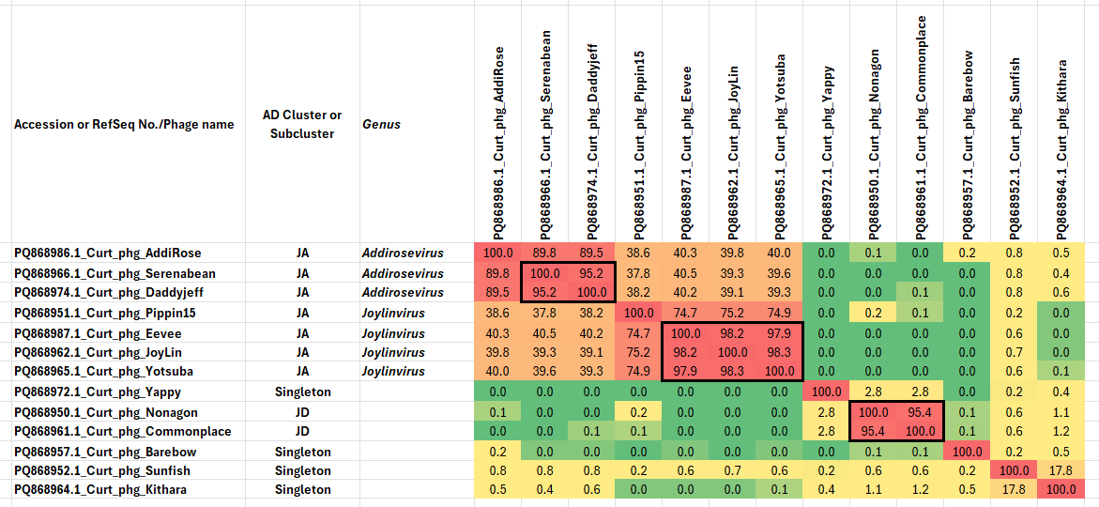

Figure 1. VIRIDIC heatmap of this group of phages. VIRIDIC (Virus Intergenomic Distance Calculator; VIRIDIC (Virus Intergenomic Distance Calculator; [1]; http://rhea.icbm.uni-oldenburg.de/VIRIDIC/) computes pairwise intergenomic distances/similarities amongst phage genomes. Data values which are bordered in black correspond to strains. Abbreviations: phg = phage; Curt = Curtobacterium.

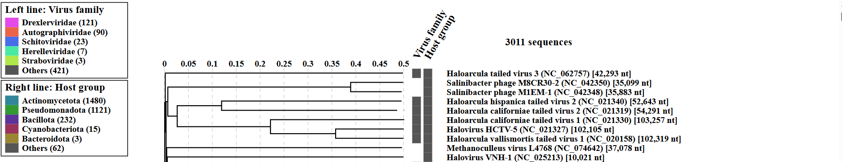
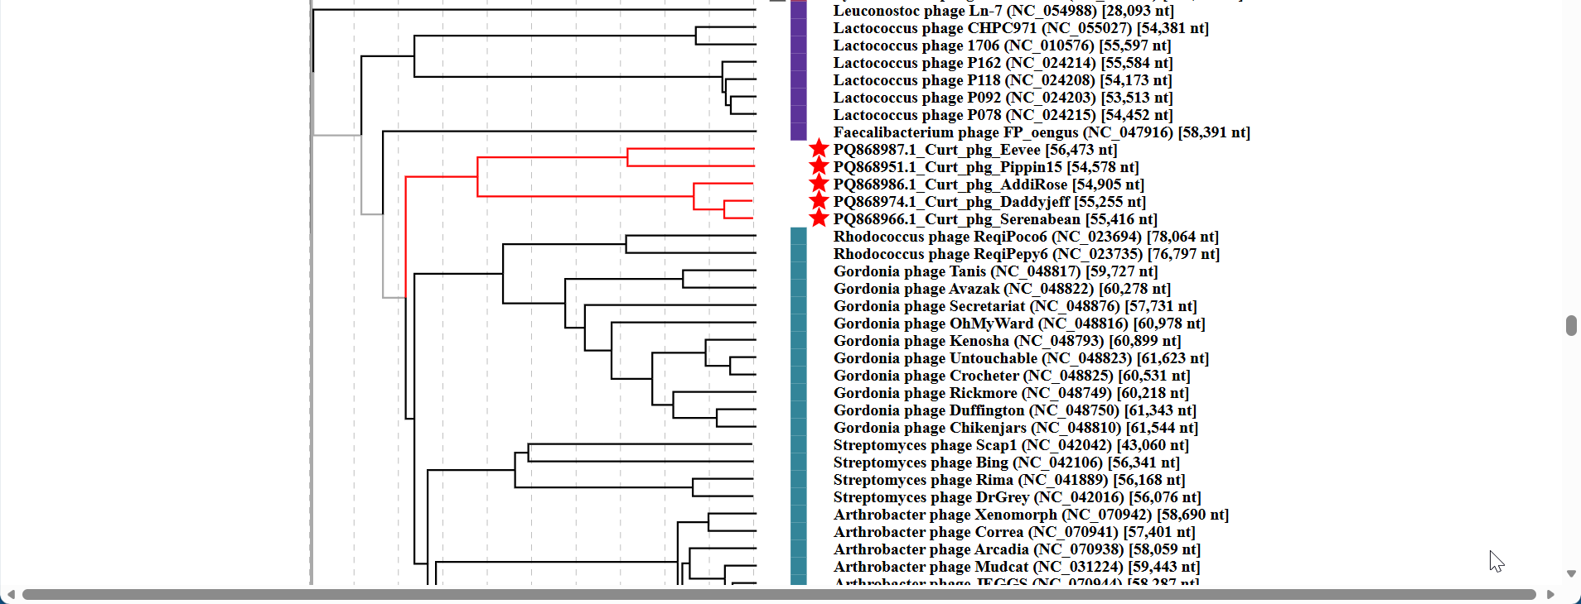
Figure 2. ViPTree analysis: ViPTree analysis (https://www.genome.jp/viptree/; [2]) is based upon Rohwer and Edwards (2002) Phage Proteomic Tree [3]. The taxons under discussion are indicated with red bars and stars. Abbreviations: phg = phage; Curt = Curtobacterium

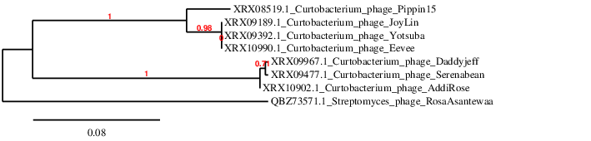Figure 3. Phylogenetic tree constructed with the large subunit terminase proteins from these and related phages using “One Click” Phylogeny.fr [9] at https://www.phylogeny.fr using the TerL protein from Streptomyces phage RosaAsantewaa as an outlier.
Table 1. Characteristics of the two phages in the genus Addirosevirus.

Phage name | Host | Morphotype | Lifestyle | Accession No. | Genome size | %G+C | 3’ overhang | No. proteins | No. tRNA
Curtobacterium phage AddiRose | Curtobacterium flaccumfaciens NRRL B-729 SEA | Siphovirus | Lytic | PQ868986 | 54905 bp | 60.4 | CGCCCGCCT | 88 | 0
Curtobacterium phage Daddyjeff | Curtobacterium flaccumfaciens NRRL B-729 SEA | Siphovirus | Lytic | PQ868974 | 55255 bp | 60.2 | CGCCCGCCT | 90 | 0

Table 2. Characteristics of the two phages in the genus Joylinvirus.

Phage name | Host | Morphotype | Lifestyle | Accession No. | Genome size | %G+C | 3’ overhang | No. proteins | No. tRNA
Curtobacterium phage JoyLin | Curtobacterium flaccumfaciens NRRL B-729 SEA | Siphovirus | Lytic | PQ868962 | 57226 bp | 59.4 | CGCCCAGCC | 85 | 0
Curtobacterium phage Pippin15 | Curtobacterium flaccumfaciens NRRL B-729 SEA | Siphovirus | Lytic | PQ868951 | 54578  bp | 58.8 | CGCCCAGCC | 89 | 0

Table 2. CoreGenes 5.0 [5] revealed 51 homologs shared between these four phages.
Curtobacterium phage AddiRose | Curtobacterium phage Daddyjeff | Curtobacterium phage JoyLin | Curtobacterium phage Pippin15
PQ868986 | PQ868974 | PQ868962 | PQ868951
PI:XRX10893.1 | PI:XRX09958.1 | PI:XRX09179.1 | PI:XRX08596.1
Product:membrane protein | Product:membrane protein | Product:membrane protein | Product:membrane protein
PI:XRX10894.1 | PI:XRX09959.1 | PI:XRX09180.1 | PI:XRX08511.1
Product:hypothetical protein | Product:hypothetical protein | Product:hypothetical protein | Product:hypothetical protein
PI:XRX10895.1 | PI:XRX09960.1 | PI:XRX09181.1 | PI:XRX08512.1
Product:membrane protein | Product:membrane protein | Product:membrane protein | Product:membrane protein
PI:XRX10896.1 | PI:XRX09961.1 | PI:XRX09182.1 | PI:XRX08513.1
Product:hypothetical protein | Product:hypothetical protein | Product:hypothetical protein | Product:hypothetical protein
PI:XRX10897.1 | PI:XRX09962.1 | PI:XRX09183.1 | PI:XRX08514.1
Product:HNH endonuclease | Product:HNH endonuclease | Product:HNH endonuclease | Product:HNH endonuclease
PI:XRX10898.1 | PI:XRX09963.1 | PI:XRX09184.1 | PI:XRX08515.1
Product:hypothetical protein | Product:hypothetical protein | Product:hypothetical protein | Product:hypothetical protein
PI:XRX10899.1 | PI:XRX09964.1 | PI:XRX09185.1 | PI:XRX08516.1
Product:hypothetical protein | Product:hypothetical protein | Product:hypothetical protein | Product:hypothetical protein
Product:minor tail protein | Product:minor tail protein | Product:minor tail protein | Product:minor tail protein
PI:XRX10901.1 | PI:XRX09966.1 | PI:XRX09188.1 | PI:XRX08518.1
Product:hypothetical protein | Product:hypothetical protein | Product:hypothetical protein | Product:hypothetical protein
PI:XRX10902.1 | PI:XRX09967.1 | PI:XRX09189.1 | PI:XRX08519.1
Product:terminase | Product:terminase | Product:terminase | Product:terminase
PI:XRX10905.1 | PI:XRX09970.1 | PI:XRX09193.1 | PI:XRX08523.1
Product:portal protein | Product:portal protein | Product:portal protein | Product:portal protein
PI:XRX10906.1 | PI:XRX09971.1 | PI:XRX09194.1 | PI:XRX08524.1
Product:hypothetical protein | Product:hypothetical protein | Product:hypothetical protein | Product:hypothetical protein
PI:XRX10907.1 | PI:XRX09972.1 | PI:XRX09195.1 | PI:XRX08525.1
Product:major capsid protein and protease fusion | Product:major capsid and protease fusion protein | Product:major capsid and protease fusion protein | Product:major capsid and protease fusion protein
PI:XRX10970.1 | PI:XRX10045.1 | PI:XRX09196.1 | PI:XRX08526.1
Product:hypothetical protein | Product:hypothetical protein | Product:hypothetical protein | Product:hypothetical protein
PI:XRX10908.1 | PI:XRX09973.1 | PI:XRX09197.1 | PI:XRX08527.1
Product:tail terminator | Product:tail terminator | Product:tail terminator | Product:tail terminator
PI:XRX10909.1 | PI:XRX09974.1 | PI:XRX09198.1 | PI:XRX08528.1
Product:major tail protein | Product:major tail protein | Product:major tail protein | Product:major tail protein
PI:XRX10910.1 | PI:XRX09975.1 | PI:XRX09199.1 | PI:XRX08529.1
Product:hypothetical protein | Product:hypothetical protein | Product:hypothetical protein | Product:hypothetical protein
PI:XRX10911.1 | PI:XRX09976.1 | PI:XRX09200.1 | PI:XRX08530.1
Product:major tail protein | Product:major tail protein | Product:major tail protein | Product:major tail protein
PI:XRX10912.1 | PI:XRX09977.1 | PI:XRX09201.1 | PI:XRX08531.1
Product:minor tail protein | Product:minor tail protein | Product:minor tail protein | Product:minor tail protein
Product:hypothetical protein | Product:hypothetical protein | Product:hypothetical protein | Product:hypothetical protein
PI:XRX10914.1 | PI:XRX09979.1 | PI:XRX09203.1 | PI:XRX08533.1
Product:tape measure protein | Product:tape measure protein | Product:tape measure protein | Product:tape measure protein
PI:XRX10915.1 | PI:XRX09980.1 | PI:XRX09204.1 | PI:XRX08534.1
Product:minor tail protein | Product:minor tail protein | Product:minor tail protein | Product:minor tail protein
PI:XRX10916.1 | PI:XRX09981.1 | PI:XRX09205.1 | PI:XRX08535.1
Product:minor tail protein | Product:minor tail protein | Product:minor tail protein | Product:minor tail protein
PI:XRX10917.1 | PI:XRX09982.1 | PI:XRX09206.1 | PI:XRX08536.1
Product:holin | Product:holin | Product:holin | Product:holin
PI:XRX10918.1 | PI:XRX09983.1 | PI:XRX09207.1 | PI:XRX08537.1
Product:hypothetical protein | Product:hypothetical protein | Product:hypothetical protein | Product:hypothetical protein
PI:XRX10922.1 | PI:XRX09988.1 | PI:XRX09211.1 | PI:XRX08538.1
Product:hypothetical protein | Product:hypothetical protein | Product:hypothetical protein | Product:hypothetical protein
PI:XRX10926.1 | PI:XRX09992.1 | PI:XRX09215.1 | PI:XRX08545.1
Product:hypothetical protein | Product:hypothetical protein | Product:hypothetical protein | Product:hypothetical protein
PI:XRX10928.1 | PI:XRX09994.1 | PI:XRX09217.1 | PI:XRX08547.1
Product:hypothetical protein | Product:hypothetical protein | Product:membrane protein | Product:membrane protein
PI:XRX10929.1 | PI:XRX09995.1 | PI:XRX09220.1 | PI:XRX08550.1
Product:hypothetical protein | Product:hypothetical protein | Product:hypothetical protein | Product:hypothetical protein
PI:XRX10930.1 | PI:XRX09996.1 | PI:XRX09221.1 | PI:XRX08552.1
Product:hypothetical protein | Product:hypothetical protein | Product:hypothetical protein | Product:hypothetical protein
PI:XRX10934.1 | PI:XRX10000.1 | PI:XRX09261.1 | PI:XRX08554.1
Product:hypothetical protein | Product:hypothetical protein | Product:hypothetical protein | Product:hypothetical protein
PI:XRX10935.1 | PI:XRX10001.1 | PI:XRX09223.1 | PI:XRX08555.1
Product:hypothetical protein | Product:hypothetical protein | Product:hypothetical protein | Product:hypothetical protein
PI:XRX10938.1 | PI:XRX10004.1 | PI:XRX09224.1 | PI:XRX08558.1
Product:hypothetical protein | Product:hypothetical protein | Product:hypothetical protein | Product:hypothetical protein
PI:XRX10940.1 | PI:XRX10006.1 | PI:XRX09226.1 | PI:XRX08560.1
Product:NrdH-like glutaredoxin | Product:NrdH-like glutaredoxin | Product:NrdH-like glutaredoxin | Product:NrdH-like glutaredoxin
PI:XRX10942.1 | PI:XRX10008.1 | PI:XRX09228.1 | PI:XRX08562.1
Product:hypothetical protein | Product:hypothetical protein | Product:hypothetical protein | Product:hypothetical protein
PI:XRX10943.1 | PI:XRX10009.1 | PI:XRX09229.1 | PI:XRX08563.1
Product:hypothetical protein | Product:hypothetical protein | Product:hypothetical protein | Product:hypothetical protein
PI:XRX10944.1 | PI:XRX10010.1 | PI:XRX09230.1 | PI:XRX08564.1
Product:DNA primase/polymerase | Product:DNA primase/polymerase | Product:DNA primase/polymerase | Product:DNA primase/polymerase
PI:XRX10945.1 | PI:XRX10011.1 | PI:XRX09232.1 | PI:XRX08566.1
Product:hypothetical protein | Product:hypothetical protein | Product:hypothetical protein | Product:hypothetical protein
PI:XRX10946.1 | PI:XRX10012.1 | PI:XRX09234.1 | PI:XRX08567.1
Product:SSB protein | Product:SSB protein | Product:SSB protein | Product:SSB protein
Product:cyclic nucleotide sequestering protein | Product:cyclic nucleotide sequestering protein | Product:cyclic nucleotide sequestering protein | Product:cyclic nucleotide sequestering protein
PI:XRX10950.1 | PI:XRX10016.1 | PI:XRX09237.1 | PI:XRX08571.1
Product:nicotinate ribosyltransferase | Product:nicotinate ribosyltransferase | Product:nicotinate ribosyltransferase | Product:nicotinate ribosyltransferase
PI:XRX10951.1 | PI:XRX10017.1 | PI:XRX09238.1 | PI:XRX08572.1
Product:hypothetical protein | Product:hypothetical protein | Product:hypothetical protein | Product:hypothetical protein
Product:DNA binding protein | Product:DNA binding protein | Product:helix-turn-helix DNA binding domain protein | Product:helix-turn-helix DNA binding protein
PI:XRX10955.1 | PI:XRX10023.1 | PI:XRX09243.1 | PI:XRX08577.1
Product:hypothetical protein | Product:hypothetical protein | Product:hypothetical protein | Product:hypothetical protein
PI:XRX10973.1 | PI:XRX10028.1 | PI:XRX09251.1 | PI:XRX08584.1
Product:DNA helicase | Product:DNA helicase | Product:DNA helicase | Product:DNA helicase
PI:XRX10958.1 | PI:XRX10029.1 | PI:XRX09255.1 | PI:XRX08590.1
Product:hypothetical protein | Product:hypothetical protein | Product:hypothetical protein | Product:hypothetical protein
PI:XRX10965.1 | PI:XRX10038.1 | PI:XRX09256.1 | PI:XRX08591.1
Product:HNH endonuclease | Product:HNH endonuclease | Product:HNH endonuclease | Product:HNH endonuclease
PI:XRX10966.1 | PI:XRX10039.1 | PI:XRX09257.1 | PI:XRX08592.1
Product:VRR-Nuc domain protein | Product:VRR-Nuc domain protein | Product:VRR-Nuc domain protein | Product:VRR-Nuc domain protein
PI:XRX10967.1 | PI:XRX10040.1 | PI:XRX09258.1 | PI:XRX08593.1
Product:Cas4 exonuclease | Product:Cas4 family exonuclease | Product:Cas4 family endonuclease | Product:Cas4 family exonuclease
PI:XRX10968.1 | PI:XRX10041.1 | PI:XRX09259.1 | PI:XRX08594.1
Product:helix-turn-helix DNA binding domain protein | Product:helix-turn-helix DNA binding domain protein | Product:helix-turn-helix DNA-binding domain protein | Product:helix-turn-helix DNA-binding domain protein
PI:XRX10969.1 | PI:XRX10042.1 | PI:XRX09260.1 | PI:XRX08595.1
Product:hypothetical protein | Product:hypothetical protein | Product:hypothetical protein | Product:hypothetical protein

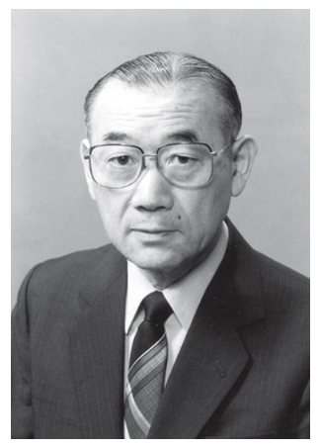

This taxon is named in honour of Professor Kazuo Komagata was born in 1928 (Urasa, Niigata Prefecture, Japan; d. 2022). “His father was a physician, and his mother was a nurse. During World War II, in 1945, he entered the Department of Agricultural Chemistry, Morioka College of Agriculture and Forestry. After graduation in 1948, he became a research student in the Laboratory of Fermentation, Faculty of Agriculture, the University of Tokyo.
In 1954, he moved to the Institute of Applied Microbiology (IAM), at the University of Tokyo. He worked at the taxonomy and preservation laboratory headed by Prof. Hiroshi Iizuka. During the studies on bacteria in rice, microorganisms in petroleum and natural gas fields in Japan, he isolated a large number of bacteria, including pseudomonads and actinobacteria, but the taxonomy at that time could not give taxonomic positions to them clearly. Consequently, this experience raised his interest in bacterial systematics.

In 1960, he moved to the Central Research Laboratories of Ajinomoto, a pioneer manufacturer of sodium glutamate. He was asked to establish a laboratory of microbial systematics because the company recognized the importance of microorganisms
for future development and patent strategy. During work for the company, he proposed new taxonomy of coryneform bacteria, including glutamic acid producers, by introducing chemotaxonomy. He received his PhD in 1960 from the University of Tokyo for taxonomic study of the genus Pseudomonas.

In 1968, he returned to his home laboratory at the IAM, the University of Tokyo as an associate professor. He began to educate and train students and fellows and initiated the study of microbial systematics. He focused on chemosystematics, such as the cellular fatty acid composition, quinone systems, DNA base composition and DNA–DNA relatedness. He was promoted to Professor in 1978, retired in 1989 from the University of Tokyo at the official retirement age, and became Emeritus Professor in 1989.

In 1981, Prof. Komagata was appointed Director of the newly established culture collection, Japan Collection of Microorganisms (JCM), RIKEN (formerly the Institute of Physical and Chemical Research), and served concurrently as professor for IAM, the
University of Tokyo. Prof. Komagata’s task was to build up the foundation and development of a ‘research-oriented’ culture collection. JCM has grown into one of the leading culture collections in the world. K. S. worked at JCM under Prof. Komagata’s
directorship for enrichment of microbial resources of JCM and taxonomic studied of bacteria.

In recognition of his contributions as mentioned above, he became an Honorary Member of Society for Bioscience and Bioengineering, Japan in 1988, an Honorary Member of WFCC in 1990, a Life Member of ICSB (at present the International Committee on
Systematics Prokaryotes: ICSP) in 1994, and a Life Member of the Japan Society for Bioscience, Biotechnology and Agrochemistry in 1998. He received an award from the Food Hygienic Society in Japan for microbial studies on frozen food in 1968, the Senior
Scientist Award from the Japan Society for Bioscience, Biotechnology and Agrochemistry in 1988, the Van Niel International Prize from the Division of Bacteriology and Applied Microbiology, IUMS in 1999, and the Bergey Medal from the Bergey’s Manual
Trust in 2005. In addition, the Japan Academy awarded Prof. Komagata the Duke of Edinburgh Prize for ‘Studies on microbial taxonomy and development of microbial culture collections’ in 2014.”

(derived from: In memoriam – Kazuo Komagata (1928 – 2022) by Mitsuo Sakamoto and Ken-ichiro Suzuki. 2023. Int. J. Syst. Evol. Microbiol. 2023;73:005791
DOI 10.1099/ijsem.0.005791, including photograph.

