

The International Committee on Taxonomy of Viruses
Taxonomy Proposal Form, 2026

Part 1a: Details of taxonomy proposals

Title: | Create a new genus Jinquanvirus including four new species in the class Caudoviricetes
Code assigned: | 2026.038B

Author(s), affiliation and email address(es):
Given name (+middle initial(s)) | Surname | Affiliation | Email address | Corr. author(s)
Jinquan | Li | Huazhong Agricultural University, Wuhan, China | lijinquan2017@163.com | X
Shan | Wang | Huazhong Agricultural University, Wuhan, China | shine_w@live.cn
Yang | ZHOU | Huazhong Agricultural University, Wuhan, China | zhouyang@mail.hzau.edu.cn
Zhiyong | SONG | Huazhong Agricultural University, Wuhan, China | songzhiyong@mail.hzau.edu.cn
Renwei | Wu | Huazhong Agricultural University, Wuhan, China | wurenwei@mail.hzau.edu.cn
Yongxin | LUO | Huazhong Agricultural University, Wuhan, China | l18539043686@163.com
Jiayi | OU | Huazhong Agricultural University, Wuhan, China | oujiayi1025@163.com
Qing | Li | Huazhong Agricultural University, Wuhan, China | liqingbio@webmail.hzau.edu.cn
Wenhao | Miao | Huazhong Agricultural University, Wuhan, China | miao_wen_hao@163.com

Part 1b: Taxonomy Proposal Submission
ICTV Subcommittee:
Animal DNA Viruses and Retroviruses |  | Bacterial viruses | X
Animal minus-strand and dsRNA viruses |  | Fungal and protist viruses
Animal positive-strand RNA viruses |  | Plant viruses
Archaeal viruses |  | General -

List the ICTV Study Group(s) that have seen or have been involved in creating this proposal:
Caudoviricetes Study Group

Optional – complete only if formally voted on by an ICTV Study Group:
Study Group | Number of members
Study Group | Votes in support | Votes against | No vote

Submission date: | 25/05/2026

Part 1c: Feedback from ICTV Executive Committee (EC) meeting
Executive Committee Meeting Decision code: | X
A – Accept
Ac – Accept subject to revision by relevant subcommittee chair. No further vote required
U – Accept without revision but with re-evaluation and email vote by the EC
Uc – Accept subject to revision and re-evaluation and email vote by the EC
Ud – Deferred to the next EC meeting, with an invitation to revise based on EC comments
J - Reject
W - Withdrawn

Comments from the Executive Committee:

Part 1d: Revised Taxonomy Proposal Submission
Response of proposer:
Revision date:

Part 3: TAXONOMIC PROPOSAL
https://ictv.global/taxonomy/templates
Taxonomic changes proposed:
Establish new taxon | X | Split taxon
Abolish taxon |  | Merge taxon
Move taxon |  | Promote taxon
Rename taxon |  | Demote taxon
Move and rename

Etymology (origin) of proposed taxonomic names:
Taxon name | Etymology of the term
Jinquanvirus | The genus is named after the Jinquan River, situated in Yunxi County, Hubei Province, China and which runs alongside the Shangjin Ancient City.

Permission for use of names derived from a living person:
Taxon name | Full name of person from whom the name is derived | Attached

Abstract of Taxonomy Proposal:
Description of current taxonomy:
The bacteriophages described in this proposal are currently unclassified.

Proposed taxonomic change(s):
We propose to create a new genus named “Jinquanvirus” containing four new species.

Demarcation criteria:
Species demarcation criteria: Two phages are assigned to the same species if their genomes are more than 95% identical over their genome length for isolates. These values can be calculated by a number of tools, such as BLASTn – usually calculated using intergenomic distance calculator VIRIDIC.
Genus demarcation criteria: The Bacterial Viruses Subcommittee has established 70% nucleotide identity of the genome length as the cut-off for genera. Genus-level groupings should always be monophyletic in the signature genes, as tested with a phylogenetic tree.

Justification:
We isolated four new phages LPAB1, LPAB17, LPAB65 and LPAB85 that infect Acinetobacter baumannii. Based on whole genome comparisons using VIRIDIC and ViPTree, LPAB1, LPAB17, LPAB65 and LPAB85 exhibit less than 70% similarity with phages of other genera. Therefore, we propose the creation of a new genus, Jinquanvirus, named after the Jinquan river in Hubei province, China. We also propose four species in this genus; Jinquanvirus LPAB1, Jinquanvirus LPAB17, Jinquanvirus LPAB65, and Jinquanvirus LPAB85.

- Text of Taxonomy proposal:

Description of current taxonomy:
The bacteriophages described in this proposal are currently unclassified.

Proposed taxonomic change(s):
We propose to create a new genus named “Jinquanvirus” containing four new species.

Demarcation criteria:
Species demarcation criteria: Two phages are assigned to the same species if their genomes are more than 95% identical over their genome length for isolates. These values can be calculated by a number of tools, such as BLASTn – usually calculated using intergenomic distance calculator VIRIDIC [2].
Genus demarcation criteria: The Bacterial Viruses Subcommittee has established 70% nucleotide identity of the genome length as the cut-off for genera. Genus-level groupings should always be monophyletic in the signature genes, as tested with a phylogenetic tree [2].

Justification:
A TBLASTX distance tree including Acinetobacter baumannii phages LPAB1, LPAB17, LPAB65 and LPAB85 were constructed using ViPTree [3-4] (Figure 1). The results showed that LPAB1, LPAB17, LPAB65 and LPAB85 descended from a common deep-branching root alongside 17 other bacteriophages. VIRIDIC analysis [1] calculated the pairwise intergenomic similarity between phage genomes, and the results showed that these Acinetobacter phage formed a single genus and four species (Figure 2). In summary, we propose a new genus, “Jinquanvirus” containing four new species.

References:
1. Moraru C, Varsani A, Kropinski AM (2020) VIRIDIC-A Novel Tool to Calculate the Intergenomic Similarities of Prokaryote-Infecting Viruses. Viruses 12(11):1268. PMID: 33172115 / PMCID: PMC7694805 doi: 10.3390/v12111268.
2. Turner D, Kropinski AM, Adriaenssens EM (2021) A Roadmap for Genome-Based Phage Taxonomy. Viruses 13(3):506. PMID: 33803862 / PMCID: PMC8003253 doi: 10.3390/v13030506.
3. Nishimura Y, Yoshida T, Kuronishi M et al (2017) ViPTree: the viral proteomic tree server. Bioinformatics 33(15):2379-2380. PMID: 28379287. doi: 10.1093/bioinformatics/btx157.
4. Rohwer F, Edwards R (2002) The Phage Proteomic Tree: a genome-based taxonomy for phage. J Bacteriol 184(16):4529-35. PMID: 12142423 / PMCID: PMC135240. doi: 10.1128/jb.184.16.4529-4535.2002.

Accompanying files:
Filename | Description of contents

Tables, Figures:
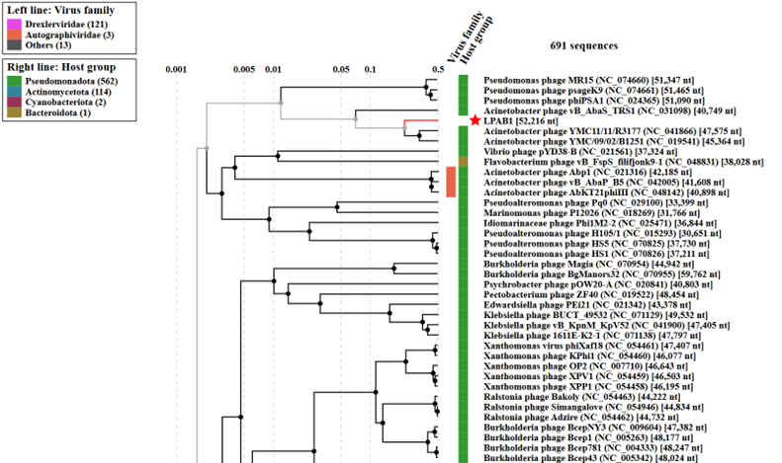
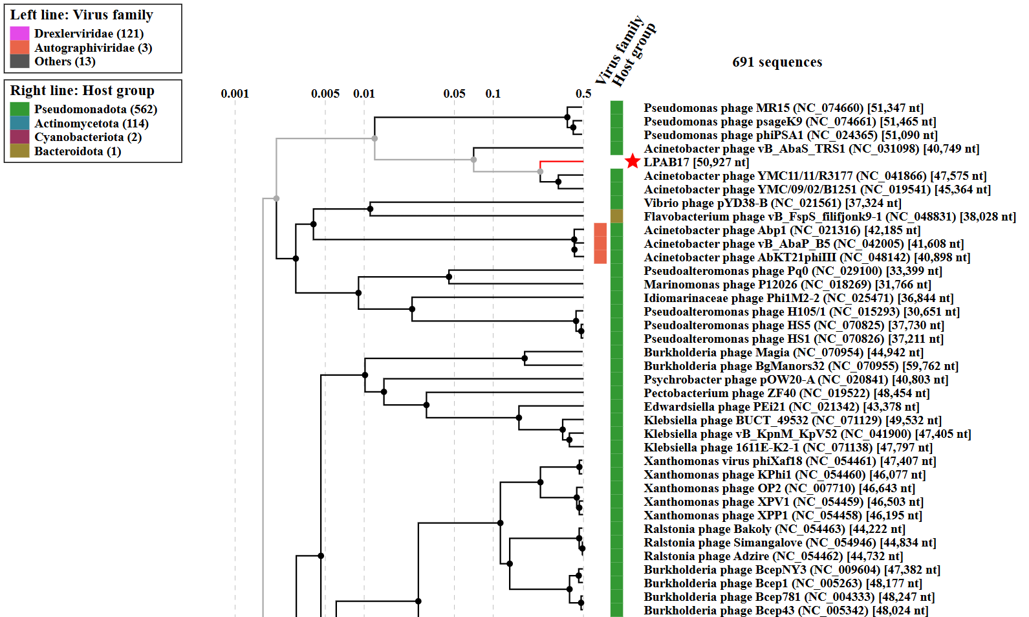
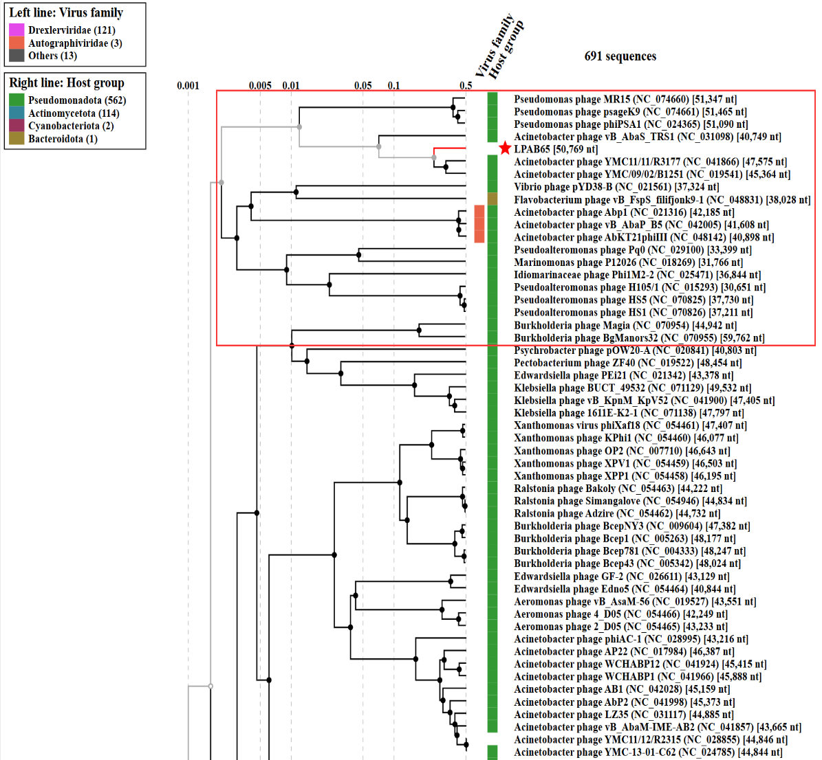
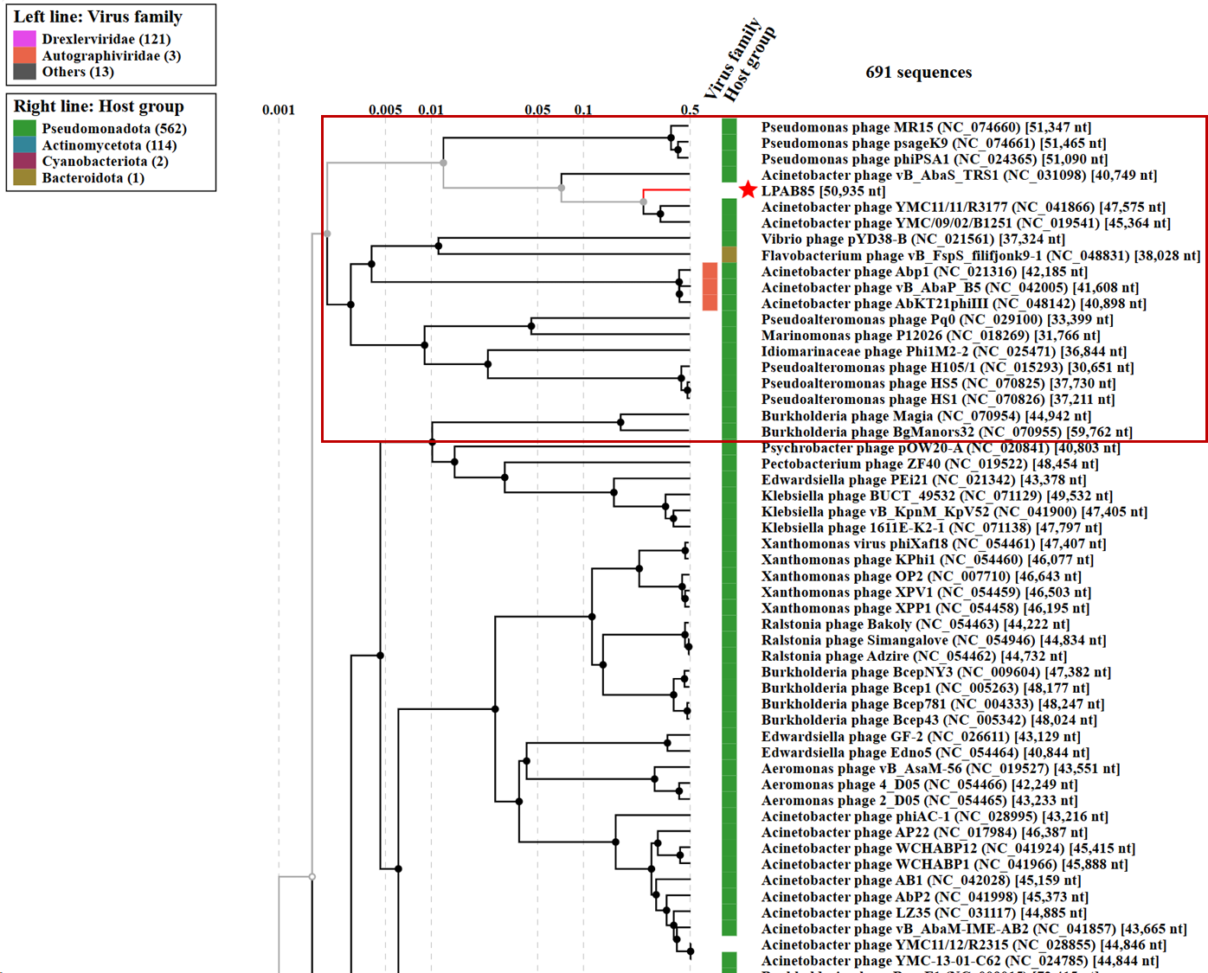
Figure 1. ViPTree analysis: ViPTree analysis (https://www.genome.jp/viptree/https://www.genome.jp/viptree/) is based upon Rohwer and Edwards (2002) Phage Proteomic Tree. The phages of interest are indicated with red box.
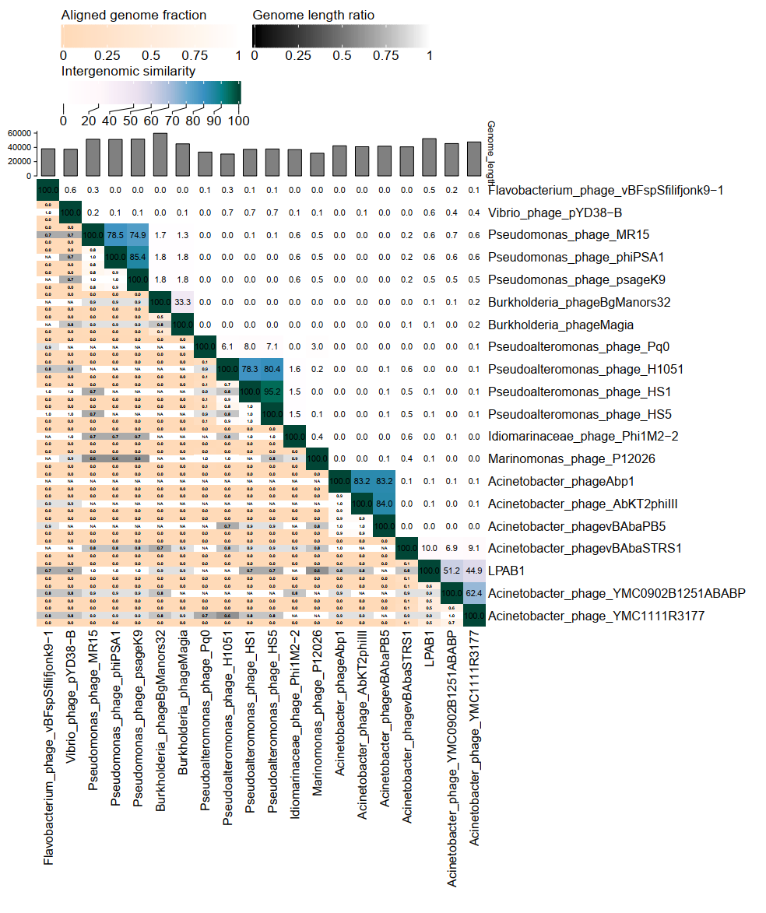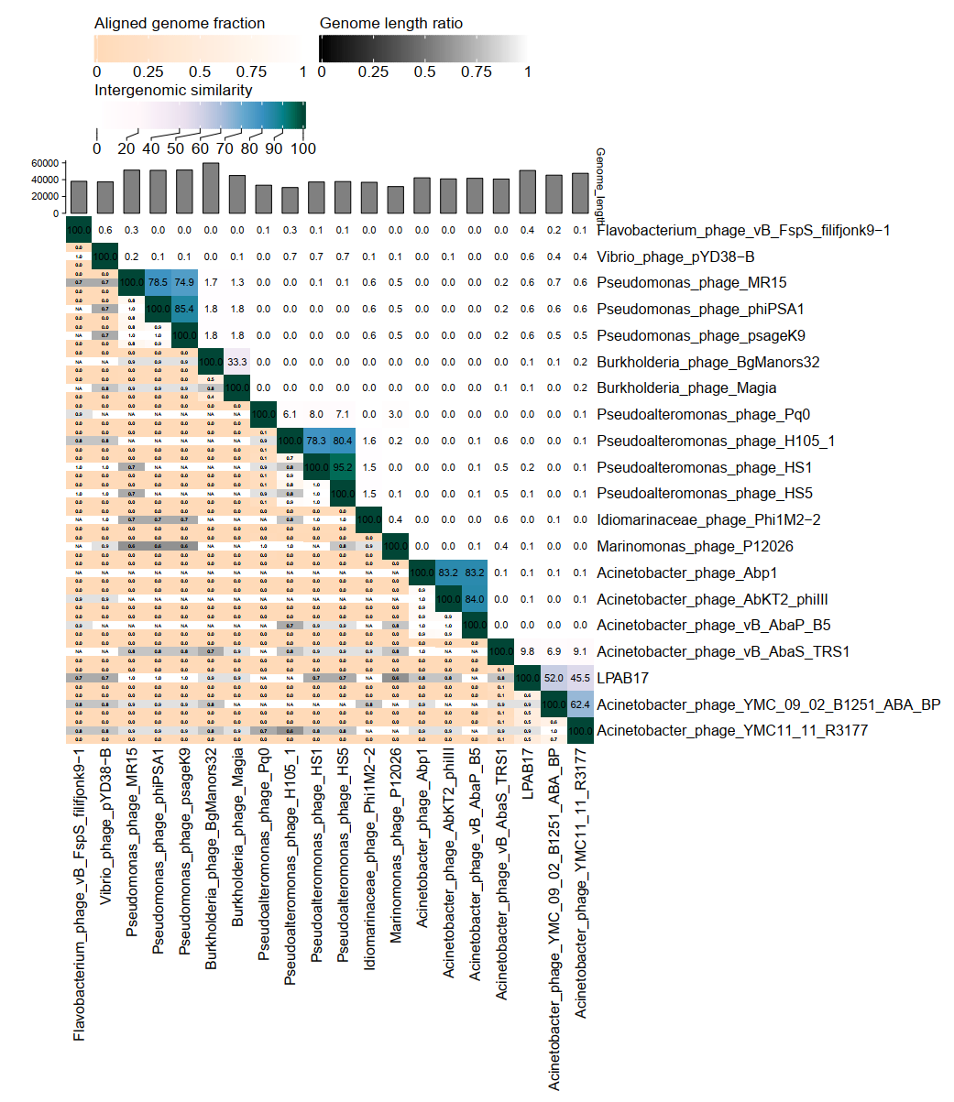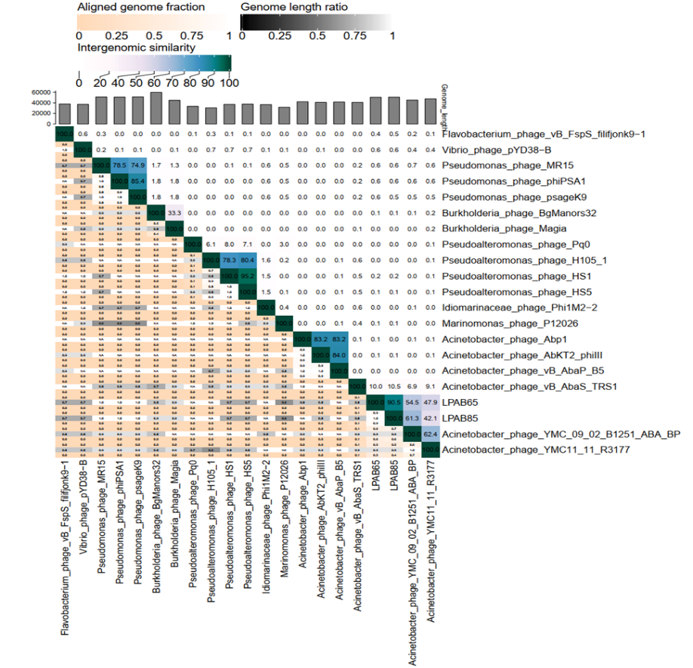Figure 2. VIRIDIC heatmap: VIRIDIC (Virus Intergenomic Distance Calculator; http://rhea.icbm.uni-oldenburg.de/VIRIDIC/about:blankhttp://rhea.icbm.uni-oldenburg.de/VIRIDIC/) computes pairwise intergenomic distances/similarities amongst phage genomes.

Origin of the name of this taxon: The name of this genus comes from a river in China.

Historical aspects: Phage samples are sourced from Slaughterhouse samples in Hubei Province.

Specific References: None

Genome summary:

Phage name | INSDC | Size (Kb) | GC% | Protein | tRNA
Acinetobacter baumannii phage LPAB1 | PZ490319 | 52,216 | 39% | 81 | 0

Phage name | INSDC | Size (Kb) | GC% | Protein | tRNA
Acinetobacter baumannii phage LPAB17 | PZ490320 | 50,927 | 39% | 80 | 0

Phage name | INSDC | Size (Kb) | GC% | Protein | tRNA
Acinetobacter baumannii phage LPAB65 | PV612228 | 50.769 | 39.35 | 81 | 0

Phage name | INSDC | Size (Kb) | GC% | Protein | tRNA
Acinetobacter baumannii phage LPAB85 | PV679990 | 50.935 | 39.18 | 74 | 0

