

The International Committee on Taxonomy of Viruses
Taxonomy Proposal Form, 2026

Part 1a: Details of taxonomy proposals

Title: | To create a new subfamily, Jebvirinae with six genera in the class Caudoviricetes
Code assigned: | 2026.036B

Author(s), affiliation and email address(es):
Given name (+middle initial(s)) | Surname | Affiliation | Email address | Corr. author(s)
Ipek | Kurtböke | Environmental Microbiology, University of the Sunshine Coast,  School of Science, Technology and Engineering,  Maroochydore DC, Australia | IKurtbok@usc.edu.au
Cristina M. | Moraru | Department of Chemistry, Environmental Metagenomics,  University of Duisburg-Essen,  D-45141 Essen,  Germany | lilianacristina.moraru@uni-due.de
Andrew M. | Kropinski | University of Guelph, Guelph, Ontario, Canada N1G2W1 | Phage.Canada@gmail.com | x

Part 1b: Taxonomy Proposal Submission
ICTV Subcommittee:
Animal DNA Viruses and Retroviruses |  | Bacterial viruses | x
Animal minus-strand and dsRNA viruses |  | Fungal and protist viruses
Animal positive-strand RNA viruses |  | Plant viruses
Archaeal viruses |  | General -

List the ICTV Study Group(s) that have seen or have been involved in creating this proposal:
Optional – complete only if formally voted on by an ICTV Study Group:
Study Group | Number of members
Study Group | Votes in support | Votes against | No vote
Actinophages

Submission date: | 01/04/2026

Part 1c: Feedback from ICTV Executive Committee (EC) meeting
Executive Committee Meeting Decision code: | X
A – Accept
Ac – Accept subject to revision by relevant subcommittee chair. No further vote required
U – Accept without revision but with re-evaluation and email vote by the EC
Uc – Accept subject to revision and re-evaluation and email vote by the EC
Ud – Deferred to the next EC meeting, with an invitation to revise based on EC comments
J - Reject
W - Withdrawn

Comments from the Executive Committee:

Part 1d: Revised Taxonomy Proposal Submission
Response of proposer:
Revision date:

Part 3: TAXONOMIC PROPOSAL

Taxonomic changes proposed:
Establish new taxon | x | Split taxon
Abolish taxon |  | Merge taxon
Move taxon |  | Promote taxon
Rename taxon |  | Demote taxon
Move and rename

Etymology (origin) of proposed taxonomic names:
Taxon name | Etymology of the term
“Jebvirinae” | All these phages are assigned to the Actinobacteriophage Database Cluster JB
"Transitvirus" | Named after the first virus of its type Curtobacterium phage Transit
"Aykavirus" | Named after the first virus of its type Curtobacterium phage Ayka
"Momosvirus" | Named after the first virus of its type Curtobacterium phage Momos
"Pizevirus" | Named after the first virus of its type Curtobacterium phage Pize
"Rejevirus" | Named after the first virus of its type Curtobacterium phage Reje
"Fairywrenvirus" | Named after the first virus of its type Curtobacterium phage Fairywren

Permission for use of names derived from a living person:
Taxon name | Full name of person from whom the name is derived | Attached

Abstract of Taxonomy Proposal:

Description of current taxonomy:
None of the bacteriophages discussed in this proposal have been classified by the ICTV. They belong to a group of podoviruses peripherally related to Bacillus phage phi29 (Salasmaviridae) and are assigned into two subclusters of Cluster JB by the Actinobacteriophage Database.

Proposed taxonomic change(s):
We propose to create a new subfamily named “Jebvirinae” containing the following new genera: "Transitvirus", "Aykavirus", "Momosvirus", "Pizevirus", "Rejevirus" and "Fairywrenvirus".
Apart from “Transitvirus“ (3 species) all the others are single species genera.

Demarcation criteria for new taxon/taxa:
Subfamily demarcation criteria: Subfamilies are to be created when two or more genera are related below the family level. In practical terms, this usually means that they share a low degree of sequence similarity (usually about 40-50%) and that the genera form a clade in a marker tree phylogeny.

Genus demarcation criteria: An intergenomic similarity cut-off of 70%, a combination of average nucleotide identity and alignment fraction, is used to determine genera demarcation. Members of the same genus have >70% intergenomic similarity and cluster tightly in marker gene phylogenies.

Species demarcation criteria: A demarcation value of 95% intergenomic similarity was used to define different species according to intergenomic similarity. Members of the same genus have >95% intergenomic similarity [6].

Justification:
Pairwise comparisons of intergenomic nucleotide sequence similarity demonstrate that these bacteriophages cluster into six genera and eight new species in accordance with the current demarcation criteria. These assignments are supported by the TBLASTX distance tree and phylogenetic analysis of the DNA polymerase. The new genera exhibit >4% intergenomic similarity and all representative genomes share 11 common proteins equivalent to approximately 50% of the total encoded proteins. Based on this evidence we propose a new subfamily “Jebvirinae” with six new genera and eight new species.

Text of Taxonomy proposal:
Description of current taxonomy:
None of the bacteriophages discussed in this proposal have been classified by the ICTV. They belong to a group of podoviruses peripherally related to Bacillus phage phi29 (Salasmaviridae) and are assigned into two subclusters of Cluster JB by the Actinobacteriophage Database.

Proposed taxonomic change(s):
We propose to create a new subfamily named “Jebvirinae” containing the following new genera: "Transitvirus", "Aykavirus", "Momosvirus", "Pizevirus", "Rejevirus" and "Fairywrenvirus".
Apart from “Transitvirus“ (3 species) all the others are single species genera.

Demarcation criteria for new taxon/taxa:
Subfamily demarcation criteria: Subfamilies are to be created when two or more genera are related below the family level. In practical terms, this usually means that they share a low degree of sequence similarity (usually about 40-50%) and that the genera form a clade in a marker tree phylogeny.

Genus demarcation criteria: An intergenomic similarity cut-off of 70%, a combination of average nucleotide identity and alignment fraction, is used to determine genera demarcation. Members of the same genus have >70% intergenomic similarity and cluster tightly in marker gene phylogenies.

Species demarcation criteria: A demarcation value of 95% intergenomic similarity was used to define different species according to intergenomic similarity. Members of the same genus have >95% intergenomic similarity [6].

Justification:
Pairwise comparisons of intergenomic nucleotide sequence similarity demonstrate that these bacteriophages cluster into six genera and eight new species in accordance with the current demarcation criteria (Figure 1) [1]. These assignments are supported by the TBLASTX distance tree (Figure 2) [2.3] and phylogenetic analysis of the DNA polymerase (Figure 3) [9]. The new genera exhibit >4% intergenomic similarity and all representative genomes share 11 common proteins equivalent to approximately 50% of the total encoded proteins [5]. Based on this evidence we propose a new subfamily “Jebvirinae” with six new genera and eight new species.

References:
1. Moraru C, Varsani A, Kropinski AM. VIRIDIC-A Novel Tool to Calculate the Intergenomic Similarities of Prokaryote-Infecting Viruses. Viruses. 2020 Nov 6;12(11):1268. doi: 10.3390/v12111268. PMID: 33172115; PMCID: PMC7694805. http://kronos.icbm.uni-oldenburg.de/viridic/
2. Nishimura Y, Yoshida T, Kuronishi M, Uehara H, Ogata H, Goto S. ViPTree: the viral proteomic tree server. Bioinformatics. 2017; 33(15):2379-2380. doi:10.1093/bioinformatics/btx157. PubMed PMID: 28379287. https://www.genome.jp/viptree/
3. Rohwer F, Edwards R. The Phage Proteomic Tree: a genome-based taxonomy for phage. J Bacteriol. 2002 Aug;184(16):4529-35. PubMed PMID: 12142423
4. Turner D, Reynolds D, Seto D, Mahadevan P. CoreGenes3.5: a webserver for the determination of core genes from sets of viral and small bacterial genomes. BMC Res Notes. 2013;6:140. doi: 10.1186/1756-0500-6-140. PMID: 23566564.
5. Davis P, Seto D, Mahadevan P. CoreGenes5.0: An Updated User-Friendly Webserver for the Determination of Core Genes from Sets of Viral and Bacterial Genomes. Viruses. 2022 Nov 16;14(11):2534. doi: 10.3390/v14112534. PMID: 36423143; PMCID: PMC9693508.
6. Turner D, Kropinski AM, Adriaenssens EM. A Roadmap for Genome-Based Phage Taxonomy. Viruses. 2021 Mar 18;13(3):506. doi: 10.3390/v13030506. PMID: 33803862; PMCID: PMC8003253.
Lemoine F, Correia D, Lefort V, Doppelt-Azeroual O, Mareuil F, Cohen-Boulakia S, Gascuel O. NGPhylogeny.fr: new generation phylogenetic services for non-specialists. Nucleic Acids Res. 2019 Jul 2;47(W1):W260-W265. doi: 10.1093/nar/gkz303. PMID: 31028399; PMCID: PMC6602494.
7. Letunic I, Bork P. Interactive Tree Of Life (iTOL): an online tool for phylogenetic tree display and annotation. Bioinformatics. 2007 Jan 1;23(1):127-8. doi: 10.1093/bioinformatics/btl529. Epub 2006 Oct 18. PMID: 17050570.
8. Zhou T, Xu K, Zhao F, Liu W, Li L, Hua Z, Zhou X. itol.toolkit accelerates working with iTOL (Interactive Tree of Life) by an automated generation of annotation files. Bioinformatics. 2023 Jun 1;39(6):btad339. doi: 10.1093/bioinformatics/btad339. PMID: 37225402; PMCID: PMC10243930
9. Dereeper A, Guignon V, Blanc G, Audic S, Buffet S, Chevenet F, Dufayard JF, Guindon S, Lefort V, Lescot M, Claverie JM, Gascuel O. Phylogeny.fr: robust phylogenetic analysis for the non-specialist. Nucleic Acids Res. 2008 Jul 1;36(Web Server issue):W465-9. doi: 10.1093/nar/gkn180. Epub 2008 Apr 19. PMID: 18424797; PMCID: PMC2447785.

Accompanying files:
Filename | Description of contents
Jebvirinae_6ng_8nsp | Excel spreadsheet accompanying this proposal

Tables, Figures:

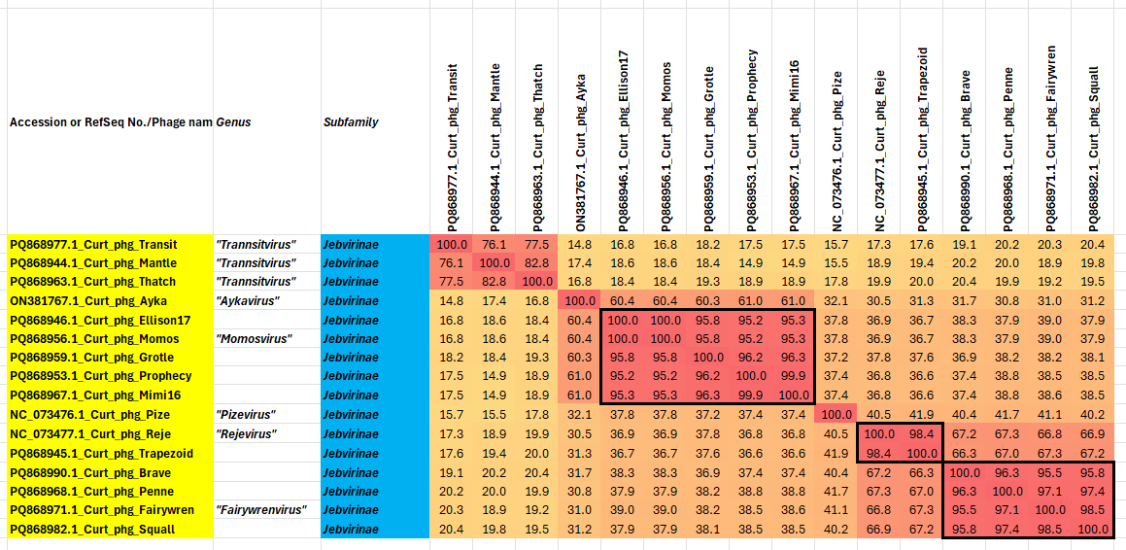

Figure 1. VIRIDIC heatmap of this group of phages. VIRIDIC (Virus Intergenomic Distance Calculator; VIRIDIC (Virus Intergenomic Distance Calculator; [1]; http://rhea.icbm.uni-oldenburg.de/VIRIDIC/) computes pairwise intergenomic distances/similarities amongst phage genomes. Data values which are bordered in black correspond to strains. Abbreviations: phg = phage; Curt = Curtobacterium.
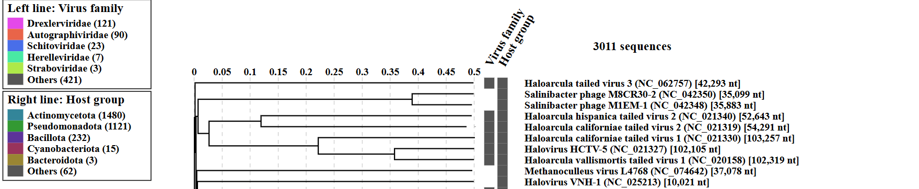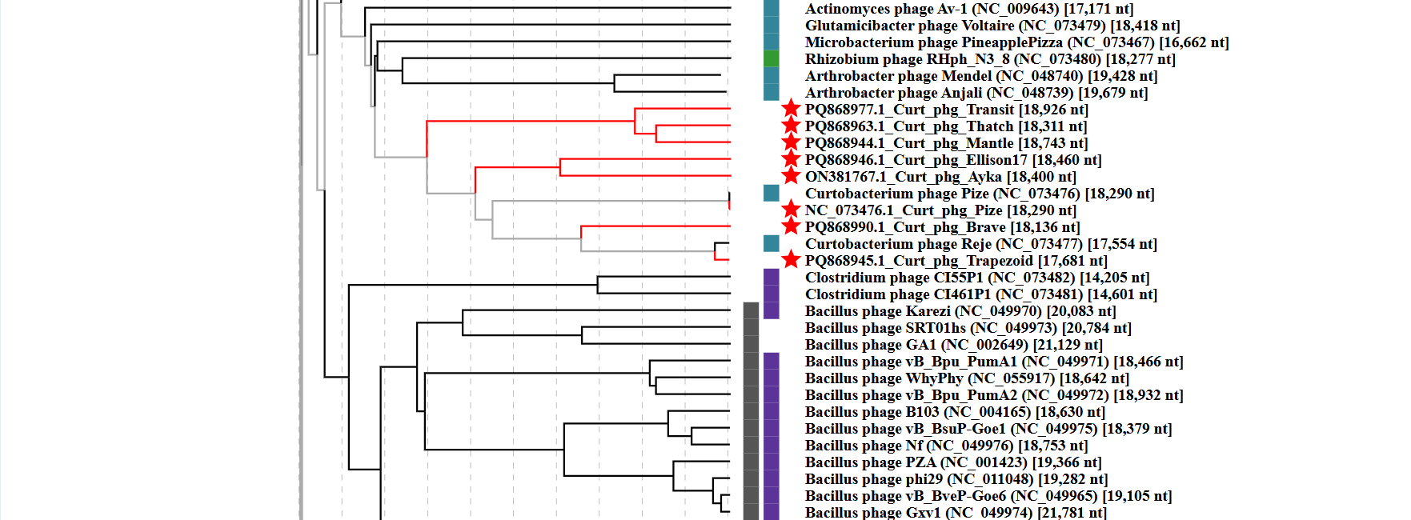Figure 2. ViPTree analysis: ViPTree analysis (https://www.genome.jp/viptree/; [2]) is based upon Rohwer and Edwards (2002) Phage Proteomic Tree [3]. The taxons under discussion are indicated with red bars and stars. Abbreviations: phg = phage; Curt = Curtobacterium.
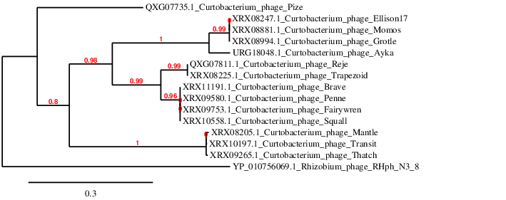Figure 3. Phylogenetic tree constructed with the DNA polymerases from these and related phages using “One Click” Phylogeny.fr [9] at https://www.phylogeny.fr using the DNA polymerase from Rhizobium phage RHph_N3_8 as an outlier.

Table 1. Characteristics of the phages described in the proposal which belong to “Transitvirus”

Phage name | Host | Morphotype | Lifestyle | Accession No. | Genome size | %G+C | Genome Termini | No. proteins | No. tRNA
Curtobacterium phage Transit | Curtobacterium flaccumfaciens NRRL B-729 SEA | Podovirus | Lytic | PQ868977 | 18926 bp | 52.2 | Terminal protein | 22 | 0
Curtobacterium phage Mantle | Curtobacterium flaccumfaciens NRRL B-729 SEA | Podovirus | Lytic | PQ868944 | 18743 bp | 52.8 | Terminal protein | 20 | 0
Curtobacterium phage Thatch | Curtobacterium flaccumfaciens NRRL B-729 SEA | Podovirus | Lytic | PQ868963 | 18311 bp | 52.6 | Terminal protein | 19 | 0

Table 2. Characteristics of the phages described in the proposal which belong to "Aykavirus"

Phage name | Host | Morphotype | Lifestyle | Accession No. | Genome size | %G+C | Genome Termini | No. proteins | No. tRNA
Curtobacterium phage Ayka(*) | Curtobacterium flaccumfaciens pv. flaccumfaciens C089 | Podovirus | Lytic | ON381767 | 18400 bp | 52.6 | Terminal protein(**) | 22 | 0
(*) Unclassified in the Actinobacteriophage Database (**) Not given in GenBank

Table 3. Characteristics of the phages described in the proposal which belong to "Momosvirus"

Phage name | Host | Morphotype | Lifestyle | Accession No. | Genome size | %G+C | Genome Termini | No. proteins | No. tRNA
Curtobacterium phage Momos | Curtobacterium flaccumfaciens NRRL B-729 SEA | Podovirus | Lytic | PQ868956 | 18460 bp | 55.9 | Terminal protein | 24 | 0

Table 4. Characteristics of the phages described in the proposal which belong to "Pizevirus"

Phage name | Host | Morphotype | Lifestyle | Accession No. | Genome size | %G+C | Genome Termini | No. proteins | No. tRNA
Curtobacterium phage Pize (*) | Curtobacterium sp. | Podovirus | Lytic | MZ333134 | 18290 bp | 58.6 | Terminal protein (**) | 22 | 0
(*) Unclassified in the Actinobacteriophage Database; (**) Not given in GenBank; isolated in Denmark

Table 5. Characteristics of the phages described in the proposal which belong to "Rejevirus"

Phage name | Host | Morphotype | Lifestyle | Accession No. | Genome size | %G+C | Genome Termini | No. proteins | No. tRNA
Curtobacterium phage Reje (*) | Curtobacterium sp. | Podovirus | Lytic | MZ333136 | 17554 bp | 57.0 | Terminal protein (**) | 20 | 0
(*) Unclassified in the Actinobacteriophage Database (**) ;Not given in GenBank; isolated in Denmark

Table 6. Characteristics of the phages described in the proposal which belong to "Fairywrenvirus"

Phage name | Host | Morphotype | Lifestyle | Accession No. | Genome size | %G+C | Genome Termini | No. proteins | No. tRNA
Curtobacterium phage Fairywren | Curtobacterium flaccumfaciens NRRL B-729 SEA | Podovirus | Lytic | PQ868971 | 18108 bp | 53.5 | Terminal protein | 24 | 0

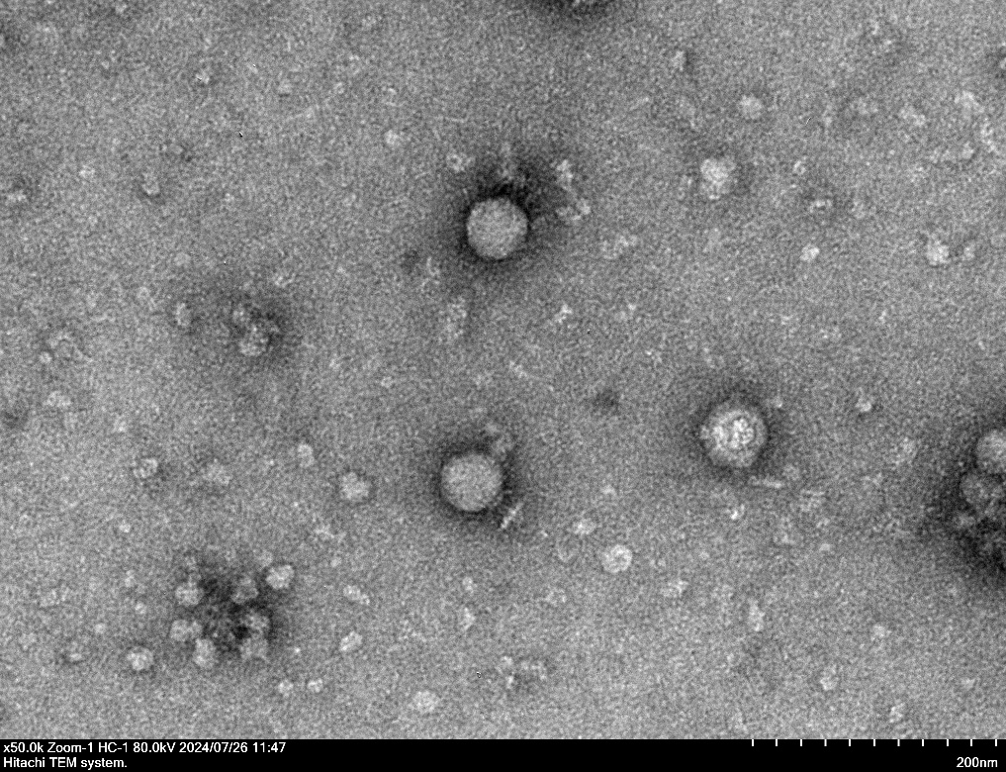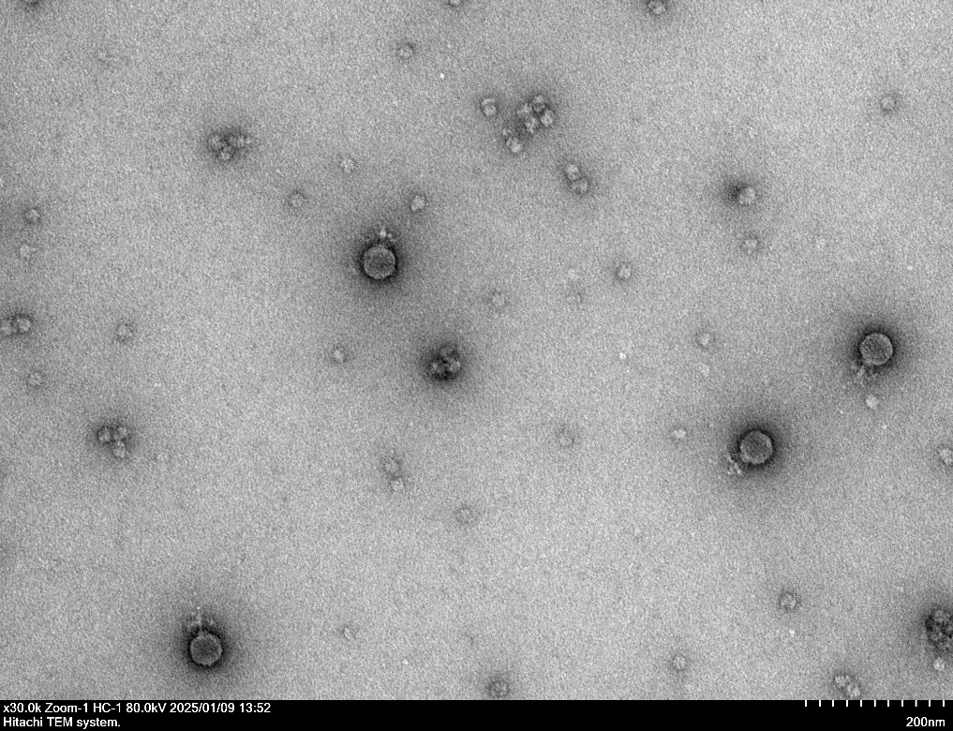
Figure 4. Electron micrograph: Electron micrographs of negatively stained Curtobacterium phages Fairywren (Left, https://phagesdb.org/phages/Fairywren/) and Prophecy (Right, https://phagesdb.org/phages/Prophecy/) . Limited permission was granted by The Actinobacteriophage Database (https://phagesdb.org/), funded by the Howard Hughes Medical Institute, to use this electron micrograph for this taxonomy proposal; it cannot be reused without permission of The Actinobacteriophage Database.

Table 7. CoreGenes 5.0 [5] analysis of the 11 common proteins found in these phages.

Curtobacterium phage Transit | Curtobacterium phage Mantle | Curtobacterium phage Ayka | Curtobacterium phage Momos | Curtobacterium phage Pize | Curtobacterium phage Reje | Curtobacterium phage Fairywren
PQ868977 | PQ868944 | ON381767 | PQ868956 | NC_073476 | NC_073477 | PQ868971
PI:XRX10195.1 | PI:XRX08203.1 | PI:URG18046.1 | PI:XRX08879.1 | PI:YP_010755972.1 | PI:YP_010755994.1 | PI:XRX09775.1
Product:SSB protein | Product:SSB protein | Product:ssDNA binding protein | Product:SSB protein | Product:ssDNA binding protein | Product:ssDNA binding protein | Product:SSB protein
PI:XRX10196.1 | PI:XRX08204.1 | PI:URG18047.1 | PI:XRX08880.1 | PI:YP_010755973.1 | PI:YP_010755995.1 | PI:XRX09752.1
Product:DNA terminal protein | Product:DNA terminal protein | Product:terminal protein | Product:DNA terminal protein | Product:hypothetical protein | Product:hypothetical protein | Product:DNA terminal protein
PI:XRX10197.1 | PI:XRX08205.1 | PI:URG18048.1 | PI:XRX08881.1 | PI:YP_010755974.1 | PI:YP_010755996.1 | PI:XRX09753.1
Product:DNA polymerase | Product:DNA polymerase | Product:DNA polymerase type B | Product:DNA polymerase | Product:DNA polymerase | Product:DNA polymerase | Product:DNA polymerase
PI:XRX10199.1 | PI:XRX08207.1 | PI:URG18050.1 | PI:XRX08883.1 | PI:YP_010755976.1 | PI:YP_010755998.1 | PI:XRX09755.1
Product:hypothetical protein | Product:hypothetical protein | Product:scaffolding protein | Product:hypothetical protein | Product:hypothetical protein | Product:hypothetical protein | Product:hypothetical protein
PI:XRX10200.1 | PI:XRX08208.1 | PI:URG18051.1 | PI:XRX08884.1 | PI:YP_010755977.1 | PI:YP_010755999.1 | PI:XRX09756.1
Product:major capsid protein | Product:major capsid protein | Product:major capsid protein | Product:major capsid protein | Product:major capsid protein | Product:major capsid protein | Product:major capsid protein
PI:XRX10201.1 | PI:XRX08209.1 | PI:URG18052.1 | PI:XRX08885.1 | PI:YP_010755978.1 | PI:YP_010756000.1 | PI:XRX09757.1
Product:tail knob protein | Product:tail knob protein | Product:distal tail knob | Product:tail knob protein | Product:major tail protein | Product:major tail protein | Product:tail knob protein
PI:XRX10202.1 | PI:XRX08210.1 | PI:URG18053.1 | PI:XRX08886.1 | PI:YP_010755979.1 | PI:YP_010756001.1 | PI:XRX09758.1
Product:portal protein | Product:portal protein | Product:connector protein | Product:portal protein | Product:upper collar protein | Product:upper collar protein | Product:portal protein
PI:XRX10203.1 | PI:XRX08211.1 | PI:URG18054.1 | PI:XRX08887.1 | PI:YP_010755980.1 | PI:YP_010756002.1 | PI:XRX09759.1
Product:lower collar protein | Product:lower collar protein | Product:proximal tail tube connector protein | Product:lower collar protein | Product:lower collar protein | Product:lower collar protein | Product:lower collar protein
PI:XRX10204.1 | PI:XRX08212.1 | PI:URG18055.1 | PI:XRX08888.1 | PI:YP_010755981.1 | PI:YP_010756003.1 | PI:XRX09760.1
Product:pre-neck appendage protein | Product:pre-neck appendage protein | Product:tail spike protein | Product:pre-neck appendage protein | Product:hypothetical protein | Product:tail related protein | Product:pre-neck appendage protein
PI:XRX10206.1 | PI:XRX08214.1 | PI:URG18057.1 | PI:XRX08890.1 | PI:YP_010755983.1 | PI:YP_010756005.1 | PI:XRX09762.1
Product:endolysin | Product:endolysin | Product:tail associated lysin | Product:endolysin | Product:hypothetical protein | Product:hypothetical protein | Product:endolysin
PI:XRX10208.1 | PI:XRX08215.1 | PI:URG18058.1 | PI:XRX08891.1 | PI:YP_010755984.1 | PI:YP_010756006.1 | PI:XRX09763.1
Product:terminase | Product:terminase | Product:DNA encapsidation ATPase | Product:terminase | Product:terminase | Product:terminase | Product:terminase

