

The International Committee on Taxonomy of Viruses
Taxonomy Proposal Form, 2026

Part 1a: Details of taxonomy proposals

Title: | To create a new family, Hwanungviridae, with two genera in the class Caudoviricetes
Code assigned: | 2026.034B

Author(s), affiliation and email address(es):
Given name (+middle initial(s)) | Surname | Affiliation | Email address | Corr. author(s)
Juntao | Shen | State Key Laboratory of Quantitative Synthetic Biology, Shenzhen Institute of Synthetic Biology, Shenzhen Institutes of Advanced Technology, Chinese Academy of Sciences, Shenzhen, China | jt.shen1@siat.ac.cn
Cristina M. | Moraru | Department of Chemistry, Environmental Metagenomics,  University of Duisburg-Essen,  D-45141 Essen,  Germany | lilianacristina.moraru@uni-due.de
Andrew M. | Kropinski | University of Guelph, Guelph, Ontario, Canada N1G2W1 | Phage.Canada@gmail.com | x

Part 1b: Taxonomy Proposal Submission
ICTV Subcommittee:
Animal DNA Viruses and Retroviruses |  | Bacterial viruses | x
Animal minus-strand and dsRNA viruses |  | Fungal and protist viruses
Animal positive-strand RNA viruses |  | Plant viruses
Archaeal viruses |  | General -

List the ICTV Study Group(s) that have seen or have been involved in creating this proposal:
Caudoviricetes Study Group
Optional – complete only if formally voted on by an ICTV Study Group:
Study Group | Number of members
Study Group | Votes in support | Votes against | No vote

Submission date: | 30/07/2026

Part 1c: Feedback from ICTV Executive Committee (EC) meeting
Executive Committee Meeting Decision code: | X
A – Accept
Ac – Accept subject to revision by relevant subcommittee chair. No further vote required
U – Accept without revision but with re-evaluation and email vote by the EC
Uc – Accept subject to revision and re-evaluation and email vote by the EC
Ud – Deferred to the next EC meeting, with an invitation to revise based on EC comments
J - Reject
W - Withdrawn

Comments from the Executive Committee:

Part 1d: Revised Taxonomy Proposal Submission
Response of proposer:
Revision date:

Part 3: TAXONOMIC PROPOSAL

Taxonomic changes proposed:
Establish new taxon | x | Split taxon
Abolish taxon |  | Merge taxon
Move taxon |  | Promote taxon
Rename taxon |  | Demote taxon
Move and rename

Etymology (origin) of proposed taxonomic names:
Taxon name | Etymology of the term
"Namguvirus" | Named after the district, in south-central Busan, South Korea, where at Inha University the first phage of its type was isolated
"Hebeivirus" | Named after the province in northern China where the Shenzhen Institute of Synthetic Biology is located.
“Hwanungviridae” | Hwanung is the son of Hwanin (환인; 桓因), the "Lord of Heaven". Along with his ministers of clouds, rain, and wind, he instituted laws and moral codes and taught the humans various arts, medicine, and agriculture.

Permission for use of names derived from a living person:
Taxon name | Full name of person from whom the name is derived | Attached

Abstract of Taxonomy Proposal:

Description of current taxonomy:
These phages are currently unclassified.

Proposed taxonomic change(s):
We propose to create two new genera: "Namguvirus" and "Hebeivirus" in a new family named “Hwanungviridae”

Family demarcation criteria: The family is represented by a cohesive and monophyletic group in the main predicted proteome-based clustering tools (ViPTree, GRAViTy dendrogram, vConTACT2 network). Members of the family share a significant number of orthologous genes (the number will depend on the genome sizes and number of coding sequences of members of the family).

Genus demarcation criteria: An intergenomic similarity cut-off of 70%, a combination of average nucleotide identity and alignment fraction, is used to determine genera demarcation. Members of the same genus have >70% intergenomic similarity and cluster tightly in marker gene phylogenies.

Species demarcation criteria: A demarcation value of 95% intergenomic similarity was used to define different species according to intergenomic similarity. Members of the same genus have >95% intergenomic similarity [6].

Justification: On the basis of VIRIDIC, VIPTREE and phylogenetic analyses these siphoviruses form a new family.

Text of Taxonomy proposal:
Description of current taxonomy:
These phages are currently unclassified.

Proposed taxonomic change(s):
We propose to create two new genera: "Namguvirus" and "Hebeivirus" in a new family named “Hwanungviridae”

Demarcation criteria for new taxon/taxa:
Family demarcation criteria:
The family is represented by a cohesive and monophyletic group in the main predicted proteome-based clustering tools (ViPTree, GRAViTy dendrogram, vConTACT2 network). Members of the family share a significant number of orthologous genes (the number will depend on the genome sizes and number of coding sequences of members of the family).

Genus demarcation criteria: An intergenomic similarity cut-off of 70%, a combination of average nucleotide identity and alignment fraction, is used to determine genera demarcation. Members of the same genus have >70% intergenomic similarity and cluster tightly in marker gene phylogenies.

Species demarcation criteria: A demarcation value of 95% intergenomic similarity was used to define different species according to intergenomic similarity. Members of the same genus have >95% intergenomic similarity.

Justification:
To identify related genomes in the INSDC, a protein clustering approach was employed using a custom Python pipeline with 28,717 genomes in the 14Apr2025 release of INPHARED [2] as input. Briefly, proteins were clustered using MMSeqs2 [3] with parameters set to a minimum sequence identity of ≥30% sequence identity and an ≥80% coverage threshold. The pipeline converted the number of shared protein clusters between genomes into an all-vs-all Jaccard distance matrix, which formed the basis of a connected-component network. The network was split into discrete islands using a minimum Jaccard similarity of 0.05 and subsequently hierarchically clustered at set distance thresholds. At each level, the number and identity of conserved protein clusters was determined.

Six phages were found to form a distinct clade based on the Jaccard similarity calculated from shared protein clusters, exhibiting 17 protein homologs common to all genomes (Figures 1 and 2). This clade, for which we propose new family, “Hwanungviridae”, was supported by the hierarchically clustered TBLASTX distance tree (ViPTree) [5,6], where the genomes form a deep-branching monophyletic clade (Figure 3). We note that Croceibacter phage P2559Y (KC688701) also groups within this clade, and examination of the phylogeny of the DNA polymerase. Intergenomic nucleotide similarities calculated using VIRIDIC [7] (Figure 4) support the creation of two genera, "Namguvirus" and "Hebeivirus", and three new species.

References:
- Turner D, Kropinski AM, Adriaenssens EM. A Roadmap for Genome-Based Phage Taxonomy. Viruses. 2021 Mar 18;13(3):506. doi: 10.3390/v13030506. PMID: 33803862; PMCID: PMC8003253.
- Cook R, Brown N, Redgwell T, Rihtman B, Barnes M, Clokie M, Stekel DJ, Hobman J, Jones MA, Millard A. (2021) INfrastructure for a PHAge REference Database: Identification of Large-Scale Biases in the Current Collection of Cultured Phage Genomes. Phage 2(4):214-223. doi: 10.1089/phage.2021.0007.
- Steinegger M, Söding J. (2017) MMseqs2 enables sensitive protein sequence searching for the analysis of massive data sets. Nat Biotechnol. 35(11):1026-1028. doi: 10.1038/nbt.3988.
- Nishimura Y, Yoshida T, Kuronishi M, Uehara H, Ogata H, Goto S. ViPTree: the viral proteomic tree server. Bioinformatics. 2017; 33(15):2379-2380. doi:10.1093/bioinformatics/btx157. PubMed PMID: 28379287. https://www.genome.jp/viptree/
- Rohwer F, Edwards R. The Phage Proteomic Tree: a genome-based taxonomy for phage. J Bacteriol. 2002 Aug;184(16):4529-35. PubMed PMID: 12142423
- Moraru C, Varsani A, Kropinski AM. VIRIDIC-A Novel Tool to Calculate the Intergenomic Similarities of Prokaryote-Infecting Viruses. Viruses. 2020 Nov 6;12(11):1268. doi: 10.3390/v12111268. PMID: 33172115; PMCID: PMC7694805. http://kronos.icbm.uni-oldenburg.de/viridic/
- Dereeper A, Guignon V, Blanc G, Audic S, Buffet S, Chevenet F, Dufayard JF, Guindon S, Lefort V, Lescot M, Claverie JM, Gascuel O. Phylogeny.fr: robust phylogenetic analysis for the non-specialist. Nucleic Acids Res. 2008 Jul 1;36(Web Server issue):W465-9. doi: 10.1093/nar/gkn180. Epub 2008 Apr 19. PMID: 18424797; PMCID: PMC2447785.
- Lemoine F, Correia D, Lefort V, Doppelt-Azeroual O, Mareuil F, Cohen-Boulakia S, Gascuel O. NGPhylogeny.fr: new generation phylogenetic services for non-specialists. Nucleic Acids Res. 2019 Jul 2;47(W1):W260-W265. doi: 10.1093/nar/gkz303. PMID: 31028399; PMCID: PMC6602494.

Accompanying files:
Filename | Description of contents
Hwanungviridae _1nf_2ng_3nsp | Excel spreadsheet associated with this TaxoProp

Tables, Figures:

Table 1. Conserved proteins present in all member of the proposed family Hwanungviridae

Cluster | Predicted function | Average within-cluster % identity | Average protein length (aa)
1 | hypothetical protein | 100 | 69.33
2 | portal protein | 67.07 | 589.67
3 | dUTPase | 64.2 | 159
4 | virion structural protein | 69.13 | 361.67
5 | tail protein | 64.8 | 147.67
6 | virion structural protein | 62.53 | 253.33
7 | tail length tape measure protein | 54.67 | 1115.67
8 | DNA polymerase | 84.53 | 667.67
9 | endonuclease | 81.33 | 97.33
10 | virion structural protein | 100 | 312
11 | major head protein | 66.33 | 219
12 | hypothetical protein | 81.67 | 430.33
13 | exonuclease | 65.1 | 397.67
14 | Gp2.5-like ssDNA binding protein and ssDNA annealing protein | 74.47 | 183.33
15 | DNA helicase | 69.03 | 802.33
16 | DNA helicase | 75.37 | 464.33
17 | hypothetical protein | 77 | 767.67

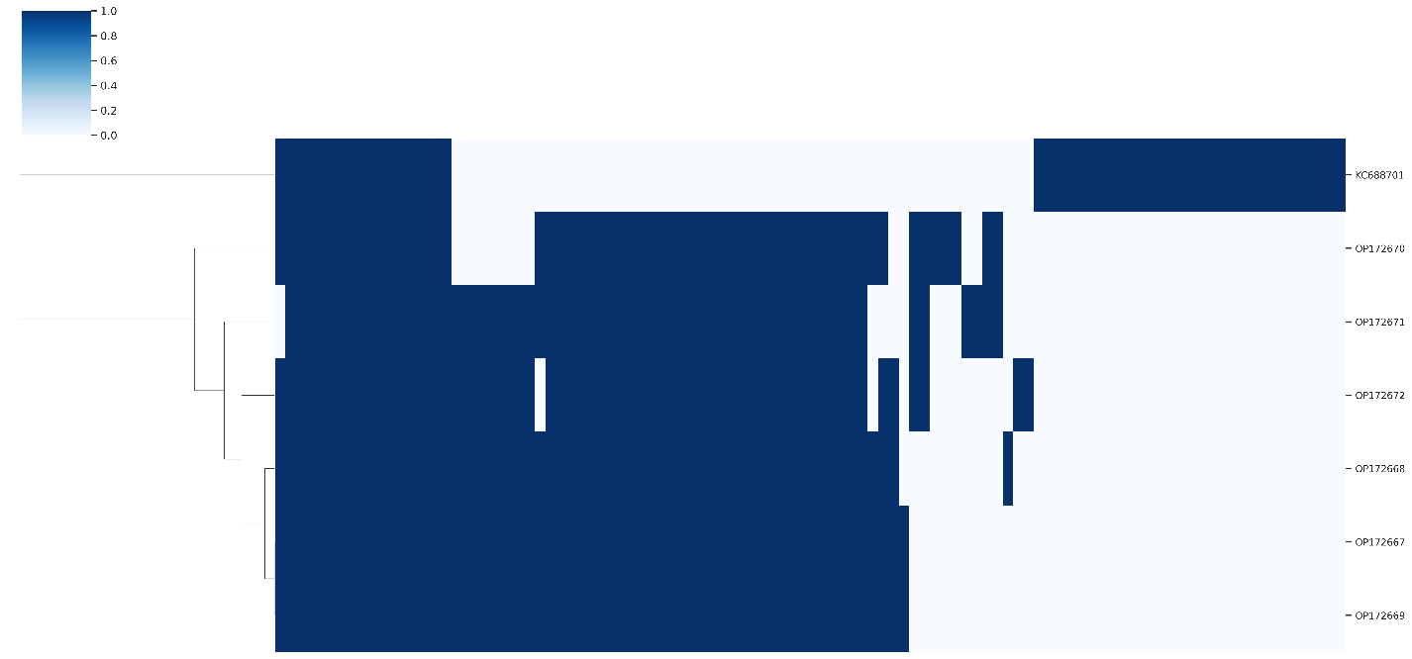

Figure 1. Presence-absence matrix of protein clusters by genome. Rows and columns were hierarchically clustered using the complete linkage method. Rows represent individual genomes with columns representing protein clusters. Vertical blue bars denote the presence of protein clusters in each genome.

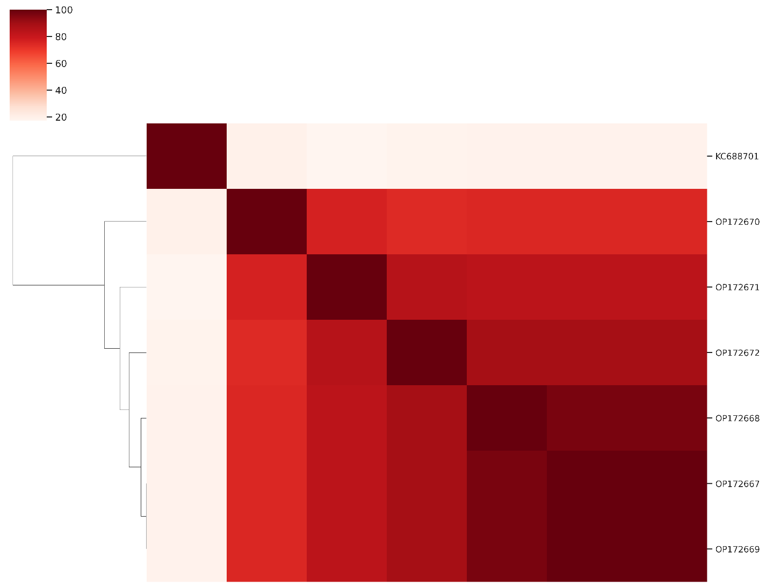
Figure 2. Heatmap of Jaccard similarity calculated from the percentage of shared protein clusters between genomes.

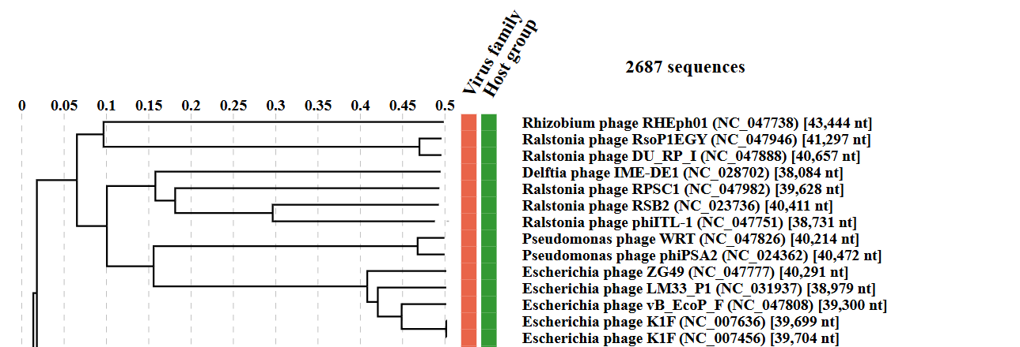
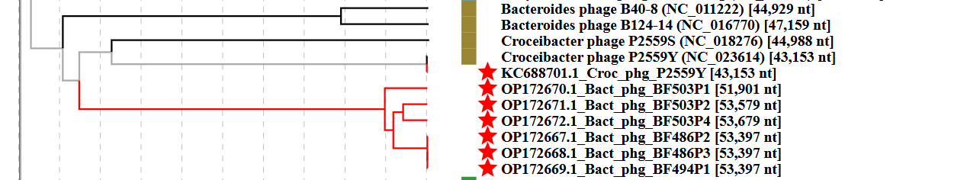

Figure 3. ViPTree analysis: ViPTree analysis (https://www.genome.jp/viptree/; [4,5]) is based upon Rohwer and Edwards (2002) Phage Proteomic Tree [3]. The taxa under discussion are indicated with red branches and stars. Abbreviations: phg = phage; Bact = Bacteroides; Croc = Croceibacter

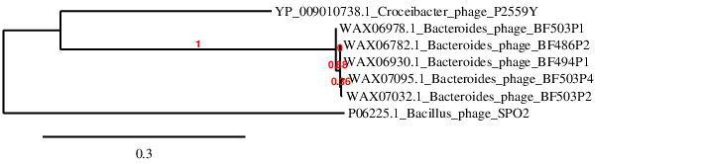Figure 4. Phylogenetic tree constructed with the DNA polymerase proteins from these and related phages using “One Click” Phylogeny.fr [7,8] at https://www.phylogeny.fr using the DNAPol protein from Bacillus phage SPO2 as an outlier.
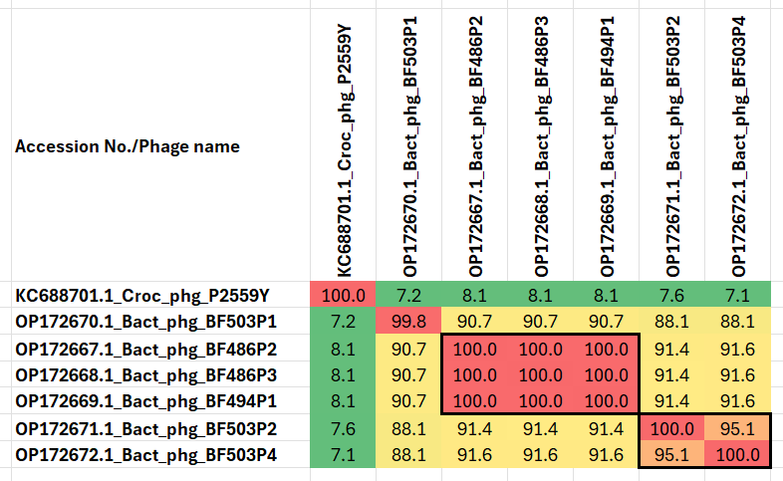

Figure 5. VIRIDIC heatmaps of this group of phages. VIRIDIC (Virus Intergenomic Distance Calculator; VIRIDIC (Virus Intergenomic Distance Calculator; [6]; http://rhea.icbm.uni-oldenburg.de/VIRIDIC/) computes pairwise intergenomic distances/similarities amongst phage genomes. The yellow highlighted Accession numbers represent new species. Data values which are bordered in black correspond to strains. Abbreviations: phg = phage; Bact = Bacteroides; Croc = Croceibacter

Table 1. Characteristics of the only phage in the genus “Namguvirus.”

Phage name | Host | Morphotype | Lifestyle | Accession No. | Genome size | %G+C | No. proteins | No. tRNA
Croceibacter phage P2559Y | Croceibacter atlanticus HTCC2559 | Siphovirus | Lytic | KC688701 | 43,153 bp | 38.9 | 51 | 0
Specific reference: Kang I, Kang D, Cho JC. Complete genome sequence of bacteriophage P2559Y, a marine phage that infects Croceibacter atlanticus HTCC2559. Mar Genomics. 2016 Oct;29:35-38. doi: 10.1016/j.margen.2016.07.001. Epub 2016 Jul 7. PMID: 27397795.

Table 2. Characteristics of the phage in the genus “Hebeivirus”.

Phage name | Host | Morphotype | Lifestyle | Accession No. | Genome size | %G+C | No. proteins | No. tRNA
Bacteroides phage BF486P2 | Bacteroides fragilis DA486 | Not indicted | Not indicated | OP172667 | 53,397 bp | 35.3 | 61 | 0
Bacteroides phage BF503P2 | Bacteroides fragilis DA503 | Not indicted | Not indicted | OP172671 | 53,579 bp | 35.3 | 63 | 0
Specific reference: Shen J, Zhang J, Mo L, Li Y, Li Y, Li C, Kuang X, Tao Z, Qu Z, Wu L, Chen J, Liu S, Zeng L, He Z, Chen Z, Deng Y, Zhang T, Li B, Dai L, Ma Y. Large-scale phage cultivation for commensal human gut bacteria. Cell Host Microbe. 2023 Apr 12;31(4):665-677.e7. doi: 10.1016/j.chom.2023.03.013. PMID: 37054680.
Table 3. List of genomes used in the analysis of this family
Genome | Description | Genome Length (bp) | molGC (%)
KC688701 | Croceibacter phage P2559Y | 43153 | 38.922
OP172672 | Bacteroides phage BF503P4 | 53679 | 35.319
OP172671 | Bacteroides phage BF503P2 | 53579 | 35.29
OP172670 | Bacteroides phage BF503P1 | 51901 | 35.084
OP172669 | Bacteroides phage BF494P1 | 53397 | 35.311
OP172668 | Bacteroides phage BF486P3 | 53397 | 35.318
OP172667 | Bacteroides phage BF486P2 | 53397 | 35.307

