

The International Committee on Taxonomy of Viruses
Taxonomy Proposal Form, 2026

Part 1a: Details of taxonomy proposals

Title: | To create a new family, Haruspexviridae, with one genus (Caudoviricetes)
Code assigned: | 2026.033B

Author(s), affiliation and email address(es):
Given name (+middle initial(s)) | Surname | Affiliation | Email address | Corr. author(s)
Sofia | Dahlman | School of Biological Sciences, Monash University, Melbourne, Victoria, Australia | sofia.dahlman1@monash.edu
Cristina M. | Moraru | Department of Chemistry, Environmental Metagenomics,  University of Duisburg-Essen,  D-45141 Essen,  Germany | lilianacristina.moraru@uni-due.de
Andrew M. | Kropinski | University of Guelph, Guelph, Ontario, Canada N1G2W1 | Phage.Canada@gmail.com | x

Part 1b: Taxonomy Proposal Submission
ICTV Subcommittee:
Animal DNA Viruses and Retroviruses |  | Bacterial viruses | x
Animal minus-strand and dsRNA viruses |  | Fungal and protist viruses
Animal positive-strand RNA viruses |  | Plant viruses
Archaeal viruses |  | General -

List the ICTV Study Group(s) that have seen or have been involved in creating this proposal:
Caudoviricetes Study Group
Optional – complete only if formally voted on by an ICTV Study Group:
Study Group | Number of members
Study Group | Votes in support | Votes against | No vote

Submission date: | August 5, 2026

Part 1c: Feedback from ICTV Executive Committee (EC) meeting
Executive Committee Meeting Decision code: | X
A – Accept
Ac – Accept subject to revision by relevant subcommittee chair. No further vote required
U – Accept without revision but with re-evaluation and email vote by the EC
Uc – Accept subject to revision and re-evaluation and email vote by the EC
Ud – Deferred to the next EC meeting, with an invitation to revise based on EC comments
J - Reject
W - Withdrawn

Comments from the Executive Committee:

Part 1d: Revised Taxonomy Proposal Submission
Response of proposer:
Revision date:

Part 3: TAXONOMIC PROPOSAL

Taxonomic changes proposed:
Establish new taxon | x | Split taxon
Abolish taxon |  | Merge taxon
Move taxon |  | Promote taxon
Rename taxon |  | Demote taxon
Move and rename

Etymology (origin) of proposed taxonomic names:
Taxon name | Etymology of the term
"Haruspexviridae" | A haruspex was a person trained to practice divination by the inspection of the entrails of sacrificed animals, especially the livers of sacrificed sheep and poultry, a practice called haruspicy in the Ancient Roman religion.
“Rouxvirus” | Named after the address of L’Institut Pasteur in Paris, France (28 Rue du Dr Roux)

Permission for use of names derived from a living person:
Taxon name | Full name of person from whom the name is derived | Attached

Abstract of Taxonomy Proposal:

Description of current taxonomy:
These phages are unclassified and show very limited DNA and protein similarity to existing viruses.

Proposed taxonomic change(s):
We propose to create one new genus "Rouxvirus" with five new species in a new family named “Haruspexviridae”

Demarcation criteria for new taxon/taxa:
Family demarcation criteria:
The family is represented by a cohesive and monophyletic group in the main predicted proteome-based clustering tools (ViPTree, GRAViTy dendrogram, vConTACT2 network). Members of the family share a significant number of orthologous genes (the number will depend on the genome sizes and number of coding sequences of members of the family).

Genus demarcation criteria: An intergenomic similarity cut-off of 70%, a combination of average nucleotide identity and alignment fraction, is used to determine genera demarcation. Members of the same genus have >70% intergenomic similarity and cluster tightly in marker gene phylogenies.

Species demarcation criteria: A demarcation value of 95% intergenomic similarity was used to define different species according to intergenomic similarity. Members of the same genus have >95% intergenomic similarity.

Justification:
These bacteriophages form a deep-rooted clade in a whole proteome TBLASTX distance tree. Analysis of the protein-encoding genes demonstrated that these bacteriophages share a total of 34 conserved homologs that include the portal vertex, major capsid, large terminase subunit and capsid maturation protease proteins. Based on these data we propose these bacteriophages represent a new family in the class Caudoviricetes; “Haruspexviridae”. Analysis of intergenomic nucleotide similarities enabled the identification of a single genus for which we propose the name “Rouxvirus” and five member species.

Text of Taxonomy proposal:
Description of current taxonomy: These phages are unclassified and show very limited DNA and protein similarity to existing viruses.

Proposed taxonomic change(s): We propose to create one new genus: "Rouxvirus" in a new family named “Haruspexviridae”

Demarcation criteria for new taxon/taxa:
Family demarcation criteria: The family is represented by a cohesive and monophyletic group in the main predicted proteome-based clustering tools (ViPTree, GRAViTy dendrogram, vConTACT2 network). Members of the family share a significant number of orthologous genes (the number will depend on the genome sizes and number of coding sequences of members of the family).

Genus demarcation criteria: An intergenomic similarity cut-off of 70%, a combination of average nucleotide identity and alignment fraction, is used to determine genera demarcation. Members of the same genus have >70% intergenomic similarity and cluster tightly in marker gene phylogenies.

Species demarcation criteria: A demarcation value of 95% intergenomic similarity was used to define different species according to intergenomic similarity. Members of the same genus have >95% intergenomic similarity [1].

Justification:
To identify related genomes in the INSDC, a protein clustering approach was employed using a custom Python pipeline with 28,717 genomes in the 14Apr2025 release of INPHARED [2] as input. Briefly, proteins were clustered using MMSeqs2 [3] with parameters set to a minimum sequence identity of ≥30% sequence identity and an ≥80% coverage threshold. The pipeline converted the number of shared protein clusters between genomes into an all-vs-all Jaccard distance matrix, which formed the basis of a connected-component network. The network was split into discrete islands using a minimum Jaccard similarity of 0.05 and subsequently hierarchically clustered at set distance thresholds. At each level, the number and identity of conserved protein clusters was determined.

Twenty-one Bacteriodes phages were found to form a distinct clade based on the Jaccard similarity calculated from shared protein clusters, exhibiting 34 protein homologs common to all genomes (Figures 1 and 2). This clade, for which we propose new family, “Haruspexviridae”, was supported by the hierarchically clustered TBLASTX distance tree (ViPTree) [5,6], where the genomes form a deep-branching monophyletic clade (Figure 3) and examination of the phylogeny of the large terminase subunit. Intergenomic nucleotide similarities calculated using VIRIDIC [7] (Figure 4) support the creation of a single genus, Rouxvirus, including five new species.

References:
- Turner D, Kropinski AM, Adriaenssens EM. A Roadmap for Genome-Based Phage Taxonomy. Viruses. 2021 Mar 18;13(3):506. doi: 10.3390/v13030506. PMID: 33803862; PMCID: PMC8003253.
- Cook R, Brown N, Redgwell T, Rihtman B, Barnes M, Clokie M, Stekel DJ, Hobman J, Jones MA, Millard A. (2021) INfrastructure for a PHAge REference Database: Identification of Large-Scale Biases in the Current Collection of Cultured Phage Genomes. Phage 2(4):214-223. doi: 10.1089/phage.2021.0007.
- Steinegger M, Söding J. (2017) MMseqs2 enables sensitive protein sequence searching for the analysis of massive data sets. Nat Biotechnol. 35(11):1026-1028. doi: 10.1038/nbt.3988.
- Nishimura Y, Yoshida T, Kuronishi M, Uehara H, Ogata H, Goto S. ViPTree: the viral proteomic tree server. Bioinformatics. 2017; 33(15):2379-2380. doi:10.1093/bioinformatics/btx157. PubMed PMID: 28379287. https://www.genome.jp/viptree/
- Rohwer F, Edwards R. The Phage Proteomic Tree: a genome-based taxonomy for phage. J Bacteriol. 2002 Aug;184(16):4529-35. PubMed PMID: 12142423
- Moraru C, Varsani A, Kropinski AM. VIRIDIC-A Novel Tool to Calculate the Intergenomic Similarities of Prokaryote-Infecting Viruses. Viruses. 2020 Nov 6;12(11):1268. doi: 10.3390/v12111268. PMID: 33172115; PMCID: PMC7694805. http://kronos.icbm.uni-oldenburg.de/viridic/
- Nakamura T, Yamada KD, Tomii K, Katoh K. (2018) Parallelization of MAFFT for large-scale multiple sequence alignments. Bioinformatics. 34(14):2490-2492. doi: 10.1093/bioinformatics/bty121.
- Katoh K, Standley DM. (2013) MAFFT multiple sequence alignment software version 7: improvements in performance and usability. Mol Biol Evol. 30(4):772-80. doi: 10.1093/molbev/mst010.
- Nguyen LT, Schmidt HA, von Haeseler A, and Minh BQ (2015) IQ-TREE: A fast and effective stochastic algorithm for estimating maximum likelihood phylogenies. Molecular Biology and Evolution, 32:268-274. https://doi.org/10.1093/molbev/msu300
- Kalyaanamoorthy S, Minh BQ, Wong TKF, von Haeseler A, and Jermiin JS (2017) ModelFinder: Fast Model Selection for Accurate Phylogenetic Estimates, Nature Methods, 14:587–589. https://doi.org/10.1038/nmeth.4285
- Hoang DT, Chernomor O, von Haeseler A, Minh BQ, Vinh LS (2018) UFBoot2: Improving the ultrafast bootstrap approximation. Molecular Biology and Evolution, 35:518–522. https://doi.org/10.1093/molbev/msx281
- Letunic I, Bork P. Interactive Tree Of Life (iTOL): an online tool for phylogenetic tree display and annotation. Bioinformatics. 2007 Jan 1;23(1):127-8. doi: 10.1093/bioinformatics/btl529. Epub 2006 Oct 18. PMID: 17050570.
- Zhou T, Xu K, Zhao F, Liu W, Li L, Hua Z, Zhou X. itol.toolkit accelerates working with iTOL (Interactive Tree of Life) by an automated generation of annotation files. Bioinformatics. 2023

Accompanying files:
Filename | Description of contents

Tables, Figures:

Table 1. Core proteins present in all genomes of the proposed family Haruspexviridae

Cluster | Predicted function | Average within-cluster % identity | Average protein length (aa)
1 | head-tail adaptor | 99.68 | 142
2 | hypothetical protein | 96.74 | 217
3 | ATPase | 99.64 | 226
4 | tail completion or Neck1 protein | 98.54 | 211
5 | hypothetical protein | 99.72 | 160
6 | hypothetical protein | 95.74 | 148
7 | DNA binding protein | 100 | 149
8 | hypothetical protein | 99.78 | 93.6
9 | hypothetical protein | 97.16 | 302
10 | hypothetical protein | 98.62 | 133
11 | hypothetical protein | 98.6 | 152.6
12 | hypothetical protein | 99.84 | 129
13 | terminase large subunit | 99.12 | 522.2
14 | tail protein | 99.44 | 155
15 | DNA transposition protein | 99.22 | 290
16 | hypothetical protein | 97.52 | 90
17 | amidase | 100 | 154.8
18 | hypothetical protein | 98.42 | 480
19 | hypothetical protein | 98.54 | 70
20 | tail length tape measure protein | 99.66 | 1455
21 | endonuclease VII | 99.52 | 171
22 | hypothetical protein | 100 | 67
23 | head maturation protease | 99.46 | 342.4
24 | hypothetical protein Unknown (5) | 96.02 | 102
25 | hypothetical protein Unknown (5) | 100 | 164
26 | hypothetical protein Unknown (5) | 99.14 | 192
27 | hypothetical protein Unknown (5) | 91.48 | 67
28 | portal protein | 99.38 | 463
29 | hypothetical protein | 99.24 | 2242.4
30 | hypothetical protein | 93.8 | 1282.6
31 | anti-termination protein Q-like | 99.4 | 72
32 | hypothetical protein | 99.74 | 408
33 | hypothetical protein | 99.22 | 79
34 | hypothetical protein | 99.82 | 116

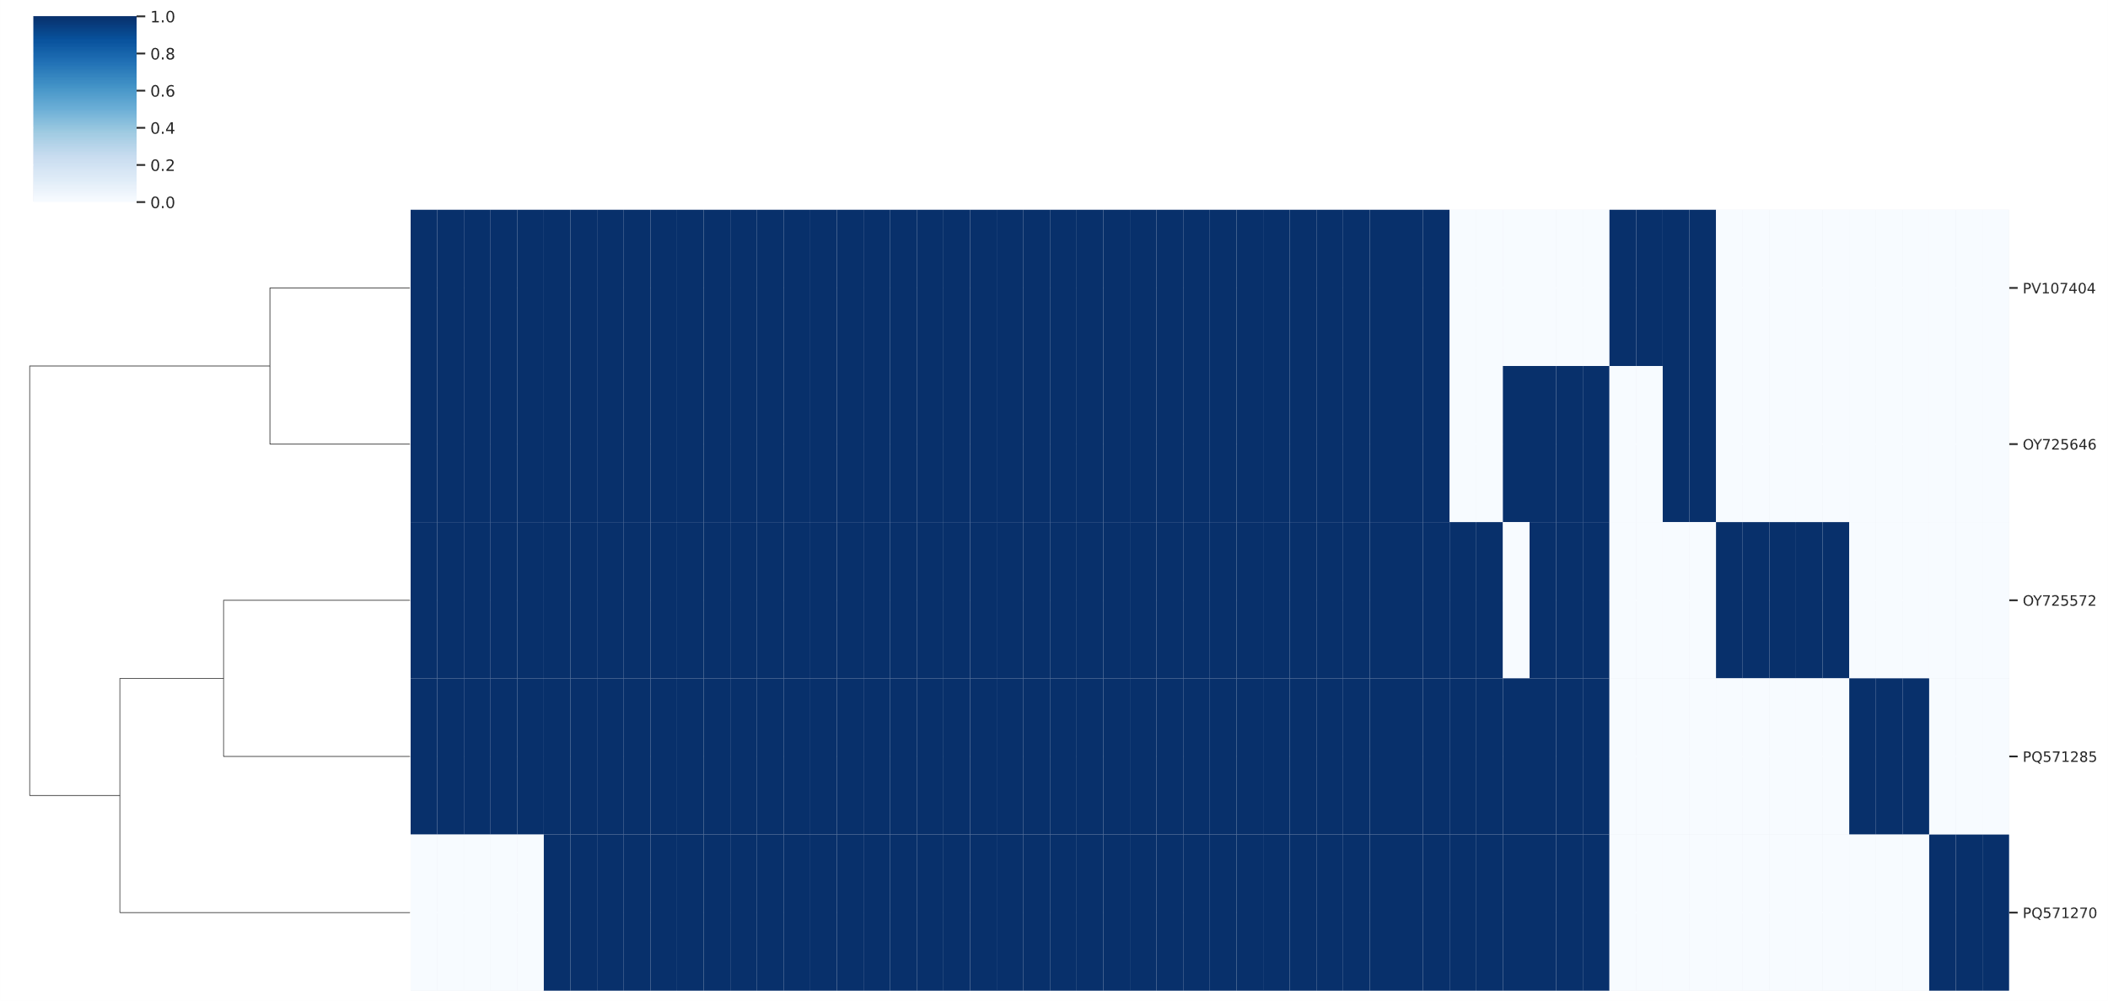

Figure 1. Presence-absence matrix of protein clusters by genome. Rows and columns were hierarchically clustered using the complete linkage method. Rows represent individual genomes with columns representing protein clusters. Vertical blue bars denote the presence of protein clusters in each genome.

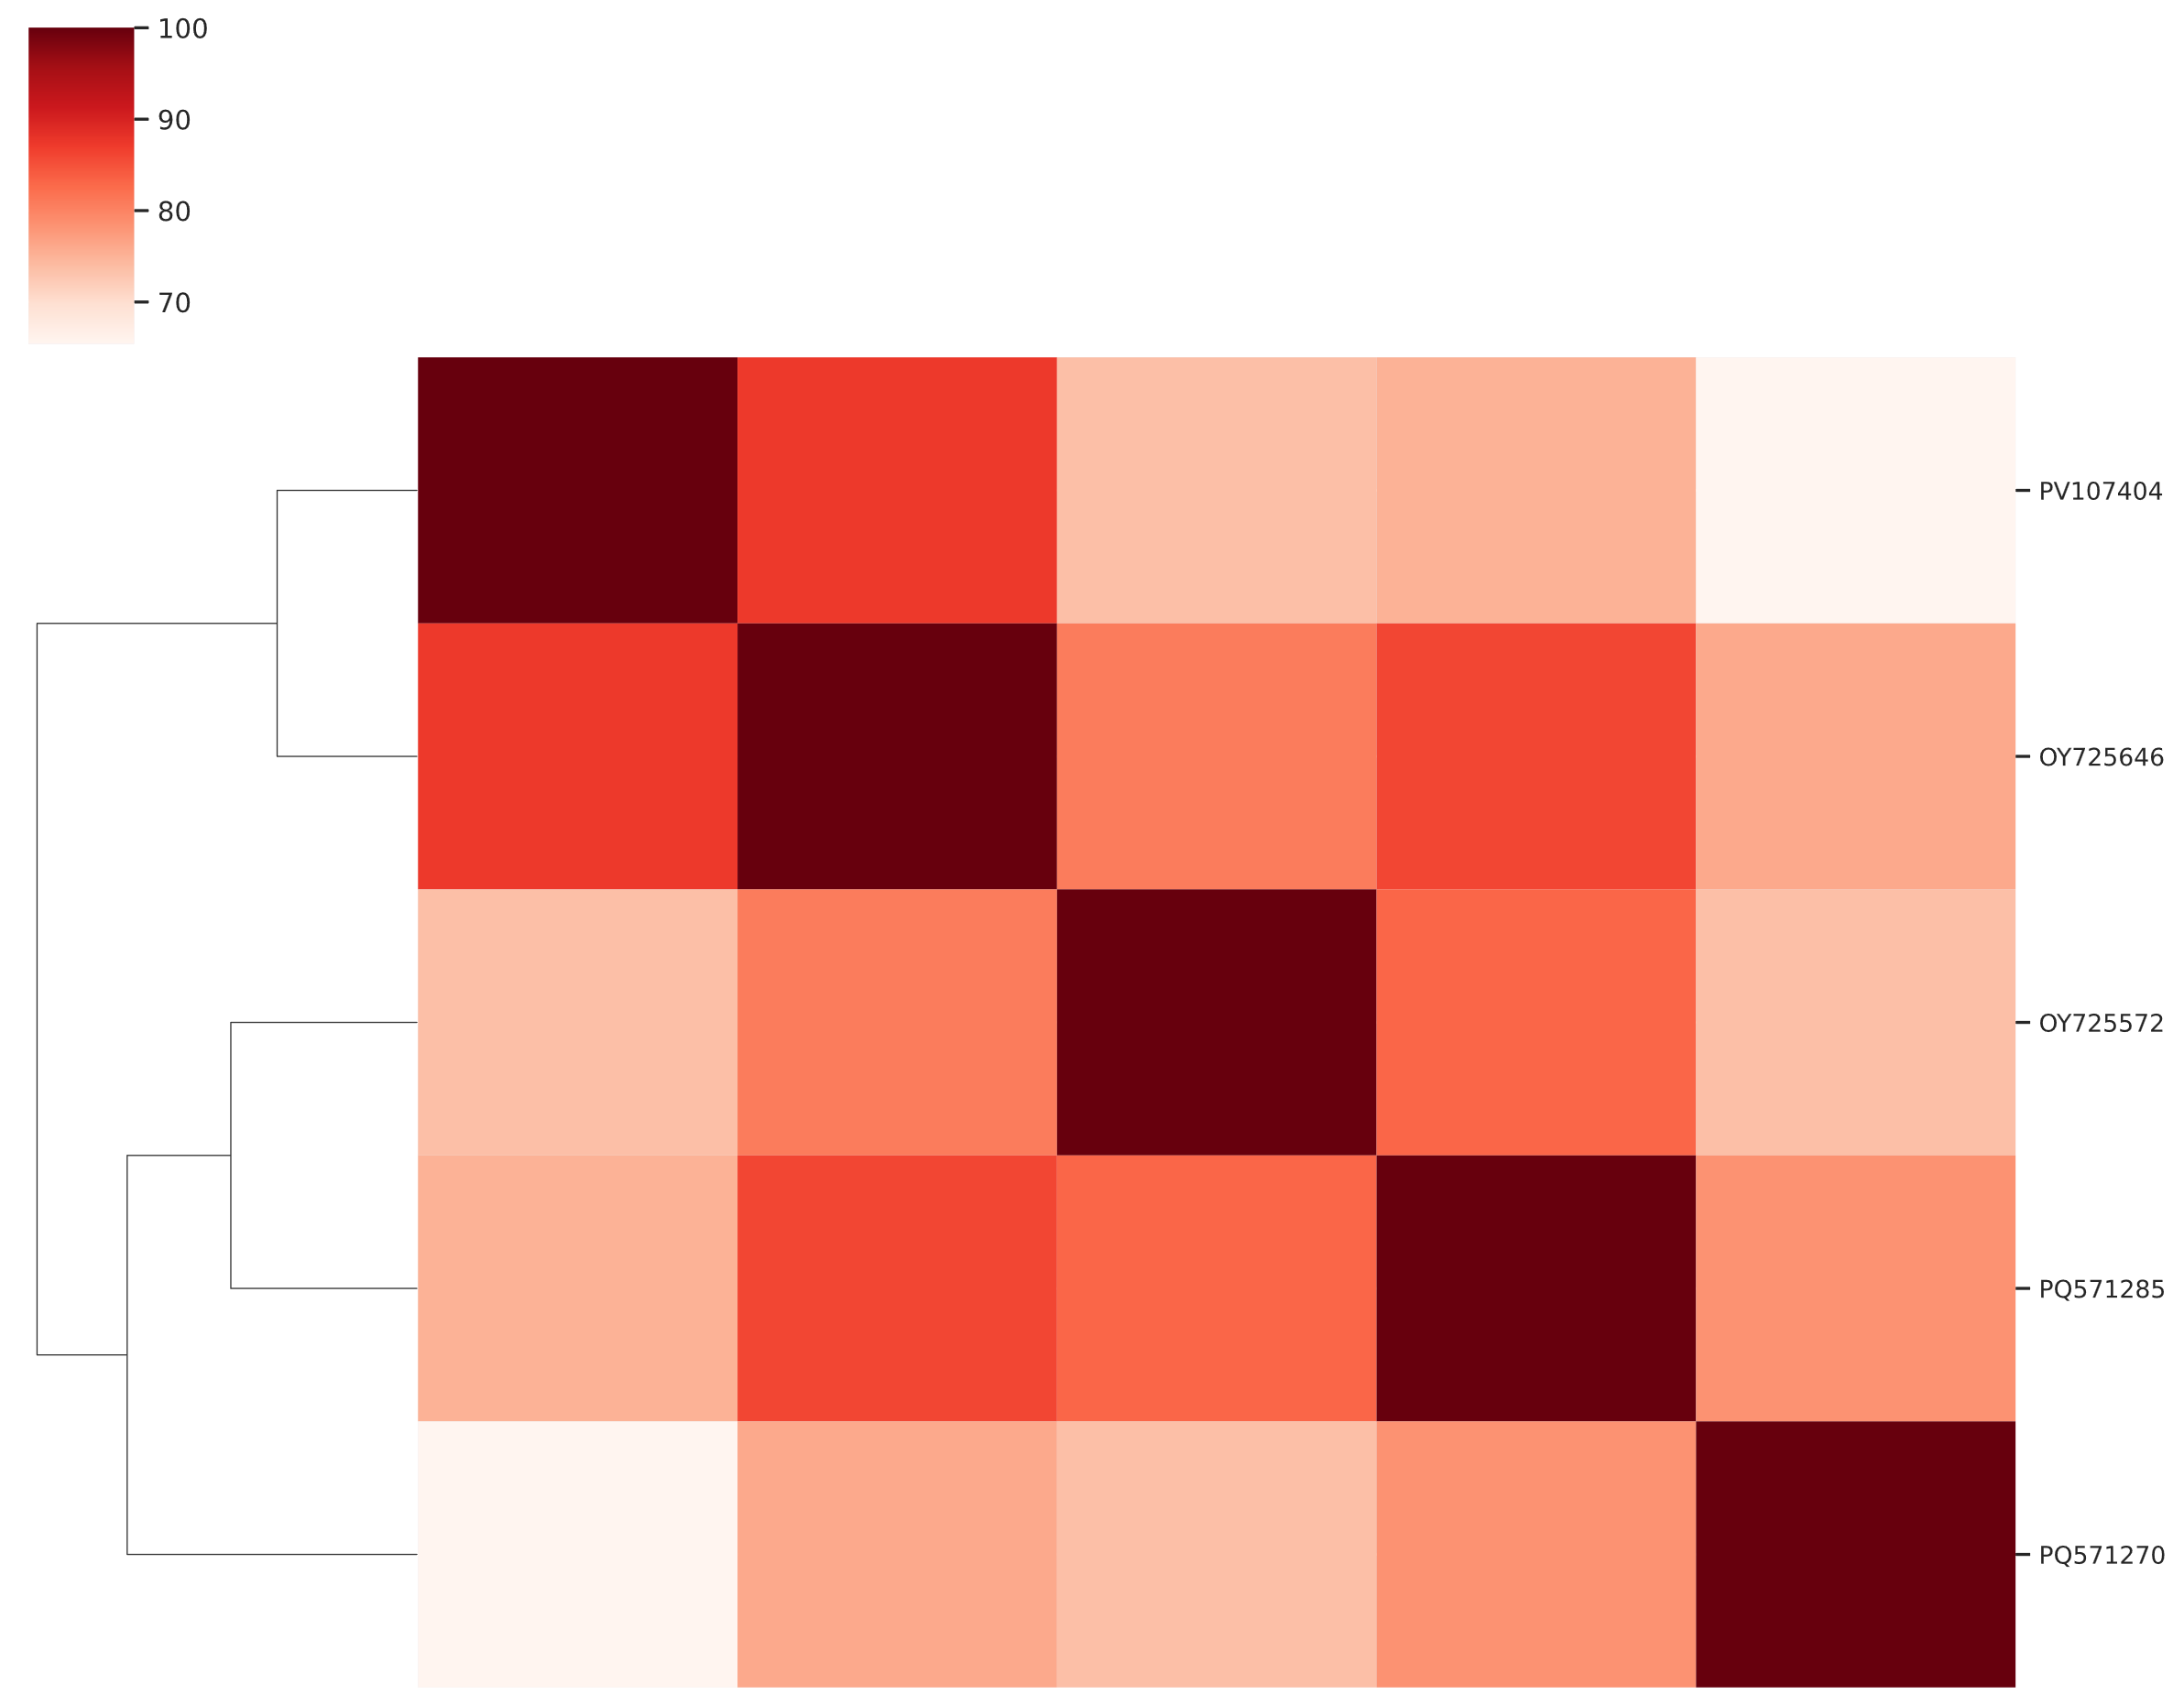

Figure 2. Heatmap of Jaccard similarity calculated from the percentage of shared protein clusters between genomes.

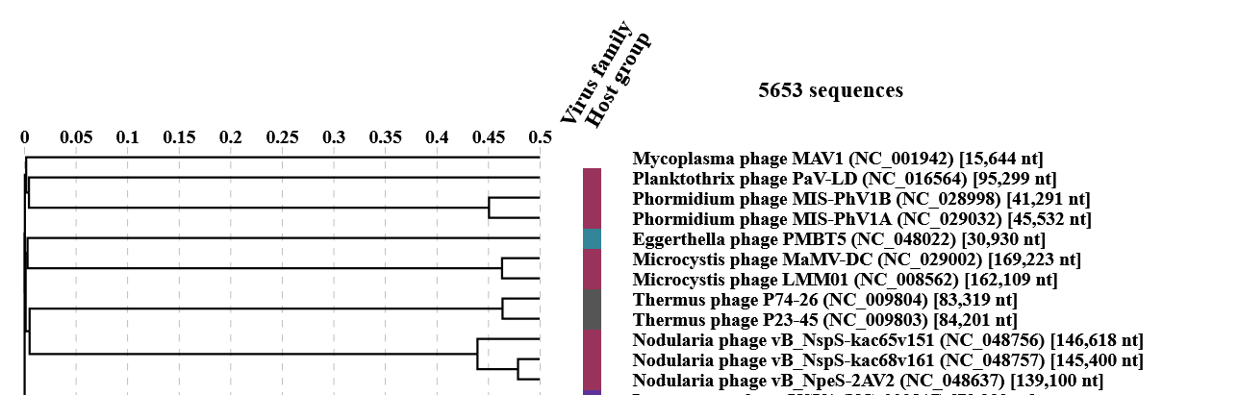
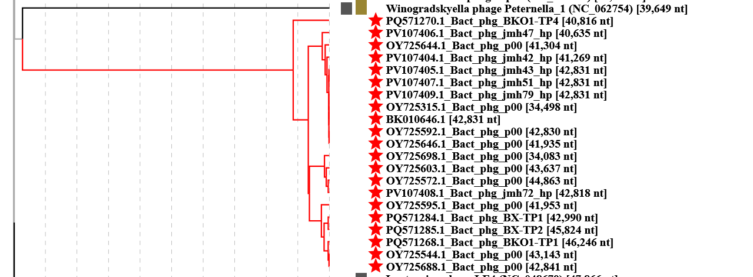

Figure 3. ViPTree analysis: ViPTree analysis (https://www.genome.jp/viptree/; [4]) is based upon Rohwer and Edwards (2002) Phage Proteomic Tree [5]. The taxons under discussion are indicated with red bars and stars. Abbreviations: phg = phage; Bact = Bacteroides

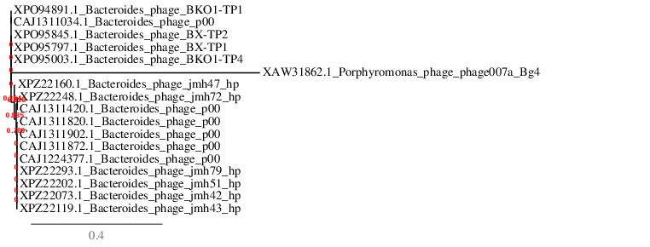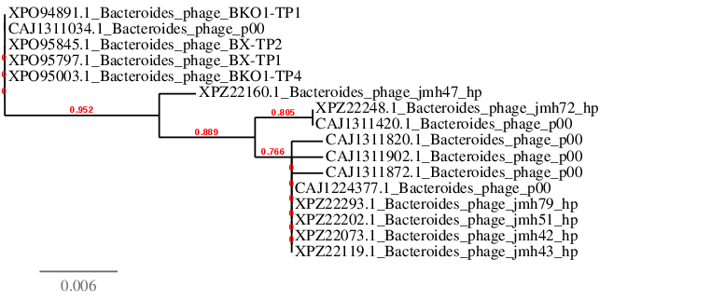
Figure 4. Phylogenetic tree constructed with the large subunit terminase (TerL) proteins from these phages using “One Click” Phylogeny.fr [9] at http://phylogeny.lirmm.fr/phylo_cgi/simple_phylogeny.cgi . TOP, rooted with the TerL protein from Porphyromonas phage phage007a_Bg4 ; BOTTOM, unrooted.

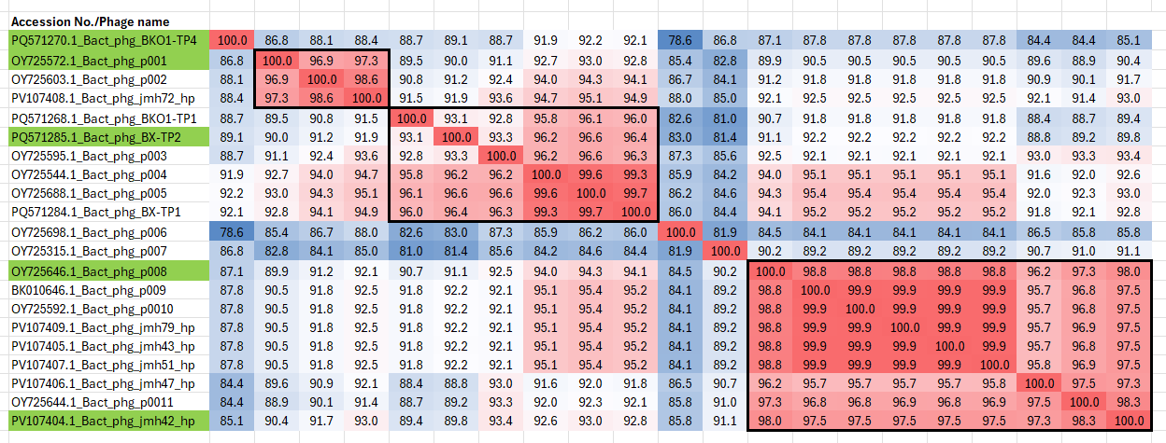

Figure 4. VIRIDIC heatmaps of this group of phages. VIRIDIC (Virus Intergenomic Distance Calculator; VIRIDIC (Virus Intergenomic Distance Calculator; [6]; http://rhea.icbm.uni-oldenburg.de/VIRIDIC/) computes pairwise intergenomic distances/similarities amongst phage genomes. These phages which are considered strains are boxed in black. Names highlighted in green represent new species. Abbreviations: phg = phage; Bact = Bacteroides

Table 1. Characteristics of the phages in the genus “Rouxvirus”

Phage name | Host | Morphotype | Lifestyle | Accession No. | Genome size | %G+C | No. proteins | No. tRNA
Bacteroides phage BKO1-TP4 | Bacteroides koreensis HM3 | Siphovirus | Temperate | PQ571270 | 40,816 bp | 53.0 | 43 | 0
Bacteroides phage p001 | Not given | Siphovirus | Temperate | OY725572 | 44,863 bp | 52.2 | 49 | 0
Bacteroides phage BX-TP2 | Bacteroides xylanisolvens HM7 | Siphovirus | Temperate | PQ571285 | 45,824 bp | 51.6 | 48 | 0
Bacteroides phage p008 | Not given | Siphovirus | Temperate | OY725646 | 41,935 bp | 53.4 | 45 | 1
Bacteroides phage jmh42_hp | Bacteroides thetaiotaomicron jmh42 | Siphovirus | Temperate | PV107404 | 41,269 bp | 53.8 | 42 | 0

Bacteroides phage p001 and Bacteroides phage p008 are so named because of a ENA database error which did not differentiate between them

Specific reference: Vendrell-Fernández S, Beamud B, Abou Haydar Y, Am de Sousa J, Burlaud-Gaillard J, Kornobis E, Raynal B, Vinh J, Bikard D, Ghigo JM. Incomplete lytic cycle of a widespread Bacteroides bacteriophage leads to the formation of defective viral particles. PLoS Biol. 2025 Mar 31;23(3):e3002787. doi: 10.1371/journal.pbio.3002787. PMID: 40163458; PMCID: PMC12135933.

