

The International Committee on Taxonomy of Viruses
Taxonomy Proposal Form, 2026

Part 1a: Details of taxonomy proposals

Title: | Create one new genus, Southlakevirus, in the class Caudoviricetes
Code assigned: | 2026.032B

Author(s), affiliation and email address(es):
Given name (+middle initial(s)) | Surname | Affiliation | Email address | Corr. author(s)
Shitian | Huo | National Key Laboratory of Agricultural Microbiology, Huazhong Agricultural University, Wuhan 430070, China | shitianhuo@webmail.hzau.edu.cn
Pengfei | Zhu | National Key Laboratory of Agricultural Microbiology, Huazhong Agricultural University, Wuhan 430070, China | zpf@webmail.hzau.edu.cn
Donghai | Peng | National Key Laboratory of Agricultural Microbiology, Huazhong Agricultural University, Wuhan 430070, China | donghaipeng@webmail.hzau.edu.cn | X
Jikai | Xu | National Key Laboratory of Agricultural Microbiology, Huazhong Agricultural University, Wuhan 430070, China | jikaixu@webmail.hzau.edu.cn

Part 1b: Taxonomy Proposal Submission
ICTV Subcommittee:
Animal DNA Viruses and Retroviruses |  | Bacterial viruses | X
Animal minus-strand and dsRNA viruses |  | Fungal and protist viruses
Animal positive-strand RNA viruses |  | Plant viruses
Archaeal viruses |  | General -

List the ICTV Study Group(s) that have seen or have been involved in creating this proposal:
Caudoviricetes Study Group

Optional – complete only if formally voted on by an ICTV Study Group:
Study Group | Number of members
Study Group | Votes in support | Votes against | No vote

Submission date: | 11/03/2026

Part 1c: Feedback from ICTV Executive Committee (EC) meeting
Executive Committee Meeting Decision code: | X
A – Accept
Ac – Accept subject to revision by relevant subcommittee chair. No further vote required
U – Accept without revision but with re-evaluation and email vote by the EC
Uc – Accept subject to revision and re-evaluation and email vote by the EC
Ud – Deferred to the next EC meeting, with an invitation to revise based on EC comments
J - Reject
W - Withdrawn

Comments from the Executive Committee:

Part 1d: Revised Taxonomy Proposal Submission
Response of proposer:
Revision date:

Part 3: TAXONOMIC PROPOSAL
https://ictv.global/taxonomy/templates

Taxonomic changes proposed:
Establish new taxon | X | Split taxon
Abolish taxon |  | Merge taxon
Move taxon |  | Promote taxon
Rename taxon |  | Demote taxon
Move and rename

Etymology (origin) of proposed taxonomic names:
Taxon name | Etymology of the term
Southlakevirus | Aeromonas phage BMBAH1 was isolated from a water sample collected from South Lake at Huazhong Agricultural University. We propose to name the new viral genus represented by this phage as Southlakevirus，after the abbreviation of the sampling location.

Permission for use of names derived from a living person:
Taxon name | Full name of person from whom the name is derived | Attached

Abstract of Taxonomy Proposal:
Description of current taxonomy:
Aeromonas phage BMBAH1 is currently unclassified

Proposed taxonomic change(s):
Create a new genus, “Southlakevirus” with one new species: Southlakevirus BMBAH1.

Demarcation criteria for new taxon/taxa:
Species demarcation criteria: Two phages are assigned to the same species if their genomes are more than 95% identical over their genome length for isolates[1].
These values can be calculated by a number of tools, such as BLASTn [4,5] – usually calculated using intergenomic distance calculator VIRIDIC .
Genus demarcation criteria: In search for criteria that create cohesive and distinct genera that are reproducible and monophyletic, the Bacterial Viruses Subcommittee has established 70% nucleotide identity of the genome length as the cut-off for genera. Genus-level groupings should always be monophyletic in the signature genes, as tested with a phylogenetic tree [1].

Justification:
VipTree [2] analysis showed Aeromonas phage BMBAH1 forms a distinct lineage. VIRIDIC [3] analysis revealed minimal genomic similarity to any known phages, with a maximum intergenomic similarity of 30.7%. In phylogenetic trees constructed based on the amino acid sequences of major capsid protein (MCP) and the terminase large subunit (TerL), phage BMBAH1 remained monophyletic. These findings support the conclusion that phage BMBAH1 represents a new genus of bacterial viruses in the class Caudoviricetes.

- Text of Taxonomy proposal:

Description of current taxonomy:
Aeromonas phage BMBAH1 is currently unclassified

Proposed taxonomic change(s):
Create a new genus, “Southlakevirus” with one new species: Southlakevirus BMBAH1.

Demarcation criteria for new taxon/taxa:
Species demarcation criteria: Two phages are assigned to the same species if their genomes are more than 95% identical over their genome length for isolates[1].
These values can be calculated by a number of tools, such as BLASTn [4,5] – usually calculated using intergenomic distance calculator VIRIDIC .
Genus demarcation criteria: In search for criteria that create cohesive and distinct genera that are reproducible and monophyletic, the Bacterial Viruses Subcommittee has established 70% nucleotide identity of the genome length as the cut-off for genera. Genus-level groupings should always be monophyletic in the signature genes, as tested with a phylogenetic tree [1].

Justification:
Aeromonas phage BMBAH1 was isolated from water samples using Aeromonas hydrophila as the host strain. Transmission electron micrographs indicated Aeromonas phage BMBAH1 possesses an icosahedral head and a long, non-contractile tail. The genome of Aeromonas phage BMBAH1 is 237 kb in full length with a guanine-cytosine (GC) content of 44.3%.
Proteome-based phylogenetic analysis using VipTree revealed that Aeromonas phage BMBAH1 formed a distinct lineage (Figure 2). Furthermore, VIRIDIC-based analysis revealed that phage BMBAH1 exhibited the highest intergemomic nucleotide sequence similarity to Aeromonas phage D3 (NC_070957.1), with a value of 30.7% (Figure 3), which aligns with the branching structure of the TBLASTX distance tree obtained from ViPTree. In phylogenetic trees constructed based on the amino acid sequences of the major capsid protein (MCP) and the terminase large subunit (TerL), phage BMBAH1 remained monophyletic (Figure 4). Collectively, these findings support the classification of phage BMBAH1 as a representative of a new viral genus.

References:
- Turner D, Kropinski AM, Adriaenssens EM. A Roadmap for Genome-Based Phage Taxonomy. Viruses. 2021 Mar 18;13(3):506. doi: 10.3390/v13030506. PMID: 33803862; PMCID: PMC8003253.
- Nishimura Y, Yoshida T, Kuronishi M, Uehara H, Ogata H, Goto S. ViPTree: the viral proteomic tree server. Bioinformatics. 2017 Aug 1;33(15):2379-2380. doi: 10.1093/bioinformatics/btx157. PMID: 28379287.
- Moraru C, Varsani A, Kropinski AM. VIRIDIC-A Novel Tool to Calculate the Intergenomic Similarities of Prokaryote-Infecting Viruses. Viruses. 2020 Nov 6;12(11):1268. doi: 10.3390/v12111268. PMID: 33172115; PMCID: PMC7694805..
- Sayers EW, Beck J, Bolton EE, Bourexis D, Brister JR, Canese K, Comeau DC, Funk K, Kim S, Klimke W, Marchler-Bauer A, Landrum M, Lathrop S, Lu Z, Madden TL, O'Leary N, Phan L, Rangwala SH, Schneider VA, Skripchenko Y, Wang J, Ye J, Trawick BW, Pruitt KD, Sherry ST. Database resources of the National Center for Biotechnology Information. Nucleic Acids Res. 2021 Jan 8;49(D1):D10-D17. doi: 10.1093/nar/gkaa892. PMID: 33095870; PMCID: PMC7778943
- O'Leary NA, Wright MW, Brister JR, Ciufo S, Haddad D, McVeigh R, et al. Reference sequence (RefSeq) database at NCBI: current status, taxonomic expansion, and functional annotation. Nucleic Acids Res. 2016;44(D1):D733-45. doi: 10.1093/nar/gkv1189. PMID: 26553804.
- Letunic I, Bork P. Interactive Tree of Life (iTOL) v6: recent updates to the phylogenetic tree display and annotation tool. Nucleic Acids Res. 2024 Jul 5;52(W1):W78-W82. doi: 10.1093/nar/gkae268. PMID: 38613393; PMCID: PMC11223838.

Accompanying files:
Filename | Description of contents

Tables, Figures:

<Start here>
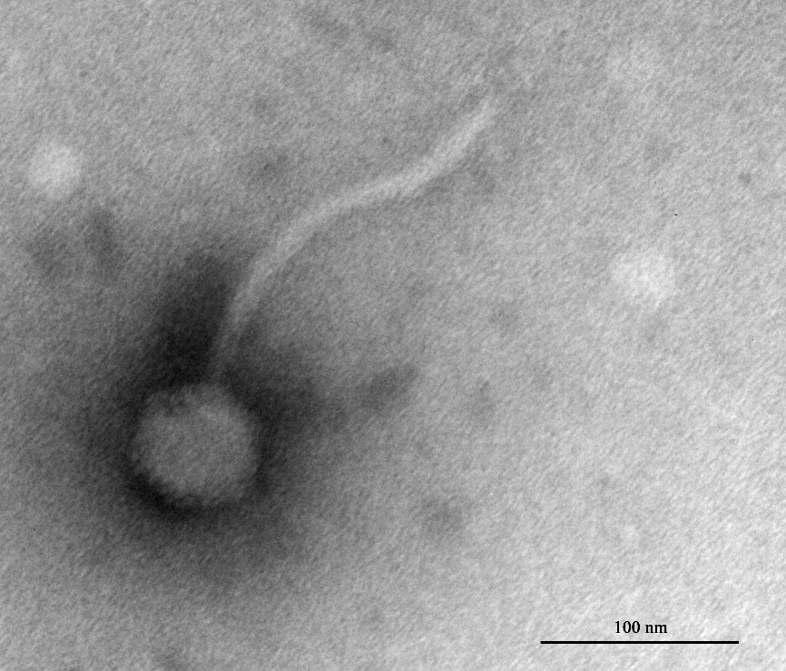

Figure1: Electron micrographs of Aeromonas phage BMBAH1 negatively stained with2% uranyl acetate.
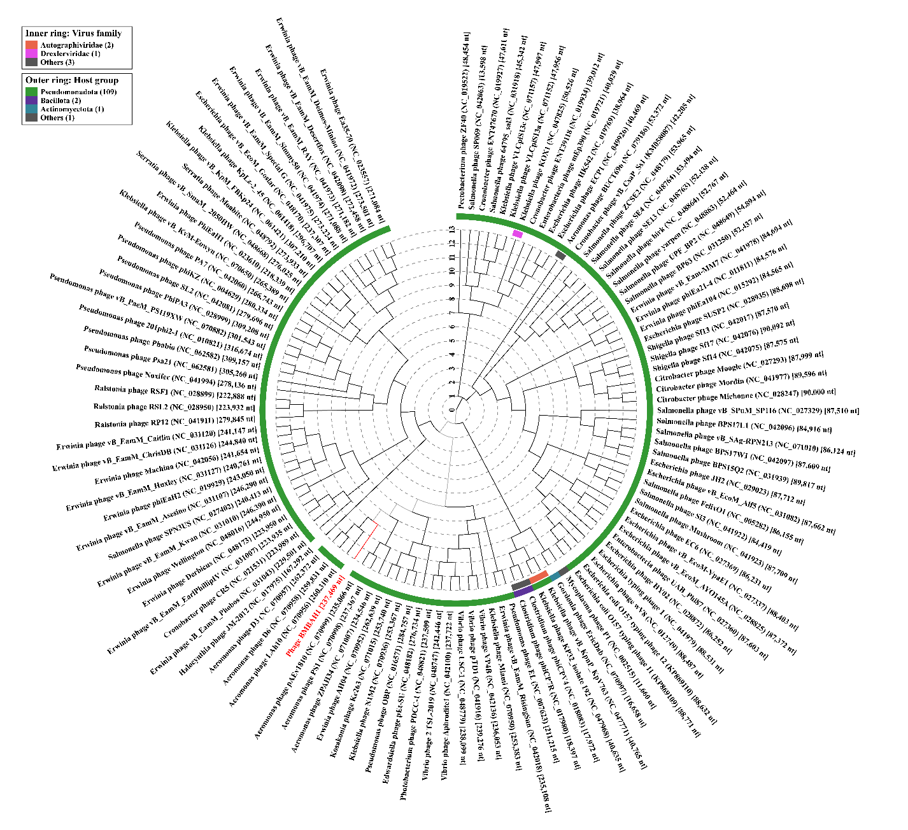

Figure 2: ViPTree analysis. In the phylogenetic tree, Aeromonas phage BMBAH1 forms a distinct lineage, with its closest relatives being Aeromonas phages D3, D6, and Lah10. Aeromonas phage BMBAH1 is marked in red.
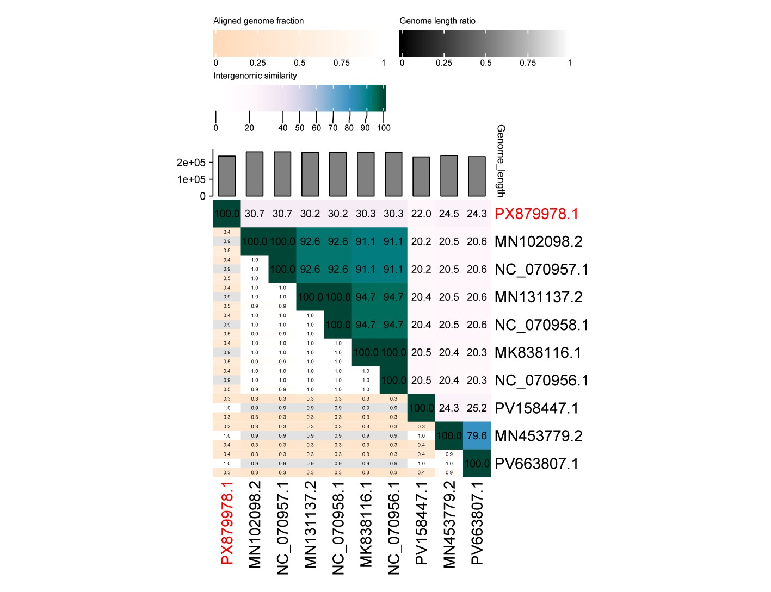 Figure 3: Intergenomic similarity analysis using VIRIDIC revealed that Aeromonas phage BMBAH1 shared the highest nucleotide sequence similarity with Aeromonas phage D3 (NC_070957.1) at 30.7%, indicating its closest relationship among all compared phages. This result aligns with the findings from the ViPTree analysis. Aeromonas phage BMBAH1 is marked in red.

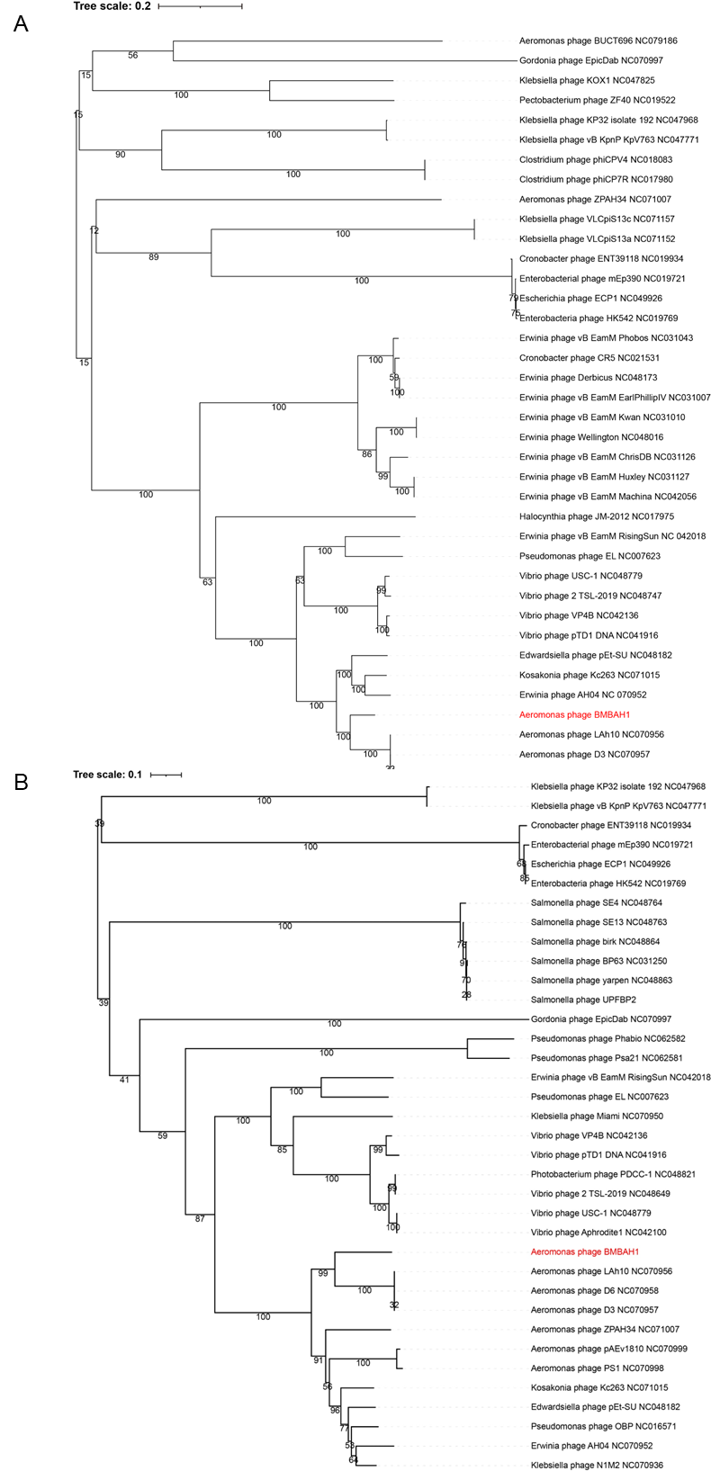
Figure 4: Phylogenetic tree constructed based on amino acid sequences of conserved genes. The major capsid protein (Fig.4A) and terminase large subunit (Fig.4B) of phage BMBAH1 remain monophyletic, consistent with the phylogeny inferred from the whole-genome protein complement. In the figure, use the names of phages to replace the corresponding protein sequence names. Phylogenetic trees were reconstructed using the maximum-likelihood method implemented in IQ-TREE [6]with 1,000 ultrafast bootstrap replicates.

