

The International Committee on Taxonomy of Viruses
Taxonomy Proposal Form, 2026

Part 1a: Details of taxonomy proposals

Title: | To create four new genera of Gordonia siphoviruses in the class Caudoviricetes
Code assigned: | 2026.031B

Author(s), affiliation and email address(es):
Given name (+middle initial(s)) | Surname | Affiliation | Email address | Corr. author(s)
Ipek | Kurtböke | Environmental Microbiology, University of the Sunshine Coast,  School of Science, Technology and Engineering,  Maroochydore DC, Australia | IKurtbok@usc.edu.au
Cristina M. | Moraru | Department of Chemistry, Environmental Metagenomics,  University of Duisburg-Essen,  D-45141 Essen,  Germany | lilianacristina.moraru@uni-due.de
Andrew M. | Kropinski | University of Guelph, Guelph, Ontario, Canada N1G2W1 | Phage.Canada@gmail.com | x

Part 1b: Taxonomy Proposal Submission
ICTV Subcommittee:
Animal DNA Viruses and Retroviruses |  | Bacterial viruses | x
Animal minus-strand and dsRNA viruses |  | Fungal and protist viruses
Animal positive-strand RNA viruses |  | Plant viruses
Archaeal viruses |  | General -

List the ICTV Study Group(s) that have seen or have been involved in creating this proposal:
Optional – complete only if formally voted on by an ICTV Study Group:
Study Group | Number of members
Study Group | Votes in support | Votes against | No vote
Actinophage

Submission date: | 07/04/2026

Part 1c: Feedback from ICTV Executive Committee (EC) meeting
Executive Committee Meeting Decision code: | X
A – Accept
Ac – Accept subject to revision by relevant subcommittee chair. No further vote required
U – Accept without revision but with re-evaluation and email vote by the EC
Uc – Accept subject to revision and re-evaluation and email vote by the EC
Ud – Deferred to the next EC meeting, with an invitation to revise based on EC comments
J - Reject
W - Withdrawn

Comments from the Executive Committee:

Part 1d: Revised Taxonomy Proposal Submission
Response of proposer:
Revision date:

Part 3: TAXONOMIC PROPOSAL

Taxonomic changes proposed:
Establish new taxon | x | Split taxon
Abolish taxon |  | Merge taxon
Move taxon |  | Promote taxon
Rename taxon |  | Demote taxon
Move and rename

Etymology (origin) of proposed taxonomic names:
Taxon name | Etymology of the term
Gudmitvirus | Named directly after Gordonia phage Gudmit
Kikovirus | Named directly after Gordonia phage Kiko
Siskovirus | Named directly after Gordonia phage Sisko
Coldpizzavirus | Named directly after Gordonia phage Coldpizza

Permission for use of names derived from a living person:
Taxon name | Full name of person from whom the name is derived | Attached

Abstract of Taxonomy Proposal:

Description of current taxonomy:
The bacteriophages described in this proposal are currently unclassified. These phages have been assigned to the Actinobacteriophage Database Clusters DR (ColdPizza, Sisko) are lytic while Gudmit is a singleton and Kiko belongs to Cluster DB. They are peripherally related to Rosebushvirus.

Proposed taxonomic change(s):
We propose to create four new genera: "Gudmitvirus", "Kikovirus", "Siskovirus" and "Coldpizzavirus" with 7 new species.

Demarcation criteria for new taxon/taxa:
Genus demarcation criteria: An intergenomic similarity cut-off of 70%, a combination of average nucleotide identity and alignment fraction, is used to determine genera demarcation. Members of the same genus have >70% intergenomic similarity and cluster tightly in marker gene phylogenies.

Species demarcation criteria: A demarcation value of 95% intergenomic similarity was used to define different species according to intergenomic similarity. Members of the same genus have >95% intergenomic similarity.

Justification:
The viruses described in this proposal are siphoviruses that infect Gordonia sp. Analysis of intergenomic nucleotide similarity with VIRIDIC supports the creation of five new genera and eight new species in concordance with the current demarcation criteria. These genera are also supported by the branch structure of the TBLASTX distance tree (ViPTree) and phylogenetic analysis of the large terminase subunit.

Text of Taxonomy proposal:
Description of current taxonomy:
The bacteriophages described in this proposal are currently unclassified. These phages have been assigned to the Actinobacteriophage Database Clusters DR (ColdPizza, Sisko) are lytic while Gudmit is a singleton and Kiko belongs to Cluster DB. They are peripherally related to Rosebushvirus.

Proposed taxonomic change(s):
We propose to create four new genera: "Gudmitvirus", "Kikovirus", "Siskovirus" and "Coldpizzavirus" with 7 new species.

Demarcation criteria for new taxon/taxa:
Genus demarcation criteria: An intergenomic similarity cut-off of 70%, a combination of average nucleotide identity and alignment fraction, is used to determine genera demarcation. Members of the same genus have >70% intergenomic similarity and cluster tightly in marker gene phylogenies.

Species demarcation criteria: A demarcation value of 95% intergenomic similarity was used to define different species according to intergenomic similarity. Members of the same genus have >95% intergenomic similarity.

Justification:
The viruses described in this proposal are siphoviruses that infect Gordonia sp. Analysis of intergenomic nucleotide similarity with VIRIDIC supports the creation of five new genera and eight new species in concordance with the current demarcation criteria. These genera are also supported by the branch structure of the TBLASTX distance tree (ViPTree) and phylogenetic analysis of the large terminase subunit.

References:
1. Moraru C, Varsani A, Kropinski AM. VIRIDIC-A Novel Tool to Calculate the Intergenomic Similarities of Prokaryote-Infecting Viruses. Viruses. 2020 Nov 6;12(11):1268. doi: 10.3390/v12111268. PMID: 33172115; PMCID: PMC7694805. http://kronos.icbm.uni-oldenburg.de/viridic/
2. Nishimura Y, Yoshida T, Kuronishi M, Uehara H, Ogata H, Goto S. ViPTree: the viral proteomic tree server. Bioinformatics. 2017; 33(15):2379-2380. doi:10.1093/bioinformatics/btx157. PubMed PMID: 28379287. https://www.genome.jp/viptree/
3. Rohwer F, Edwards R. The Phage Proteomic Tree: a genome-based taxonomy for phage. J Bacteriol. 2002 Aug;184(16):4529-35. PubMed PMID: 12142423
4. Turner D, Reynolds D, Seto D, Mahadevan P. CoreGenes3.5: a webserver for the determination of core genes from sets of viral and small bacterial genomes. BMC Res Notes. 2013;6:140. doi: 10.1186/1756-0500-6-140. PMID: 23566564.
5. Davis P, Seto D, Mahadevan P. CoreGenes5.0: An Updated User-Friendly Webserver for the Determination of Core Genes from Sets of Viral and Bacterial Genomes. Viruses. 2022 Nov 16;14(11):2534. doi: 10.3390/v14112534. PMID: 36423143; PMCID: PMC9693508.
6. Turner D, Kropinski AM, Adriaenssens EM. A Roadmap for Genome-Based Phage Taxonomy. Viruses. 2021 Mar 18;13(3):506. doi: 10.3390/v13030506. PMID: 33803862; PMCID: PMC8003253.
Lemoine F, Correia D, Lefort V, Doppelt-Azeroual O, Mareuil F, Cohen-Boulakia S, Gascuel O. NGPhylogeny.fr: new generation phylogenetic services for non-specialists. Nucleic Acids Res. 2019 Jul 2;47(W1):W260-W265. doi: 10.1093/nar/gkz303. PMID: 31028399; PMCID: PMC6602494.
7. Letunic I, Bork P. Interactive Tree Of Life (iTOL): an online tool for phylogenetic tree display and annotation. Bioinformatics. 2007 Jan 1;23(1):127-8. doi: 10.1093/bioinformatics/btl529. Epub 2006 Oct 18. PMID: 17050570.
8. Zhou T, Xu K, Zhao F, Liu W, Li L, Hua Z, Zhou X. itol.toolkit accelerates working with iTOL (Interactive Tree of Life) by an automated generation of annotation files. Bioinformatics. 2023 Jun 1;39(6):btad339. doi: 10.1093/bioinformatics/btad339. PMID: 37225402; PMCID: PMC10243930
9. Dereeper A, Guignon V, Blanc G, Audic S, Buffet S, Chevenet F, Dufayard JF, Guindon S, Lefort V, Lescot M, Claverie JM, Gascuel O. Phylogeny.fr: robust phylogenetic analysis for the non-specialist. Nucleic Acids Res. 2008 Jul 1;36(Web Server issue):W465-9. doi: 10.1093/nar/gkn180. Epub 2008 Apr 19. PMID: 18424797; PMCID: PMC2447785.

Accompanying files:
Filename | Description of contents
Gordoniaphages_4ng_7nsp | Excel spreadsheet associated with this TaxoProp

Tables, Figures:

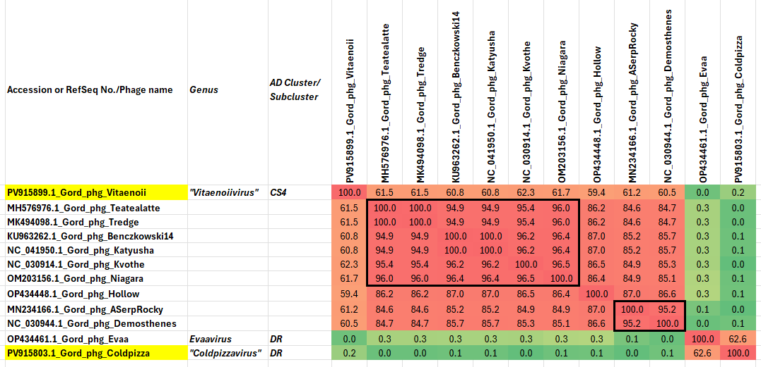

Figure 1. VIRIDIC heatmaps of this group of phages. VIRIDIC (Virus Intergenomic Distance Calculator; VIRIDIC (Virus Intergenomic Distance Calculator; [1]; http://rhea.icbm.uni-oldenburg.de/VIRIDIC/) computes pairwise intergenomic distances/similarities amongst phage genomes. The yellow highlighted Accession numbers represent new species. Data values which are bordered in black correspond to strains. Abbreviations: phg = phage; Gord = Gordonia; Myco = Mycobacterium, Tsuk = Tsukamurella. Because of the difficulty in seeing the second figure we have attached the complete Excel spreadsheet,

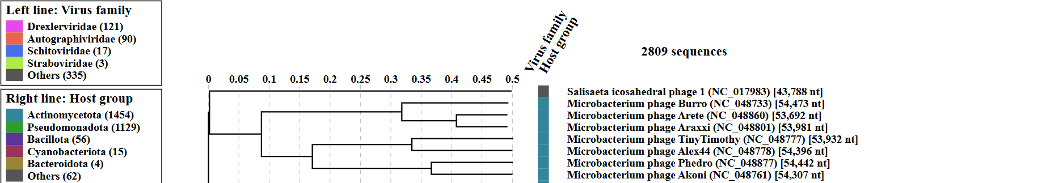
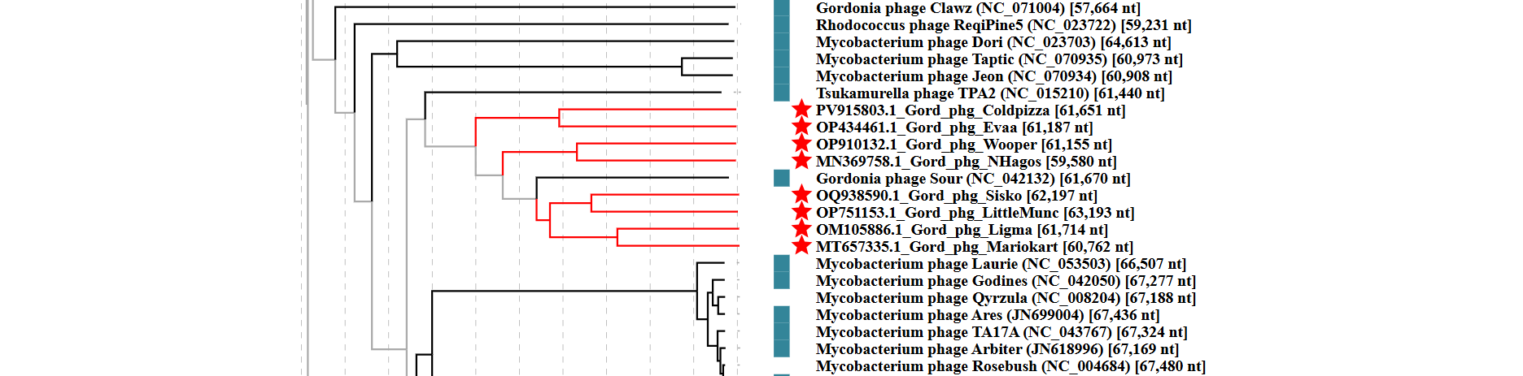
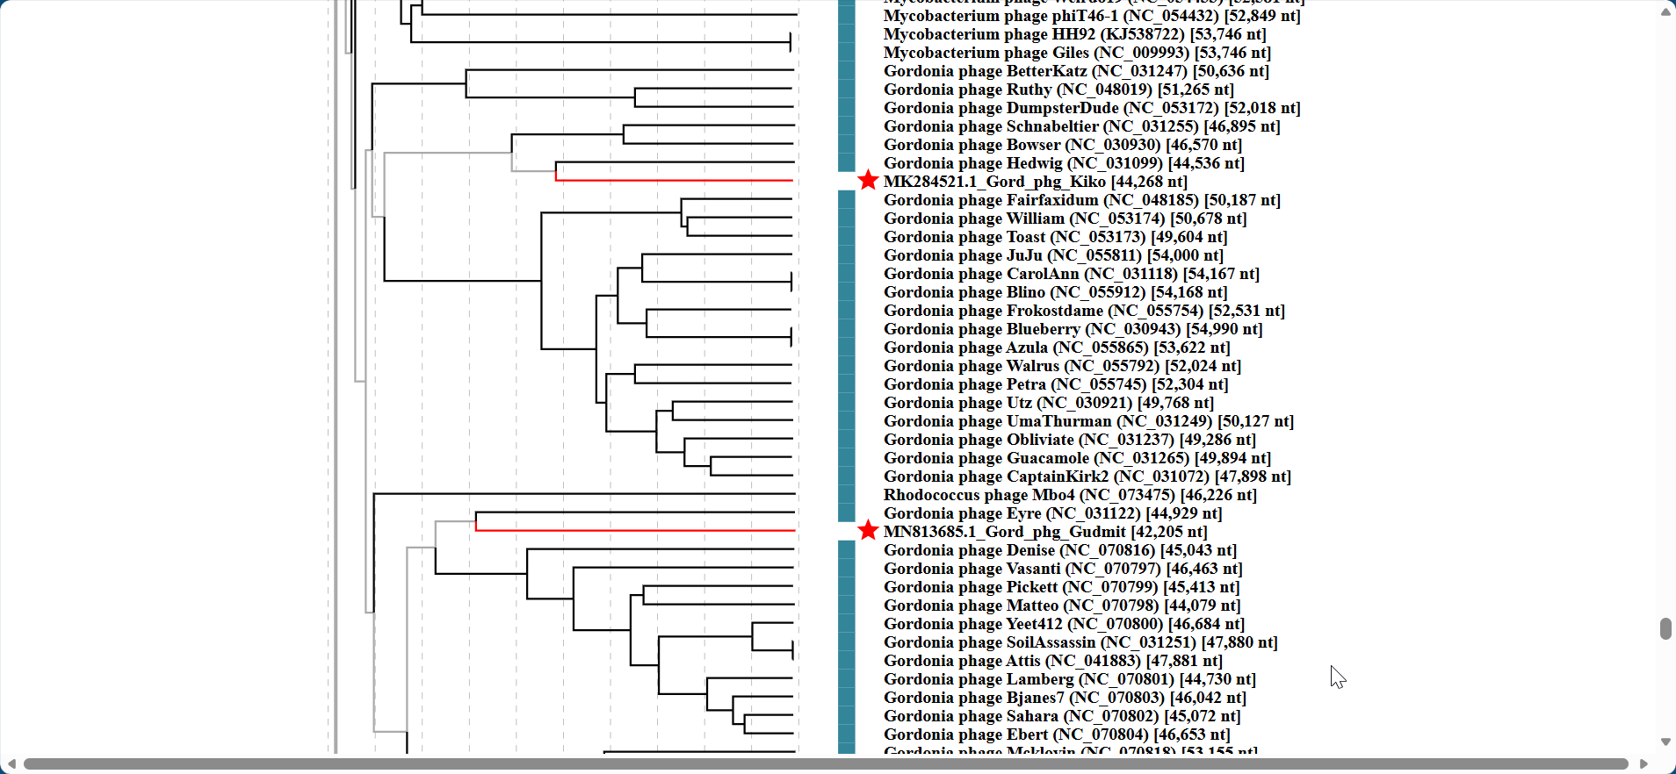

Figure 2. ViPTree analysis: ViPTree analysis (https://www.genome.jp/viptree/; [2]) is based upon Rohwer and Edwards (2002) Phage Proteomic Tree [3]. The taxons under discussion are indicated with red bars and stars. Abbreviations: phg = phage; Gord = Gordonia; Myco = Mycobacterium, Tsuk = Tsukamurella.

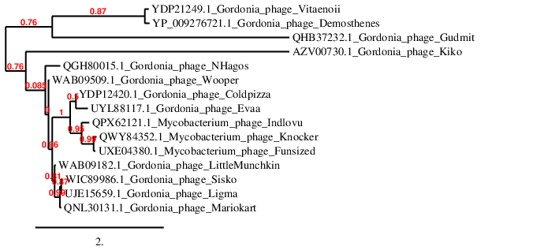Figure 3. Phylogenetic tree constructed with the large subunit terminase proteins from these and related phages using “One Click” Phylogeny.fr [9] at https://www.phylogeny.fr using the TerL protein from Gordonia phage Demosthenes as an outlier.

Table 1. Characteristics of the phage in the genus “Coldpizzavirus”.

Phage name | Host | Morphotype | Lifestyle | Accession No. | Genome size | %G+C | Termini | No. proteins | No. tRNA
Gordonia phage Coldpizza | Gordonia rubripertincta NRRL B-16540 | Siphovirus | Lytic | PV915803 | 61651 bp | 67.6 | Circularly Permuted | 79 | 0

Table 2. Characteristics of the phages in the genus “Siskovirus”.

Phage name | Host | Morphotype | Lifestyle | Accession No. | Genome size | %G+C | Termini | No. proteins | No. tRNA
Gordonia phage Sisko | Gordonia terrae 3612 | Siphovirus | Lytic | OQ938590 | 62197 bp | 69.9 | Circularly permuted | 84 | 0
Gordonia phage BiggityBass | Gordonia terrae CAG3 | Siphovirus | Lytic | ON260813 | 63202 bp | 69.4 | Circularly permuted | 84 | 0
Gordonia phage AnClar | Gordonia terrae 3612 | Siphovirus | Lytic | MN908693 | 61856 bp | 69.8 | Circularly permuted | 81 | 0
Gordonia phage LittleMunchkin | Gordonia terrae CAG3 | Siphovirus | Lytic | OP751153 | 63193 bp | 69.4 | Circularly permuted | 85 | 0

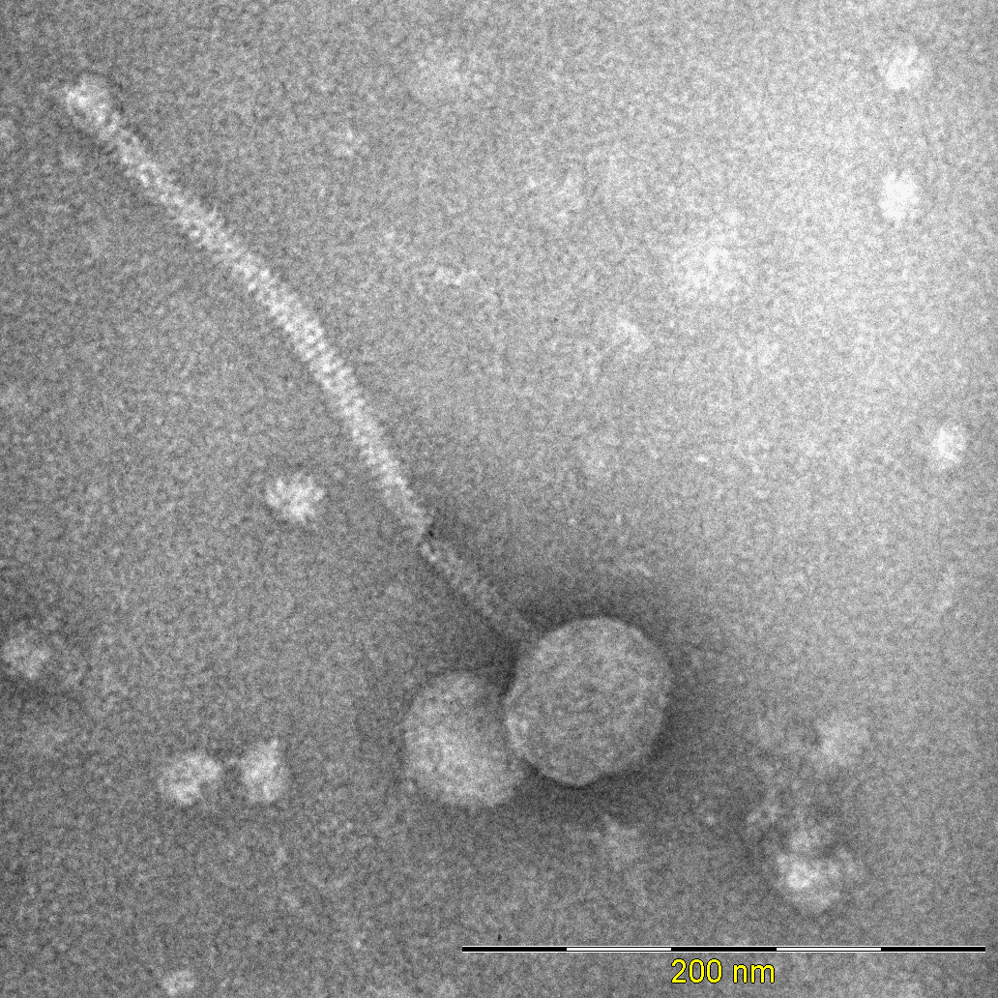
Figure 4. Electron micrograph: Electron micrograph of negatively stained Gordonia phage Cisko (https://phagesdb.org/phages/Cisko/). Limited permission was granted by The Actinobacteriophage Database (https://phagesdb.org/), funded by the Howard Hughes Medical Institute, to use this electron micrograph for this taxonomy proposal; it cannot be reused without permission of The Actinobacteriophage Database.

Table 3. Characteristics of the phage in the genus “Kikovirus”.

Phage name | Host | Morphotype | Lifestyle | Accession No. | Genome size | %G+C | 3’-cohesive ends | No. proteins | No. tRNA
Gordonia phage Kiko | Gordonia terrae 3612 | Siphovirus | Temperate | MK284521 | 44268 bp | 66.5 | TCCTCGGTCA | 67 | 0

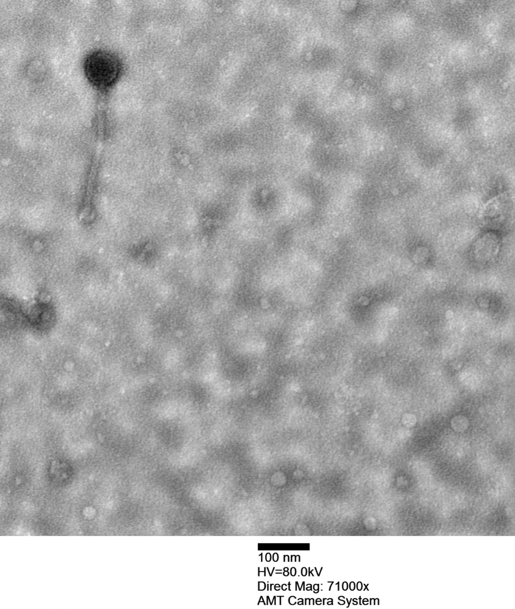
Figure 5. Electron micrograph: Electron micrograph of negatively stained Gordonia phage Kiko (https://phagesdb.org/phages/Kiko/). Limited permission was granted by The Actinobacteriophage Database (https://phagesdb.org/), funded by the Howard Hughes Medical Institute, to use this electron micrograph for this taxonomy proposal; it cannot be reused without permission of The Actinobacteriophage Database.

Table 4. Characteristics of the phage in the genus “Gudmitvirus”.

Phage name | Host | Morphotype | Lifestyle | Accession No. | Genome size | %G+C | 3’-cohesive ends | No. proteins | No. tRNA
Gordonia phage Gudmit | Gordonia terrae 3612 | Siphovirus | Temperate | MN813685 | 42205 bp | 65.9 | TCCCCCGGCG | 73 | 0

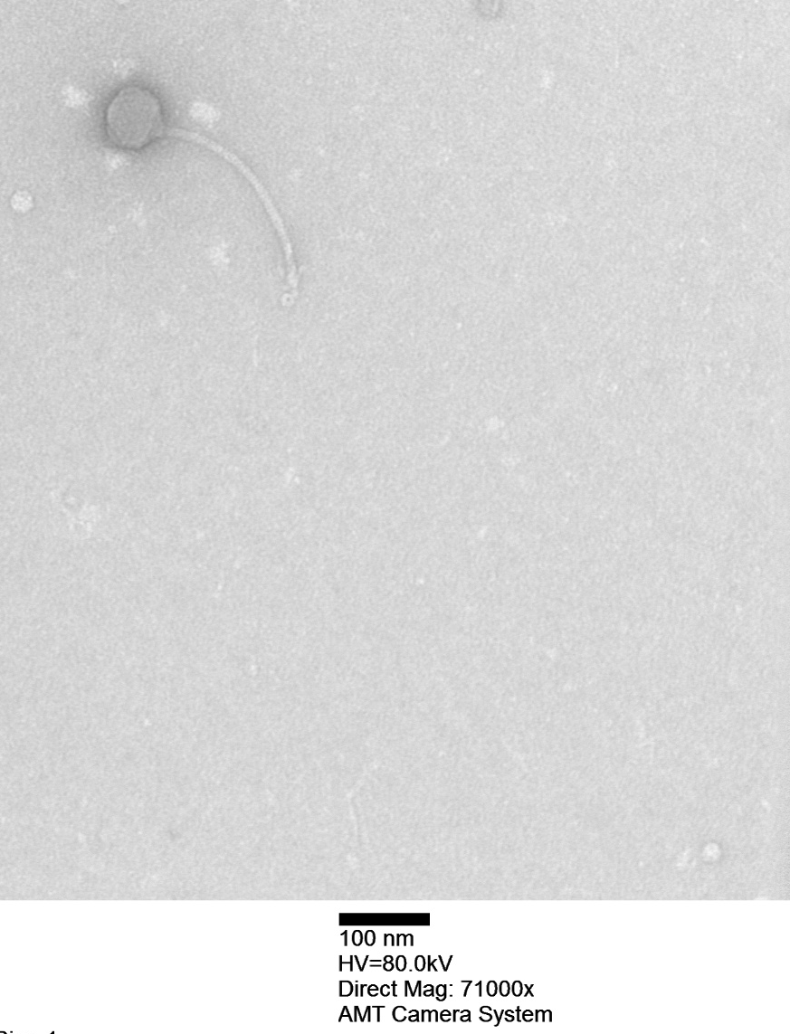

Figure 6. Electron micrograph: Electron micrograph of negatively stained Gordonia phage Gudmit (https://phagesdb.org/phages/Gudmit/). Limited permission was granted by The Actinobacteriophage Database (https://phagesdb.org/), funded by the Howard Hughes Medical Institute, to use this electron micrograph for this taxonomy proposal; it cannot be reused without permission of The Actinobacteriophage Database.

