

The International Committee on Taxonomy of Viruses
Taxonomy Proposal Form, 2026

Part 1a: Details of taxonomy proposals

Title: | To create one new genus, Gandarillasvirus in the class Caudoviricetes
Code assigned: | 2026.030B

Author(s), affiliation and email address(es):
Given name (+middle initial(s)) | Surname | Affiliation | Email address | Corr. author(s)
Andrea I. | Moreno Swit | Escuela de Medicina Veterinaria, Pontificia Universidad Católica de Chile, Santiago 7820436, Chile | andrea.moreno@uc.cl | X
Cristina M. | Moraru | Department of Chemistry, Environmental Metagenomics,  University of Duisburg-Essen,  D-45141 Essen,  Germany | lilianacristina.moraru@uni-due.de
Andrew M. | Kropinski | University of Guelph, Guelph, Ontario, Canada N1G2W1 | Phage.Canada@gmail.com | x

Part 1b: Taxonomy Proposal Submission
ICTV Subcommittee:
Animal DNA Viruses and Retroviruses |  | Bacterial viruses | x
Animal minus-strand and dsRNA viruses |  | Fungal and protist viruses
Animal positive-strand RNA viruses |  | Plant viruses
Archaeal viruses |  | General -

List the ICTV Study Group(s) that have seen or have been involved in creating this proposal:
Caudoviricetes Study Group
Optional – complete only if formally voted on by an ICTV Study Group:
Study Group | Number of members
Study Group | Votes in support | Votes against | No vote

Submission date: | 27/05/2026

Part 1c: Feedback from ICTV Executive Committee (EC) meeting
Executive Committee Meeting Decision code: | X
A – Accept
Ac – Accept subject to revision by relevant subcommittee chair. No further vote required
U – Accept without revision but with re-evaluation and email vote by the EC
Uc – Accept subject to revision and re-evaluation and email vote by the EC
Ud – Deferred to the next EC meeting, with an invitation to revise based on EC comments
J - Reject
W - Withdrawn

Comments from the Executive Committee:

Part 1d: Revised Taxonomy Proposal Submission
Response of proposer:
Revision date:

Part 3: TAXONOMIC PROPOSAL

Taxonomic changes proposed:
Establish new taxon | x | Split taxon
Abolish taxon |  | Merge taxon
Move taxon |  | Promote taxon
Rename taxon |  | Demote taxon
Move and rename

Etymology (origin) of proposed taxonomic names:
Taxon name | Etymology of the term
Gandarillasvirus | Named in honour of the first rector of the Pontifical Catholic University of Chile (Santiago) - Joaquín Larraín Gandarillas (†) (https://en.wikipedia.org/wiki/Joaqu%C3%ADn_Larra%C3%ADn_Gandarillas)

Permission for use of names derived from a living person:
Taxon name | Full name of person from whom the name is derived | Attached

Abstract of Taxonomy Proposal:

Description of current taxonomy:
The bacterial virus described in the proposal is currently unclassified.

Proposed taxonomic change(s):
We propose to create a new genus named “Gandarillasvirus” and one new species.

Demarcation criteria for new taxon/taxa:
Genus demarcation criteria: An intergenomic similarity cut-off of 70%, a combination of average nucleotide identity and alignment fraction, is used to determine genera demarcation. Members of the same genus have >70% intergenomic similarity and cluster tightly in marker gene phylogenies.

Species demarcation criteria: A demarcation value of 95% intergenomic similarity was used to define different species according to intergenomic similarity. Members of the same genus have >95% intergenomic similarity [6].

Justification:
The bacteriophage LPJP1 infects the species Listeria grayi and possesses a 233.5 kbp genome. Searches conducted using BLASTN identified it as a genomic orphan, but which exhibited a low level of intergenomic similarity with some viruses infecting Staphylococcus sp. This relationship is further supported by whole genome TBLASTX distance analysis and phylogenetic analysis of the major capsid precursor protein.

Text of Taxonomy proposal:
Description of current taxonomy:
The bacterial virus described in the proposal is currently unclassified.

Proposed taxonomic change(s):
We propose to create a new genus named “Gandarillasvirus” and one new species.

Demarcation criteria for new taxon/taxa:
Genus demarcation criteria: An intergenomic similarity cut-off of 70%, a combination of average nucleotide identity and alignment fraction, is used to determine genera demarcation. Members of the same genus have >70% intergenomic similarity and cluster tightly in marker gene phylogenies.

Species demarcation criteria: A demarcation value of 95% intergenomic similarity was used to define different species according to intergenomic similarity. Members of the same genus have >95% intergenomic similarity [6].

Justification:
The bacteriophage LPJP1 infects the species Listeria grayi and possesses a 233.5 kbp genome. Searches conducted using BLASTN identified it as a genomic orphan, but which exhibited a low level of intergenomic similarity with some viruses infecting Staphylococcus sp. (Figure 1). This relationship is further supported by whole genome TBLASTX distance analysis (Figure 2) and phylogenetic analysis of the major capsid precursor protein (Figure 3).
References:
1. Moraru C, Varsani A, Kropinski AM. VIRIDIC-A Novel Tool to Calculate the Intergenomic Similarities of Prokaryote-Infecting Viruses. Viruses. 2020 Nov 6;12(11):1268. doi: 10.3390/v12111268. PMID: 33172115; PMCID: PMC7694805. http://kronos.icbm.uni-oldenburg.de/viridic/
2. Nishimura Y, Yoshida T, Kuronishi M, Uehara H, Ogata H, Goto S. ViPTree: the viral proteomic tree server. Bioinformatics. 2017; 33(15):2379-2380. doi:10.1093/bioinformatics/btx157. PubMed PMID: 28379287. https://www.genome.jp/viptree/
3. Rohwer F, Edwards R. The Phage Proteomic Tree: a genome-based taxonomy for phage. J Bacteriol. 2002 Aug;184(16):4529-35. PubMed PMID: 12142423
4. Turner D, Reynolds D, Seto D, Mahadevan P. CoreGenes3.5: a webserver for the determination of core genes from sets of viral and small bacterial genomes. BMC Res Notes. 2013;6:140. doi: 10.1186/1756-0500-6-140. PMID: 23566564.
5. Davis P, Seto D, Mahadevan P. CoreGenes5.0: An Updated User-Friendly Webserver for the Determination of Core Genes from Sets of Viral and Bacterial Genomes. Viruses. 2022 Nov 16;14(11):2534. doi: 10.3390/v14112534. PMID: 36423143; PMCID: PMC9693508.
6. Turner D, Kropinski AM, Adriaenssens EM. A Roadmap for Genome-Based Phage Taxonomy. Viruses. 2021 Mar 18;13(3):506. doi: 10.3390/v13030506. PMID: 33803862; PMCID: PMC8003253.
Lemoine F, Correia D, Lefort V, Doppelt-Azeroual O, Mareuil F, Cohen-Boulakia S, Gascuel O. NGPhylogeny.fr: new generation phylogenetic services for non-specialists. Nucleic Acids Res. 2019 Jul 2;47(W1):W260-W265. doi: 10.1093/nar/gkz303. PMID: 31028399; PMCID: PMC6602494.
7. Letunic I, Bork P. Interactive Tree Of Life (iTOL): an online tool for phylogenetic tree display and annotation. Bioinformatics. 2007 Jan 1;23(1):127-8. doi: 10.1093/bioinformatics/btl529. Epub 2006 Oct 18. PMID: 17050570.
8. Zhou T, Xu K, Zhao F, Liu W, Li L, Hua Z, Zhou X. itol.toolkit accelerates working with iTOL (Interactive Tree of Life) by an automated generation of annotation files. Bioinformatics. 2023 Jun 1;39(6):btad339. doi: 10.1093/bioinformatics/btad339. PMID: 37225402; PMCID: PMC10243930
9. Dereeper A, Guignon V, Blanc G, Audic S, Buffet S, Chevenet F, Dufayard JF, Guindon S, Lefort V, Lescot M, Claverie JM, Gascuel O. Phylogeny.fr: robust phylogenetic analysis for the non-specialist. Nucleic Acids Res. 2008 Jul 1;36(Web Server issue):W465-9. doi: 10.1093/nar/gkn180. Epub 2008 Apr 19. PMID: 18424797; PMCID: PMC2447785.

Accompanying files:
Filename | Description of contents
Gandarillasvirus_1ng_1nsp | Excel spreadsheet associated with this TaxoProp

Tables, Figures:

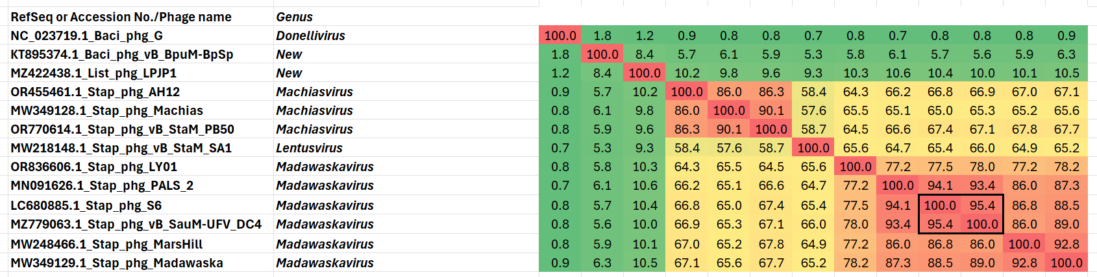

Figure 1. VIRIDIC heatmap of this group of phages. VIRIDIC (Virus Intergenomic Distance Calculator; VIRIDIC (Virus Intergenomic Distance Calculator; [1]; http://rhea.icbm.uni-oldenburg.de/VIRIDIC/) computes pairwise intergenomic distances/similarities amongst phage genomes. Abbreviations: phg = phage; List = Listeria; Stap = Staphylococcus; Baci = Bacillus


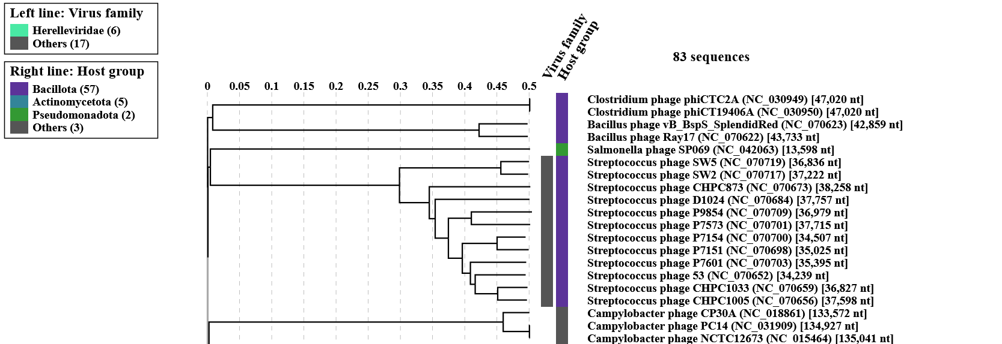

Figure 2. ViPTree analysis: ViPTree analysis (https://www.genome.jp/viptree/; [2]) is based upon Rohwer and Edwards (2002) Phage Proteomic Tree [3]. The taxons under discussion are indicated with red bars and stars, and blue arrowheads. Abbreviations: phg = phage; Paen = Paenibacillus; Virg = Virgibacillus
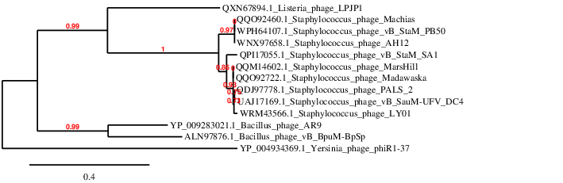Figure 3. Phylogenetic tree constructed with the major capsid precursor proteins from this and related phages using “One Click” Phylogeny.fr [9] at https://www.phylogeny.fr using the homologous proteins from Bacillus phages as outliers.

Table 1. Characteristics of the only phage in the genus “Gandarillasvirus”

Phage name | Host | Morpho-type | Life-style | Access-ion No. | Gen-ome size | %  G+C | No. proteins | No. tRNA
Listeria phage LPJP1 | Listeria grayi | myovirus | Lytic | MZ422438 | 223580bp | 25.9 | 229 | 4

Specific reference: Erickson S, Paulson J, Brown M, Hahn W, Gil J, Barron-Montenegro R, Moreno-Switt AI, Eisenberg M, Nguyen MM. Isolation and engineering of a Listeria grayi bacteriophage. Sci Rep. 2021 Sep 23;11(1):18947. doi: 10.1038/s41598-021-98134-1. PMID: 34556683; PMCID: PMC8460666.

Notes:
- LPJP1 is the first published phage capable of lysing and forming plaques on Listeria grayi
- DNA probably contains deoxyuridine in place of thymidine
- A one-step growth curve of LPJP1 revealed a burst size of approximately 50 to 60 pfu/cell with a latent period of roughly 70 min.

