

The International Committee on Taxonomy of Viruses
Taxonomy Proposal Form, 2026

Part 1a: Details of taxonomy proposals

Title: | To create four new genera in the class Caudoviricetes
Code assigned: | 2026.028B

Author(s), affiliation and email address(es):
Given name (+middle initial(s)) | Surname | Affiliation | Email address | Corr. author(s)
Heather | Hendrickson | School of Biological Sciences, University of Canterbury, Christchurch 8140, New Zealand | heather.hendrickson@canterbury.ac.nz
Danielle | Kok | School of Biological Sciences, University of Canterbury, Christchurch 8140, New Zealand | danielle.kok@canterbury.ac.nz
Jakub | Barylski | Institute of Experimental Biology, Department of Molecular Virology, Adam Mickiewicz University,  Poznań, Poland | jakub.barylski@gmail.com | X
Cristina M. | Moraru | Department of Chemistry, Environmental Metagenomics,  University of Duisburg-Essen,  D-45141 Essen,  Germany | lilianacristina.moraru@uni-due.de
Andrew M. | Kropinski | University of Guelph, Guelph, Ontario, Canada N1G2W1 | Phage.Canada@gmail.com | x

Part 1b: Taxonomy Proposal Submission
ICTV Subcommittee:
Animal DNA Viruses and Retroviruses |  | Bacterial viruses | x
Animal minus-strand and dsRNA viruses |  | Fungal and protist viruses
Animal positive-strand RNA viruses |  | Plant viruses
Archaeal viruses |  | General -

List the ICTV Study Group(s) that have seen or have been involved in creating this proposal:
Optional – complete only if formally voted on by an ICTV Study Group:
Study Group | Number of members
Study Group | Votes in support | Votes against | No vote

Submission date: | 24/04/2026

Part 1c: Feedback from ICTV Executive Committee (EC) meeting
Executive Committee Meeting Decision code: | X
A – Accept
Ac – Accept subject to revision by relevant subcommittee chair. No further vote required
U – Accept without revision but with re-evaluation and email vote by the EC
Uc – Accept subject to revision and re-evaluation and email vote by the EC
Ud – Deferred to the next EC meeting, with an invitation to revise based on EC comments
J - Reject
W - Withdrawn

Comments from the Executive Committee:

Part 1d: Revised Taxonomy Proposal Submission
Response of proposer:
Revision date:

Part 3: TAXONOMIC PROPOSAL

Taxonomic changes proposed:
Establish new taxon | x | Split taxon
Abolish taxon |  | Merge taxon
Move taxon |  | Promote taxon
Rename taxon |  | Demote taxon
Move and rename

Etymology (origin) of proposed taxonomic names:
Taxon name | Etymology of the term
Bracaraaugustavirus | Named after the Roman city of Bracara Augusta which became modern-day Braga, Portugal where the first phage of its type was isolated.
Lilovirus | Named directly after Paenibacillus phage Lilo
Ratsupitesvirus | Named after the address of the Latvian Biomedical Research and Study Centre where the first virus of its type was isolated
Ericveevirus | Named directly after Paenibacillus phage phiERICV

Permission for use of names derived from a living person:
Taxon name | Full name of person from whom the name is derived | Attached

Abstract of Taxonomy Proposal:

Description of current taxonomy:
The bacteriophages discussed in this proposal are currently unclassified. The subfamily Gochnauervirinae was created in 2020 and currently includes four genera (2020.064B.R.Gochnauervirinae).

Proposed taxonomic change(s):
We propose to create three new genera: “Bracaraaugustavirus”, "Ratsupitesvirus","Ericveevirus" and one new genus “Lilovirus” in the subfamily Gochnauervirinae

Demarcation criteria for new taxon/taxa:
Genus demarcation criteria:
An intergenomic similarity cut-off of 70%, a combination of average nucleotide identity and alignment fraction, is used to determine genera demarcation. Members of the same genus have >70% intergenomic similarity and cluster tightly in marker gene phylogenies.

Species demarcation criteria: A demarcation value of 95% intergenomic similarity was used to define different species according to intergenomic similarity. Members of the same genus have >95% intergenomic similarity.

Justification:
These viruses infect bacteria of the genera Paenibacillus and Virgibacillus. VIRIDIC was used to quantify the intergenomic nucleotide similarity between these genomes, revealing that they formed four new genera. This assignment was supported by TBLASTX distance analysis (ViPTree) and phylogenetic analysis of the large terminase subunit.

Text of Taxonomy proposal:
Description of current taxonomy:
The bacteriophages discussed in this proposal are currently unclassified. The subfamily Gochnauervirinae was created in 2020 and currently includes four genera (2020.064B.R.Gochnauervirinae).

Proposed taxonomic change(s):
We propose to create three new genera: “Bracaraaugustavirus”, "Ratsupitesvirus","Ericveevirus" and one new genus “Lilovirus” in the subfamily Gochnauervirinae

Demarcation criteria for new taxon/taxa:
Genus demarcation criteria:
An intergenomic similarity cut-off of 70%, a combination of average nucleotide identity and alignment fraction, is used to determine genera demarcation. Members of the same genus have >70% intergenomic similarity and cluster tightly in marker gene phylogenies.

Species demarcation criteria: A demarcation value of 95% intergenomic similarity was used to define different species according to intergenomic similarity. Members of the same genus have >95% intergenomic similarity.

Justification:
These viruses infect bacteria of the genera Paenibacillus and Virgibacillus. VIRIDIC was used to quantify the intergenomic nucleotide similarity between these genomes, revealing that they formed four new genera and seven new species (Figure 1). This assignment was supported by TBLASTX distance analysis (Figure 2, ViPTree [2,3]) and phylogenetic analysis of the large terminase subunit (Figure 3).

References:
1. Moraru C, Varsani A, Kropinski AM. VIRIDIC-A Novel Tool to Calculate the Intergenomic Similarities of Prokaryote-Infecting Viruses. Viruses. 2020 Nov 6;12(11):1268. doi: 10.3390/v12111268. PMID: 33172115; PMCID: PMC7694805. http://kronos.icbm.uni-oldenburg.de/viridic/
2. Nishimura Y, Yoshida T, Kuronishi M, Uehara H, Ogata H, Goto S. ViPTree: the viral proteomic tree server. Bioinformatics. 2017; 33(15):2379-2380. doi:10.1093/bioinformatics/btx157. PubMed PMID: 28379287. https://www.genome.jp/viptree/
3. Rohwer F, Edwards R. The Phage Proteomic Tree: a genome-based taxonomy for phage. J Bacteriol. 2002 Aug;184(16):4529-35. PubMed PMID: 12142423
4. Turner D, Reynolds D, Seto D, Mahadevan P. CoreGenes3.5: a webserver for the determination of core genes from sets of viral and small bacterial genomes. BMC Res Notes. 2013;6:140. doi: 10.1186/1756-0500-6-140. PMID: 23566564.
5. Davis P, Seto D, Mahadevan P. CoreGenes5.0: An Updated User-Friendly Webserver for the Determination of Core Genes from Sets of Viral and Bacterial Genomes. Viruses. 2022 Nov 16;14(11):2534. doi: 10.3390/v14112534. PMID: 36423143; PMCID: PMC9693508.
6. Turner D, Kropinski AM, Adriaenssens EM. A Roadmap for Genome-Based Phage Taxonomy. Viruses. 2021 Mar 18;13(3):506. doi: 10.3390/v13030506. PMID: 33803862; PMCID: PMC8003253.
Lemoine F, Correia D, Lefort V, Doppelt-Azeroual O, Mareuil F, Cohen-Boulakia S, Gascuel O. NGPhylogeny.fr: new generation phylogenetic services for non-specialists. Nucleic Acids Res. 2019 Jul 2;47(W1):W260-W265. doi: 10.1093/nar/gkz303. PMID: 31028399; PMCID: PMC6602494.
7. Letunic I, Bork P. Interactive Tree Of Life (iTOL): an online tool for phylogenetic tree display and annotation. Bioinformatics. 2007 Jan 1;23(1):127-8. doi: 10.1093/bioinformatics/btl529. Epub 2006 Oct 18. PMID: 17050570.
8. Zhou T, Xu K, Zhao F, Liu W, Li L, Hua Z, Zhou X. itol.toolkit accelerates working with iTOL (Interactive Tree of Life) by an automated generation of annotation files. Bioinformatics. 2023 Jun 1;39(6):btad339. doi: 10.1093/bioinformatics/btad339. PMID: 37225402; PMCID: PMC10243930
9. Dereeper A, Guignon V, Blanc G, Audic S, Buffet S, Chevenet F, Dufayard JF, Guindon S, Lefort V, Lescot M, Claverie JM, Gascuel O. Phylogeny.fr: robust phylogenetic analysis for the non-specialist. Nucleic Acids Res. 2008 Jul 1;36(Web Server issue):W465-9. doi: 10.1093/nar/gkn180. Epub 2008 Apr 19. PMID: 18424797; PMCID: PMC2447785.

Accompanying files:
Filename | Description of contents
Bacillus phages_4ng_7nsp | Excel spreadsheet associated with this TaxoProp

Tables, Figures:

.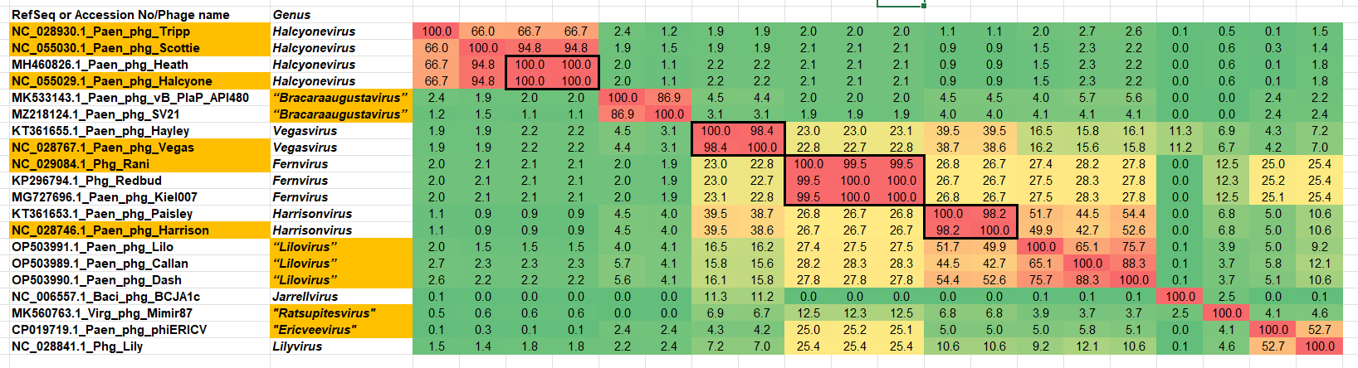

Figure 1. VIRIDIC heatmap of this group of phages. VIRIDIC (Virus Intergenomic Distance Calculator; VIRIDIC (Virus Intergenomic Distance Calculator; [1]; http://rhea.icbm.uni-oldenburg.de/VIRIDIC/) computes pairwise intergenomic distances/similarities amongst phage genomes. Abbreviations: phg = phage; Paen = Paenibacillus; Virg = Virgibacillus

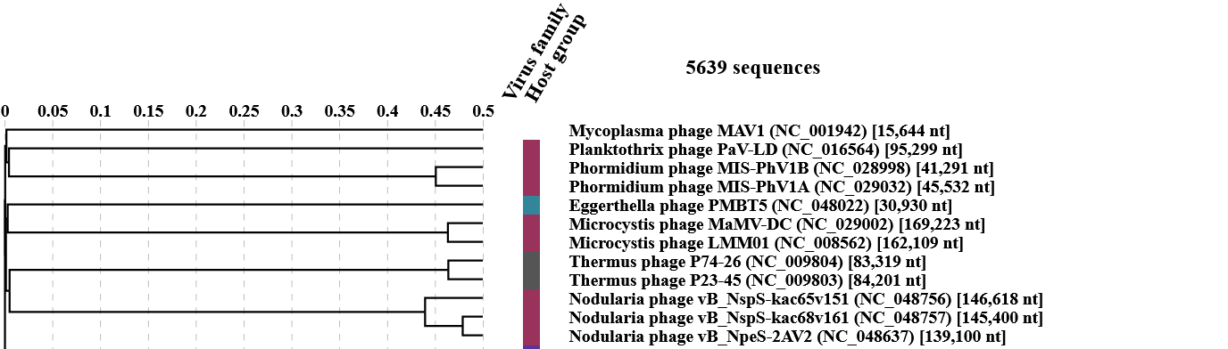
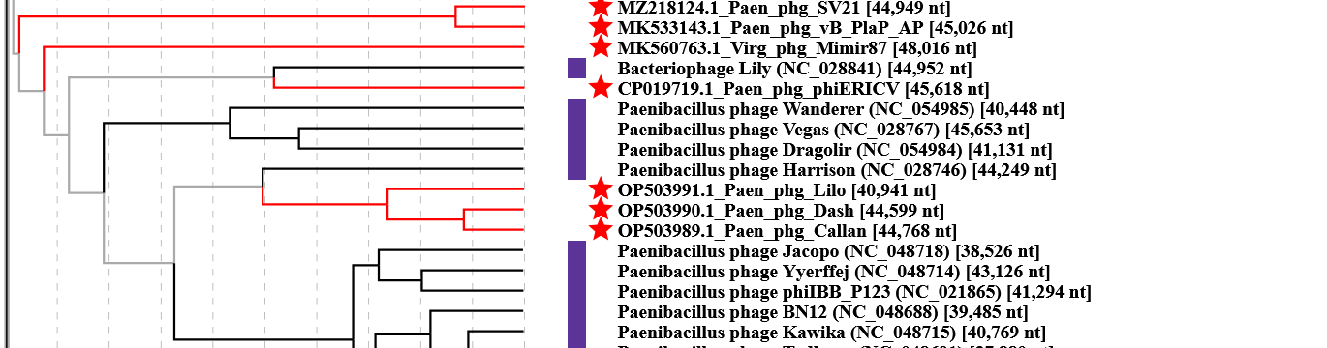

Figure 2. ViPTree analysis: ViPTree analysis (https://www.genome.jp/viptree/; [2]) is based upon Rohwer and Edwards (2002) Phage Proteomic Tree [3]. The taxons under discussion are indicated with red bars and stars, and blue arrowheads. Abbreviations: phg = phage; Paen = Paenibacillus; Virg = Virgibacillus
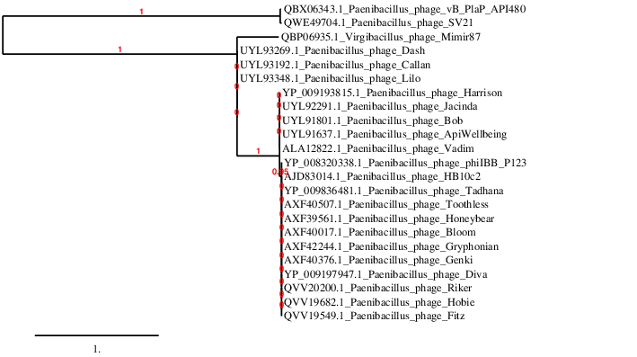Figure 3. Phylogenetic tree constructed with the large subunit terminase proteins from these and related phages using “One Click” Phylogeny.fr [9] at https://www.phylogeny.fr using the TerL proteins from Paenibacillus phage Fitz as an outlier.

Table 1. Characteristics of the two phages in the genus Bracaraaugustavirus.

Phage name | Host | Morpho-type | Life-style | Access-ion No. | Gen-ome size | %  G+C | No. proteins | No. tRNA
Paenibacillus phage vB_PlaP_API480 | Paenibacillus larvae Pl02-27 | Podovirus | Lyic | MK533143 | 45026 bp | 39.2 | 77 | 0
Paenibacillus phage SV21 | Paenibacillus larvae SV227B | Podovirus | Lytic | MZ218124 | 44949 bp | 39.3 | 79 | 0

Table 2. Characteristics of the three phages in the genus Lilovirus.

Phage name | Host | Morpho-type | Life-style | Access-ion No. | Gen-ome size | %  G+C | No. proteins | No. tRNA
Paenibacillus phage Lilo | Paenibacillus larvae F1A | Siphovirus | Temperate | OP503991 | 40,941 bp | 40.3 | 70 | 0
Paenibacillus phage Callan | Paenibacillus larvae 2006 | Siphovirus | Temperate | OP503989 | 44,768 bp | 39.7 | 77 | 0
Paenibacillus phage Dash | Paenibacillus larvae 2006 | Siphovirus | Temperate | OP503990 | 44,599 bp | 39.4 | 79 | 0
Specific reference: Kok DN, Gosselin SP, Howard B, Cresawn SG, Tsourkas PK, Hendrickson HL. Genomic Analysis of 96 Paenibacillus larvae Bacteriophages Including 26 from Aotearoa, New Zealand. Viruses. 2025 Jan 21;17(2):137. doi: 10.3390/v17020137. PMID: 40006892; PMCID: PMC11860570.
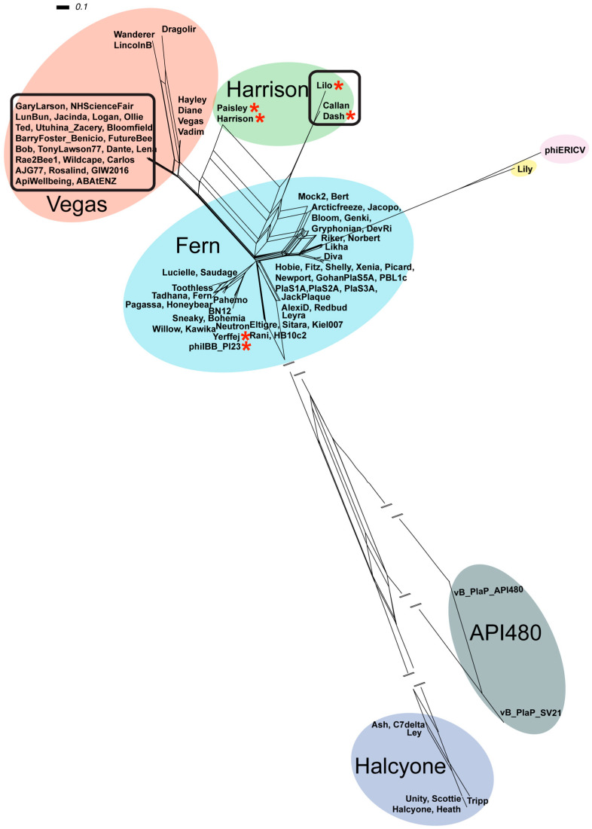Figure 4. “Phylogenetic network of 96 P. larvae phage genomes using NeighborNet transformed tANI distances, visualised and constructed via SplitsTree. Coloured circles indicate phages grouped into a cluster. Blue = Fern cluster, Red = Vegas cluster, Purple = Halcyone cluster, Green = Harrison cluster, Yellow for singleton Lily, Pink for singleton phiERICV and Grey for the API480 cluster.” Reproduced from Kok et al., (2025), doi: 10.3390/v17020137

Table 3. Characteristics of the only phage in the genus “Ratsupitesvirus”

Phage name | Host | Morpho-type | Life-style | Access-ion No. | Gen-ome size | %  G+C | No. proteins | No. tRNA
Virgibacillus phage Mimir87 | Virgibacillus halotolerans | Siphovirus | Lytic | MK560763 | 48016 bp | 36.8 | 68 | 0
Specific reference: Zrelovs N, Cernooka E, Dislers A, Kazaks A. Isolation and characterization of the novel Virgibacillus-infecting bacteriophage Mimir87. Arch Virol. 2020 Mar;165(3):737-741. doi: 10.1007/s00705-019-04516-2. Epub 2019 Dec 24. PMID: 31875246.

Table 4. Characteristics of the only phage in the genus "Ericveevirus"

Phage name | Host | Morpho-type | Life-style | Access-ion No. | Gen-ome size | %  G+C | No. proteins | No. tRNA
Paenibacillus phage phiERICV | Paenibacillus larvae subsp. larvae strain Eric_V | Siphovirus | Lytic | CP019719 | 45618 bp | 42.1 |  | 0
Specific reference: Beims H, Bunk B, Erler S, Mohr KI, Spröer C, Pradella S, Günther G, Rohde M, von der Ohe W, Steinert M. Discovery of Paenibacillus larvae ERIC V: Phenotypic and genomic comparison to genotypes ERIC I-IV reveal different inventories of virulence factors which correlate with epidemiological prevalences of American Foulbrood. Int J Med Microbiol. 2020 Feb;310(2):151394. doi: 10.1016/j.ijmm.2020.151394. Epub 2020 Jan 16. PMID: 31959580.

