

The International Committee on Taxonomy of Viruses
Taxonomy Proposal Form, 2026

Part 1a: Details of taxonomy proposals

Title: | To create a new genus, Elvavirus including 31 species in the class Caudoviricetes
Code assigned: | 2026.026B

Author(s), affiliation and email address(es):
Given name (+middle initial(s)) | Surname | Affiliation | Email address | Corr. author(s)
Ipek | Kurtböke | Environmental Microbiology, University of the Sunshine Coast,  School of Science, Technology and Engineering,  Maroochydore DC, Australia | IKurtbok@usc.edu.au
Cristina M. | Moraru | Department of Chemistry, Environmental Metagenomics,  University of Duisburg-Essen,  D-45141 Essen,  Germany | lilianacristina.moraru@uni-due.de
Andrew M. | Kropinski | University of Guelph, Guelph, Ontario, Canada N1G2W1 | Phage.Canada@gmail.com | x

Part 1b: Taxonomy Proposal Submission
ICTV Subcommittee:
Animal DNA Viruses and Retroviruses |  | Bacterial viruses | x
Animal minus-strand and dsRNA viruses |  | Fungal and protist viruses
Animal positive-strand RNA viruses |  | Plant viruses
Archaeal viruses |  | General -

List the ICTV Study Group(s) that have seen or have been involved in creating this proposal:
Actinophages
Optional – complete only if formally voted on by an ICTV Study Group:
Study Group | Number of members
Study Group | Votes in support | Votes against | No vote

Submission date: | 24/03/2026

Part 1c: Feedback from ICTV Executive Committee (EC) meeting
Executive Committee Meeting Decision code: | X
A – Accept
Ac – Accept subject to revision by relevant subcommittee chair. No further vote required
U – Accept without revision but with re-evaluation and email vote by the EC
Uc – Accept subject to revision and re-evaluation and email vote by the EC
Ud – Deferred to the next EC meeting, with an invitation to revise based on EC comments
J - Reject
W - Withdrawn

Comments from the Executive Committee:

Part 1d: Revised Taxonomy Proposal Submission
Response of proposer:
Revision date:

Part 3: TAXONOMIC PROPOSAL

Taxonomic changes proposed:
Establish new taxon | x | Split taxon
Abolish taxon |  | Merge taxon
Move taxon |  | Promote taxon
Rename taxon |  | Demote taxon
Move and rename

Etymology (origin) of proposed taxonomic names:
Taxon name | Etymology of the term
Elvavirus | Named after Microbacterium phage Elva

Permission for use of names derived from a living person:
Taxon name | Full name of person from whom the name is derived | Attached

Abstract of Taxonomy Proposal:

Description of current taxonomy:
None of these phages have been classified by ICTV but are related to phages belonging to Armstrongvirus and Dismasvirus. They all belong to the Actinobacteriophage Database cluster EB.

Proposed taxonomic change(s):
We propose to create a new genus “Elvavirus” and 31 new species.

Demarcation criteria for new taxon/taxa:
Genus demarcation criteria: An intergenomic similarity cut-off of 70%, a combination of average nucleotide identity and alignment fraction, is used to determine genera demarcation. Members of the same genus have >70% intergenomic similarity and cluster tightly in marker gene phylogenies.

Species demarcation criteria: A demarcation value of 95% intergenomic similarity was used to define different species according to intergenomic similarity. Members of the same genus have >95% intergenomic similarity.

Justification:
The lytic Curtobacterium siphoviruses described in this proposal form a single genus based on intergenomic nucleotide similarity and the current ICTV BVS demarcation criteria for genera and species. This assignment was further confirmed by examination of a hierarchially clustered TBLAST distance tree and by phylogenetic analysis of the large terminase subunit, where these genomes form a monophyletic clade.

Text of Taxonomy proposal:
Description of current taxonomy:
None of these phages have been classified by ICTV but are related to phages belonging to Armstrongvirus and Dismasvirus. They all belong to the Actinobacteriophage Database cluster EB.

Proposed taxonomic change(s):
We propose to create a new genus “Elvavirus” and 31 new species.

Demarcation criteria for new taxon/taxa:
Genus demarcation criteria: An intergenomic similarity cut-off of 70%, a combination of average nucleotide identity and alignment fraction, is used to determine genera demarcation. Members of the same genus have >70% intergenomic similarity and cluster tightly in marker gene phylogenies.

Species demarcation criteria: A demarcation value of 95% intergenomic similarity was used to define different species according to intergenomic similarity. Members of the same genus have >95% intergenomic similarity [6].

Justification:
The lytic Curtobacterium siphoviruses described in this proposal (Table 1) form a single genus based on intergenomic nucleotide similarity (Figure 1) and the current ICTV BVS demarcation criteria for genera and species [6]. This assignment was further confirmed by examination of a hierarchically clustered TBLASTX distance tree (Figure 2) and by phylogenetic analysis of the large terminase subunit (Figure 3), where these genomes form a monophyletic clade.

References:
1. Moraru C, Varsani A, Kropinski AM. VIRIDIC-A Novel Tool to Calculate the Intergenomic Similarities of Prokaryote-Infecting Viruses. Viruses. 2020 Nov 6;12(11):1268. doi: 10.3390/v12111268. PMID: 33172115; PMCID: PMC7694805. http://kronos.icbm.uni-oldenburg.de/viridic/
2. Nishimura Y, Yoshida T, Kuronishi M, Uehara H, Ogata H, Goto S. ViPTree: the viral proteomic tree server. Bioinformatics. 2017; 33(15):2379-2380. doi:10.1093/bioinformatics/btx157. PubMed PMID: 28379287. https://www.genome.jp/viptree/
3. Rohwer F, Edwards R. The Phage Proteomic Tree: a genome-based taxonomy for phage. J Bacteriol. 2002 Aug;184(16):4529-35. PubMed PMID: 12142423
4. Turner D, Reynolds D, Seto D, Mahadevan P. CoreGenes3.5: a webserver for the determination of core genes from sets of viral and small bacterial genomes. BMC Res Notes. 2013;6:140. doi: 10.1186/1756-0500-6-140. PMID: 23566564.
5. Davis P, Seto D, Mahadevan P. CoreGenes5.0: An Updated User-Friendly Webserver for the Determination of Core Genes from Sets of Viral and Bacterial Genomes. Viruses. 2022 Nov 16;14(11):2534. doi: 10.3390/v14112534. PMID: 36423143; PMCID: PMC9693508.
6. Turner D, Kropinski AM, Adriaenssens EM. A Roadmap for Genome-Based Phage Taxonomy. Viruses. 2021 Mar 18;13(3):506. doi: 10.3390/v13030506. PMID: 33803862; PMCID: PMC8003253.
Lemoine F, Correia D, Lefort V, Doppelt-Azeroual O, Mareuil F, Cohen-Boulakia S, Gascuel O. NGPhylogeny.fr: new generation phylogenetic services for non-specialists. Nucleic Acids Res. 2019 Jul 2;47(W1):W260-W265. doi: 10.1093/nar/gkz303. PMID: 31028399; PMCID: PMC6602494.
7. Letunic I, Bork P. Interactive Tree Of Life (iTOL): an online tool for phylogenetic tree display and annotation. Bioinformatics. 2007 Jan 1;23(1):127-8. doi: 10.1093/bioinformatics/btl529. Epub 2006 Oct 18. PMID: 17050570.
8. Zhou T, Xu K, Zhao F, Liu W, Li L, Hua Z, Zhou X. itol.toolkit accelerates working with iTOL (Interactive Tree of Life) by an automated generation of annotation files. Bioinformatics. 2023 Jun 1;39(6):btad339. doi: 10.1093/bioinformatics/btad339. PMID: 37225402; PMCID: PMC10243930
9. Dereeper A, Guignon V, Blanc G, Audic S, Buffet S, Chevenet F, Dufayard JF, Guindon S, Lefort V, Lescot M, Claverie JM, Gascuel O. Phylogeny.fr: robust phylogenetic analysis for the non-specialist. Nucleic Acids Res. 2008 Jul 1;36(Web Server issue):W465-9. doi: 10.1093/nar/gkn180. Epub 2008 Apr 19. PMID: 18424797; PMCID: PMC2447785.

Accompanying files:
Filename | Description of contents
Elvavirus_1ng_31nsp | Excel spreadsheet which accompanies this TaxoProp

Tables, Figures:

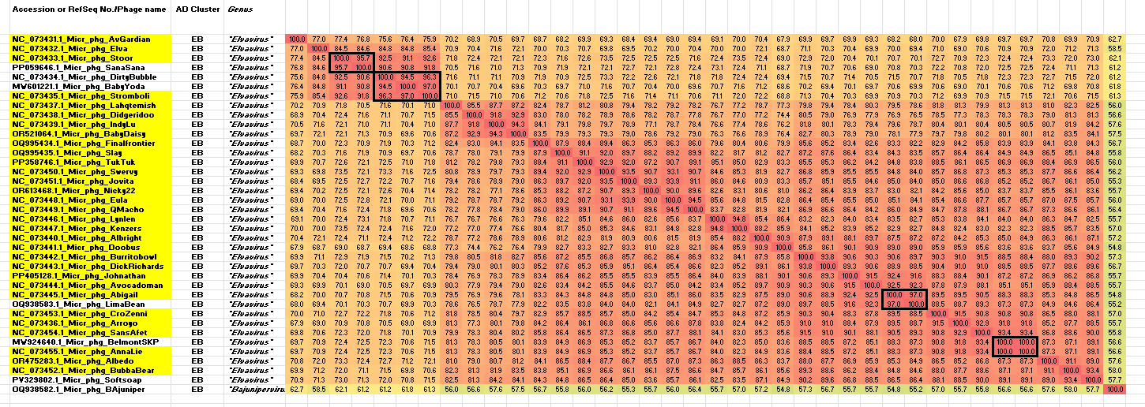

Figure 1. VIRIDIC heatmap of this group of phages. VIRIDIC (Virus Intergenomic Distance Calculator; VIRIDIC (Virus Intergenomic Distance Calculator; [1]; http://rhea.icbm.uni-oldenburg.de/VIRIDIC/) computes pairwise intergenomic distances/similarities amongst phage genomes. Data values which are bordered in black correspond to strains. The yellow highlighted viruses are new species. Abbreviations: AD Cluster = Actinobacteriophage Database; phg = phage; Micr = Microbacterium. Because this diagram is somewhat difficult to read we have attached the full-sized Excel spread sheet.
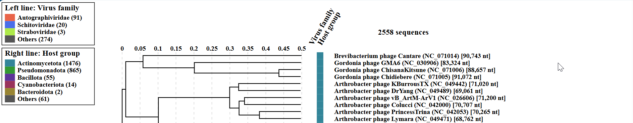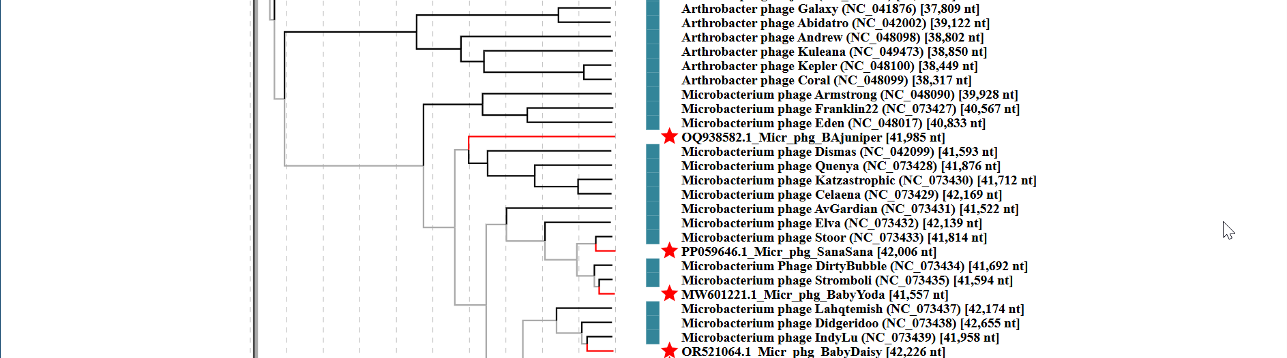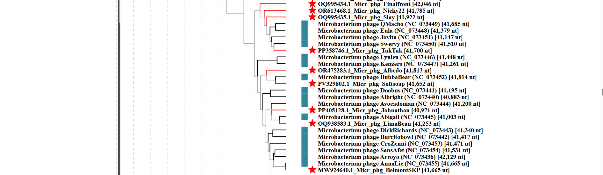
Figure 2. ViPTree analysis: ViPTree analysis (https://www.genome.jp/viptree/; [2]) is based upon Rohwer and Edwards (2002) Phage Proteomic Tree [3]. The taxons under discussion are indicated with red bars and stars. Abbreviations: phg = phage; Micr = Microbacterium
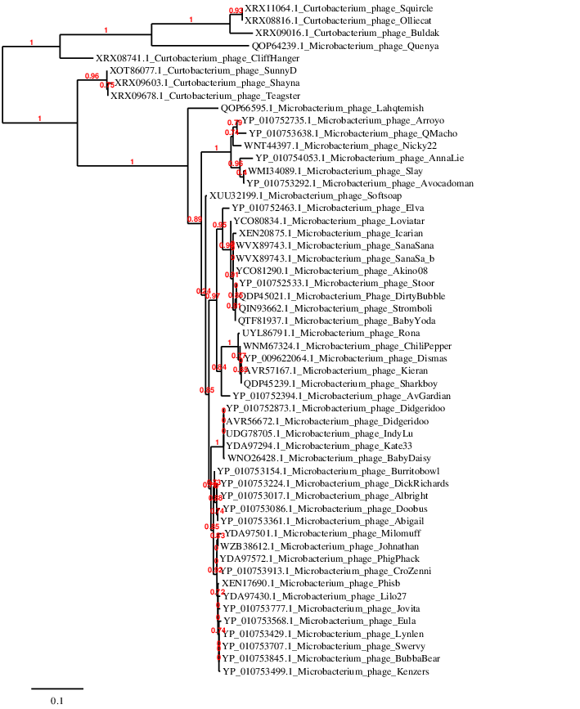Figure 3. Phylogenetic tree constructed with the large subunit terminase proteins from these and related phages using “One Click” Phylogeny.fr [9] at https://www.phylogeny.fr using the TerL protein from Curtobacterium phage Teagster as an outlier.

Table 1. Species in the genus Elvavirus

Accession No. | Phage name | Taxon name
MT310853.1 | Microbacterium phage AvGardian | Elvavirus avgardian
MH045567.1 | Microbacterium phage Elva | Elvavirus elva
MW924647.1 | Microbacterium phage Stoor | Elvavirus stoor
MT024860.1 | Microbacterium phage Stromboli | Elvavirus stromboli
MT889392.1 | Microbacterium phage Lahqtemish | Elvavirus lahqtemish
MH045566.1 | Microbacterium phage Didgeridoo | Elvavirus didgeridoo
OK318958.1 | Microbacterium phage IndyLu | Elvavirus indylu
OR521064.1 | Microbacterium phage BabyDaisy | Elvavirus babydaisy
OQ995434.1 | Microbacterium phage Finalfrontier | Elvavirus finalfrontier
OQ995435.1 | Microbacterium phage Slay | Elvavirus slay
PP358746.1 | Microbacterium phage TukTuk | Elvavirus tuktuk
MZ747513.1 | Microbacterium phage Swervy | Elvavirus swervy
OP434439.1 | Microbacterium phage Jovita | Elvavirus jovita
OR613468.1 | Microbacterium phage Nicky22 | Elvavirus nicky22
ON724018.1 | Microbacterium phage Eula | Elvavirus eula
OP434443.1 | Microbacterium phage QMacho | Elvavirus qmacho
MT310896.1 | Microbacterium phage Lynlen | Elvavirus lynlen
OP172875.1 | Microbacterium phage Kenzers | Elvavirus kenzers
MW601224.1 | Microbacterium phage Albright | Elvavirus albright
MZ820083.1 | Microbacterium phage Doobus | Elvavirus doobus
MT639649.1 | Microbacterium phage Burritobowl | Elvavirus burritobowl
MT889389.1 | Microbacterium phage DickRichards | Elvavirus dickrichards
PP405128.1 | Microbacterium phage Johnathan | Elvavirus johnathan
MT889372.1 | Microbacterium phage Avocadoman | Elvavirus avocadoman
MZ322012.1 | Microbacterium phage Abigail | Elvavirus abigail
MW712721.1 | Microbacterium phage CroZenni | Elvavirus crozenni
MK937610.1 | Microbacterium phage Arroyo | Elvavirus arroyo
MN329675.1 | Microbacterium phage SansAfet | Elvavirus sansafet
MT818427.1 | Microbacterium phage AnnaLie | Elvavirus annalie
OR475283.1 | Microbacterium phage Albedo | Elvavirus albedo
MK814753.1 | Microbacterium phage BubbaBear | Elvavirus bubbabear

