

The International Committee on Taxonomy of Viruses
Taxonomy Proposal Form, 2026

Part 1a: Details of taxonomy proposals

Title: | Create one new family, Einkeremviridae including two subfamilies, two genera and 56 new species in the class Caudoviricetes
Code assigned: | 2026.025B

Author(s), affiliation and email address(es):
Given name (+middle initial(s)) | Surname | Affiliation | Email address | Corr. author(s)
Dann | Turner | School of Applied Sciences, University of the West of England, Bristol, UK | dann2.turner@uwe.ac.uk | X
Andrew M. | Kropinski | University of Guelph, Guelph, Ontario, Canada | Phage.Canada@gmail.com
Cedric | Lood | Department of Biology, University of Oxford, Oxford, UK | cedric.lood@biology.ox.ac.uk

Part 1b: Taxonomy Proposal Submission
ICTV Subcommittee:
Animal DNA Viruses and Retroviruses |  | Bacterial viruses | X
Animal minus-strand and dsRNA viruses |  | Fungal and protist viruses
Animal positive-strand RNA viruses |  | Plant viruses
Archaeal viruses |  | General -

List the ICTV Study Group(s) that have seen or have been involved in creating this proposal:
Optional – complete only if formally voted on by an ICTV Study Group:
Study Group | Number of members
Study Group | Votes in support | Votes against | No vote

Submission date: | 01/09/2026

Part 1c: Feedback from ICTV Executive Committee (EC) meeting
Executive Committee Meeting Decision code: | X
A – Accept
Ac – Accept subject to revision by relevant subcommittee chair. No further vote required
U – Accept without revision but with re-evaluation and email vote by the EC
Uc – Accept subject to revision and re-evaluation and email vote by the EC
Ud – Deferred to the next EC meeting, with an invitation to revise based on EC comments
J - Reject
W - Withdrawn

Comments from the Executive Committee:

Part 1d: Revised Taxonomy Proposal Submission
Response of proposer:
Revision date:

Part 3: TAXONOMIC PROPOSAL
https://ictv.global/taxonomy/templates

Taxonomic changes proposed:
Establish new taxon | X | Split taxon
Abolish taxon | X | Merge taxon
Move taxon |  | Promote taxon
Rename taxon |  | Demote taxon
Move and rename

Etymology (origin) of proposed taxonomic names:
Taxon name | Etymology of the term
Einkeremviridae | Named after the former Palestinian village southwest of Jerusalem where at the Institute of Dental Sciences and School of Dental Medicine, Hebrew University the first virus of its type was isolated
Eggerthvirinae | Named after the American bacteriologist Arnold H. Eggerth (1896–1963) who first characterized Propionibacterium (Cutibacterium) avidum in 1935
Jeungpyeongvirinae | Named after a county located in the central part of North Chungcheong Province, South Korea where at Korea National University of Transportation some of these phages were isolated
Avidumvirus | Named after the species of bacterium which the first representative of this genus infects
Species epithets | Species epithets are derived from name of the exemplar isolate deposited in the INSDC

Permission for use of names derived from a living person:
Taxon name | Full name of person from whom the name is derived | Attached

Abstract of Taxonomy Proposal:
Description of current taxonomy:
The genus Pahexavirus was originally established in 2016 with the name Pa6virus (https://ictv.global/ictv/proposals/2016.034a-dB.A.v1.Pa6virus.pdf). The genus currently includes 57 species. The other bacteriophages detailed in this proposal are currently unclassified.

Proposed taxonomic change(s):
We propose the creation of a new family, “Einkeremviridae” and two new subfamilies; “Eggerthvirinae” and “Jeungpyeongvirinae”. The subfamily “Eggerthvirinae” will include one new genus including one new species. The existing genus Pahexavirus will be moved into the subfamily “Jeungpyeongvirinae” along with 56 newly created species.

Demarcation criteria for new taxon/taxa:
Family demarcation criteria: The proposed family shares 10 core genes at thresholds of 30% amino acid identity and 80% coverage. This is supported by clustering in the core genome phylogenetic tree.
Sub-family demarcation criteria: Robust clustering in the core genome phylogenetic tree with a suggested minimum shared core gene content of 25%. Members of the same subfamily typically share >25% nucleotide identity across the genome length.
Genus demarcation criteria: An intergenomic similarity cut-off of 70%, a combination of average nucleotide identity and alignment fraction is used to determine genera demarcation. Members of the same genus have >70% intergenomic similarity and cluster tightly in marker gene phylogenies.
Species demarcation criteria: A demarcation value of 95% intergenomic similarity was used to define different species according to intergenomic similarity. Members of the same species have >95% intergenomic similarity.

Justification:
Comparative analysis of these genomes demonstrates that the proposed family shares 10 signature proteins that are present in all representative genomes. The single species in the proposed genus “Avidumvirus” has 34-47% shared protein clusters with species classified within the genus Pahexavirus and ~30% intergenomic nucleotide similarity. Based on these data, and the branching structure of the concatenated core-gene maximum likelihood phylogeny, we propose that these species represent a new family that includes two subfamilies, two genera and 116 species.

- Text of Taxonomy proposal:

Description of current taxonomy:
The genus Pahexavirus was originally established in 2016 with the name Pa6virus (https://ictv.global/ictv/proposals/2016.034a-dB.A.v1.Pa6virus.pdf). The genus currently includes 57 species. The other bacteriophages detailed in this proposal are currently unclassified.

Proposed taxonomic change(s):
We propose the creation of a new family, “Einkeremviridae” and two new subfamilies; “Eggerthvirinae” and “Jeungpyeongvirinae”. The subfamily “Eggerthvirinae” will include one new genus including one new species. The existing genus Pahexavirus will be moved into the subfamily “Jeungpyeongvirinae” along with 57 newly created species.

Demarcation criteria for new taxon/taxa:
Family demarcation criteria: The proposed family shares 10 core genes at thresholds of 30% amino acid identity and 80% coverage. This is supported by clustering in the core genome phylogenetic tree.
Sub-family demarcation criteria: Robust clustering in the core genome phylogenetic tree with a suggested minimum shared core gene content of 25%. Members of the same subfamily typically share >25% nucleotide identity across the genome length.
Genus demarcation criteria: An intergenomic similarity cut-off of 70%, a combination of average nucleotide identity and alignment fraction is used to determine genera demarcation. Members of the same genus have >70% intergenomic similarity and cluster tightly in marker gene phylogenies.
Species demarcation criteria: A demarcation value of 95% intergenomic similarity was used to define different species according to intergenomic similarity. Members of the same species have >95% intergenomic similarity.

Justification:
A protein clustering approach was employed to identify family-level relationships amongst bacterial virus genomes deposited in the INSDC. Briefly, the INPHARED2 database [1, 2, 6] of bacteriophage genomes (10th August 2026 release) was used as the input dataset, consisting of 36,350 genomes and 2,860,170 proteins. Proteins were clustered using MMSeqs2 [3] with parameters of 30% minimum sequence identity and 80% coverage. A custom python pipeline was used to convert the number of shared protein clusters between genomes into an all-vs-all Jaccard distance matrix which then formed the basis for creation of a connected-component network. The network was split into islands using a minimum Jaccard distance of 0.05 and then hierarchically clustered at set distance thresholds.

The “Einkeremviridae” formed a large, disconnected island in the network analysis where all genomes shared 10 core proteins (Table 1). A concatenated maximum likelihood phylogeny of these core proteins (Figure 1) and intergenomic nucleotide similarity (Figure 2) suggested the presence of two genera, two subfamilies and 57 new species (Figures 3 & 4). The single representative species in the subfamily Eggerthvirinae shares 34-47% shared protein clusters with species in the subfamily Jeungpyeongvirinae.

References:
- Sayers EW, Beck J, Bolton EE, Bourexis D, Brister JR, Canese K, Comeau DC, Funk K, Kim S, Klimke W, Marchler-Bauer A, Landrum M, Lathrop S, Lu Z, Madden TL, O'Leary N, Phan L, Rangwala SH, Schneider VA, Skripchenko Y, Wang J, Ye J, Trawick BW, Pruitt KD, Sherry ST. Database resources of the National Center for Biotechnology Information. Nucleic Acids Res. 2021 Jan 8;49(D1):D10-D17. doi: 10.1093/nar/gkaa892.
- O'Leary NA, Wright MW, Brister JR, Ciufo S, Haddad D, McVeigh R, et al. Reference sequence (RefSeq) database at NCBI: current status, taxonomic expansion, and functional annotation. Nucleic Acids Res. 2016;44(D1):D733-45. doi: 10.1093/nar/gkv1189.
- Steinegger M, Söding J. (2017) MMseqs2 enables sensitive protein sequence searching for the analysis of massive data sets. Nat Biotechnol. 35(11):1026-1028. doi: 10.1038/nbt.3988.
- Nakamura T, Yamada KD, Tomii K, Katoh K. (2018) Parallelization of MAFFT for large-scale multiple sequence alignments. Bioinformatics. 34(14):2490-2492. doi: 10.1093/bioinformatics/bty121.
- Katoh K, Standley DM. (2013) MAFFT multiple sequence alignment software version 7: improvements in performance and usability. Mol Biol Evol. 30(4):772-80. doi: 10.1093/molbev/mst010.
- Cook R, Brown N, Redgwell T, Rihtman B, Barnes M, Clokie M, Stekel DJ, Hobman J, Jones MA, Millard A. (2021) INfrastructure for a PHAge REference Database: Identification of Large-Scale Biases in the Current Collection of Cultured Phage Genomes. Phage 2(4):214-223. doi: 10.1089/phage.2021.0007.

Accompanying files:
Filename | Description of contents
Einkeremviridae_intergenomic_similarity | Pairwise intergenomic nucleotide similarity matrix

Tables, Figures:

<Start here>
Table 1. Core proteins found in all species within the proposed family.
Protein cluster | Function | Mean length (aa)
1 | head maturation protease | 251
2 | major head protein | 316
3 | head closure Hc1 | 111
4 | neck protein | 93
5 | head scaffolding protein (170) | 184
6 | minor tail protein | 123
7 | portal protein | 440
8 | hypothetical protein | 95
9 | minor tail protein | 314
10 | holin | 132

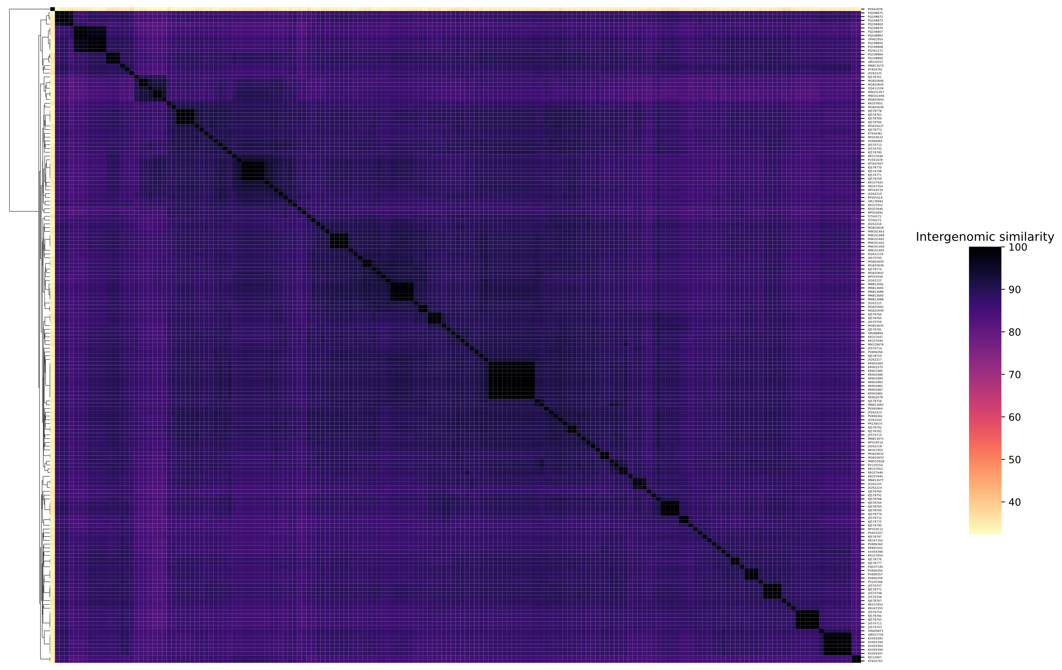
Figure 1. Heatmap of Intergenomic nucleotide sequence similarity. Intergenomic similarities were calculated using TaxMyPhage. The full numerical matrix is provided as supplementary material.

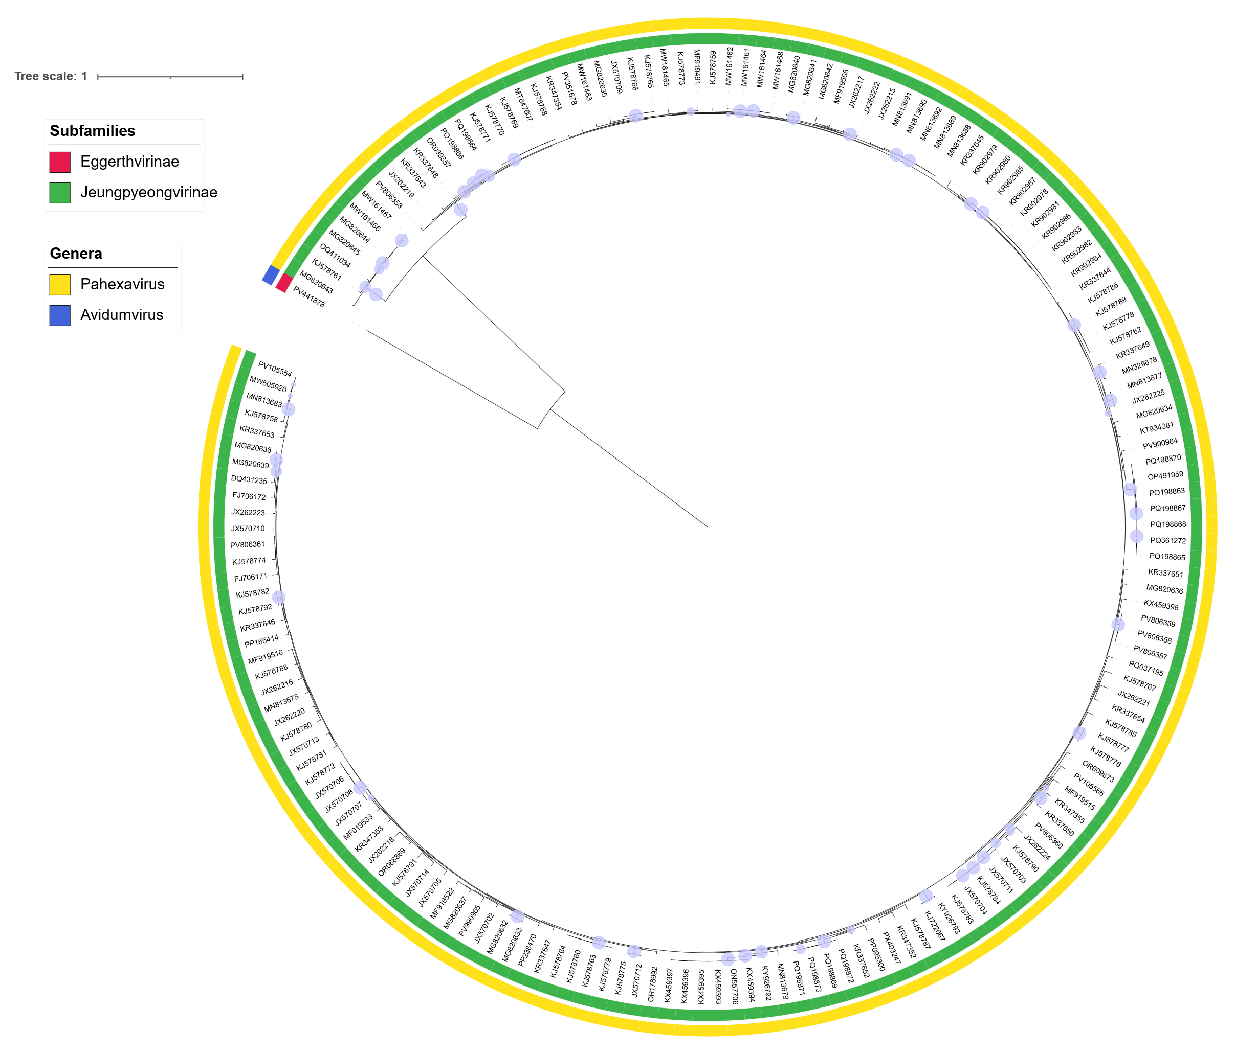
Figure 2. Concatenated core-gene maximum-likelihood phylogenetic tree. Protein clusters were aligned with MAFFT e-insi [4, 5] and trimmed with trimAl with a gap threshold of 0.5. The tree was inferred using IQTree3 using a best-fit partition model inferred from trees of individual protein cluster alignments and 1000 ultra-fast bootstrap and SH-aLRT test replicates. The tree was rooted at the midpoint and bootstrap support ≥95% are shown as circles at branch points.

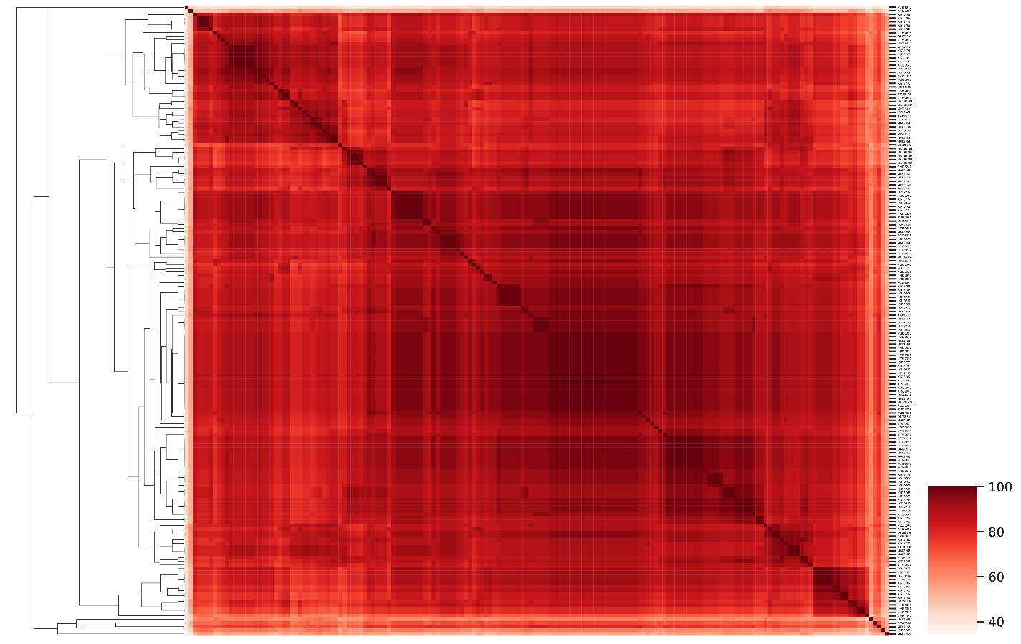
Figure 3. Heatmap showing the Jaccard similarity between pairs of genomes based on the percentage of shared protein clusters.

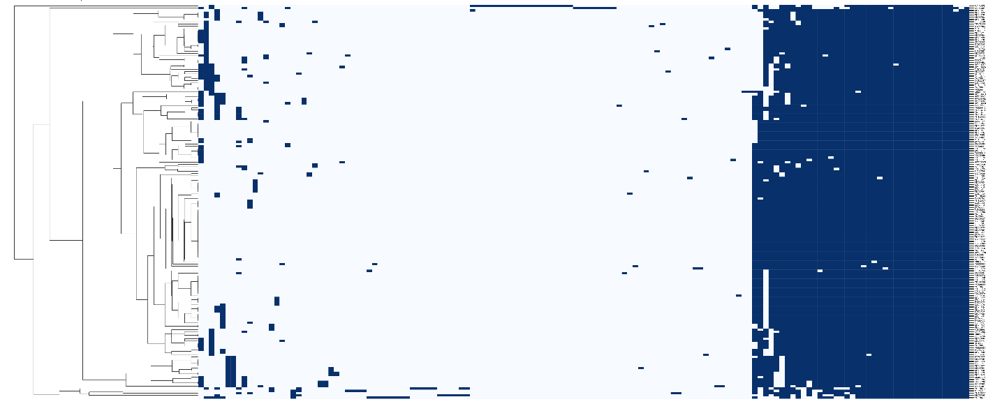
Figure 4. Presence-absence heatmap of protein clusters. Genomes are plotted as rows and protein clusters as columns. A blue line represents the presence of a protein cluster within a genome.

