

The International Committee on Taxonomy of Viruses
Taxonomy Proposal Form, 2026

Part 1a: Details of taxonomy proposals

Title: | To create a new subfamily, Edclasvirinae, of Microbacterium siphoviruses with six genera in the class Caudoviricetes
Code assigned: | 2026.024B

Author(s), affiliation and email address(es):
Given name (+middle initial(s)) | Surname | Affiliation | Email address | Corr. author(s)
Ipek | Kurtböke | Environmental Microbiology, University of the Sunshine Coast,  School of Science, Technology and Engineering,  Maroochydore DC, Australia | IKurtbok@usc.edu.au
Cristina M. | Moraru | Department of Chemistry, Environmental Metagenomics,  University of Duisburg-Essen,  D-45141 Essen,  Germany | lilianacristina.moraru@uni-due.de
Andrew M. | Kropinski | University of Guelph, Guelph, Ontario, Canada N1G2W1 | Phage.Canada@gmail.com | x

Part 1b: Taxonomy Proposal Submission
ICTV Subcommittee:
Animal DNA Viruses and Retroviruses |  | Bacterial viruses | x
Animal minus-strand and dsRNA viruses |  | Fungal and protist viruses
Animal positive-strand RNA viruses |  | Plant viruses
Archaeal viruses |  | General -

List the ICTV Study Group(s) that have seen or have been involved in creating this proposal:
Actinophage Study Group

Optional – complete only if formally voted on by an ICTV Study Group:
Study Group | Number of members
Study Group | Votes in support | Votes against | No vote

Submission date: | 09/04/2026

Part 1c: Feedback from ICTV Executive Committee (EC) meeting
Executive Committee Meeting Decision code: | X
A – Accept
Ac – Accept subject to revision by relevant subcommittee chair. No further vote required
U – Accept without revision but with re-evaluation and email vote by the EC
Uc – Accept subject to revision and re-evaluation and email vote by the EC
Ud – Deferred to the next EC meeting, with an invitation to revise based on EC comments
J - Reject
W - Withdrawn

Comments from the Executive Committee:

Part 1d: Revised Taxonomy Proposal Submission
Response of proposer:
Revision date:

Part 3: TAXONOMIC PROPOSAL

Taxonomic changes proposed:
Establish new taxon | x | Split taxon
Abolish taxon |  | Merge taxon
Move taxon | x | Promote taxon
Rename taxon |  | Demote taxon
Move and rename

Etymology (origin) of proposed taxonomic names:
Taxon name | Etymology of the term
Edclasvirinae | Named directly after Actinobacteriophage Database Cluster ED to which these phages belong
Yumavirus | Named after Microbacterium phage Yuma
Jackovirus | Named after Microbacterium phage Jacko
Hortusvirus | Named after Microbacterium phage Hortus1
Wolfstarvirus | Named after Microbacterium phage Wolfstar
Hubbsvirus | Named after Microbacterium phage Hubbs

Permission for use of names derived from a living person:
Taxon name | Full name of person from whom the name is derived | Attached

Abstract of Taxonomy Proposal:

Description of current taxonomy:
None of these phages have been classified by the ICTV, but they are related to a member of the Farahnazvirus (2018.003B.A.v1.Farahnazvirus).

Proposed taxonomic change(s):
We propose to create subfamily, “Edclasvirinae” named after the Actinobacteriophage Database cluster ED to which all these viruses belong. We propose to create the following genera: “Yumavirus”, “Jackovirus”, "Hortusvirus”, “Wolfstarvirus” and “Hubbsvirus”. In addition, the genus Farahnazvirus will be moved to this subfamily.

Demarcation criteria for new taxon/taxa:
Subfamily demarcation criteria: Subfamilies are to be created when two or more genera are related below the family level. In practical terms, this usually means that they share a low degree of sequence similarity (usually about 40-50%) and that the genera form a clade in a marker tree phylogeny.

Genus demarcation criteria: An intergenomic similarity cut-off of 70%, a combination of average nucleotide identity and alignment fraction, is used to determine genera demarcation. Members of the same genus have >70% intergenomic similarity and cluster tightly in marker gene phylogenies.

Species demarcation criteria: A demarcation value of 95% intergenomic similarity was used to define different species according to intergenomic similarity. Members of the same genus have >95% intergenomic similarity.

Justification:
Examination intergenomic nucleotide sequence similarity indicated that these bacteriophage genomes formed six genera that exhibit >36% similarity to each other. Both the TBLASTX distance tree and phylogeny of the large terminase subunit confirmed the assignment of genera and relatedness of these bacterial viruses. A total of 79 protein homologs are present in all member species of the proposed taxa, which collectively supports the proposal of one new subfamily with six genera.

Text of Taxonomy proposal:
Description of current taxonomy:
None of these phages have been classified by the ICTV, but they are related to a member of the Farahnazvirus (2018.003B.A.v1.Farahnazvirus).

Proposed taxonomic change(s):
We propose to create subfamily, “Edclasvirinae” named after the Actinobacteriophage Database cluster ED to which all these viruses belong. We propose to create the following genera: “Yumavirus”, “Jackovirus”, "Hortusvirus”, “Wolfstarvirus” and “Hubbsvirus”. In addition, the genus Farahnazvirus will be moved to this subfamily.

Demarcation criteria for new taxon/taxa:
Subfamily demarcation criteria: Subfamilies are to be created when two or more genera are related below the family level. In practical terms, this usually means that they share a low degree of sequence similarity (usually about 40-50%) and that the genera form a clade in a marker tree phylogeny [6].

Genus demarcation criteria: An intergenomic similarity cut-off of 70%, a combination of average nucleotide identity and alignment fraction, is used to determine genera demarcation. Members of the same genus have >70% intergenomic similarity and cluster tightly in marker gene phylogenies.

Species demarcation criteria: A demarcation value of 95% intergenomic similarity was used to define different species according to intergenomic similarity. Members of the same genus have >95% intergenomic similarity [6].

Justification:
Examination intergenomic nucleotide sequence similarity indicated that these bacteriophage genomes formed six genera that exhibit >36% similarity to each other (Figure 1). Both the TBLASTX distance tree (Figure 2) and phylogeny of the large terminase subunit (Figure 3) confirmed the assignment of genera and relatedness of these bacterial viruses. Using CoreGenes3.5, a total of 79 protein homologs are present in all member species of the proposed taxa, which collectively supports the proposal of one new subfamily with six genera.

References:
1. Moraru C, Varsani A, Kropinski AM. VIRIDIC-A Novel Tool to Calculate the Intergenomic Similarities of Prokaryote-Infecting Viruses. Viruses. 2020 Nov 6;12(11):1268. doi: 10.3390/v12111268. PMID: 33172115; PMCID: PMC7694805. http://kronos.icbm.uni-oldenburg.de/viridic/
2. Nishimura Y, Yoshida T, Kuronishi M, Uehara H, Ogata H, Goto S. ViPTree: the viral proteomic tree server. Bioinformatics. 2017; 33(15):2379-2380. doi:10.1093/bioinformatics/btx157. PubMed PMID: 28379287. https://www.genome.jp/viptree/
3. Rohwer F, Edwards R. The Phage Proteomic Tree: a genome-based taxonomy for phage. J Bacteriol. 2002 Aug;184(16):4529-35. PubMed PMID: 12142423
4. Turner D, Reynolds D, Seto D, Mahadevan P. CoreGenes3.5: a webserver for the determination of core genes from sets of viral and small bacterial genomes. BMC Res Notes. 2013;6:140. doi: 10.1186/1756-0500-6-140. PMID: 23566564.
5. Davis P, Seto D, Mahadevan P. CoreGenes5.0: An Updated User-Friendly Webserver for the Determination of Core Genes from Sets of Viral and Bacterial Genomes. Viruses. 2022 Nov 16;14(11):2534. doi: 10.3390/v14112534. PMID: 36423143; PMCID: PMC9693508.
6. Turner D, Kropinski AM, Adriaenssens EM. A Roadmap for Genome-Based Phage Taxonomy. Viruses. 2021 Mar 18;13(3):506. doi: 10.3390/v13030506. PMID: 33803862; PMCID: PMC8003253.
Lemoine F, Correia D, Lefort V, Doppelt-Azeroual O, Mareuil F, Cohen-Boulakia S, Gascuel O. NGPhylogeny.fr: new generation phylogenetic services for non-specialists. Nucleic Acids Res. 2019 Jul 2;47(W1):W260-W265. doi: 10.1093/nar/gkz303. PMID: 31028399; PMCID: PMC6602494.
7. Letunic I, Bork P. Interactive Tree Of Life (iTOL): an online tool for phylogenetic tree display and annotation. Bioinformatics. 2007 Jan 1;23(1):127-8. doi: 10.1093/bioinformatics/btl529. Epub 2006 Oct 18. PMID: 17050570.
8. Zhou T, Xu K, Zhao F, Liu W, Li L, Hua Z, Zhou X. itol.toolkit accelerates working with iTOL (Interactive Tree of Life) by an automated generation of annotation files. Bioinformatics. 2023 Jun 1;39(6):btad339. doi: 10.1093/bioinformatics/btad339. PMID: 37225402; PMCID: PMC10243930
9. Dereeper A, Guignon V, Blanc G, Audic S, Buffet S, Chevenet F, Dufayard JF, Guindon S, Lefort V, Lescot M, Claverie JM, Gascuel O. Phylogeny.fr: robust phylogenetic analysis for the non-specialist. Nucleic Acids Res. 2008 Jul 1;36(Web Server issue):W465-9. doi: 10.1093/nar/gkn180. Epub 2008 Apr 19. PMID: 18424797; PMCID: PMC2447785.

Accompanying files:
Filename | Description of contents
Edclasvirinae_6ng_19nsp | Excel spreadsheet associated with this TaxoProp

Tables, Figures:

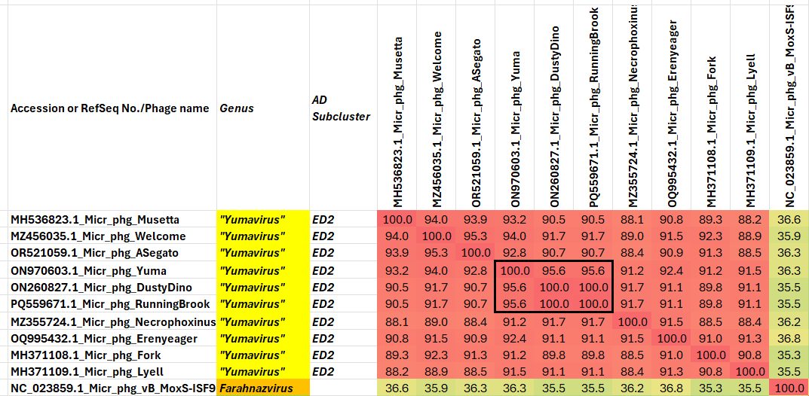

Figure 1. VIRIDIC heatmap of this group of phages. VIRIDIC (Virus Intergenomic Distance Calculator; VIRIDIC (Virus Intergenomic Distance Calculator; [1]; http://rhea.icbm.uni-oldenburg.de/VIRIDIC/) computes pairwise intergenomic distances/similarities amongst phage genomes. Abbreviations: phg = phage; Micr = Microbacterium; AD = Actinobacteriophage Database. Because of the size of this figure the complete version is attached as an Excel spreadsheet.

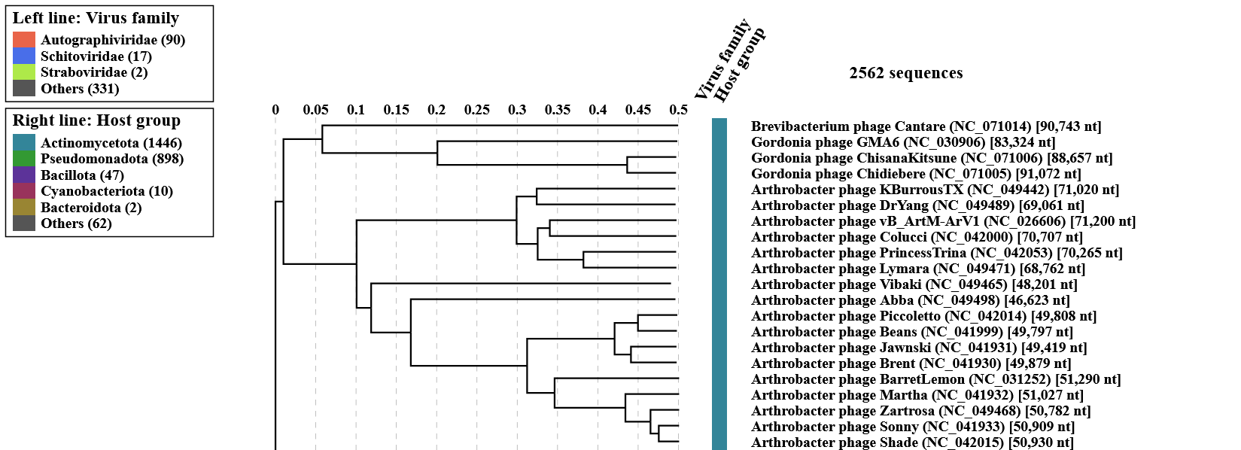
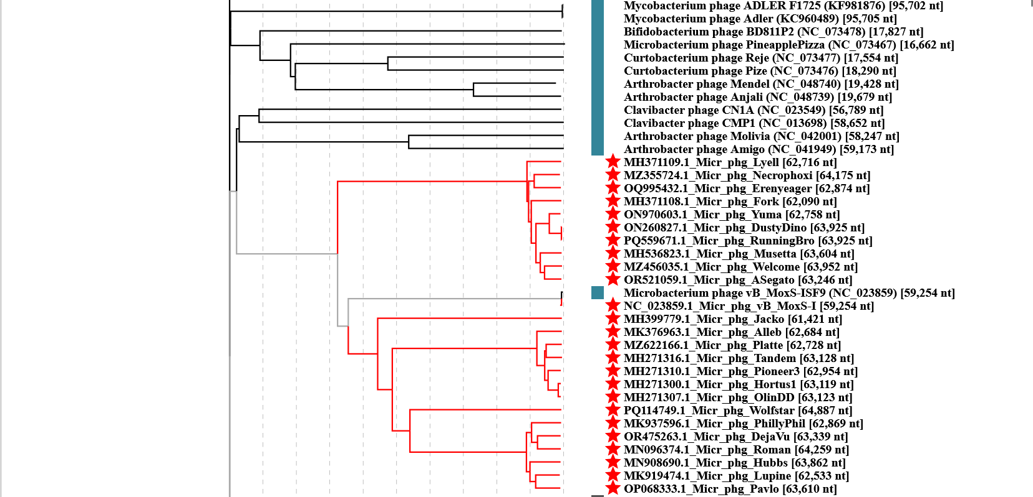

Figure 2. ViPTree analysis: ViPTree analysis (https://www.genome.jp/viptree/; [2]) is based upon Rohwer and Edwards (2002) Phage Proteomic Tree [3]. The taxons under discussion are indicated with red bars and stars. Abbreviations: phg = phage; Micr = Microbacterium.
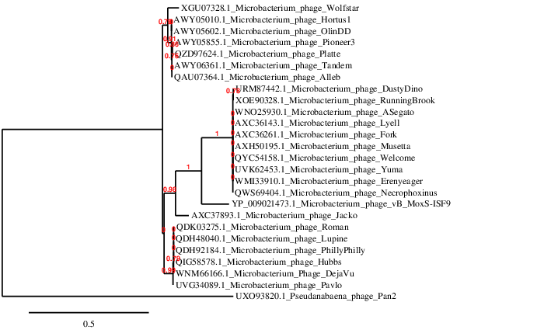Figure 3. Phylogenetic tree constructed with the large subunit terminase proteins from these and related phages using “One Click” Phylogeny.fr [9] at https://www.phylogeny.fr using the TerL protein from Pseudoanabaena phage Pan2 as outliers.

Table 1. Characteristics of the phage in the genus Yumavirus.

Phage name | Host | Morphotype | Life-style | Accession No. | Genome size | %G+C | Termini | No. proteins | No. tRNA
Microbacterium phage Musetta | Microbacterium foliorum NRRL B-24224 | Siphovirus | Lytic | MH536823 | 63604 bp | 61.7 | DTR 3809 bp | 119 | 4
Microbacterium phage Welcome | Microbacterium foliorum NRRL B-24224 | Siphovirus | Lytic | MZ456035 | 63952 bp | 61.7 | DTR  3808 bp | 122 | 5
Microbacterium phage ASegato | Microbacterium foliorum NRRL B-24224 | Siphovirus | Lytic | OR521059 | 63246 bp | 61.7 | DTR 3797 bp | 121 | 3
Microbacterium phage Yuma | Microbacterium foliorum NRRL B-24224 | Siphovirus | Lytic | ON970603 | 62758 bp | 61.7 | DTR 3707 bp | 120 | 3
Microbacterium phage Necrophoxinus | Microbacterium foliorum NRRL B-24224 | Siphovirus | Lytic | MZ355724 | 64175 bp | 61.7 | DTR  3932 bp | 123 | 3
Microbacterium phage Erenyeager | Microbacterium foliorum NRRL B-24224 | Siphovirus | Lytic | OQ995432 | 62874 bp | 61.7 | DTR 3213 bp | 117 | 5
Microbacterium phage Fork | Microbacterium foliorum NRRL B-24224 | Siphovirus | Lytic | MH371108 | 62090 bp | 61.8 | DTR 3099 bp | 117 | 3
Microbacterium phage Lyell | Microbacterium foliorum NRRL B-24224 | Siphovirus | Lytic | MH371109 | 62716 bp | 61.6 | DTR  3549 bp | 122 | 3
DTR = direct terminal repeat

Figure 4. Electron micrograph: Electron micrograph of negatively stained Microbacterium phage Yuma (https://phagesdb.org/phages/Yuma/). Limited permission was granted by The Actinobacteriophage Database (https://phagesdb.org/), funded by the Howard Hughes Medical Institute, to use this electron micrograph for this taxonomy proposal; it cannot be reused without permission of The Actinobacteriophage Database.
Table 2. Characteristics of the only phage in the genus Jackovirus.

Phage name | Host | Morphotype | Lifestyle | Accession No. | Genome size | %G+C | Termini | No. proteins | No. tRNA
Microbacterium phage Jacko | Microbacterium paraoxydans NRRL B-14843 | Siphovirus | Lytic | MH399779 | 61421 bp | 64.9 | unknown | 114 | 2

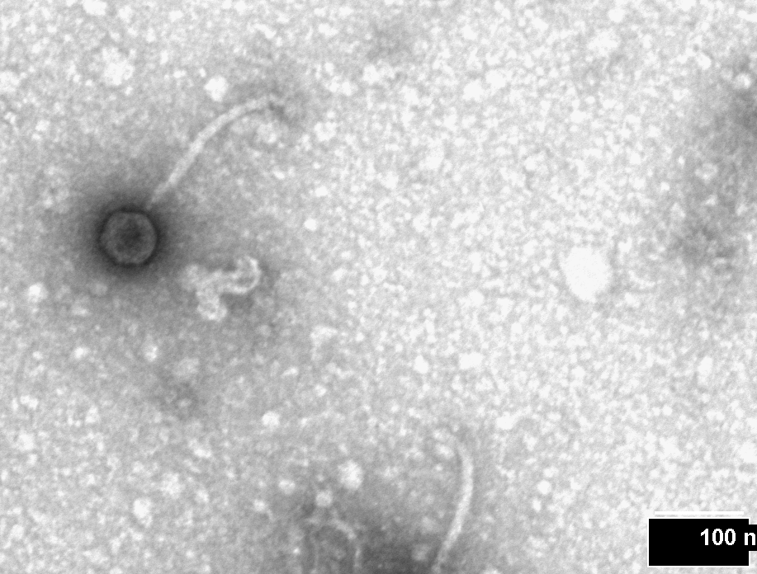
Figure 5. Electron micrograph: Electron micrograph of negatively stained Microbacterium phage Jacko (https://phagesdb.org/phages/Jacko/). Limited permission was granted by The Actinobacteriophage Database (https://phagesdb.org/), funded by the Howard Hughes Medical Institute, to use this electron micrograph for this taxonomy proposal; it cannot be reused without permission of The Actinobacteriophage Database.
Table 3. Characteristics of the only phage in the genus Hortusvirus.

Phage name | Host | Morphotype | Lifestyle | Accession No. | Genome size | %G+C | Termini | No. proteins | No. tRNA
Microbacterium phage Hortus1 | Microbacterium paraoxydans NWU1 | Siphovirus | Lytic | MH271300 | 63119 bp | 64.6 | DTR | 114 | 4
  3159 bp
Microbacterium phage Alleb | Microbacterium paraoxydans NWU1 | Siphovirus | Lytic | MK376963 | 62684 bp | 64.5 | unknown | 115 | 4
DTR = direct terminal repeat

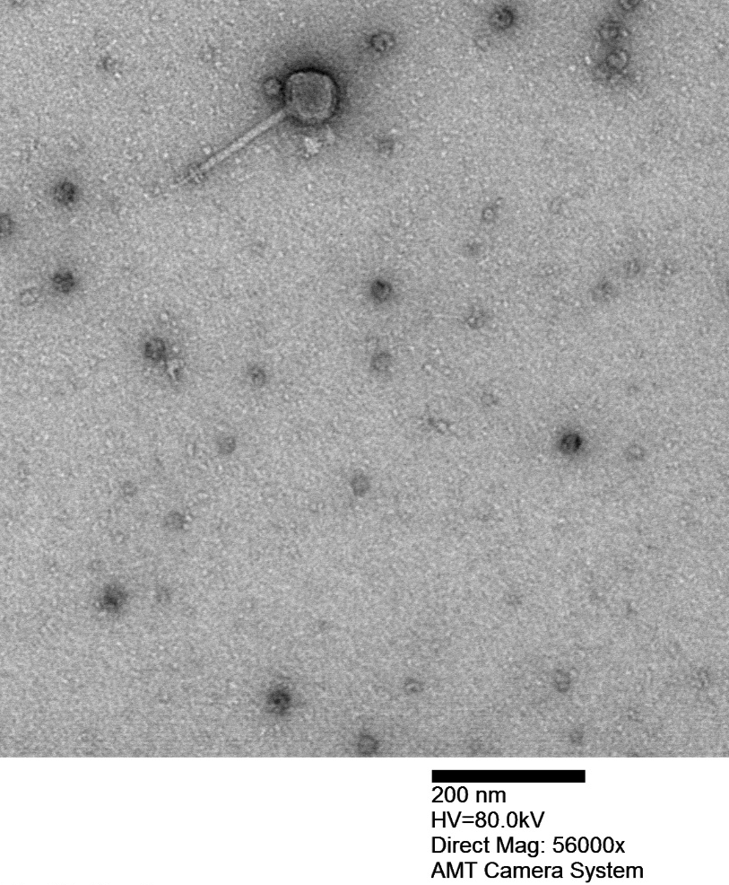

Figure 6. Electron micrograph: Electron micrograph of negatively stained Microbacterium phage Hortus (https://phagesdb.org/phages/Hortus/). Limited permission was granted by The Actinobacteriophage Database (https://phagesdb.org/), funded by the Howard Hughes Medical Institute, to use this electron micrograph for this taxonomy proposal; it cannot be reused without permission of The Actinobacteriophage Database.
Table 4. Characteristics of the only phage in the genus Wolfstarvirus.

Phage name | Host | Morphotype | Lifestyle | Accession No. | Genome size | %G+C | Termini | No. proteins | No. tRNA
Microbacterium phage Wolfstar | Microbacterium paraoxydans NRRL B-24275 | Siphovirus | Lytic | PQ114749 | 64887 bp | 63.8 | DTR  3746 bp | 121 | 3
DTR = direct terminal repeat

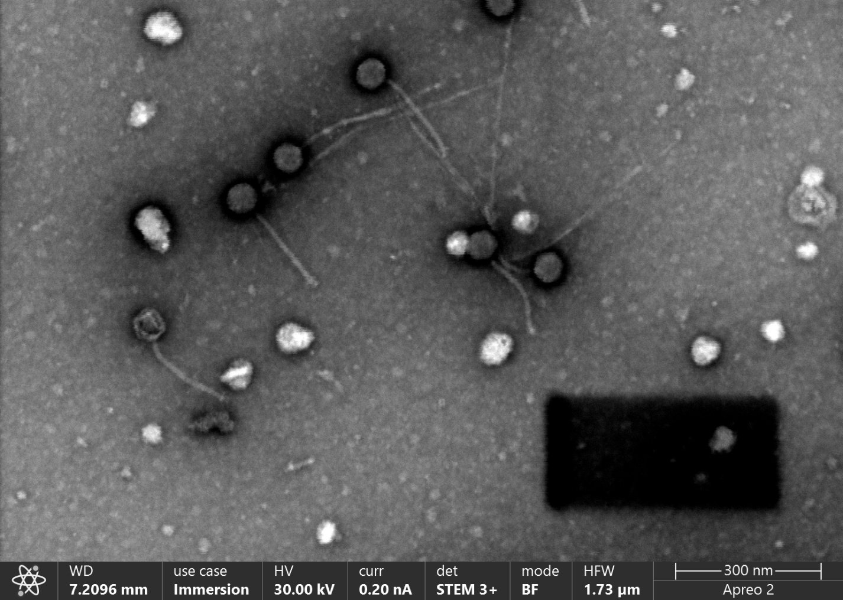

Figure 7. Electron micrograph: Electron micrograph of negatively stained Microbacterium phage Wolfstar (https://phagesdb.org/phages/Wolfstar/). Limited permission was granted by The Actinobacteriophage Database (https://phagesdb.org/), funded by the Howard Hughes Medical Institute, to use this electron micrograph for this taxonomy proposal; it cannot be reused without permission of The Actinobacteriophage Database.
Table 5. Characteristics of the only phage in the genus Hubbsvirus.

Phage name | Host | Morphotype | Lifestyle | Accession No. | Genome size | %G+C | Termini | No. proteins | No. tRNA
Microbacterium phage PhillyPhilly | Microbacterium foliorum NRRL B-24224 | Siphovirus | Lytic | MK937596 | 62869 bp | 62.7 | DTR  3380 bp | 118 | 0
Microbacterium phage Roman | Microbacterium foliorum NRRL B-24224 | Siphovirus | Lytic | MN096374 | 64259 bp | 62.8 | DTR  3172 bp | 123 | 0
Microbacterium phage DejaVu | Microbacterium foliorum NRRL B-24224 | Siphovirus | Lytic | OR475263 | 63339 bp | 62.8 | DTR  2959 bp | 123 | 0
Microbacterium phage Hubbs | Microbacterium foliorum NRRL B-24224 | Siphovirus | Lytic | MN908690 | 63862 bp | 62.8 | DTR  3463 bp | 121 | 0
Microbacterium phage Lupine | Microbacterium foliorum NRRL B-24224 | Siphovirus | Lytic | MK919474 | 62533 bp | 62.7 | DTR 3260 bp | 117 | 0
Microbacterium phage Pavlo | Microbacterium foliorum NRRL B-24224 | Siphovirus | Lytic | OP068333 | 63610 bp | 62.8 | DTR 3354 bp | 119 | 0
DTR = direct terminal repeat
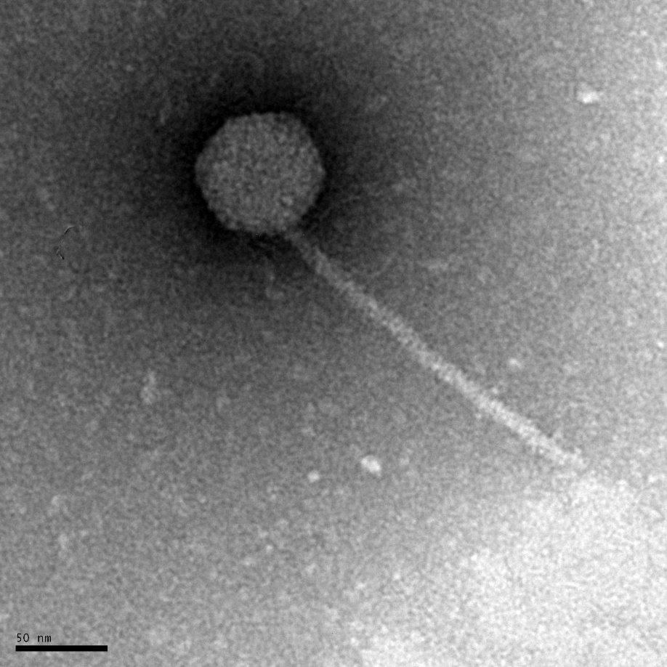
Figure 8. Electron micrograph: Electron micrograph of negatively stained Microbacterium phage Roman (https://phagesdb.org/phages/Roman/). Limited permission was granted by The Actinobacteriophage Database (https://phagesdb.org/), funded by the Howard Hughes Medical Institute, to use this electron micrograph for this taxonomy proposal; it cannot be reused without permission of The Actinobacteriophage Database.
CoreGenes 5.0 analysis [5] revealed 79 homologs (67%) across these genera including: NrdH-like glutaredoxin, 4 exonucleases, terminase, portal protein, capsid maturation protease, major capsid protein, head-to-tail stopper, tail terminator, 2 tail assembly chaperones, tape measure protein, minor tail protein, endolysin, RuvC-like resolvase, DNA primase/polymerase, RNA ligase, polynucleotide kinase, DNA helicase, and helix-turn-helix DNA binding protein.

