

The International Committee on Taxonomy of Viruses
Taxonomy Proposal Form, 2026

Part 1a: Details of taxonomy proposals

Title: | To create a new family, Devocviridae, with one genus in the class Caudoviricetes
Code assigned: | 2026.022B

Author(s), affiliation and email address(es):
Given name (+middle initial(s)) | Surname | Affiliation | Email address | Corr. author(s)
Sofia | Dahlman | School of Biological Sciences, Monash University, Melbourne, Victoria, Australia | sofia.dahlman1@monash.edu | X
Cristina M. | Moraru | Department of Chemistry, Environmental Metagenomics,  University of Duisburg-Essen,  D-45141 Essen,  Germany | lilianacristina.moraru@uni-due.de
Andrew M. | Kropinski | University of Guelph, Guelph, Ontario, Canada N1G2W1 | Phage.Canada@gmail.com | x

Part 1b: Taxonomy Proposal Submission
ICTV Subcommittee:
Animal DNA Viruses and Retroviruses |  | Bacterial viruses | x
Animal minus-strand and dsRNA viruses |  | Fungal and protist viruses
Animal positive-strand RNA viruses |  | Plant viruses
Archaeal viruses |  | General -

List the ICTV Study Group(s) that have seen or have been involved in creating this proposal: https://ictv.global/sc
Caudoviricetes Study Group
Optional – complete only if formally voted on by an ICTV Study Group:
Study Group | Number of members
Study Group | Votes in support | Votes against | No vote

Submission date: | 30/07/2026

Part 1c: Feedback from ICTV Executive Committee (EC) meeting
Executive Committee Meeting Decision code: | X
A – Accept
Ac – Accept subject to revision by relevant subcommittee chair. No further vote required
U – Accept without revision but with re-evaluation and email vote by the EC
Uc – Accept subject to revision and re-evaluation and email vote by the EC
Ud – Deferred to the next EC meeting, with an invitation to revise based on EC comments
J - Reject
W - Withdrawn

Comments from the Executive Committee:

Part 1d: Revised Taxonomy Proposal Submission
Response of proposer:
Revision date:

Part 3: TAXONOMIC PROPOSAL

Taxonomic changes proposed:
Establish new taxon | x | Split taxon
Abolish taxon |  | Merge taxon
Move taxon |  | Promote taxon
Rename taxon |  | Demote taxon
Move and rename

Etymology (origin) of proposed taxonomic names:
Taxon name | Etymology of the term
"Devocviridae" | Named after the Danish Enteric Virome Catalog (DEVoC) which demonstrated the rich abundance of these phages in the gut
“Lovevirus” | Named after Bacteroides phage LoVEphage

Permission for use of names derived from a living person:
Taxon name | Full name of person from whom the name is derived | Attached

Abstract of Taxonomy Proposal:

Description of current taxonomy:
These phages are unclassified and show very limited DNA and protein similarity to existing viruses.

Proposed taxonomic change(s):
We propose to create one new genus, “Lovevirus” in a new family named “Devocviridae” and six new species.

Family demarcation criteria:
The family is represented by a cohesive and monophyletic group by ViPTree and protein clustering. Members of the family share a significant number of orthologous genes, the number of which will vary dependent upon the genome sizes and number of coding sequences of members of the family.

Genus demarcation criteria:
An intergenomic similarity cut-off of 70%, a combination of average nucleotide identity and alignment fraction, is used to determine genera demarcation. Members of the same genus have >70% intergenomic similarity and cluster tightly in marker gene phylogenies.

Species demarcation criteria:
A demarcation value of 95% intergenomic similarity was used to define different species according to intergenomic similarity. Members of the same genus have >95% intergenomic similarity.

Justification:
These bacteriophages form a deep-rooted clade in a whole proteome TBLASTX distance tree. Analysis of the protein-encoding genes demonstrated that these bacteriophages share a total of 68 conserved homologs that include the portal vertex, major capsid, large terminase subunit and major tail proteins. Based on these data we propose these bacteriophages represent a new family in the class Caudoviricetes; “Devocviridae”. Analysis of intergenomic nucleotide similarities enabled the identification of a single genus for which we propose the name “Lovevirus” and six member species.

Text of Taxonomy proposal:
Description of current taxonomy:
These phages are unclassified and show very limited DNA and protein similarity to existing viruses.

Proposed taxonomic change(s):
We propose to a new family “Devocviridae” and one new genus “Lovevirus” with six new species.

Family demarcation criteria:
The family is represented by a cohesive and monophyletic group by ViPTree and protein clustering. Members of the family share a significant number of orthologous genes, the number of which will vary dependent upon the genome sizes and number of coding sequences of members of the family.

Genus demarcation criteria:
An intergenomic similarity cut-off of 70%, a combination of average nucleotide identity and alignment fraction, is used to determine genera demarcation. Members of the same genus have >70% intergenomic similarity and cluster tightly in marker gene phylogenies.

Species demarcation criteria:
A demarcation value of 95% intergenomic similarity was used to define different species according to intergenomic similarity. Members of the same genus have >95% intergenomic similarity [1].

Justification:
Bacillus phage LoVEphage was assembled from metagenome data obtained from the Danish Enteric Virome Catalog [2]. To identify related genomes in the INSDC, a protein clustering approach using MMSeqs2 [3] with thresholds of 30% amino acid identity and 80% coverage was used with 28,717 genomes in the 14Apr2025 release of INPHARED [4] as input. To assign genomes into initial groups, a large, connected component network was created which was then partitioned using a minimum Jaccard distance threshold of 0.05. Hierarchical clustering (complete linkage) of the network was then used to segregate each group into three levels based on the proportion of shared protein clusters. At each level, the number and identity of conserved protein clusters was determined. Ten genomes related to LoVEphage were identified that share 68 proteins in common (Figures 1, 2 and 3).

Assignment of family status was supported by the hierarchically clustered TBLASTX distance tree (ViPTree) [5,6], where the genomes form a deep-branching monophyletic clade (Figure 5). Intergenomic nucleotide similarities calculated using VIRIDIC [7] (Figure 4) support the creation of a single genus, Lovevirus, including six species.

References:
- Turner D, Kropinski AM, Adriaenssens EM. A Roadmap for Genome-Based Phage Taxonomy. Viruses. 2021 Mar 18;13(3):506. doi: 10.3390/v13030506. PMID: 33803862; PMCID: PMC8003253.
- Van Espen L, Bak EG, Beller L, Close L, Deboutte W, Juel HB, Nielsen T, Sinar D, De Coninck L, Frithioff-Bøjsøe C, Fonvig CE, Jacobsen S, Kjærgaard M, Thiele M, Fullam A, Kuhn M, Holm JC, Bork P, Krag A, Hansen T, Arumugam M, Matthijnssens J. A Previously Undescribed Highly Prevalent Phage Identified in a Danish Enteric Virome Catalog. mSystems. 2021 Oct 26;6(5):e0038221. doi: 10.1128/mSystems.00382-21. Epub 2021 Oct 19. PMID: 34665009; PMCID: PMC8525569.
- Steinegger M, Söding J. (2017) MMseqs2 enables sensitive protein sequence searching for the analysis of massive data sets. Nat Biotechnol. 35(11):1026-1028. doi: 10.1038/nbt.3988.
- Cook R, Brown N, Redgwell T, Rihtman B, Barnes M, Clokie M, Stekel DJ, Hobman J, Jones MA, Millard A. (2021) INfrastructure for a PHAge REference Database: Identification of Large-Scale Biases in the Current Collection of Cultured Phage Genomes. Phage 2(4):214-223. doi: 10.1089/phage.2021.0007.
- Nishimura Y, Yoshida T, Kuronishi M, Uehara H, Ogata H, Goto S. ViPTree: the viral proteomic tree server. Bioinformatics. 2017; 33(15):2379-2380. doi:10.1093/bioinformatics/btx157. PubMed PMID: 28379287. https://www.genome.jp/viptree/
- Rohwer F, Edwards R. The Phage Proteomic Tree: a genome-based taxonomy for phage. J Bacteriol. 2002 Aug;184(16):4529-35. PubMed PMID: 12142423
- Moraru C, Varsani A, Kropinski AM. VIRIDIC-A Novel Tool to Calculate the Intergenomic Similarities of Prokaryote-Infecting Viruses. Viruses. 2020 Nov 6;12(11):1268. doi: 10.3390/v12111268. PMID: 33172115; PMCID: PMC7694805. http://kronos.icbm.uni-oldenburg.de/viridic/
- Nakamura T, Yamada KD, Tomii K, Katoh K. (2018) Parallelization of MAFFT for large-scale multiple sequence alignments. Bioinformatics. 34(14):2490-2492. doi: 10.1093/bioinformatics/bty121.
- Katoh K, Standley DM. (2013) MAFFT multiple sequence alignment software version 7: improvements in performance and usability. Mol Biol Evol. 30(4):772-80. doi: 10.1093/molbev/mst010.
- Nguyen LT, Schmidt HA, von Haeseler A, and Minh BQ (2015) IQ-TREE: A fast and effective stochastic algorithm for estimating maximum likelihood phylogenies. Molecular Biology and Evolution, 32:268-274. https://doi.org/10.1093/molbev/msu300
- Kalyaanamoorthy S, Minh BQ, Wong TKF, von Haeseler A, and Jermiin JS (2017) ModelFinder: Fast Model Selection for Accurate Phylogenetic Estimates, Nature Methods, 14:587–589. https://doi.org/10.1038/nmeth.4285
- Hoang DT, Chernomor O, von Haeseler A, Minh BQ, Vinh LS (2018) UFBoot2: Improving the ultrafast bootstrap approximation. Molecular Biology and Evolution, 35:518–522. https://doi.org/10.1093/molbev/msx281
- Letunic I, Bork P. Interactive Tree Of Life (iTOL): an online tool for phylogenetic tree display and annotation. Bioinformatics. 2007 Jan 1;23(1):127-8. doi: 10.1093/bioinformatics/btl529. Epub 2006 Oct 18. PMID: 17050570.
- Zhou T, Xu K, Zhao F, Liu W, Li L, Hua Z, Zhou X. itol.toolkit accelerates working with iTOL (Interactive Tree of Life) by an automated generation of annotation files. Bioinformatics. 2023 Jun 1;39(6):btad339. doi: 10.1093/bioinformatics/btad339. PMID: 37225402; PMCID: PMC10243930.

Accompanying files:
Filename | Description of contents

Tables, Figures:

Table 1. Characteristics of viruses in the proposed family:

Genome | Description | Genome Length (bp) | molGC (%) | Core Proteins
PQ571302 | Phocaeicola phage PV4-TP1 | 72163 | 39.2 | 68
PQ571265 | Bacteroides phage BI-TP1 | 71593 | 39.1 | 68
OY731444 | Bacteroides phage LoVEphage | 71478 | 39.1 | 68
OY731433 | Bacteroides phage LoVEphage | 71258 | 39.0 | 68
OY725593 | Bacteroides phage LoVEphage | 71431 | 39.1 | 68
MW660583 | Bacteroides phage LoVEphage | 71495 | 39.0 | 68

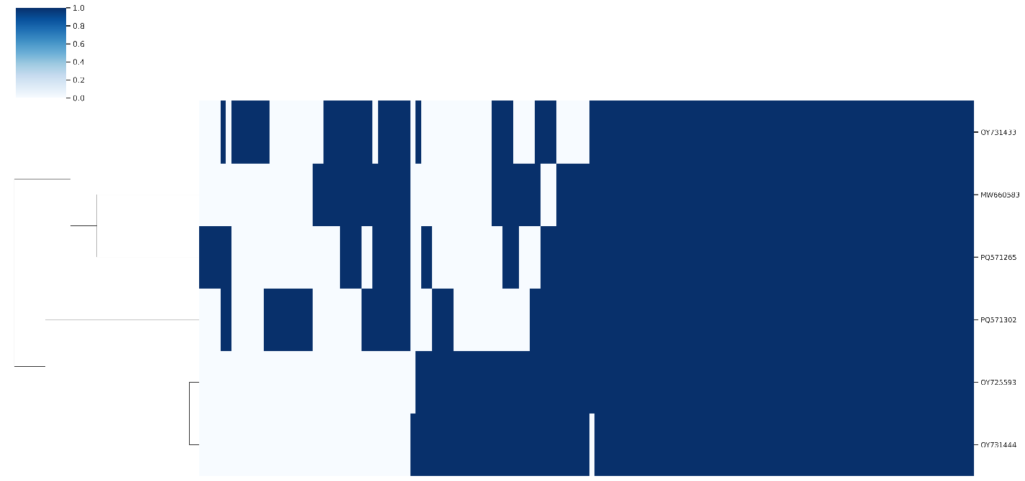
Figure 1. Presence-absence matrix of protein clusters by genome. Rows and columns were hierarchically clustered using the complete linkage method. Rows represent individual genomes with columns representing protein clusters. Vertical blue bars denote the presence of protein clusters in each genome.

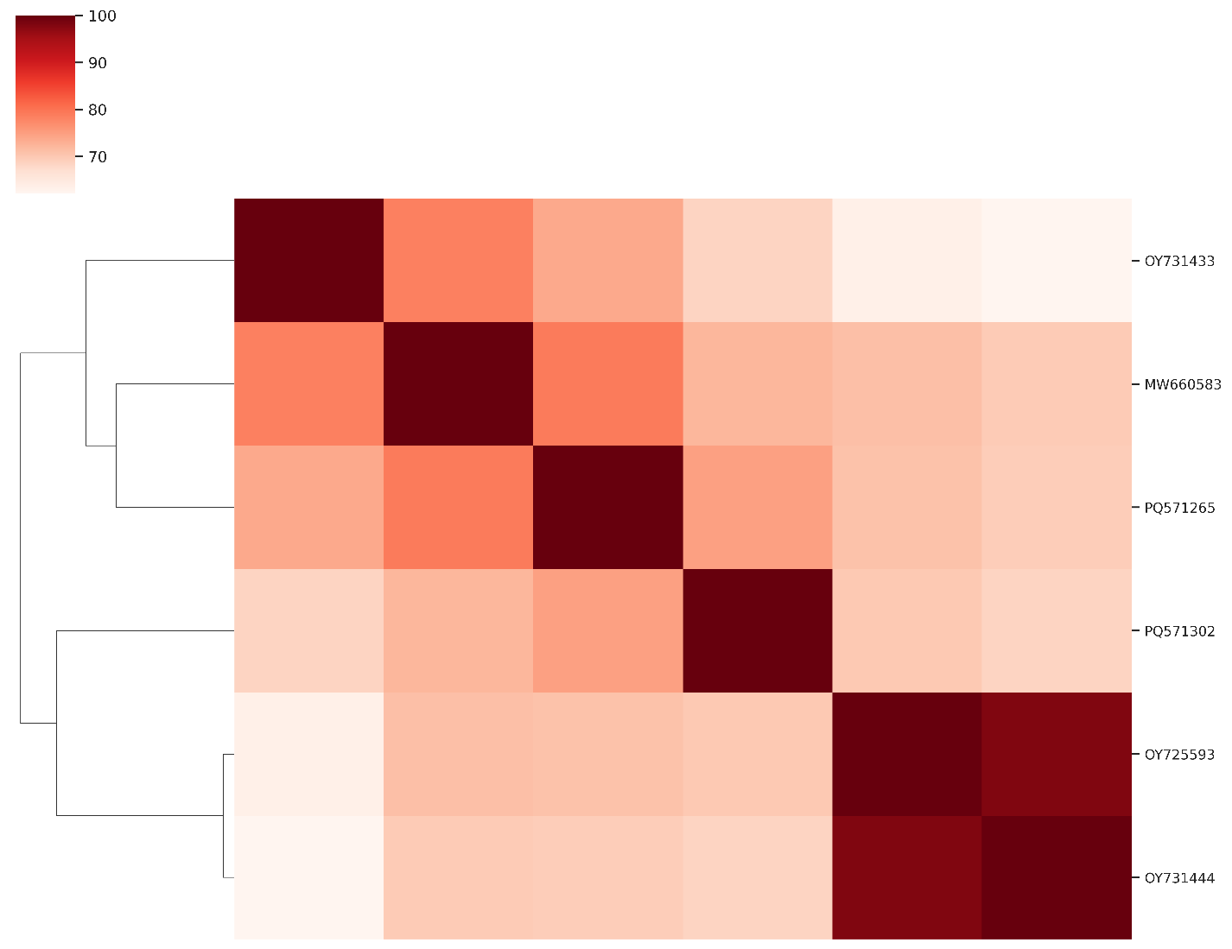
Figure 2. Heatmap of Jaccard similarity calculated from the percentage of shared protein clusters between genomes.

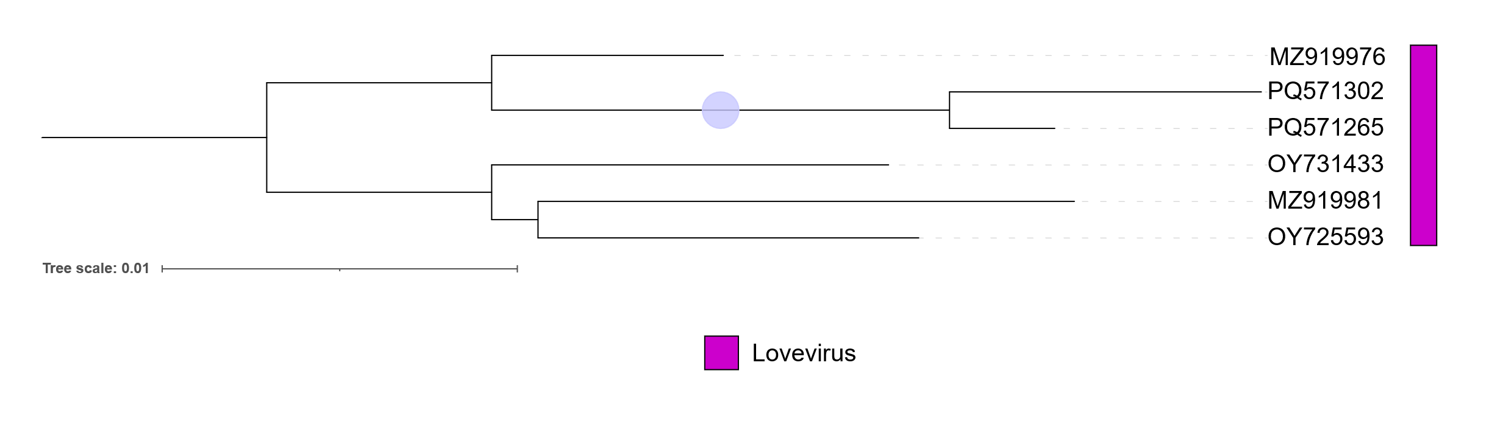
Figure 3. Concatenated core-gene maximum-likelihood phylogenetic tree. Protein clusters were aligned with MAFFT e-insi [8, 9] and trimmed with trimAl with a gap threshold of 0.5. The tree was inferred using IQTree3 [10] using a best-fit partition model inferred [11] from trees of individual protein cluster alignments and 1000 ultra-fast bootstrap [12] and SH-Alrt test replicates. The tree was rooted at the midpoint and bootstrap support ≥95% are shown as circles at branch points. The tree was visualized using iTOL [13,14].

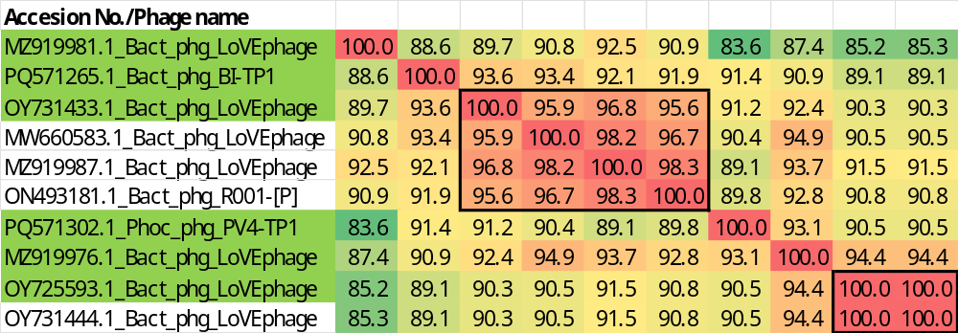

Figure 4. VIRIDIC heatmaps of this group of phages. VIRIDIC (Virus Intergenomic Distance Calculator; VIRIDIC (Virus Intergenomic Distance Calculator; [1]; http://rhea.icbm.uni-oldenburg.de/VIRIDIC/) computes pairwise intergenomic distances/similarities amongst phage genomes. These phages which are considered strains are boxed in black. Names highlighted in green represent new species. Abbreviations: phg = phage; Bact = Bacteroides; Phoc = Phocaeicola.

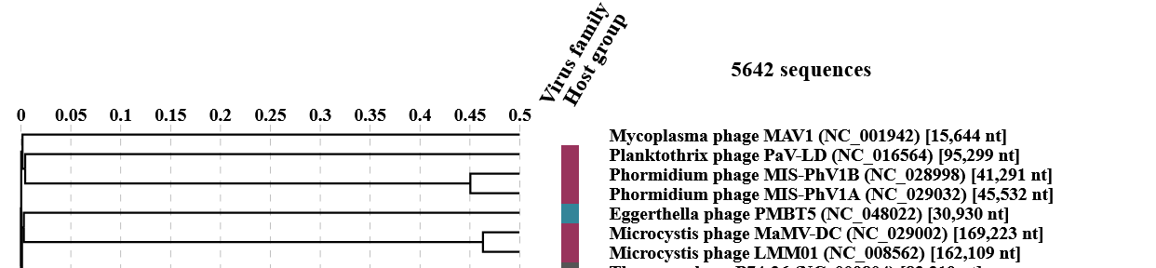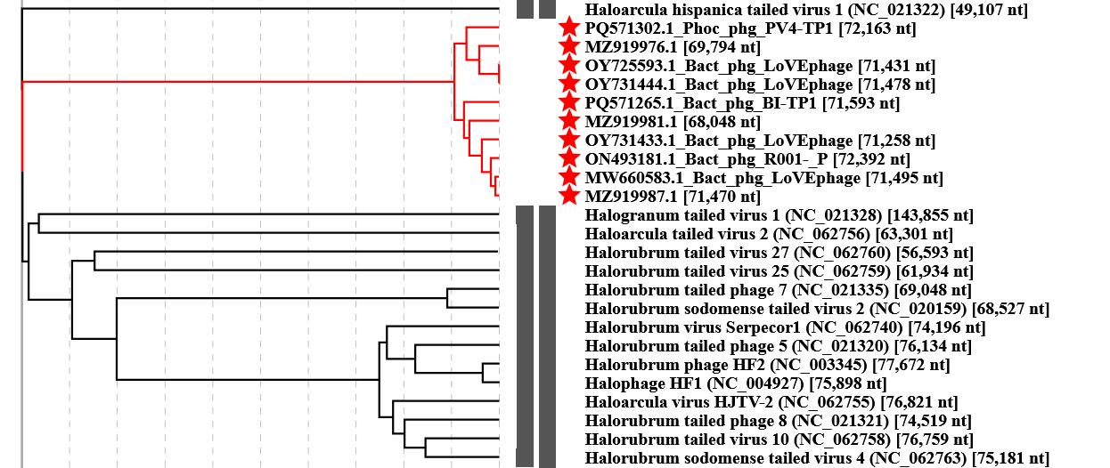
Figure 5. ViPTree analysis: ViPTree analysis (https://www.genome.jp/viptree/; [2]) is based upon Rohwer and Edwards (2002) Phage Proteomic Tree [3]. The taxa under discussion are indicated with red stars. Abbreviations: phg = phage; Bact = Bacteroides; Phoc = Phocaeicola.

Table 1. Characteristics of the only phages in the genus Lovevirus.

Phage name | Host | Morphotype | Lifestyle | Accession No. | Genome size | %G+C | No. proteins | No. tRNA
Bacteroides phage LoVEphage isolate DEVoC_ALD_038 | Bacteroides sp. | Siphovirus | Temperate | MZ919981 | 68,048 bp | 39.1 | 123 | 5(*)
Bacteroides phage BI-TP1 | Bacteroides intestinalis BG4 | Siphovirus | Temperate | PQ571265 | 71,593 bp | 39.1 | 102 | 9(*)
Bacteroides phage LoVEphage1 | Not given | Siphovirus | Temperate | OY731433 | 71,258 bp | 39.0 | 103 | 4
Phocaeicola phage PV4-TP1 | Phocaeicola vulgatus BM8 | Siphovirus | Temperate | PQ571302 | 72,163 bp | 39.2 | 105 | 0
Bacteroides phage LoVEphage isolate DEVoC_ALD_016 | Bacteroides sp. | Siphovirus | Temperate | MZ919976 | 69,794 bp | 39.2 | 124 | 9
Bacteroides phage LoVEphage2 | Not given | Siphovirus | Temperate | OY725593 | 71,431 bp | 39.1 | 103 | 8
(*) None that no tRNAs are annnoted in GenBank file. The numbers presented here were predicted using tRNAScan-SE (https://trna.ucsc.edu/tRNAscan-SE/)

Bacteroides phage LoVEphage1 and Bacteroides phage LoVEphage2 are so named because of an ENA database error which did not differentiate between them

Specific reference: Van Espen L, Bak EG, Beller L, Close L, Deboutte W, Juel HB, Nielsen T, Sinar D, De Coninck L, Frithioff-Bøjsøe C, Fonvig CE, Jacobsen S, Kjærgaard M, Thiele M, Fullam A, Kuhn M, Holm JC, Bork P, Krag A, Hansen T, Arumugam M, Matthijnssens J. A Previously Undescribed Highly Prevalent Phage Identified in a Danish Enteric Virome Catalog. mSystems. 2021 Oct 26;6(5):e0038221. doi: 10.1128/mSystems.00382-21. Epub 2021 Oct 19. PMID: 34665009; PMCID: PMC8525569.

