

The International Committee on Taxonomy of Viruses
Taxonomy Proposal Form, 2026

Part 1a: Details of taxonomy proposals

Title: | Create a new genus Chaozhouvirus and one new species in the class Caudoviricetes
Code assigned: | 2026.018B

Author(s), affiliation and email address(es):
Given name (+middle initial(s)) | Surname | Affiliation | Email address | Corr. author(s)
Jinquan | Li | Huazhong Agricultural University, Wuhan, China | lijinquan2017@163.com | X
Yang | Zhou | Huazhong Agricultural University, Wuhan, China | zhouyang@mail.hzau.edu.cn
Shan | Wang | Huazhong Agricultural University, Wuhan, China | shanwang@mai.hzau.edu.cn
Zhechang | Li | Huazhong Agricultural University, Wuhan, China | 1353357093@qq.com
Yating | Guo | Huazhong Agricultural University, Wuhan, China | guoyating0626@126.com
Qing | LI | Huazhong Agricultural University, Wuhan, China | liqingbio@webmail.hzau.edu.cn
Renwei | Wu | Huazhong Agricultural University, Wuhan, China | wurenwei@mail.hzau.edu.cn
Yu | Ma | Huazhong Agricultural University, Wuhan, China
Part 1b: Taxonomy Proposal Submission
ICTV Subcommittee:
Animal DNA Viruses and Retroviruses |  | Bacterial viruses | X
Animal minus-strand and dsRNA viruses |  | Fungal and protist viruses
Animal positive-strand RNA viruses |  | Plant viruses
Archaeal viruses |  | General -

List the ICTV Study Group(s) that have seen or have been involved in creating this proposal:
Bacterial Viruses
Optional – complete only if formally voted on by an ICTV Study Group:
Study Group | Number of members
Study Group | Votes in support | Votes against | No vote

Submission date: | 25/05/2026

Part 1c: Feedback from ICTV Executive Committee (EC) meeting
Executive Committee Meeting Decision code: | X
A – Accept
Ac – Accept subject to revision by relevant subcommittee chair. No further vote required
U – Accept without revision but with re-evaluation and email vote by the EC
Uc – Accept subject to revision and re-evaluation and email vote by the EC
Ud – Deferred to the next EC meeting, with an invitation to revise based on EC comments
J - Reject
W - Withdrawn

Comments from the Executive Committee:

Part 1d: Revised Taxonomy Proposal Submission
Response of proposer:
Revision date:

Part 3: TAXONOMIC PROPOSAL
https://ictv.global/taxonomy/templates
Taxonomic changes proposed:
Establish new taxon | X | Split taxon
Abolish taxon |  | Merge taxon
Move taxon |  | Promote taxon
Rename taxon |  | Demote taxon
Move and rename

Etymology (origin) of proposed taxonomic names:
Taxon name | Etymology of the term

Permission for use of names derived from a living person:
Taxon name | Full name of person from whom the name is derived | Attached

Abstract of Taxonomy Proposal:
Description of current taxonomy:
The bacterial viruses described in this proposal are currently unclassified

Proposed taxonomic change(s):
Create a new genus, “Chaozhouvirus” and a single species, “Chaozhouvirus LPCPA58”.

Demarcation criteria for new taxon/taxa:
Species demarcation criteria: Two phages are assigned to the same species if their genomes are more than 95% identical over their genome length for isolates.
These values can be calculated by a number of tools, such as BLASTn – usually calculated using intergenomic distance calculator VIRIDIC [1].
Genus demarcation criteria: In search for criteria that create cohesive and distinct genera that are reproducible and monophyletic, the Bacterial Viruses Subcommittee has established 70% nucleotide identity of the genome length as the cut-off for genera. Genus-level groupings should always be monophyletic in the signature genes, as tested with a phylogenetic tree. [2]

Justification:
A TBLASTX distance tree of Clostridium phage LPCPA58 was constructed using VIPTree [3-4]. LPCPA58, along with 14 other phages, formed a shallow-branching clade on the VIPTree distance-based phylogeny, and were subsequently selected for VIRIDIC analysis. VIRIDIC analysis computed the pairwise genomic distances and similarities between the phage genomes, revealing that LPCPA58 exhibited nucleotide similarity below 70% to these close branching phages. Furthermore, a maximum-likelihood (ML) tree was constructed using the terminase large subunit of the 15 phages, with 500 bootstrap replicates [5-6]. The topology of the ML tree supports the results of VIPTree. In conclusion, we propose a new genus, Chaozhouvirus, containing one new species,Chaozhouvirus LPCPA58.

- Text of Taxonomy proposal:

Description of current taxonomy:
The bacterial viruses described in this proposal are currently unclassified

Proposed taxonomic change(s):
Create a new genus, “Chaozhouvirus” and a single species, “Chaozhouvirus LPCPA58”.

Demarcation criteria for new taxon/taxa:
Species demarcation criteria: Two phages are assigned to the same species if their genomes are more than 95% identical over their genome length for isolates.
These values can be calculated by a number of tools, such as BLASTn – usually calculated using intergenomic distance calculator VIRIDIC [1].
Genus demarcation criteria: In search for criteria that create cohesive and distinct genera that are reproducible and monophyletic, the Bacterial Viruses Subcommittee has established 70% nucleotide identity of the genome length as the cut-off for genera. Genus-level groupings should always be monophyletic in the signature genes, as tested with a phylogenetic tree. [2]

Justification:
A TBLASTX distance tree of Clostridium phage LPCPA58 was constructed using VIPTree (Figure 1) [3-4]. LPCPA58, along with 14 other phages, formed a shallow-branching clade on the VIPTree distance-based phylogeny, and were subsequently selected for VIRIDIC analysis. VIRIDIC analysis computed the pairwise genomic distances and similarities between the phage genomes, revealing that LPCPA58 exhibited nucleotide similarity below 70% to these close branching phages (Figure 2). Furthermore, a maximum-likelihood (ML) tree was constructed using the terminase large subunit of the 15 phages, with 500 bootstrap replicates [5-6]. The topology of the ML tree supports the results of VIPTree (Figure 3)W. In conclusion, we propose a new genus, Chaozhouvirus, containing one new species,Chaozhouvirus LPCPA58.
References:
1. Moraru C, Varsani A, Kropinski AM (2020) VIRIDIC-A Novel Tool to Calculate the Intergenomic Similarities of Prokaryote-Infecting Viruses. Viruses 12(11):1268. PMID: 33172115 / PMCID: PMC7694805 doi: 10.3390/v12111268.
2. Turner D, Kropinski AM, Adriaenssens EM (2021) A Roadmap for Genome-Based Phage Taxonomy. Viruses 13(3):506. PMID: 33803862 / PMCID: PMC8003253 doi: 10.3390/v13030506.
3. Nishimura Y, Yoshida T, Kuronishi M et al (2017) ViPTree: the viral proteomic tree server. Bioinformatics 33(15):2379-2380. PMID: 28379287. doi: 10.1093/bioinformatics/btx157.
4. Rohwer F, Edwards R (2002) The Phage Proteomic Tree: a genome-based taxonomy for phage. J Bacteriol 184(16):4529-35. PMID: 12142423 / PMCID: PMC135240. doi: 10.1128/jb.184.16.4529-4535.2002.
5. Nishijima S, Nagata N, Kiguchi Y et al (2022) Extensive gut virome variation and its associations with host and environmental factors in a population-level cohort. Nat Commun 13(1):5252. PMID: 36068216 / PMCID: PMC9448778 doi: 10.1038/s41467-022-32832-w.
6. Kozlov AM, Darriba D, Flouri T et al (2019) RAxML-NG: a fast, scalable and user-friendly tool for maximum likelihood phylogenetic inference. Bioinformatics 35(21):4453-4455. PMID: 31070718 / PMCID: PMC6821337 doi: 10.1093/bioinformatics/btz305.

Accompanying files:
Filename | Description of contents

Tables, Figures:

<Start here>

Tables, Figures:
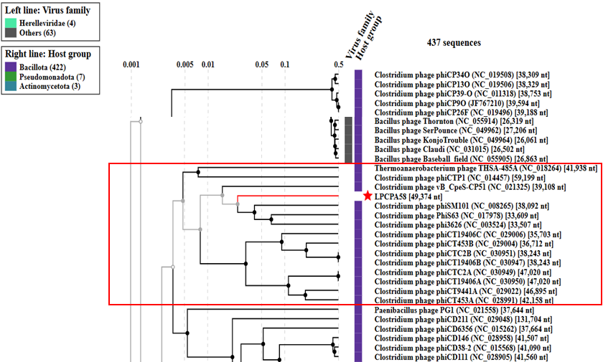Figure 1. ViPTree analysis: ViPTree analysis (https://www.genome.jp/viptree/; [3]) is based upon Rohwer and Edwards (2002) Phage Proteomic Tree [4]. The candidate phages are indicated by red stars, and the phylogenetically related phages selected for VIRIDIC analysis are enclosed in red boxes.

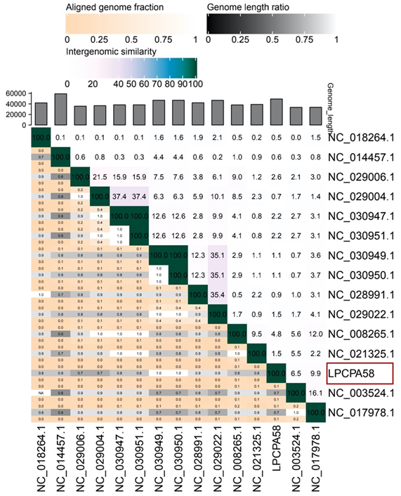Figure 2. VIRIDIC heat map: VIRIDIC (Virus Intergenomic Distance Calculator [1]; http://rhea.icbm.uni-oldenburg.de/VIRIDIC/) computes pairwise intergenomic distances/similarities amongst phage genomes. Candidate phages are indicated with red box.

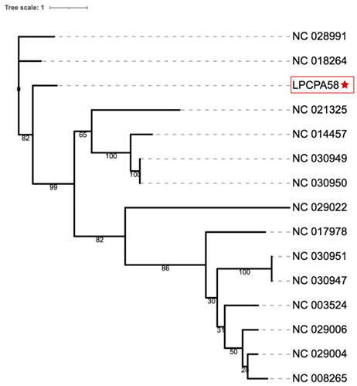
Figure 3. Phylogeny: The phylogenetic tree was constructed using the major capsid protein of phages [5]. MUSCLE was used for multiple alignment and RAxML-NG was used for building phylogenetic tree using maximum-likelihood method with 500 bootstraps [6]. The new species is indicated with red box and star.

Origin of the name of this taxon: This genus is named based on the Chaozhou, located in Chaozhou City.
Historical aspects: Ralstonia phage LPRS20 is isolated by Jinquan LI’s group in 2022, Hubei, China.
Specific References: Clostridium phage LPCPA58 was isolated by Chaozhou in 2022, using Clostridium perfringens as the host bacterium.
Genome summary:
Phage name | INSDC | Size (Kb) | GC% | Protein | tRNA
Clostridium phage LPCPA58 | OR225626 | 49.374 | 28.39 | 79 | 0

